Supplementary Information

Galactosyl and sialyl clusters: synthesis and evaluation against T. cruzi parasite

Andreza S. Figueredo ¹, Peterson de Andrade ¹, Thalita B. Riul ¹, Marcelo F. Marchiori ¹, Thais Canassa De Leo ¹, Anna Karoline A. Fleuri ¹, Sérgio Schenkman ², Marcelo D. Baruffi ¹ and Ivone Carvalho ¹
¹ School of Pharmaceutical Sciences of Ribeirão Preto, University of São Paulo, Av. do Café s/n, Monte Alegre, Ribeirão Preto 14040-903, Brazil.
² Federal University of São Paulo, Rua Pedro de Toledo 669 L6A 04039-032, São Paulo SP, Brazil.

*Corresponding author: carronal@usp.br (I. Carvalho); tel.: +551633154709
Fig. S1. ¹H NMR spectrum of compound 6.
Fig. S2. ¹³C NMR spectrum of compound 6.
Fig. S3. ESI MS analysis of compound 6.
Fig. S4. ¹H NMR spectrum of compound 7.
Fig. S5. ¹H NMR spectrum of compound 8.
Fig. S6. ¹H NMR spectrum of compound 9.
Fig. S7. ¹H NMR spectrum of glycocluster 10.
Fig. S8. ¹³C NMR spectrum of glycocluster 10.
Fig. S9. ESI MS analysis of glycocluster 10.
Fig. S10. ¹H NMR spectrum of glycocluster 11.
Fig. S11. ¹³C NMR spectrum of glycocluster 11.
Fig. S12. ESI MS analysis of glycocluster 11.
Fig. S13. ¹H NMR spectrum of glycocluster 12.
Fig. S14. ¹³C NMR spectrum of glycocluster 12.
Fig. S15. ESI MS analysis of glycocluster 12.
Fig. S16. ¹H NMR spectrum of compound 13.
Fig. S17. ¹³C NMR spectrum of compound 13.
Fig. S18. ESI MS analysis of compound 13.
Fig. S19. ¹H NMR spectrum of compound 14.
Fig. S20. ¹³C NMR spectrum of compound 14.
Fig. S21. ESI MS analysis of compound 14.
Fig. S22. ¹H NMR spectrum of compound 15.
Fig. S23. ¹³C NMR spectrum of compound 15.
Fig. S24. ESI MS analysis of compound 15.
Fig. S25. ¹H NMR spectrum of compound 18.
Fig. S26 A. ¹³C NMR spectrum of compound 18.
Fig. S26 B. ¹³C NMR spectrum of compound 18 after deconvolution with Lorentzian shape with detection sensitivity set to 1.4 and peak overlapping factor of 0.5 ppm (Software: Bruker TopSpin 2.1).
Fig. S27. ESI MS analysis of compound 18.
Fig. S28. ¹H NMR spectrum of compound 19.
Fig. S29 A. ¹³C NMR spectrum of compound 19.
Fig. S29 B. ¹³C NMR spectrum of compound 19 after deconvolution with Lorentzian shape with detection sensitivity set to 1.4 and peak overlapping factor of 0.5 ppm (Software: Bruker TopSpin 2.1).
Fig. S30. ESI MS analysis of compound 19.
Fig. S31. ¹H NMR spectrum of glycocluster 21.
Fig. S32. ¹³C NMR spectrum of glycocluster 21.
Fig. S33. ESI MS analysis of glycocluster 21.
Fig. S34. ¹H NMR spectrum of compound 22.
Fig. S35 A. ¹³C NMR spectrum of compound 22.
Fig. S35 B. ¹³C NMR spectrum of compound 22 after deconvolution with Lorentzian shape with detection sensitivity set to 1.4 and peak overlapping factor of 0.5 ppm (Software: Bruker TopSpin 2.1).
Fig. S36. ESI MS analysis of compound 22.
Fig. S37. ¹H NMR spectrum of glycocluster 1.
Fig. S38. ESI MS analysis of glycocluster 1.
Fig. S39. ¹H NMR spectrum of glycocluster 2.
Fig. S40. ESI MS analysis of glycocluster 2.
Fig. S41. ¹H NMR spectrum of glycocluster 3.
Fig. S42. ESI MS analysis of glycocluster 3.
Fig. S43. ¹H NMR spectrum of glycocluster 4.
Fig. S44. ESI MS analysis of glycocluster 4.
Fig. S45. ¹H NMR spectrum of glycocluster 5.
Fig. S46. ESI MS analysis of glycocluster 5.

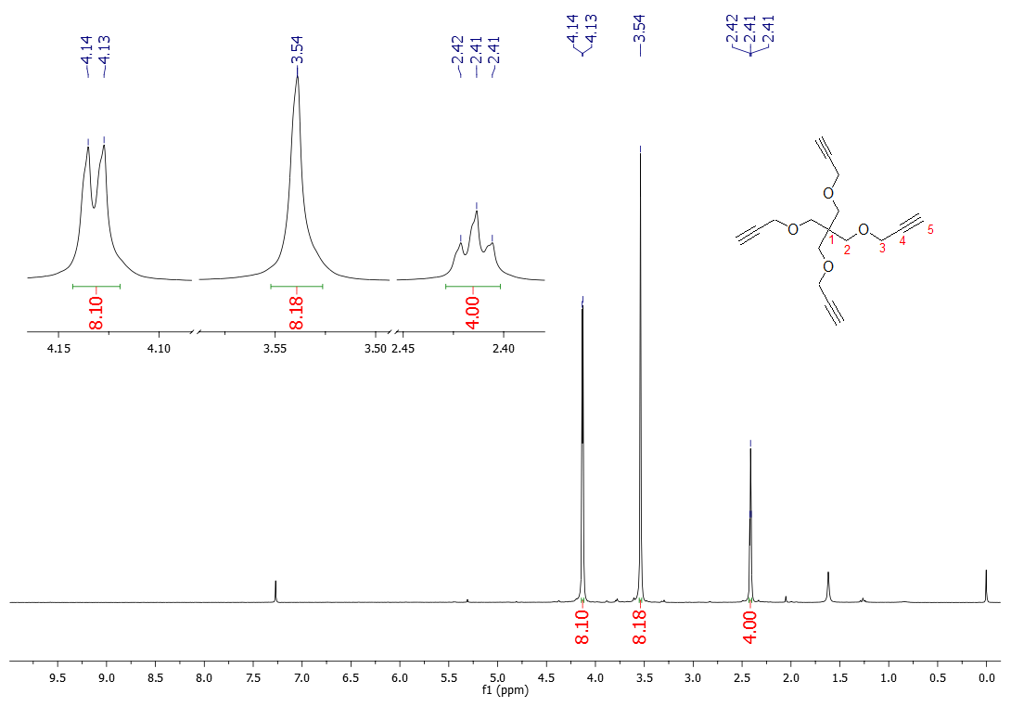
Fig. S1. ¹H NMR (400 MHz, CDCl₃) spectrum of compound 6.

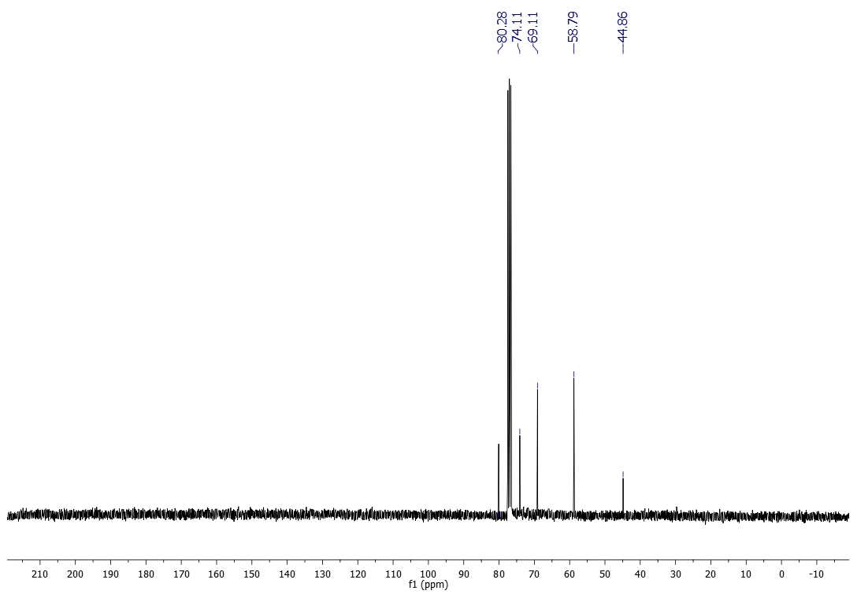
Fig. S2. ¹³C NMR (100 MHz, CDCl₃) spectrum of compound 6.

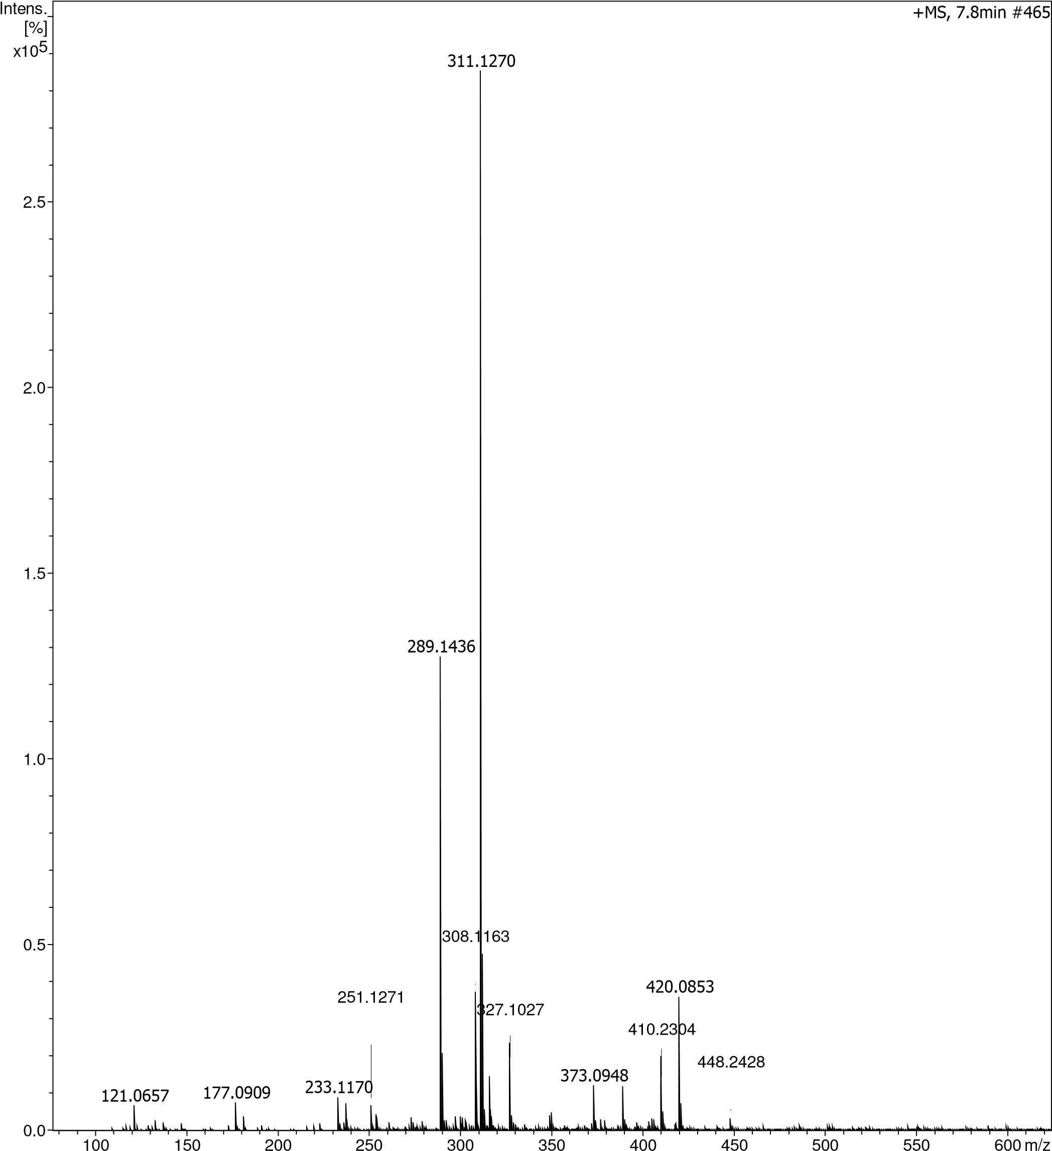
Fig. S3. HRMS (ESI) analysis of compound 6: m/z [M+H]⁺ calculated for C₁₇H₂₁O₄⁺ 289.1434; found: 289.1436.

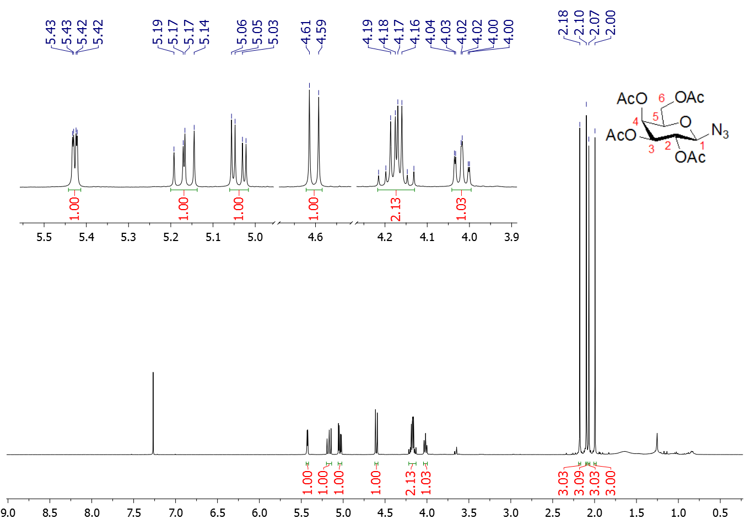
Fig. S4. ¹H NMR (400 MHz, CDCl₃) spectrum of compound 7.
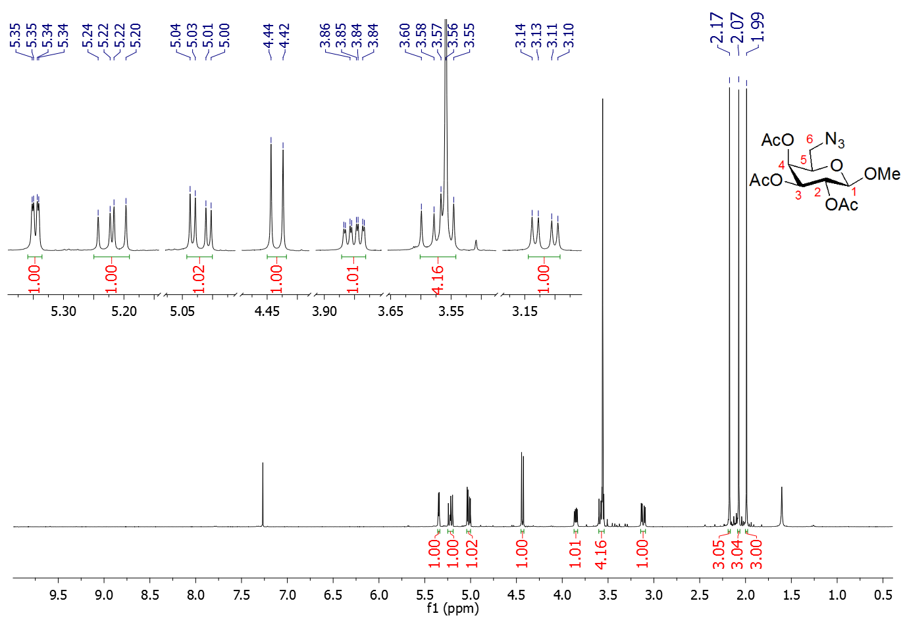
Fig. S5. ¹H NMR (500 MHz, CDCl₃) spectrum of compound 8.
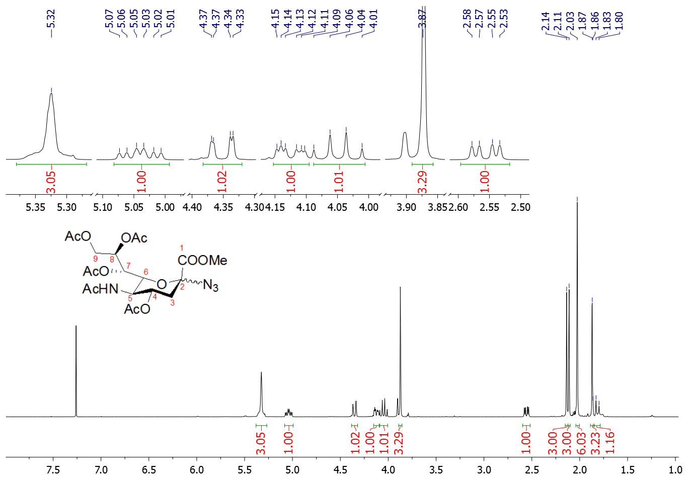
Fig. S6. ¹H NMR (400 MHz, CDCl₃) spectrum of compound 9.

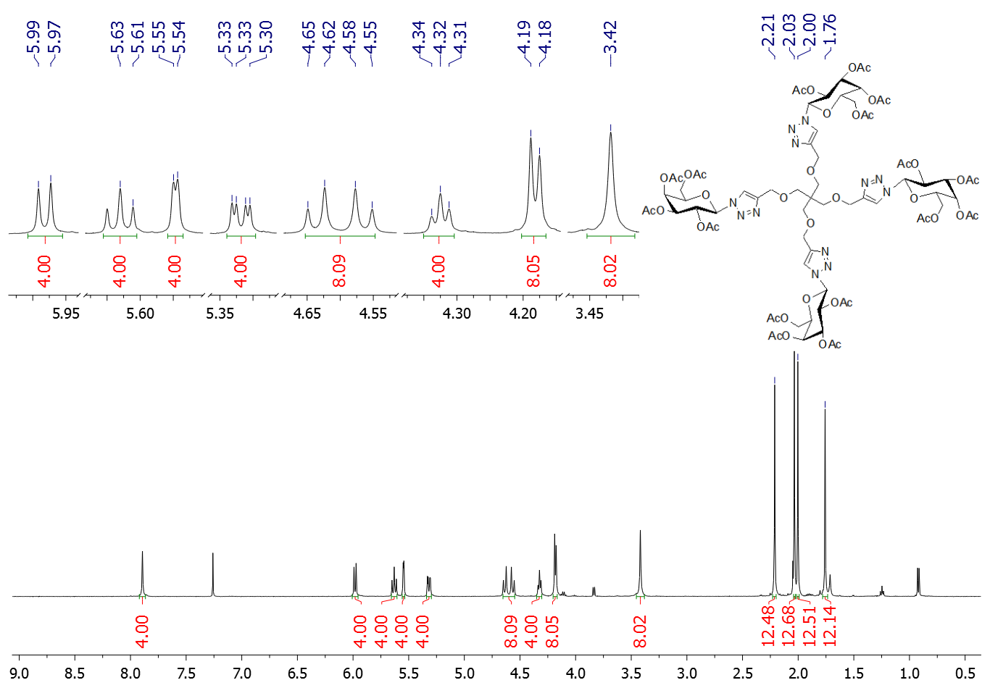
Fig. S7. ¹H NMR (500 MHz, CDCl₃) spectrum of glycocluster 10.
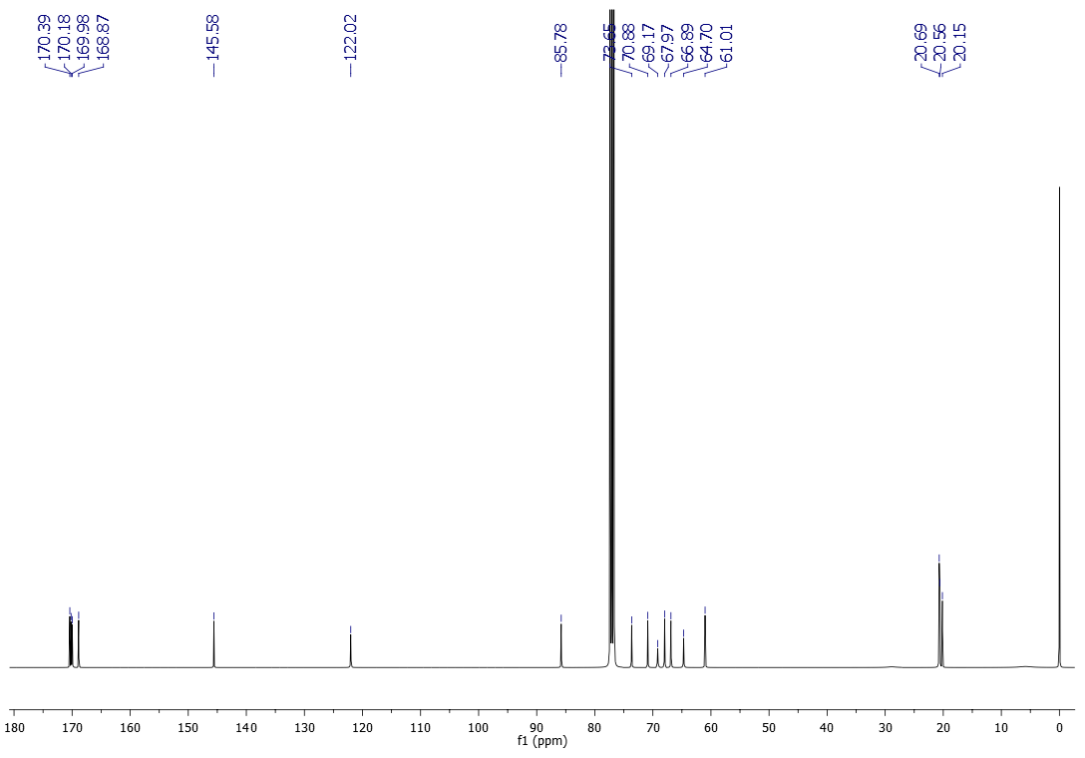
Fig. S8. ¹³C NMR (125 MHz, CDCl₃) spectrum of glycocluster 10.
913.2809913.2809
1392.44171392.4417
1803.57361803.5736
1781.58461781.5846
1819.54431819.5443
1335.47101335.4710
216216
MS, 3.6min #MS, 3.6min #
++
00
22
44
66
44
x10x10
Intens.Intens.
]]
[[
%%
600600
800800
10001000
12001200
14001400
16001600
18001800
20002000
22002200
24002400
m/zm/z
Fig. S9. HRMS (ESI) analysis of glycocluster 10: m/z [M+Na]⁺ calculated for C₇₃H₉₆N₁₂NaO₄₀⁺ 1803.5739; found: 1803.5736.

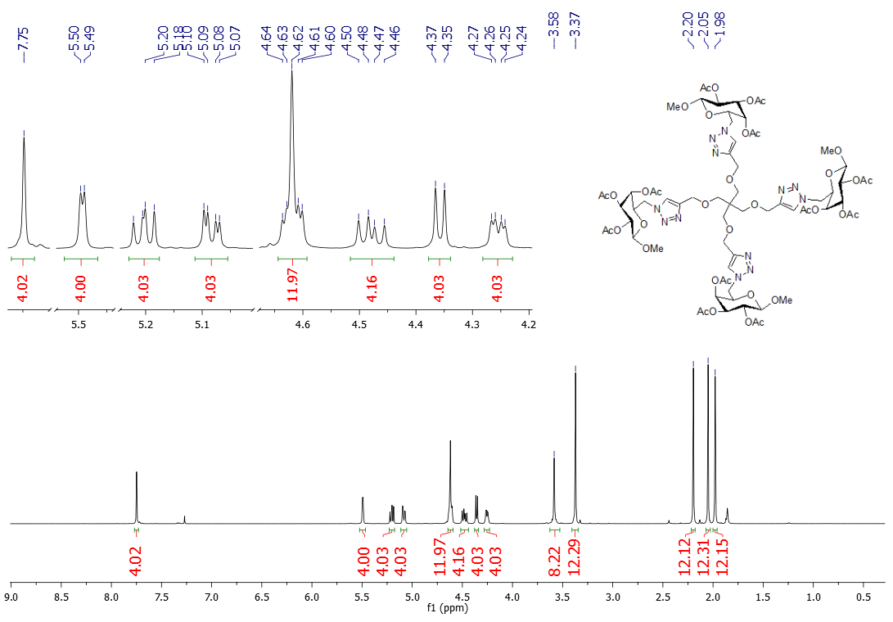
Fig. S10. ¹H NMR (500 MHz, CDCl₃) spectrum of glycocluster 11.

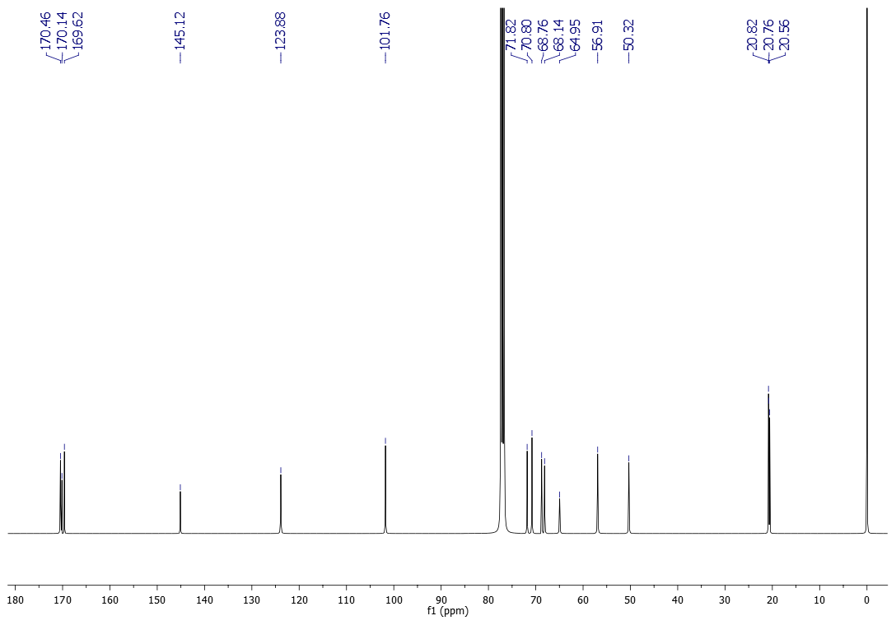
Fig. S11. ¹³C NMR (125 MHz, CDCl₃) spectrum of glycocluster 11.
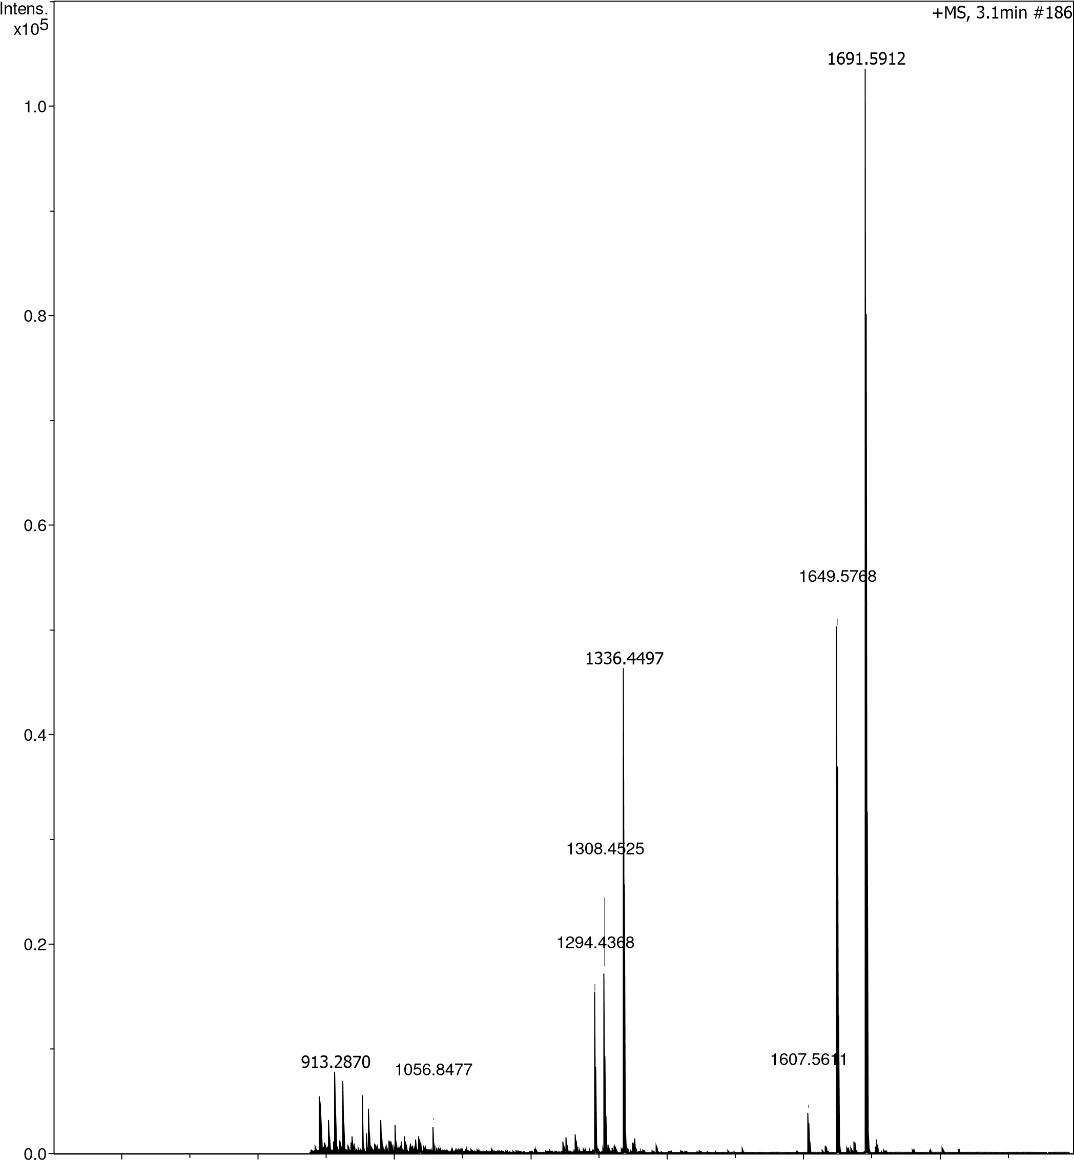
Fig. S12. HRMS (ESI) analysis of glycocluster 11: m/z [M+Na]⁺ calculated for C₆₉H₉₆N₁₂NaO₃₆⁺ 1691.5942; found: 1691.5912.

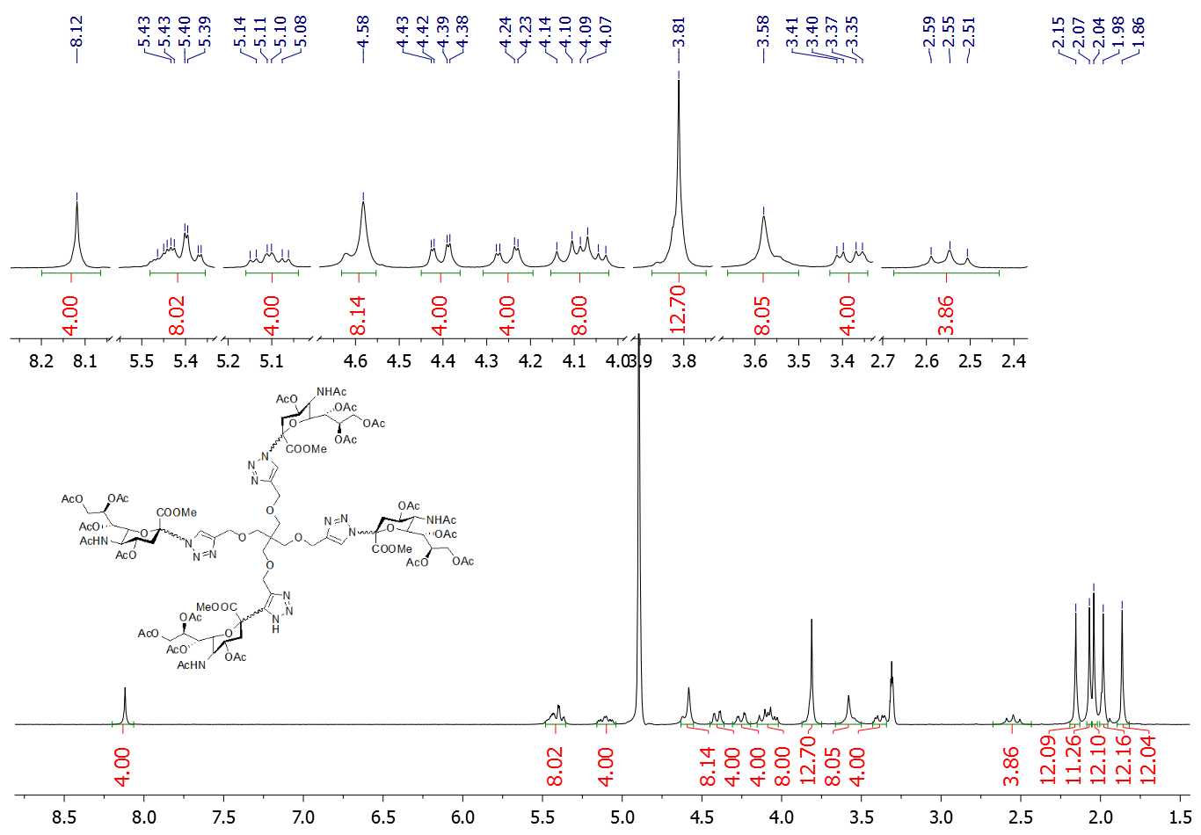
Fig. S13. ¹H NMR (300 MHz, CD₃OD) spectrum of glycocluster 12.

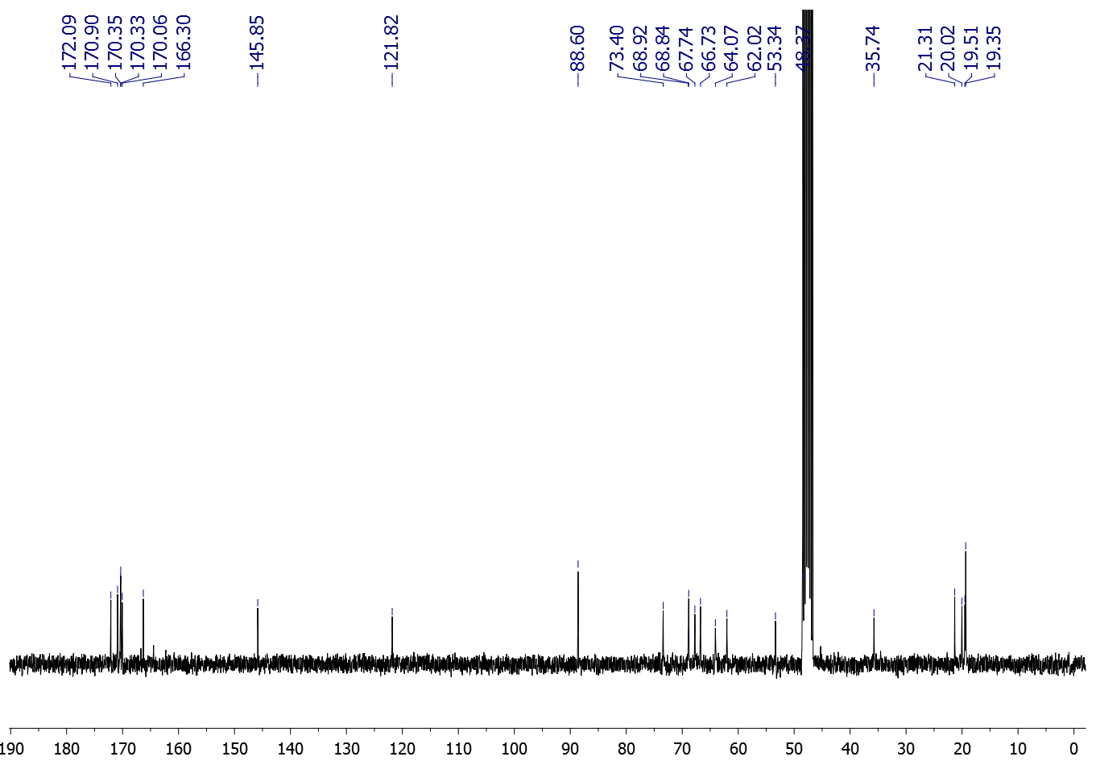
Fig. S14. ¹³C NMR (75 MHz, CD₃OD) spectrum of glycocluster 12.
1799.3187
2375.8075
2803.4436
0.0
0.2
0.4
0.6
0.8
1.0
1.2
6
x10
Intens.
1000
2000
3000
4000
5000
m/z
1

1

Fig. S15. ESI MS analysis of glycocluster 12: m/z [M+Na]⁺ calculated for C₉₇H₁₃₂N₁₆NaO₅₂⁺ 2375.8069; found: 2375.8075.
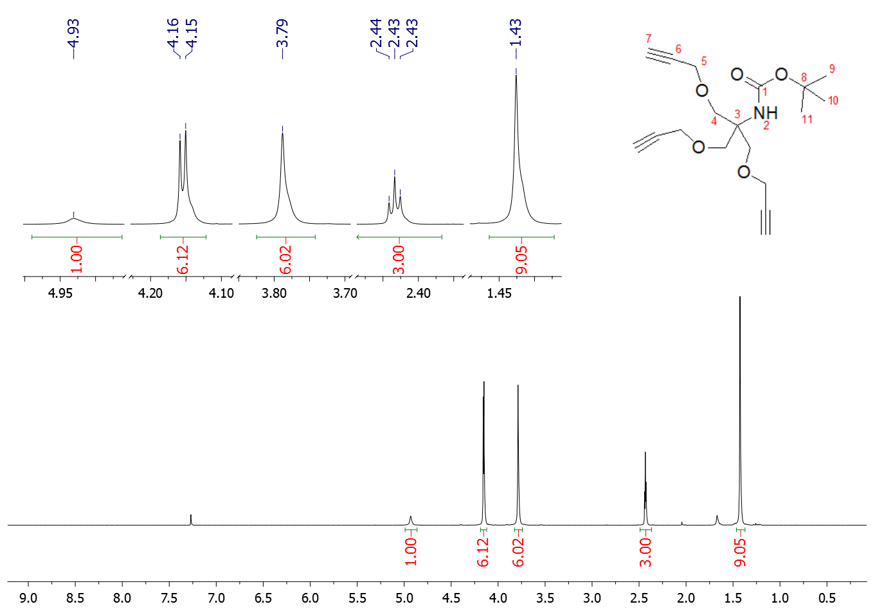
Fig. S16. ¹H NMR (300 MHz, CDCl₃) spectrum of compound 13.
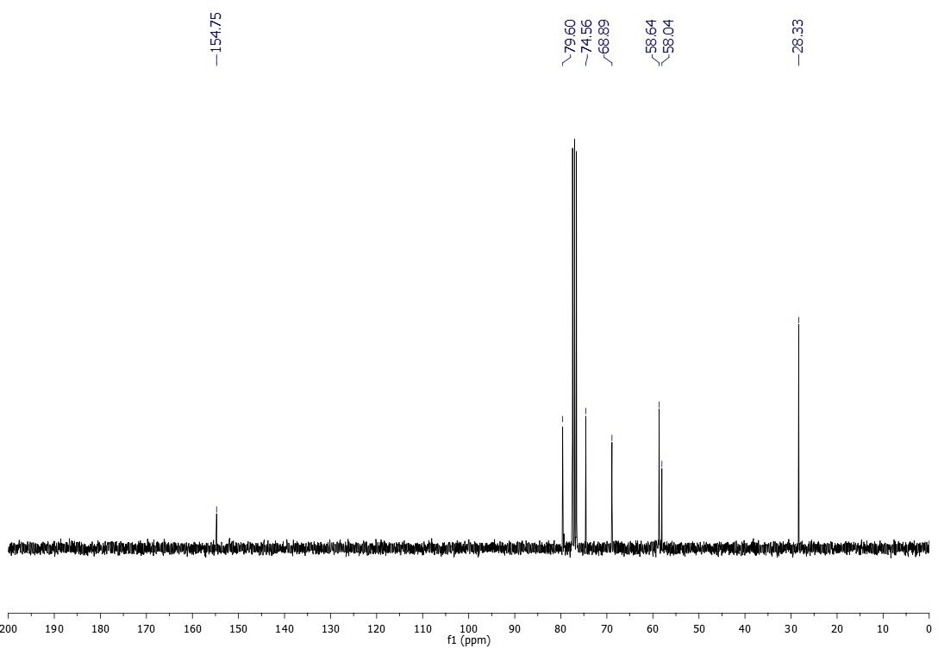
Fig. S17. ¹³C NMR (75 MHz, CDCl₃) spectrum of compound 13.

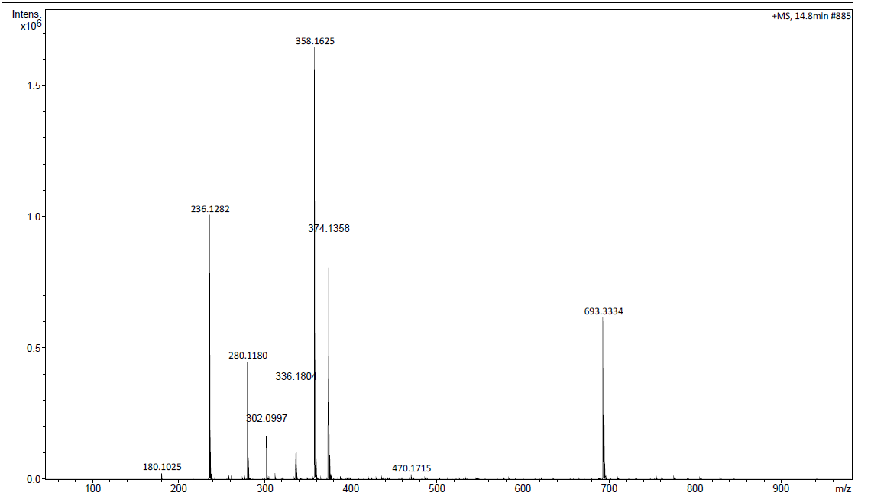
Fig. S18. HRMS (ESI) analysis of compound 13: m/z [M+Na]⁺ calculated for C₁₈H₂₅NNaO₅⁺ 358.1625; found: 358.1625.
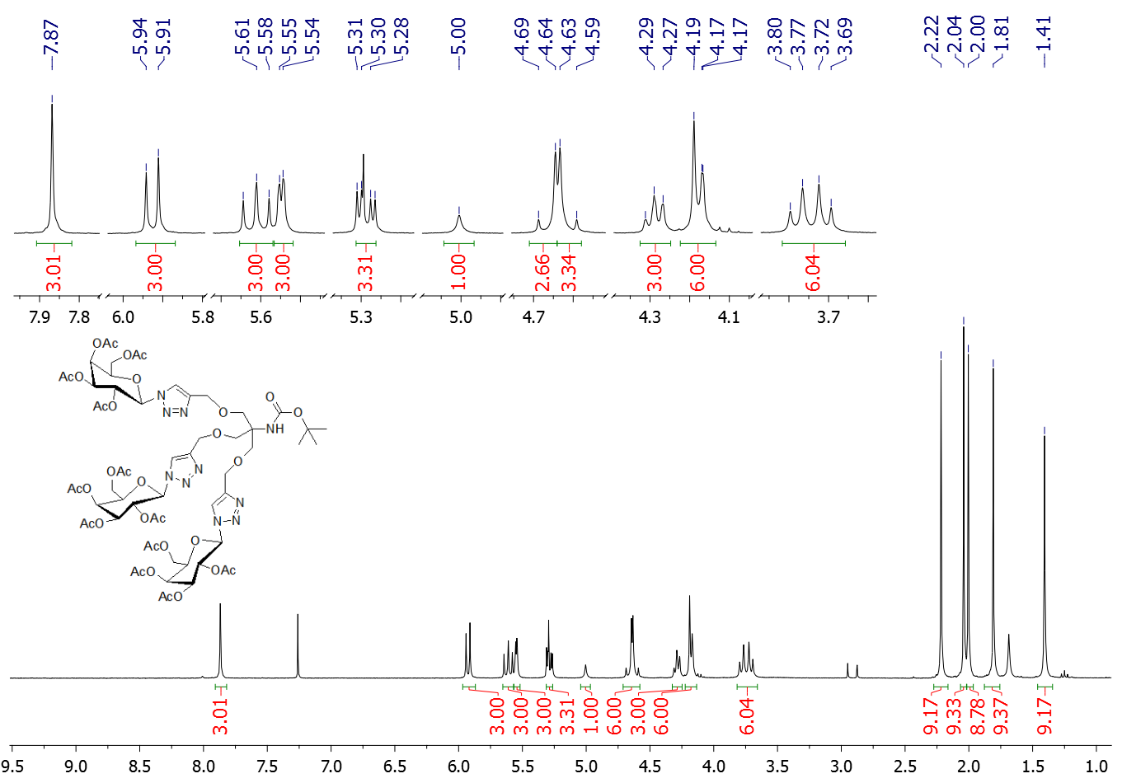
Fig. S19. ¹H NMR (300 MHz, CDCl₃) spectrum of compound 14.

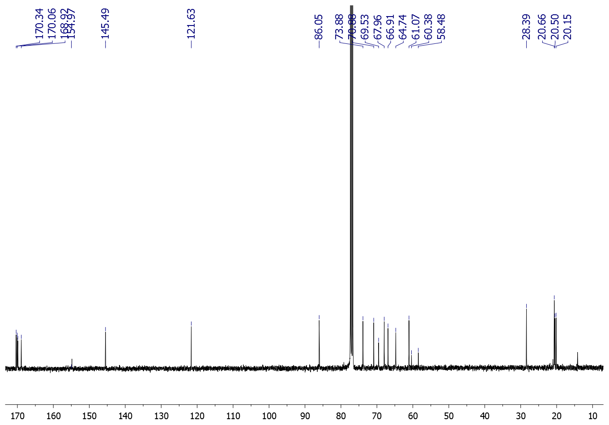
Fig. S20. ¹³C NMR (75 MHz, CDCl₃) spectrum of compound 14.
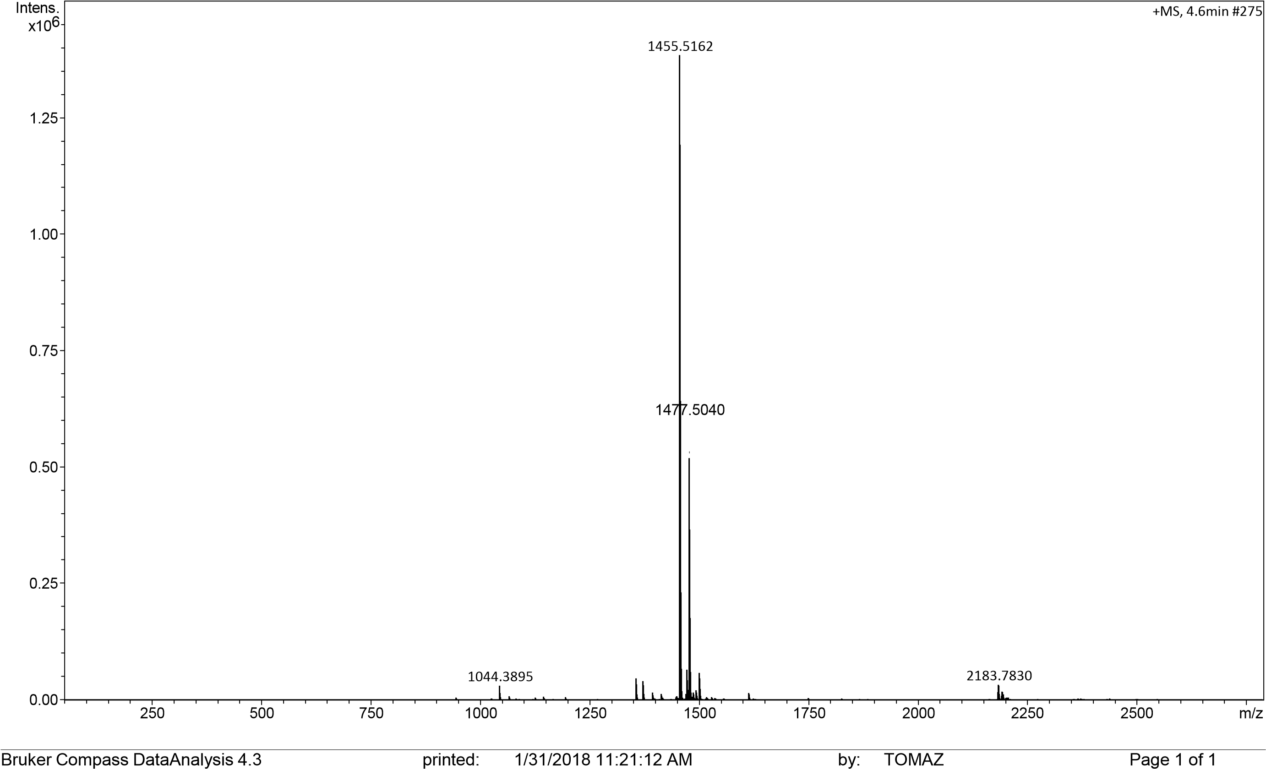
Fig. S21. HRMS (ESI) analysis of compound 14: m/z [M+H]⁺ calculated for C₆₀H₈₃N₁₀O₃₂⁺ 1455.5169; found: 1455.5162; [M+Na]⁺ calculated for C₆₀H₈₂NaN₁₀O₃₂⁺ 1477.4989, found: 1477.5040.

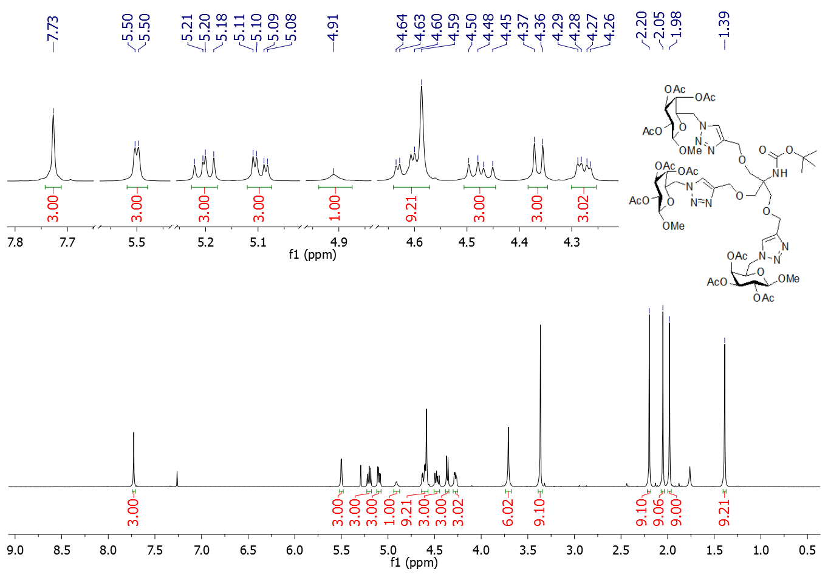
Fig. S22. ¹H NMR spectrum (500 MHz, CDCl₃) of compound 15.

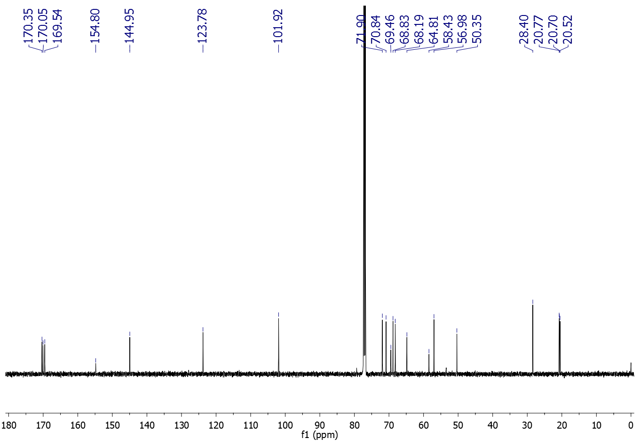
Fig. S23. ¹³C NMR (125 MHz, CDCl₃) spectrum of compound 15.
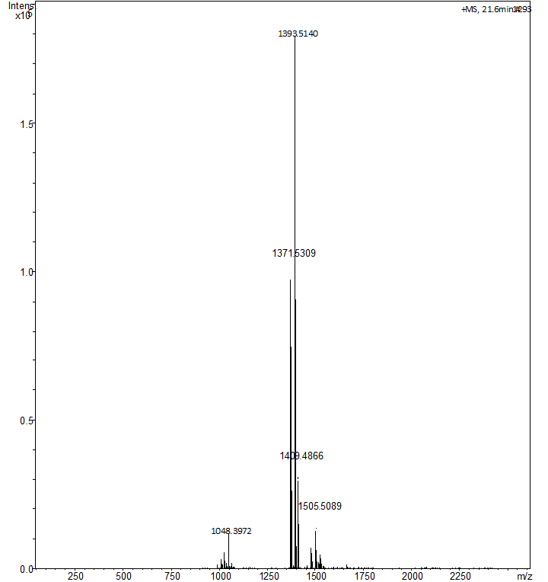
Fig. S24. ESI MS analysis of compound 15: m/z [M+Na]⁺ calculated for C₅₇H₈₂N₁₀NaO₂₉⁺ 1393.5140; found: 1393.5140; [M+K]⁺ calculated for C₅₇H₈₂N₁₀KO₂₉⁺ 1409.4881, found: 1409.4866.

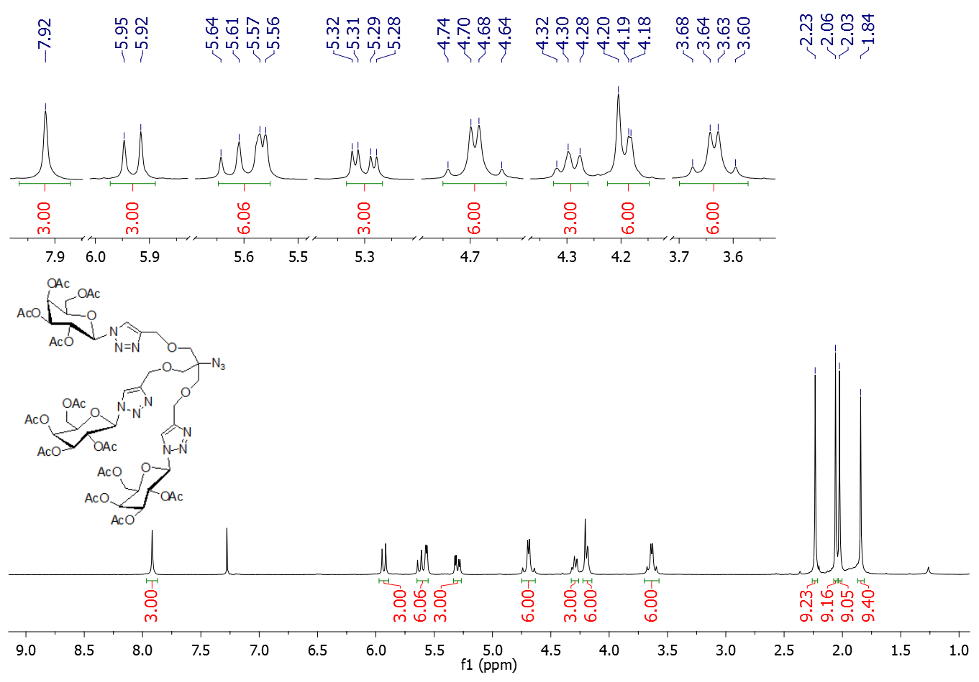
Fig. S25. ¹H NMR (300 MHz, CDCl₃) spectrum of compound 18.

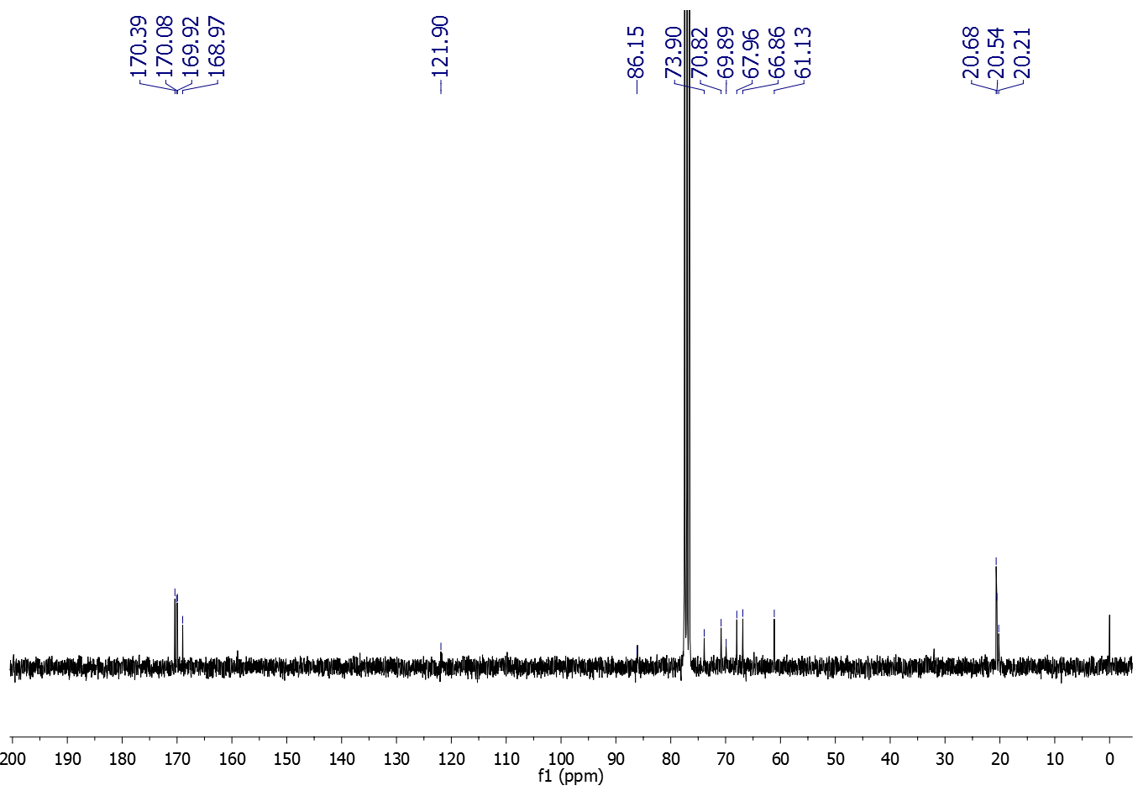
Fig. S26 A. ¹³C NMR (75 MHz, CDCl₃) spectrum of compound 18.
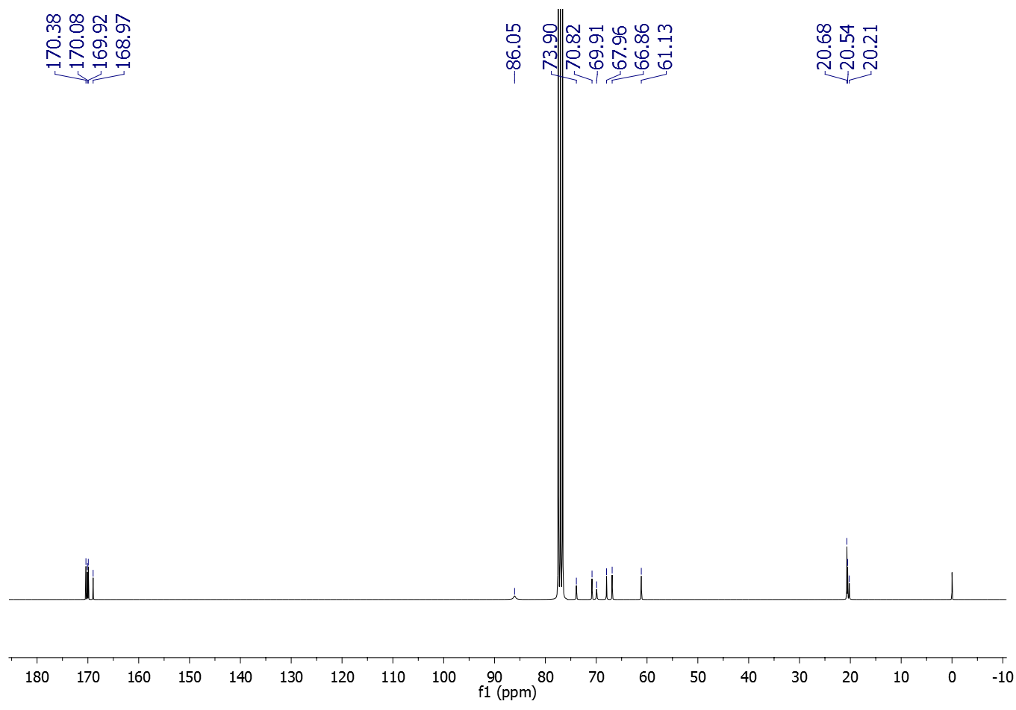
Fig. S26 B. ¹³C NMR spectrum (75 MHz, CDCl₃) of compound 18 after deconvolution with Lorentzian shape with detection sensitivity set to 1.4 and peak overlapping factor of 0.5 ppm (Software: Bruker TopSpin 2.1).

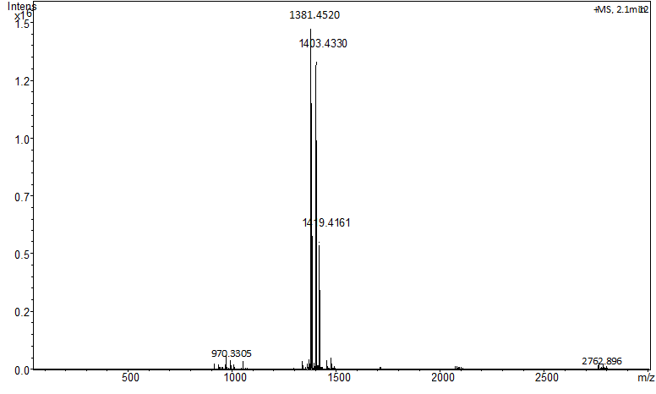
Fig. S27. HRMS (ESI) analysis of compound 18: m/z [M+H]⁺ calculated for C₅₅H₇₃N₁₂O₃₀⁺1381.4550; found: 1381.4520; [M+Na]⁺ calculated for C₅₅H₇₂NaN₁₂O₃₅⁺1403.3070, found: 1403.4330; [M+K]⁺ calculated for C₅₅H₇₂KN₁₂O₃₅⁺1419.4109, found: 1419.4161.

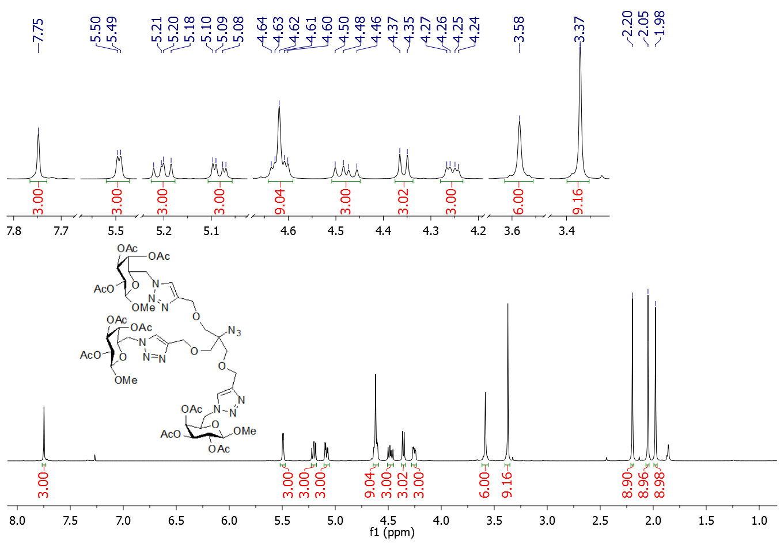
Fig. S28. ¹H NMR spectrum (500 MHz, CDCl₃) of compound 19.
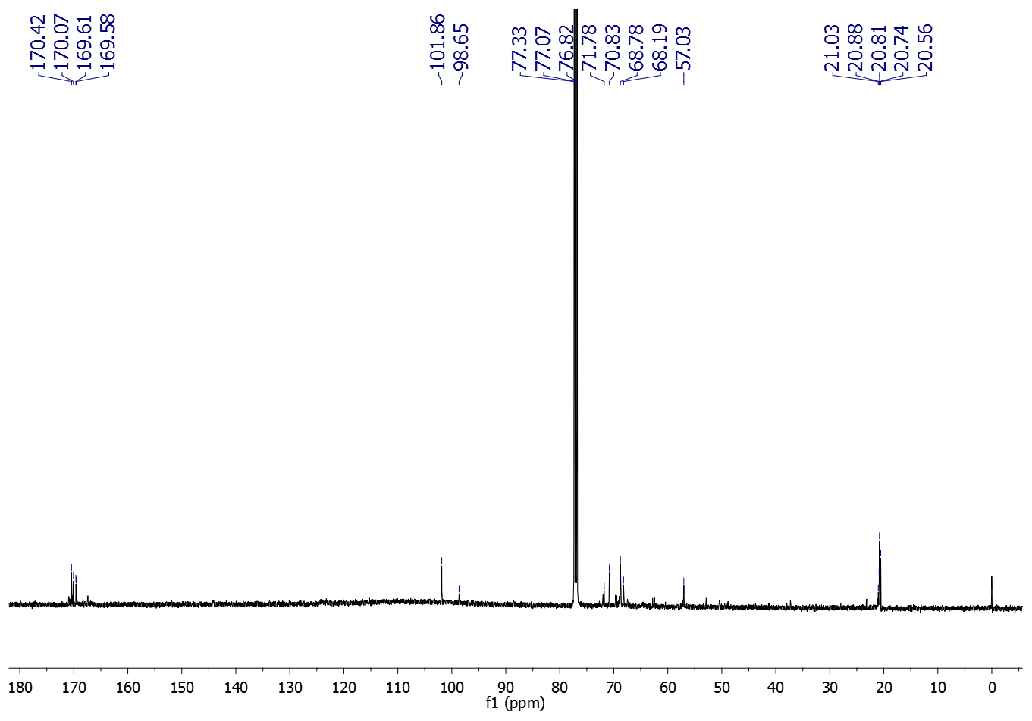
Fig. S29 A. ¹³C NMR (125 MHz, CDCl₃) spectrum of compound 19.

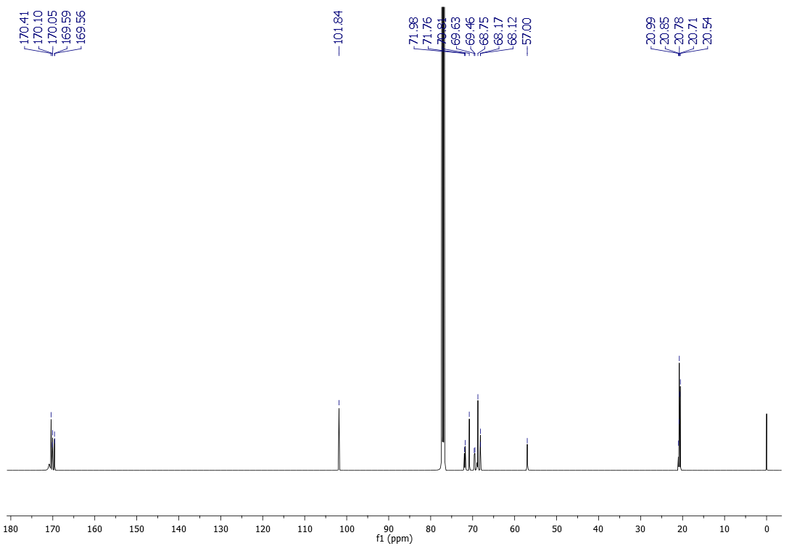
Fig. S29 B. ¹³C NMR spectrum (125 MHz, CDCl₃) of compound 19 after deconvolution with Lorentzian shape with detection sensitivity set to 1.4 and peak overlapping factor of 0.5 ppm (Software: Bruker TopSpin 2.1).

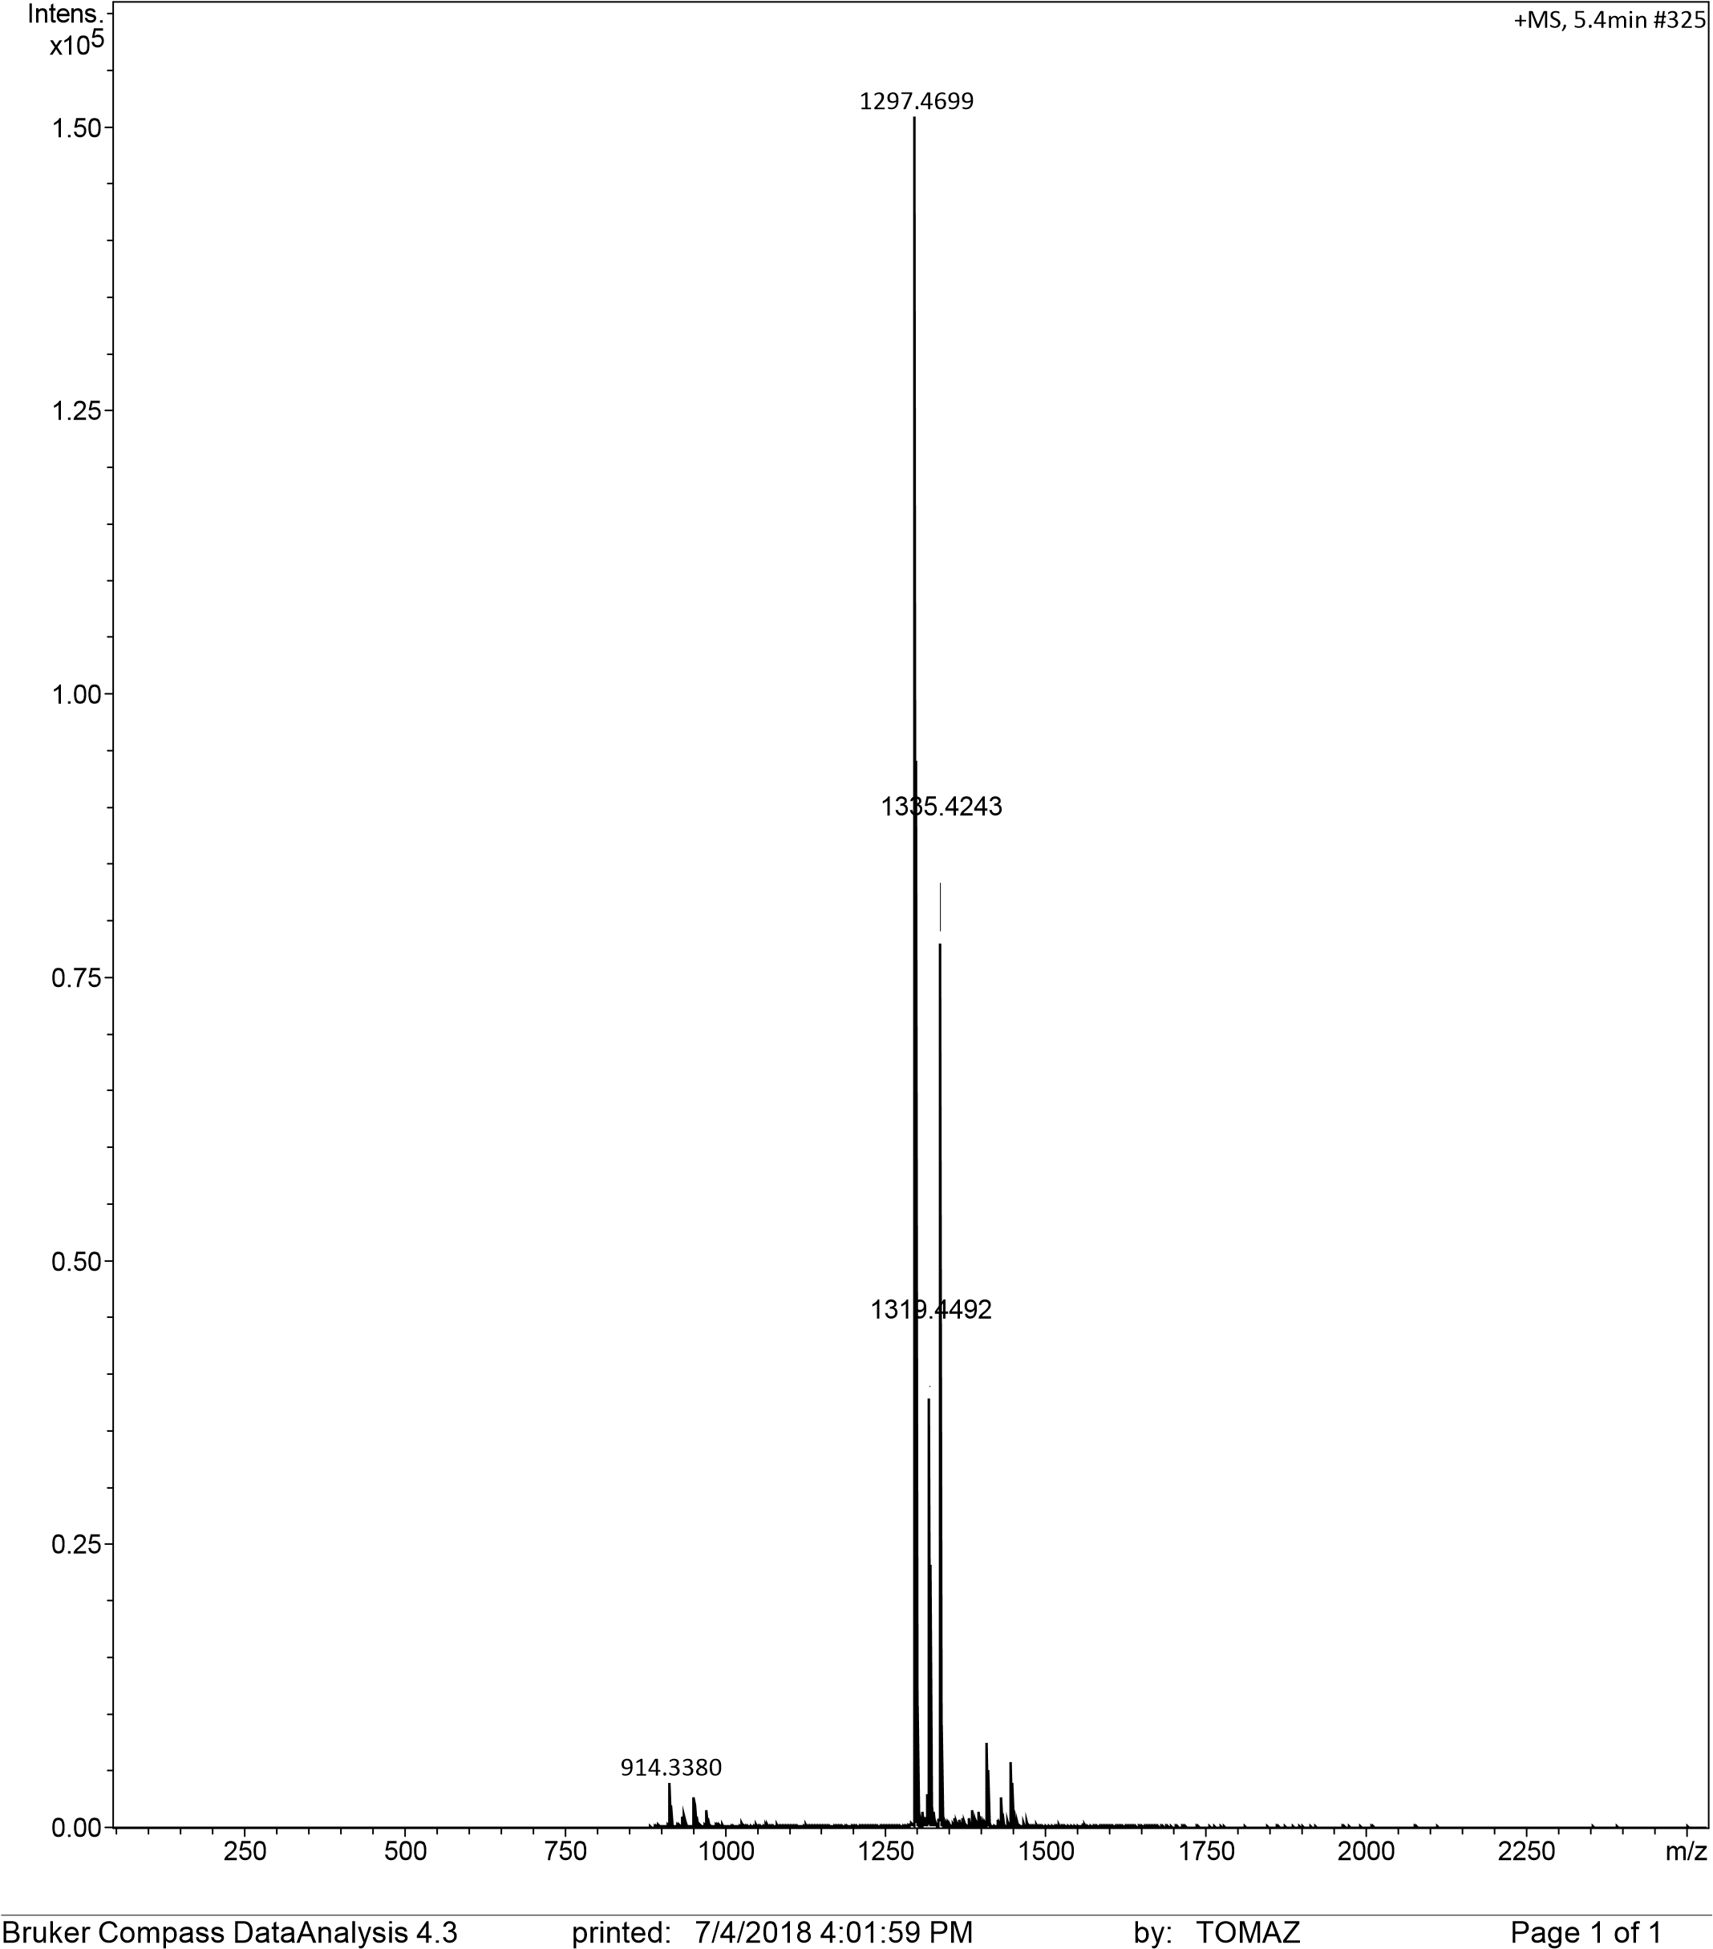
Fig. S30. ESI MS analysis of compound 19: m/z [M+H]⁺ calculated for C₅₂H₇₃N₁₂O₂₇⁺1297.4703; found: 1297.4699; [M+Na]⁺ calculated for C₅₂H₇₂N₁₂NaO₂₇⁺ 1319.4522, found: 1319.4492; [M+K]⁺ calculated for C₅₂H₇₂KN₁₂O₂₇⁺1345.4261, found^{: 1}345.4243.

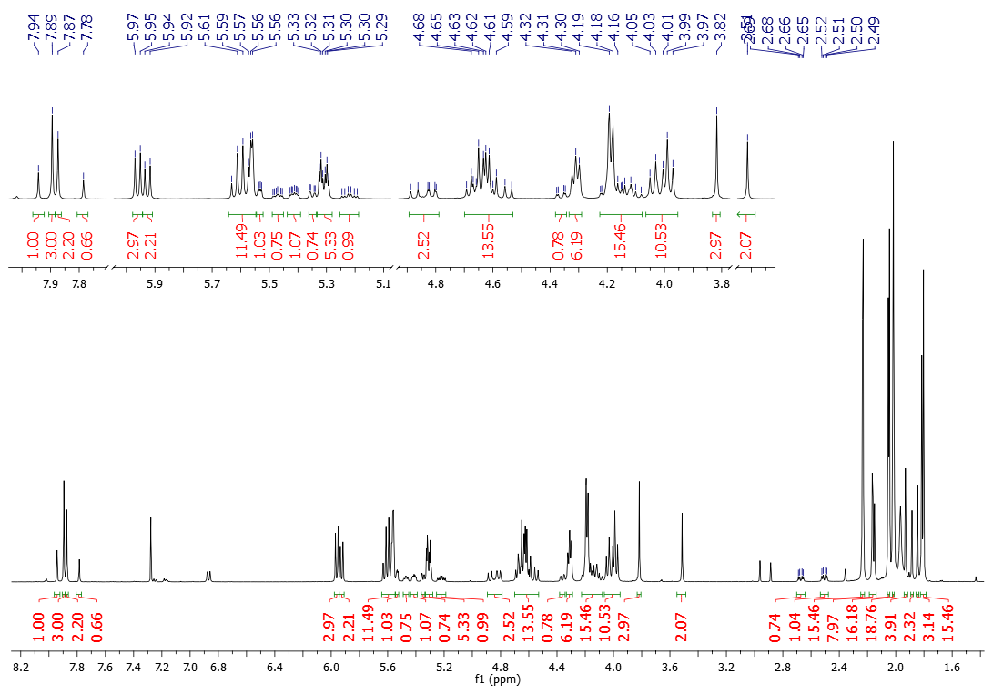
Fig. S31. ¹H NMR (500 MHz, CDCl₃) spectrum of glycocluster 21.

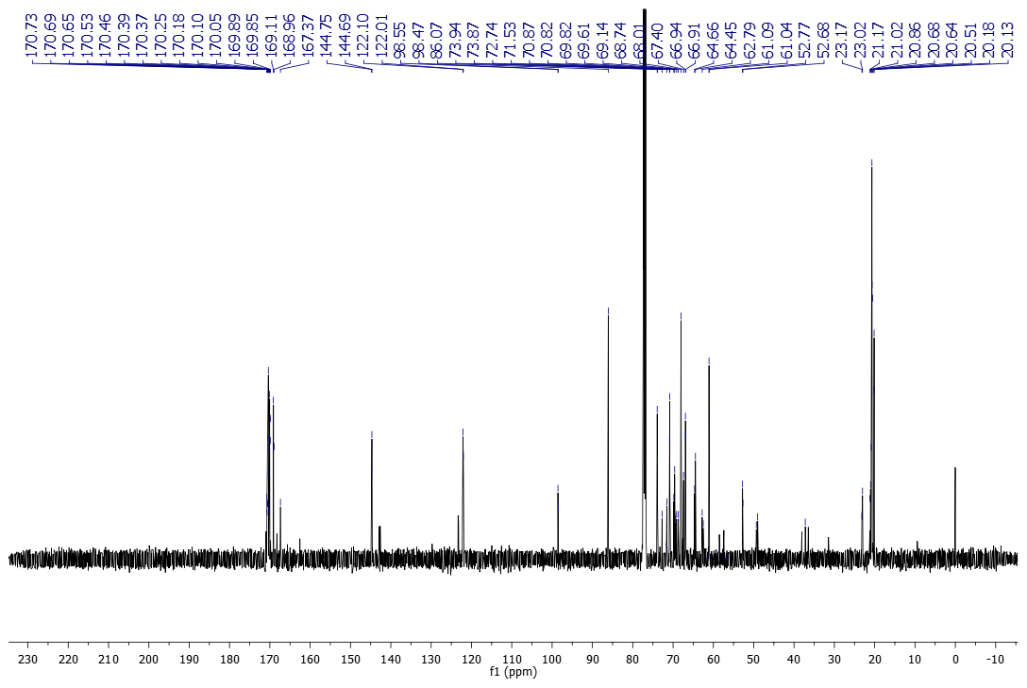
Fig. S32. ¹³C NMR (125 MHz, CDCl₃) spectrum of glycocluster 21.

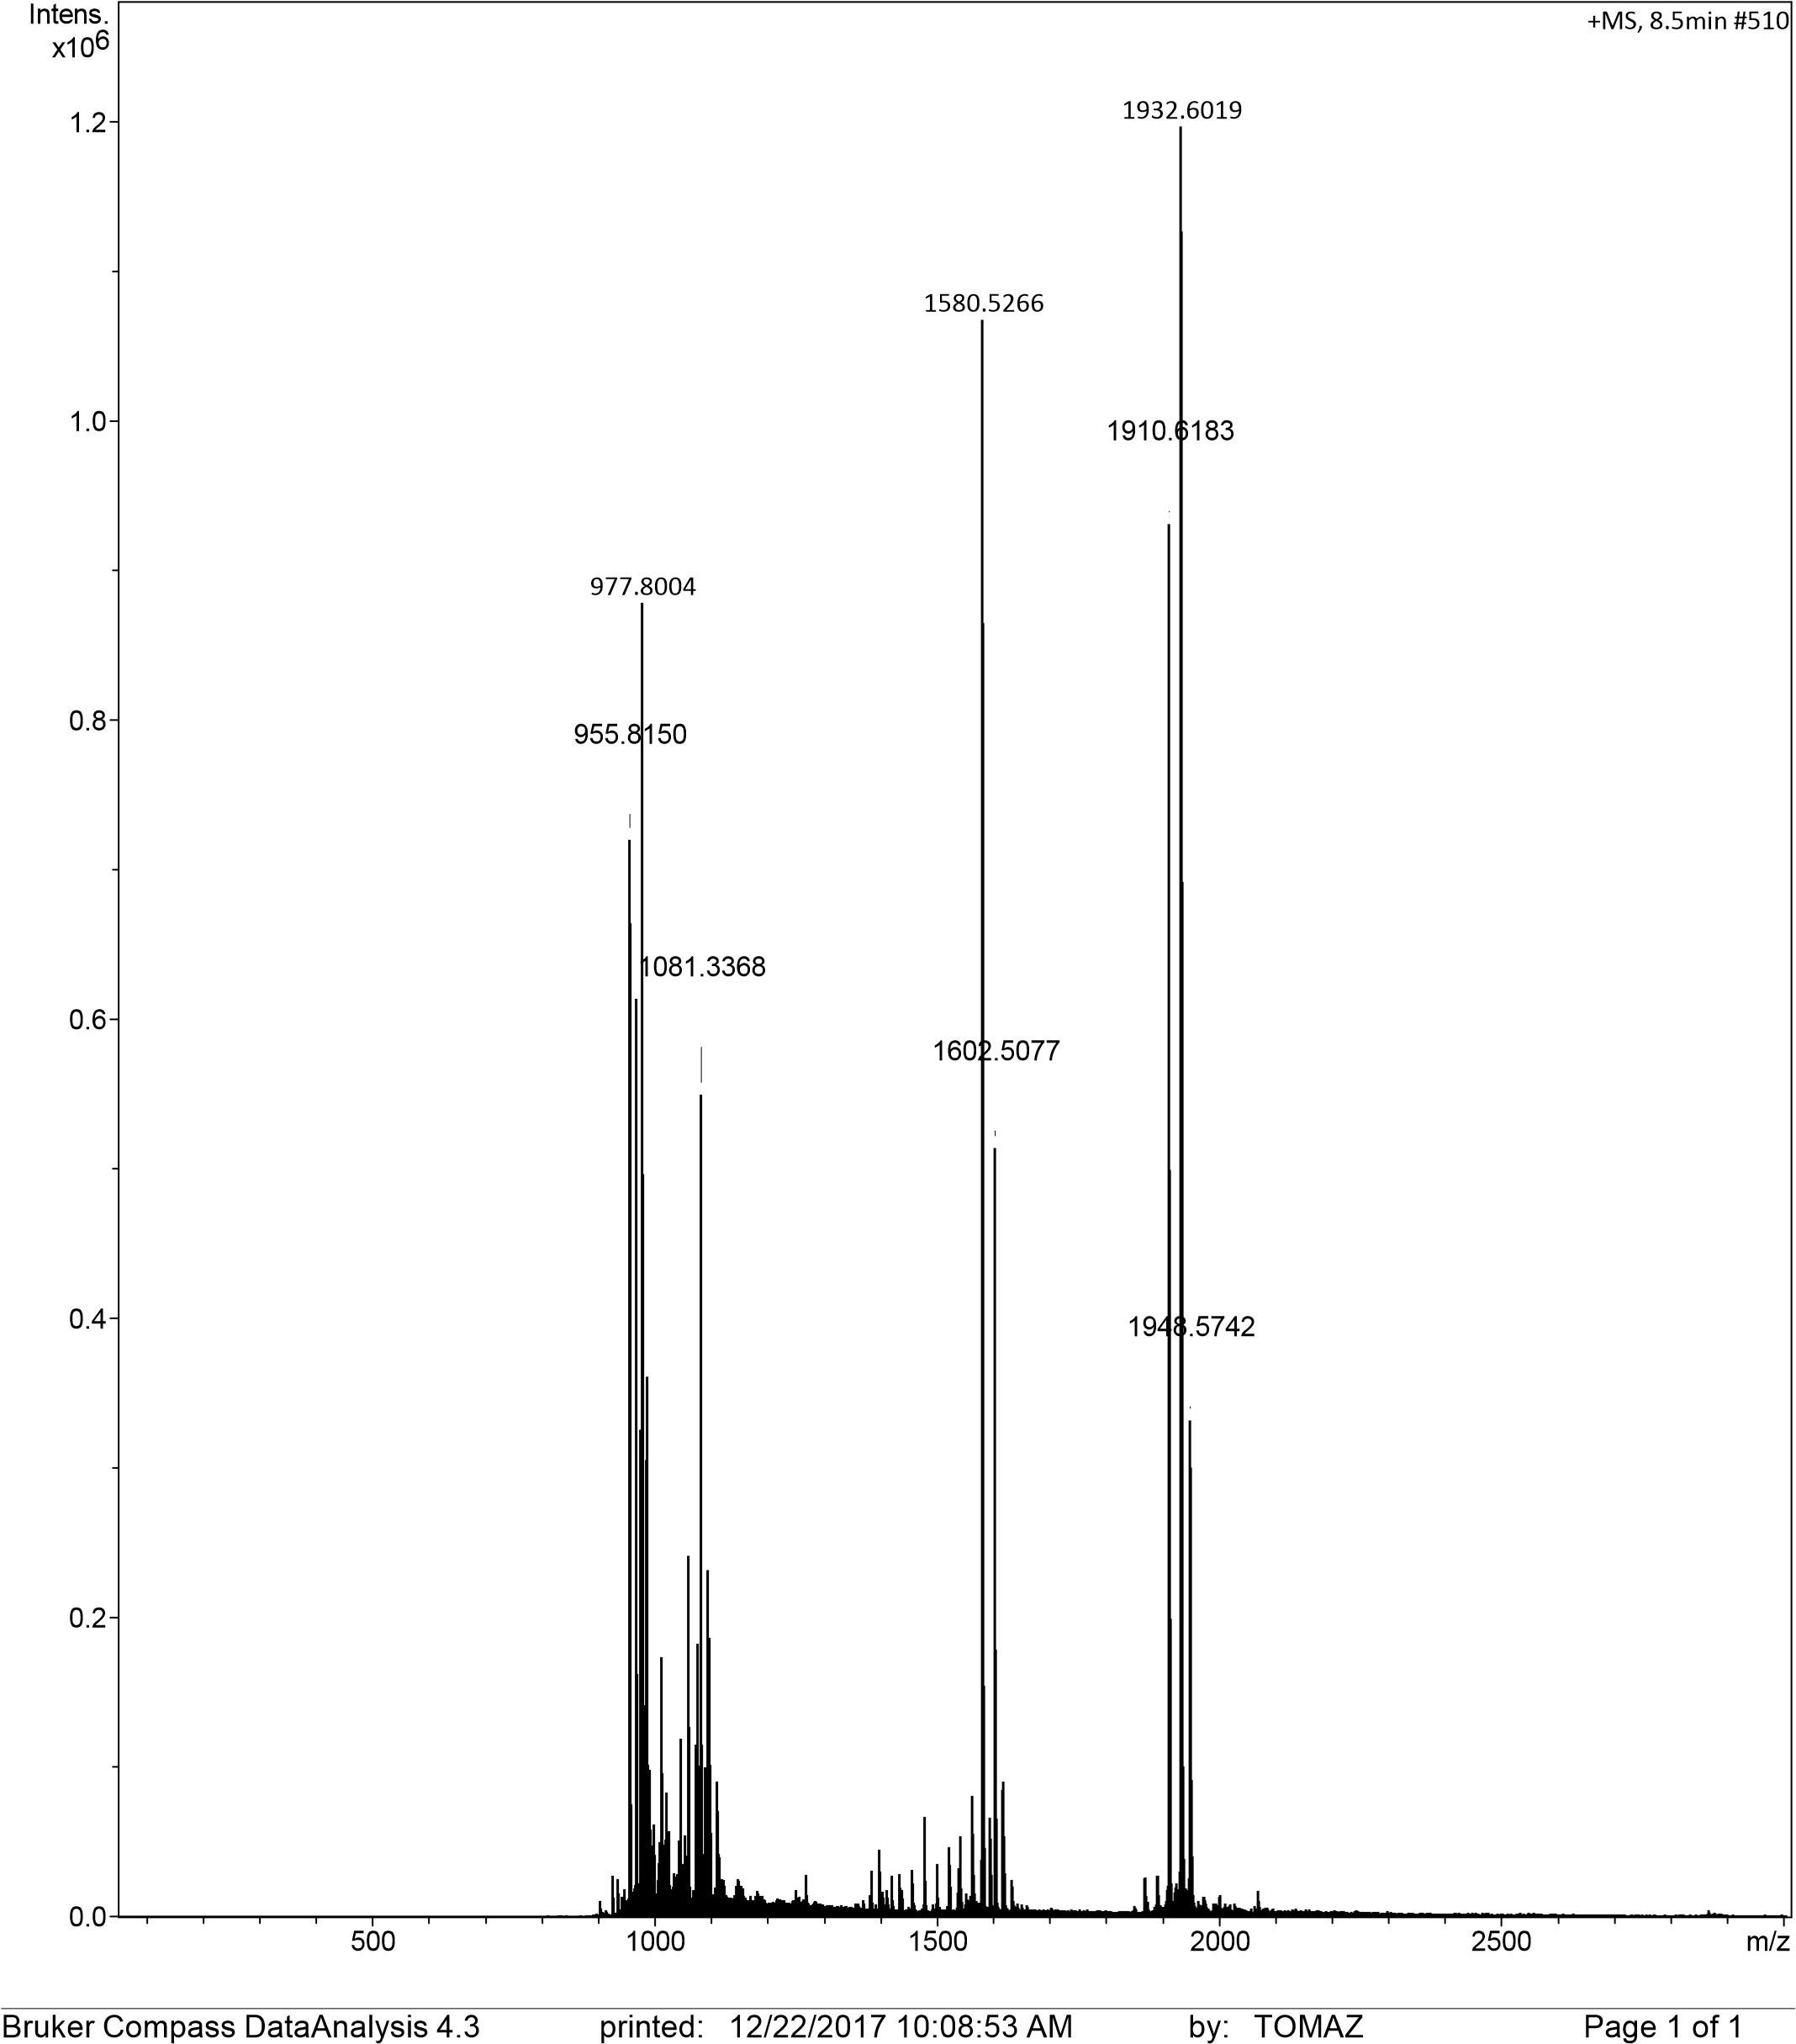
Fig. S33. ESI MS analysis of glycocluster 21: m/z [M+Na]⁺ calculated for C₇₈H₁₀₃NaN₁₃O₄₃⁺ 1932.6165; found: 1932.6019; [M+K]⁺ calculated for C₇₈H₁₀₃KN₁₃O₄₃⁺ 1948.5804; found: 1948.5742.

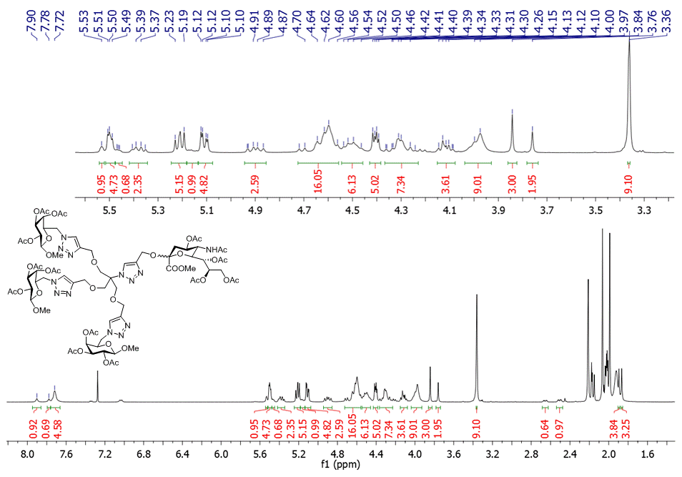
Fig. S34. ¹H NMR spectrum (500 MHz, CDCl₃) of compound 22.

Fig. S35 A. ¹³C NMR (125 MHz, CDCl₃) spectrum of compound 22.
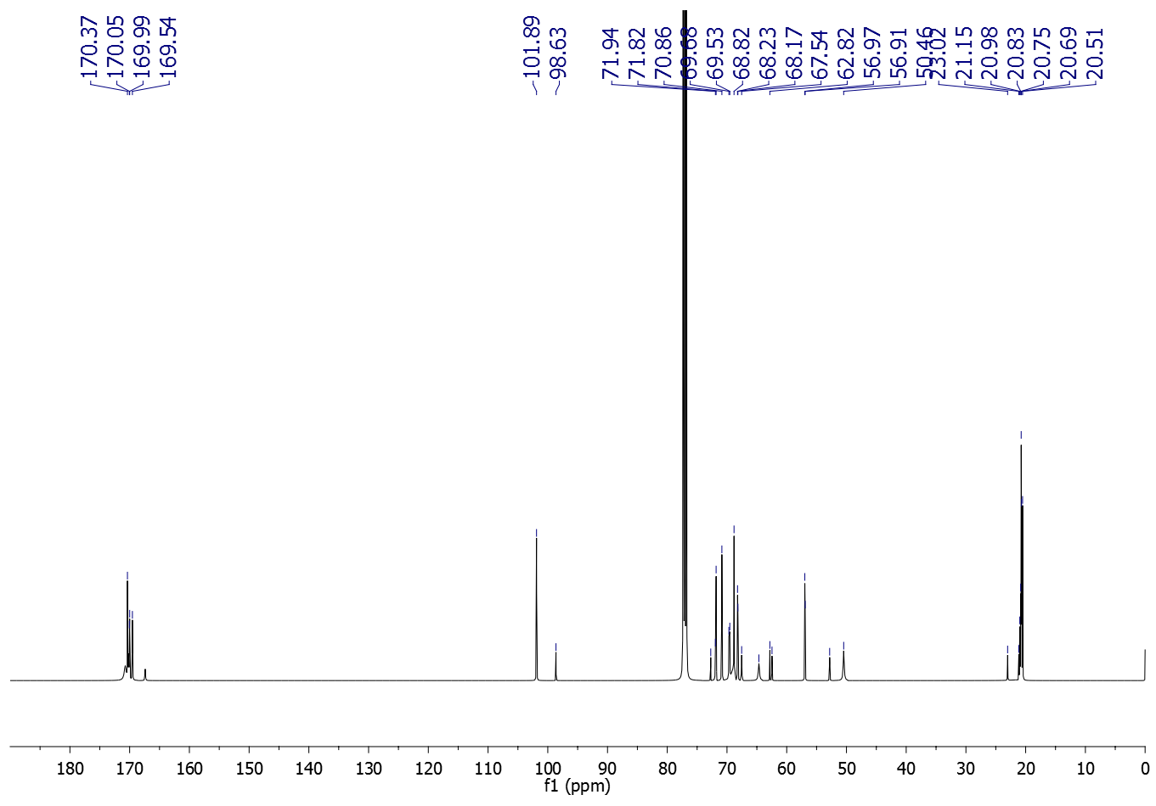
Fig. S35 B. ¹³C NMR spectrum (125 MHz, CDCl₃) of compound 22 after deconvolution with Lorentzian shape with detection sensitivity set to 1.4 and peak overlapping factor of 0.5 ppm (Software: Bruker TopSpin 2.1).

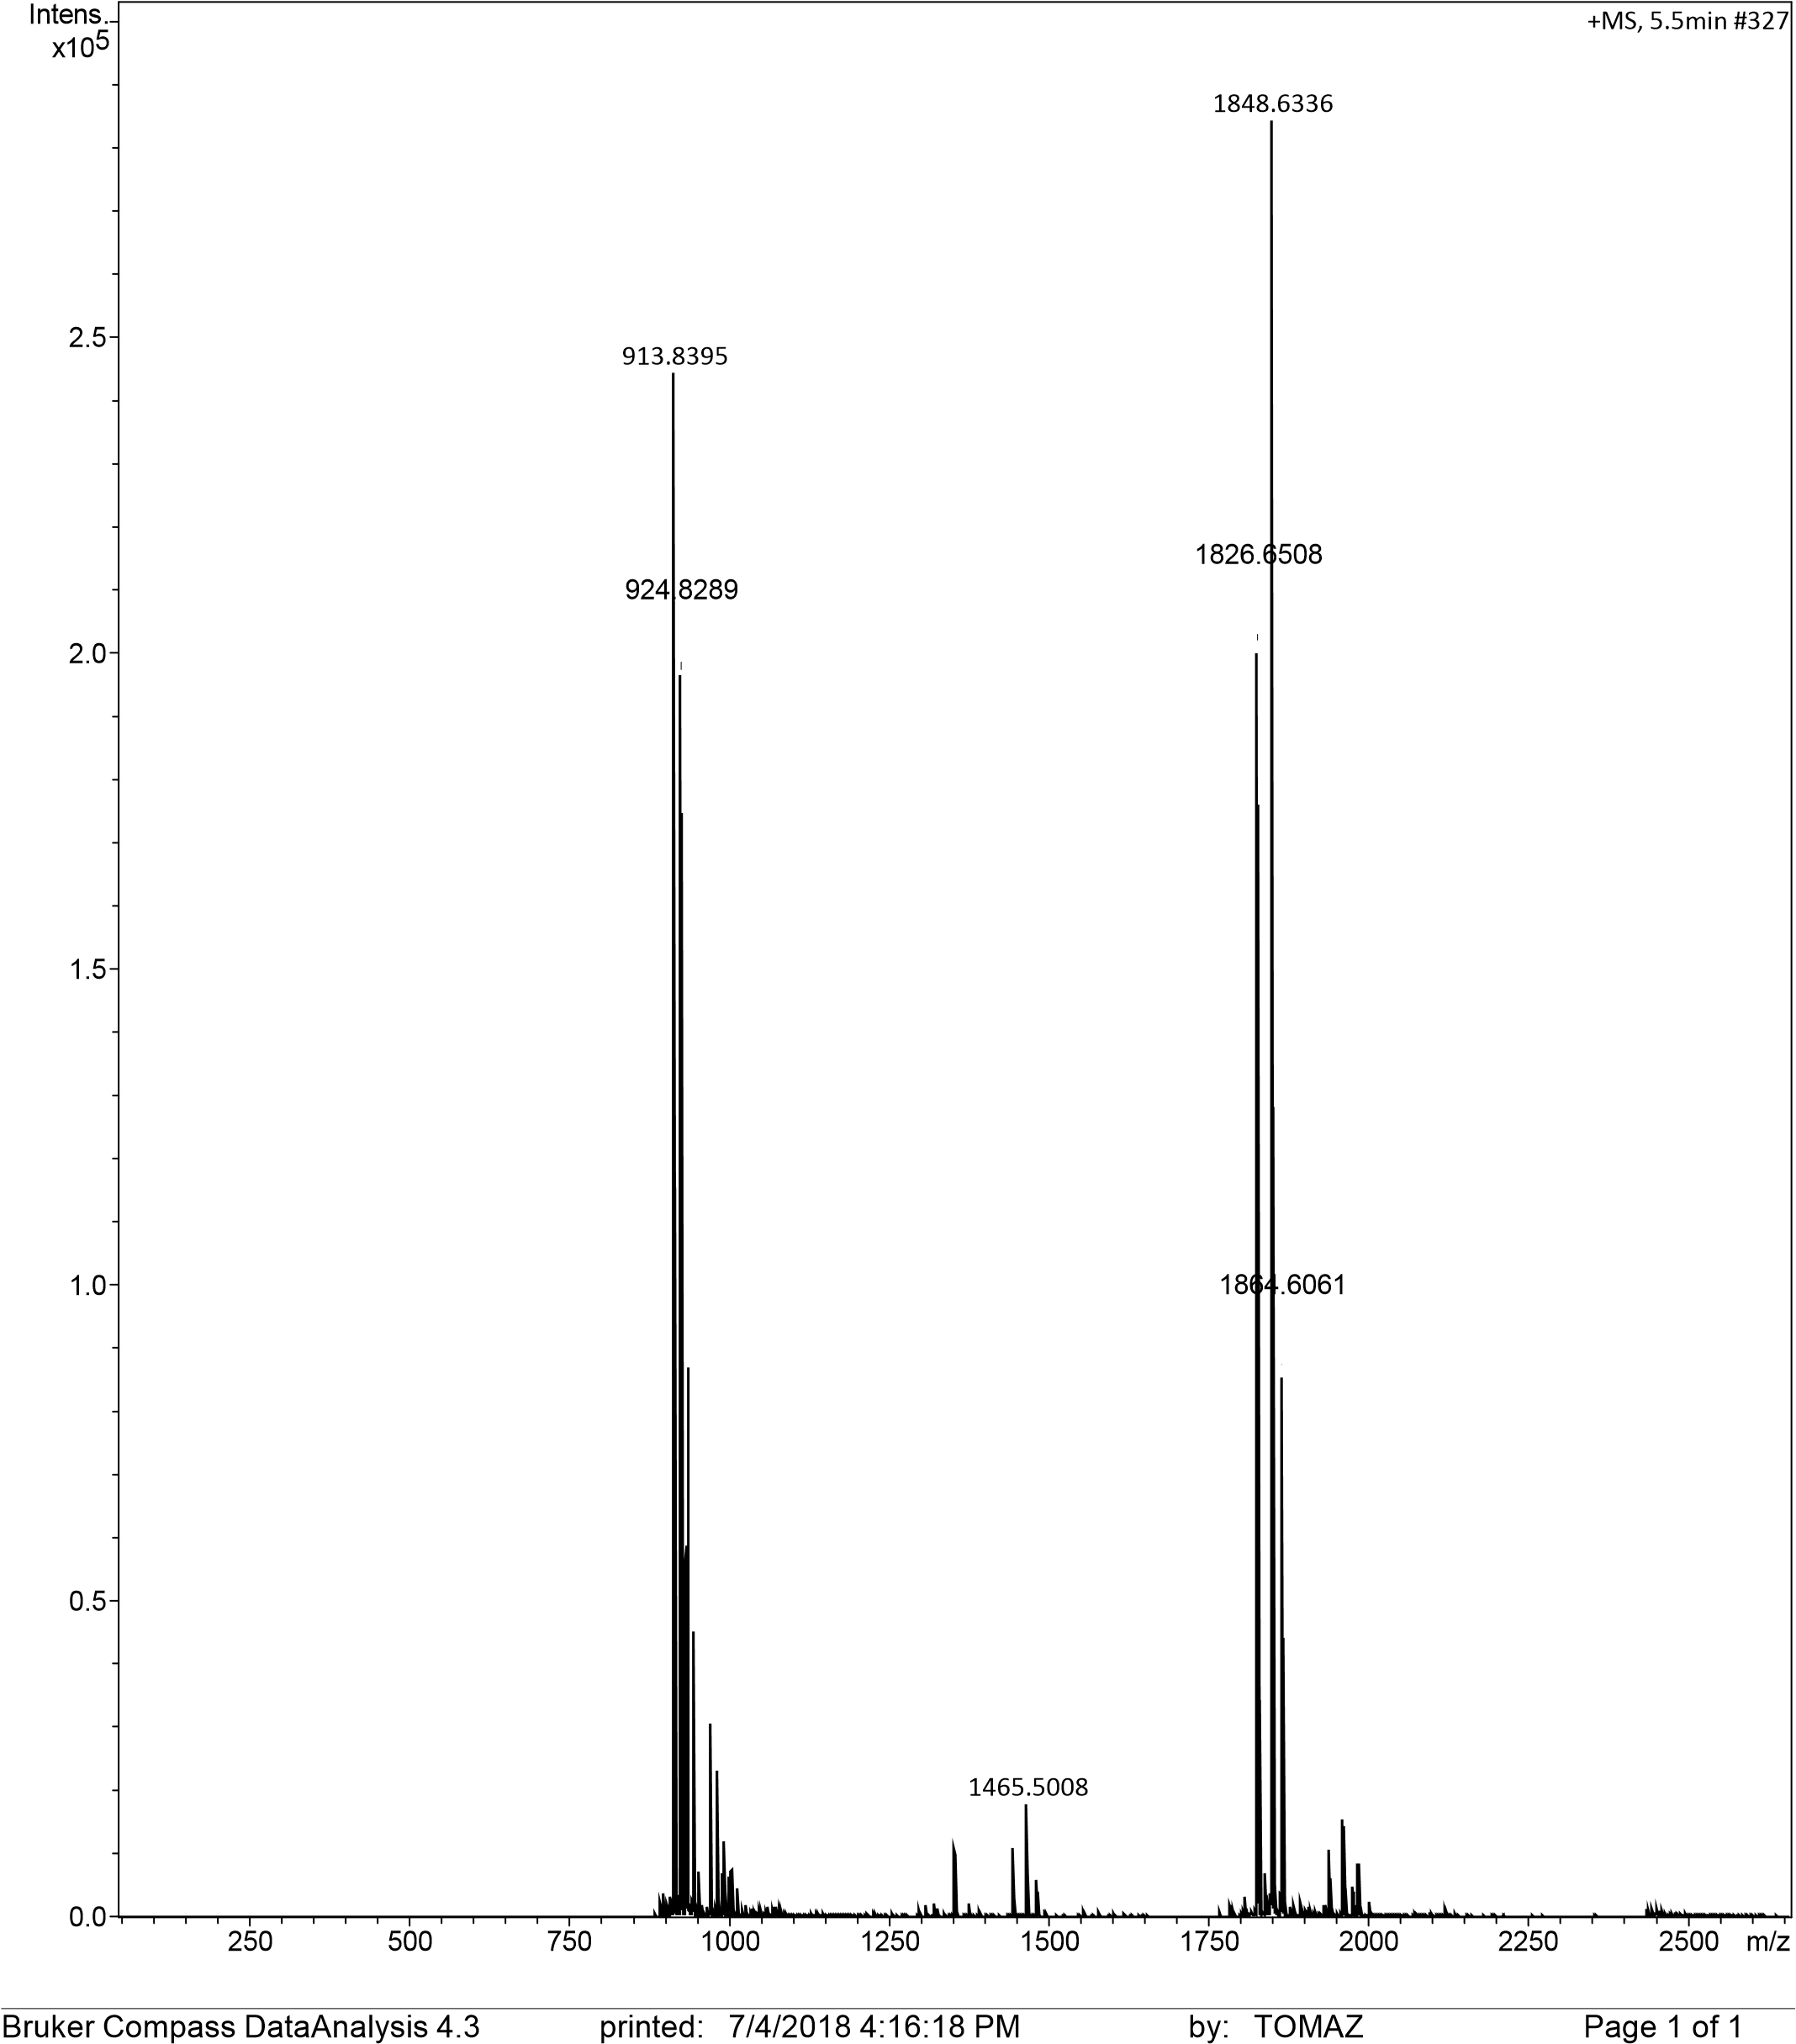
Fig. S36. ESI MS analysis of compound 22: m/z [M+Na]⁺ calculated for C₇₅H₁₀₃NaN₁₃NaO₄₀⁺ 1848.6317; found: 1848.6336; [M+K]⁺ calculated for C₇₅H₁₀₃KN₁₃NaO₄₀⁺ 1864.6057, found: 1864.6061.

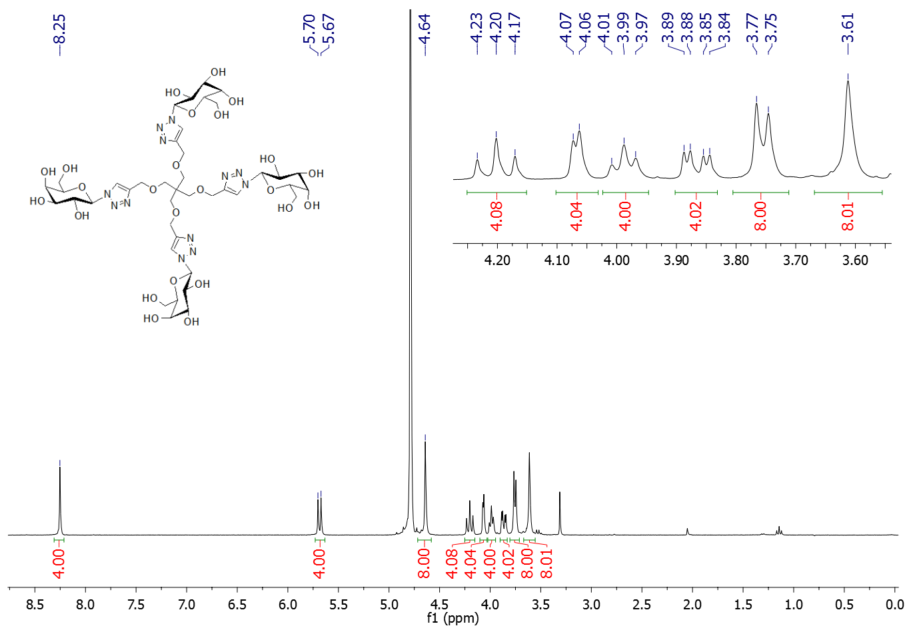
Fig. S37. ¹H NMR (300 MHz, D₂O) spectrum of glycocluster 1.

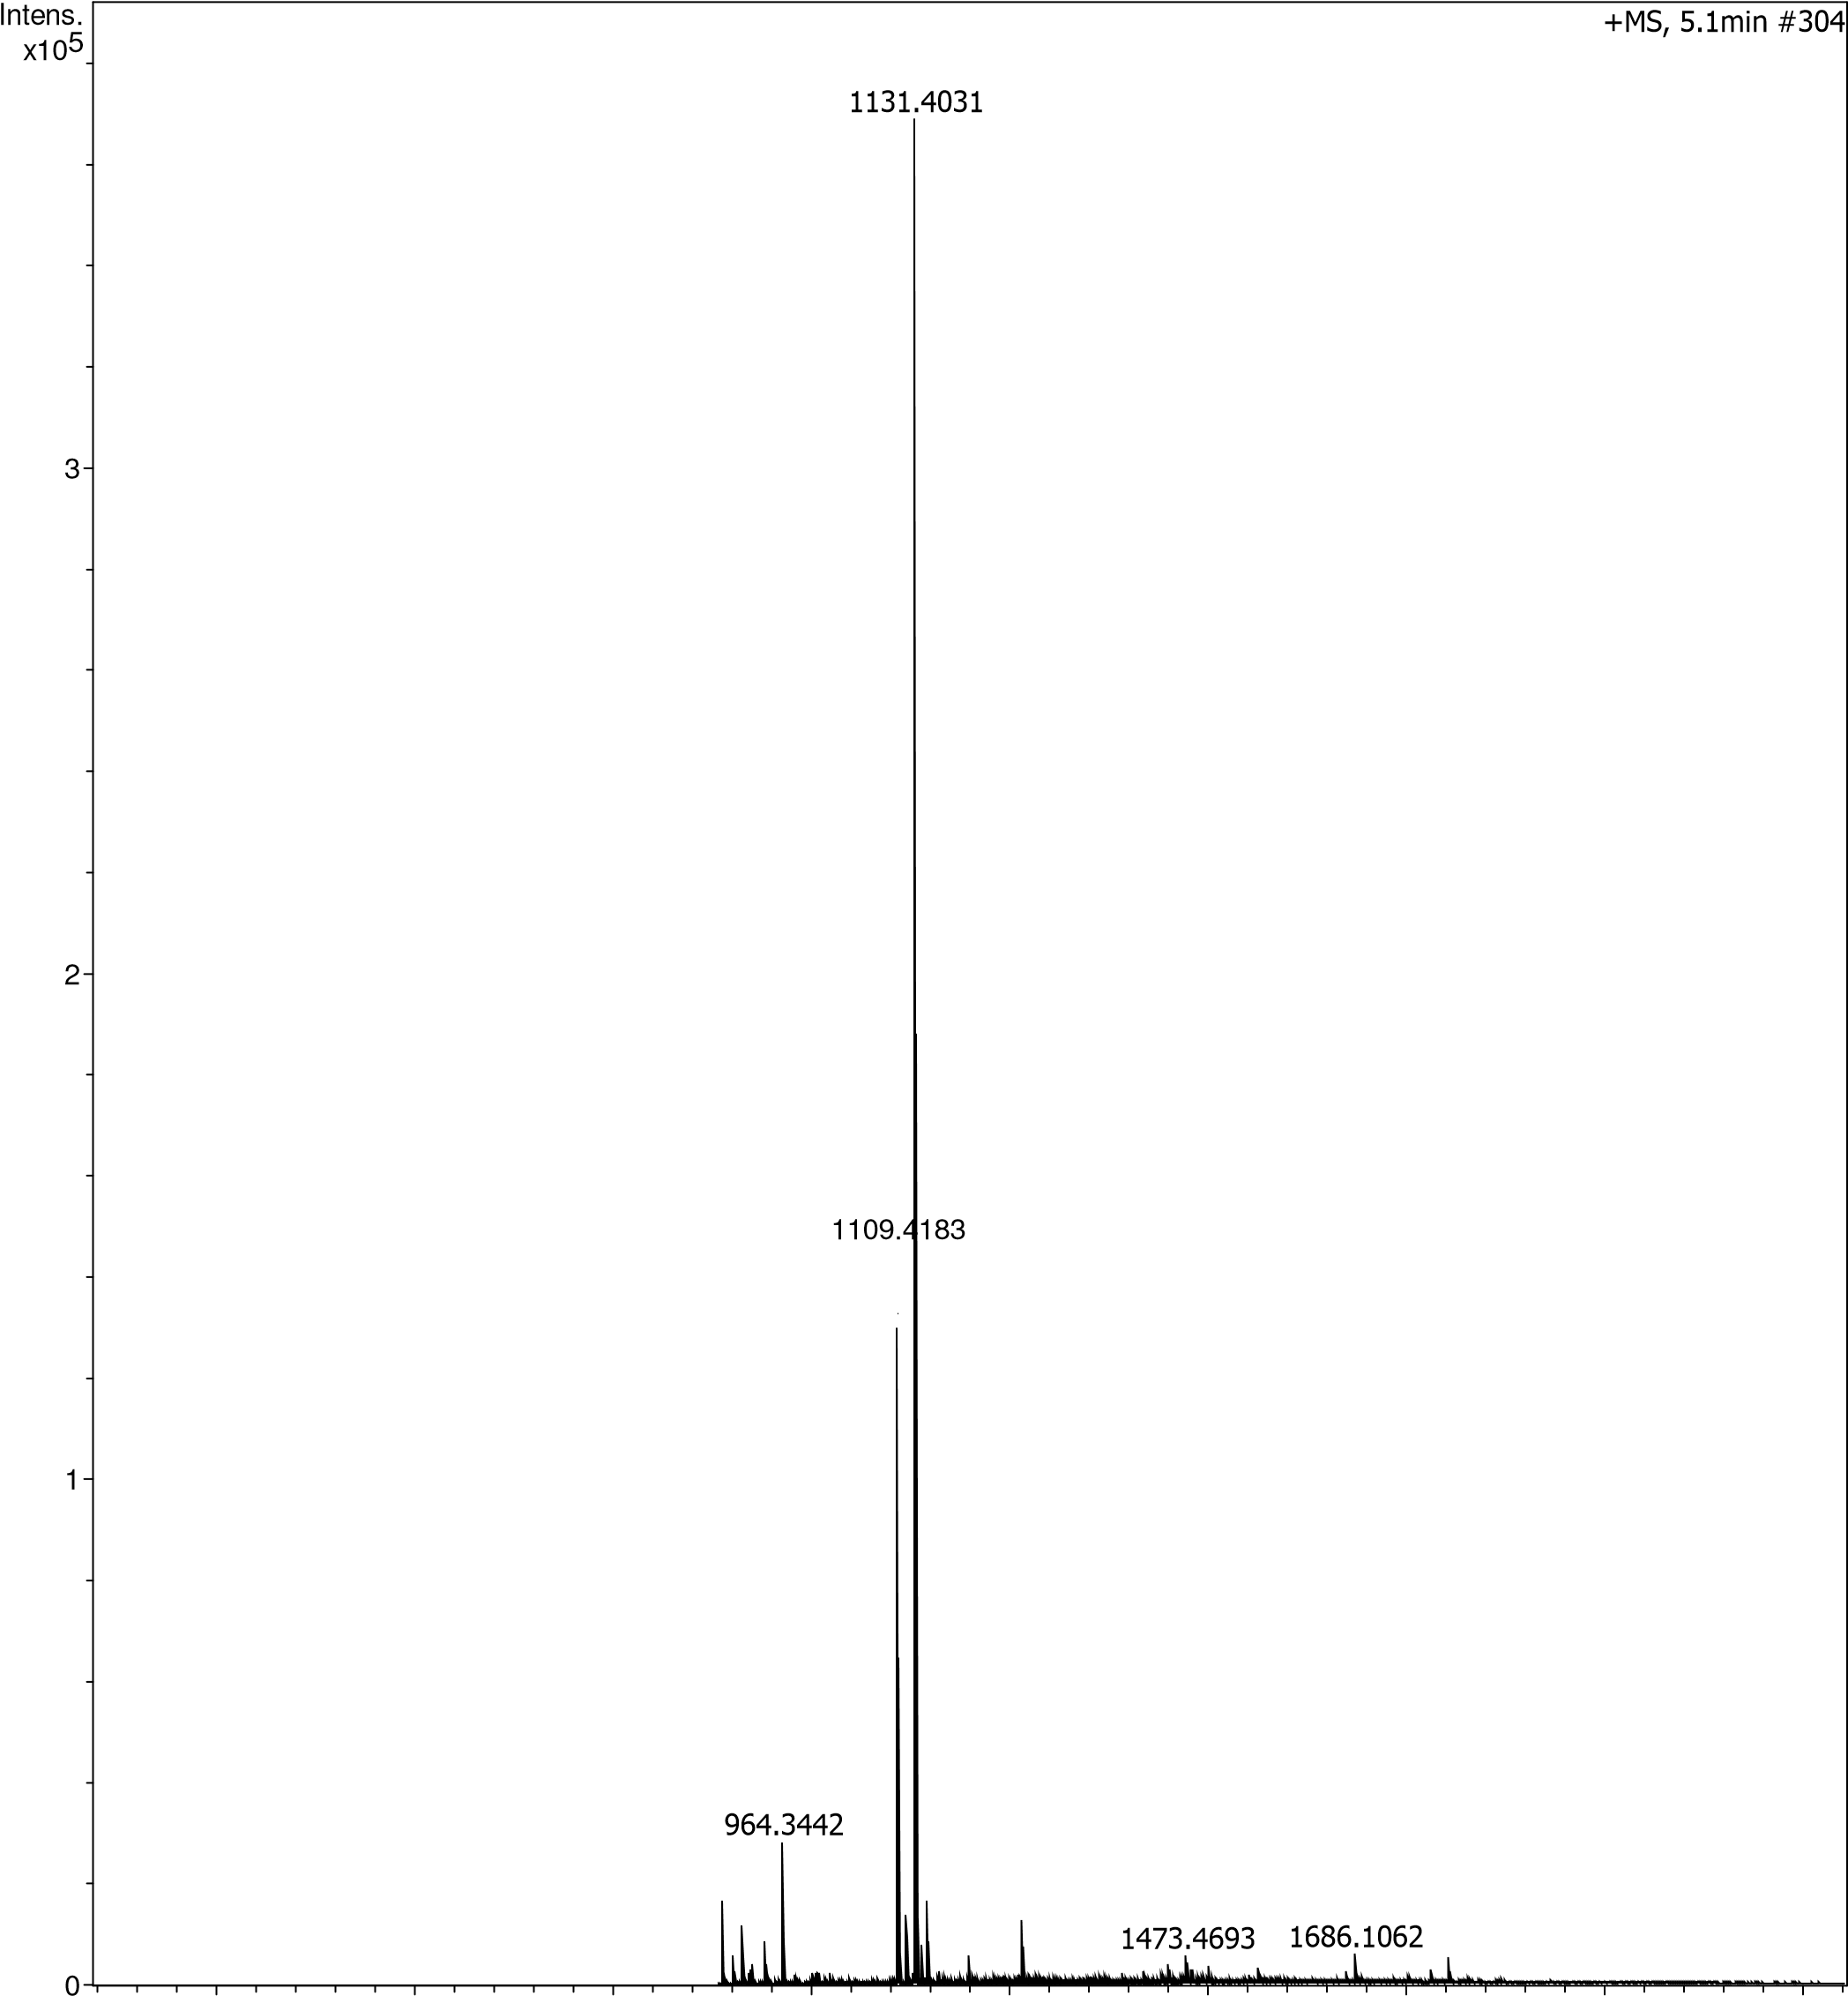
Fig. S38. HRMS (ESI) analysis of glycocluster 1: m/z [M+Na]⁺ calculated for C₄₁H₆₄N₁₂NaO₂₄⁺ 1131.4049; found: 1131.4031.

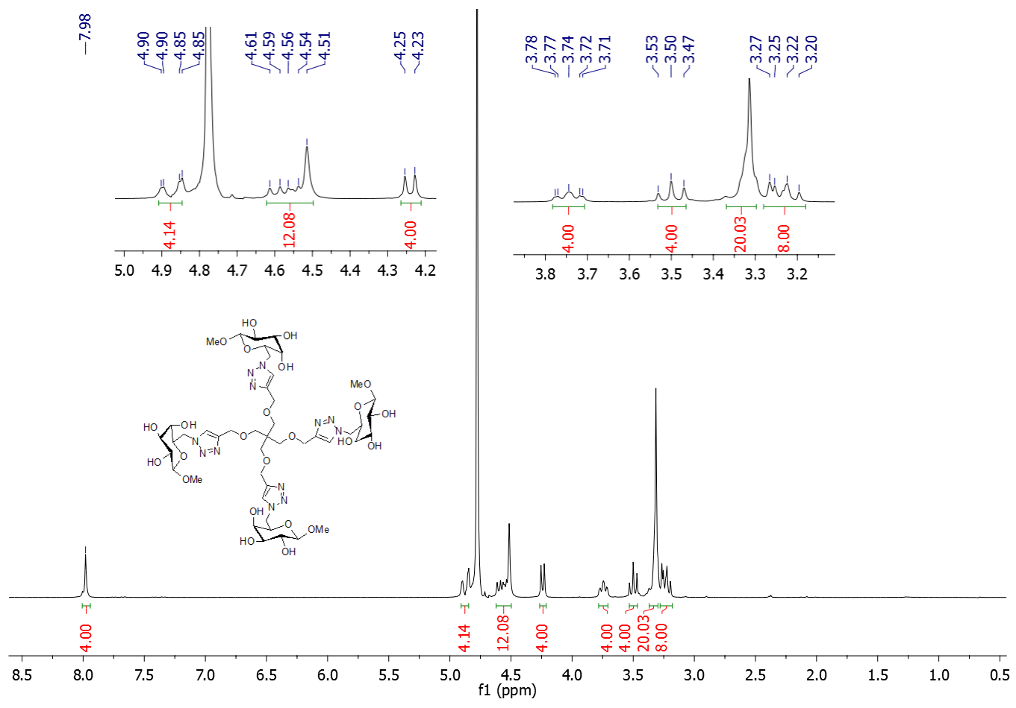
Fig. S39. ¹H NMR spectrum of glycocluster 2.

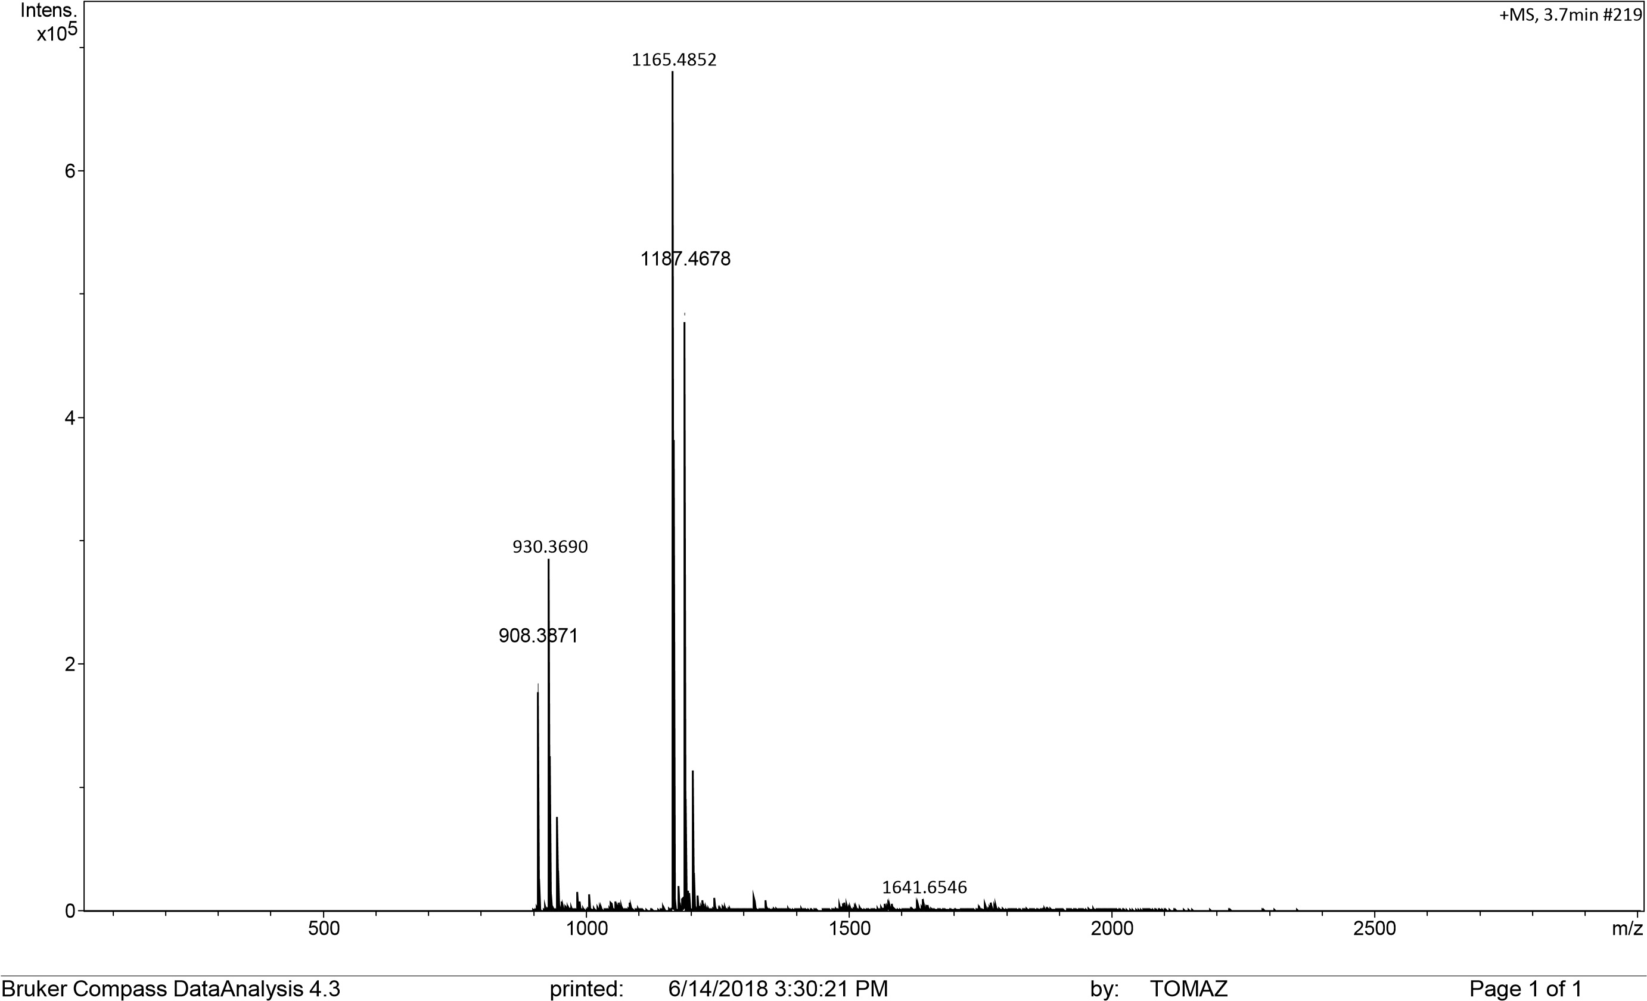
Fig. S40. HRMS (ESI) analysis of compound 2: m/z [M+H]⁺ calculated for C₄₅H₇₃N₁₂O₂₄⁺1165.4855; found: 1165.4852; [M+Na]⁺ calculated for C₄₅H₇₂NaN₁₂O₂₄⁺1187.4675, found: 1187.4678.
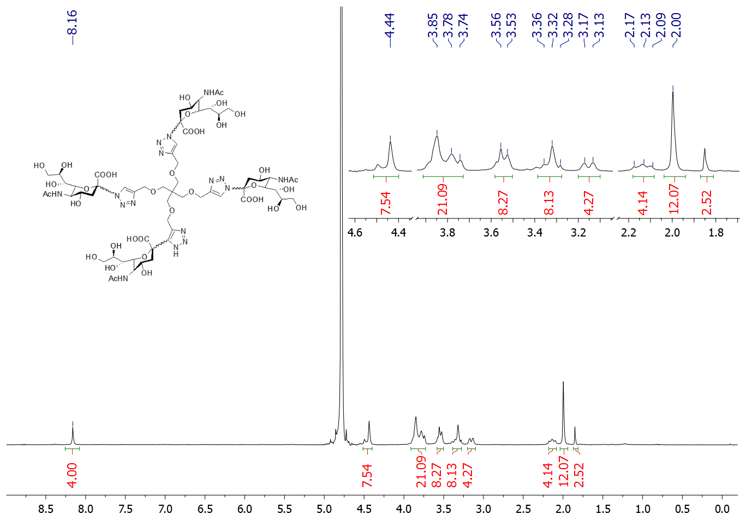
Fig. S41. ¹H NMR (300 MHz, D₂O) spectrum of glycocluster 3.

1328.1695
1497.5160
1663.5749
1647.5749
1690.5633
1296.4703
1664.5873
148
MS, 2.5min #
+
0
1
2
3
4
5
6
5
x10
Intens.
]
[
%
600
800
1000
1200
1400
1600
1800
2000
2200
2400
m/z
Fig. S42. HRMS (ESI) analysis of compound 3: m/z [M+Na]⁺ calculated forC₆₁H₉₂N₁₅NaO₃₆⁺1647.5752; found: 1647.5749.

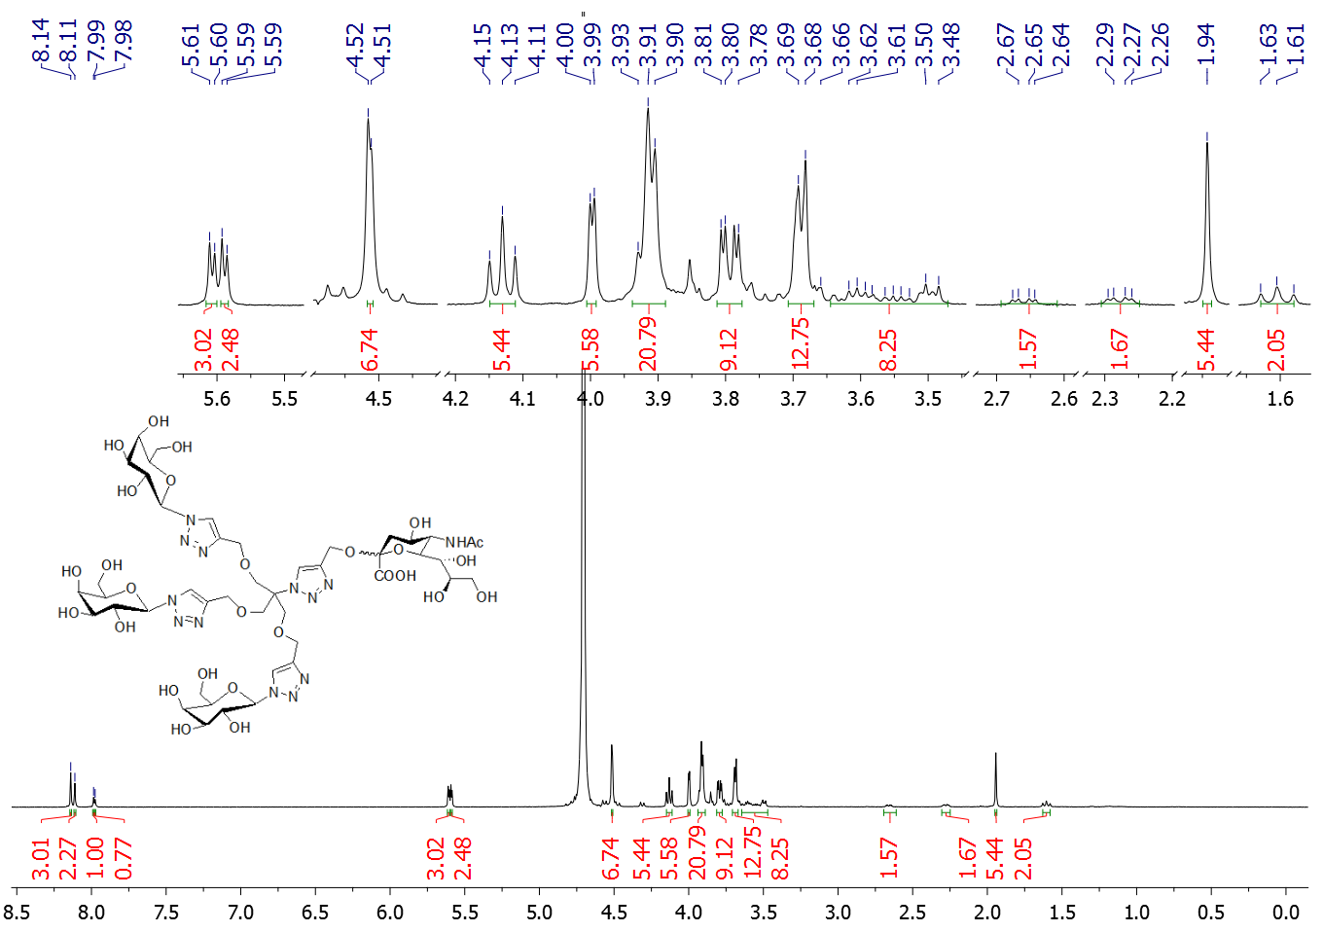
Fig. S43. ¹H NMR (500 MHz, D₂O) spectrum of glycocluster 4.

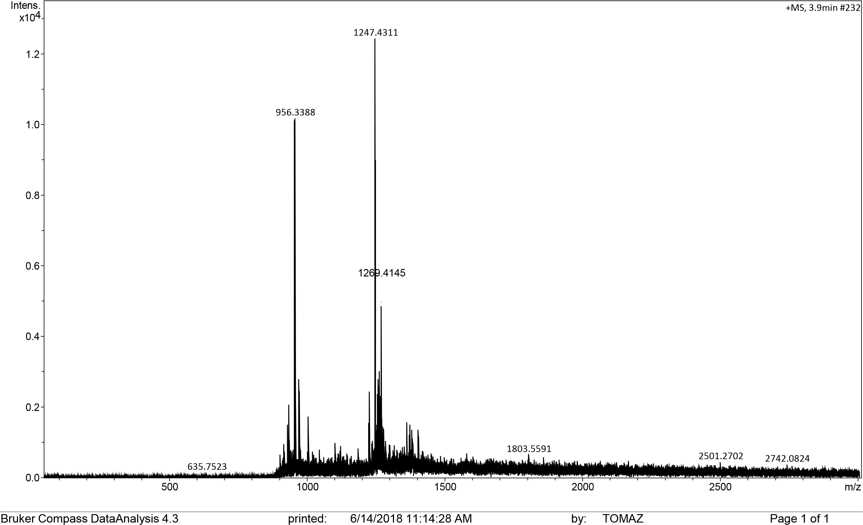
Fig. S44. HRMS (ESI) analysis of compound 4: m/z [M+H+Na]⁺ calculated for C₄₅H₇₀N₁₃NaO₂₇²⁺1247.4391; found: 1247.4311.
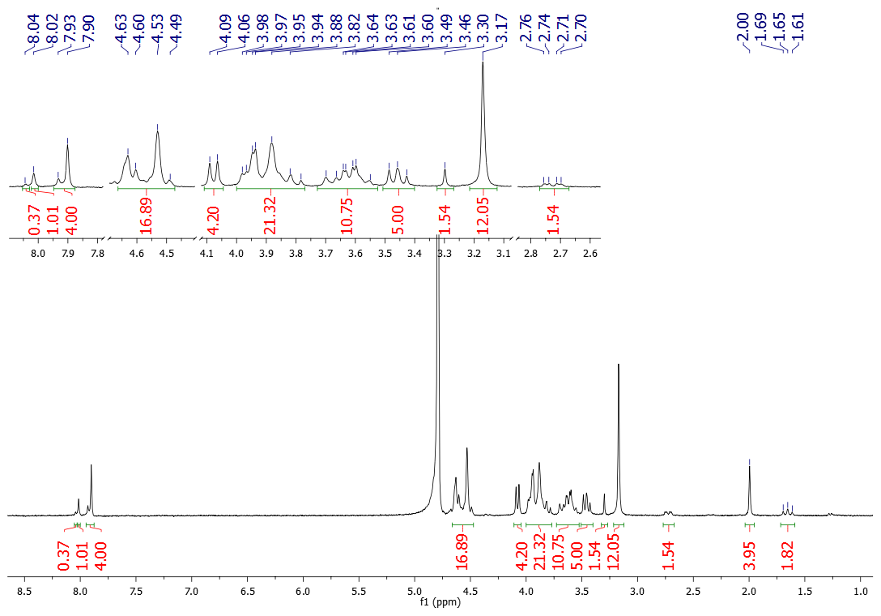
Fig. S45. ¹H NMR (300 MHz, D₂O) spectrum of glycocluster 5.

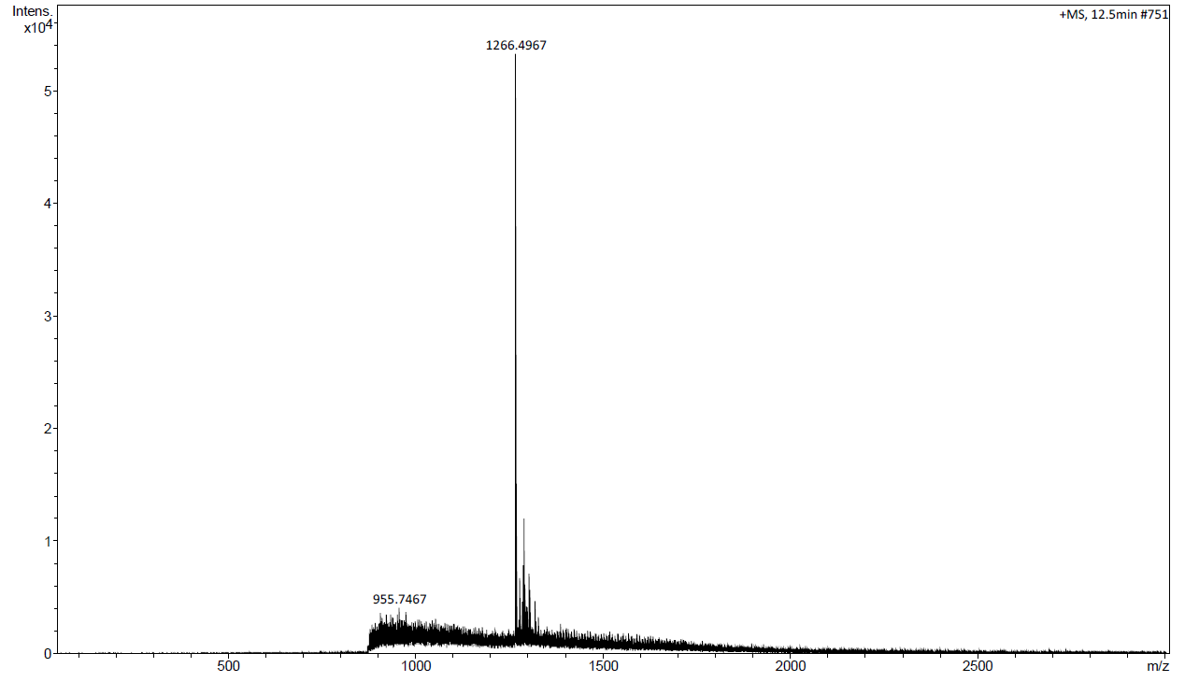
Fig. S46. ESI MS analysis of glycocluster 5: m/z [M+Na]⁺ calculated for C₄₈H₇₆N₁₃O₂₇⁺ 1266.4968; found: 1266.4968.

