SUPPORTING INFORMATION

An efficient and eco-friendly method for the thiol-Michael addition in aqueous solutions using amino acid ionic liquids (AAILs) as organocatalysts.

Roberto Figueroa Guíñez,¹ José G. Santos, ¹ Ricardo A. Tapia, ¹ Jackson J. Alcazar, ¹ Margarita E. Aliaga^{1,}* and Paulina Pavez.^{1,}*
¹Facultad de Química y de Farmacia, Pontificia Universidad Católica de Chile, Casilla 306, Santiago 6094411, Chile.

Author Information
∗Corresponding authors. Tel.: +56-02-23541743; fax: +56-02-26864744; e-mail: mealiaga@uc.cl and ppavezg@uc.cl

Table of Contents | Page
Scheme S1. Synthesis of amino acid ionic liquids (Bmim[AA]s) | S3
Characterization data of Bmim[AA]s. | S3
Synthesis and characterization of Michael adduct | S4
Fig. S1. ¹H NMR spectrum of Michael adduct between 1 and L-Cys in DMSO-d₆. | S5
Fig. S2. ¹³C NMR spectrum of Michael adduct between 1 and L-Cys in DMSO-d₆. | S5
Fig. S3. Dept-135 NMR spectrum of Michael adduct between 1 and L-Cys in DMSO-d₆. | S6
Fig. S4. (a) Proposed Michael adducts A and B. The dashed arrow indicates the correlation by HMBC NMR spectrum. (b) HMQC spectrum of Michael adduct between 1 and L-Cys in DMSO-d₆. | S7
Fig. S5. HRMS-ESI spectrum of Michael adduct synthesized. | S8
Product determination | S8
Fig. S6. HRMS-ESI spectrum of Michael adduct using Bmim[His] as catalyst under our kinetics experimental conditions. | S8
Fig. S7. HRMS-ESI spectrum of Michael adduct using Bmim[Ser] as catalyst under our kinetics experimental conditions. | S9
Fig. S8. HRMS-ESI spectrum of Michael adduct using Bmim[Phe] as catalyst under our kinetics experimental conditions. | S9
Fig. S9. HRMS-ESI spectrum of Michael adduct using Bmim[Ala] as catalyst under our kinetics experimental conditions. | S10
Table S1. Pseudo-first-order rate constants (k_{obsd}) for the reaction of 1 (5×10⁻⁶ M) with L-Cys (5×10⁻⁵-5.5×10⁻³ M) at 25 ± 0.1ºC. | S10
Table S2. Pseudo-first-order rate constants (k_{obsd}) for the reaction of 1 (5×10⁻⁵ M) with L-Cys (5×10⁻⁴ M) using Bmim[AA]s (5×10⁻⁶-3×10⁻⁵ M) as catalyst at 25 ± 0.1ºC. | S11
Table S3. Pseudo-first-order rate constant (k_{obsd}) for the reaction of 1 with L-Cys at 9-32ºC temperature range. | S12
Table S4. Catalytic (k_{cat}) and nucleophilic (k_{N}) rate constants for the reaction of 1 with L-Cys at 9-32ºC temperature range. | S13
Table S5. The k_{obsd} values obtained in each cycle for thiol-Michael reaction between 1 (5×10⁻⁵ M) and L-Cys (7×10⁻⁴ M) and Bmim[AA]s (2.5×10⁻⁵ M) as catalyst at 25 ± 0.1°C. | S13
Table S6. Nucleophilic rate constant of thiolate $k_{N}^{S^{-}}$(M⁻¹s⁻¹) of the reaction between 1 and L-Cys and L-cysteine derivatives (5×10⁻⁴ M) as control in pH: 5.5 at 25 ± 0.1°C. | S13
Table S7. Pseudo-first-order rate constants (k_{obsd}) for the reaction of 1 (5×10⁻⁵ M) with L-Cys (5×10⁻⁴ M) over a pH range of 5.4-6.3 at 25ºC ± 0.1. | S14

Scheme S1. Synthesis of amino acid ionic liquids.

Characterization data of Bmim[AA]s.
1-Butyl-3-methylimidazolium alanine (Bmim[Ala]) Obtained as light-yellow oil in 96% yield. ¹H NMR (400 MHz, DMSO-d₆) δ 9.82 (s, 1H), 7.88 (s, 1H), 7.81 (s, 1H), 4.20 (t, J = 7.2 Hz, 2H), 3.89 (s, 3H), 2.92 (q, J = 6.8 Hz, 1H), 1.82 – 1.67 (m, 2H), 1.29 – 1.16 (m, 2H), 1.04 (d, J = 6.9 Hz, 3H), 0.86 (t, J = 7.4 Hz, 3H); NH₂ may appear as very broad signal around 1.5 ppm. ¹³C NMR (400 MHz, DMSO-d₆) δ, ppm: 13.7; 19.2; 23.0; 31.9; 36.0; 48.8; 52.0; 122.7; 124.0; 137.8; 179.2. HRMS-ESI (+ mode): found m/z 139.1229; calculated for cation C₈H₁₅N₂ m/z 139.1230 (Δ= 0.7 ppm)
1-Butyl-3-methylimidazolium proline (Bmim[Pro]) Obtained as light-yellow oil in 94% yield. ¹H-RMN (400 MHz, DMSO-d₆) δ, ppm: 9,71 (s, 1H), 7,88 (s, 1H), 7,80 (s, 1H), 4,20 (t, J = 7,1 Hz, 2H), 3,88 (s, 3H), 3,03 – 2,92 (m, 1H), 2,70 (s, 1H), 1,84 (dd, J = 11,5, 8,2 Hz, 1H), 1,78 – 1,64 (m, 4H), 1,63 – 1,41 (m, 2H), 1,30 – 1,14 (m, 2H), 0,86 (t, J = 7,3 Hz, 3H). ¹³C-RMN (400 MHz, DMSO-d₆) δ, ppm: 176,0, 137,7, 124,0, 122,7, 62,1, 48,9, 46,8, 36,0, 31,9, 31,0, 25,8, 19,2, 13,7. HRMS-ESI (+ mode): found m/z 139.1225; calculated for cation C₈H₁₅N₂ m/z 139.1230 (Δ= 3.6 ppm)
1-Butyl-3-methylimidazolium phenylalanine (Bmim[Phe]) Obtained as light-yellow oil, 95% yield. ¹H NMR (400 MHz, DMSO-d₆) δ 9.88 (s, 1H), 7.90 (s, 1H), 7.85 (s, 1H), 7.27 – 6.93 (m, 5H), 4.19 (t, J = 7.1 Hz, 2H), 3.87 (s, 3H), 3.19 (dd, J = 8.4, 3.6 Hz, 1H), 3.05 (dd, J = 13.2, 3.8 Hz, 1H), 2.53 (dd, J = 13.0, 8.7 Hz, 1H), 1.83 – 1.56 (m, 2H), 1.31 – 1.06 (m, 2H), 0.81 (t, J = 7.3 Hz, 3H); NH₂ may appear as very broad signal around 1.5 ppm. ¹³C NMR (400 MHz, DMSO-d₆) δ, ppm: 13.2; 18.7; 31.5; 35.5; 42.2; 48.3; 58.0; 122.2; 123.5; 125.3; 127.7; 129.2; 137.2; 140.9; 177.2. HRMS-ESI (+ mode): found m/z 139.1229; calculated for cation C₈H₁₅N₂ m/z 139.1230 (Δ= 0.7 ppm)
1-Butyl-3-methylimidazolium Histidine (Bmim[His]) Obtained as light-yellow in 97% yield. ¹H-RMN (400 MHz, DMSO-d₆) δ, ppm: 9,62 (s, 1H), 7,83 (s, 1H), 7,76 (s, 1H), 7,44 (s, 1H), 6,68 (s, 1H), 4,16 (t, J = 7,1 Hz, 2H), 3,85 (s, 3H), 3,17 (dd, J = 8,7, 3,6 Hz, 1H), 2,94 (dd, J = 14,3, 3,5 Hz, 1H), 2,46 (dd, J = 14,2, 8,8 Hz, 1H), 1,84 – 1,56 (m, 2H), 1,33 – 1,05 (m, 2H), 0,82 (t, J = 7,3 Hz, 3H); NH₂ may appear as very broad signal around 1.5 ppm. ¹³C-RMN (400 MHz, DMSO-d₆) δ, ppm: 177,8, 137,0, 134,4, 123,5, 122,2, 56,6, 48,3, 35,5, 33,4, 31,4, 18,7, 13,1. HRMS-ESI (+ mode): found m/z 139.1229; calculated for cation C₈H₁₅N₂ m/z 139.1230 (Δ= 0.7 ppm)
1-Butyl-3-methylimidazolium serine (Bmim[Ser]) Obtained as light-yellow oil in 95% yield. ¹H NMR (400 MHz, DMSO-d₆) δ, ppm: 9.43 (s, 1H), 7.80 (s, 1H), 7.74 (s, 1H), 4.17 (t, J = 7.2 Hz, 2H), 3.86 (s, 3H), 3.39 – 3.27 (m, 2H), 2.93 (t, J = 6.8 Hz, 1H), 1.82 – 1.70 (m, 2H), 1.32 – 1.17 (m, 2H), 0.89 (t, J = 7.4 Hz, 3H). NH₂ may appear as very broad signal around 1.5 ppm and OH may appear as very broad signal around 1.5-4.0 ppm. ¹³C NMR (400 MHz, dmso-d₆) δ, ppm: 13.3, 18.8, 31.5, 35.7, 48.5, 56.4, 64.8, 122.3, 123.6, 137.0, 175.8. HRMS-ESI (+ mode): found m/z 139.1230; calculated for cation C₈H₁₅N₂ m/z 139.1230 (Δ= 0 ppm)
1-Butyl-3-methylimidazolium glycine (Bmim[Gly]) Obtained as light-yellow oil in 95% yield. ¹H NMR (400 MHz, DMSO-d₆) δ 9.79 (s, 1H), 7.87 (s, 1H), 7.80 (s, 1H), 4.20 (t, J = 7.1 Hz, 2H), 3.88 (s, 3H), 2.73 (s, 1H), 1.75 (p, J = 7.2 Hz, 2H), 1.21 (dt, J = 14.4, 7.3 Hz, 2H), 0.87 (t, J = 7.3 Hz, 3H). NH₂ may appear as very broad signal around 1.5 ppm and OH may appear as very broad signal around 1.5-4.0 ppm. ¹³C NMR (400 MHz, dmso-d₆) δ 175.61, 137.32, 123.57, 122.26, 48.35, 46.53, 35.59, 31.44, 18.77, 13.27. HRMS-ESI (+ mode): found m/z 139.1230; calculated for cation C₈H₁₅N₂ m/z 139.1230 (Δ= 0 ppm)
1-Butyl-3-methylimidazolium methionine (Bmim[Met]) Obtained as light-yellow oil in 96% yield. ¹H NMR (400 MHz, DMSO-d₆) δ 9.73 (s, 1H), 7.85 (t, J = 1.6 Hz, 1H), 7.78 (s, 1H), 4.19 (t, J = 7.1 Hz, 2H), 3.88 (s, 3H), 2.86 (dd, J = 7.9, 4.6 Hz, 1H), 2.45 (d, J = 7.9 Hz, 2H), 1.98 (s, 2H), 1.83 – 1.70 (m, 3H), 1.46 (dq, J = 15.1, 7.6 Hz, 1H), 1.24 (h, J = 7.4 Hz, 2H), 0.88 (t, J = 7.4 Hz, 3H). NH₂ may appear as very broad signal around 1.5 ppm and OH may appear as very broad signal around 1.5-4.0 ppm. ¹³C NMR (400 MHz, dmso-d₆) δ 177.55, 137.73, 124.02, 122.70, 56.04, 48.83, 36.54, 36.07, 31.90, 31.41, 19.24, 15.15, 13.73. HRMS-ESI (+ mode): found m/z 139.1230; calculated for cation C₈H₁₅N₂ m/z 139.1230 (Δ= 0 ppm)
1-Butyl-3-methylimidazolium asparagine (Bmim[Asn]) Obtained as light-yellow oil in 97% yield. ¹H NMR (400 MHz, DMSO-d₆) δ 9.65 (s, 1H), 7.94 (s, 1H), 7.84 (d, J = 1.7 Hz, 1H), 7.77 (d, J = 1.8 Hz, 1H), 6.71 (s, 1H), 4.18 (t, J = 7.2 Hz, 2H), 3.14 (dd, J = 9.0, 4.1 Hz, 1H), 2.57 – 1.89 (m, 2H), 1.74 (p, J = 7.3 Hz, 2H), 1.22 (h, J = 7.3 Hz, 2H), 0.97 – 0.77 (m, 3H). ¹³C NMR (50 MHz, DMSO-d₆) δ 176.72, 174.77, 137.11, 123.51, 122.18, 53.64, 48.32, 42.50, 35.56, 31.36, 18.71, 13.20. HRMS-ESI (+ mode): found m/z 139.1231; calculated for cation C₈H₁₅N₂ m/z 139.1230 (Δ= 0.7 ppm)

Synthesis and characterization of Michael adduct.

A solution of L-Cys (87 mg, 7.2x10⁻⁴ mole) in 1.2 mL water was added dropwise to a solution of trans-β-nitrostyrene (107 mg, 7.2x10⁻⁴ mole) in 2 mL acetonitrile at 0°C. Then, the reaction mixture was stirred at room temperature for 30 minutes and the resulting precipitate was collected by filtration and washed with cold methanol. Recrystallization from methanol-water (1:1) afforded 121 mg (62.2%) of Michael adduct. Melting Point 182-184°C

Fig. S1: ¹H NMR spectrum of Michael adduct between 1 and L-Cys in DMSO-d₆.

Fig. S2. ¹³C NMR spectrum of Michael adduct between 1 and L-Cys in DMSO-d₆.

Fig. S3. Dept-135 NMR spectrum of Michael adduct between 1 and L-Cys in DMSO-d₆.

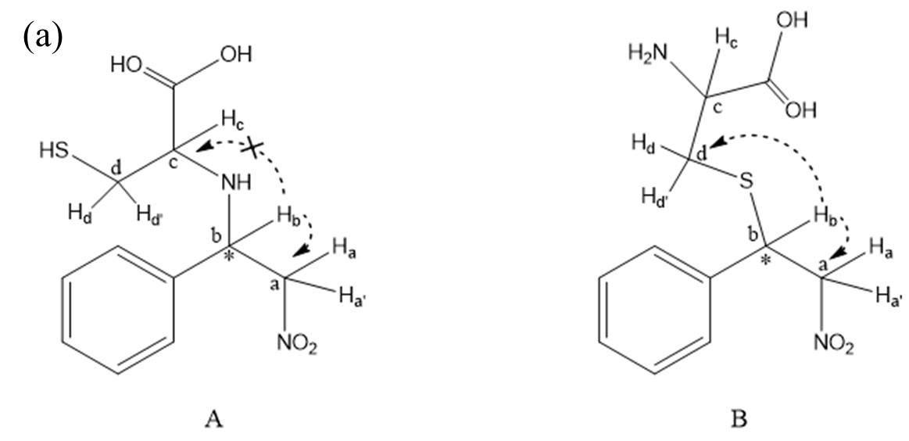

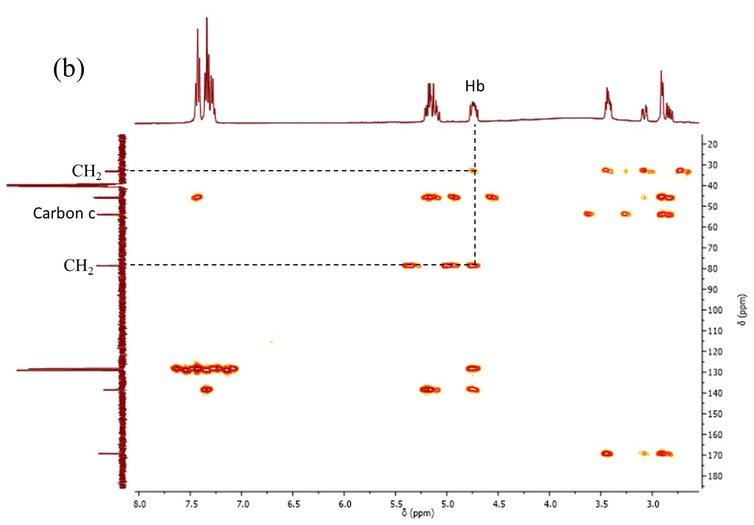

Fig. S4. (a) Proposed Michael adducts A and B. The dashed arrow indicates the correlation by HMBC NMR spectrum. (b) HMBC NMR spectrum of Michael adduct between 1 and L-Cys in DMSO-d₆.

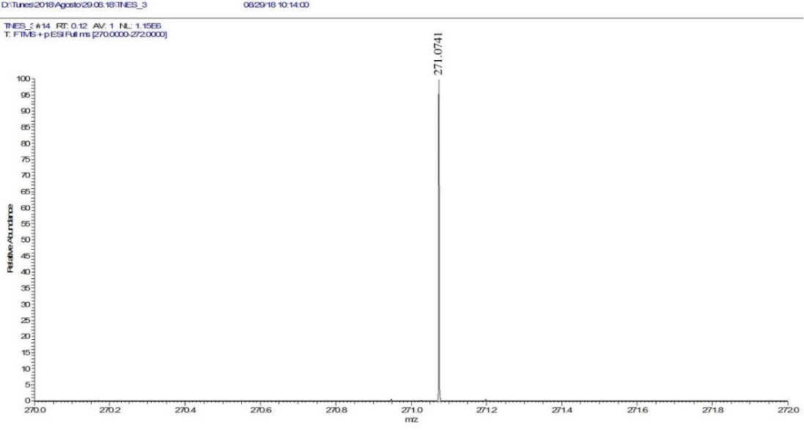

Fig. S5. HRMS-ESI spectrum of Michael adduct [M+H]⁺ at m/z 271.0741.

Product determination.

The Michael adduct was characterized by HRMS at the end of the reactions of 1 with L-cysteine in the same kinetic conditions using four different Bmim[AA]s (see Fig. S6-S9). The scan parameters: Resolution: 140000, AGC target: 1e 6, Max. inject time: 200 HESI source: Sheath gas flow: 30, Aux gas flow rate: 3, Sweep gas flow rate: 0, Capillary temp.: 250°C, S-lens RF level: 0, Heater temp: 50°C.

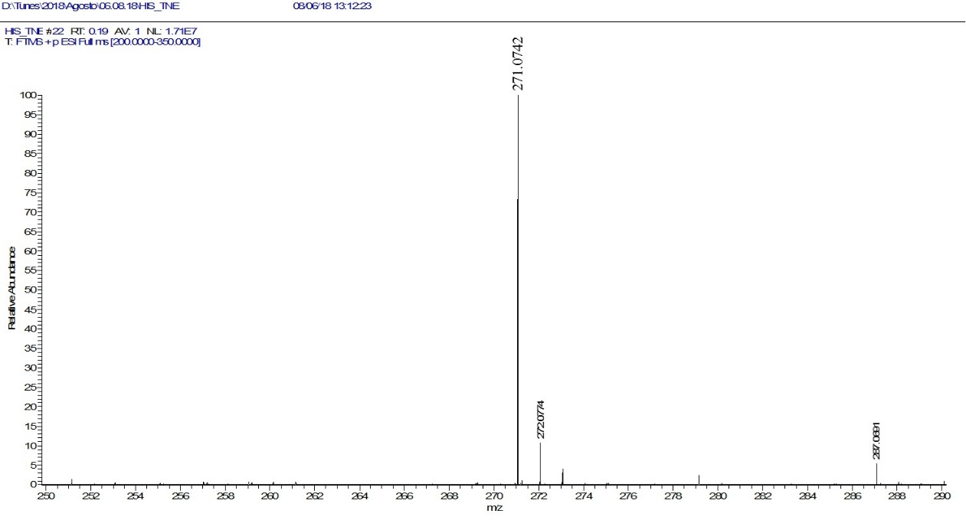

Fig. S6. HRMS-ESI spectrum of Michael adduct [M+H]⁺ at m/z 271.0742, using Bmim[His] as catalyst under our kinetics experimental conditions.

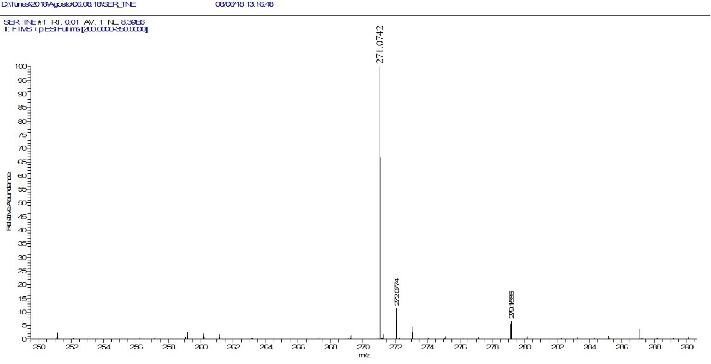

Fig. S7. HRMS-ESI spectrum of Michael adduct [M+H]⁺ at m/z 271.0742, using Bmim[Ser] as catalyst under our kinetics experimental conditions.

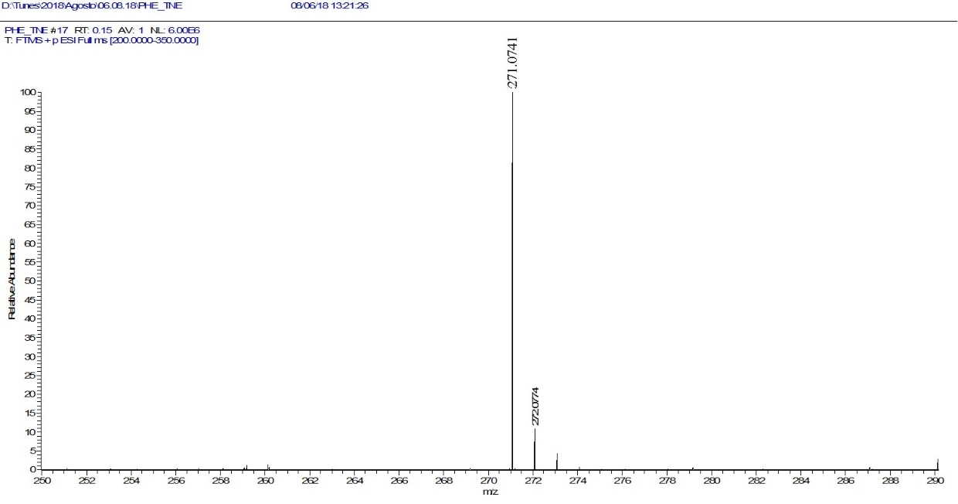

Fig. S8. HRMS-ESI spectrum of Michael adduct [M+H]⁺ at m/z 271.0741, using Bmim[Phe] as catalyst under our kinetics experimental conditions.

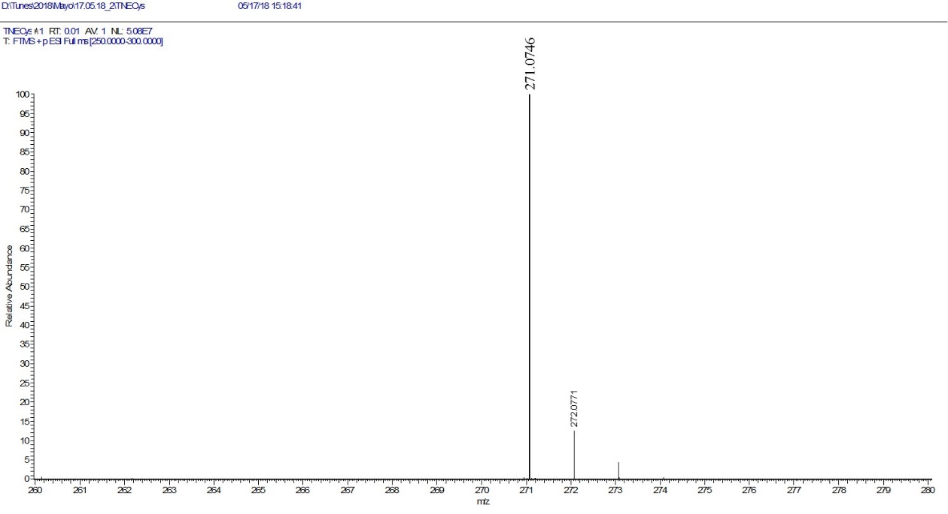

Fig. S9. HRMS-ESI spectrum of Michael adduct [M+H]⁺ at m/z 271.0746, using Bmim[Ala] as catalyst under our kinetics experimental conditions.

Table S1. Pseudo-first-order rate constants (k_{obsd}) for the reaction of 1 (5×10⁻⁶ M) with L-Cys (5×10⁻⁵-5.5×10⁻³ M) at 25ºC ± 0.1.
10⁵ [L-Cys]/M | 10² k_{obsd} (s⁻¹)
4.98 | 0.16
7.56 | 0.20
14.9 | 0.40
19.9 | 0.54
24.9 | 0.70
29.9 | 0.95
34.8 | 1.16
39.8 | 1.51
50.0 | 1.90
100 | 3.40
150 | 5.20
199 | 6.92
298 | 10.0
348 | 11.7
398 | 12.9
547 | 17.5

Pseudo first-order rate constants were reproducible within a ± 5%

Table S2. Pseudo-first-order rate constants (k_{obsd}) for the reaction of 1 (5×10⁻⁵ M) with L-Cys (5×10⁻⁴ M) using Bmim[AA]s (5×10⁻⁶-3×10⁻⁵ M) as catalyst at 25ºC ± 0.1.

Bmim[Ala] | Bmim[Phe] | Bmim[Asn]
  10⁶[cat]/M | 10²k_{obsd}/s⁻¹
  0.00 | 1.90
  6.12 | 2.34
  12.2 | 3.31
  18.4 | 4.74
  24.5 | 5.28
  30.6 | 6.02
  10⁶[cat]/M | 10²k_{obsd}/s⁻¹
  0.00 | 1.90
  5.00 | 2.87
  10.0 | 3.30
  15.0 | 3.96
  20.0 | 4.76
  25.0 | 5.53
  30.0 | 5.91
  10⁶[cat]/M | 10²k_{obsd}/s⁻¹
  0.00 | 1.90
  5.01 | 2.48
  10.0 | 2.86
  15.0 | 3.51
  20.0 | 4.24

Bmim[Ser] | Bmim[Met] | Bmim[Gly]
  10⁶[cat]/M | 10²k_{obsd}/s⁻¹
  0.00 | 1.90
  4.97 | 2.45
  9.95 | 2.87
  14.9 | 3.70
  19.9 | 4.17
  24.9 | 4.62
  29.8 | 5.10
  10⁶[cat]/M | 10²k_{obsd}/s⁻¹
  4.97 | 1.63
  9.94 | 2.03
  14.9 | 2.49
  19.9 | 3.01
  24.8 | 3.57
  29.8 | 4.40
  10⁶[cat]/M | 10²k_{obsd}/s⁻¹
  4.95 | 1.80
  9.91 | 2.29
  14.9 | 2.49
  19.8 | 2.84
  24.8 | 3.36

Bmim[His] | Bmim[Pro]
  10⁶[cat]/M | 10²k_{obsd}/s⁻¹
  0.00 | 1.90
  4.96 | 2.85
  9.92 | 3.81
  14.9 | 4.40
  19.9 | 5.40
  24.8 | 6.25
  29.8 | 6.96
  10⁶[cat]/M | 10²k_{obsd}/s⁻¹
  0.00 | 1.90
  9.60 | 2.23
  19.2 | 2.99
  24.0 | 3.55
  28.8 | 3.81

Pseudo first-order rate constants were reproducible within a ± 5%

Table S3. Pseudo-first-order rate constant (k_{obsd}) for the reaction of 1 with L-Cys at 9-32ºC temperature range.

Temperature 9.8 ± 0.1ºC | Temperature 14.1 ± 0.1ºC | Temperature 19.6 ± 0.1ºC
  10⁴[L-Cys]/M | 10²k_{obsd}/s⁻¹
  9.95 | 1.07
  14.9 | 1.27
  24.9 | 1.65
  29.8 | 1.77
  34.8 | 2.12
  10⁴[L-Cys]/M | 10²k_{obsd}/s⁻¹
  4.97 | 1.38
  9.95 | 1.94
  14.9 | 2.05
  19.9 | 2.68
  24.9 | 2.77
  29.8 | 3.22
  34.8 | 3.33
  10⁴[L-Cys]/M | 10²k_{obsd}/s⁻¹
  4.97 | 0.94
  14.9 | 2.01
  19.9 | 3.09
  24.9 | 3.35
  29.8 | 3.95

Temperature 16.0 ± 0.1ºC | Temperature 14.1 ± 0.1ºC | Temperature 31.5 ± 0.1ºC
  10⁶[BmimMet]/M | 10²k_{obsd}/s⁻¹
  5.07 | 2.79
  10.1 | 2.87
  15.2 | 3.02
  25.4 | 3.79
  30.4 | 4.06
  10⁶[BmimMet]/M | 10²k_{obsd}/s⁻¹
  5.03 | 3.74
  10.1 | 4.30
  15.1 | 4.41
  20.1 | 4.89
  25.2 | 5.52
  10⁶[BmimMet]/M | 10²k_{obsd}/s⁻¹
  5.07 | 6.87
  10.1 | 8.50
  15.2 | 10.4
  20.3 | 11.8
  25.4 | 12.7
  30.4 | 13.8

Temperature 16.4 ± 0.1ºC | Temperature 20.9 ± 0.1ºC | Temperature 32.4 ± 0.1ºC
  10⁶[BmimHis]/M | 10²k_{obsd}/s⁻¹
  4.97 | 2.71
  9.94 | 3.60
  14.9 | 3.77
  19.9 | 4.19
  29.8 | 5.88
  29.8 | 6.96
  10⁶[BmimHis]/M | 10²k_{obsd}/s⁻¹
  4.97 | 3.66
  9.94 | 5.50
  14.9 | 5.54
  19.9 | 6.39
  24.8 | 6.71
  10⁶[BmimHis]/M | 10²k_{obsd}/s⁻¹
  2.00 | 7.15
  4.00 | 7.63
  6.00 | 8.25
  8.00 | 8.73
  12.0 | 9.60

Temperature 10.0 ± 0.1 ºC | Temperature 15.1 ± 0.1 ºC | Temperature 19.7 ± 0.1 ºC
  10⁶[BmimGly]/M | 10²k_{obsd}/s⁻¹
  0.00 | 0.76
  4.97 | 0.79
  9.94 | 0.94
  19.9 | 1.33
  24.8 | 1.54
  29.8 | 1.60
  10⁶[BmimGly]/M | 10²k_{obsd}/s⁻¹
  0.00 | 1.18
  9.94 | 1.63
  14.9 | 1.85
  19.9 | 2.11
  24.8 | 2.29
  29.8 | 2.57
  10⁶[BmimGly]/M | 10²k_{obsd}/s⁻¹
  9.94 | 2.61
  14.9 | 2.97
  19.9 | 3.11
  24.8 | 3.50
  29.8 | 3.75

Temperature 16.5 ± 0.1 ºC | Temperature 20.9 ± 0.1 ºC | Temperature 32.2 ± 0.1 ºC
  10⁶[BmimAsn]/M | 10²k_{obsd}/s⁻¹
  5.03 | 2.67
  10.1 | 2.87
  15.1 | 2.99
  25.2 | 3.76
  30.2 | 4.34
  10⁶[BmimAsn]/M | 10²k_{obsd}/s⁻¹
  4.98 | 3.70
  9.95 | 3.55
  14.9 | 4.51
  19.9 | 4.56
  24.9 | 5.15
  10⁶[BmimAsn]/M | 10²k_{obsd}/s⁻¹
  5.03 | 9.00
  10.1 | 9.63
  15.1 | 10.5
  20.1 | 11.5
  30.2 | 13.9

Temperature 9.0 ± 0.1 ºC | Temperature 14.7 ± 0.1 ºC | Temperature 19.3 ± 0.1 ºC
  10⁶[BmimAla]/M | 10²k_{obsd}/s⁻¹
  0.00 | 0.41
  4.93 | 0.56
  9.87 | 0.66
  19.7 | 0.95
  24.7 | 1.08
  29.6 | 1.36
  10⁶[BmimAla]/M | 10²k_{obsd}/s⁻¹
  4.93 | 1.60
  9.87 | 1.88
  14.8 | 2.13
  19.7 | 2.37
  29.6 | 2.97
  10⁶[BmimAla]/M | 10²k_{obsd}/s⁻¹
  0.00 | 1.39
  4.96 | 1.70
  9.93 | 2.26
  14.9 | 2.66
  19.9 | 2.81
  24.8 | 3.20
  29.8 | 3.71

Pseudo first-order rate constants were reproducible within a ± 5%

Table S4. Catalytic (k_{cat}) and nucleophilic (k_{N}) rate constants for the reaction of 1 with L-Cys at 9-32ºC temperature range.

T(°C)±0.1 | k_{N} (M⁻¹s⁻¹) | T(°C)±0.1 | k_{cat} (M⁻¹s⁻¹) Bmim[Ala] | T(°C)±0.1 | k_{cat} (M⁻¹s⁻¹) Bmim[Gly]
9.80 | 3.98 | 9.00 | 301 | 10.0 | 317
14.1 | 6.55 | 14.7 | 550 | 15.1 | 462
19.6 | 12.3 | 19.3 | 757 | 19.7 | 525
25.0 | 31.6 | 25.0 | 1440 | 25.0 | 741

T(°C)±0.1 | k_{cat} (M⁻¹s⁻¹) Bmim[Asn] | T(°C)±0.1 | k_{cat} (M⁻¹s⁻¹) Bmim[Met] | T(°C)±0.1 | k_{cat} (M⁻¹s⁻¹) Bmim[His]
16.5 | 656 | 16.0 | 539 | 16.4 | 1190
20.9 | 784 | 20.9 | 825 | 20.9 | 1410
25.0 | 1140 | 25.0 | 1090 | 25.0 | 1700
32.2 | 1970 | 31.5 | 2740 | 32.4 | 2480

Pseudo first-order rate constants were reproducible within a ± 5%

Table S5. The k_{obsd} values obtained in each cycle for thiol-Michael reaction between 1 (5×10⁻⁵ M) and L-Cys (7×10⁻⁴ M) and Bmim[AA]s (2.5×10⁻⁵ M) as catalyst at 25 ± 0.1°C.
Cycle number | 10²k_{obsd} (s⁻¹)  Bmim[Ala] | 10²k_{obsd} (s⁻¹)  Bmim[Asn] | 10²k_{obsd} (s⁻¹)  Bmim[Pro] | 10²k_{obsd} (s⁻¹)  Bmim[Met]
1 | 8.55 | 5.97 | 4.27 | 5.46
2 | 7.86 | 5.36 | 4.25 | 5.51
3 | 7.03 | 5.15 | 4.16 | 5.25
4 | 6.42 | 4.91 | 4.00 | 4.90
Cycle number | 10²k_{obsd} (s⁻¹)  Bmim[His] | 10²k_{obsd} (s⁻¹)  Bmim[Ser] | 10²k_{obsd} (s⁻¹)  Bmim[Gly] | 10²k_{obsd} (s⁻¹)  Bmim[Phe]
1 | 9.49 | 5.10 | 4.53 | 5.91
2 | 9.37 | 4.54 | 4.55 | 5.38
3 | 8.97 | 4.32 | 4.34 | 5.57
4 | 8.30 | 4.76 | 4.31 | 5.58

Pseudo first-order rate constants were reproducible within a ± 5%

Table S6. Nucleophilic rate constant of thiolate $k_{N}^{S^{-}}$(M⁻¹s⁻¹) of the reaction between 1 and L-Cys and L-cysteine derivatives (5×10⁻⁴ M) as control in pH: 5.5 at 25 ± 0.1°C.
Compound | 10²k_{obsd} (s⁻¹) | 10³$F_{N}^{S^{-}}$ | 10⁻³ $k_{N}^{S^{-}}$(M⁻¹s⁻¹ )
L-cysteine | 1.77 | 2.51 | 14.1
N-acetyl-L-cysteine | 0.0548 | 0.10 | 11.0
D-penicillamine | 0.429 | 3.96 | 2.17

Pseudo first-order rate constants were reproducible within a ± 5%

Table S7. Pseudo-first-order rate constants (k_{obsd}) for the reaction of 1 (5×10⁻⁵ M) with L-Cys (5×10⁻⁴ M) over a pH range of 5.4-6.3 at 25 ± 0.1ºC.
pH | 10² k_{obsd}/s⁻¹
5.43 | 2.07
5.63 | 2.34
6.06 | 4.40
6.17 | 5.09
6.26 | 5.43

Pseudo first-order rate constants were reproducible within a ± 5%

