SUPPORTING INFORMATION

Nanoparticles for the Multivalent Presentation of a TnThr Mimetic and As Tool for Solid State NMR (SSNMR) Coating Investigation

Francesco Papi,∝ Giulia Targetti,∝ Linda Cerofolini,≠ Claudio Luchinat, ∝≠ Marco Fragai∝≠ * and Cristina Nativi∝ *

NMR and ESI-MS spectra of amido benzylester Pag. S2
NMR and ESI-MS spectra of compound 6 S5
Biological data S8
Figure S1 S11
Figure S2 S12
Figure S3 S13
Figure S4 S14
Figure S5 S15

NMR and ESI-MS spectra of amido benzylester

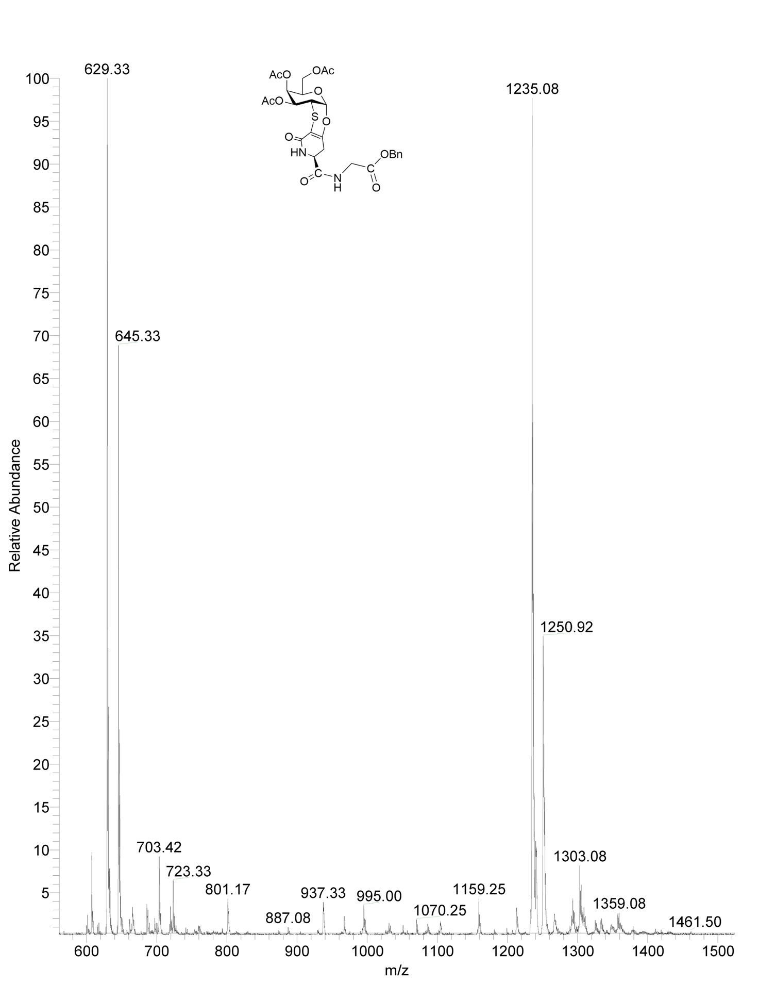

NMR and ESI-MS spectra of compound 6

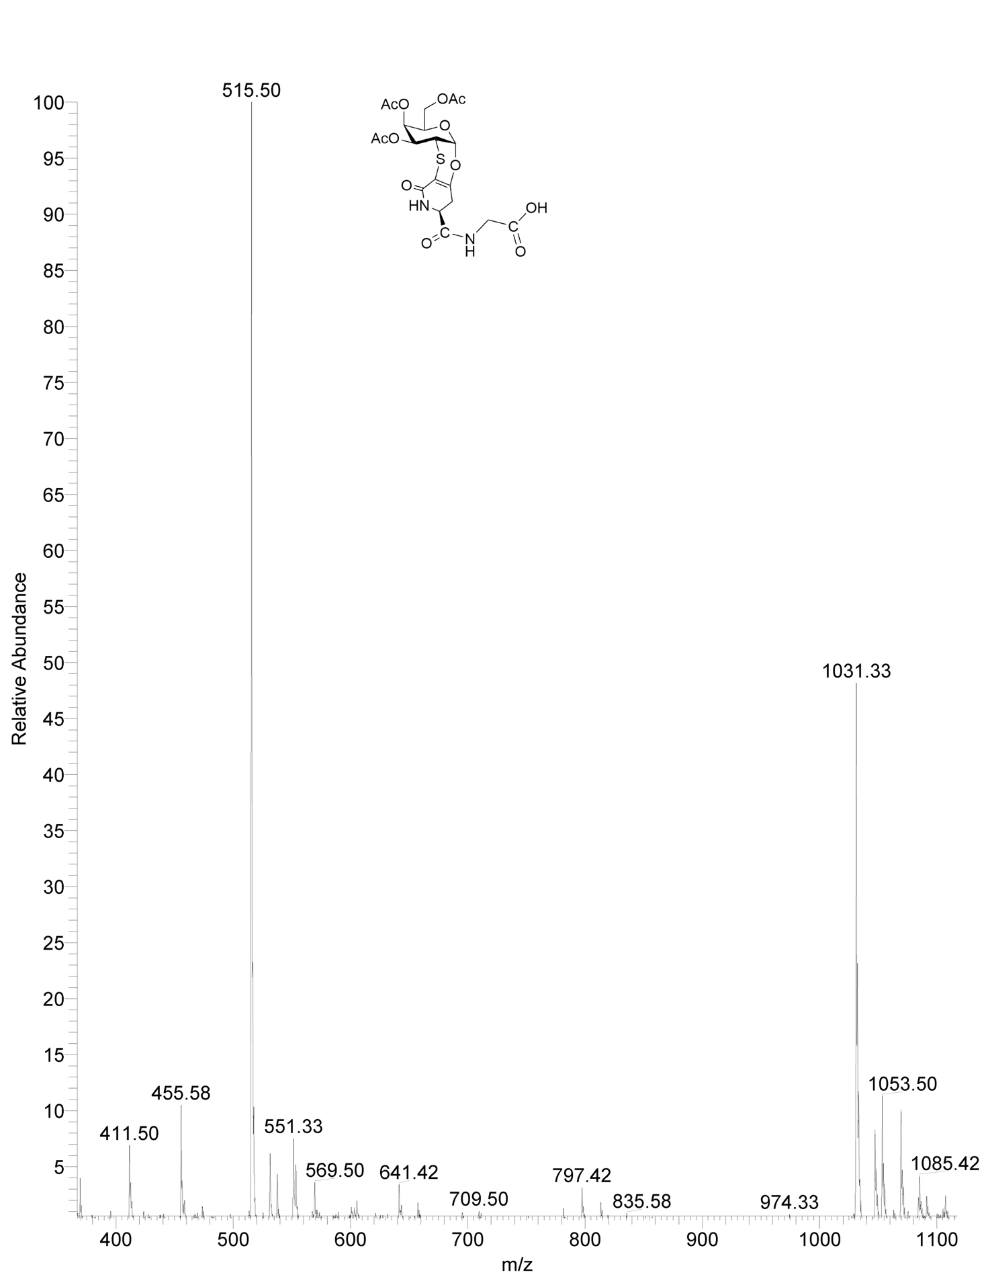

Biological Data
Iron nanoparticles.
Cell culture. The RAW 264.7 murine macrophage cell line (ATCC TIB-71; American Type Culture Collection, Manassas, VA, USA) was cultured in high glucose (4.5 g/l) Dulbecco's modified Eagle's medium (DMEM) supplemented with 10% heat-inactivated fetal bovine serum (FBS), 2mM L-glutamine, 100 IU/ml penicillin and 100 μg/ml streptomycin (Lonza, Milan, Italy) and kept in a 37 °C incubator with 5% CO₂. Cells were grown in 75-cm² flasks and sub-cultured by scraping when they reached 90% confluence with a 1:5 or 1:10 ratio in fresh medium. Before each experiment, viable cell count was assessed by trypan blue staining; thereafter cells were seeded and rendered quiescent by 18h serum deprivation.
Limulus amebocyte lysate (LAL) assay. LPS levels in each compound were measured in duplicate in serial 1:10 dilutions of each sample made with pyrogen-free water using a chromogenic LAL assay (Lonza, Basel, Switzerland), according to the manufacturer's protocol. The sensitivity of the LAL assay was 0.01 ng/ml.
MTT assay. Cell viability was measured by the 3-(4,5-dimethylthiazol-2-yl)-2,5- diphenyl-tetrazolium bromide (MTT) assay, as previously described (Lombardi et al., 2002). Briefly, RAW 264.7 cells were seeded in 24-well plates and treated with increasing concentrations (0.01-30 μg/ml) of 2, CMNPs or GMNPs for 24, 48 and 72 h at 37° C in a 5% CO₂ humidified incubator. The percentage of cell viability was calculated as (x × 100)/y, where x, and y were the absorbance read in compound-treated, and compound-untreated cells, respectively.
Calcein-AM assay. RAW 264.7 cells were labelled with 1 μM Calcein-AM (CAM) (Molecular Probes, Invitrogen) in serum-free PBS for 15 min at 37° C in the dark. After being washed, labelled cells were seeded in 24-well plates and allowed to adhere over-night at 37° C in a humidified incubator. The day after, RAW 264.7 cells were treated with increasing concentrations (0.01-30 μg/ml) of 2, CMNPs or GMNPs for 24, 48 and 72 h at 37° C in a 5% CO₂ humidified incubator. After incubation time the cells of each well were harvested, washed, labelled with propidium iodide (PI), and the viability was measured by flow cytometry. Lived cells were identified as CAM^{high}/PI⁻ population whereas dead cells were CAM^{low}/PI⁺. Viability was calculated by FACSDiva software and expressed as the percentage of CAM^{high}/PI⁻ population relative to untreated cells.
Qualitative study of MNPs uptake. RAW 264.7 cells (5 x 10⁴ cells/well) were allowed to adhere overnight on sterile glass cover slips in 24-well culture plates and treated with CMNPs or GMNPs (30 μg/ml) in complete medium for 24h at 37°C, 5% CO₂. The cover slips were washed twice with ice-cold PBS to remove unbound MNPs and cells were fixed with 4% paraformaldehyde for 15 min at 4° C. After two additional PBS washing, cells on the cover slips were stained with fresh prepared Prussian blue reagent (2% potassium ferrocyanide [Sigma Aldrich]/12% HCl, 1:1, v/v) for 30 min. The cells were washed five times with PBS, and subsequently the cover slips were mounted on glass slides by SlowFade® reagent (Invitrogen, Milano, Italy). Cells were then observed by an inverted optical microscope (objective x 40) with an integrated camera (Motic AE2000 with integrated Moticam 3.0).
Quantitative study of MNPs uptake. RAW 264.7 cells were seeded (1 x 10⁵ cells/well) in 12-well culture plates and treated with 2, CMNPs or GMNPs (30 μg/ml) for 24 h at 37° C in a 5% CO₂ humidified incubator. Following incubation, cells were washed twice with cold PBS to remove unbound MNPs, gently scraped from the culture plates on ice, and centrifuged (900 rpm, 5 min, 4°C). Cell pellets were resuspended in 200 μl PBS containing 2% FBS and analyzed by FACScalibur (FACS-Vantage, BD Bioscience, Milan). A total of 5000 viable cells were collected for each sample. For calculation cell debris and free particles were excluded by an electronical gate containing RAW 264.7 cells of all size and granularities in a FSC-SSC-histogram. Univariant histograms of SSC determined the mean of cell granularity used as measure of uptake by RAW 264.7 cells. Data were analyzed by using FACSDiva software (BD Bioscience, Milan).
For uptake time-course determination, RAW 264.7 cells were seeded (1 x 10⁵ cells/well) in 12-well culture plates and incubated with 2, CMNPs or GMNPs (30 μg/ml) for up to 72 h at 37° C in a 5% CO₂ humidified incubator. At different incubation times (1, 3, 6, 18, 24, 48 and 72h) cell samples were harvested, prepared and analysed by FACS, as described above.
To explore the relationship between cellular uptake and compound concentration RAW 264.7 cells were seeded in 12-well culture plates and incubated with increasing concentrations (0.01-30 μg/ml) of 2, CMNPs or GMNPs for 24, 48, and 72 h at 37° C in a 5% CO₂ humidified incubator. Following incubation cell samples were harvested, prepared and analyzed by FACS, as described above.
RT-PCR. RAW 264.7 cells were seeded (1 x 10⁶ cells/well) in 6-well culture plates and treated with increasing concentrations (1-30 μg/ml) of 2, CMNPs or GMNPs for 24 h at 37° C in a 5% CO₂ humidified incubator. Bacterial LPS (0.1 μg/ml)-treated and -untreated cells were used as positive and standard controls, respectively, for RT-PCR analysis. Total RNA was isolated using the GenEluteTM mammalian total RNA kit (Sigma Aldrich, Milan) and reverse-transcribed to cDNA using ThermoScript RT-PCRTM kit (Invitrogen, Milan, Italy), according to the manufacturer’s instructions. For amplification, 3 μl of cDNA were added to GoTaq FlexiDNA Polymerase (Promega, Milan, Italy) in 25 μl reaction buffer, containing 0.5 μM of forward and reverse primers (Table 1S, Supplementary Information). Amplification products were resolved in 1% agarose gel by electrophoresis and visualized with ethidium bromide. Signals were quantified with densitometric analysis software (NIH Image 1.32; Bethesda, MD, USA). Data were expressed as the ratio of the signals obtained for each gene in one sample divided by that obtained for the reference gene (mouse β-actin) in the same sample.
TNF-α release. RAW 264.7 cells were seeded in 24-well culture plates and treated with increasing concentrations (0.01-30 μg/ml) of 2, CMNPs or GMNPs for 24, 48 and 72 h at 37° C in a 5% CO₂ humidified incubator. Bacterial LPS (0.1 μg/ml)-treated cells, and -untreated cells were used as positive and standard controls, respectively, of TNF-α release. At the end of each experiment, supernatants were collected and stored at −20 °C until assays. The amounts of TNF-α in cell culture media were assayed using enzyme-linked immunosorbent assay (ELISA) kits (Biolegend, San Diego, USA), according to the manufacturer's instructions. The concentrations of TNF-α in the samples were determined by extrapolation from specific reference standard curves.
Statistical analysis. Results were expressed as means ± SEM of at least three independent experiments run in triplicate. Statistical significance was evaluated by the one-way ANOVA followed by Student’s t-test for unpaired populations (Graph Pad Software, Inc., San Diego, USA). Differences were considered statistically significant when p ≤ 0.05.

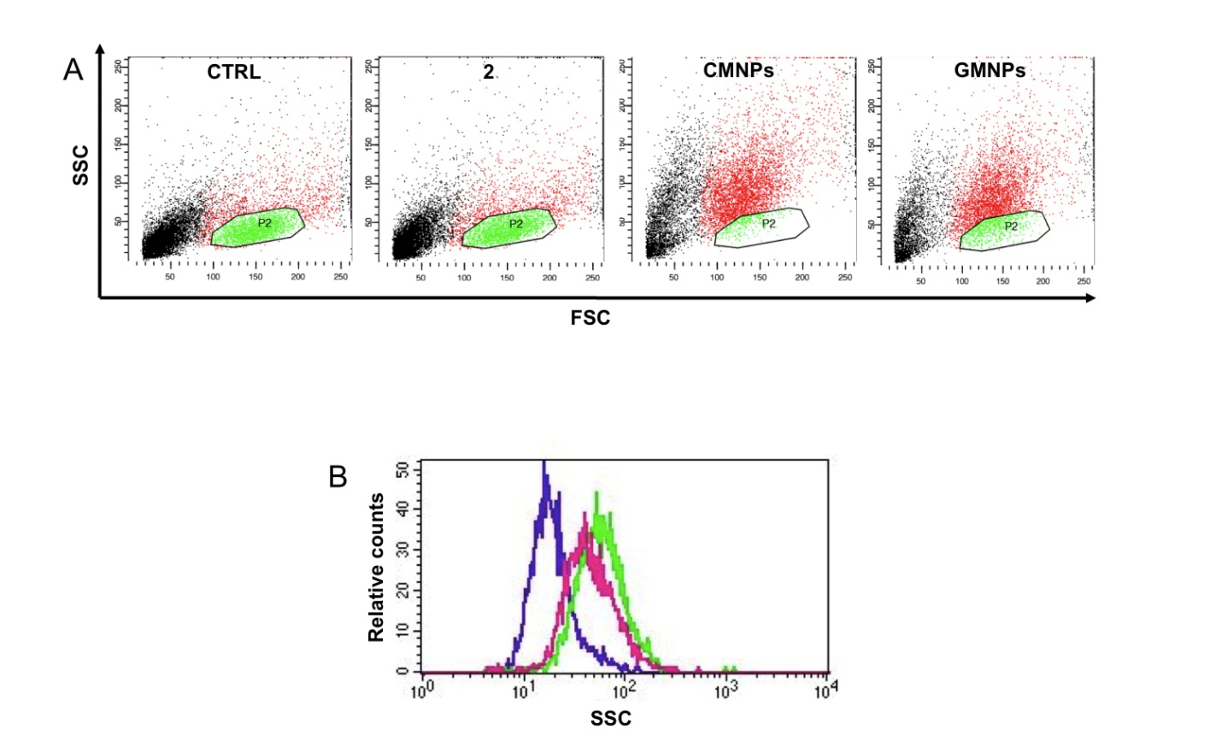
Figure S1. Quantitative evaluation of the 2, CMNPs and GMNPs uptake. RAW 264.7 cells were treated with 30 μg/ml of 2, CMNPs or GMNPs for 24h. The compound uptake was determined by measuring the cell granularity by FACS. (A) Representative dot plots showing the effects of compound uptake on granularity (SSC) and size (FSC) of RAW 264.7 cells. Images are from a representative experiment carried out three times with similar results. (B) Overlay plot of the RAW 264.7 cell SSC measured after CMNPs (green) or GMNPs (pink) uptake. Untreated cells are shade in violet.

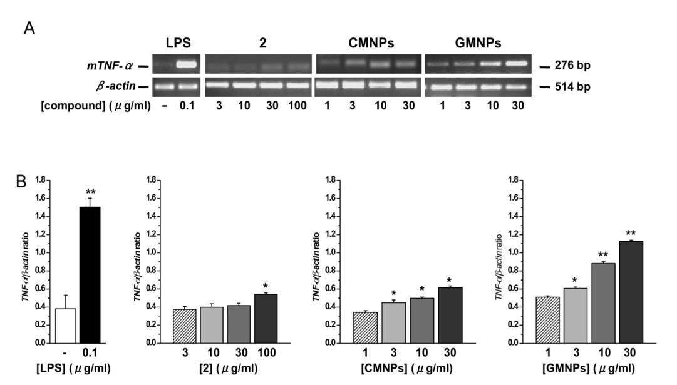

Figure S2. Effects of 2, CMNPs and GMNPs on TNF-α gene expression. RAW 264.7 cells were treated (24h) with increasing concentrations (0.01-30 μg/ml) of 2, CMNPs or GMNPs. Expression of β-actin was used as a loading control. Compound untreated cells (CTRL) were considered as negative, while 0.1 μg/ml LPS-treated cells as positive controls. (A) Representative results of RT-PCR for the TNF-α and β-actin gene expression. (B) The signals were densitometrically analyzed and data, calculated as mean ± SEM of at least three independent determinations, are expressed as ratio (TNF-α/β-actin) of the signals obtained for each sample divided by that obtained for β-actin in the same sample to permit between-sample comparisons. *p≤ 0.05; **p≤0.01 vs. controls (compound-untreated cells).

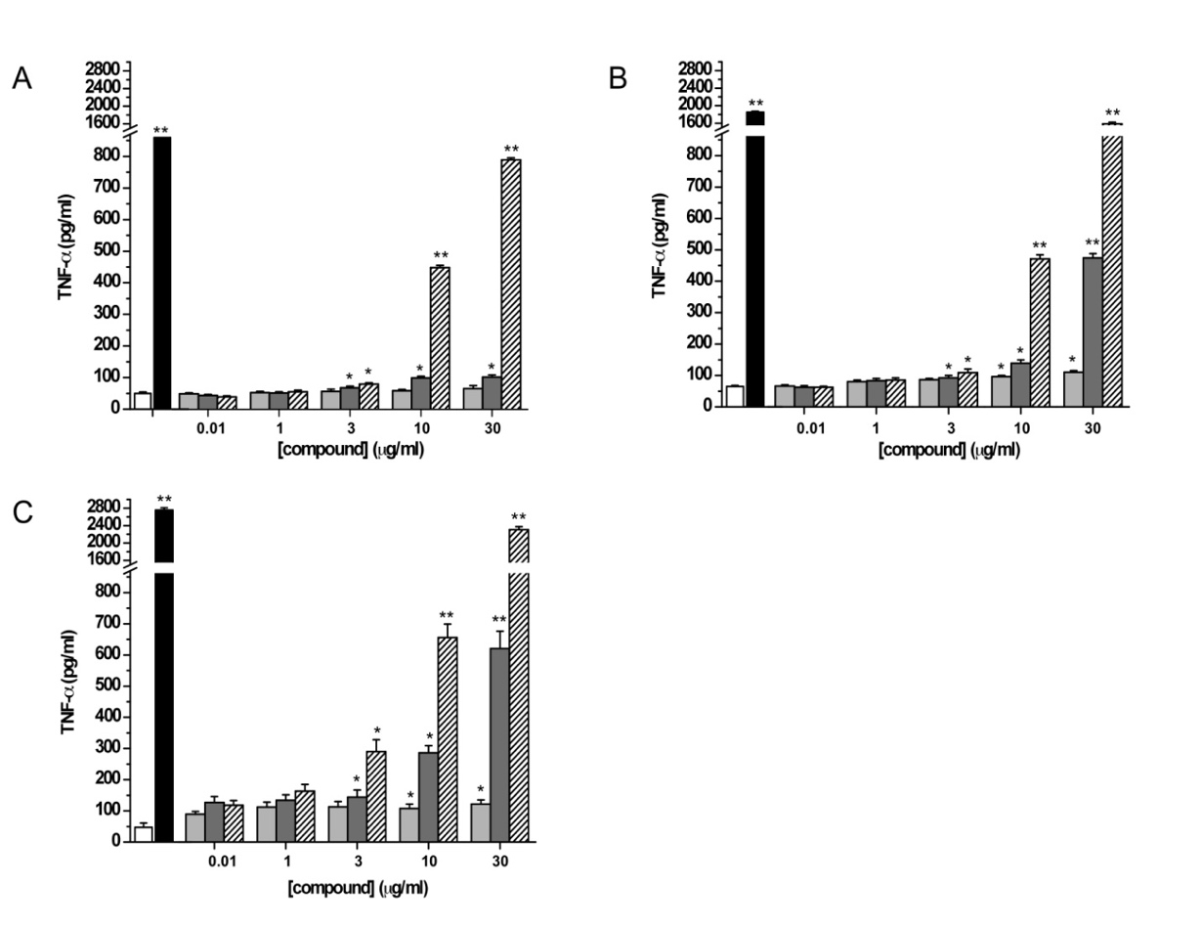
Figure S3. Effects of 2, CMNPs and GMNPs treatment on TNF-α release. RAW 264.7 cells were treated with increasing concentrations (0.01-30 μg/ml) of 2 (light gray bars), CMNPs (gray bars) or GMNPs (striped bars) for 24h (A), 48 h (B) and 72h (C). Compound untreated cells (white bars) were considered as negative, while 0.1 μg/ml LPS-treated cells (black bars) as positive controls. Supernatants were collected and assayed for TNF-α levels by standard ELISA. The data represent mean ± SEM of at least three independent experiments. *p≤ 0.05; **p≤0.01 vs. controls (compound-untreated cells).

Dextran-based Single Chain Polymer Nanoparticles
Analysis of interleukins and cytokines secretion. Pelikine compact ELISA kits (Sanquin reagents, Amsterdam, the Netherlands) were used to quantify IL-6, IL-10 and IFN-γ secretion. 96 well-plate Maxisorp plates (Nunc, 430341) were first coated with desired coating antibodies and cytokines were measured according to manufacturer's protocols.
In a first set of experiments, the IL-6 production after 24h incubation of nanoparticles (10µg/mL) in the presence of the positive control LPS (100 ng/mL) was set as 100%. Data show average ±SD of one representative donor out of three independent donors tested.
For the study of IL-10 secretion after 24h stimulation, cytokine production in the presence of the positive control Pam₃CSK₄ (10 ng/mL) was set as 100%. Combined data of three independent donors are shown. Data show average ±SD.
For the study of IFN-γ secretion after 4 days of incubation with the nanoparticles, data are expressed as fold increase compared with control PBMC treated with medium (set as 1). SEB (Staphylococcus aureus Enterotoxin B Superantigen) was used as positive control. Combined data of three independent donors are shown.
Significant differences between DXT-SCPNs and TnThr-DXT-SCPNs were calculated showing p < 0.01 in all the experiments performed.

Figure S4. IL-6 analysis by ELISA on human PBMC stimulated with DXT-SCPN and Tn-DXT-SCPN (also referred as TnThr-DXT-SCPN). LPS (100 ng/mL) was used as positive control and, due to differences in human donors responses, data were expressed as (A) % of maturation (setting the positive control as 100% of response), or (B) pg/mL of IL-6. Significant differences between DXT-SCPNs and Tn-DXT-SCPNs were calculated showing p < 0.01.

Figure S5. IL-10 (A) and IFN-γ (B) analysis by ELISA on human PBMC stimulated with DXT-based nanoparticles (n=3); combined data of three independent donors are shown). Pam₃CSK₄ (A) and SEB (B) were used as positive controls. Data have been expressed (A) as relative IL-10 secretion (setting Pam₃CSK₄ stimulation as 100%) or (B) as fold increase respect to the medium (set = 1). Significant differences between DXT-SCPNs and Tn-DXT-SCPNs (also referred as TnThr-DXT-SCPNs) were calculated showing p < 0.01.

