**Supplementary Material**

**Titanium based complexes with melanin precursors   
as a tool for directing melanogenic pathways**

Giuseppe Vitiello1,2, Pietro Melone1, Brigida Silvestri1, Alessandro Pezzella3,4,5, Paola Di Donato4,6, Gerardino D’Errico5, Michela Di Napoli7, Anna Zanfardino7, Mario Varcamonti7, Giuseppina Luciani*1

1 Department of Chemical, Materials and Production Engineering, University of Naples “Federico II”, p.le V. Tecchio 80, 80125 Naples, Italy

2 CSGI, Consorzio interuniversitario per lo sviluppo dei Sistemi a Grande Interfase, Sesto Fiorentino, via della Lastruccia 3, Firenze, Italy.

3 National Interuniversity Consortium of Materials Science and Technology (INSTM), Florence, Italy

4 Institute for Polymers, Composites and Biomaterials (IPCB), CNR, Via Campi Flegrei 34, I-80078 Pozzuoli (NA), Italy

5 Department of Chemical Sciences, University of Naples “Federico II” Via Cintia 4, I-80126 Naples Italy

6 Department of Science and Technology, University of Naples “Parthenope”, Centro Direzionale, Isola C4, 80143 Naples, Italy

7 Department of Biology, University of Naples “Federico II” Via Cintia 4, I-80126 Naples Italy

* Corresponding author: tel.: +390817682433; fax: +390817682595. E-mail address: luciani@unina.it

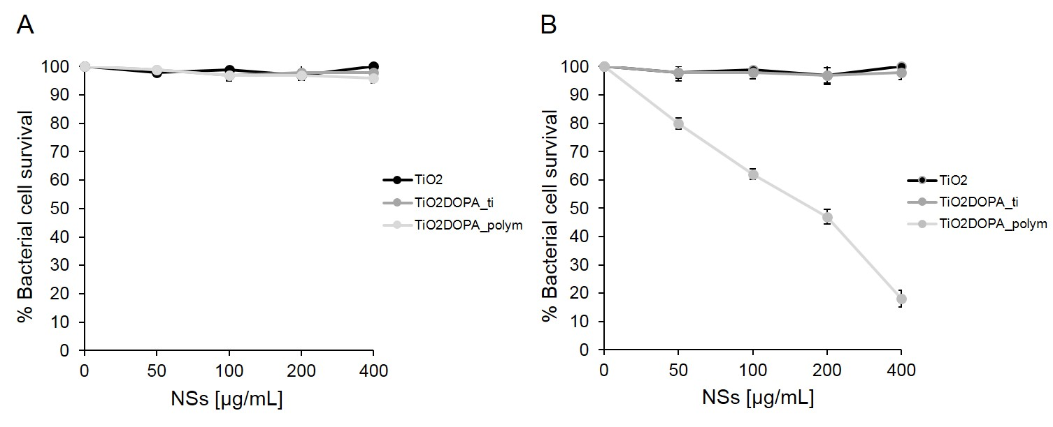

**Fig. S1**: Antimicrobial activity of TiO2 (black circles), TiO2DOPA_ti (dark gray circles) and TiO2DOPA_polym (light gray circles) at different concentrations (0 – 400 μg/mL) evaluated by colony count assay, against *Escherichia coli DH5α* strain after 10 minutes of incubation (panel A) and after 4h of incubation (panel B). The % of bacterial survival is represented on the y axis. The assays were performed for three independent experiments.

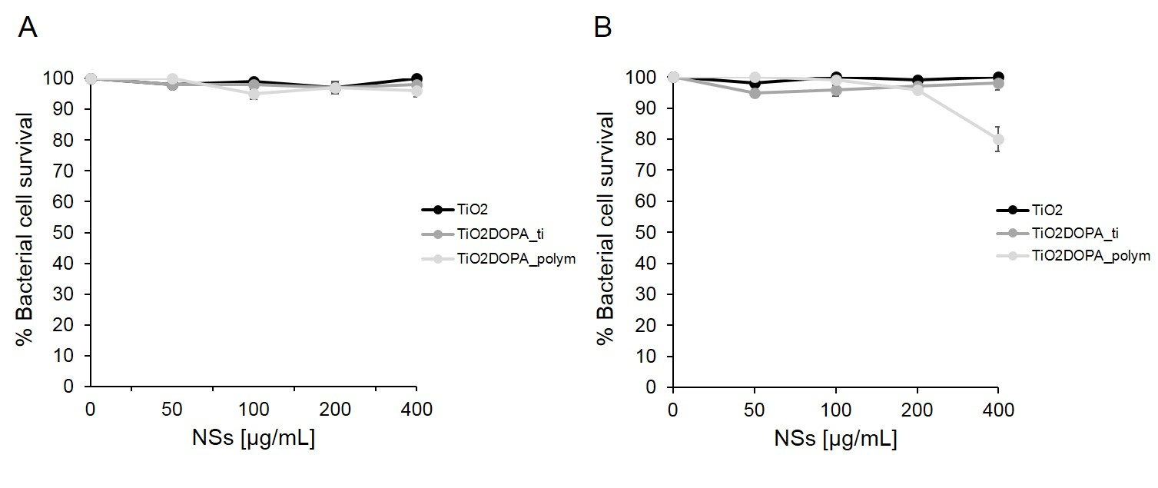

**Fig. S2**: Antimicrobial activity of TiO2 (black circles), TiO2DOPA_ti (dark gray circles) and TiO2DOPA_polym (light gray circles) at different concentrations (0 – 400 μg/mL) evaluated by colony count assay, against *Staphylococcus aureus ATCC 6538* strain after 10 minutes of incubation (panel A) and after 4h of incubation (panel B). The % of bacterial survival is represented on the y axis. The assays were performed for three independent experiments.

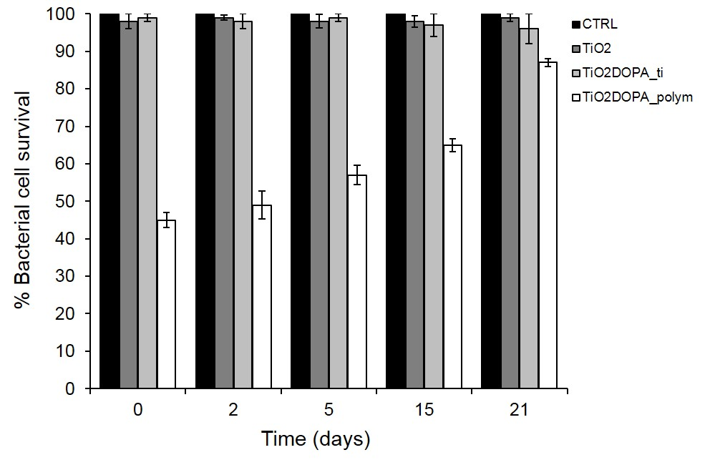

**Fig. S3:** Antimicrobial activity of TiO2, TiO2DOPA_ti and TiO2DOPA_polym nanostructures stored for different times (0-21 days), evaluated by colony count assay, against *Escherichia coli DH5α* strain. The % of bacterial survival is represented on the y axis. *E. coli* cells with any treatment represent the negative control (black bars); survival of bacteria treated with 200 μg/mL TiO2 is reported with dark gray bars, TiO2DOPA_ti with light gray bars and TiO2DOPA_polym with white bars. The assays were performed for three independent experiments. P value was ˂ 0.05.

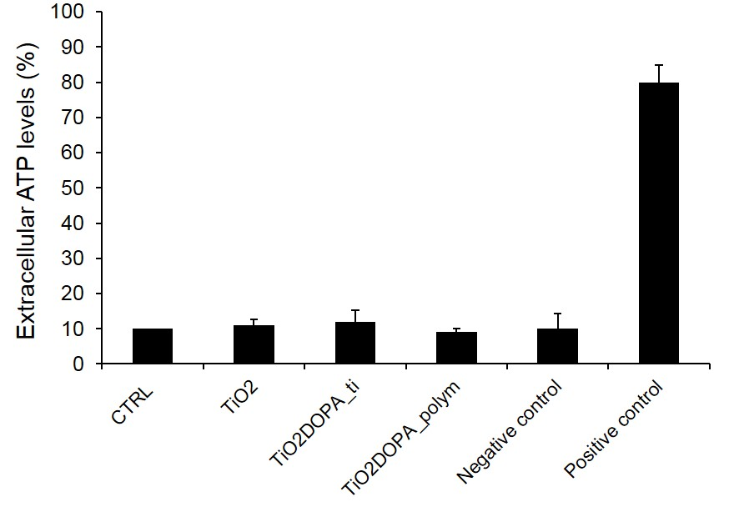

**Fig. S4**: Adenosine triphosphate (ATP) percentage in culture of *Escherichia coli DH5α* treated with NSs (200μg/ml) for 10 minutes. The positive control is represented by the polimixin B (10 µg/mL) known to form pores in the membrane and to determine the release of ATP. The negative control is represented by the ampicillin (50 µg/mL). Vertical bars indicate ±SD. Experiments were carried out in triplicate.

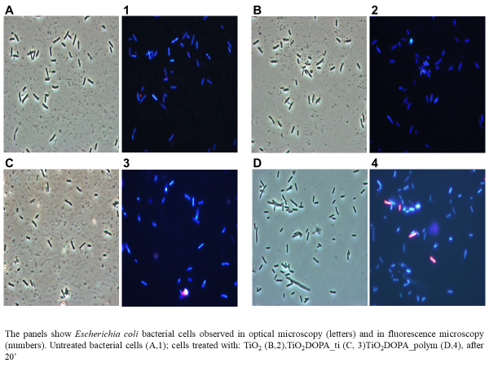**Fig. S5:** The panels show *Escherichia coli DH5α* bacterial cells observed in optical microscopy (letters) and in fluorescence microscopy (numbers). Untreated bacterial cells (A, 1); cells treated with: TiO2 (B, 2), TiO2DOPA_ti (C, 3), TiO2DOPA_polym (D, 4).

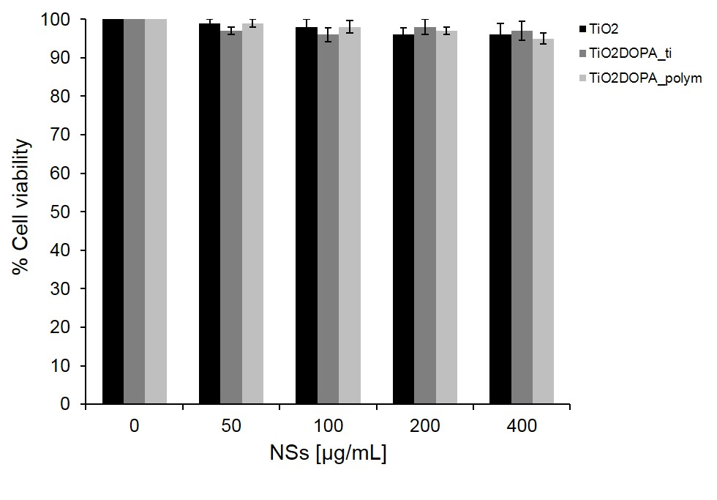

**Fig. S6:** Cytotoxic effects of TiO2, TiO2DOPA_ti and TiO2DOPA_polym [0-400µg/mL] on HaCat (Human keratinocytes) human cells by performing the 3-(4,5-dimethylthiazol-2-yl)-2,5 diphenyltetrazolium bromide (MTT) reduction inhibition assay. The mean values and SD from three independent experiments run in triplicate are shown.



**Fig. S7:** XRD spectra of bare TiO2 and TiO2-DOPA_ti nanostructures.



**Fig. S8:** EPR spectra of TiO2 (**a**), TiO2DOPA_ti (continuous lines) and TiO2DOPA_polym (dotted lines) nanohybrids prepared at different TTiP/DOPA weight ratios by using 1 (**b**), 2 (**c**), 5 (**d**), 10 (**e**) and 20 (**f**) mg of DOPA monomer.

|  |  |  |
| --- | --- | --- |
| **SAMPLES** | **B /G** | |
|  | *ti* | *polym* |
| **DOPA-melanin** | 4.8 ± 0.2 | |
| **TiO2-DOPA1** | 7.0 ± 0.2 | 7.0 ± 0.2 |
| **TiO2-DOPA2** | 7.1 ± 0.2 | 7.2 ± 0.2 |
| **TiO2-DOPA5** | 7.0 ± 0.2 | 6.9 ± 0.2 |
| **TiO2-DOPA10** | 7.0 ± 0.2 | 7.2 ± 0.2 |
| **TiO2-DOPA20** | 6.9 ± 0.2 | 6.9 ± 0.2 |

**Table S1:** EPR spectral parameters for DOPA-based/TiO2 nanohybrids.



**Fig. S9**: Plot of normalised amplitude vs. power intensities of free radicals of TiO2DOPA_ti at (panel **A**) and TiO2DOPA_polym (panel **B**) hybrids at different titanium precursor/DOPA ratios.



**Fig. S10:** UV-vis spectra of acetic acid/DOPA aqueous mixtures in the absence of TTiP (**a**) and after neutralization with NaOH at pH=4 (**b**), pH=5.5 (**c**) and pH=7 (**d**).