Supplementary data for:

TiO₂ Microrods with Stacked 3D Nanovoids for Photoelectrochemical Water Splitting

Filip Mamon¹, Radek Fajgar², Vera Jandova², Eva Koci¹, Ivo Jakubec¹, Alexander Zhigunov³, Tatjana Brovdyova⁴ and Snejana Bakardjieva^{1*}

¹Institute of Inorganic Chemistry of the CAS, 205 68 Rez, Czech Republic
²Institute of Chemical Process and Fundamentals of the CAS, Rozvojova 2/135, 165 02 Prague, CR
³Institute of Macromolecular Chemistry of the CAS, Heyrovskeho nam.1888/2, 162 00 Prague, Czech Republic;
⁴Faculty of Mechanical Engineering of the UJEP, Pasteurova 3334/7, 400 96 Usti nad Labem

* The corresponding authors e-mail: snejana@iic.cas.cz
(Snejana BAKARDJIEVA)

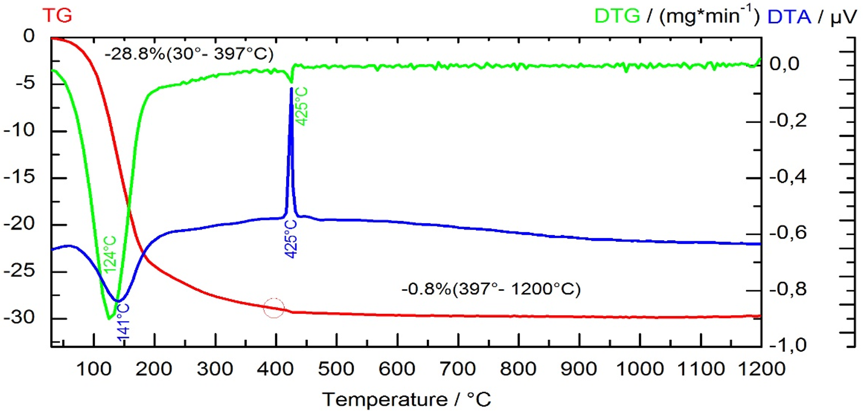

Fig.S1: TG/DTA of samples 1D TiO/500, 1D TiO/650, 1D TiO/800 and 1D TiO/950

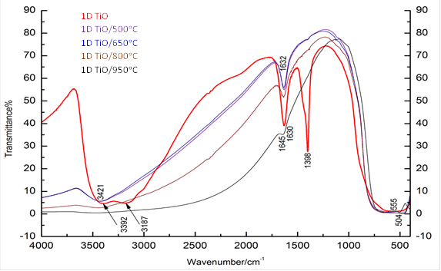

Fig.S2: FTIR spectra of the intermediate precursor 1D TiO and annealed samples 1D TiO/500, 1D TiO/650, 1D TiO/800, 1D TiO/950.

