**Supporting Information for**

**‘Switch-on’ DNA Sensor Based on Poly(*p*-phenylene vinylenes) Bound Tentacle Probes**

*Anupama R. Gulur Srinivasa, David Barkera, Jadranka Travas-Sejdica,b\**

aPolymer Electronics Research Centre, School of Chemical Sciences, The University of Auckland, Private Bag 92019, Auckland, New Zealand

bMacDiarmid Institute for Advanced Materials and Nanotechnology, Victoria University of

Wellington, P.O. Box 600, Wellington, New Zealand

Email: j.travas-sejdic@auckland.ac.nz

**This File Includes:**

**Section S1: Switch-On DNA sensor response with PPV-MagSi beads**

**Section S1: Switch-On DNA sensor response with PPV-MagSi beads**

# Section S1.1 Switch-On DNA sensor response with PMDH-MagSi and PDMonoG-MagSi beads

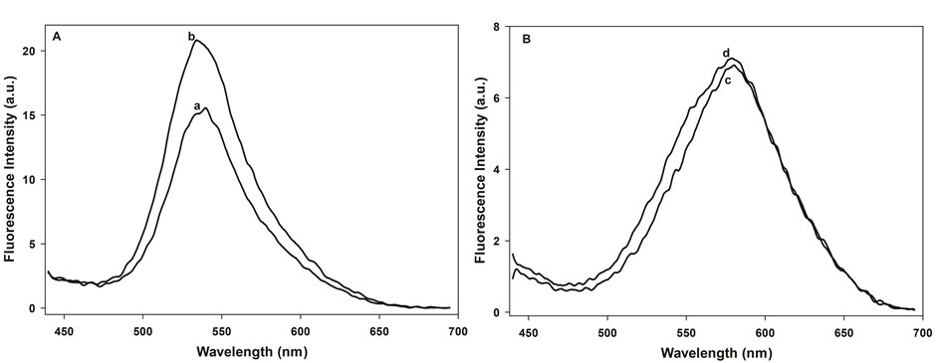

Figure S1.1. The fluorescence spectra of (A) **PMDH**-MagSi DNA sensor with (a) TP and (b) Target, (B) **PDMonoG**-MagSi DNA sensor with (c) TP and (d) Target in Tris-HCl buffer.

# Section S1.2 Selectivity of the switch-on DNA sensor response with PMDH-MagSi beads

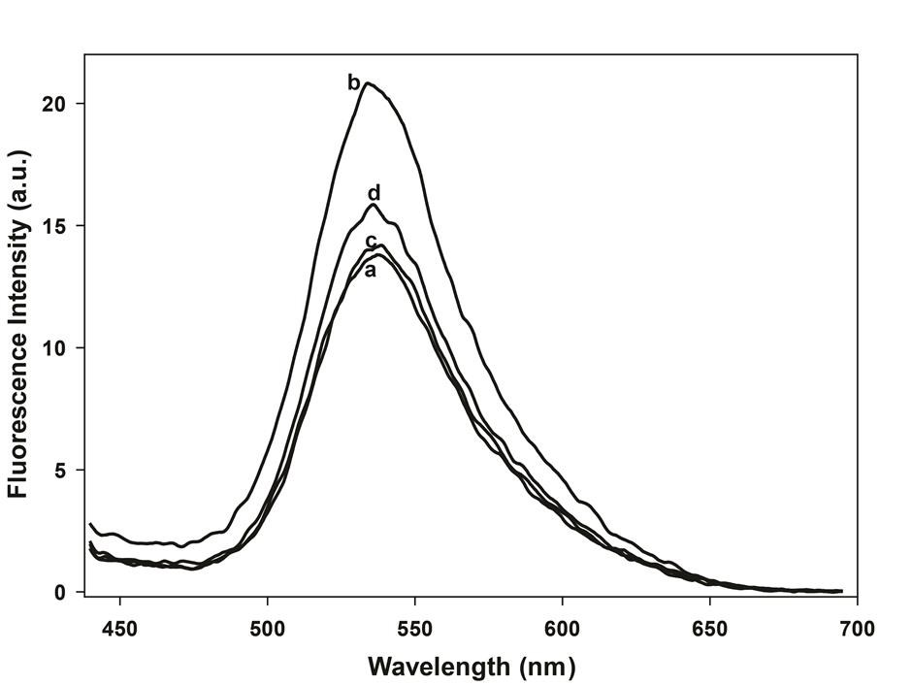

Figure S1.2. The fluorescence spectra of **PMDH**-MagSi DNA sensor with (a) TP, (b) Target, (c) NonC and (d) 2BMisM in Tris-HCl buffer.