Supplemental figures
Supplementary Figure S1: Flow-chart of patients’ progress into the study steps.
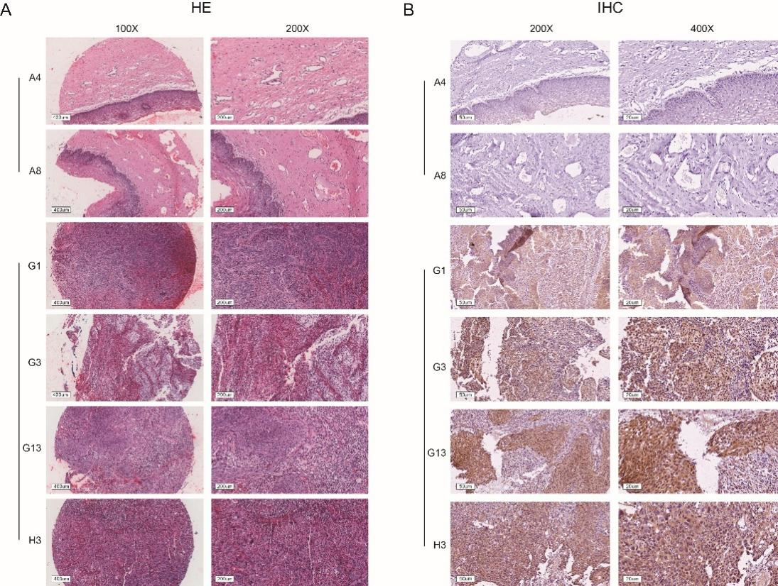
Supplementary Figure S2: Staining images of cervical cancer tissues. (A) HE staining in cervical cancer tissues (samples G1, G3, G13, H3) is more intense than in adjacent noncancerous tissues (samples A4, A8). Representative images at 100× and 200× magnifications are shown. Scale bar, 400 μm and 200 μm. (B) ACAT2 staining in cervical cancer tissues (samples G1, G3, G13, H3) is stronger than in adjacent noncancerous tissues (samples A4, A8). Representative IHC images at 200× and 400× magnifications are shown. Scale bar, 50 μm and 20 μm.

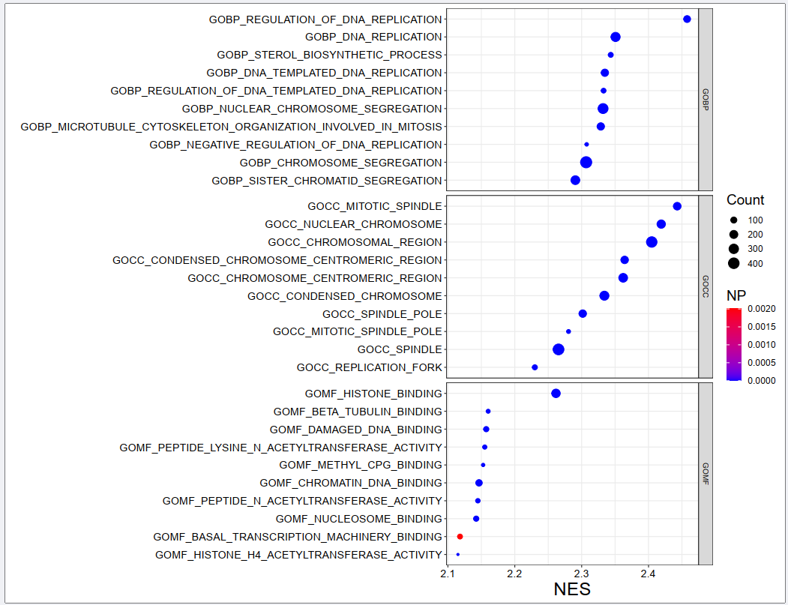
Supplementary Figure S3: Gene Ontology (GO) enrichment analysis, highlighting biological processes (BP), cellular components (CC), and molecular functions (MF). Top 10 results displayed for each category.

