Supporting information

Inhibition of Hornification in Simao Pine Fibers and Recycled Paper with Different Beating Degrees by Microwave Expansion Treatment
Zinuo Meng, Jizhen Huang*, Liangliang An, Changrong Shi, Ya Zhang, Wanruo Lei, Yuxin Liu*
Faculty of Chemical Engineering, Kunming University of Science and Technology, Kunming, Yunnan 650500, China
*Corresponding Author:
Jizhen Huang, E-mail: huangjizhen211@163.com; Yuxin Liu, E-mail: yuxinliukm@kmust.edu.cn.

Number of pages: 2
Number of figures: 3

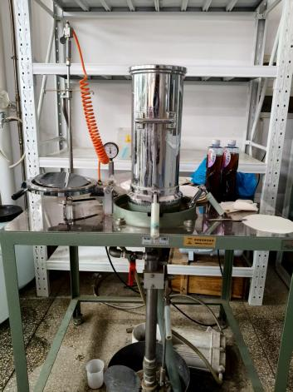
Figure S1. A physical image of the sheet former

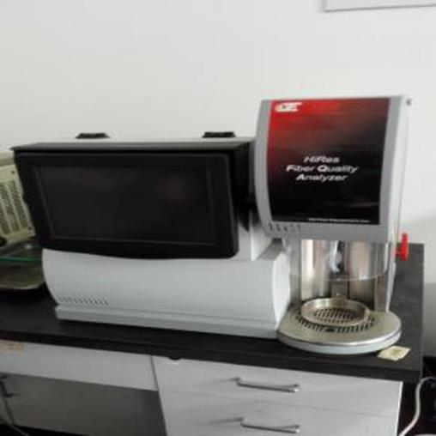
Figure S2. Physical image of fiber quality analyzer

Figure S3. TEA (a), Tear index (b), Opacity (c) of different beating degrees paper. tensile length (d), width ratio (e) of recycled fibers after secondary microwave puffing. 75°SR crystallinity (f), 24°SR crystallinity (g)

