(1) Range Analysis and Variance Analysis of Yield:
Table 3-5 presents the analysis of microcapsule yield results
Level | Factor |  |  |  |  |  |  | Yield (%)
Level | A Polymerization temperature (℃) |  | B Stirring speed (rpm) |  |  | C pH | D Polymerization time (h) | Yield (%)
3-1 |  | 45 |  | 1000 | 2.5 |  | 1 | 82.95
3-2 |  | 45 |  | 1200 | 3.0 |  | 2 | 84.13
3-3 |  | 45 |  | 1400 | 3.5 |  | 3 | 78.53
3-4 |  | 60 |  | 1000 | 3.0 |  | 3 | 92.67
3-5 |  | 60 |  | 1200 | 3.5 |  | 1 | 85.54
3-6 |  | 60 |  | 1400 | 2.5 |  | 2 | 89.58
3-7 |  | 75 |  | 1000 | 3.5 |  | 2 | 75.85
3-8 |  | 75 |  | 1200 | 2.5 |  | 3 | 84.13
3-9 |  | 75 |  | 1400 | 3.0 |  | 1 | 91.66
K1 |  | 245.61 |  | 251.47 | 256.66 |  | 260.14
K2 |  | 267.78 |  | 253.8 | 268.45 |  | 249.56
K3 |  | 251.64 |  | 259.77 | 239.92 |  | 255.33
k1 |  | 81.87 |  | 83.82 | 85.55 |  | 86.71
k2 |  | 89.26 |  | 84.6 | 89.48 |  | 83.19
k3 |  | 83.88 |  | 86.59 | 79.97 |  | 85.11
R |  | 7.39 |  | 2.77 | 9.51 |  | 3.53
Optimal Formulation |  | A2B3C2D1
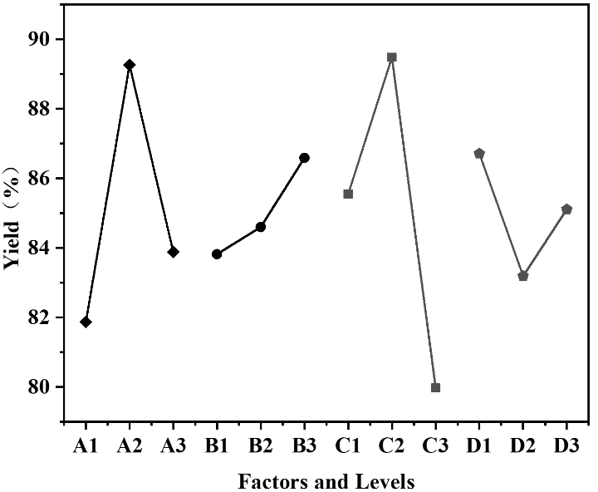
Fig.3-8 Intuitive Diagram of Yield Results
Microcapsule yield, UF utilization rate, and relative hiding power are crucial for the preparation of UF@CS-MC. Yield is the most intuitive indicator for evaluating the comprehensive performance of microcapsules, directly related to resource conservation and cost reduction, and holds significant importance for practical production investment and real-world applications. Table 3-5 and Figure 3-8 show the analysis results and intuitive analysis chart of microcapsule yield. Group 3-4 achieved the highest yield of 92.67%, followed by Group 3-9 with 91.66%. By comparing the ranges of several influencing factors, the order of influence was determined as C > A > D > B. The most influential factor is C (pH value), followed by polymerization temperature, and finally polymerization time and stirring speed.
Variance analysis was performed on the orthogonal experimental data. Since the experiment involved four factors and three levels, the merged error method was used for variance analysis, with the factor with the smallest range (stirring speed) serving as the error source. As shown in the variance calculation data in Table 3-6, the critical F-value table was consulted, revealing that when the degrees of freedom for both numerator and denominator were 2, the critical F-value (F_{0.05} = 19). Analysis of the variance data showed that pH value (F = 25.89) had a statistically significant impact on yield (P ≤ 0.05), while polymerization temperature (F = 15.83) and polymerization time (F = 3.38) did not reach statistical significance. The most influential factor was pH value.
Table 3-6 presents the analysis of variance (ANOVA) table
Source of Variation | Sum of Squares (SS) | Degrees of Freedom (df) | F-value | Significance
Polymerization Temp. (°C) | 87.89 | 2 | 15.83 | *
Stirring Speed (Error) (rpm) | 14.84 | 2 | - | -
pH Value | 143.81 | 2 | 25.89 | **
Polymerization Time (h) | 18.76 | 2 | 3.38 | *
Total | 257.12 | 8 | - | -
Note：* represents P ≥ 0.05、** represents P ≤ 0.05、*** represents P ≤ 0.01
Combining the results of range and variance analysis, it was concluded that the most significant factor affecting the yield of UF@CS-MC is pH value.
(2) Range Analysis and Variance Analysis of UF Utilization Rate:
Table 3-7 Analysis of UF Wall Material Utilization Rate Results
Level | Factor |  |  |  |  |  |  | UF utilization rate (%)
Level | A Polymerization temperature (℃) |  | B Stirring speed (rpm) |  |  | C pH | D Polymerization time (h) | UF utilization rate (%)
3-1 |  | 45 |  | 1000 | 2.5 |  | 1 | 59.09
3-2 |  | 45 |  | 1200 | 3.0 |  | 2 | 50.46
3-3 |  | 45 |  | 1400 | 3.5 |  | 3 | 44.69
3-4 |  | 60 |  | 1000 | 3.0 |  | 3 | 47.01
3-5 |  | 60 |  | 1200 | 3.5 |  | 1 | 80.51
3-6 |  | 60 |  | 1400 | 2.5 |  | 2 | 44.15
3-7 |  | 75 |  | 1000 | 3.5 |  | 2 | 77.33
3-8 |  | 75 |  | 1200 | 2.5 |  | 3 | 45.32
3-9 |  | 75 |  | 1400 | 3.0 |  | 1 | 84.45
K1 |  | 154.23 |  | 183.42 | 148.55 |  | 224.04
K2 |  | 171.66 |  | 176.28 | 181.92 |  | 171.93
K3 |  | 207.09 |  | 173.28 | 202.52 |  | 137.01
k1 |  | 51.41 |  | 61.14 | 49.52 |  | 74.68
k2 |  | 57.22 |  | 58.76 | 60.64 |  | 57.31
k3 |  | 69.03 |  | 57.76 | 67.51 |  | 45.67
R |  | 17.62 |  | 3.38 | 17.99 |  | 29.01
Optimal Formulation |  | A3B1C3D1
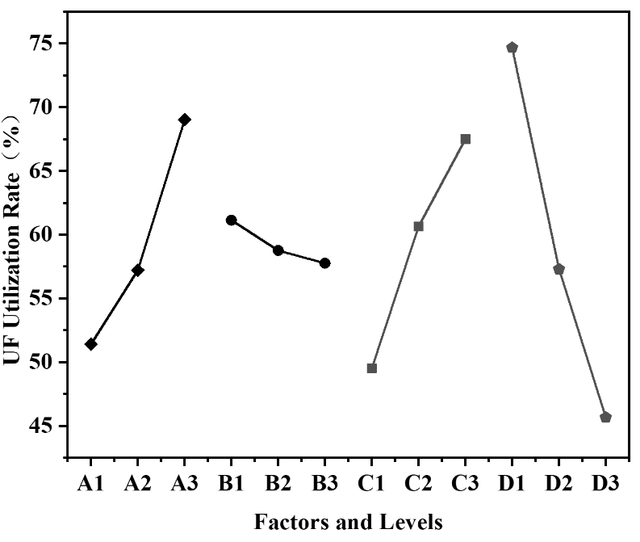
Fig.3-9 Intuitive Diagram of UF Utilization Rate Results
The UF wall material utilization rate affects both preparation costs and the performance of microcapsules. In the orthogonal experiment, the mean values, ranges, and intuitive charts of UF wall material utilization rate are shown in Table 3-7 and Figure 3-9. Group 3-6 had the lowest utilization rate, followed by Group 3-3, both below 50%. The highest utilization rate was achieved by Group 3-9, reaching 84.45%. The range data effectively reflects the magnitude of influence of experimental conditions on microcapsule preparation. By analyzing and comparing the data range, the order of influence of factors was determined as D > C > A > B. Factors C and A were close in influence, but the most influential factor was D (polymerization time), followed by pH value and polymerization temperature, with stirring speed having the least impact.
Variance analysis was performed on the orthogonal data of UF utilization rate. As shown in the variance calculation data in Table 3-8, the critical F-value table was consulted, revealing that when the degrees of freedom for both numerator and denominator were 2, the critical F-value (F_{0.05} = 19). Analysis of the variance data showed that pH value (F = 35.68), polymerization temperature (F = 34.15), and polymerization time (F = 92.62) had statistically significant impacts on yield (P ≤ 0.05). The most influential factor was polymerization time.
Combining the results of range and variance analysis, it was concluded that the most significant factor affecting the UF wall material utilization rate of UF@CS-MC is polymerization time.
Table 3-8 presents the analysis of variance (ANOVA) table
Source of Variation | Sum of Squares (SS) | Degrees of Freedom (df) | F-value | Significance
Polymerization Temp. (°C) | 465.12 | 2 | 34.15 | ***
Stirring Speed (Error) (rpm) | 17.14 | 2 | - | -
pH Value | 485.97 | 2 | 35.68 | ***
Polymerization Time (h) | 1,261.82 | 2 | 92.62 | ***
Total | 1,854.05 | 8 | - | -
Note：* represents P ≥ 0.05、** represents P ≤ 0.05、*** represents P ≤ 0.01
(3) Range Analysis and Variance Analysis of Relative Hiding Power:
Relative hiding power represents the filler's ability to obscure color compared to titanium dioxide as a reference, reflecting the optical performance of the filler. In the orthogonal experiment, the mean values, ranges, and intuitive charts of relative hiding power are shown in Table 3-9 and Figure 3-10. Group 3-9 had the lowest utilization rate, followed by Group 3-8. The highest relative hiding power was achieved by Group 3-6, reaching 97.23%. By analyzing and comparing the range data, the order of influence of factors was determined as A > D > C > B. The most influential factor was A (polymerization temperature), followed by polymerization time and pH value, with stirring speed having the least impact.
Variance analysis was performed on the orthogonal data of microcapsule relative hiding power. As shown in the variance calculation data in Table 3-10, the critical F-value table was consulted, revealing that when the degrees of freedom for both numerator and denominator were 2, the critical F-value (F_{0.05} = 19). Analysis of the variance data showed that pH value (F = 4.25), polymerization temperature (F = 6.41), and polymerization time (F = 5.74) did not reach statistical significance (P ≤ 0.05). However, the most influential factor was polymerization temperature.
Combining the results of range and variance analysis, it was concluded that the most significant factor affecting the relative hiding power of UF@CS-MC is polymerization temperature.
Table 3-9 Analysis of Microcapsule Relative Hiding Power Results
Level | Factor |  |  |  |  |  |  | Relative hiding power (%)
Level | A Polymerization temperature (℃) |  | B Stirring speed (rpm) |  |  | C pH | D Polymerization time (h) | Relative hiding power (%)
3-1 |  | 45 |  | 1000 | 2.5 |  | 1 | 94.10
3-2 |  | 45 |  | 1200 | 3.0 |  | 2 | 95.76
3-3 |  | 45 |  | 1400 | 3.5 |  | 3 | 94.90
3-4 |  | 60 |  | 1000 | 3.0 |  | 3 | 94.77
3-5 |  | 60 |  | 1200 | 3.5 |  | 1 | 96.60
3-6 |  | 60 |  | 1400 | 2.5 |  | 2 | 97.23
3-7 |  | 75 |  | 1000 | 3.5 |  | 2 | 97.21
3-8 |  | 75 |  | 1200 | 2.5 |  | 3 | 91.52
3-9 |  | 75 |  | 1400 | 3.0 |  | 1 | 89.98
K1 |  | 284.77 |  | 286.08 | 282.85 |  | 280.68
K2 |  | 288.6 |  | 283.88 | 280.52 |  | 290.2
K3 |  | 278.71 |  | 282.11 | 288.7 |  | 281.19
k1 |  | 94.92 |  | 95.36 | 94.28 |  | 93.56
k2 |  | 96.2 |  | 94.63 | 93.51 |  | 96.73
k3 |  | 92.9 |  | 94.04 | 96.23 |  | 93.73
R |  | 3.3 |  | 1.32 | 2.73 |  | 3.17
Optimal Formulation |  | A2B1C3D2
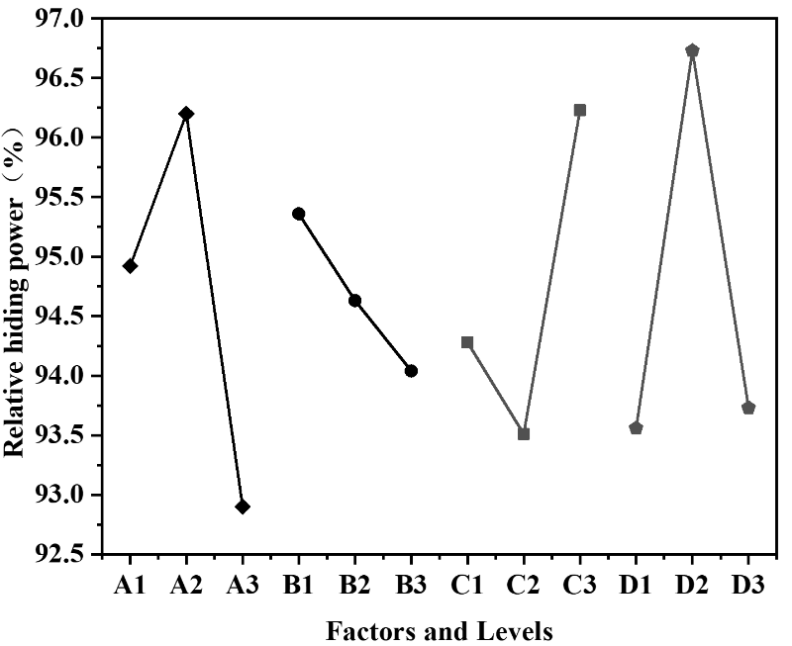
Fig.3-10 Intuitive Diagram of Relative Hiding Power Results
Table 3-10 presents the analysis of variance (ANOVA) table
Source of Variation | Sum of Squares (SS) | Degrees of Freedom (df) | F-value | Significance
Polymerization Temp. (°C) | 16.83 | 2 | 6.41 | *
Stirring Speed (Error) (rpm) | 2.62 | 2 | - | -
pH Value | 11.18 | 2 | 4.25 | *
Polymerization Time (h) | 15.13 | 2 | 5.76 | *
Total | 44.76 | 8 | - | -
Note：* represents P ≥ 0.05、** represents P ≤ 0.05、*** represents P ≤ 0.01

