Supplementary Material
The preparation of cellulose acetate capsules using emulsification techniques: high-shear bulk mixing and microfluidics
Katarzyna Mystek et al.
DOI 10.1515/npprj-2023-0051

Movie showing the ongoing emulsification process, optical microscope image of Emulsion S2, DSC curve of CA, thermal expansion of Capsule S2, optical microscopy image of the actual flow-focusing junction during an ongoing emulsification when both the organic and water phases are stained with the dyes, optical microscope image of the wet PVA-stabilized capsules synthetized via microfluidics with the size distribution profile.

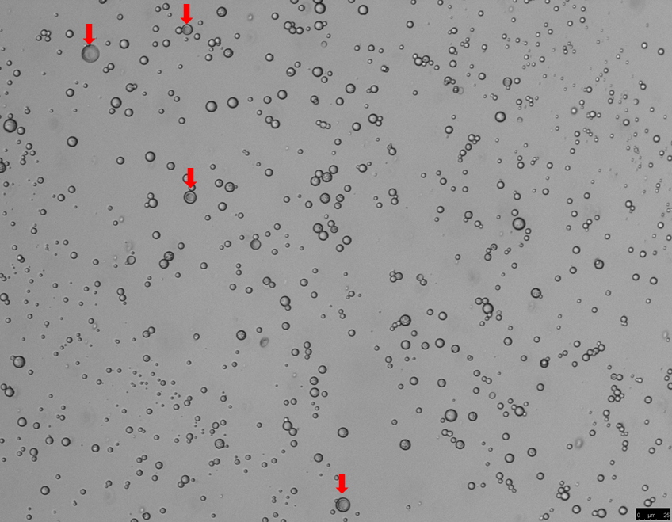
Supplementary Figure S1: Optical microscope image of Emulsion S2. The red arrows mark double emulsion droplets.

Supplementary Figure S2: DSC curve of the cellulose acetate.

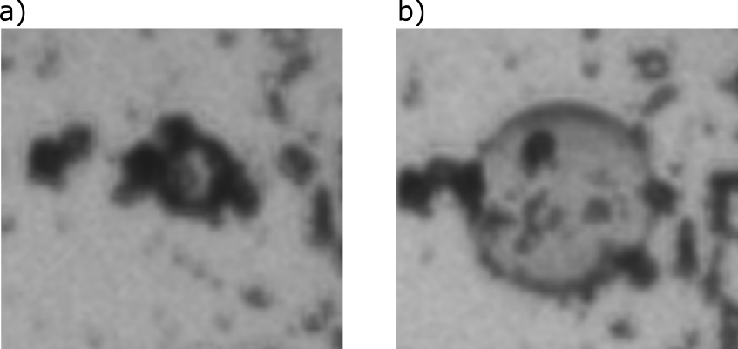
Supplementary Figure S3: Thermal expansion of Capsule S2. Images show a capsule in the (a) native (non-expanded) and (b) expanded state.

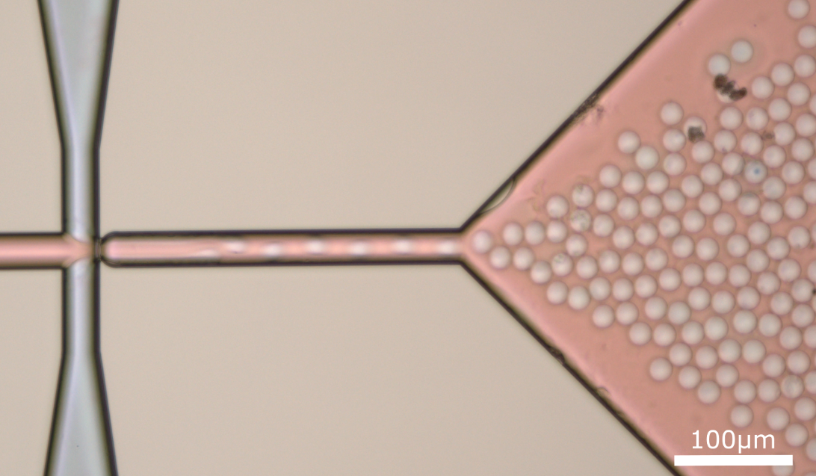
Supplementary Figure S4: Optical microscopy image of the actual flow-focusing junction during the emulsification when both the organic and water phases are stained with oil red and methylene blue, respectively.

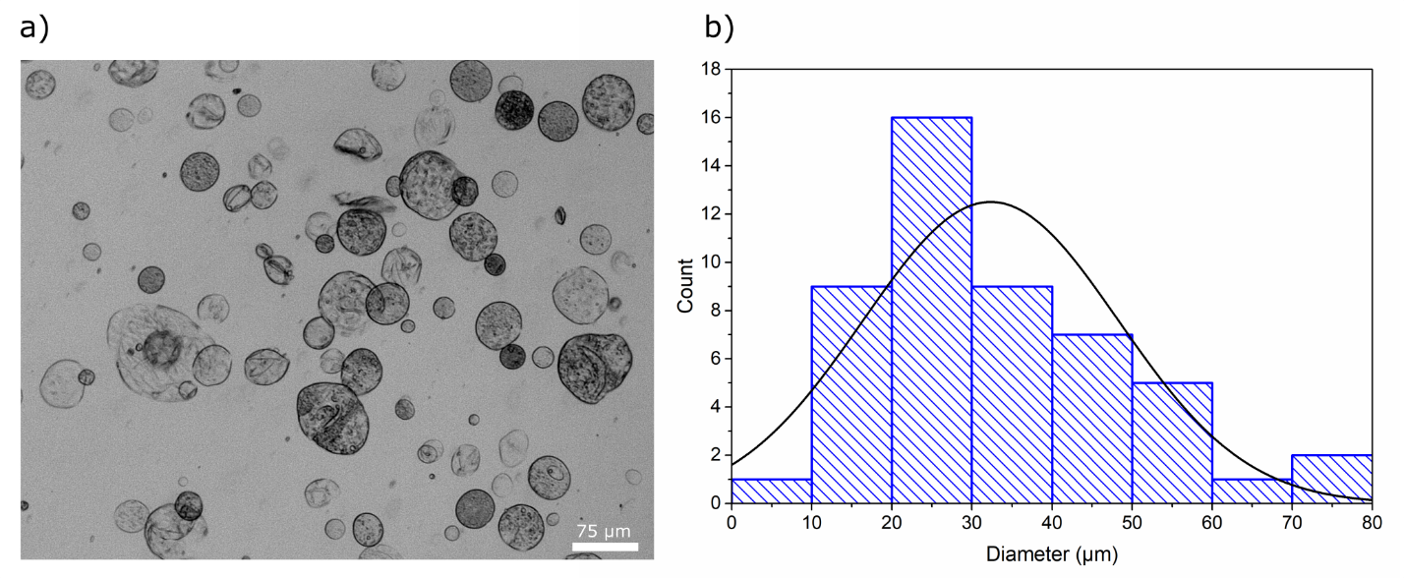
Supplementary FigureS5: (a) Optical microscope image of the wet PVA-stabilized capsules synthetized via microfluidics (b) size distribution profile.

