Supplementary information

# Arrhenius plots

This section contains Arrhenius plots for the elucidation of apparent activation energies as reported in Table 1 in the main text.

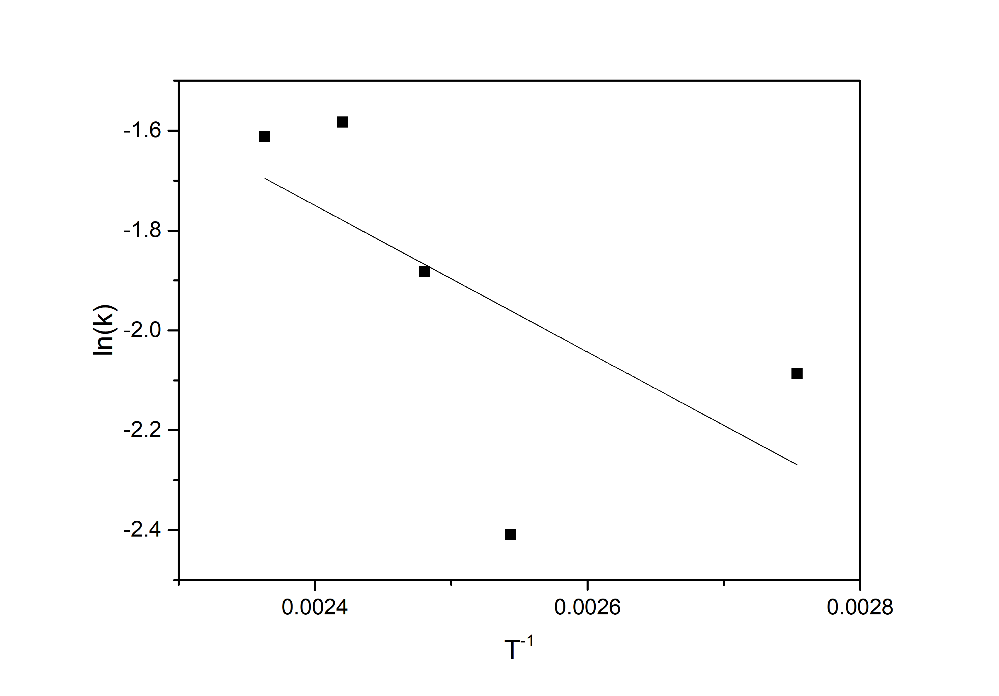

Supplementary Figure 1: Arrhenius analysis of the impregnation of spruce in water.

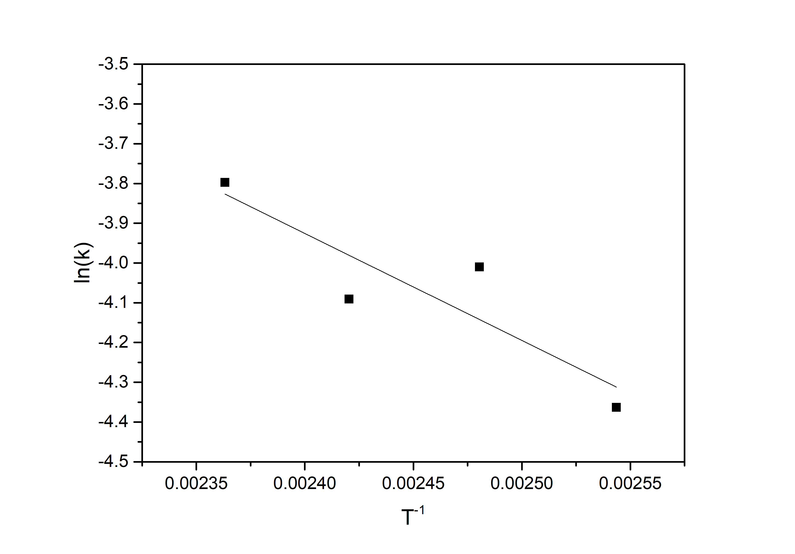

Supplementary Figure 2: Arrhenius analysis of the impregnation of spruce in glycerol.

# Additional NMR data

This section contains supplementary E-HSQC data as well as a supplementary 31P NMR spectrum.

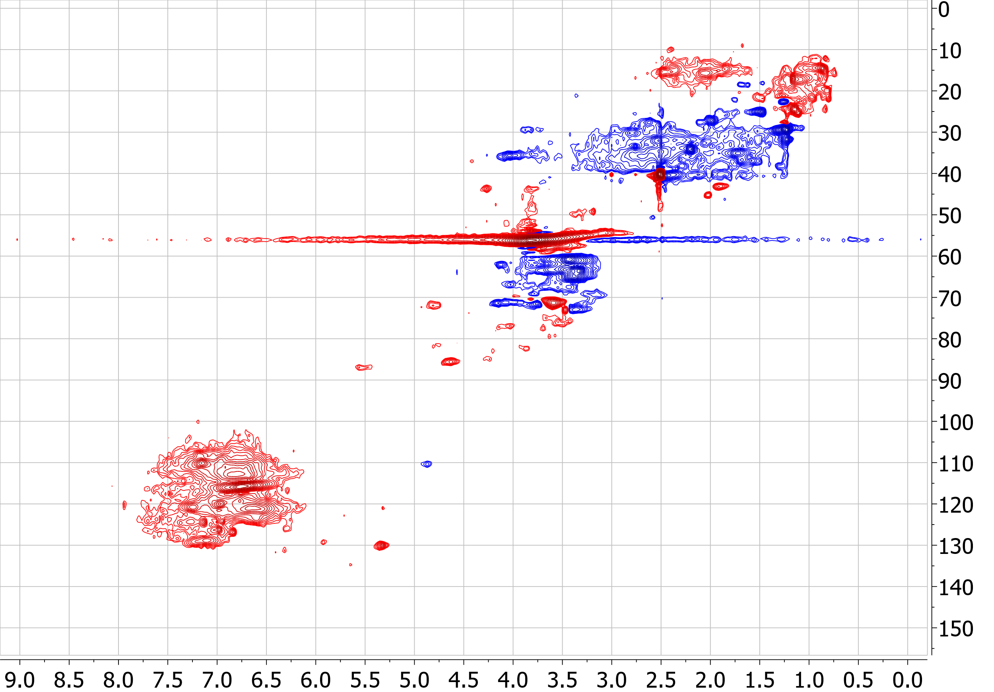

Supplementary Figure 3: E-HSQC spectra of the lignin extracted from the glycerol black liquor, showing CH and CH3 functionalities in red, and CH2 functionalities in blue.

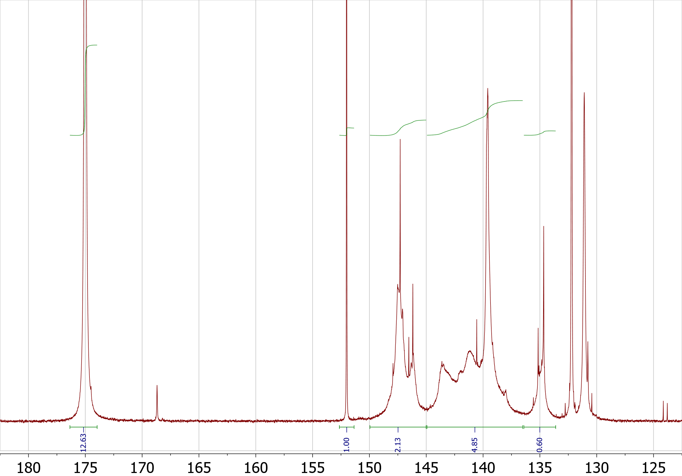

Supplementary Figure 4: Phosphorous 31P NMR spectra of the lignin extracted from the glycerol liquor, showing raw integral data of (from left to right) the excess 2-Chloro-4,4,5,5-tetramethyl-1,3,2-dioxaphospholane phosphorylating reagent, the 1-Allyl-3-methyl-imidazolium chloride internal standard, the aliphatic hydroxyl region, the phenolic hydroxyl region and the carboxylic hydroxyl region.