Supporting Material for
Second-harmonic generation in NbOI₂-integrated silicon nitride
microdisk resonators
Ning Liu^{1,2}, Qiang Liu^{1,2}, Yutian Lin^{1,2}, Zhihong Zhu ^{1,2,*}, and Ken Liu^{1,2,*}
¹College of Advanced Interdisciplinary Studies & Hunan Provincial Key Laboratory of Novel Nano-Optoelectronic Information Materials and Devices, National University of Defense Technology, Changsha 410073, China.
² Nanhu Laser Laboratory, National University of Defense Technology, Changsha 410073, China.
*Corresponding authors: Zhihong Zhu, zzhwcx@163.com, Ken Liu, liukener@163.com

Table of Content
Note S1: Robustness and versatility of phase matching technology by designing geometry
Note S2: Analysis of SHG conversion efficiency
Figure S1: Acquisition of 2D NbOI₂
Figure S2: Optical absorption spectrum of 2D NbOI₂ and corresponding ${\left(αhν\right)}^{1/2}-hν$ plot
Figure S3: Stability of 2D NbOI₂ under ambient conditions
Figure S4: Schematic illustrations of the atomic structure of NbOI₂
Figure S5: Fabrication process flow of the suspended Si₃N₄ microdisks
Figure S6: Wet etching rate of SiO₂
Figure S7: OM image of a typical Si₃N₄ microdisk used in the experiment
Figure S8: OM images of the 2D NbOI₂ and the PVA/NbOI₂/Si₃N₄ microdisk heterostructure
Figure S9: Phase matching analysis of a Si₃N₄ microdisk resonator integrated with 30nm-thick NbOI₂ flake.
Figure S10: Raw transmission spectrum of the Si₃N₄ microdisk integrated with NbOI₂ at 1540-1560 nm.

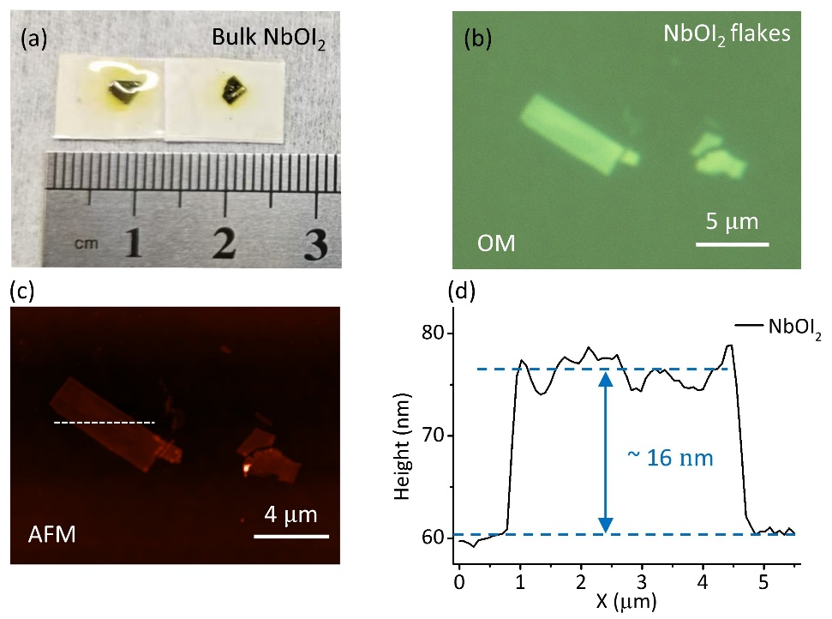
Figure S1. Acquisition of 2D NbOI₂. (a) Optical image of bulk NbOI₂ crystals. (b) Optical microscopy (OM) image of 2D NbOI₂ flakes obtained via mechanical exfoliation. (c) Atomic force microscopy (AFM) image corresponding to the NbOI₂ flakes in (b). (d) Height profile along the white dashed line in (c), indicating a thickness of ~16 nm for the NbOI₂ flake.

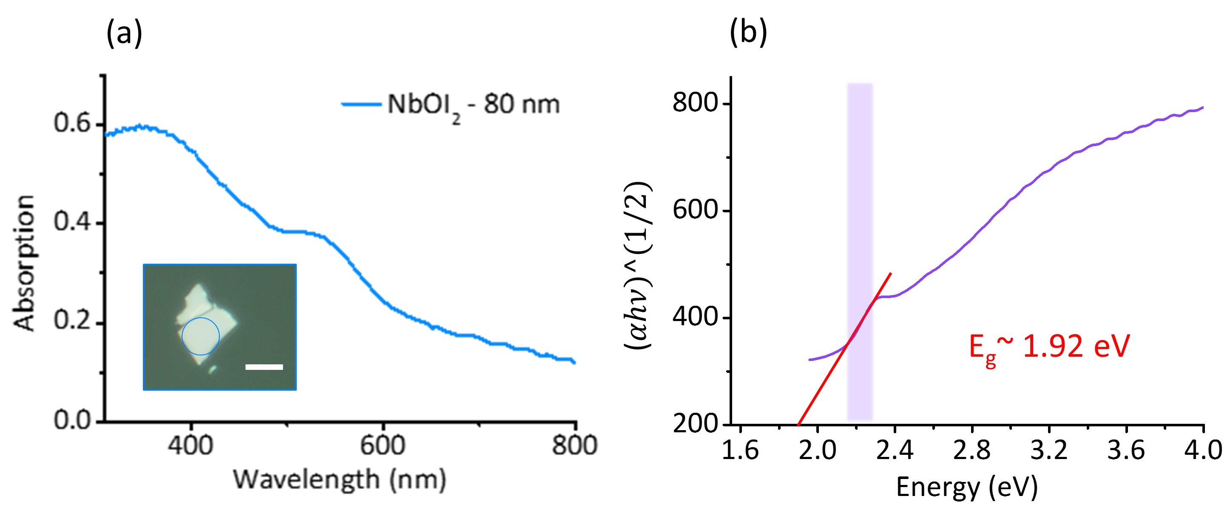
Figure S2. Optical absorption spectrum of 2D NbOI₂ and corresponding ${\left(αhν\right)}^{1/2}-hν$ plot. (a) Optical absorption spectrum of a 80 nm-thick NbOI₂ flake. Inset: OM image of the sample for absorption measurement, with the blue circle marking the tested region. Scale bar: 5 μm. (b) ${\left(αhν\right)}^{1/2}-hν$ plot derived from the absorption spectrum in (a) (purple shaded area denotes the linear fitting region), yielding a bandgap of ~1.92 eV for the 90 nm-thick NbOI₂ flake.

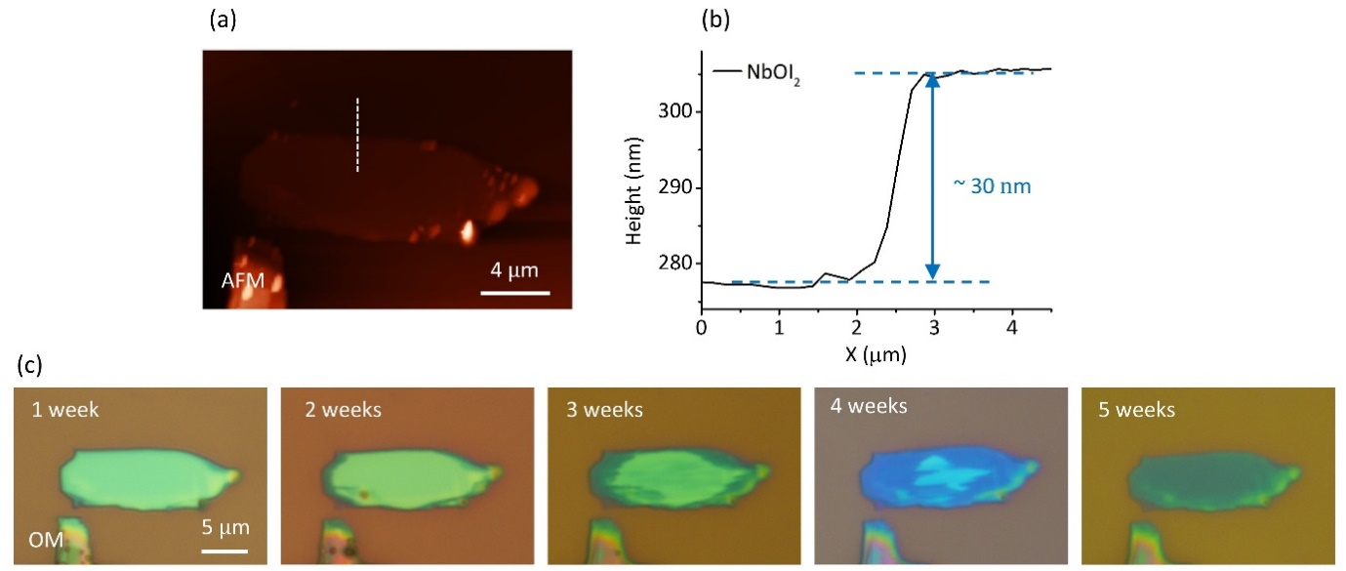
Figure S3. Stability of 2D NbOI₂ under ambient conditions. (a) AFM image of the 2D NbOI₂ in Figure 1c. (b) Height profile along the white dashed line in (a), indicating a thickness of ~30 nm. (c) OM images of time-dependent degradation of the NbOI₂ flake under ambient conditions (~60% relative humidity).

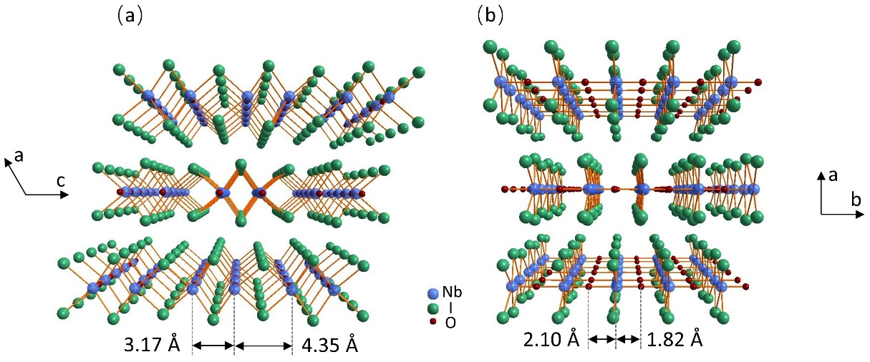
Figure S4. Schematic illustrations of the atomic structure of NbOI₂. (a) Side view of the NbOI₂ structure along the c-axis, showing an alternation in Nb–Nb distances. (b) Side view along the b-axis, highlighting alternating variations in Nb–O bond lengths.

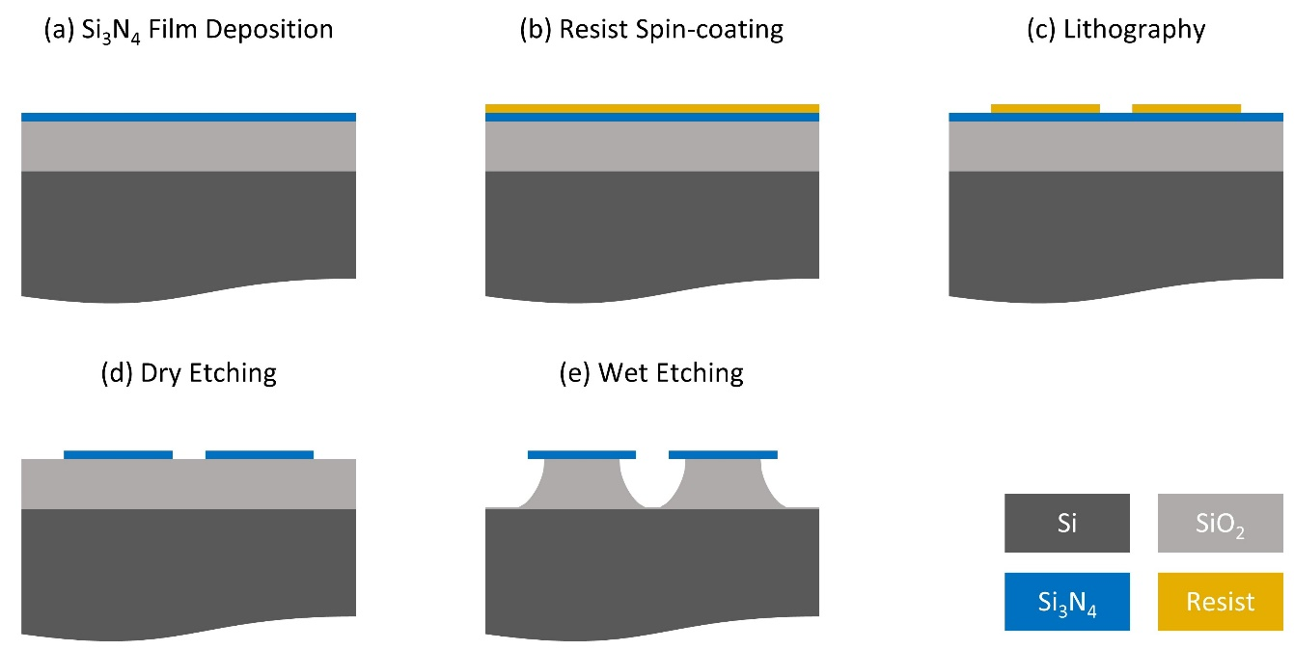
Figure S5. Fabrication process flow of the suspended Si₃N₄ microdisks. (a) Deposition of a Si₃N₄ thin film on a SiO₂/Si substrate. (b) Spin-coating of photoresist. (c) Lithography for microdisk patterning. (d) Dry etching to transfer the pattern to the Si₃N₄ layer. (e) Wet etching of SiO₂ to release the Si₃N₄ microdisks.

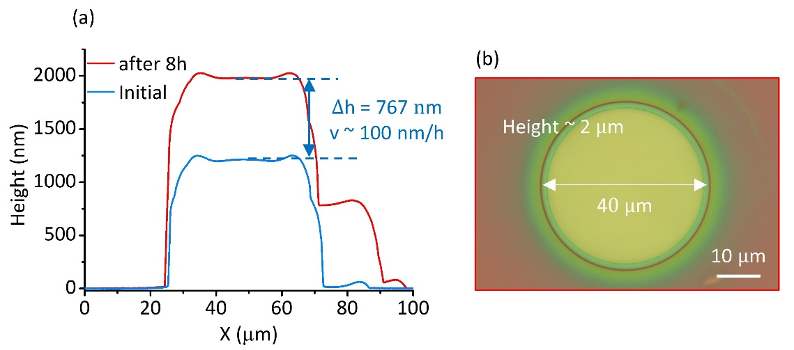
Figure S6. Wet etching rate of SiO₂. (a) Test results of surface-to-substrate height on the Si₃N₄ microdisk before (blue line) and after (red line) 8 hours of wet etching, demonstrating a SiO₂ etching rate of ~100 nm/h. The etching was performed with 1/3 mol/L KOH solution under an 80°C water bath. (b) OM image of the Si₃N₄ microdisk. The height difference between the upper surface of Si₃N₄ microdisk and the substrate is about 2 μm, and the diameter of the microdisk is 40 μm.

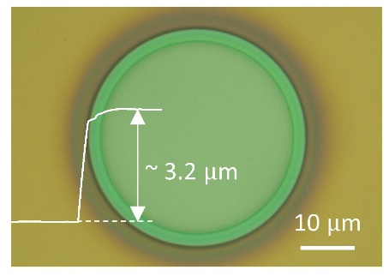
Figure S7. OM image of a typical Si₃N₄ microdisk used in the experiment. Inset: The white line indicates the height difference (~3.2 μm) between the top surface of the SiN microdisk and the substrate.

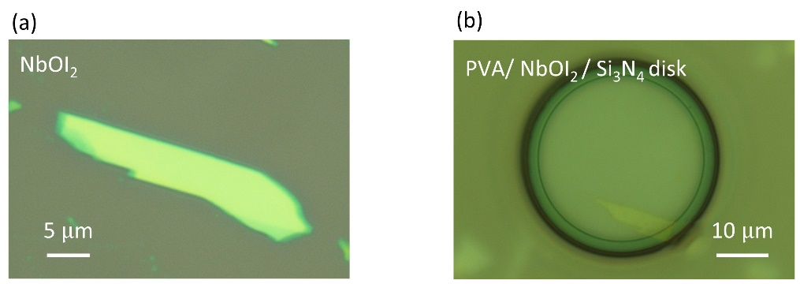
Figure S8. (a) OM image for the 2D NbOI₂ in Figure 2c. (b) OM image of the PVA/NbOI₂/ Si₃N₄ microdisk heterostructure.

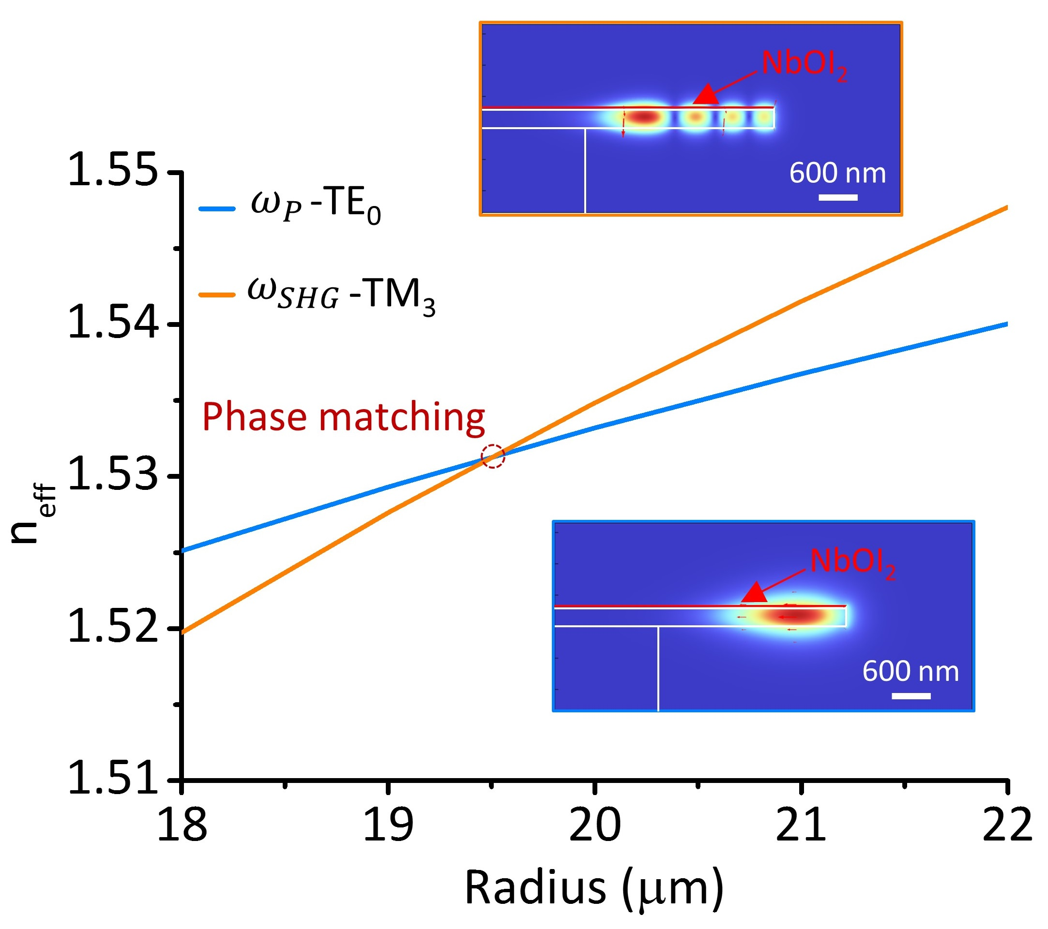
Figure S9. Effective refractive index (n_{eff}) curves of the TE₀ mode at the fundamental frequency ($ω_{P}$-TE₀, blue line) and the TM₃ mode at the second harmonic frequency ($ω_{SHG}$-TM₃, orange line) as functions of the microdisk diameter for a Si₃N₄ microdisk integrated with a 30 nm-thick NbOI₂ flake. The intersection at a radius of ~19.6 μm indicates the phase-matching point. Insets: Electric field distributions of the TE₀ (fundamental frequency) and TM₃ (second-harmonic frequency) modes.

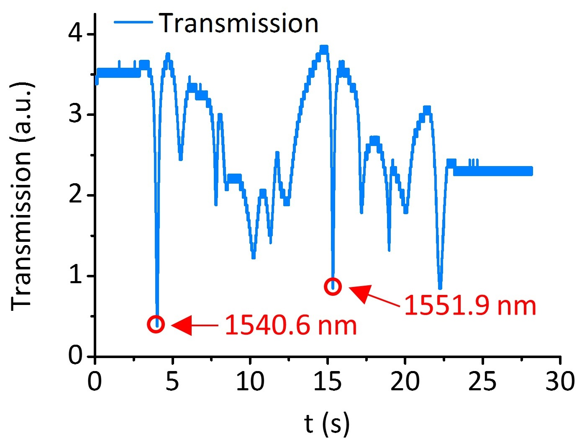
Figure S10. Raw transmission spectrum of the Si₃N₄ microdisk integrated with NbOI₂ at 1540-1560 nm, where the two resonant wavelengths studied in Figure 3 are marked with red circles.

Note S1: Robustness and versatility of phase matching technology by designing geometry
The phase-matching achieved through photonic design is indeed highly versatile and serves as a powerful tool for engineering a wide range of nonlinear processes.
(1) Different nonlinear spectroscopic techniques (e.g., pump-probe, double quantum coherence) require specific phase-matching conditions. In bulk optics, this is controlled by the alignment of the wavevectors of the free-space beams. In our integrated microcavity platform, an analogous, but far more precise, control is achieved by designing the geometry (e.g., radius, waveguide width, and etch depth) to tailor the dispersion of the optical modes. This allows us to target the specific resonance conditions required for a desired nonlinear process: for sum-frequency generation (SFG), the cavity can be designed to support three resonant modes satisfying $ω_{3}=ω_{1}{+ω}_{2}$ and m₃ = m₁+m₂; for difference-frequency generation (DFG), the conditions would be $ω_{3}=ω_{1}{-ω}_{2}$ and m₃ = m₁ - m₂; for pump-probe experiments, the same principle applies. The cavity can be engineered to resonate at both the pump and probe wavelengths, dramatically enhancing the interaction strength for sensitive measurements like cross-phase modulation or two-photon absorption.
Therefore, the photonic design is not limited to SHG; it is a general-purpose methodology for achieving phase-matching in a vast landscape of $χ^{(2)}$and $χ^{(3)}$ nonlinear optics.
(2) Robustness and Post-Fabrication Tuning. Once fabricated, the phase-matching condition is inherently stable and locked into the device geometry, immune to mechanical vibrations or misalignment, which is a significant advantage over free-space setups. While the fundamental phase-matching is set by geometry, several post-fabrication tuning techniques are well-established to compensate for manufacturing tolerances or to actively switch between processes, such as “thermal tuning”, “carrier-effect tuning”, “strain tuning” and so on. These methods allow for fine-tuning the phase-matching condition with high precision, making the platform both robust and adaptable.

Note S2: Analysis of SHG conversion efficiency
We have employed nonlinear coupled-mode theory to estimate the maximum achievable SHG efficiency in the NbOI₂-integrated Si₃N₄ microdisk system.
The SHG process in a microdisk resonator involves two optical modes: mode a at the fundamental frequency (with angular frequency ω) and mode b at the second-harmonic frequency (with angular frequency ω_{b} ≈ 2ω_{a}). When the angular frequency of the pump light ω_{p} approaches ω_{a}, the microdisk system can be described by the following Hamiltonian [S1]:
 | $H=ω_{a}a^{*}a+ω_{b}b^{*}b+g\left[{\left(a^{*}\right)}^{2}b+a^{2}b^{*}\right]+ε_{p}\left(ae^{iω_{p}t}+a^{*}e^{-iω_{p}t}\right.)$, | (1)
Where, a and b represent the Bosonic operators for the fundamental mode and second-harmonic mode, respectively; $ε_{p}=\sqrt{\frac{2κ_{a,1}P_{p}}{ℏω_{p}}}$ represents the pump field strength, $P_{p}$ is the pump power, $κ_{a,1}$ is the external coupling rate between mode a and the coupling waveguide, $g$ is the nonlinear coupling strength between mode a and mode b:
 | $ℏg=ε_{0}\iiint{dθ} dr dz \frac{3χ^{\left(2\right)}\left(r\right)}{4\sqrt{2}}{\left[u_{a,z}^{*}\left(r\right)\right]}^{2}u_{b,z}\left(r\right)$, | (2)
where $ε_{0}$ is the vacuum permittivity, $χ^{\left(2\right)}\left(r\right)$ denotes the second-order susceptibility of the medium, $u_{a\left(b\right),z}\left(r\right)$ represents the electric field profiles of mode a(b) within the microdisk resonator, expressed in polar coordinates.
Next, we introduce the effective mode overlap factor:
 | $ζ=\frac{\iint{dr} dz {\left[u_{a,z}^{*}\left(r,z\right)\right]}^{2}u_{b,z}\left(r,z\right)}{\iint{dr} dz {\left|u_{a,z}\left(r,z\right)\right|}^{2}\sqrt{\iint{dr} dz {\left|u_{b,z}\left(r,z\right)\right|}^{2}}}$. | (3)

So
 | $g≈ζ\sqrt{\frac{ℏω_{a}^{2}ω_{b}}{ε_{0}2πR}⋅\frac{1}{ε_{a}\sqrt{ε_{b}}}⋅\frac{3χ^{\left(2\right)}}{4\sqrt{2}}}×δ\left(m_{b}-2m_{a}\right)$, | (4)
where $ε_{a(b)}$ represents the relative permittivity of mode a(b), which depends on the angular frequency and spatial position; m_{a}(m_{b}) denotes the angular momentum of mode a(b). For the Kronecker delta function δ(m_{b} - 2m_{a}), the coupling strength $g$ assumes a non-zero value only when momentum conservation condition m_{b} - 2m_{a} = 0 is satisfied.
Under CW pumping conditions, using the non-depletion approximation, the SHG conversion efficiency can be expressed in the following form:
 | $$η=\frac{P_{\text{SHG}}}{P_{p}^{2}}=g^{2}\frac{2κ_{b,1}}{δ_{b}^{2}+κ_{b}^{2}}{\left(\frac{2κ_{a,1}}{δ_{a}^{2}+κ_{a}^{2}}\right)}^{2}\frac{ℏω_{b}}{{\left(ℏω_{p}\right)}^{2}}.$$ | (5)
where δ_{a} = ω_{a} - ω_{p} (δ_{b} = ω_{b} - 2ω_{p}) represents the angular frequency detuning of mode a(b) relative to the pump; κ_{a} = κ_{a,1} + κ_{a,0} (κ_{b} = κ_{b,1} + κ_{b,0}) denotes the total loss rate of cavity mode a(b), specifically including the external loss rate κ_{a(b),1} and the intrinsic loss rate κ_{a(b),0}. When the pump frequency is tuned to match the frequency of cavity mode a, δ_{a} = ω_{a} - ω_{p} = 0; when the energy conservation condition is satisfied in the SHG process, i.e., ω_{b} ≈ 2ω_{a}, δ_{b} = ω_{b} - 2ω_{p} = 0 is automatically satisfied, indicating that the double-resonance condition is met in the second-harmonic conversion process.
At this point,$η$ can be further simplified to:
 | $η=\frac{16g^{2}}{{\left(\frac{κ_{b,0}}{\sqrt{κ_{b,1}}}+\sqrt{κ_{b,1}}\right)}^{2}{\left(\frac{κ_{a,0}}{\sqrt{κ_{a,1}}}+\sqrt{κ_{a,1}}\right)}^{4}}⋅\frac{1}{ℏω_{p}}$. | (6)
Furthermore, when both modes satisfy the critical coupling condition, i.e., κ_{a,1} = κ_{a,0}，κ_{b,1} = κ_{b,0}, the maximum SHG conversion efficiency can be expressed as:
 | $η_{max}=\frac{g^{2}}{4κ_{b,0}κ_{a,0}^{2}}⋅\frac{1}{ℏω_{p}}=\frac{g^{2}Q_{a,0}^{2}Q_{b,0}}{ℏω_{a}^{4}}$. | (7)
where $Q_{a,0}=\frac{ω_{a}}{2κ_{a,0}}$，$Q_{b,0}=\frac{ω_{b}}{2κ_{b,0}}$ represent the intrinsic Q factors of modes a and b.
Under the phase matching analysis of the microdisk shown in Figure 2(f), energy and momentum conservation are satisfied. Assuming the nonlinear coupling strength $g$ remains constant, subsequent experimental optimizations can increase the intrinsic quality factor of the microcavity by two orders of magnitude (the intrinsic Q of the bare Si₃N₄ microcavity rises from ~10⁴ to ~10⁶, with corresponding estimated $Q_{a,0}$ and $Q_{b,0}$ also improving by two orders of magnitude). Under critical coupling conditions, the SHG conversion efficiency can be improved to 24,000 %/W. This value exceeds the highest reported in comparable works (as listed in Table 1) by two orders of magnitude, demonstrating the significant application potential of our proposed NbOI₂-integrated Si₃N₄ microdisk resonator in the field of integrated second-order nonlinear optics.

Reference
[S1] X. Guo, C.-L. Zou, and H. X. Tang, "Second-harmonic generation in aluminum nitride microrings with 2500%/W conversion efficiency," Optica, vol. 3, no. 10, pp. 1126-1131, 2016.

