Supporting Information for Oxygen Vacancy-Driven Bandgap Tuning and Ultrafast Laser Performance in Bi₂O₂Se
Qingling Tang, Zhongben Pan*, Zeshang Ji, Hongwei Chu, Han Pan, Dechun Li*
School of Information Science and Engineering and Key Laboratory of Laser and Infrared System of Ministry of Education, Shandong University, Qingdao 266237, PR China
* To whom correspondence may be addressed. cEmail: zhongbenpan@sdu.edu.cn; dechun@sdu.edu.cn.

Table of contents
Figure S1. Two types of crystal cell diagrams (a) Bi₂O₂Se, (b) Bi₂O_{1.5}Se. 3
Figure S2. Schematic diagram of annealing device. 3
Figure S3. Schematic of I-scan/Z-scan. 4

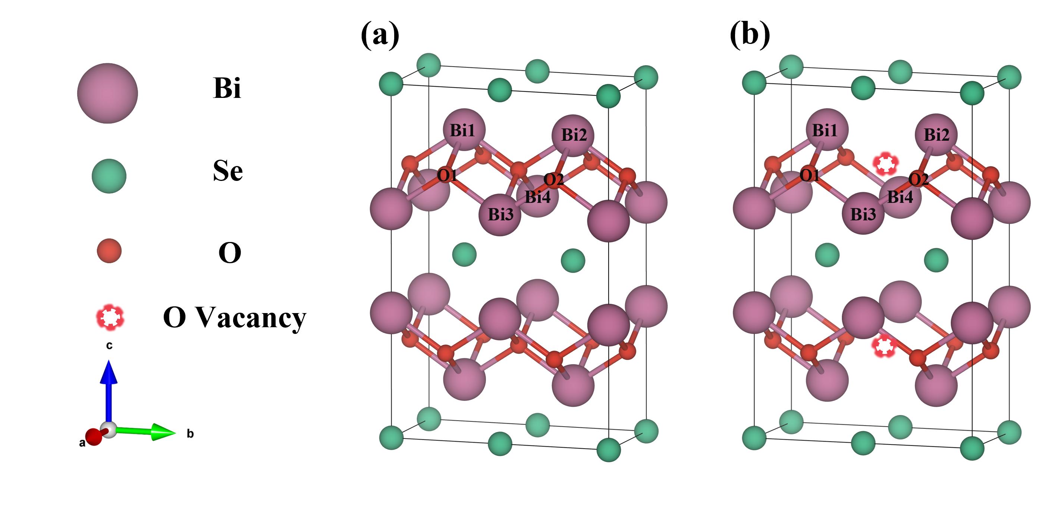

Figure S1. Two types of crystal cell diagrams (a) Bi₂O₂Se, (b) Bi₂O_{1.5}Se.

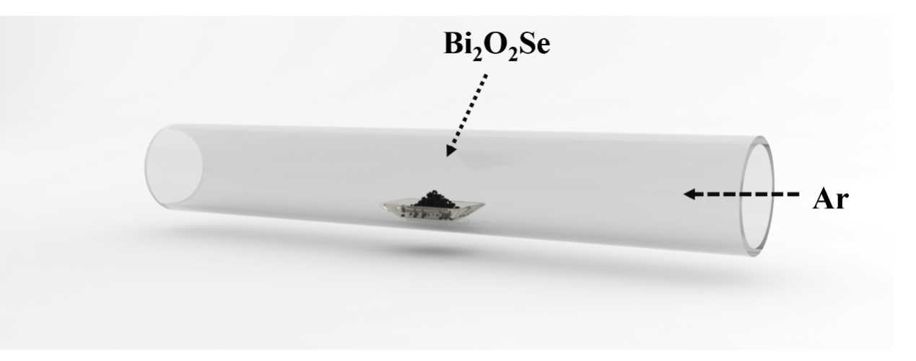

Figure S2. Schematic diagram of annealing device.

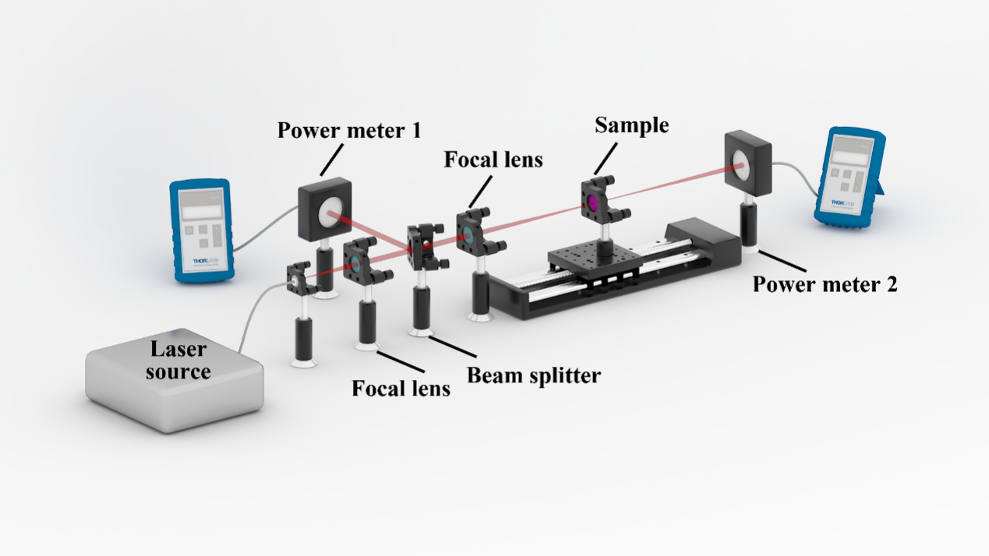

Figure S3. Schematic of I-scan/Z-scan.

