Supplementary Material

Table of Contents Section
Section S1. The performance of cylindrical meta-atoms under various incident angles.
Section S2. The specific receiving angle range for the 3D imaging experiment.

Section S1. The performance of cylindrical meta-atoms under various incident angles.

It is notable that, in the case of a large FOV, the complex transmission coefficients of the meta-atoms at different incidence angles must be taken into account. To verify the incident-angle-insensitivity of the cylindrical meta-atoms, additional numerical simulations were performed, and the results are presented in Fig. S1. Fig. S1a demonstrates the optical power transmission of the meta-atoms at various incident angles. Fig. S1b illustrates the phase delay values of the meta-atoms relative to the first meta-atom (D = 160 nm) at different incident angles. Fig. S1c shows the deviation in the phase of the meta-atoms under oblique incidence compared to normal incidence. The results indicate minimal phase and transmission variations within the ±30° FOV. By optimizing the aspect ratio of the cylindrical meta-atoms, the insensitivity to the incident angle can be further improved, as illustrated by the previous works [S1, S2].

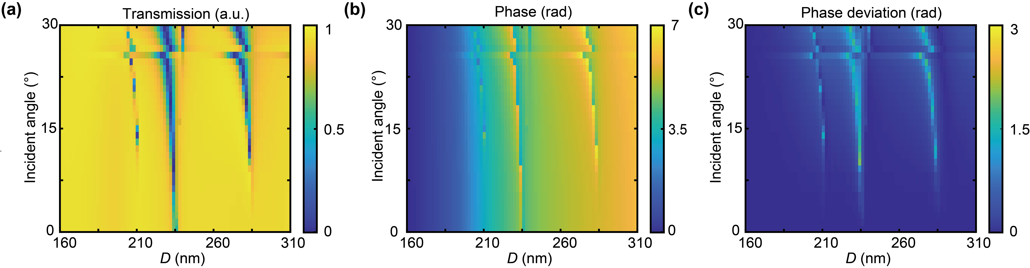
Fig. S1 | The performance of cylindrical meta-atoms under various incident angles. (a) Angle-dependent optical power transmission and (b) phase delay values of the cylindrical meta-atoms with H = 600 nm and varying D values ranging from 160 to 310 nm. (c) The deviation in the phase of the meta-atoms under oblique incidence compared to normal incidence.

Section S2. The specific receiving angle range for the 3D imaging experiment.

Due to the limitation of the scanning range in the transmitting system, the 3D imaging results display only a portion of the receiving FOV. Fig. 6b shows the receiving capability of the metasurface-based receiver within a FOV less than 7.5°. Fig. S2 illustrates the geometrical schematic of the receiving angle range in Fig. 6c and 6d. According to Eq. (6), the maximum receiving angle β₁ and the minimum receiving angle β₂ can be expressed as:
which l₁ denotes the scanning range length including the target and background, l₂ represents the distance between the MEMS-SM and the APD, and d is the distance between the target and metasurface. Based on the values of l₁, l₂ and d presented in Section 3.2, the maximum receiving angle β₁ and the minimum receiving angle β₂ is calculated to be approximately 30° and 23°. Fig. 6c and 6d show the receiving capability of the metasurface-based receiver and the fiber-optic-taper-based receiver within a FOV of 23°~30°. The comparison between the results in Fig. 6c and 6d demonstrates the superior performance of the metasurface-based receiver in a large FOV.

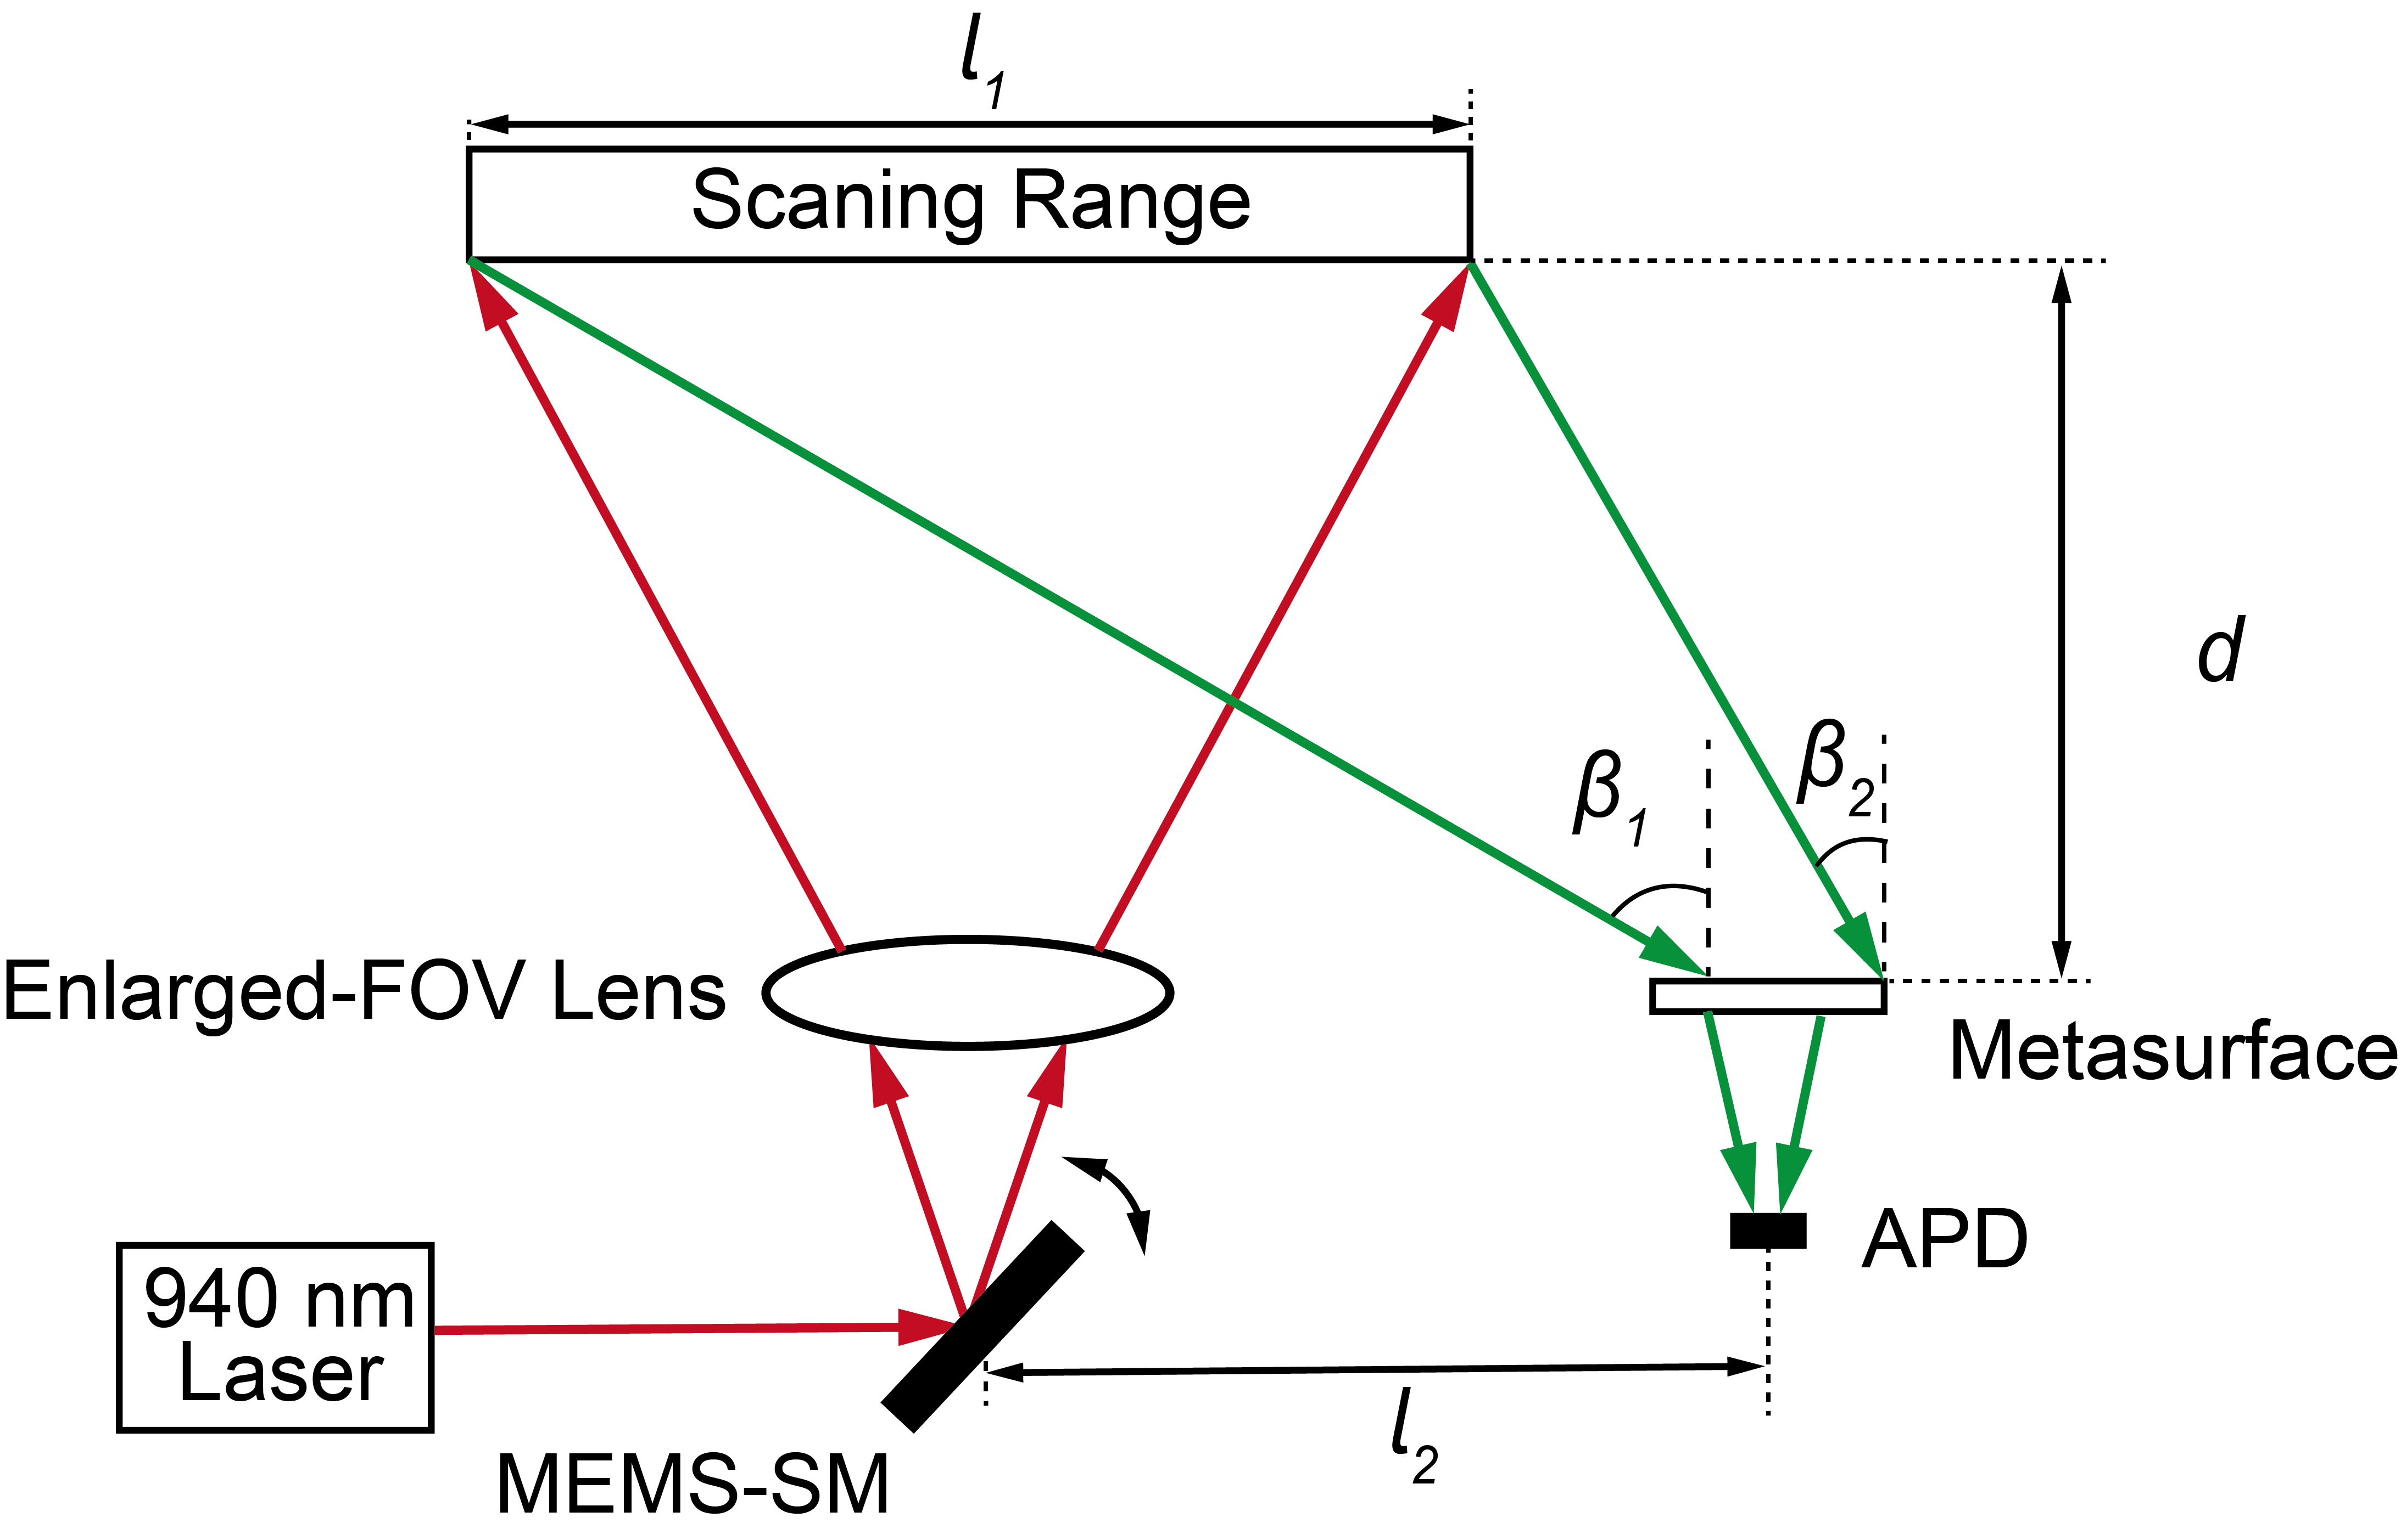
Fig. S2 | Geometric illustration of the receiving angle range in Fig. 6c and 6d.

References:
[S1] W. Liu et al., "Metasurface Enabled Wide-Angle Fourier Lens," Adv. Mater., vol. 30, no. 23, p. 1706368, 2018.
[S2] H. Zheng et al., "Compound Metalens Enabling Distortion-Free Imaging," Engineering, vol. 45, pp. 52-58, 2025.

