Supplementary Materials
Harnessing in-plane optical anisotropy in WS₂ through ReS₂ crystal

Soyeong Kwon¹, Tae Keun Yun², Peiwen J. Ma¹, and SungWoo Nam^{1,3*}

¹Department of Mechanical and Aerospace Engineering, University of California, Irvine, Irvine, CA 92697, USA
²Department of Physics, Yonsei University, Seoul, 03722, South Korea
³Department of Materials Science and Engineering, University of California, Irvine, Irvine, CA 92697, USA

*Corresponding Author Email: sungwoo.nam@uci.edu
Keywords: Transition metal dichalcogenides, Anisotropy, Photoluminescence, Charge transfer

Supplementary Information 1. (a) Raman spectra of WS₂ (blue), ReS₂ (black), and WS₂/ReS₂ (red) at excitation angle of 0° and (b) 90°.

Supplementary Information 2. (a) Atomic force microscopy topography scan image and height profiles along (b) line 1 and (c) line 2.

Supplementary Information 3. (a) PL spectrum of WS₂ (blue), ReS₂ (black), and WS₂/ReS₂ (red) at excitation angle of 90°, with an inset showing magnified spectrum in the range of ReS₂ emission. Excitation angle-dependent PL spectra of (d) ReS₂ in the range of ReS₂ emission.

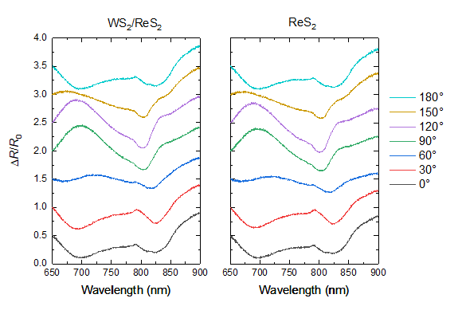
Supplementary Information 4. Excitation angle-dependent differential reflectance spectra of WS₂/ReS₂, ReS₂ in the range of ReS₂ absorption.

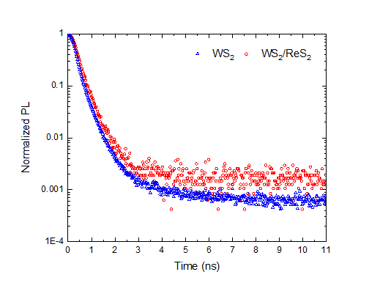
Supplementary Information 5. Time-resolved PL decay characteristics in WS₂ (blue) and WS₂/ReS₂ (red) at an excitation angle of 90°.

Supplementary Information 6. Excitation angle (0° and 90°)-dependent PL spectra of WS₂/ReS₂ in the WS₂ emission range at laser powers of (a) 2 μW and (b) 4 μW.

Supplementary Information 7. Excitation angle-dependent PL spectra of WS₂/ReS₂ in the WS₂ emission range at laser powers of (a) 2 μW and (b) 47 μW.

Supplementary Information 8. Ratio of the integrated WS₂ emission PL area, fitted with a Voigt function for each exciton (620 nm) and trion (630 nm) in WS₂/ReS₂ heterostructure at laser powers of (a) 4 μW, (b) 15 μW, and (c) 47 μW.

