Supporting Information
Optimization of NC-LSPR Coupled MoS₂ Phototransistors for High-Performance Broad-Spectrum Detection
Weichao Jiang, Yuheng Deng, Rui Su, Jingping Xu, and Lu Liu*

Figure S1. COMSOL simulation results of the AuNPs/3 nm Al₂O₃/MoS₂ structure (a) with and (b) without Au electrode coverage.
Figure S2. The AFM images of AuNPs/Al₂O₃/MoS₂ structure under different T_{AlO}.
Figure S3. The photogenerated current (I_{ph}) of T_{AlO} = 3 nm device at different polarization angles.
Table S1. The specific data for detectivity and wavelength from the references in Figure 5d.

To align the model with the experimental geometry, we reconstructed the model in COMSOL, adding a 100 nm-thick Au electrode on the top of the MoS₂, as shown in Figure S1, Figures S1a and S1b correspond to the COMSOL simulation results for the AuNPs/3 nm Al₂O₃/MoS₂ structure with and without Au electrode coverage in the source-drain region and the channel region, respectively. A significant electric field enhancement is observed beneath the Au electrode in Figure S1a, which can be attributed to the enhanced LSPR effect in the NPOM system¹. However, possibly due to the light shielding effect of the Au electrode and the vertical incident direction of the light with its polarization vector parallel to the Au film, the primary light absorption occurs from the horizontal mode of NPOM rather than the vertical dipole-dipole mode². Consequently, the electric field enhancement from the LSPR effect in the uncovered channel region is approximately 50 times greater than that in the source/drain region.

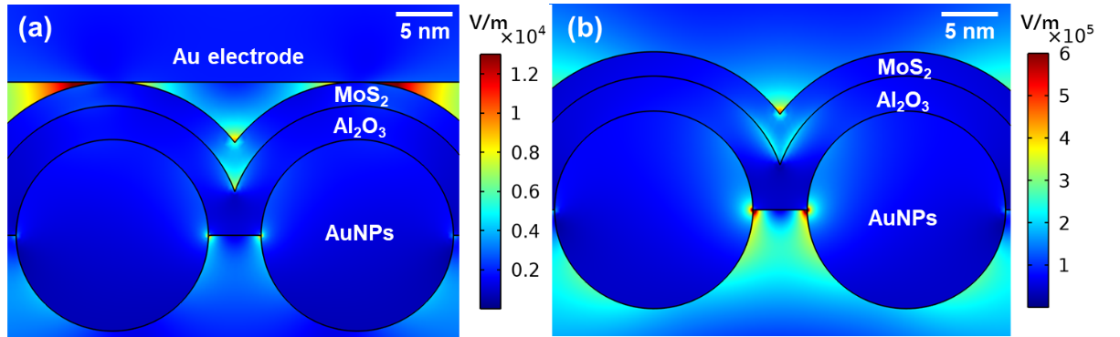
Figure S1. COMSOL simulation results of the AuNPs/3 nm Al₂O₃/MoS₂ structure (a) with and (b) without Au electrode coverage.

The atomic force microscope (AFM) images of AuNPs/Al₂O₃/MoS₂ structure with different T_{AlO}`s have been given in Figure S2. It can be observed that the uneven surface of MoS₂ gradually becomes smoother as T_{AlO} increases, which is consistent with the Raman and PL analysis in the text, i.e., with the increase of T_{AlO}, the tensile strain on MoS₂ is weakened.

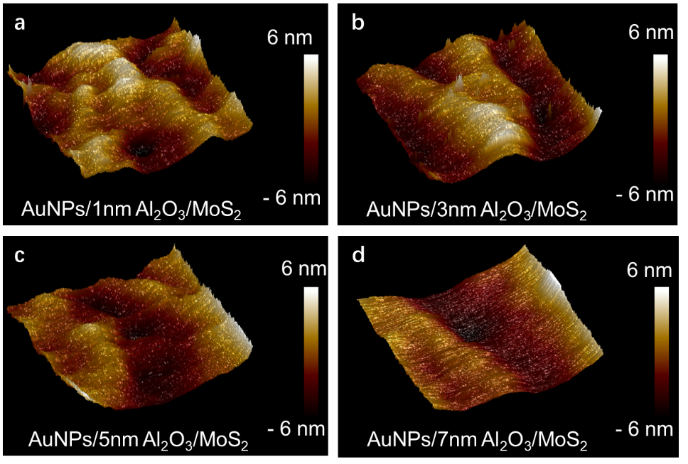
Figure S2. The AFM images of AuNPs/Al₂O₃/MoS₂ structure with different T_{AlO}`s of a) 1 nm, b) 3 nm, c) 5 nm and d) 7 nm, respectively.

The photogenerated current (I_{ph}) of T_{AlO} = 3 nm device at different polarization angles (θ) have been plotted in Figure S3. The photocurrent of the device presents an obvious polarization dependence of the incident light, and the photocurrent has a maximum value at polarization angles of 90° and 270°, and a minimum value at 0° and 180°, which is consistent with previously reported work^{3,4}.

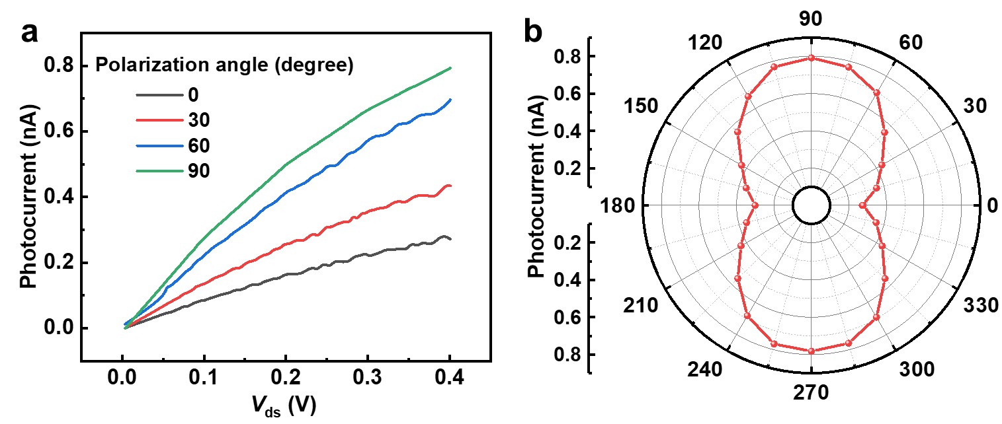
Figure S3. a) The I_{ph}-V_{d} curves and b) the I_{ph}–θ polar plot for the device with T_{AlO} = 3 nm.

Table S1. The specific data for detectivity and wavelength from the references in Figure 5d.
References | Optimization strategy | Detectivity (Jones) | Wavelength  (nm)
This work | NC-LSPR coupled effect | 3.823×10¹⁴ | 528
This work | NC-LSPR coupled effect | 1.097×10¹⁴ | 740
Ref. 40 | Pristine phototransistors | 1.5×10¹⁰ | 532
Ref. 41 | Pristine phototransistors | ~6×10⁸ | 532
Ref. 42 | Pristine phototransistors | 2×10¹⁰ | 633
Ref. 43 | Pristine phototransistors | 7.7×10¹¹ | 635
Ref. 13 | LSPR enhancement | 9.89×10⁹ | 532
Ref. 14 | LSPR enhancement | 4×10¹¹ | 740
Ref. 37 | LSPR enhancement | 3.5×10¹¹ | 520
Ref. 38 | LSPR enhancement | 6×10¹⁰ | 420
Ref. 39 | LSPR enhancement | 5.5×10⁹ | 532
Ref. 19 | NC enhancement | 1.33×10¹⁴ | 528
Ref. 17 | NC enhancement | 4.47×10¹⁴ | 637
Ref. 10 | Charge transfer assistance | 1.29×10¹² | 520
Ref. 11 | Charge transfer assistance | 9×10¹¹ | 650
Ref. 12 | Charge transfer assistance | 2.0×10⁷ | 681

References:
- W. Chen, S. Zhang, M. Kang, W. Liu, Z. Ou, Y. Li, Y. Zhang, Z. Guan and H. Xu, “Probing the limits of plasmonic enhancement using a two-dimensional atomic crystal probe,” Light Sci. Appl., vol. 7, no. 1, p. 56, 2018.
- S. Mubeen, S. Zhang, N. Kim, S. Lee, S. Kramer, H. Xu and M. Moskovits, “Plasmonic Properties of Gold Nanoparticles Separated from a Gold Mirror by an Ultrathin Oxide,” Nano Lett. vol. 12, no. 4, p. 2088, 2021.
- S. Chen, R. Cao, X. Chen, Q. Wu, Y. Zeng, S. Gao, Z. Guo, J. Zhao, M. Zhang and H. Zhang, “Anisotropic Plasmonic Nanostructure Induced Polarization Photoresponse for MoS₂-Based Photodetector,” Adv. Mater. Interfaces, vol. 7, no. 9, p. 1902179, 2020.
- Y. Tan, R. He, C. Cheng, D. Wang, Y. Chen and F. Chen, “Polarization-dependent optical absorption of MoS₂ for refractive index sensing,” Sci. Rep., vol. 4, no. 1, p. 7523, 2014.

