Supporting Information

Artificial Optoelectronic Synapse Based on CdSe Nanobelt Photosensitized MoS₂ Transistor with Long Retention Time for Neuromorphic Application

Xiaohui Song,¹ Xiaojing Lv,¹ Mengjie He,¹ Xuan Qin,¹ Fei Mao,¹ Jie Bai,¹ Yanjie Hu,¹ Zinan Ma,¹ Zhen Liu,¹ Xueping Li,² Chenhai Shen,¹ Yurong Jiang,¹ Xu Zhao,¹ Congxin Xia^{1,∗}
¹Henan Key Laboratory of Photovoltaic Materials, Department of Physics, Henan Normal University, Xinxiang 453007, China
²Department of Electronic and Electrical Engineering, Henan Normal University, Xinxiang 453007, China

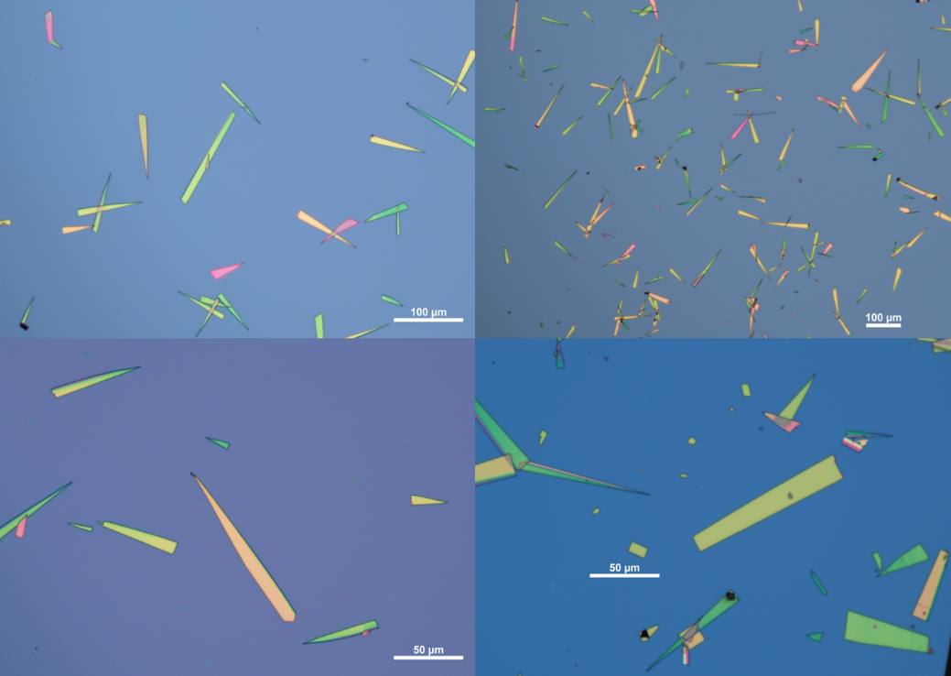
Figure S1. Optical microscopic image of the PVD synthesized CdSe nanobelts after contact printing.

Figure S2. The electrical characterizations of the pristine MoS₂ FET. (a) Typical dual-sweeping transfer curve of device. (b) The time-resolved retention performance of the drain-source current after applying gate voltage (Vg) pulse of -100 V and 100V with 10 ms duration in the dark, with V_{writing} of -100 V and 100 V separately.

Note 1. The density functional theory (DFT) calculation is carried out by the Vienna ab initio simulation package (VASP) with the projector-augmented wave (PAW) method to optimize the models and calculate their electronic properties. The generalized gradient approximation of Perdew–Burke–Ernzerhof (PBE) parametrization is used to describe the exchange-correlation potentials. The energy cutoff is set for 500eV. The force and energy convergence standards are 0.01 eV Å−1and 10⁻⁵ eV, respectively. The 13×13×1 k-points are sampled with the Monkhorst-Pack method for optimization and electronic structures. The DFT-D2 method is used to describe long-range van der walls (vdW) interactions and the dipole correction is applied in all calculations. Besides, the vacuum space greater than 20 Å along the z direction is set up for all models.
Here, the CdSe (110) supercell and MoS₂ supercell are combined to construct the CdSe/MoS₂ heterostructure model (Figure S8) with a lattice mismatch of about 1.17%, and the optimized lattice parameters is a=11.524 Å, b=8.48 Å. The optimized lattice parameters a= b = c =6.108 Å for CdSe and a=b=3.19 Å for MoS₂.

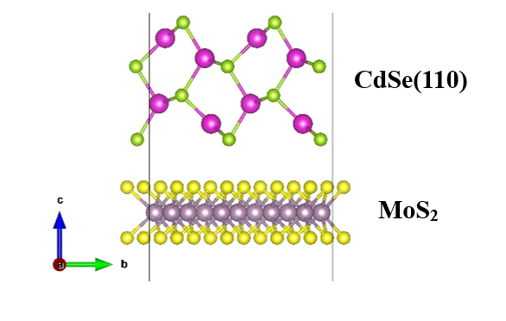
Figure S3. Optimized geometric structures of CdSe/MoS₂ heterostructure.

Figure S4. The calculated band structure (a) and the band alignment (b) of CdSe/MoS₂ heterojunction.

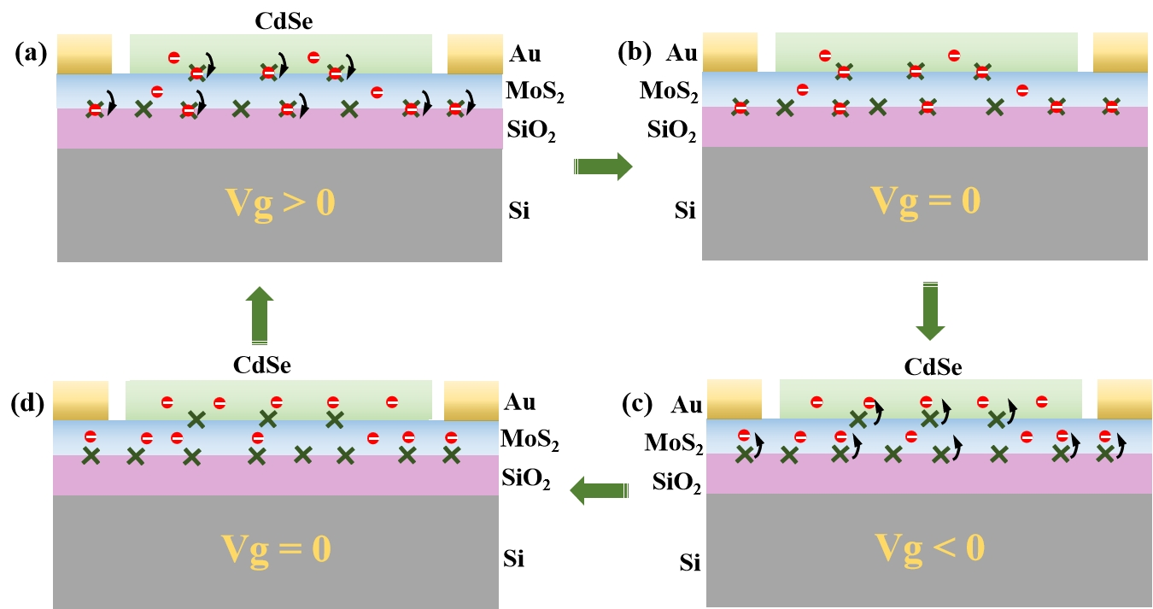
Figure S5. Schematic of interface traps that capture and release electrons. (a) When a positive gate pulse is applied, the electrons are captured by the interface traps between MoS₂ and SiO₂ substrate. (b) When the positive gate pulse is removed, the channel is driven to a low conductance state due to the trapped electrons acted as a local gate. (c) A negative gate pulse releases electrons trapped at the SiO₂/MoS₂ interface into the MoS₂ channel. (d) At the end of negative gate pulse, a high conductance channel was achieved.

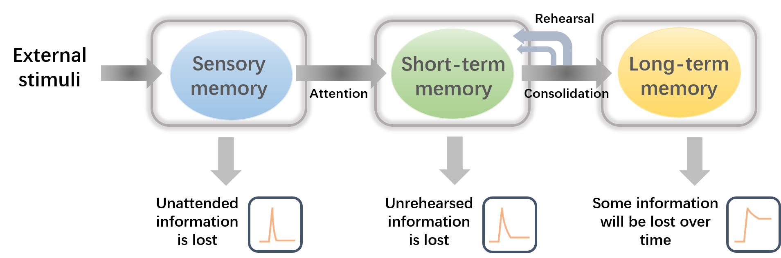
Figure S6. Schematic diagram of the memory consolidation process in the human brain.
Figure S7. (a) Performance of potentiation-depression with consecutive 4 sets of different electrical pulse numbers. (b) Different amplitudes of 6 negative V_{gs} are applied continuously in order to induce pulse potentiation, next to, different amplitudes of 6 positive V_{gs} are applied continuously for inducing pulse depression.
Figure S8. (a) The synaptic potentiation and depression under the modulation of 10/20/30/50 consecutive negative (-50 V, 10 ms duration) and then 10/20/30/50 consecutive positive (50 V, 10 ms duration) gate pulses. (b) The synaptic potentiation and depression triggered by six successively decreasing negative V_{g} pulses (from -10 to -100 V, 10 ms duration ) and then six successively increasing positive V_{g} pulses (from 10 to 100 V, 10 ms duration ).

Figure S9. The time-resolved retention performance of a bare MoS₂ transistors after removal of light pulses.

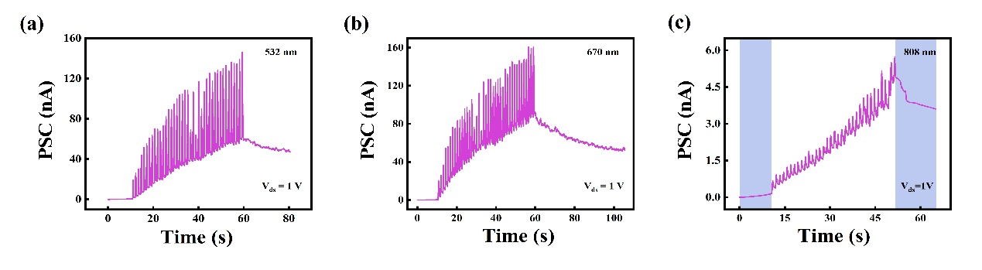
Figure 10. The PSC triggered by a series of light pulses with the different wavelengths of 532 nm, 670 nm and 808 nm.

Figure S11. Design and characteristics of the artificial optoelectronic synaptic device based on the CdSe/ReS₂ van der Waals heterojunction. (a) Schematic diagram of the fabricated device. (b) The I_{ds}-V_{ds} characteristics of the device measured under dark and illumination. (c) Typical dual-sweeping transfer curves of the device. (d) The transient EPSC response triggered by pre-synaptic light spike (wavelength: 405 nm) with the pulse duration of 1 s. (e) EPSC of the CdSe/ReS₂ transistor excited by two adjacent laser pulses (wavelength: 405 nm, pulse width: 1 s) with a time interval (Δt = 2 s). (f) The EPSC response under different numbers of light pulses (the reading voltage is fixed at 1 V). (g) The EPSCs triggered by laser pulse trains with different pulse width durations.

Figure S12. (a) The 40 cycles of potentiation/depression curves based on CdSe/MoS₂ synaptic Transistor. (b) Switching characteristic of the transistor. Data were extracted from the 40 cycles of LTP/LTD curves. (c) The simulated recognition rate as function of training epochs for file type datasets based on the ideal device and our device for the file types.

∗ Corresponding author. E-mail address: xiacongxin@htu.edu.cn

