Supplementary Material

Ruey-Tarng Liu, Yan-Ze Wu, and Chia-Chien Huang∗
Focusing and steering of mid-infrared polaritons through patterned graphene on van der Waals crystals
- Material parameters of α-phase molybdenum trioxide and graphene

1.1 Permittivity of α-phase molybdenum trioxide
The permittivity of α-phase molybdenum trioxide (α-MoO₃) was calculated by the following Lorentz model:
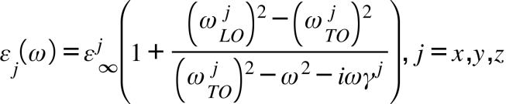, (S1)
where 𝜀_{j} denotes the principal component of the permittivity tensor; 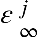(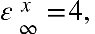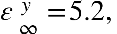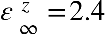)denotes the high-frequency permittivity in the j direction; 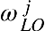(cm⁻¹) (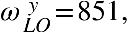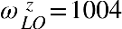) and (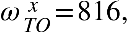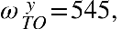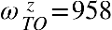) denote the longitudinal optical and transverse optical phonon frequencies, respectively; () denotes the inelastic loss rate.

1.2 Surface conductivity of graphene
The surface conductivity of graphene, denoted as σ, was computed using the Kubo formula. It comprised both intraband and interband contributions and can be expressed as follows:
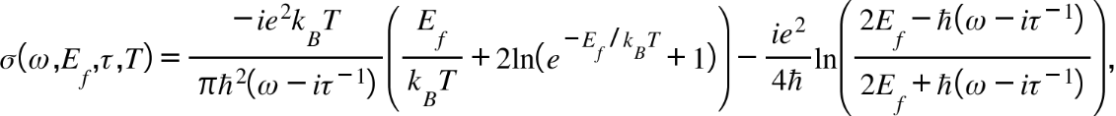 (S2)
where the parameters include the angular frequency (ω), Fermi level (E_{f}), carrier relaxation lifetime (τ) = µE_{f} /ev_{f}², absolute temperature (T), electron charge (e), Boltzmann constant (k_{B}), reduced Planck constant (ℏ), carrier mobility (µ), and Fermi velocity of electrons (v_{f}) = 10⁶ m/s. To avoid damage to the ellipse graphene and minimize the influence of the near-field signal when employing electrical gating, the proper approach to tuning the E_{f} of the graphene discs is by applying conventional chemical doping in the proposed system. In this investigation, we assumed a practical value of µ = 1,000 cm²/V·s at a room temperature of T = 300 K.

- Isofrequency contours for Re(E_{z}) fields
We conducted a Fourier transformation of the Re(E_{z}) field profiles, as illustrated in Figure 2A–D, affording numerical isofrequency contour (IFC) plots in wavevector space (k_{x}, k_{y}) corresponding to different values of m. To enhance the clarity of the numerical solutions, we plotted only the left half of the analytical IFCs of the hyperbolic profiles.

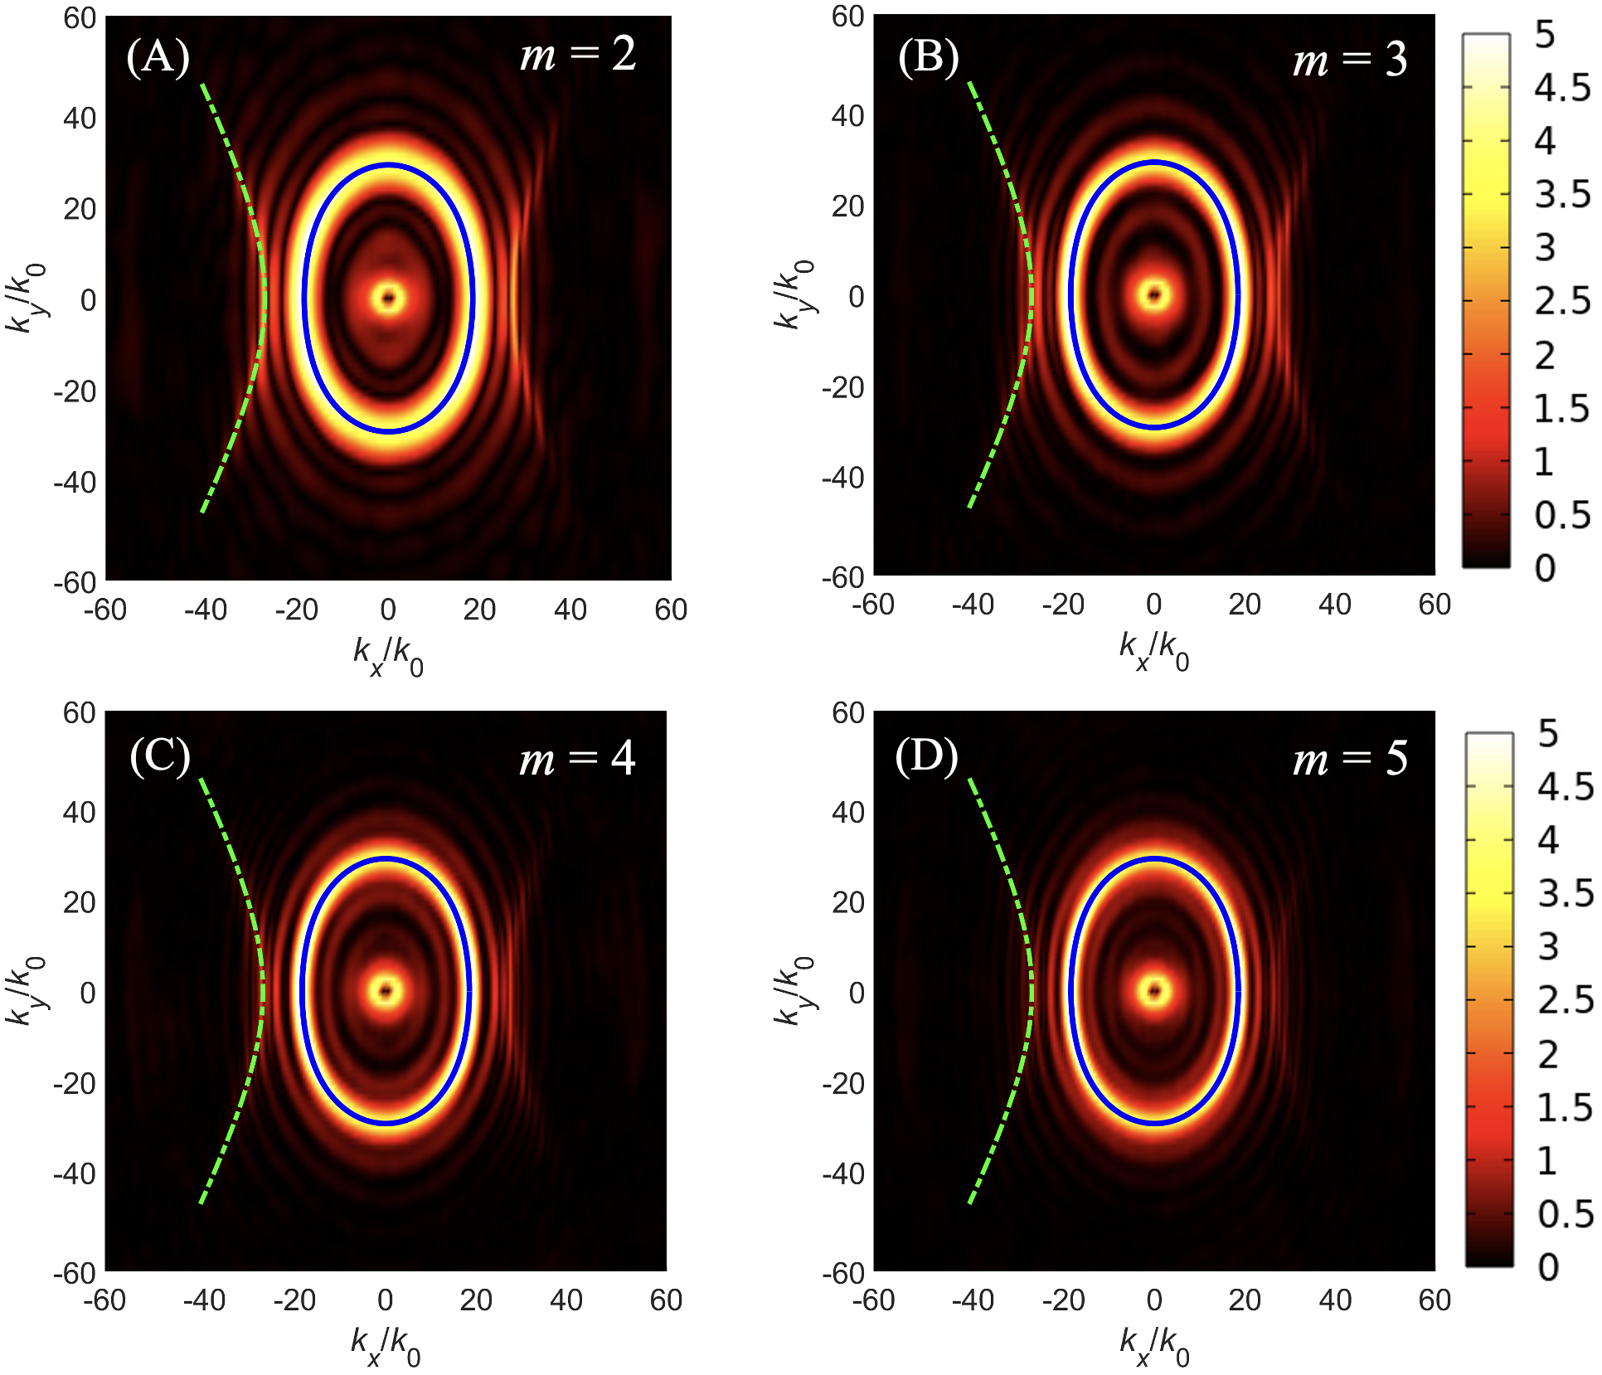

Figure S1: Isofrequency contours (IFCs) for Re(E_{z}) fields corresponding to (A) m (a positive real number) = 2, (B) 3, (C) 4, and (D) 5 under the conditions of angular frequency (ω) = 910 cm⁻¹, thickness (t) = 150 nm, and Fermi level (E_{f}) = 0.5 eV. Analytical IFCs are represented by the green dashed and cyan solid lines for reference.

- Focusing characteristics

3.1 Operating frequency
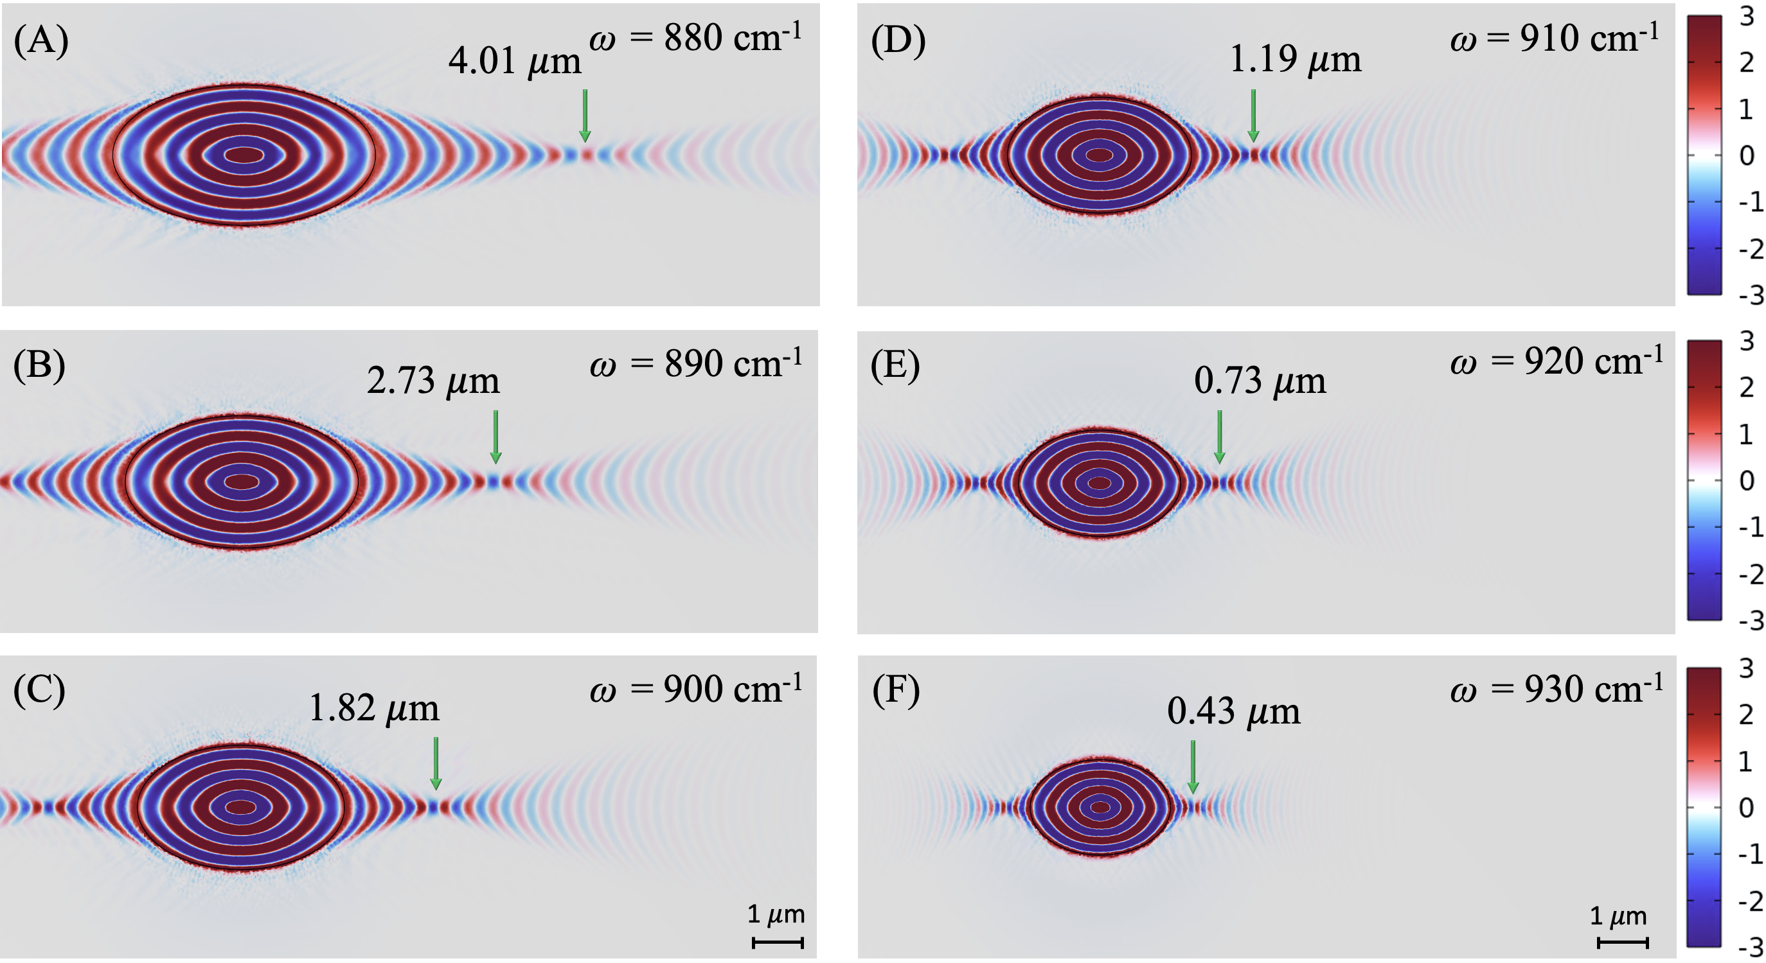
Figure S2: The Re(E_{z}) fields of the proposed structure for ω = (A) 880, (B) 890, (C) 900, (D) 910, (E) 920, and (F) 930 cm⁻¹ under the parameters of E_{f} = 0.5 eV, t = 150 nm, and m = 3.

3.2 Noninteger positive real number
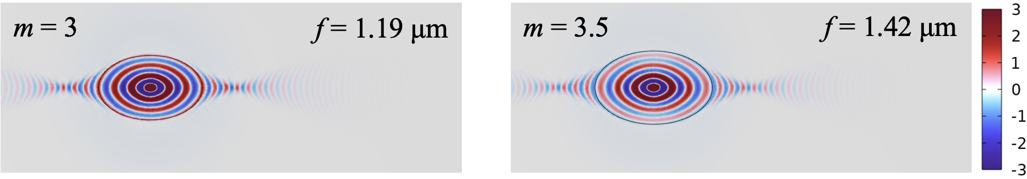
(A) (F)
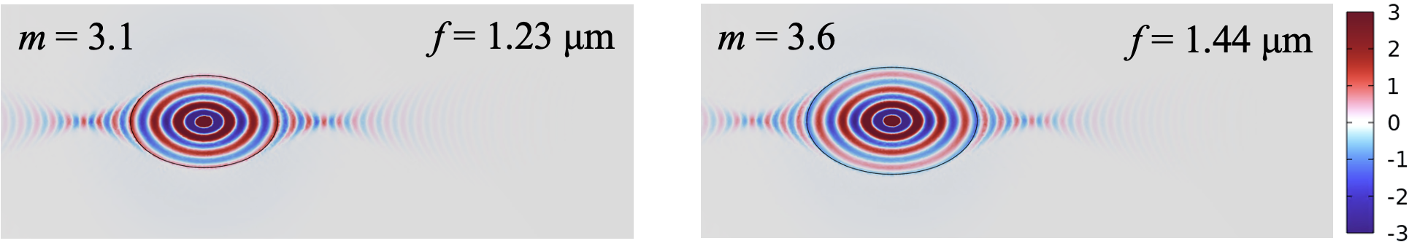
(B) (G)
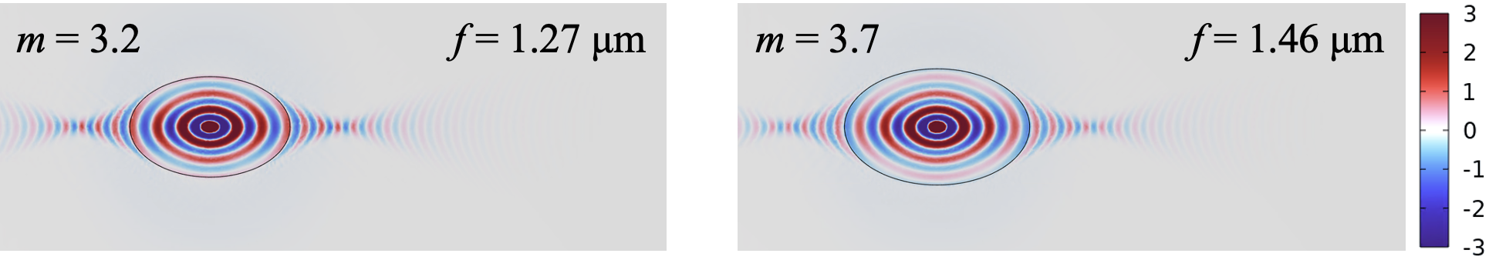
(C) (H)
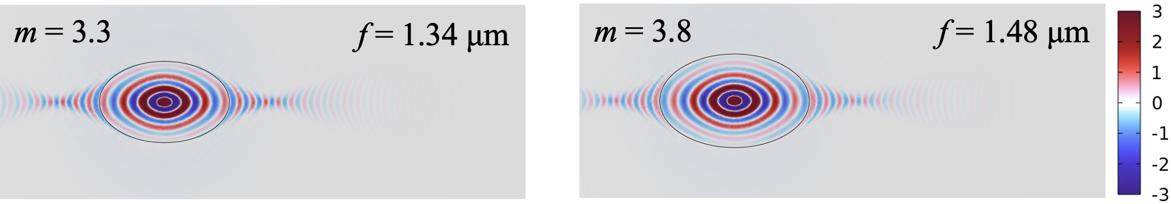
(D) (I)
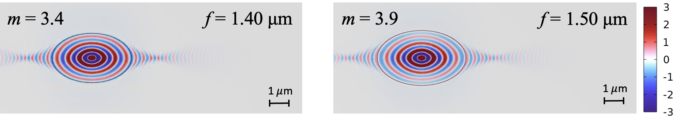
(E) (J)
Figure S3: Re(E_{z}) fields for m = (A) 3, (B) 3.1, (C) 3.2, (D) 3.3, (E) 3.4, (F) 3.5, (G) 3.6, (H) 3.7, (I) 3.8, and (J) 3.9 with the corresponding focal lengths at the parameters of ω = 910 cm⁻¹, E_{f} = 0.5 eV, and t = 150 nm.

- Permittivity of α-phase molybdenum trioxide with an orientation of angle θ
For an α-MoO₃ slab with the crystallographic direction [100] aligning with the x-direction, the permittivity tensor is expressed as ε = diag[ε_{x}, ε_{y}, ε_{z}], where ε_{x}, ε_{y}, and ε_{z} are the permittivity components along the principal axes [100], [001], and [010], respectively, of the α-MoO₃ slab. By rotating an α-MoO₃ slab counterclockwise around the z-axis, altering the angle θ, which corresponds to the orientation of the principal axis [100] for the x-axis and θ is positive for counterclockwise rotation from the x-axis, the oriented permittivity tensor is expressed as ε^{θ} =RεR^{T}, where the rotation matrix (R) and ε^{θ} are as follows:
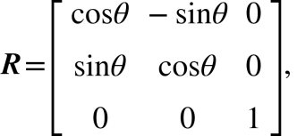 (S3)
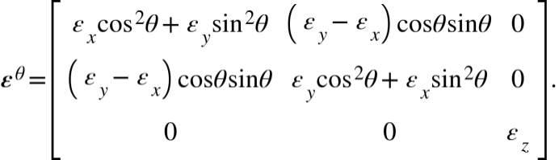 (S4)

