**Supplemental Material:**

**Tunable Magnetless Optical Isolation with Twisted Weyl Semimetals**

Vladislav Chistyakov1, Viktar S. Asadchy2, Shanhui Fan3, Andrea Alù4, and Alex Krasnok5,*

*1Saint-Petersburg, 191002, Russia*

*2Department of Electronics and Nanoengineering, Aalto University, 02150, Espoo, Finland*

*3Ginzton Laboratory and Department of Electrical Engineering, Stanford University, Stanford, CA, 94305, USA*

*4Photonics Initiative, Advanced Science Research Center, City University of New York, New York, NY, USA*

*5Department of Electrical and Computer Engineering, Florida International University, Miami, FL 33174, USA*

*\*e-mail:* akrasnok@fiu.edu

**Optical properties of used Weyl semimetals**

The optical properties of Weyl semimetals (WS) have been studied theoretically in various papers, see, e.g., Refs. [1,2]. In these works, it has been demonstrated that to account for WS topological properties in the optical response, one may use the standard form of Maxwell equations with  and the WS relative permittivity tensor [1,2]

 (S1)

and unity magnetic permeability. The off-diagonal components  are caused by the Weyl nodes splitting in the momentum space by the vector . They are responsible for the strength of magneto-optical activity and breaking the Lorentz reciprocity. The diagonal components of the in-plane isotropic WSs can be calculated using the Kubo-Greenwood formalism in the approximation of random phases to the two-band model with spin degeneracy  [2,3]:

 (S2)

where  is the background permittivity,  is the chemical potential,  is the normalized frequency,  is the Drude damping rate, , where  is the Fermi distribution function,  is the effective fine-structure constant,  is the Fermi velocity, *g* is the number of Weyl points, and , where  is the cutoff energy beyond which the band dispersion is no longer linear. For the real part of the equation (S2), according to [3], we obtain

, (S3)

where  is the plasma frequency and  is the effective background dielectric constant. In our work, the anisotropic component of the dielectric tensor is determined by , where *q* plasma frequency offset coefficient.

We used the following parameters [1] , ,  fs, , m-1,  m s-1,  eV at  K, and . **Fig. S1** shows the frequency dispersion of the real part of the , , and  components. The figure shows that almost in the entire frequency range  and  are of the same order, which indicates a high value of the magneto-optical parameter , which is significantly higher than for conventional magneto-optical materials [4]. Also, an additional plasma resonance appears in the material corresponding to the dotted blue line due to anisotropy.

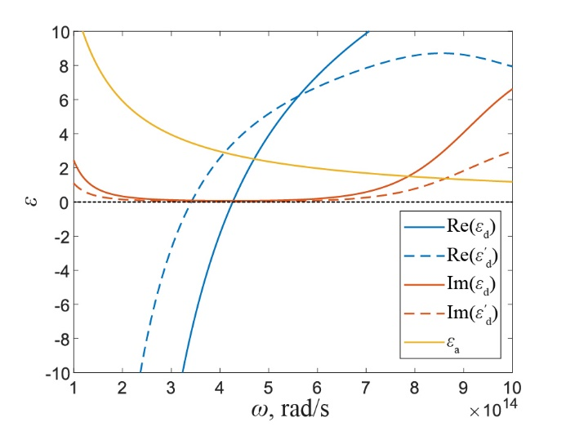

**Fig. S1**. Permetivity tensor components dispersion of the anisotropic Weyl semimetal.

**Polarizer-less optical isolator with WSs**

The anisotropy of WSs in this geometry can operate as a polarizer, eliminating the traditional polarizer and analyzer and making the design even more compact. **Fig. S2(a)** shows the geometry of the proposed polarizer-less compact isolator. In this configuration, we consider the transmission of only cross-polarizations . The thickness of the WS is adjusted to  μm to reach a maximum asymmetry  of 16%, **Fig. S2(b).** The maximum isolation for selected optimized parameters reaches 50 dB at the frequency  rad/s, **Fig. S2(c)**. Other geometrical parameters are the same as in **Figs. 1,2** in the main text.The results of the isolation spectrum as a function of the relative rotation is shown in **Fig. S2(d)**. The maximum reaches 60 dB at  and at frequency  rad/s. The isolator can operate in both directions by adjusting the twist angle.

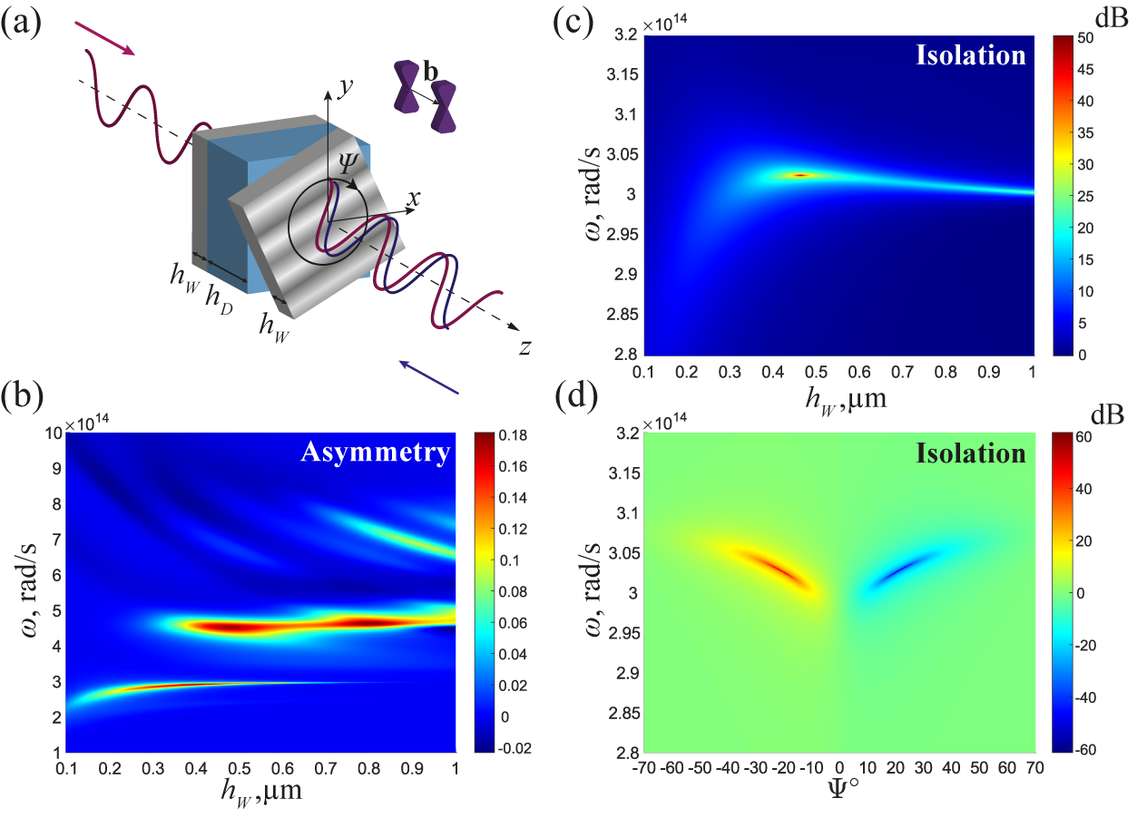

**Fig. S2.** (a) Isolator geometry without polarizers. (b),(c) Asymmetry  and isolation  spectrum as a function of frequency and thickness of the Weyl semimetal at the rotation angle . (d) Isolation as a function of frequency and angle of rotation.

**References**

[1] O. V. Kotov and Y. E. Lozovik, *Giant Tunable Nonreciprocity of Light in Weyl Semimetals*, Phys. Rev. B **98**, 195446 (2018).

[2] J. Hofmann and S. Das Sarma, *Surface Plasmon Polaritons in Topological Weyl Semimetals*, Phys. Rev. B **93**, 241402 (2016).

[3] O. V. Kotov and Y. E. Lozovik, *Dielectric Response and Novel Electromagnetic Modes in Three-Dimensional Dirac Semimetal Films*, Phys. Rev. B **93**, 1 (2016).

[4] V. S. Asadchy, M. S. Mirmoosa, A. Diaz-Rubio, S. Fan, and S. A. Tretyakov, *Tutorial on Electromagnetic Nonreciprocity and Its Origins*, Proc. IEEE **108**, 1684 (2020).