**Hybridization of surface lattice modes: towards plasmonic meta-surfaces with high flexible tunability**

Macilia Braïk,Théo Geronimi Jourdain, Stéphanie Lau-Truong, Abderrahmane Belkhir,Sarra Gam-Derouich, Alexandre Chevillot-Biraud, Claire Mangeney, and Nordin Félidj*

**Macilia Braïk, Théo Geronimi-Jourdain, Stéphanie Lau-Truong, Sarra Gam-Derouich, Alexandre Chevillot-Biraud, Nordin Félidj\***, Université Paris Cité, ITODYS, CNRS, F-75006 Paris, France

**Macilia Braïk, Abderrahmane Belkhir,** Université Mouloud Mammeri, LPCQ, BP 17 RP, 15000 Tizi-Ouzou, Algeria

**Claire Mangeney**, Université Paris Cité, LCBPT, CNRS, F-75006 Paris, France

*Nordin Félidj : corresponding author

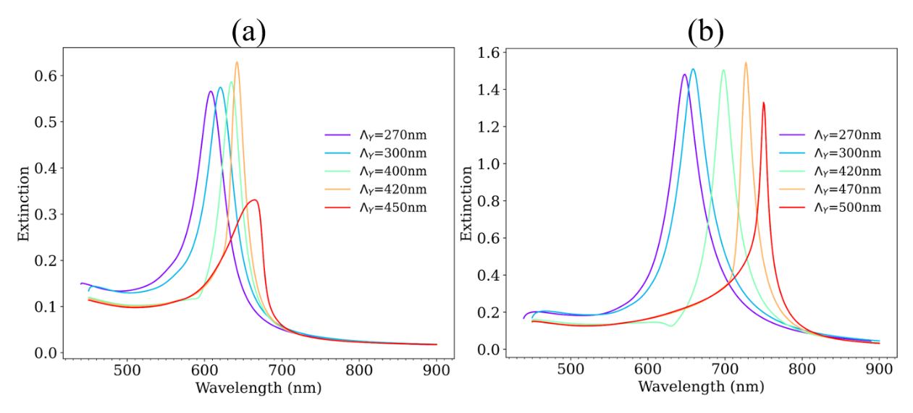

Figure SI1 Calculated extinction spectra of arrays of gold disks with diameters D1=100 nm in (a) and D2=150 nm in (b), deposited on ITO coated glass substrates. The extinction spectra are recorded in air at normal incidence, for an incident polarization along the X axis. The grating constant is fixed to Λx = 300 nm and Λy varies from 270 to 500 nm.

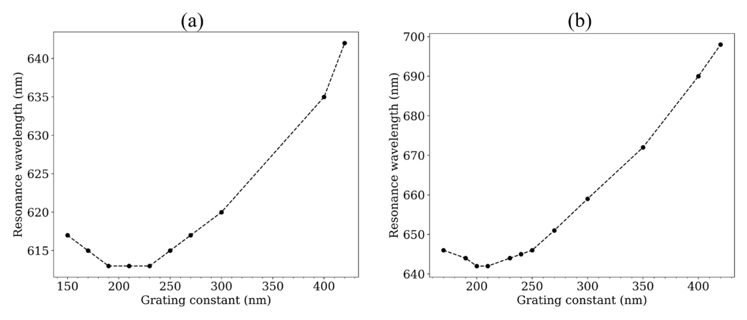

Figure SI2 Spectral position of the resonance deduced from the calculated extinction spectra of the discs array of diameter D1 = 100 nm in (a) and D2 = 150 nm in (b). The grating constant is fixed to Λx = 300 nm and Λy varies from 270 to 500 nm.

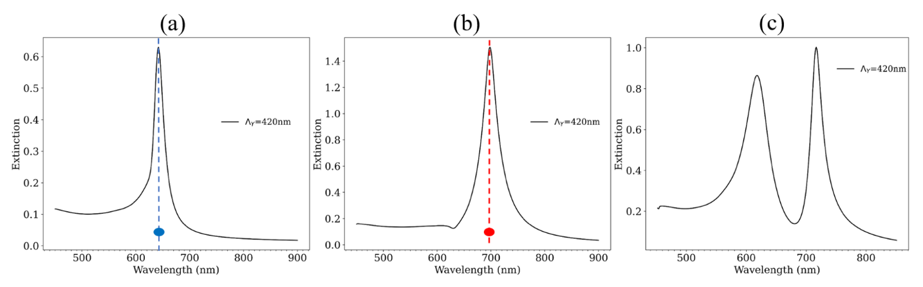

Figure SI3 Calculated extinction spectra in air, at normal incidence for a polarization along the X axis, for (a) array of gold disks of diameter D1 = 100 nm, (b) array of gold disks of diameter D2 = 150 nm and (c) binary array of disks of diameters (D1; D2) = (100 nm; 150 nm). For all the arrays, the grating constants are fixed to Λx= 300 nm and Λy = 420 nm.

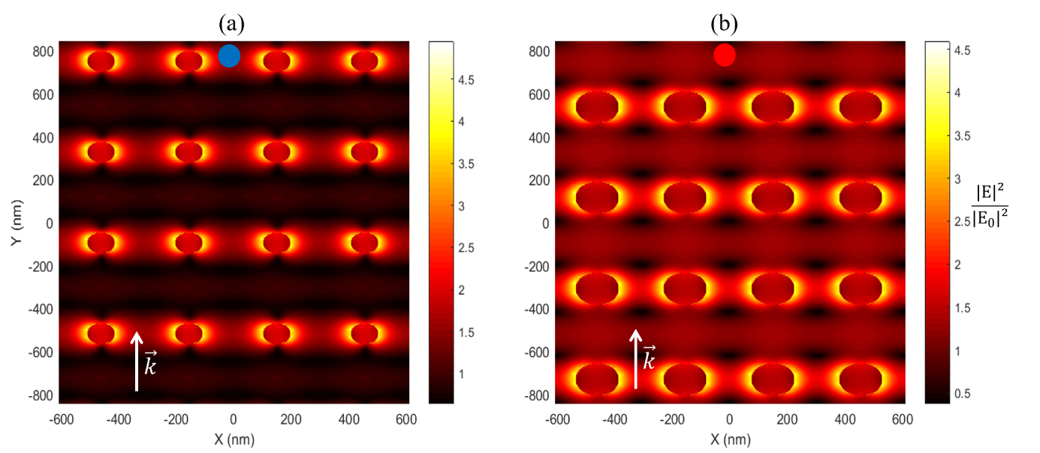

Figure SI4: Normalized intensity of the electric field distribution (calculated by the FDTD method), at the resonance wavelength, in the plan above the discs arrays of diameter D1 = 100 nm in (a) and D2= 150 nm in (b). The grating constants still fixed at Λx= 300 nm and Λy = 420 nm. For a better contrast, the values given in *colorbar* represent the normalized intensity power a third.