Erik H. Waller, Stefan Duran, Georg von Freymann
Supplementary
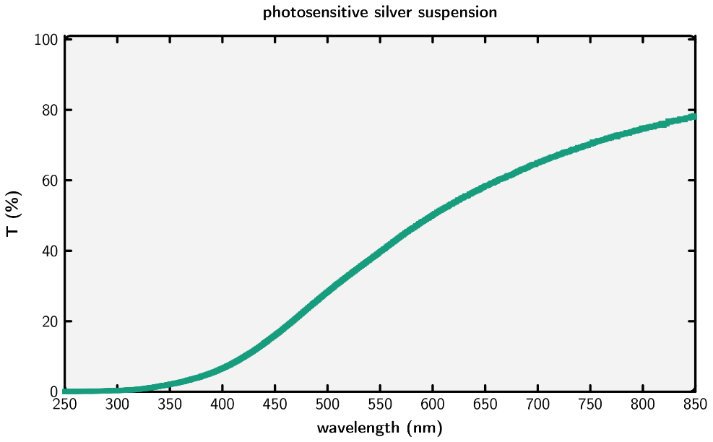
- Transmittance spectrum of photosensitive suspension
Figure S 1: Transmittance spectrum of the final silver solution.
- Conductivity measurements
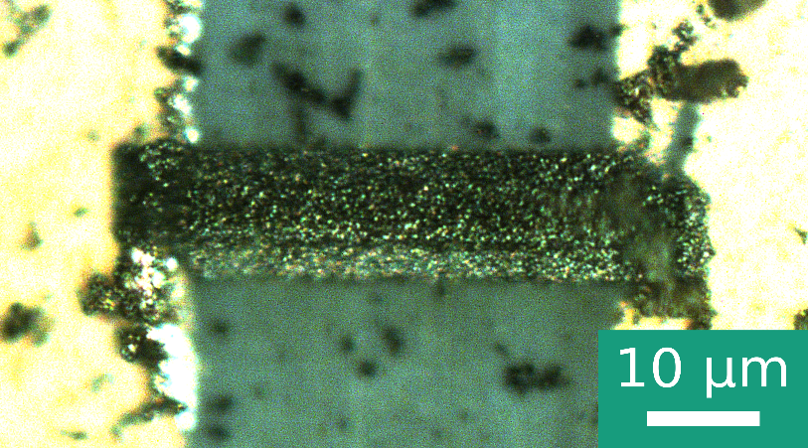
To conduct 4-point conductivity measurements first two electrodes were fabricated as follows: a Tollens reagent solution was exposed to UV light until a silver mirror formed. Using a razor blade, the thin silver layer was cut in two halves and electrical disconnection was verified. Between those electrodes a silver beam with 10 x 10 x 50 microns³ was fabricated using direct laser writing as shown in Figure S2. A home-built 4-point measurement device was used to measure the resistance of the thin silver layer alone (0.8 Ω) as well as the silver beam plus the silver layer (15.6 Ω). Using a thin wire model the resistivity was calculated by (R_{beam+layer} – R_{layer})*A_{beam}/l_{beam}, where A_{beam} is the area of the cross-section and I_{beam} is the length of the beam.
Figure S 2: Reflection light microscopy image of a direct laser written beam connecting two electrodes.

