Supporting Information
Shanshan Dang, Yanmei Mo, Junqing Zeng , Yunjie Xu, Zhongjian Xie, Han Zhang*, Bin Zhang*, Guohui Nie*
Three birds with one stone: oxygen self-supply engineering palladium nanocluser/titanium carbide hybrid for single-NIR laser-triggered synergistic photodynamic-photothermal therapy
Dr. S. Dang, Ms. Y. Mo, Dr. Y. Xu, Prof. Z. Xie, Prof. H. Zhang, Prof. B. Zhang, Prof. G. Nie
Shenzhen Key Laboratory of Nanozymes and Translational Cancer Research, Institute of Translational Medicine Department of Otolaryngology Shenzhen Second People’s Hospital, the First Affiliated Hospital of Shenzhen University, Health Science Center, Institute of Microscale Optoelectronics Shenzhen 518035, China

Mr J. Zeng
Graduate Collaborative Training Base of Shenzhen Second’ People’s Hospital, Hengyang Medical School, University of South China, Hengyang, Hunan, 421001, China

*Corresponding Authors: Han Zhang (hzhang@szu.edu.cn), Bin Zhang (wenwubin09@163.com), Guohui Nie (nieguohui@email.szu.edu.cn)

Experimental details
Materials
Ti₃C₂T_{x} (solution), 5,10,15,20-Tetrakis (4-Aminophenyl)-21H,23H Porphyrin (Thp), 3-Mercaptopropionic acid (MPA), and Palladium nitrate solution (Pd 18.09 wt% in nitric acid) were purchased from CAS-mart (China). All chemicals were purchased from commercial supplies and used without further treatment.
Preparation of monodispersed Pd catalyst
0.25 mL of Pd(NO₃)₂ aqueous solution, 2 ml of MPA solution were added in 2.35 mL of deionized water under magnetic stirring for 5 min, and then 0.3 mL of NaOH (1M) were added drop by drop to the mixture for another 5 min. Afterwards, a certain amount of NaBH₄ solution was dissolved in the solution. After it was kept under stirring at room temperature for 2 h, the dark yellow solution was transferred to the dialysis bag and performed in deionized water to remove the reductant ions for 6 h, and then the monodispersed Pd catalyst in water with negligible NaOH, MPA and NaBH₄ was obtained and stored at -20 ºC for further use.
Characterization
X-Ray photoelectron spectrum (XPS) was recorded by a Thermo Scientific Escalab 250Xi. The morphology of samples and energy X-ray dispersive spectroscopic (EDX) were performed by a Hitachi High-Tech's scanning electron microscopes SU3800. The transmission electron microscope (TEM) images were obtained on HITACHI Transmission Electron Microscope (HT7700), and the nanostructures of catalysts were performed by High-resolution Transmission electron microscope (HRTEM) images and element Mapping were performed by a field emission transmission electron microscope (JEOL EM F200). The Pd loading of Pd-Thp-Ti₃C₂T_{x} was determined by inductively coupled plasma (ICP) analysis on a Thermo Scientific Escalab 250Xi. UV-vis-NIR absorption spectra were recorded by a Evolution220 ThermoFisher. Size and Zeta potential characterization were measured on Zetaszier Nano-ZS90. The thickness of nanosheets was measured via atomic force microscope (AFM) by Dimension icon (Bruker). TEMP electron spin-resonance spectroscopy (ESR) was performed by Bruker E500.
Cell culture
SW480, A549, MHCC97L and CAKI cells were cultured in DEME supplemented with 10% fetal bovine serum and 1% penicillin-streptomycin solution, and CT26 cells were grown in RPMI 1640 supplemented with 10% fetal bovine serum and 1% penicillin-streptomycin solution. All cells were maintained at 37 ºC in a humidified incubator with 5% CO₂.
Cell uptake study
Fluorescein isothiocyanate (FITC) as the fluorescence probe was used for cellular uptake test. SW480 cells were seeded in 96-well plates with a density of 1.2*10⁵ cells per well for 24 h at 37 ºC with 5% CO₂, and then the medium (Pd-Thp-Ti₃C₂T_{x}-FITC) was added in each well. Cell images were obtained by Echo Laboratories Revolve FL at different time point over 4 h.
Western blotting
The expression of Bax, Bak, Bcl-Xl, Cytoplasmic (Cyt-c) and cleaved caspase 3 was analyzed by western blotting. Briefly. SW480 cells were seeded in 6-well plates with a density of 2.5*10⁶ cells per well for 24 h. Different nanocomposites with concentration of 25 ppm were added into wells for 4 h, and then irradiated under 808 nm with 1.0 W/cm² for 5 min. After 24 h incubation, the protein samples were collected, and took a certain amount of protein and run on 12% SDS-prolyacrylamide gels, and then transfer onto nitrocellulose membranes. The proteins expression was detected by protein-specific rabbit antibody and corresponding HRP-conjugated anti-rabbit IgG, then the blots were recorded through a luminol-based enhanced chemiluminescence HRP substrate.
Mitochondrial assay
MitoTracker Red CMXRos was used to detect the condition of mitochondria. SW480 cells were cultured in medium with different sample (25 ppm) for 4 h. The cells were irradiated under 808 nm laser at 1.0 W/cm² for 5 min, and then washed with PBS for 1 time. The fresh medium containing certain amount of MitoTracker Red CMXRos were added staying for 25min, and then washed with PBS for 2 times. Next, cells were immobilized with 4% paraformaldehyde for 20 min and washed with PBS for 2 times. Last, SW480 cells were cultured with 4',6-diamidino-2-phenylindole (DAPI) in PBS for 10 min, and then washed with PBS for 3 times. Cell images were recorded by Echo Laboratories Revolve FL.
Biosafety assay
Twenty healthy female BALB/c mice (8 weeks old) were purchased and randomly divided into 4 groups (n=5), followed by the intravenous injection of PBS, Ti₃C₂T_{x} (5 mg/mL), Thp-Ti₃C₂T_{x} (5 mg mL⁻¹) and Pd-Thp-Ti₃C₂T_{x} (5 mg/mL). The body weight was recorded every 2 days to analyze the physical condition of mice. At the 14th day, mice were sacrificed, and the blood was collected to research the standard hematology test and serum biochemistry assy. The major organs including heart, kidney, liver, lung and spleen were stained with hematoxylin and eosin H&E to study the state of these organs.

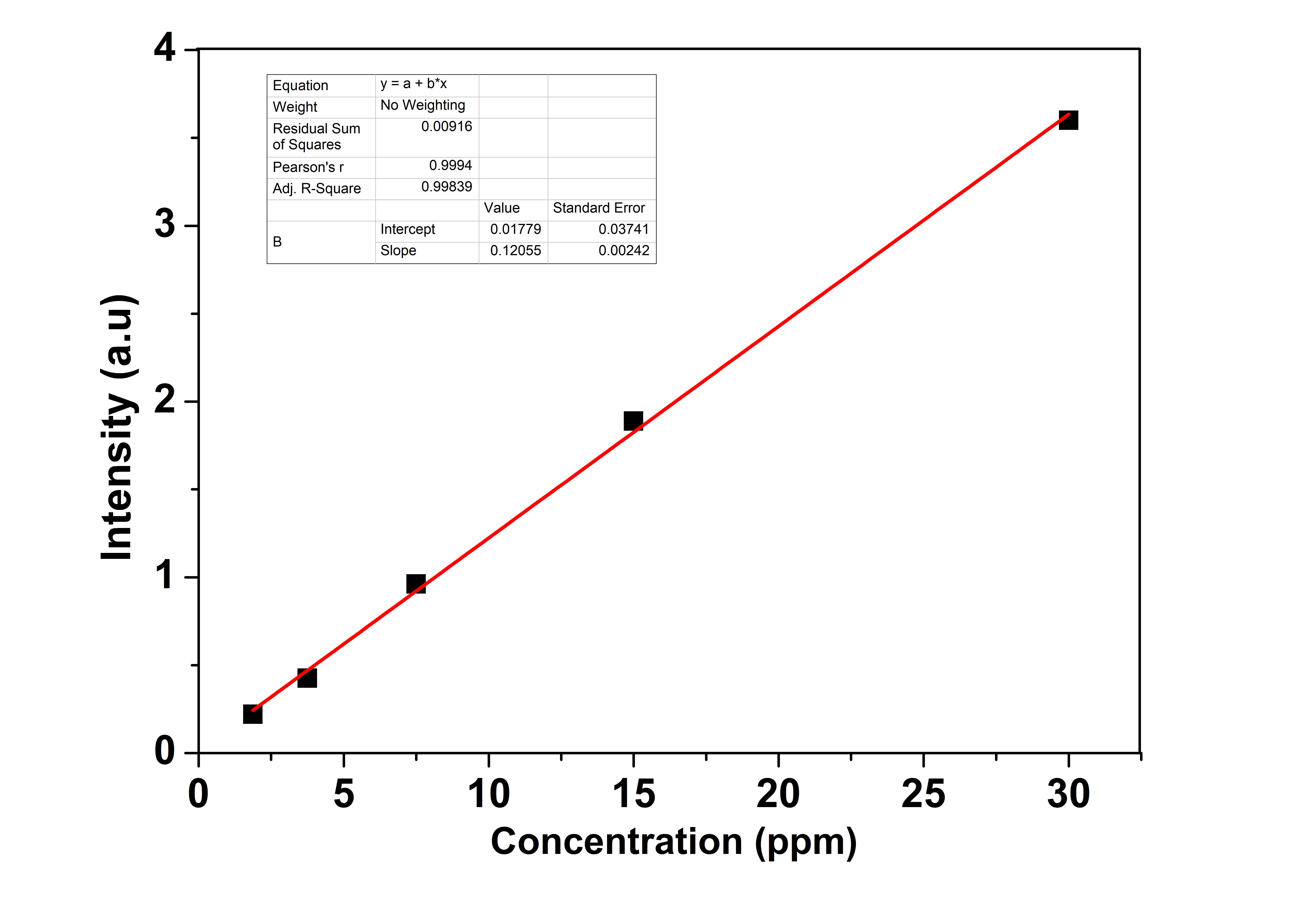
Figure S1: The standard curve correlating the UV-vis-NIR absorption intensity with the concentration of free Thp (R²=0.99).

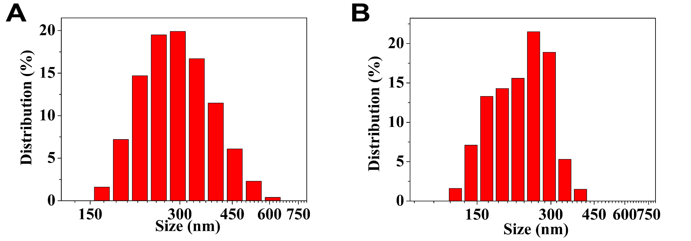
Figure S2: (A) Size distribution of Ti₃C₂T_{x} nanosheets as determined by DLS. (B) Size distribution of Pd-Thp-Ti₃C₂T_{x} after preparation for 8 days as determined by DLS

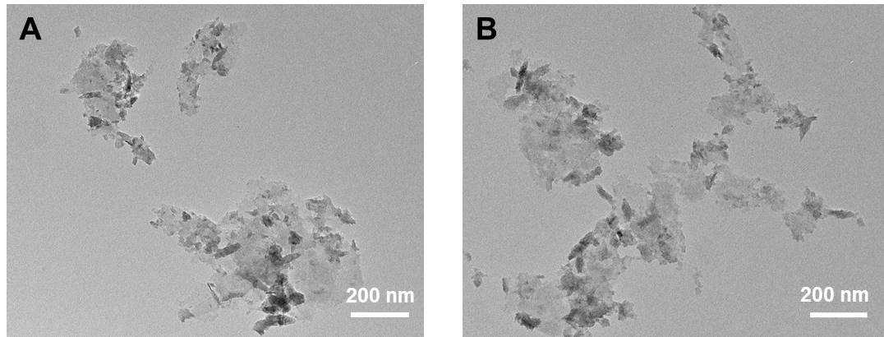
Figure S3: TEM images of (A) Thp-Ti₃C₂T_{x} and (B) Pd-Thp-Ti₃C₂T_{x}.

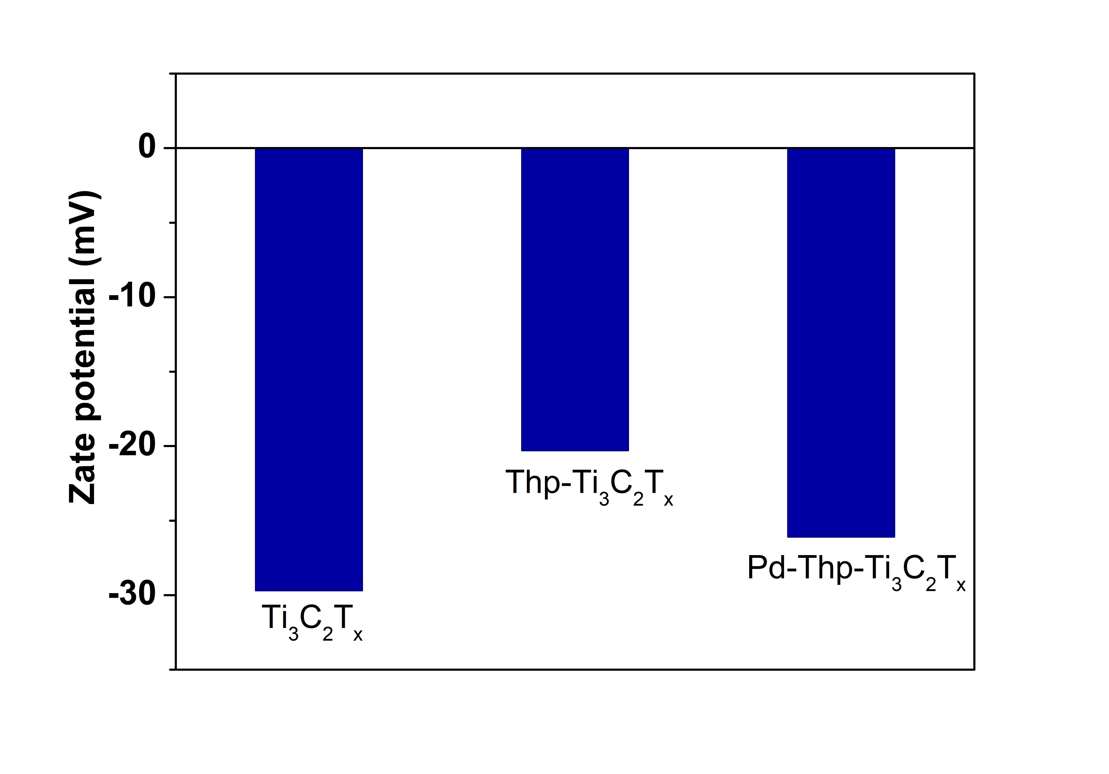
Figure S4: Zeta potential of Ti₃C₂T_{x}, Thp-Ti₃C₂T_{x} and Pd-Thp-Ti₃C₂T_{x}.

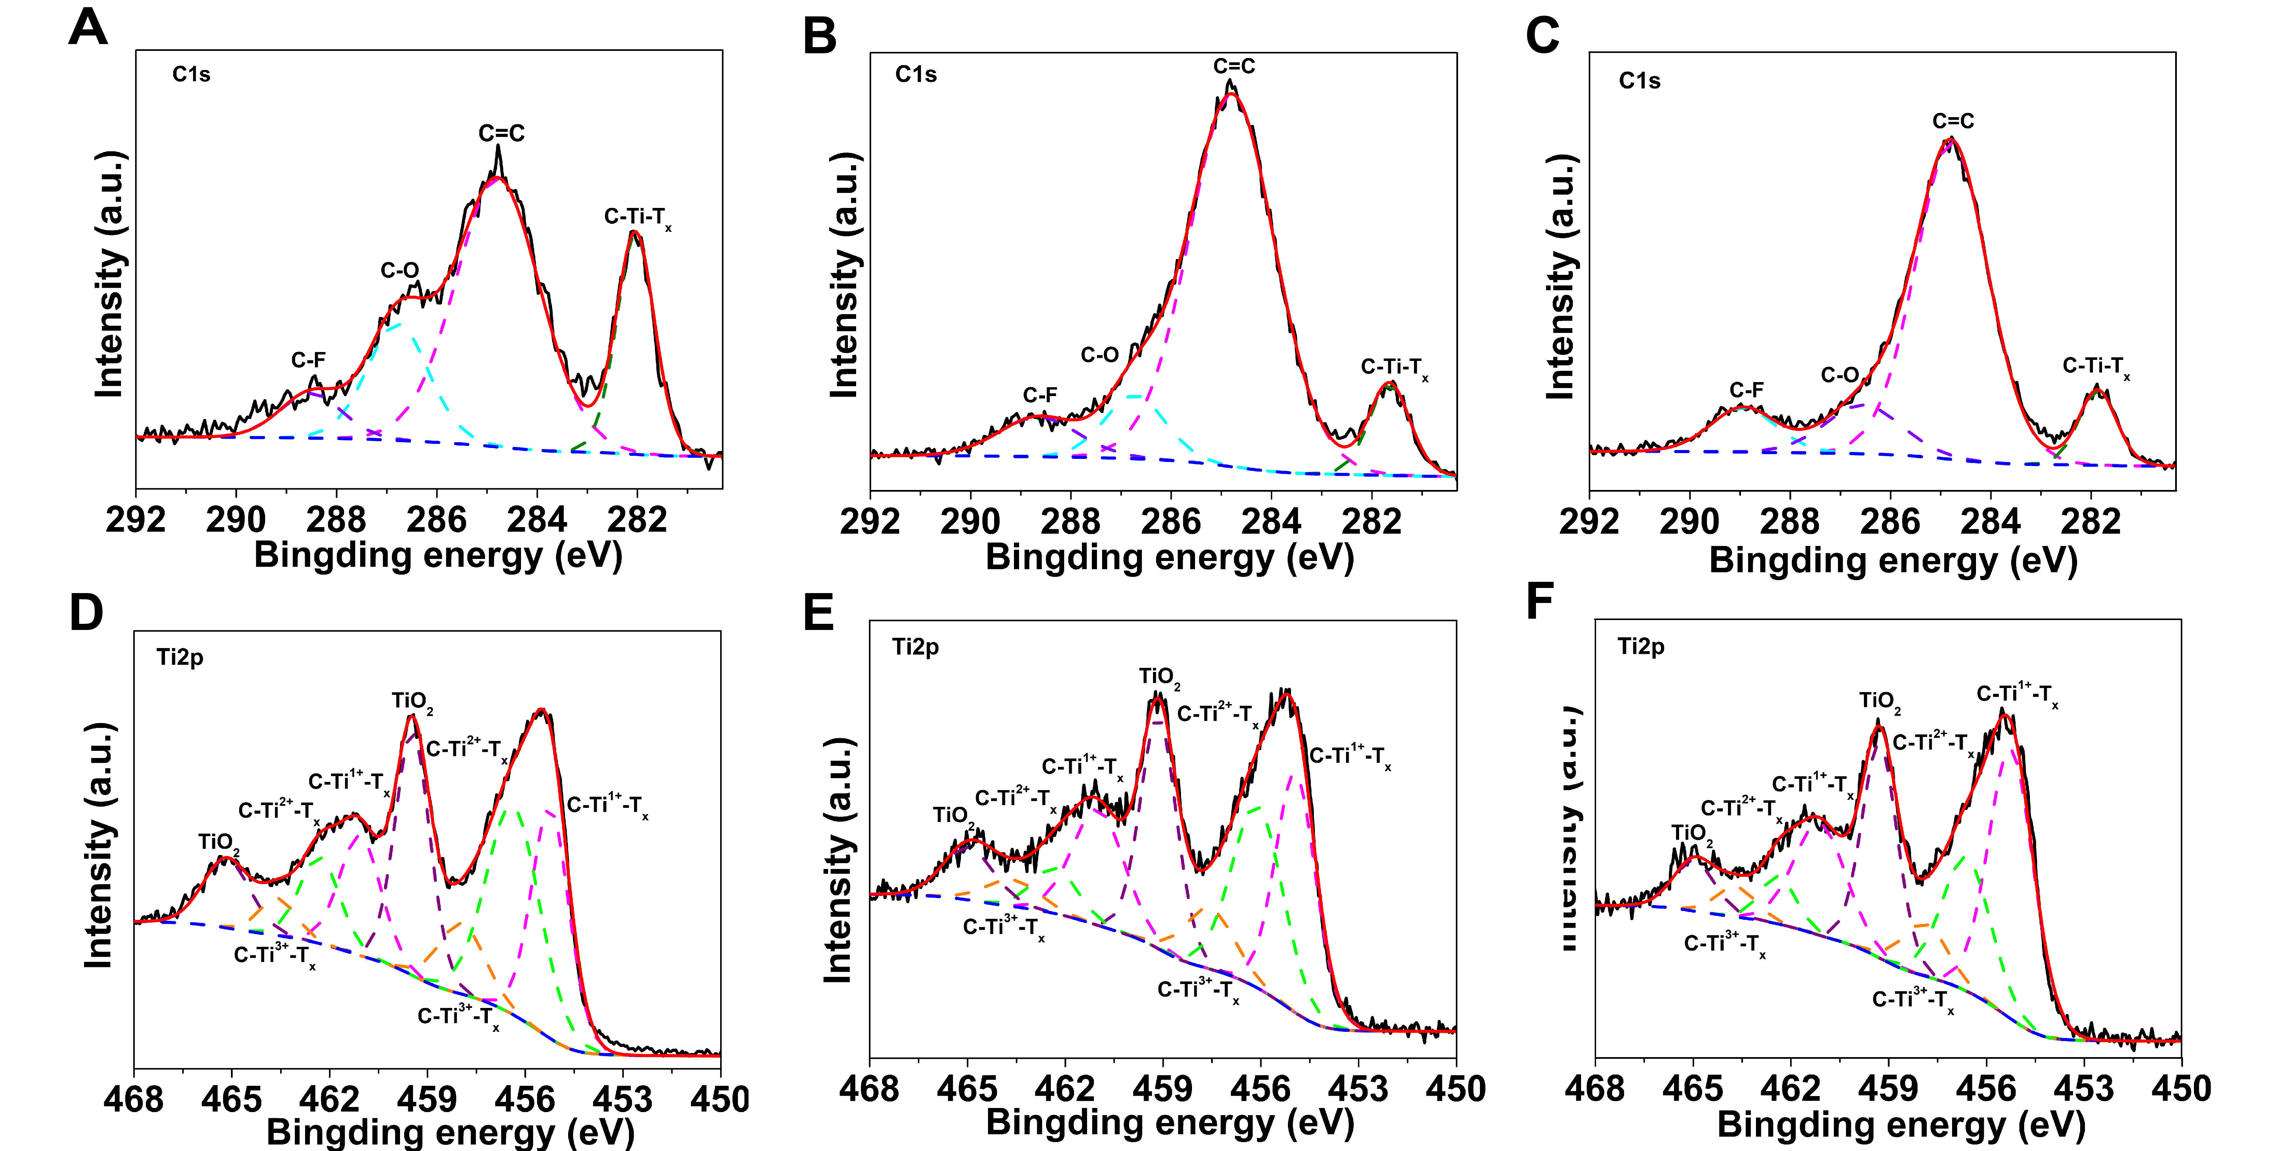
Figure S5:
(A) C1s and (D) Ti2p high-resolution XPS spectra of Ti₃C₂T_{x}. (B) C1s and (E) Ti2p high-resolution XPS spectra of Thp-Ti₃C₂T_{x}. (C) C1s and (F) Ti2p high-resolution XPS spectra of Pd-Thp-Ti₃C₂T_{x}.
Table S1: Summary of XPS Ti 2p peaks of different samples
Sample | Binding energy (eV) |  | Assigned to
Sample | Ti 2p_{3/2} | Ti 2p_{1/2} | Assigned to
Ti₃C₂T_{x} | 455.2 | 461.1 | C-Ti¹⁺-T_{x}
Ti₃C₂T_{x} | 456.4 | 462.3 | C-Ti²⁺-T_{x}
Ti₃C₂T_{x} | 457.9 | 463.6 | C-Ti³⁺-T_{x}
Ti₃C₂T_{x} | 459.4 | 465.2 | TiO₂
Thp-Ti₃C₂T_{x} | 455.0 | 461.0 | C-Ti¹⁺-T_{x}
Thp-Ti₃C₂T_{x} | 456.1 | 462.3 | C-Ti²⁺-T_{x}
Thp-Ti₃C₂T_{x} | 457.6 | 463.6 | C-Ti³⁺-T_{x}
Thp-Ti₃C₂T_{x} | 459.1 | 465.0 | TiO₂
Pd-Thp-Ti₃C₂T_{x} | 455.2 | 461.1 | C-Ti¹⁺-T_{x}
Pd-Thp-Ti₃C₂T_{x} | 456.5 | 462.4 | C-Ti²⁺-T_{x}
Pd-Thp-Ti₃C₂T_{x} | 457.9 | 463.7 | C-Ti³⁺-T_{x}
Pd-Thp-Ti₃C₂T_{x} | 459.3 | 465.0 | TiO₂

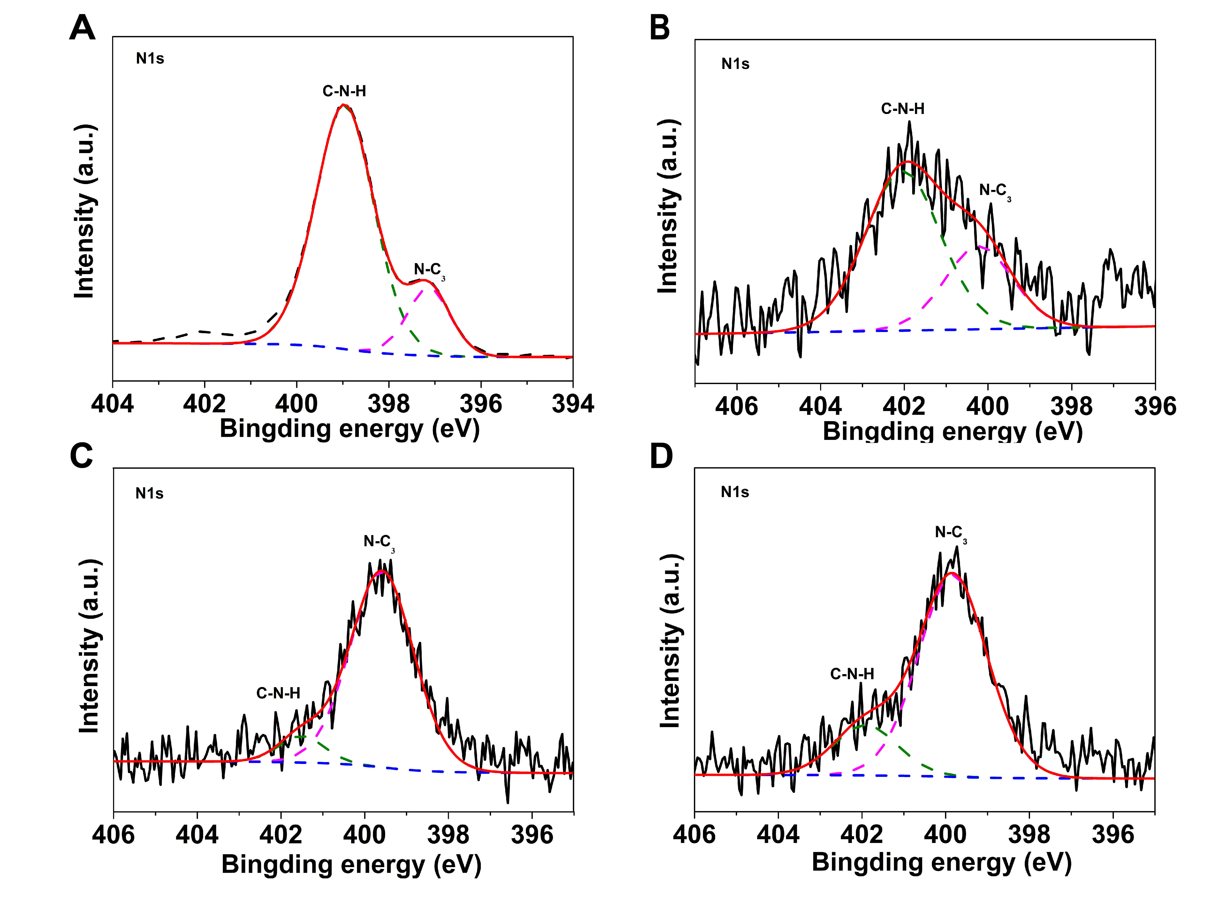
Figure S6: N1s high-resolution XPS spectra of (A) Thp, (B) Ti₃C₂T_{x}, (C)Thp-Ti₃C₂T_{x} and (D) Pd-Thp-Ti₃C₂T_{x}.

Table S2 Summary of XPS N1s peaks of different samples
Sample | Binding energy (eV) | Assigned to
Thp | 397.2 | N-C₃
Thp | 399.0 | C-N-H
Ti₃C₂T_{x} | 400.2 | N-C₃
Ti₃C₂T_{x} | 402.0 | C-N-H
Thp-Ti₃C₂T_{x} | 399.6 | N-C₃
Thp-Ti₃C₂T_{x} | 401,5 | C-N-H
Pd-Thp-Ti₃C₂T_{x} | 399.8 | N-C₃
Pd-Thp-Ti₃C₂T_{x} | 401.9 | C-N-H

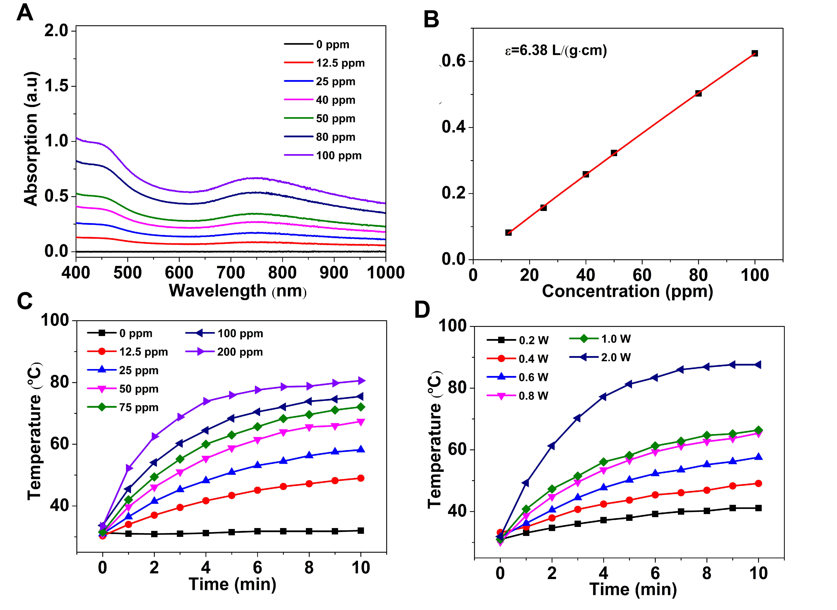
Figure S7:
(A) UV−vis−NIR spectra of Pd-Thp-Ti₃C₂T_{x} nanosheet dispersed in deionized water with certain concentrations (0, 12.5, 25, 40, 50, and 100 ppm) and (B) corresponding normalized absorbance intensity at λ=808 nm divided by the characteristic length of the cell (A/L) at elevated concentrations (R²=0.99). Photothermal-heating curves of Pd-Thp-Ti₃C₂T_{x} at (C) different concentration (808 nm, 1.0 W/cm², 10 min) and (D) power density under 808 nm (50 ppm).

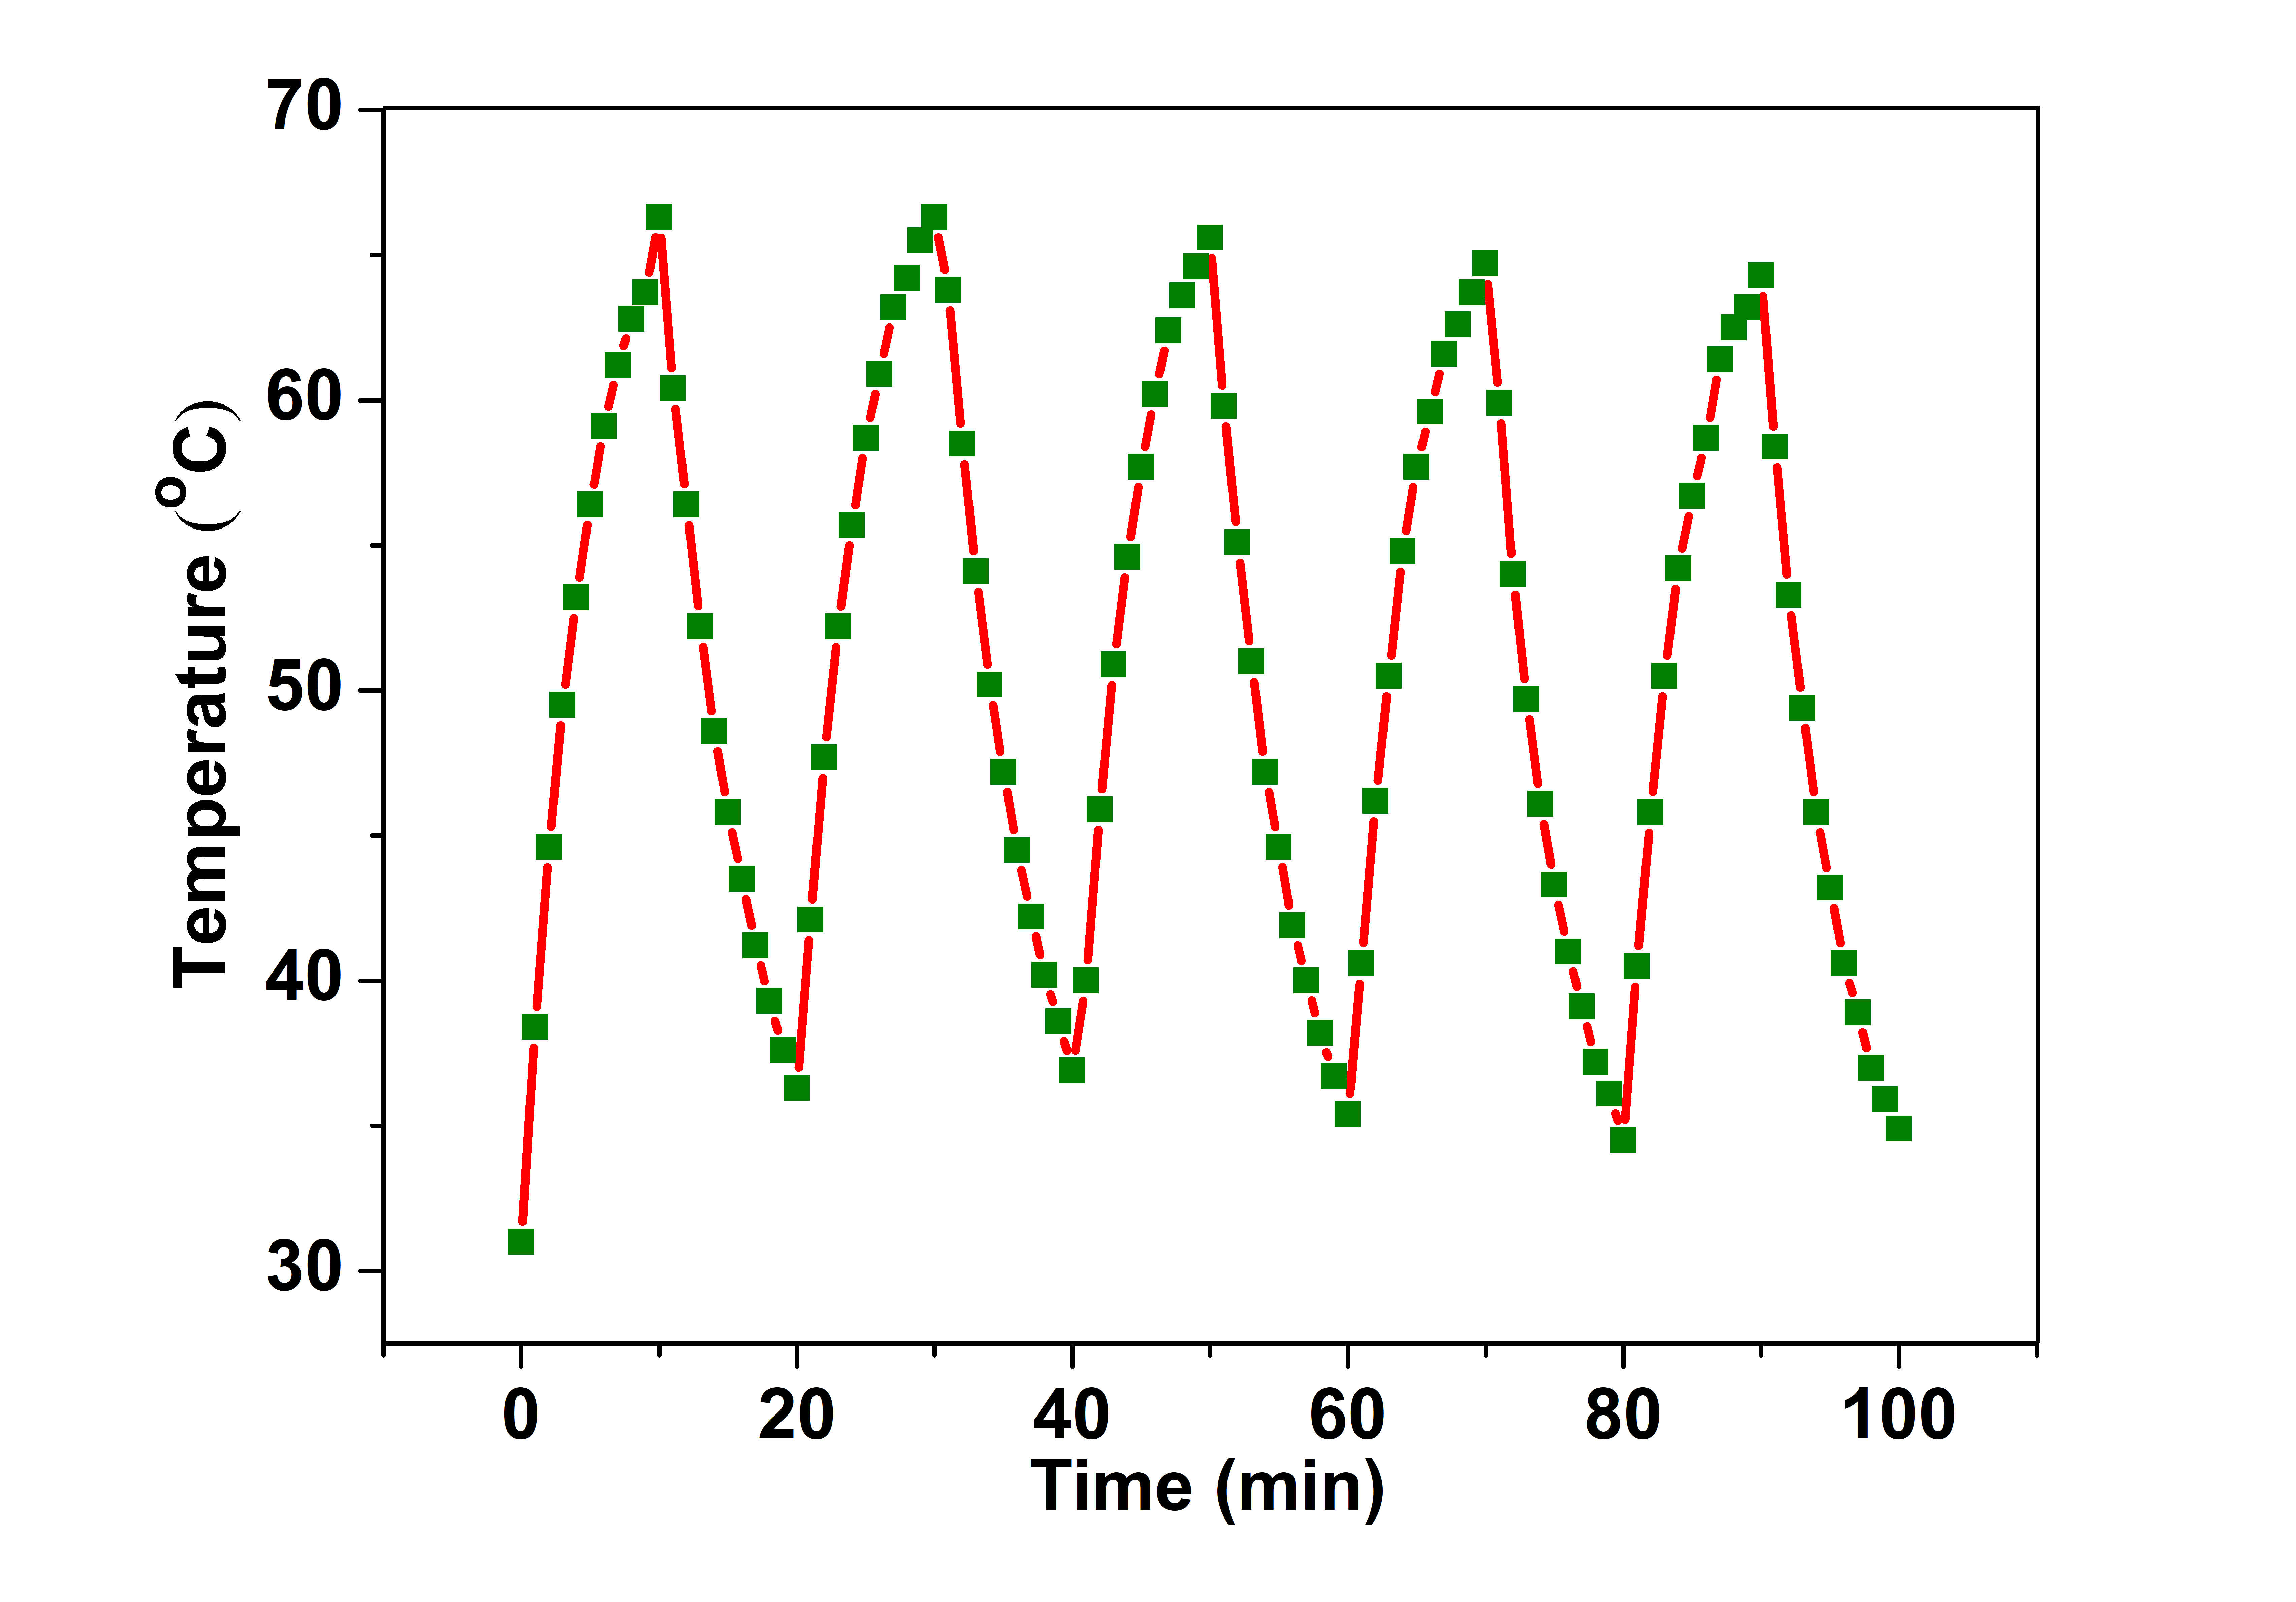
Figure S8: Recycling-heating curves of Pd-Thp-Ti₃C₂T_{x} (50 ppm) exposed to 808 nm at 1.0 W/cm² for five laser on/off cycles.

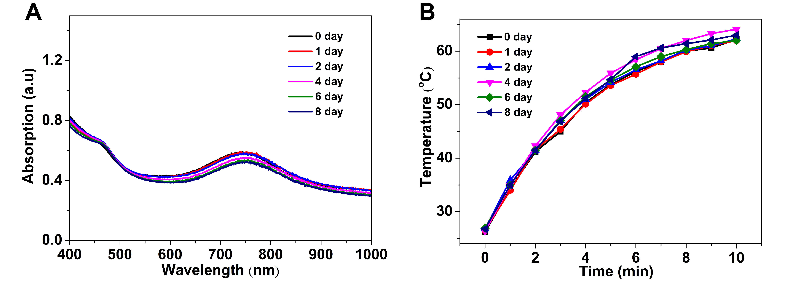
Figure S9:
(A) UV−vis−NIR spectra of Pd-Thp-Ti₃C₂T_{x} at different time (50 ppm). (B) Photothermal-heating curves of Pd-Thp-Ti₃C₂T_{x} at different time (808 nm, 1.0 W/cm² and 50 ppm).

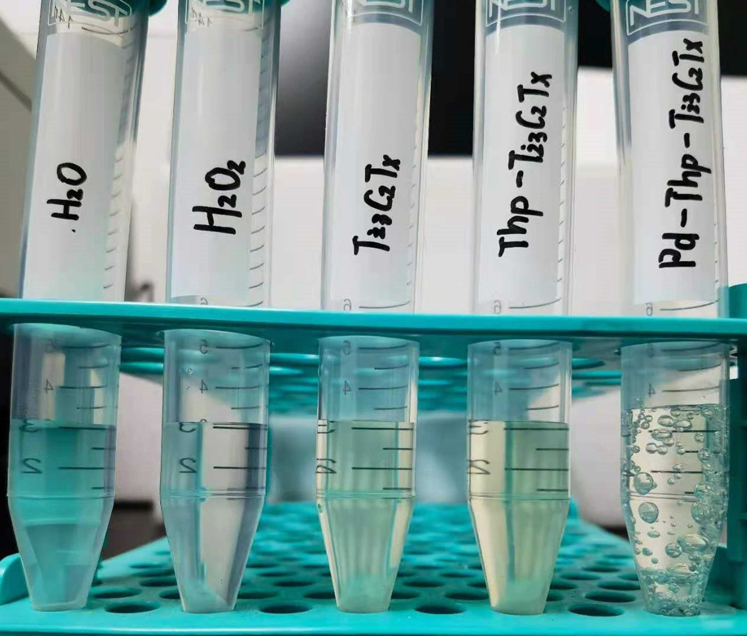
Figure S10: Bubbles generation in pure H₂O, H₂O₂, Ti₃C₂T_{x}, Thp-Ti₃C₂T_{x} and Pd-Thp-Ti₃C₂T_{x} aqueous solution.

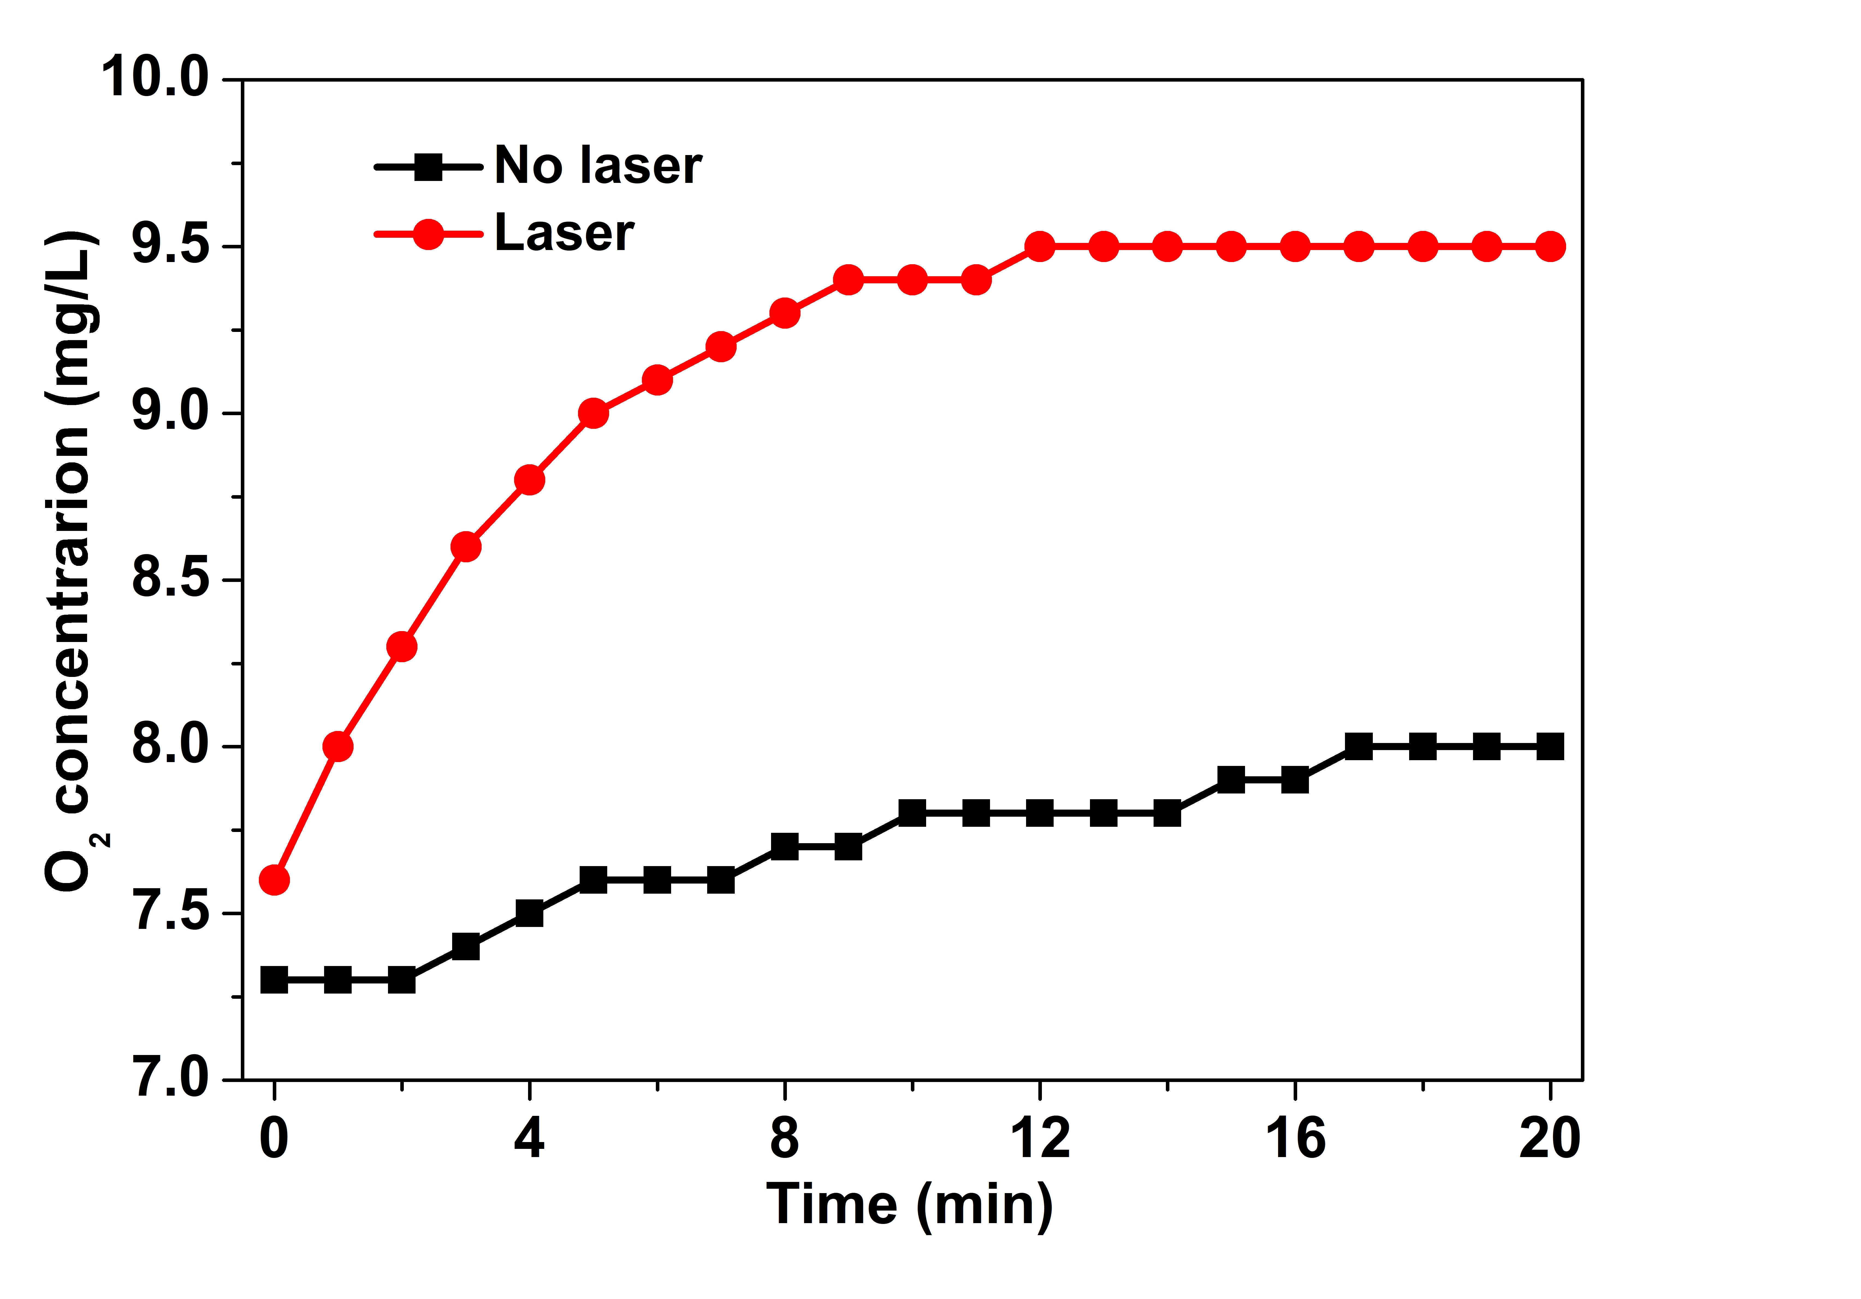
Figure S11: O₂ concentration of H₂O₂ solution in dark or under 808 nm irradiation at 1.0 W/cm², in which the concentration of H₂O₂ was the same as that tested in Fig. 3(d-e).

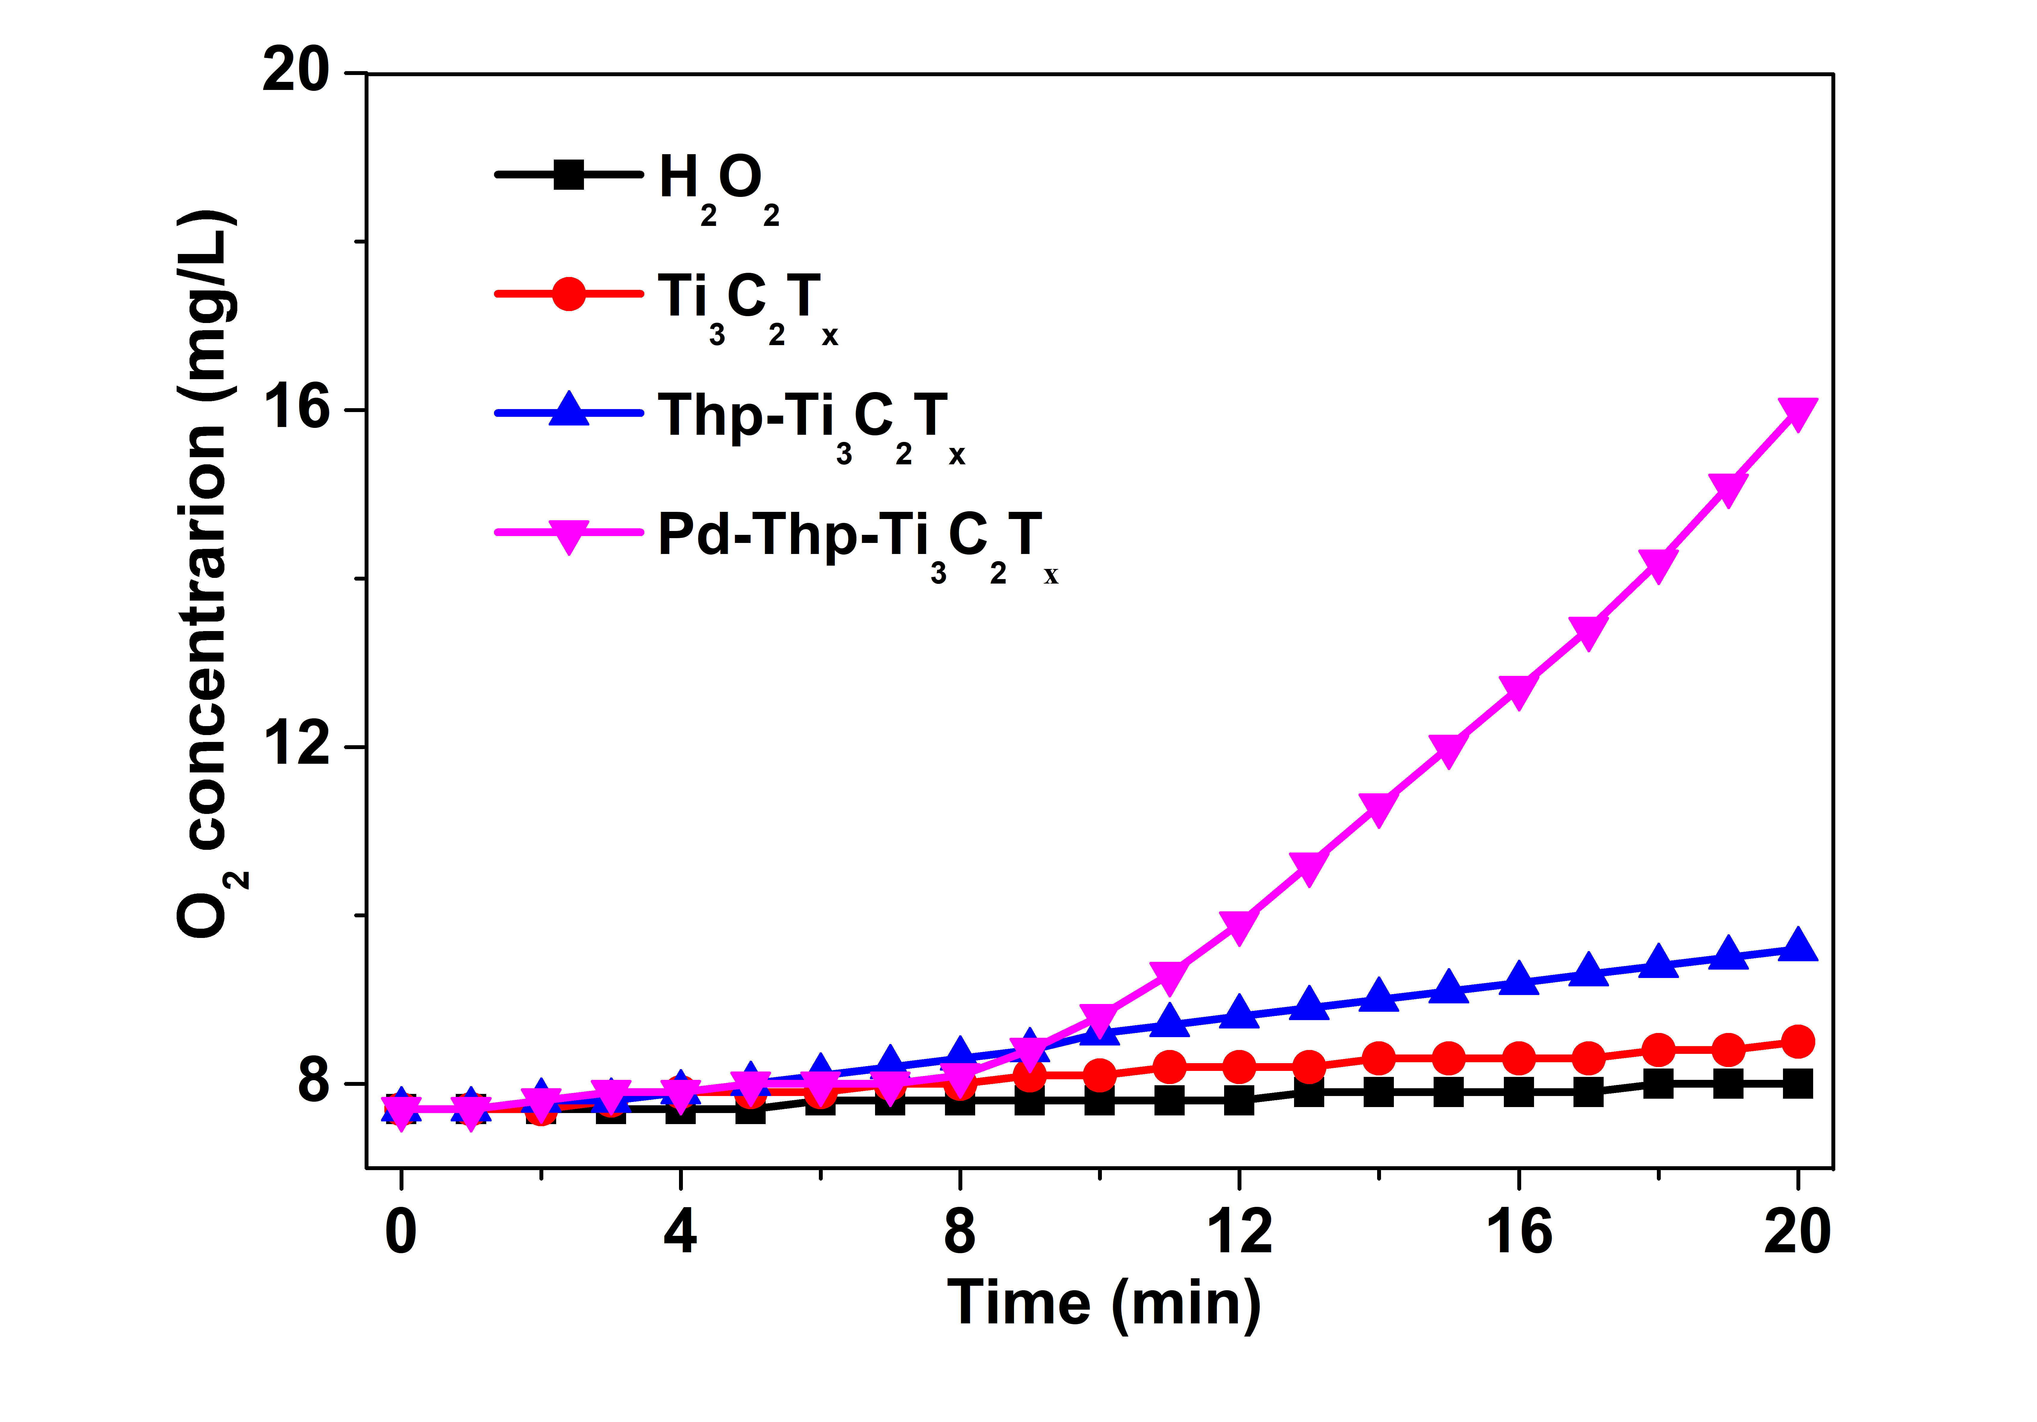
Figure S12: O₂ concentration of H₂O₂ solution after adding different nanocomposites without irradiation.

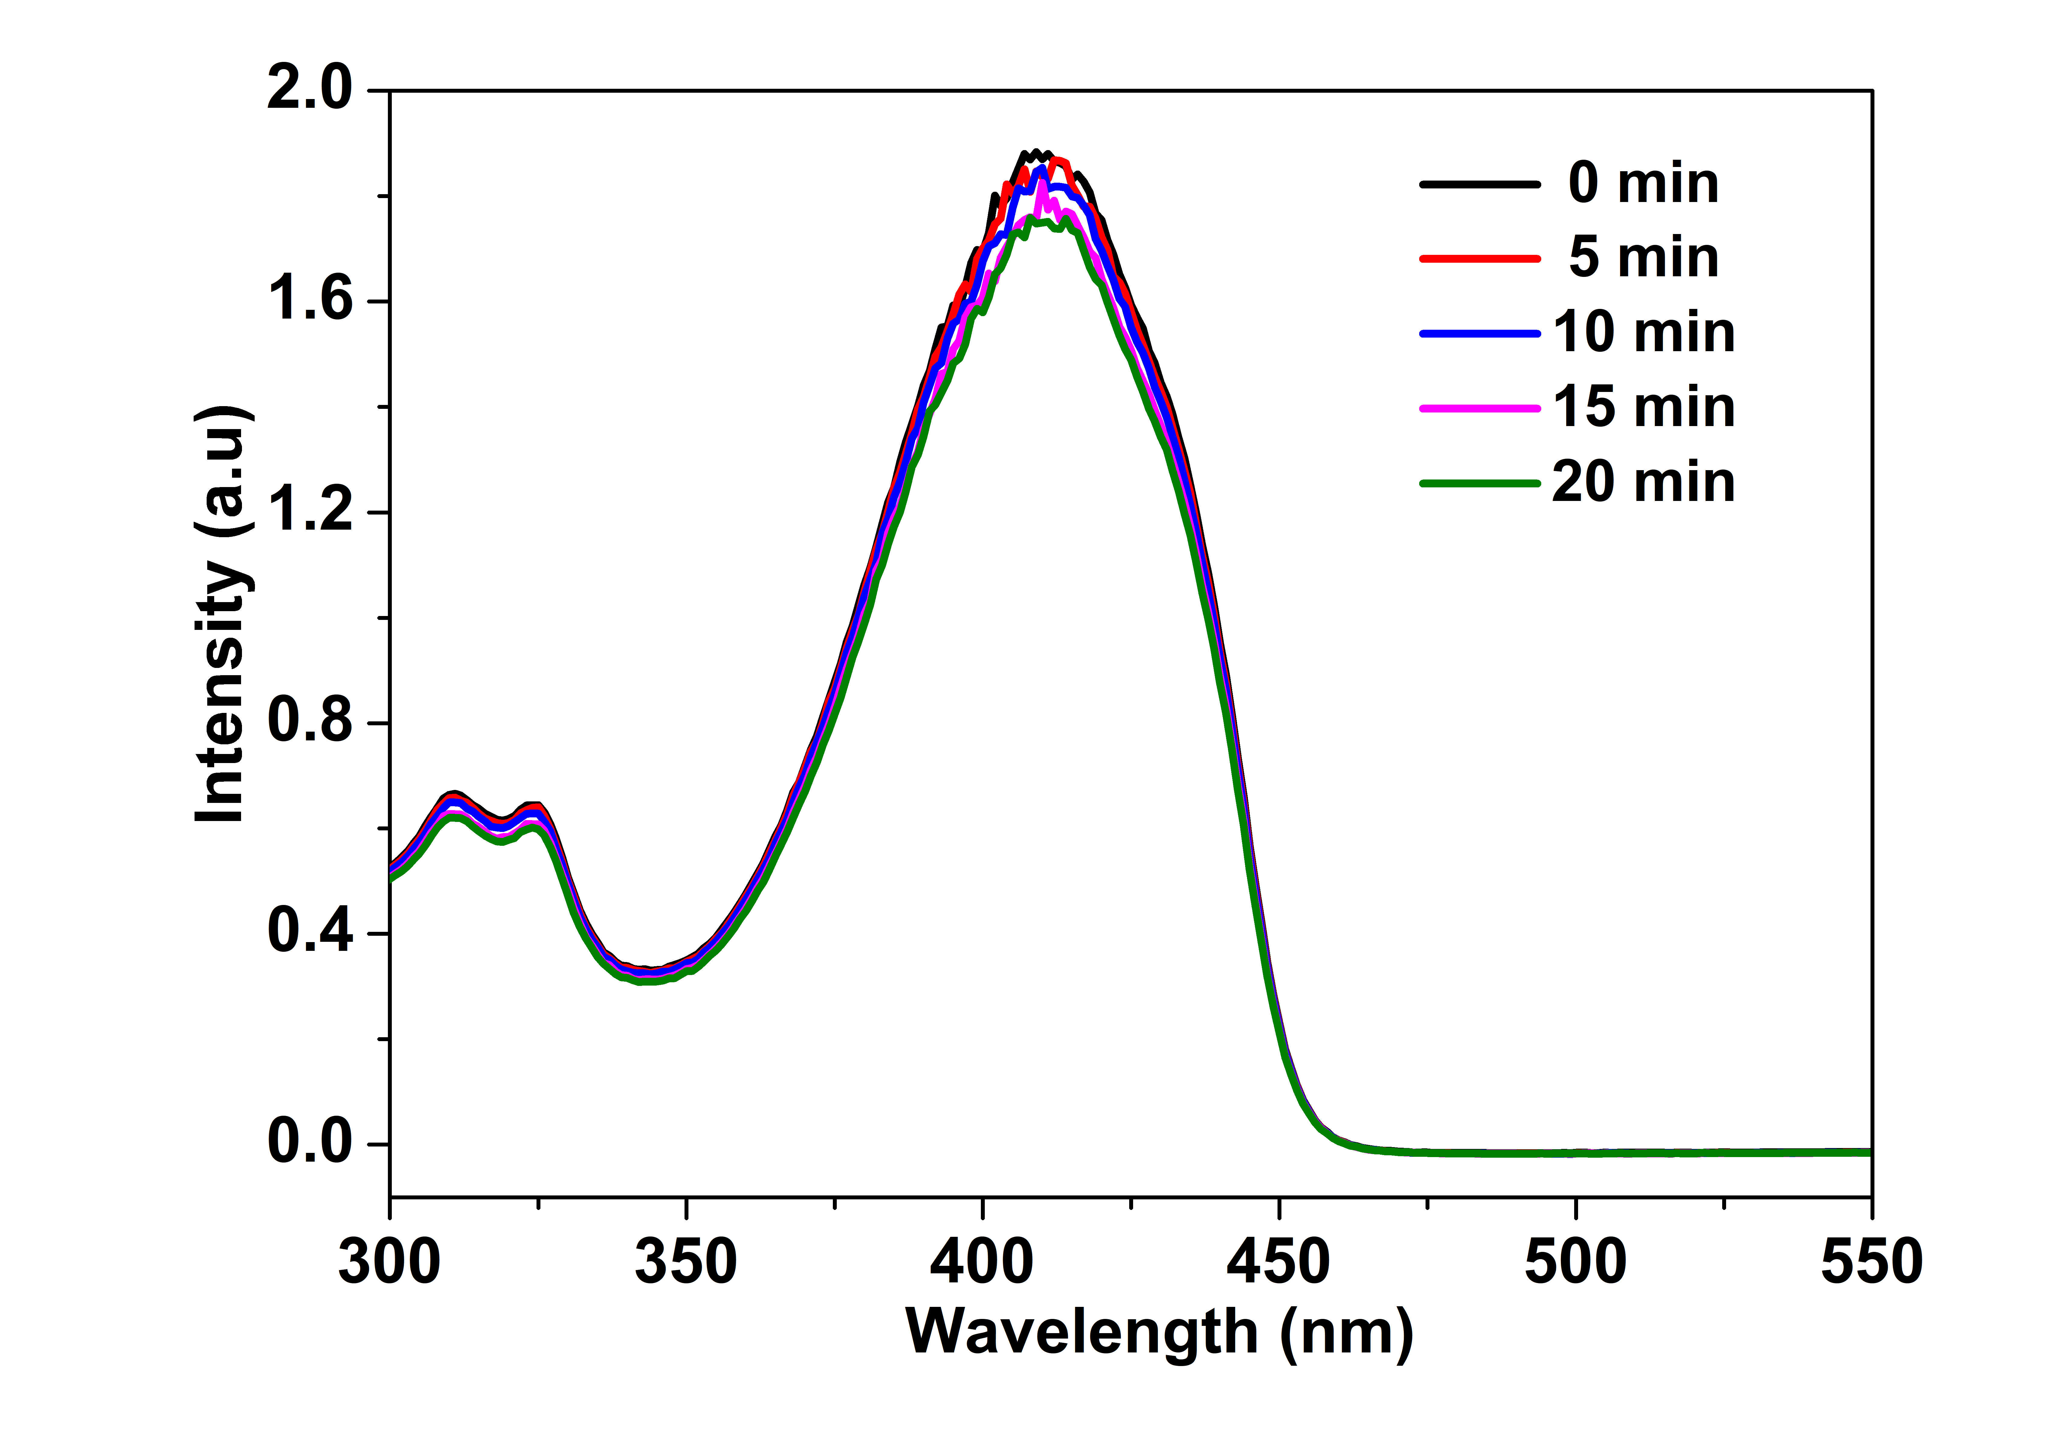
Figure S13: UV-vis-NIR absorption spectra of DPBF under laser irradiation (808 nm, 1.0 W/cm²) for different duration.

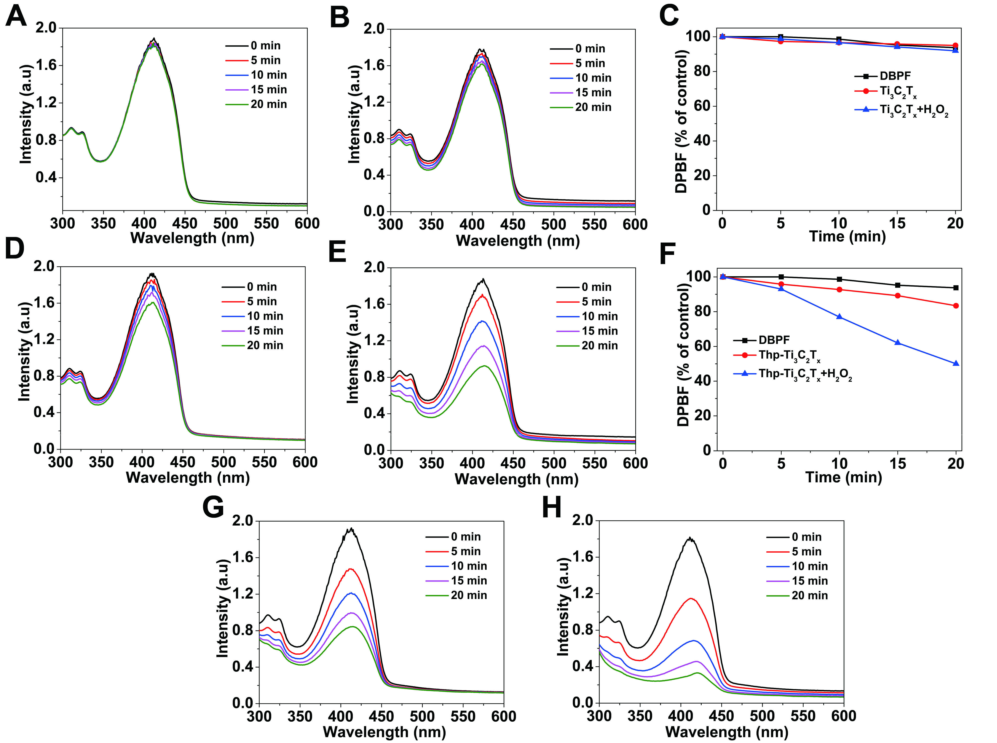
Figure S14:
Absorption spectrum changes of DPBF under 808 nm (1.0 W/cm²) laser irradiation with Ti₃C₂T_{x} in the (A) absence or (B) presence of H₂O₂. Decay curves of DPBF absorption at 410 nm in (C) Ti₃C₂T_{x} and (F) Thp-Ti₃C₂T_{x} with or without H₂O₂ after different time point of irradiation (808 nm, 1.0 W/cm²). Absorption spectrum changes of DPBF under 808 nm (1.0 W/cm²) laser irradiation with Thp-Ti₃C₂T_{x} in the (D) absence or (E) presence of H₂O₂. Absorption spectrum changes of DPBF under 808 nm (1.0 W/cm²) laser irradiation with Pd-Thp-Ti₃C₂T_{x} in the (G) absence or (H) presence of H₂O₂.

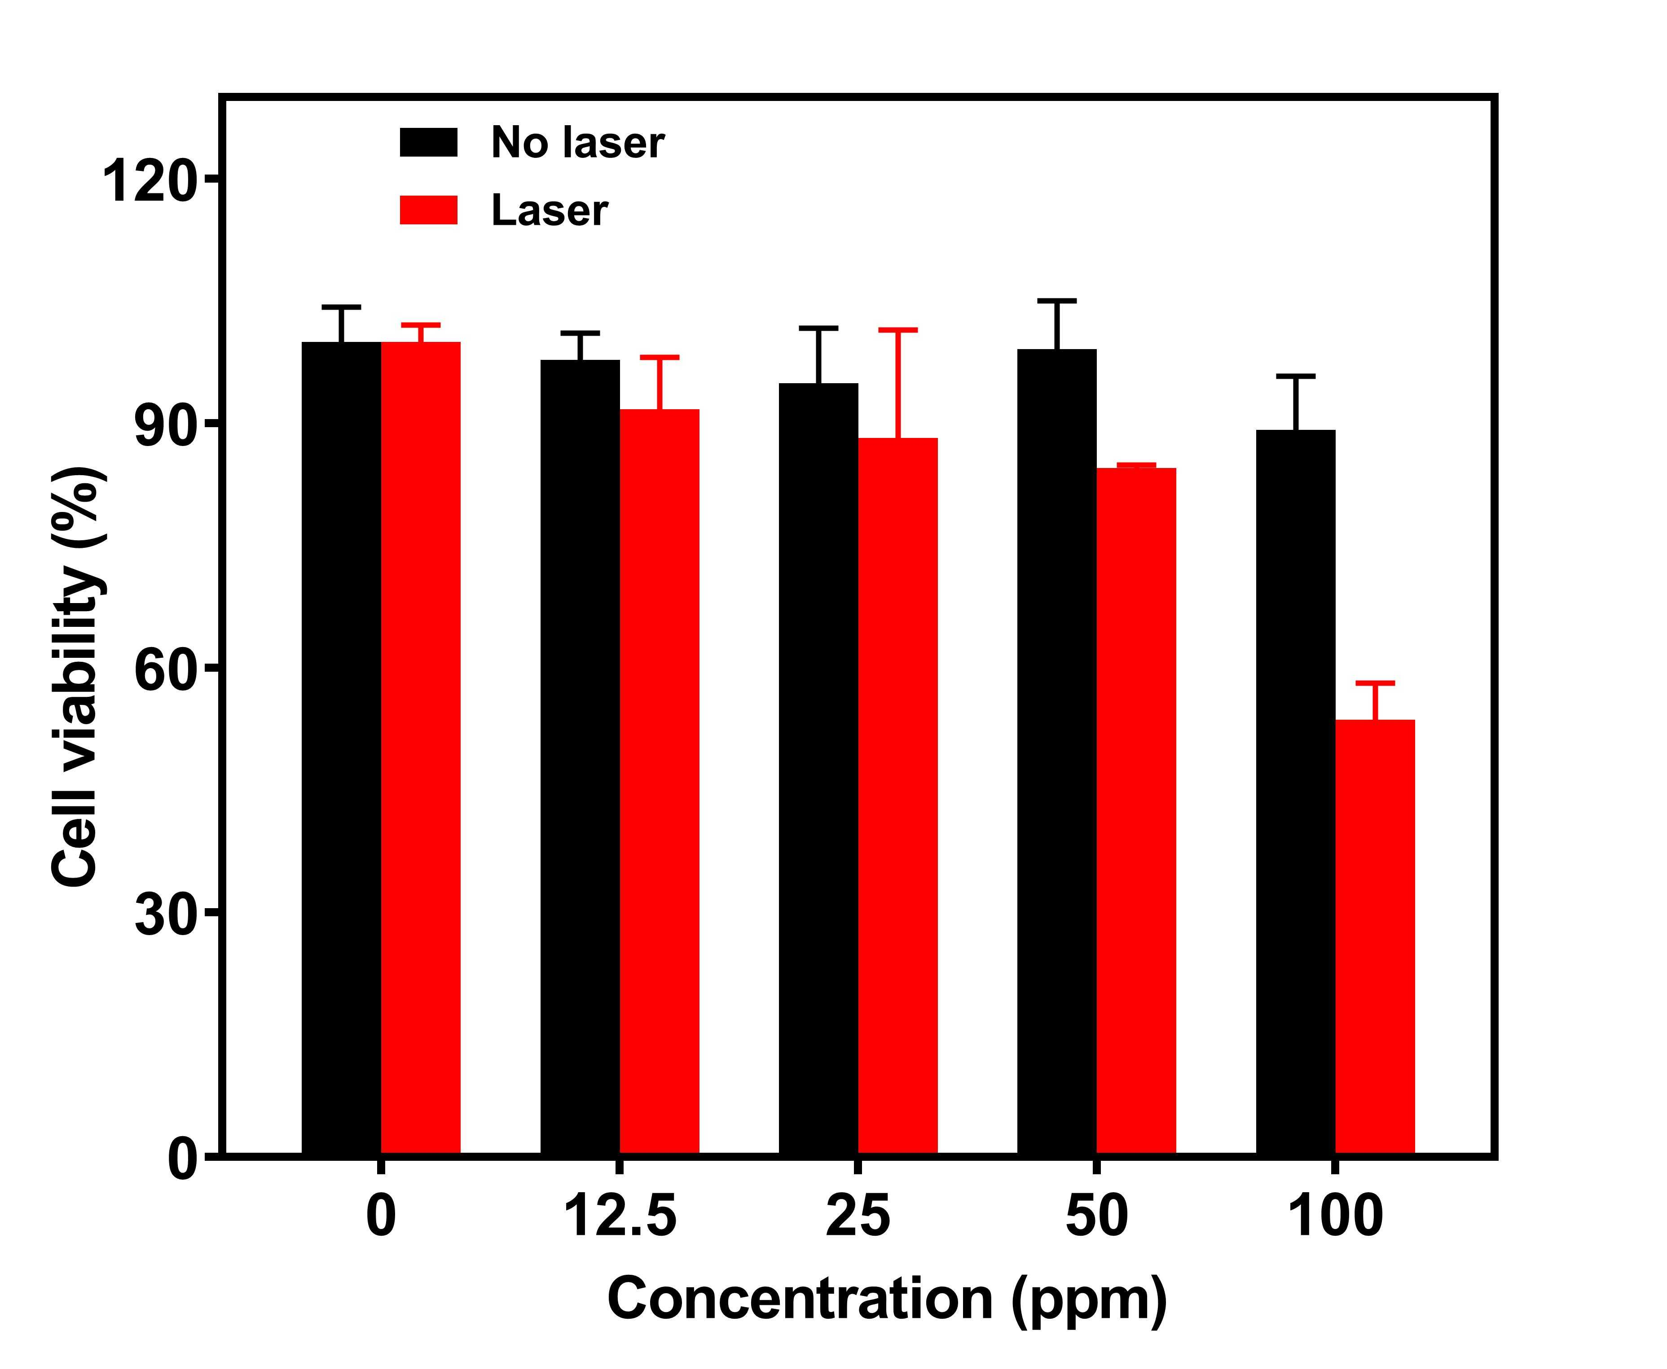
Figure S15: Cell viabilities of SW480 cells incubated with free Thp at different concentration, in which the concentration of Thp was corrected the same as that of Thp-Ti₃C₂T_{x} and Pd-Thp-Ti₃C₂T_{x}.

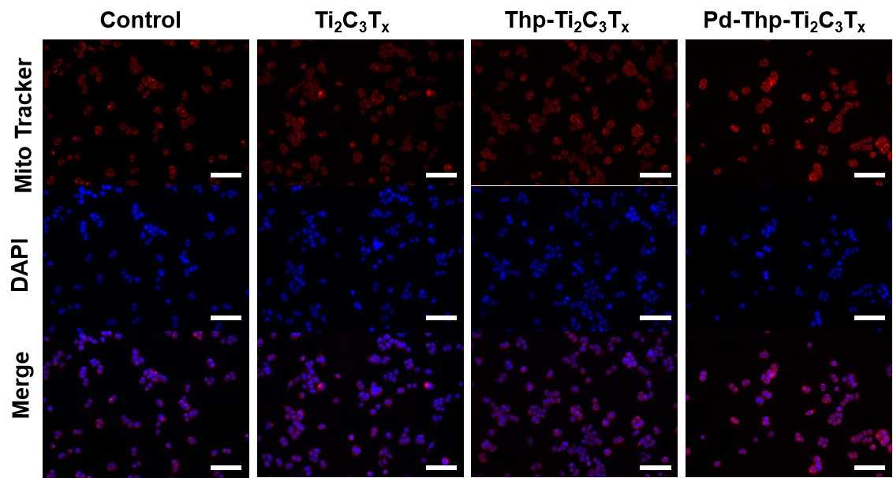
Figure S16: Cells treated with different composites were stained with MitoTracker Red CMXRos without irradiation. (Treatment condition: 12.5 ppm, 808 nm, 1.0 W /cm², 5 min; scale bar: 100 μm).

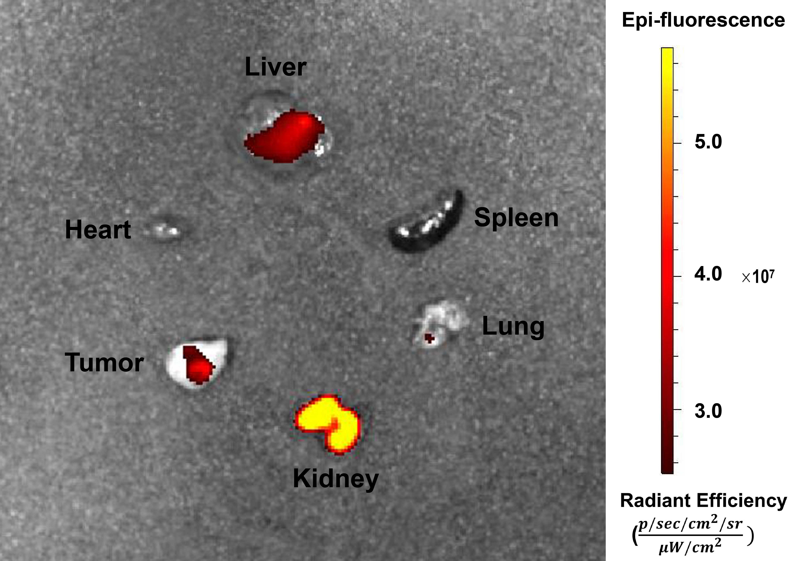
Figure S17: Fluorescence images of major organs and the tumors of mice 72 h post-irradiation.
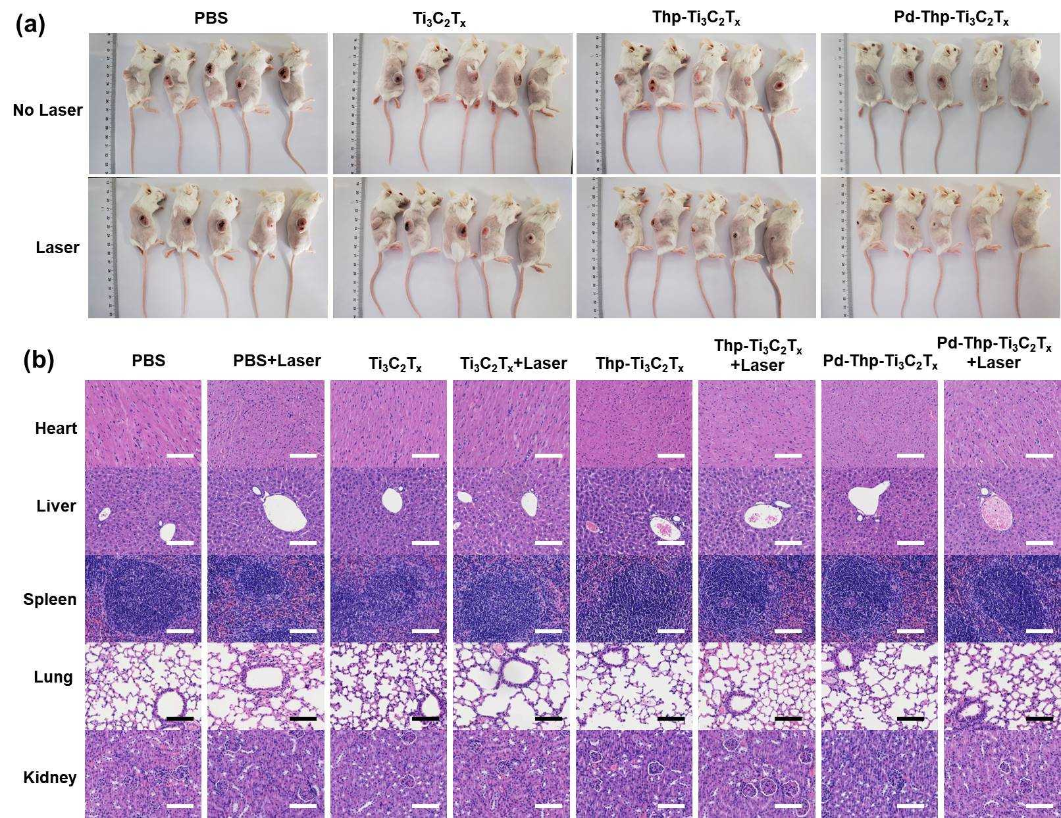
Figure S18:
(A) Digital images of each CT26-tumor-bearing mice of all groups after different treatments at 14th day. (B) H&E-stained tissue sections of major organs from BALB/c mice in biosafety experiments (Scale bar: 100 µm).

