Research Article - Supplementary Information
Chengda Pan, Qiang Ma, Shikang Liu, Yingxian Xue, Zhiyun Fang, Shiyu Zhang, Mengyao Qin, E Wu and Botao Wu*
Angularly Anisotropic Tunability of Upconversion Luminescence by Tuning Plasmonic Local-field Responses in Gold Nanorods Antennae with Different Configurations

Supplementary information
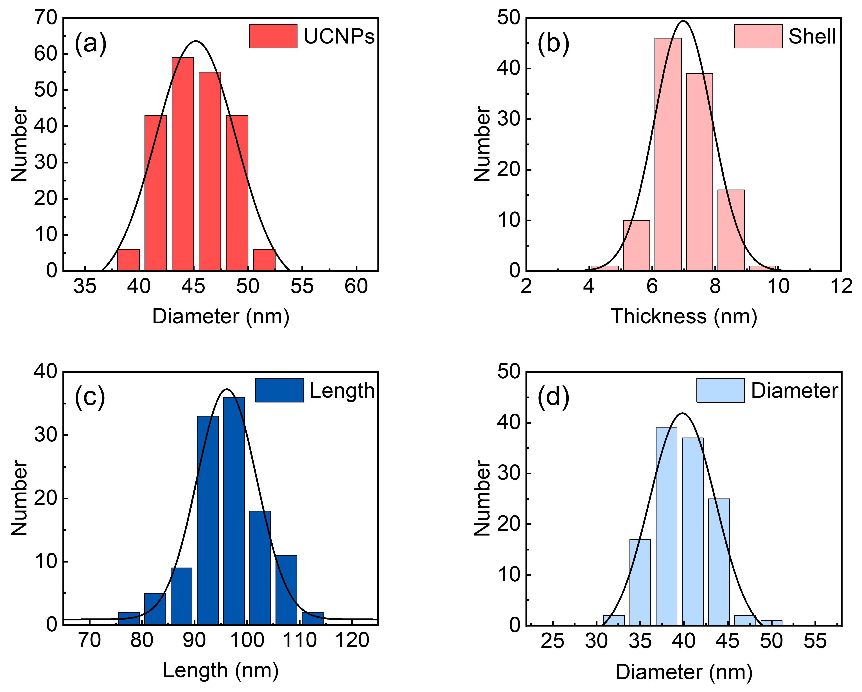
Figure S1. Size distributions of (a) silica-encapsulated UCNPs, (b) the thickness of silica shell, (c) the length and (d) diameters of gold nanorods. Mean sizes are 45.2 ± 0.3 nm, 7.0 ± 0.05 nm, 96.1 ± 0.4 nm and 39.8 ± 0.3 nm, respectively
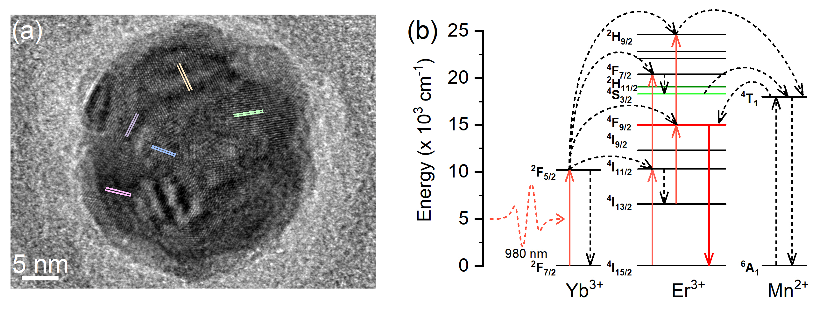
Figure S2. (a) High-resolution TEM image of the UCNPs with characteristic lattice plane information. (b) Energy level diagram with the possible upconversion transitions of Yb³⁺/Er³⁺/Mn²⁺ co-doped NaYF₄ nanocrystals.

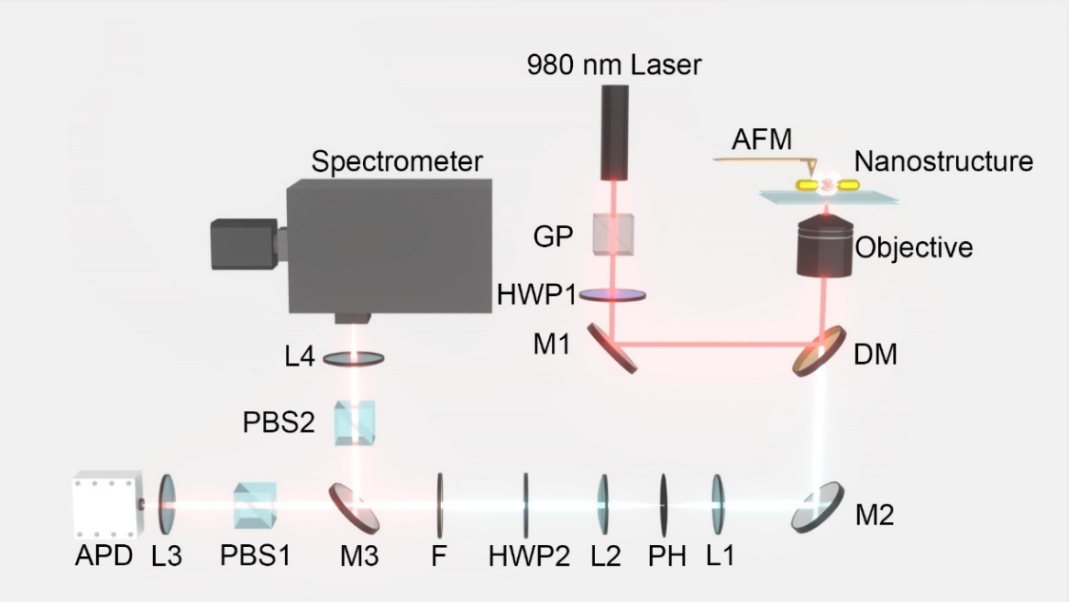
Figure S3. Schematics of experimental setup. An atomic force microscope assisted homemade scanning confocal microscope was used. AFM: atomic force microscope, GP: Glan prism, HWP: half-wave plate, M3: flip mirror, M: silver mirror, DM: dichroic mirror, L: lens, PH: pinhole, F: filter, PBS: polarized beam splitter, APD: single-photon detector based on Si-avalanche photodiode.

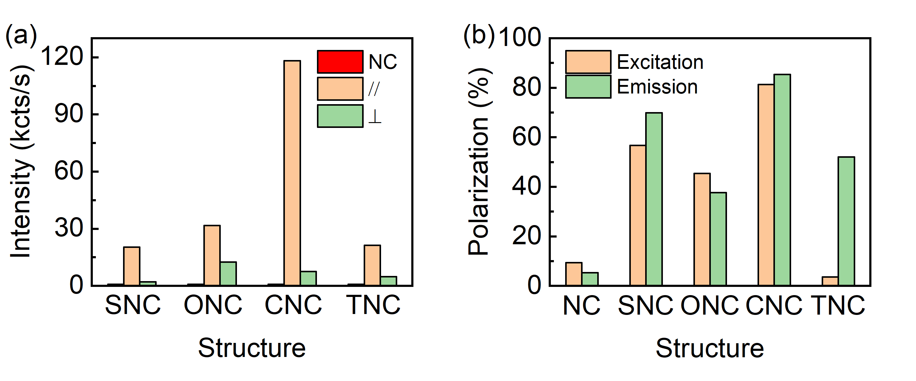
Figure S4. (a) UCL intensity comparison for the single UCNP before and after assembling with Au NRs under parallel (//, 0°) and perpendicular (⊥, 90°) polarized laser excitation. (b) DOLP of different nanoantennae-load UCNP for emission polarization under the excitation polarization angle at 0° (Emission) and excitation polarization as a function of excitation polarization angle (Excitation). The excitation power density is about 7.53 × 10² W cm⁻².

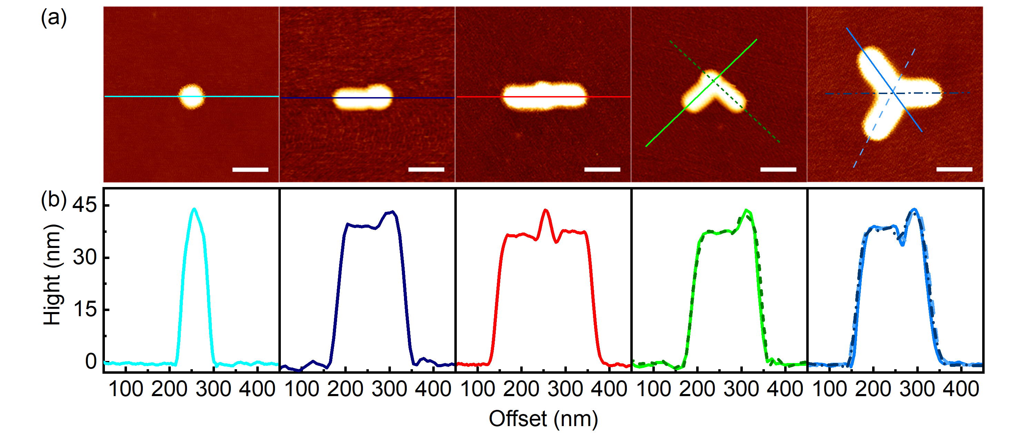
Figure S5. (a) AFM topographic images of the UCNP and different nanoantennae-load UCNP configurations. Scale bar: 100 nm. (b) Corresponding cross-section analyses along the axes direction of longitudinal of Au NRs.

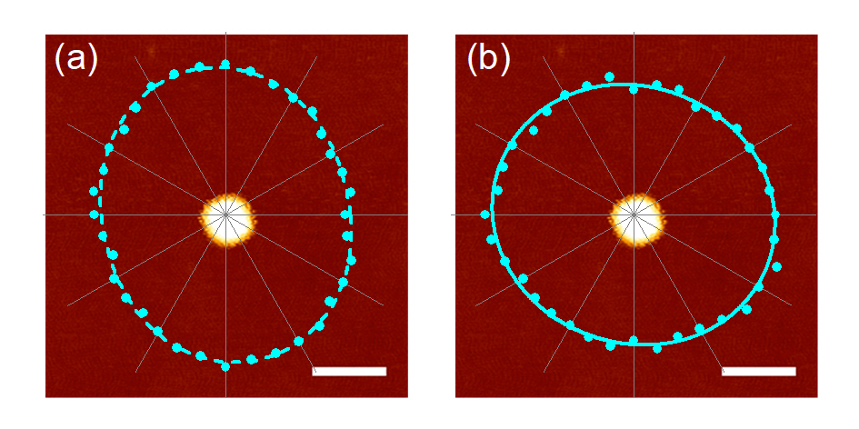
Figure S6. AFM topographic images of the UCNP and related polar plots of normalized UCL intensity at 660 nm (a) under excitation polarization angle at 0° and (b) as a function of excitation polarization angle. Scale bar: 100 nm.
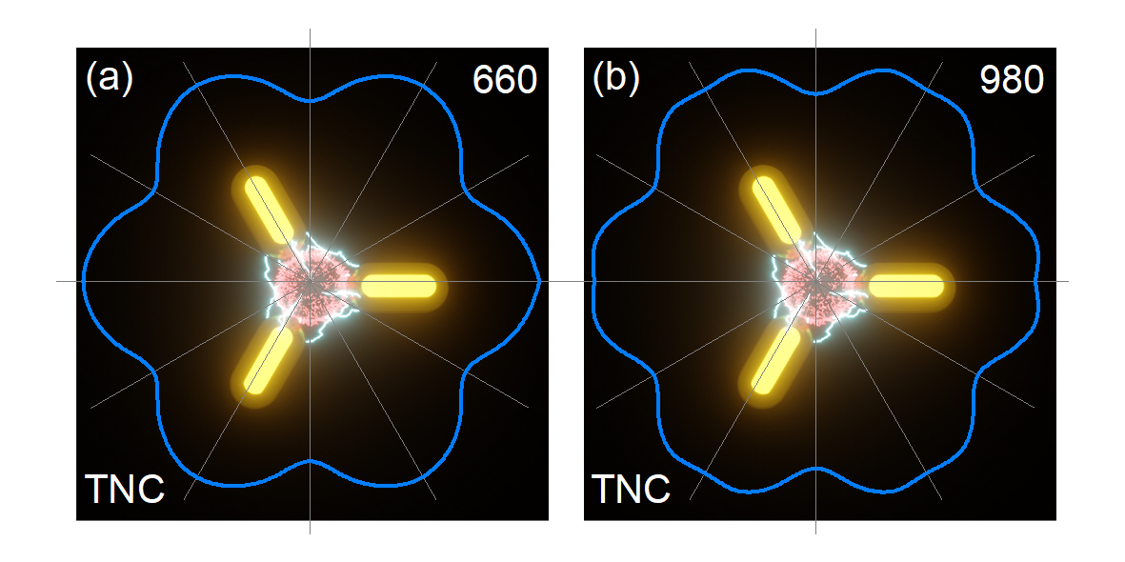
Figure S7. Schematics of TNC with the perfect angle and related polar plots of normalized electric field |E|²/|E₀|² at 660 nm (a) under excitation polarization angle at 0° and (b) as a function of excitation polarization angle. The solid curves are fitted by a sinusoidal function.

Emission Enhancement Calculation
When an emitter is nearby a metallic nanostructure, the metallic nanostructure accelerates the radiative decay rate of the emitter and provides an additional pathway for energy dissipation. The ratio $η_{a}=Γ_{em}^{R}/\left(Γ_{em}^{R}+Γ_{em}^{NR}\right)$ is defined as the antenna efficiency of the metal nanostructure. $Γ_{em}^{R}$ is the accelerated radiative decay rate of the emitter and $Γ_{em}^{NR}$ is the non-radiative decay rate due to energy dissipation. The Purcell factor $F$ can be expressed as the radiative decay rate enhancement. The emission enhancement of the UCNP can be expressed as [1]:
$$\begin{aligned} F_{em}=\frac{1}{\left(1-η_{0}\right)/F+η_{0}/η_{a}},\end{aligned}$$
Here, the quantum efficiency $η_{0}$ of the UCNPs is assumed as 1% because of small absorption cross sections caused by the forbidden transitions between 4f orbitals of the lanthanide dopants [2].

Table S1. Purcell Factors and Antenna Efficiency Calculated by the simulated radiative and nonradiative decay rates.

Sample | 660 nm
Sample | $$F$$ | $$η_{a}$$
SNC | 12.6 | 0.49
ONC | 13.7 | 0.45
CNC | 32.8 | 0.57
TNC | 19.6 | 0.49

References

- X. Liu and D. Y. Lei, “Simultaneous excitation and emission enhancements in upconversion luminescence using plasmonic double-resonant gold nanorods,” Sci. Rep., vol. 5, p. 15235, 2015.
- J. C. Boyer and F. C. J. M. V. Veggel, “Absolute quantum yield measurements of colloidal NaYF₄: Er³⁺, Yb³⁺ upconverting nanoparticles,” Nanoscale, vol. 2, pp. 1417–1419, 2010.

