Supplemental materials for

A high-gain cladded waveguide amplifier on erbium doped thin-film lithium niobate fabricated using photolithography assisted chemo-mechanical etching
Youting Liang^{1, 2}, Junxia Zhou^{1, 2}, Zhaoxiang Liu², Haisu Zhang^{1, 2, *}, Zhiwei Fang², Yuan Zhou³, Difeng Yin³, Jintian Lin³, Jianping Yu³, Rongbo Wu³, Min Wang², and Ya Cheng^{1, 2, 3, 4, 5, 6, *}
¹State Key Laboratory of Precision Spectroscopy, East China Normal University, Shanghai 200062, China.
²The Extreme Optoelectromechanics Laboratory (XXL), School of Physics and Electronic Sciences, East China Normal University, Shanghai 200241, China.
³State Key Laboratory of High Field Laser Physics and CAS Center for Excellence in Ultra-Intense Laser Science, Shanghai Institute of Optics and Fine Mechanics (SIOM), Chinese Academy of Sciences (CAS), Shanghai 201800, China.
⁴Shanghai Research Center for Quantum Sciences, Shanghai 201315, China.
⁵Collaborative Innovation Center of Extreme Optics, Shanxi University, Taiyuan 030006, China. ⁶Collaborative Innovation Center of Light Manipulations and Applications, Shandong Normal University, Jinan 250358, China.
*Correspondence: Haisu Zhang (hszhang@phy.ecnu.edu.cn), Ya Cheng (ya.cheng@siom.ac.cn).

In the Supplemental materials we describe the waveguide fabrication process by PLACE and the theoretical model for the erbium-doped waveguide amplifier.

The waveguide fabrication process by PLACE
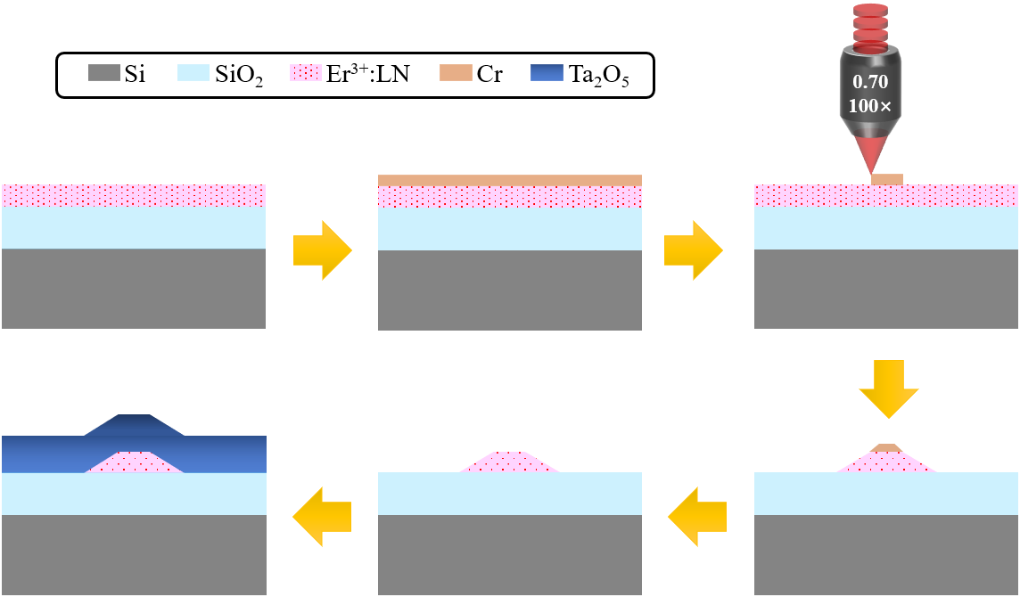
Fig. S1 Schematic illustration of waveguide fabrication process by PLACE.
The waveguide fabrication procedures by PLACE are schematically illustrated in Fig. S1, including (1) deposition of a thin layer of chromium (Cr) with a thickness of 400 nm on the LNOI wafer by magnetron sputtering, and (2) patterning of the Cr film using femtosecond laser ablation, (3) pattern transferring from the Cr mask to the underneath LN thin film by chemo-mechanical polishing (CMP), (4) removal of remaining Cr mask and a secondary CMP. After the waveguide is shaped, a thin layer of Ta₂O₅ is deposited on top of LNOI by sputtering coating. The smooth sidewalls of the fabricated LNOI waveguides are guaranteed by CMP which can maintain subnanometer surface/interface roughness comparable with the surface-tension induced atomic scale finish.

The theoretical model of Er³⁺-doped waveguide amplifier
The Er³⁺-doped amplifier model introduced in Refs. [8, 9] is employed, which includes the steady-state response of the three-level Er³⁺ with ⁴I_{15/2}, ⁴I_{13/2}, and ⁴I_{11/2}, and the migration-accelerated ETU process and the concentration quenching of erbium ions. The involved transitions are shown in Fig. S2.
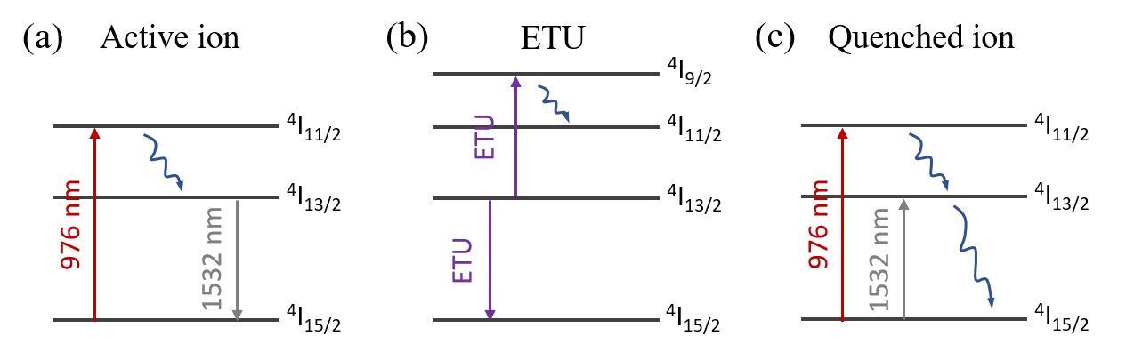
Fig. S2 The involved Er³⁺ energy levels in the amplifier model. (a) the 3-level system for active ions. (b) the migration-accelerated ETU process. (c) the 3-level system for quenched ions. The blue wavy arrows denote fast decay.

The steady-response of Er³⁺ in the pump and signal fields can be obtained by the equations below:
$\frac{dN_{2}}{dt}=F_{P}\left(σ_{a}^{P}N_{0}-σ_{e}^{P}N_{2}\right)+W_{ETU}N_{1}^{2}-\frac{1}{τ_{2}}N_{2}=0$ (1)
$\frac{dN_{1}}{dt}=F_{s}\left(σ_{a}^{S}N_{0}-σ_{e}^{S}N_{1}\right)+\frac{1}{τ_{2}}N_{2}-2W_{ETU}N_{1}^{2}-\frac{1}{τ_{1}}N_{1}=0$ (2)
$N_{0}+N_{1}+N_{2}=N_{d}$ (3)
where $N_{i}$(i=0, 1, 2) denote the population density of ⁴I_{15/2}, ⁴I_{13/2}, and ⁴I_{11/2} states, $N_{d}$ is the total density of Er³⁺, $τ_{2}$ is the non-radiative decay time from ⁴I_{11/2} to ⁴I_{13/2}, $τ_{1}$ is the intrinsic decay time of ⁴I_{13/2}, $W_{ETU}$ is the macroscopic migration parameter for (⁴I_{13/2}, ⁴I_{13/2})→(⁴I_{15/2}, ⁴I_{9/2}), $σ_{a}^{P}$($σ_{a}^{S}$) and $σ_{e}^{P}$($σ_{e}^{S}$) are the absorption and emission cross sections for the pump (signal) light. $F_{P}={I_{P}}/{hν_{P}}$ and $F_{P}={I_{S}}/{hν_{S}}$ are the photon fluxes of the pump and signal light, with $I_{P}$($I_{P}$) and $ν_{P}$($ν_{S}$) being the pump (signal) intensity and frequency. The excited population of the ⁴I_{9/2} level by ETU is not included since it will decay to the ⁴I_{11/2} level by fast multiphonon relaxation in less than 1 μs.
For the concentration quenching, a small fraction ($f_{q}$) of Er³⁺ is assumed to decay rapidly from excited states by static ETU among active ion-pairs or clusters, and excited state trapping by host material defects, resulting in a luminescence lifetime of quenched ions on the order of 1 μs. The response of quenched ions can also be described by equations (1)-(3) with the replacement of the total ion density $N_{d}$ and the excited level lifetimes $τ_{2}$&$τ_{1}$ by ${f_{q}N}_{d}$ and $τ_{q}$, respectively. The total optical gain is obtained by summing up the steady-state responses of active ions${(1-f_{q})N}_{d}$ and quenched ions ${f_{q}N}_{d}$.
Excited-state absorption (ESA) at the pump wavelength is included as a loss factor in the light propagation along the Er³⁺-doped waveguide, which written as:
$\frac{dP_{P}\left(z\right)}{dz}=P_{P}\left(z\right)\left[\iint{Ψ_{P}\left(x,y\right)\left(σ_{e}^{P}N_{2}-σ_{ESA}^{P}N_{2}-σ_{a}^{P}N_{0}\right)}dxdy-α\right]$ (4)
$\frac{dP_{S}\left(z\right)}{dz}=P_{S}\left(z\right)\left[\iint{Ψ_{S}\left(x,y\right)\left(σ_{e}^{S}N_{1}-σ_{a}^{S}N_{0}\right)}dxdy-α\right]$ (5)
$P_{P}\left(z\right)$ and $P_{S}\left(z\right)$ are the pump and signal powers at the waveguide length $z$, $α$ is the waveguide passive propagation loss. $Ψ_{P}\left(x,y\right)$ and $Ψ_{S}\left(x,y\right)$ are the normalized modal field intensities at the pump and signal wavelengths obtained from finite element simulation.
The utilized parameters for Er³⁺:LNOI waveguide amplifier are listed in table S1.
Parameter | Value | Source
$$σ_{a}^{S}$$ | 1.95×10⁻²⁰ cm² | [27]
$$σ_{e}^{S}$$ | 1.55×10⁻²⁰ cm² | [27]
$$σ_{a}^{P}$$ | 0.85×10⁻²⁰ cm² | [27]
$$σ_{e}^{P}$$ | 0 | [27]
$$σ_{ESA}^{P}$$ | 1.0×10⁻²² cm² | [28]
$$W_{ETU}$$ | 1.0×10⁻¹⁸ cm³/s | [28]
$$τ_{2}$$ | 200 μs | [28]
$$τ_{1}$$ | 2.35 ms | [29]
$$τ_{q}$$ | 1 μs | [9]
$$f_{q}$$ | 0, 0.1, 0.2
$$λ_{P}$$ | 976 nm
$$λ_{S}$$ | 1532 nm
$$α$$ | 0.1 dB/cm
$$N_{d}$$ | 1.9×10²⁰ cm⁻³

