Double Rabi Splitting in Methylene Blue Dye-Ag Nanocavity

Xiaobo Han¹, Fang Li^{1,*}, Zhicong He¹, Yahui Liu¹, Huatian Hu¹, Kai Wang^{2,*}, and Peixiang Lu^{1,2,3}
¹Hubei Key Laboratory of Optical Information and Pattern Recognition, Wuhan Institute of Technology, Wuhan 430205, China
²Wuhan National Laboratory for Optoelectronics and School of Physics, Huazhong University of Science and Technology, Wuhan 430074, China
³Guangdong Intelligent Robotics Institute, Dongguan 523808, China
*Corresponding authors: lifang@wit.edu.cn (FL), kale_wong@hust.edu.cn (KW)

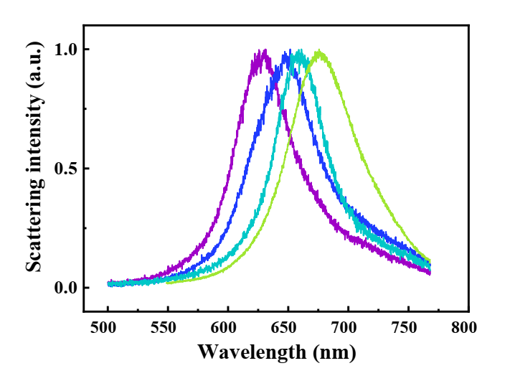
Figure S1. Scattering spectra of Ag nanocavities by varying the size of nanocubes (65-95 nm).
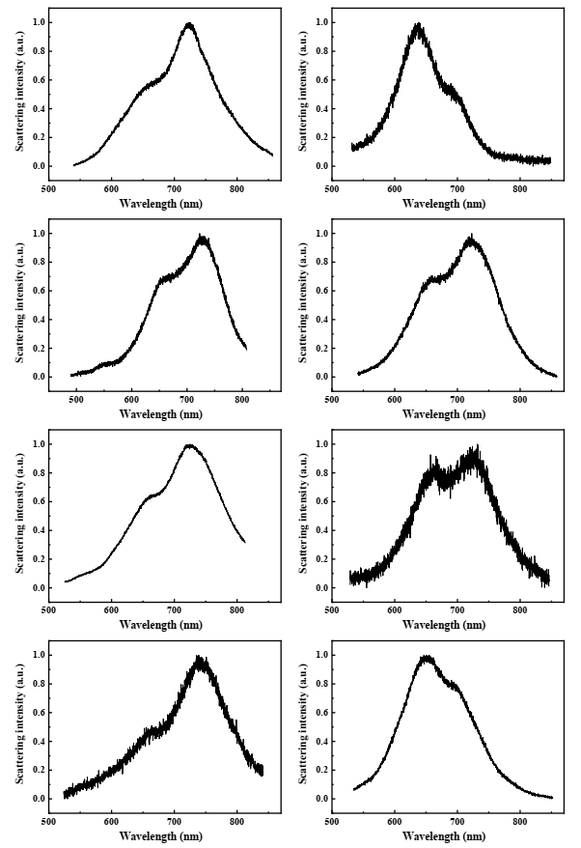
Figure S2. Representative scattering spectra of hybrids at a low dye concentration.

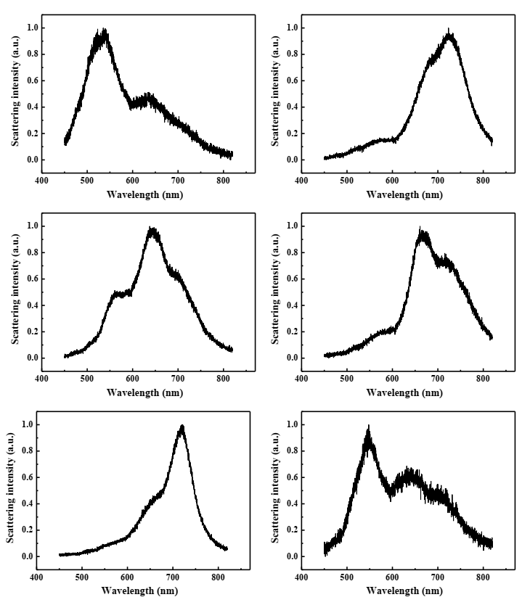
Figure S3. Representative scattering spectra of hybrids at a high dye concentration.

