Controlling and probing heat generation in an optical heater system

Hairegu Tuxun¹, Zefeng Cai¹ , Min Ji¹, Baobao Zhang¹, Chengyun Zhang¹, Jinping Li¹, Xudong Yu², Zhengkun Fu^{1*}, Zhenglong Zhang¹, Hairong Zheng^{1*}
¹School of Physics and Information Technology, Shaanxi Normal University, 710119，Xi'an, China
²State Key Laboratory of Quantum Optics and Quantum Optics Devices, Shanxi University, Taiyuan, 030006, China
*Email: zkfu@snnu.edu.cn (Z. K. Fu) and hrzheng@ snnu.edu.cn (H. R. Zheng)

Supporting information -1

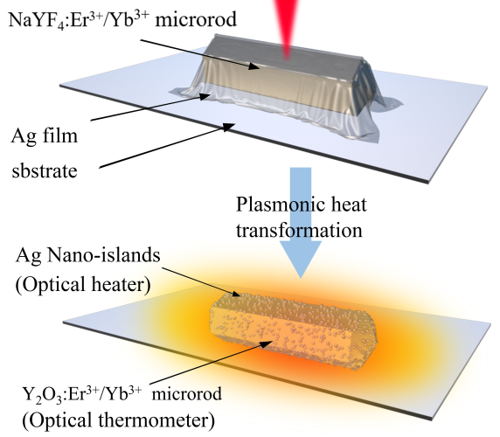
Figure S1. Schematic of the obtained optical heater (Ag NIs) coated optical thermometer Y₂O₃:Er³⁺/Yb³⁺ with the assistance of photothermal effect.

Ag NIs coated Y₂O₃:Er³⁺/Yb³⁺ microrods were obtained from NaYF₄:Er³⁺/Yb³⁺ microrods through a PT catalysis reaction caused by a surface plasmon effect [1]. In the first step, isolated NaYF₄:Er³⁺/Yb³⁺ microrods were distributed on pre-cleaned glass surfaces. Subsequently, a 20 nm thick silver film was evaporated onto the treated surface under a high vacuum environment as shown Figure S1. By applying proper laser irradiation at a wavelength of 980 nm, optical thermometer Y₂O₃:Er³⁺/Yb³⁺ coated with Ag NIs-referred to as “optical heaters” in this study-were obtained. Under laser irradiation, the LSPR can be excited and decayed into electron-hole pairs through Landau damping [2]. The hot carriers rapidly transfer energy to the lattice via elastic electron-electron scattering and electron-phonon coupling, and a high lattice temperature occurs over several picoseconds [3]. The heat generated by the Ag NIs is transferred to NaYF₄, which enables a fast temperature equilibration. When enough thermal energy conveyed to the crystal, reactant NaYF₄ will rapidly transform into Y₂O₃ and finally recrystallize to crystal over tens of milliseconds.

Supporting information -2
The hexagonal NaYF₄:Er³⁺/Yb³⁺ microrods were synthesized by the hydrothermal method. As shown by scanning electron microscope (SEM) image in Figure S2 (a), the particles are uniform microrods. A lattice spacing of 0.263 nm indicates the hexagonal (101) lattice plane of the microcrystal in Figure S2 (b). The XRD pattern shown in Figure S2 (c) is consistent with the standard peak position of the hexagonal phase of NaYF₄ (JCPDS file NO.16-0334).

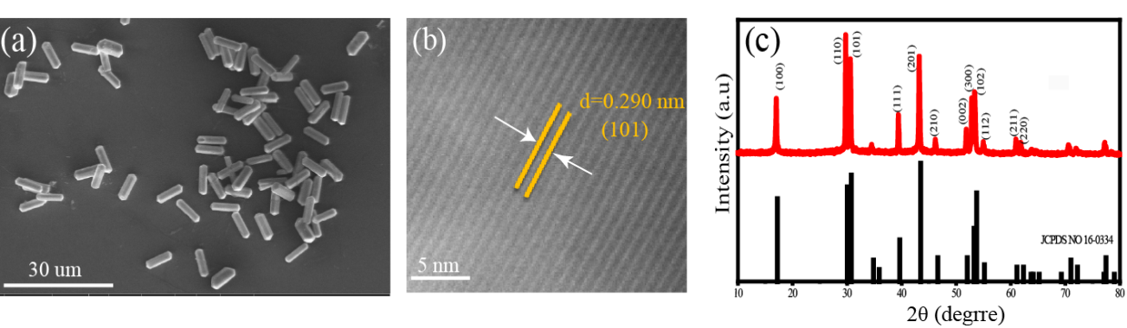
Figure S2. Characterization of NaYF₄:Er³⁺/Yb³⁺ microrod (a) SEM image; (b) HR-TEM image; (c) XRD pattern.

Supporting information -3
The SEM image and EDX elemental mapping image as shown in Figure S3 (a) and (b), indicate that the Ag film is uniformly deposited on the surface of NaYF₄:Er³⁺/Yb³⁺ on the glass substrate.

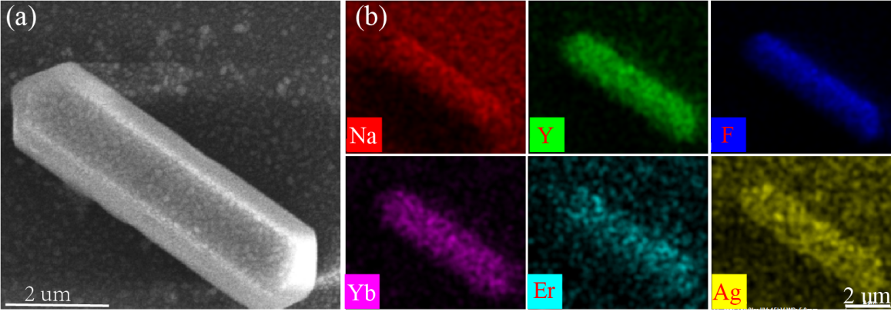
Figure S3. (a) SEM image of the microrod coated with silver film; (b) EDX elemental mapping.

Supporting information -4
Ag NIs coated Y₂O₃:Er³⁺/Yb³⁺ microrod is obtained from NaYF₄:Er³⁺/Yb³⁺ microrod through the photothermal catalysis of surface plasmon effect. As shown in Figure S4, the spectral changes also indicate that the emission arises from Er³⁺/Yb³⁺ doped into Y₂O₃.

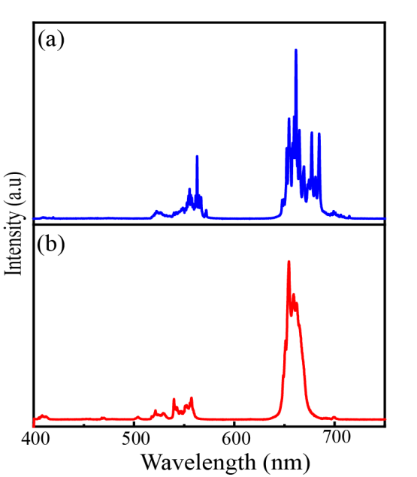
Figure S4. Luminescence spectra of (a) in situ transformed to Y₂O₃:Er³⁺/Yb³⁺ with nano-island after laser irradiation with power density of 60 mW. (b) NaYF₄:Er³⁺/Yb³⁺ with Ag films before using high power irradiated (5 mW).

Supporting information -5
After laser irradiation, the silver film is transformed into silver nano-islands and coated on the surface of Y₂O₃:Er³⁺/Yb³⁺ as shown Figure S5 (a). The energy dispersive x-ray (EDX) elemental mapping analysis further proves the transformation from NaYF₄ to Y₂O₃ as shown Figure S5 (b)-(f).

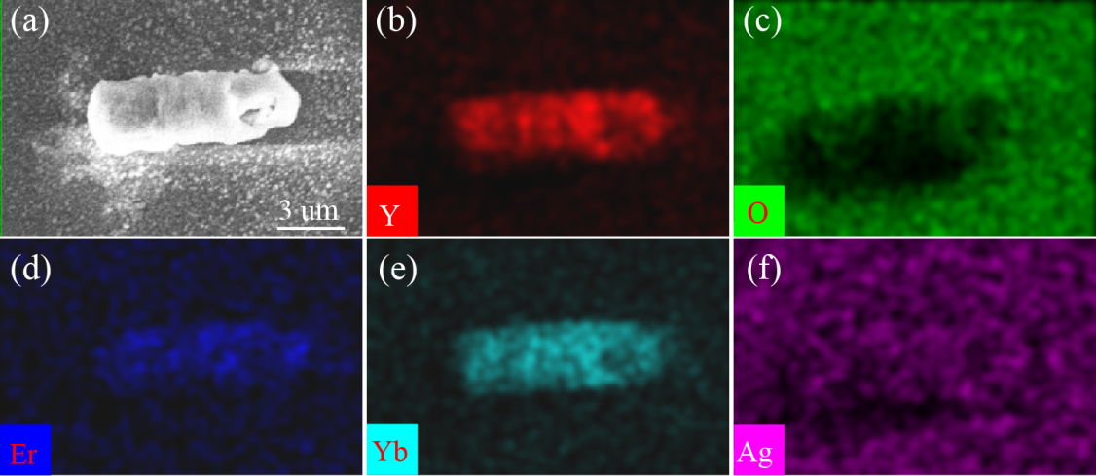
Figure S5. (a) SEM image of the microrod Y₂O₃:Er³⁺/Yb³⁺ coated with nano-islands; (b)-(f) EDX elemental mapping.

Supporting information -6
To confirm the transformation, The selected area electron diffraction (SAED) pattern is carried out as shown in Figure S6 (a), which confirms that the resulting particle is single-crystal Y₂O₃ with a cubic $Ia\overline{3}$ structure and lattice parameter $a=10.604A^{°}$. The lattice fringes spacing of 0.53 nm fits well with the Y₂O₃ faces of (200) as shown in Figure S6 (b). These results indicate that the crystal transformation of NaYF₄ into crystal Y₂O₃ through a PT catalysis reaction caused by a surface plasmon effect.

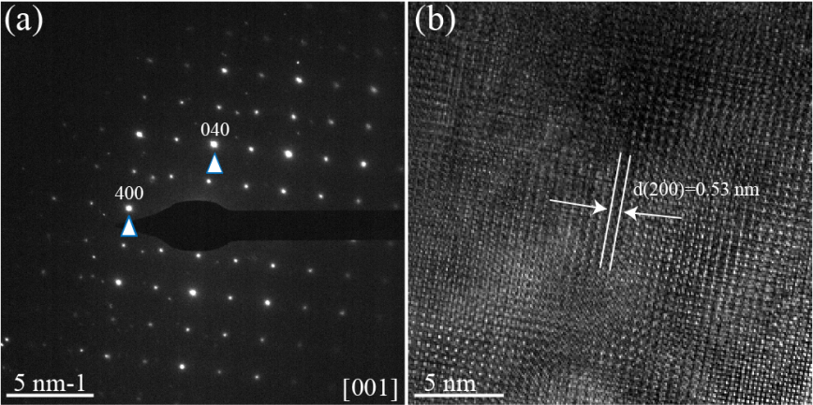
Figure S6. SAED pattern of the Y₂O₃:Er³⁺/Yb³⁺ microrod coated with nano-islands is obtained from NaYF₄:Er³⁺/Yb³⁺ microrod through the photothermal catalysis of surface plasmon effect.

Supporting information -7
From Figure S7 (a) and (b), the average size of the nano-islands is about 100-200 nm.

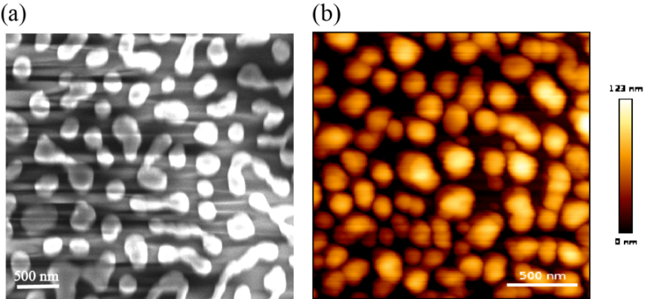
Figure S7. (a) SEM and (b) AFM image for the Ag NIs.

Supporting information -8
Luminescence spectra of the single microrod NaYF₄:Er³⁺/Yb³⁺ before and after laser irradiation are acquired on a glass substrate without coated by Ag NIs. No changes are observed in the luminescence spectra without coated by Ag NIs even after laser irradiation 30 min (Figure S8), which indicate that the plasmonic thermal effect play an important role for the crystal transformation NaYF₄ in to Y₂O₃.

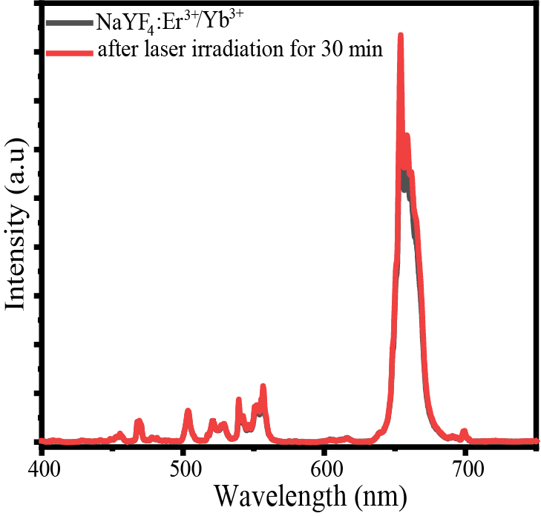
Figure S8. Control experiment, luminescence emission spectra of single NaYF₄:Er³⁺/Yb³⁺ microrod without coated Ag NIs. Black and red lines are before and after CW laser irradiation (980 nm) for 30 mins, respectively.

Supporting information -9

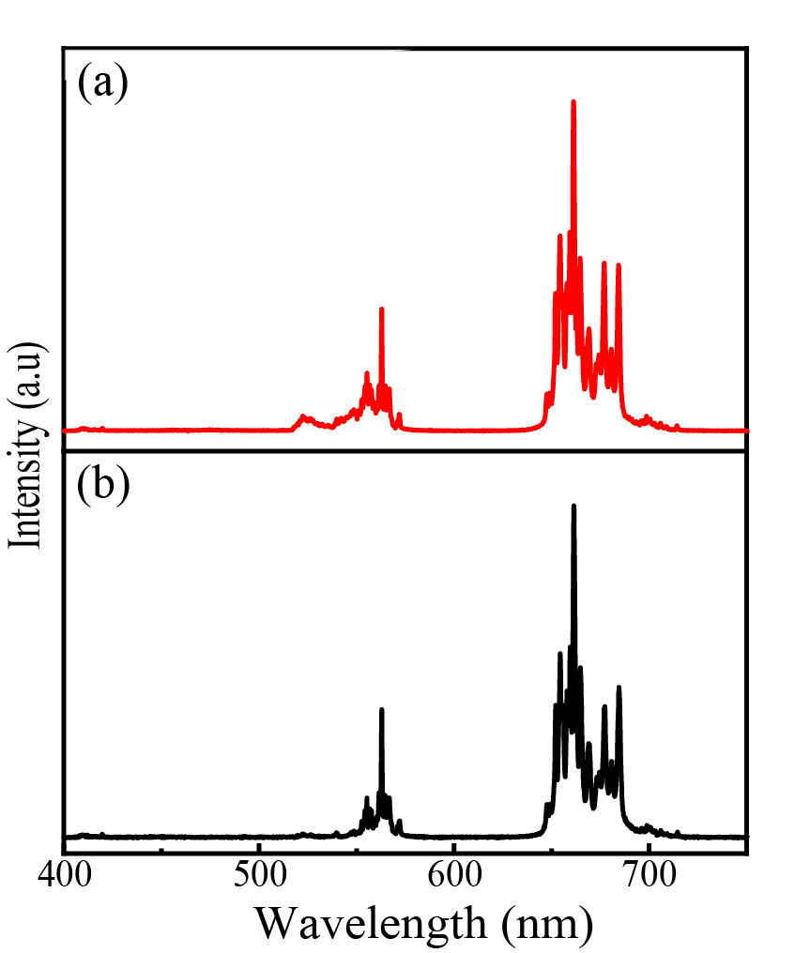
Figure S9. Upconversion emission spectra of the Y₂O₃:Er³⁺/Yb³⁺ obtained via (a) Thermal catalytic effect; (b) Conventional thermal annealing at 600℃ temperature for 1 hour.

Supporting information -10

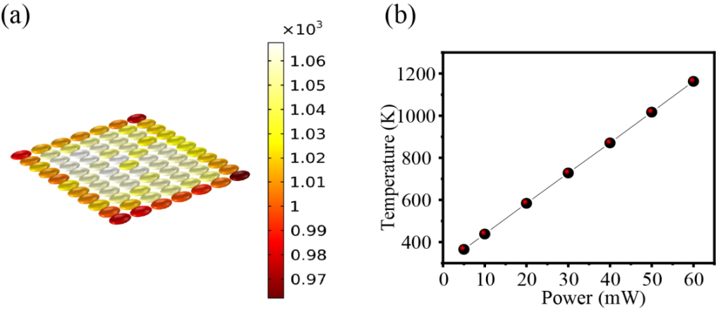
Figure S10. (a) Schematic of the temperature distribution in the optical heater composed of Ag NIs arrays; (b) the calculated temperature dependence of optical heater on the excitation power.

To clarify the mechanism of the high photothermal capacity of optical heater varying with the power illuminance, the theoretical simulation is performed as shown Ag NIs array is shown Figure S10 (a). Under proper excitation, the local temperature of the Ag NIs will increase, and the increased temperature is given by the equation of [4]:
$∆T=\frac{Iσ_{abc}}{4πkR}$ (1)

Where $σ_{abc}$ is the absorption cross-section of the Ag NPs, I is the irradiance (optical power per unit area) R is the radius of Ag NIs. The LSPR of Ag NIs can be simply derived for a metallic ellipsoid that is much smaller than the illumination wavelength.
According to equation (1), for a given size and absorption cross section, the local temperature generated by metal nanostructure depends on the power density. Figure S10 (b) demonstrates the power dependence photothermal capacity of an optical heater composed of Ag NIs. Temperature increases with the increase of power density. As the laser power increased from 5 to 60 mW, the temperature increased monotonically from 365 to 1162 K.

Supporting information -11

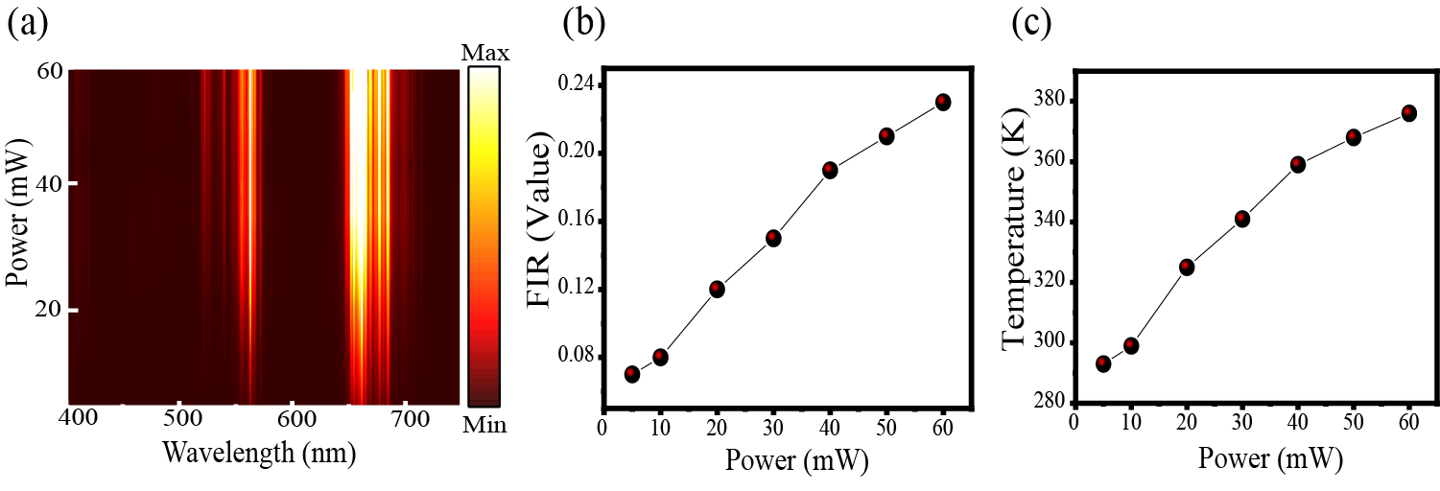
Figure S11. Power dependence (a) luminescence spectra; (b) FIR value (I₅₂₃/I₅₅₅) ; (c) Calculated temperature for the bare Y₂O₃:Yb³⁺/Er³⁺ microrod.

Supporting information -13

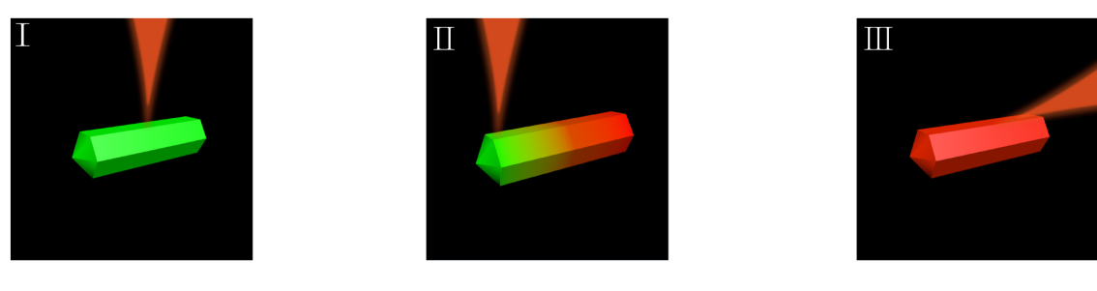
Figure S12. UC luminescence schematic structure excited at the center (Ⅰ) end (Ⅱ) and (Ⅲ) side edge of the microrod in the optical heater.

Acknowledgements
This work was supported by the National Key R&D Program of China (Grant No. 2020YFA0211300), the National Natural Science Foundation of China (Nos. 92050112, 92150110, 12074237, 61975101, 12004233 and 12104366), and the Fundamental Research Funds for Central Universities (GK202103010 and GK202103018, 2019TS119) and the Program of State Key Laboratory of Quantum Optics and Quantum Optics Devices (No. KF202003).

References:
[1] C. Zhang, J. Lu, N. Jin, L. Dong, Z. Fu, Z. Zhang, H. Zheng, “Plasmon-Driven Rapid In Situ Formation of Luminescence Single Crystal Nanoparticle,” Small, vol.15, no. 34, pp. 1901286.1-1901286.7, 2019.
[2] X. Li, D. Xiao and Z. Zhang,“Landu damping of Quantum plasmons in metal Nanostructures”New J Phys, vol.15, no. 2, pp.023011, 2013.
[3] K. Watanabe, D. Menzel, N. Nilius, et al.,“Photochemistry on Metal Nanoparticles” Chem Rev, vol.106, no. 10, pp.4301-4320, 2006.
[4] G. Baffou, R. Quidant,“Thermo-plasmonics: using metallic nanostructures as nano-sources of heat,”Laser Photonics Rev, vol. 7, no. 2, pp. 171-187, 2013.

