***Supporting Information for***

Reconfigurable Mach-Zehnder interferometer for dynamic modulations of spoof surface plasmon polaritons

Wen Yi Cui1,2, Jingjing Zhang1,2,3*, Xinxin Gao1,2, and Tie Jun Cui1,2,3,*

1 *State Key Laboratory of Millimeter Waves, Southeast University, Nanjing 210096, China*

2 *Institute of Electromagnetic Space, Southeast University, Nanjing 210096, China.*

3 *Center for Intelligent Metamaterials,* *Pazhou Laboratory, Guangzhou 510330, China.*

* Correspondence should be addressed to Jingjing Zhang and Tie Jun Cui. Emails: zhang[jingjing@seu.edu.cn](mailto:jingjingzhang@seu.edu.cn); [tjcui@seu.edu.cn](mailto:tjcui@seu.edu.cn)

1. Relationship between the capacitance of the varactor diode and the biased voltage in experiments

The chart of the capacitance versus bias voltage from the datasheet of the varactor diode is provided in Figure S1. We have also summarized the relationship between the capacitance and bias voltage obtained by fitting the measured and simulated data, as shown in Table S1. Note that the fitted capacitance data in the table are slightly smaller than the given data in Figure S2 but the difference is within the margin of error.

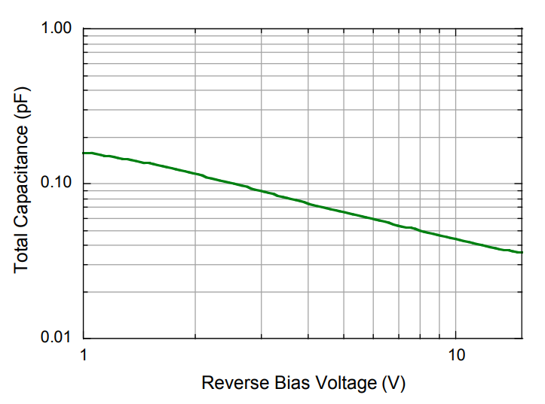

**Figure S1.** Performance curve at 25℃ from the data sheet for the varactor diode MAVR-011020- 1411

**Table S1:** Table of capacitance vs. bias voltage

|  |  |  |  |
| --- | --- | --- | --- |
| **Bias voltage** | **0V** | **3.3V** | **7V** |
| **Capacitance** | **0.2pF** | **0.07pF** | **0.05pF** |

1. Reflection property of the SSPP-based MZI structure

The reflection is mainly caused by the interference at the connecting points of two MZI arms. As shown in Figure S2(a), the measured S11 curves of the SSPP-based MZI structure also show obvious interference patterns, which are tunable through the variation of the applied voltage. The comparison of S21 and S11 at the biased voltage of 17V is given in Figure S2 (b), where we can observe that the small transmission at the S21 dips is mainly caused by the reflection. The varactor diodes also induce some reflection, but the influence is very small.

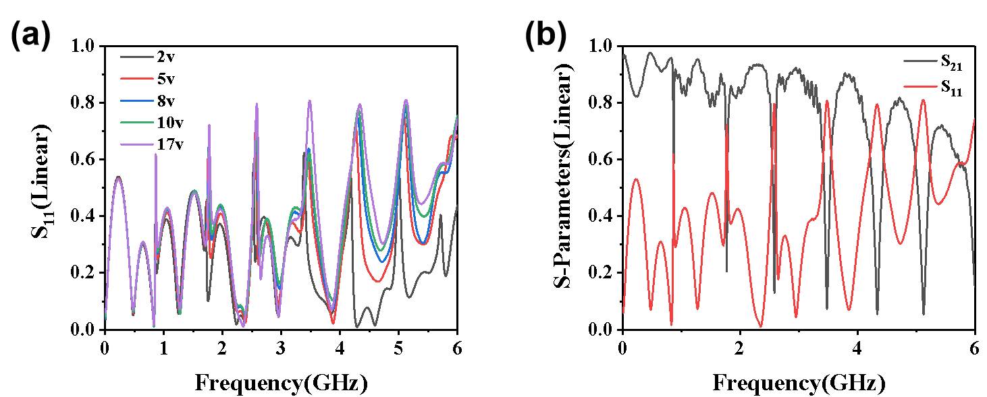

**Figure S2.** (a) S11 curves at different applied voltages. (b) S parameters of the SSPP-based MZI structure with *h* = 4mm and *h2* = 3.5mm at the biased voltage of 17V.