Supplementary Materials

Dingshan Zheng, Hailu Wang, Ruoling Chen, Long Li, Jiaxiang Guo, Yue Gu, Muhammad M. Zubair, Xiangxiang Yu, Long Jiang, Desheng Zhu, Yan Xiong, Han Zhang, Wenxing Yang*, Jinshui Miao*

High-detectivity Tin disulfide nanowire photodetectors with manipulation of localized ferroelectric polarization field

Dingshan Zheng, Hailu Wang, and Ruoling Chen are equally contributed to this work.
*Corresponding authors: Wenxing Yang, School of Physics and Optoelectronic Engineering, Yangtze University, Jingzhou 434023, China, E-mail: wenxingyang2@126.com; Jinshui Miao, State Key Laboratory of Infrared Physics, Shanghai Institute of Technical Physics, Chinese Academy of Sciences, Shanghai 200083, China, E-mail: jsmiao@mail.sitp.ac.cn
Dingshan Zheng, Ruoling Chen, Long Li, Xiangxiang Yu, Long Jiang, Desheng Zhu, and Yan Xiong, School of Physics and Optoelectronic Engineering, Yangtze University, Jingzhou 434023, China
Hailu Wang, Jiaxiang Guo, Yue Gu, and Muhammad M. Zubair, State Key Laboratory of Infrared Physics, Shanghai Institute of Technical Physics, Chinese Academy of Sciences, Shanghai 200083, China
Han Zhang, Institute of Microscale Optoelectronics, College of Physics and Optoelectronic Engineering, Shenzhen University, Shenzhen 518060, China

Figure S1: Ferroelectric polarization properties of P(VDF-TrFE) ferroelectric polymer film.
Figure S2: Retention properties of ferroelectric side-gated SnS₂ NW photodetector after depletion.
Figure S3: Linear curve of the transfer properties of ferroelectric side-gated SnS₂ NW photodetector.
Figure S4: Schematic diagrams of the ferroelectric side-gated SnS₂ nanowire structure before depletion and after depletion.
Figure S5: Low-frequency noise power density spectra of the SnS₂ NW photodetector under different bias voltages.
Figure S6: Photoresponse properties of ferroelectric side-gated SnS₂ NW photodetector after depletion under deep ultraviolet illumination (280 nm).

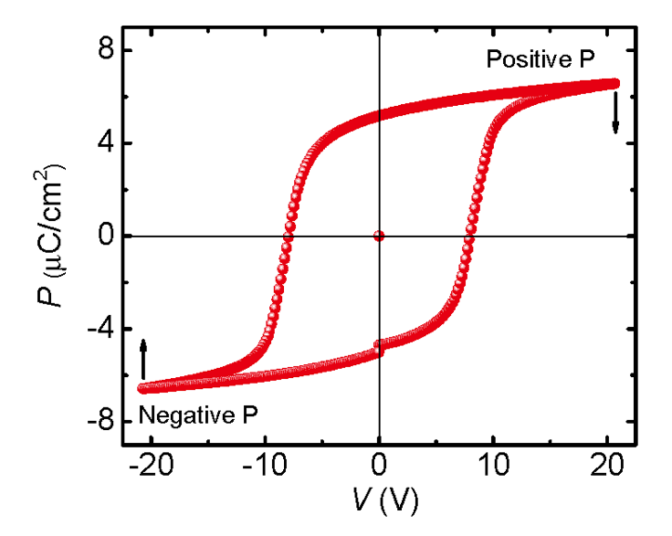
Figure S1: Ferroelectric polarization properties of P(VDF-TrFE) ferroelectric polymer film.

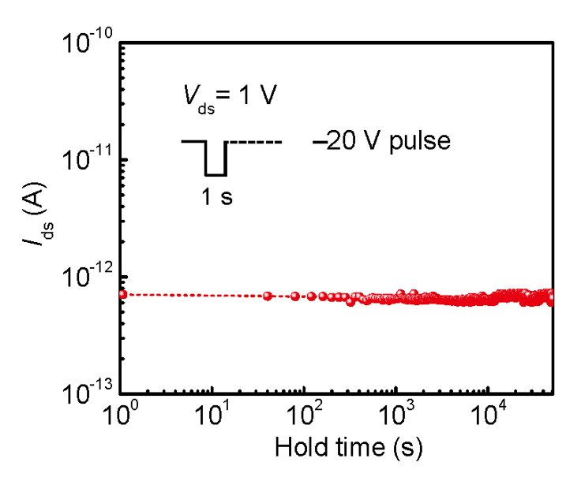
Figure S2: Retention properties of ferroelectric side-gated SnS₂ NW photodetector after depletion.

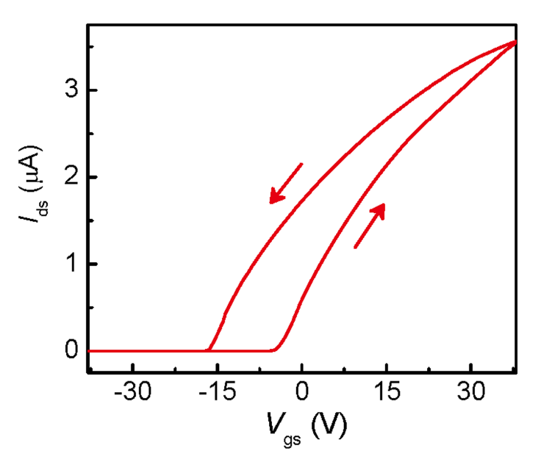
Figure S3: Linear curve of the transfer properties of ferroelectric side-gated SnS₂ NW photodetector.

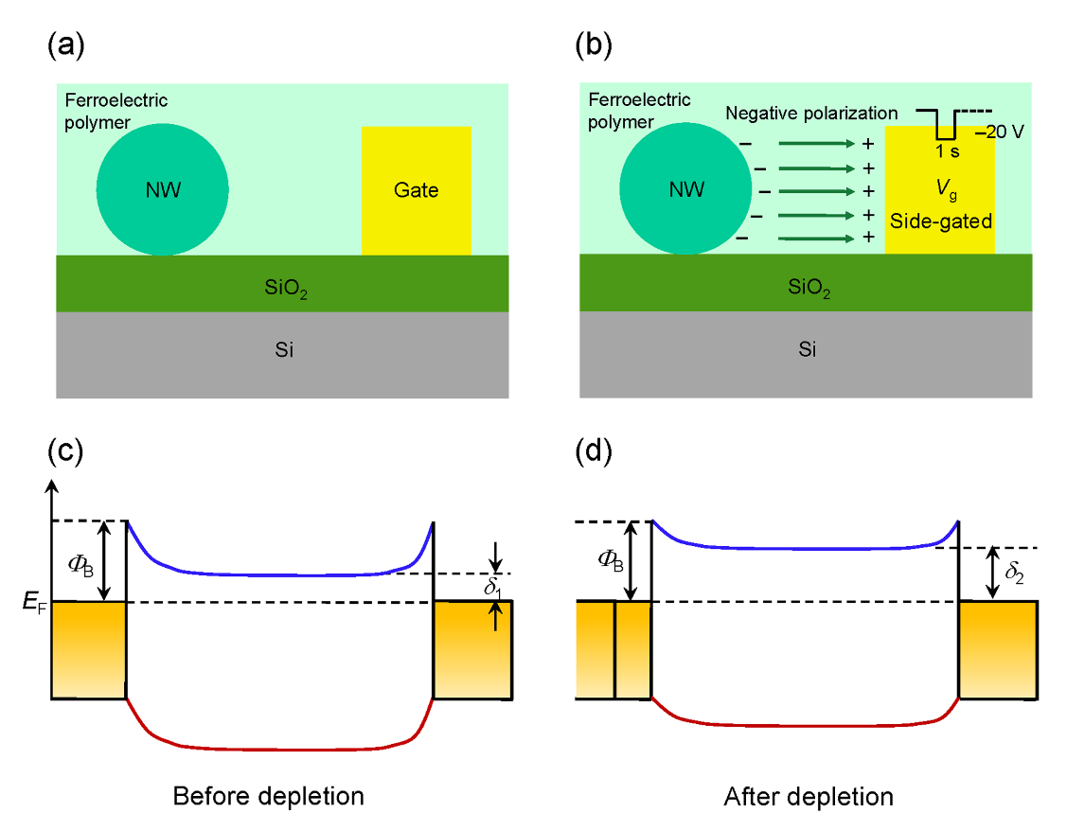
Figure S4: Schematic diagrams of the ferroelectric side-gated SnS₂ nanowire structure before depletion (a) and after depletion (b).

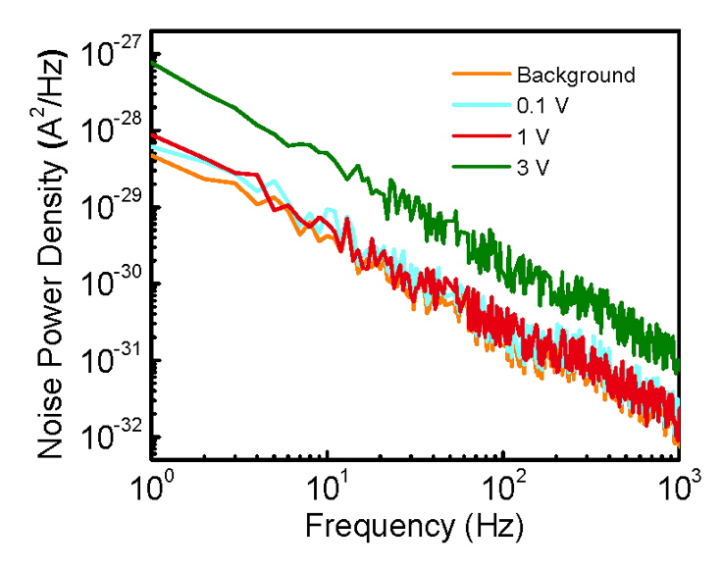
Figure S5: Low-frequency noise power density spectra of the SnS₂ NW photodetector under different bias voltages. The low-frequency noise characteristics of the device at 0.1 V and 1 V bias are close to the background noise at 0 V bias. However, the noise is much higher at 3 V bias.

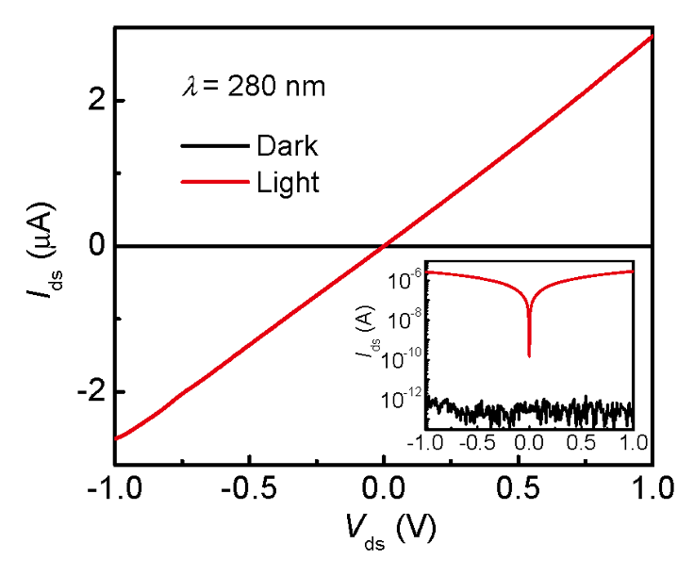
Figure S6: Photoresponse properties of ferroelectric side-gated SnS₂ NW photodetector after depletion under deep ultraviolet illumination (280 nm).

