**Supporting Information**

**Pump-controlled RGB single-mode polymer lasers based on a hybrid 2D-3D μ-cavity for temperature sensing**

*Kun Ge, Dan Guo, Ben Niu, Zhiyang Xu, Jun Ruan, and Tianrui Zhai\**

College of Physics and Optoelectronics, Faculty of Science, Beijing University of Technology, Beijing 100124, China.

*E-mail: [trzhai@bjut.edu.cn](mailto:trzhai@bjut.edu.cn)

CONTENTS

**1. The fabrication of the polymer fiber**

**2. The absorption and PL spectrum of three typical gain materials**

**3. The electric field distributions of the RGB WGM lasing**

**4. Numerical simulation for lowest modes and higher modes**

**5. The spectra of WGM lasing without the PSP and with the PSP**

**6. The high Q factor for isolated polymer fiber**

**7. The mode selection mechanism in hybrid 2D-3D μ-cavity**

**8. The numerical simulation with different coupled efficiency**

**9. The threshold for single-mode and multiple mode lasing in hybrid cavity**

**10. The evolution of peak wavelength under different pump power**

**11. The reverse evolution of peak wavelength under different pump power**

**12. The blue-shifting of multimode lasing with increasing the temperature**

**13. The evolution of PL spectrum is blue-shifting and resversible**

**14. The PL spectrum is blue-shifting for blue, green and red color laser**

**15. The PSP diameter affect the wavelength of the selected mode**

**16. The blue-shifting of single-mode in hybrid 2D-3D μ-cavity**

**1. The fabrication of the polymer fiber**

The polymer fiber is fabricated by drop-coating as shown in Fig. S1. The frame consists of a fiber, which is commercial and does not need further treatment. The blue-emitting material (S420) is dissolved in deionized water with concentration of 10 mg/ml, and the green-emitting material (uranin) and red-emitting material (RhB) are dissolved in ethanol with concentration of 9 mg/ml and 6 mg/ml, respectively. We use Polyvinyl alcohol (PVA) solution as adhesion agent to fabricate the polymer fiber for achieving the WGM lasing. The PVA is dissolved in deionized water at the concentration of 16 wt%. Then they are mixed with the volume ratio of 1:1 under magnetic stirring for 30 min.

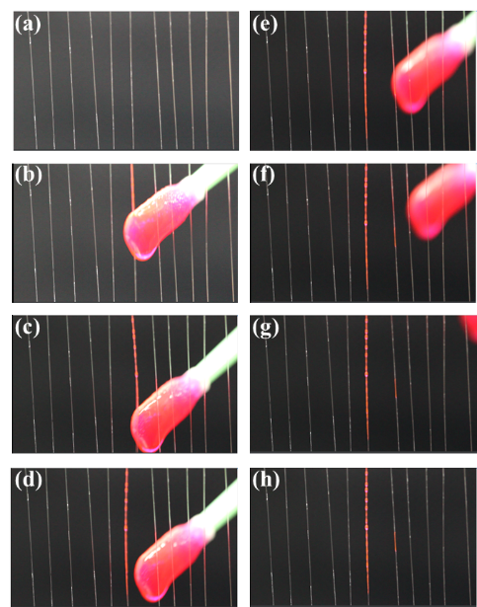

Figure S1. The fabricated progress of the polymer fiber. (a-h) The typical light-emitting polymer films are fabricated on the fibers by drop-coating.

**2. The absorption and PL spectrum of three typical gain materials**

Fig. S2a-c provide the photoluminescence (PL) emission and absorption of three typical light-emitting molecules (S420, uranin and RhB) in the experiment. The normalize absorption and the PL profile for RhB (red solid line and dashed line), uranin (green solid line and dashed line) and S420 (blue solid line and dashed line), respectively.

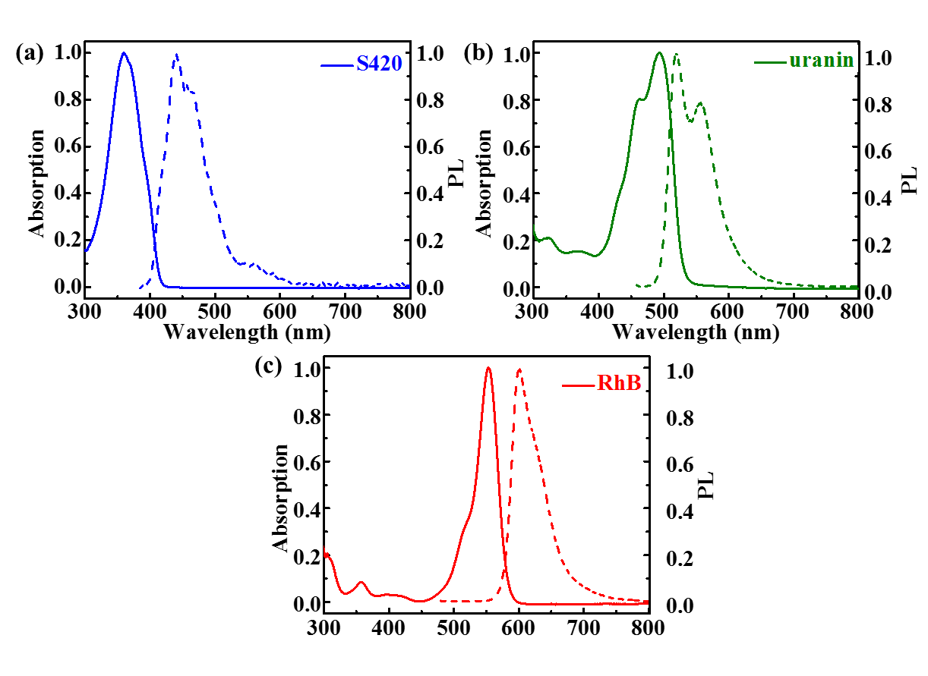

Figure S2. The PL spectrum of RGB emitting. (a-c) The normalize absorption and the PL profile for RhB (red solid line and dashed line), uranin (green solid line and dashed line) and S420 (blue solid line and dashed line), respectively.

**3. The electric field distribution for the RGB WGM lasing**

The numerically simulated electric field distribution in transverse cross-section for isolated polymer fiber microcavity is investigated with the COMSOL Multiphysics 5.4 (in Fig. S3). Fig. S3a provides the polymer fiber with blue light-emitting polymers. Fig. S3b indicates the polymer fiber with green light-emitting polymers. Fig. S3c shows the polymer fiber with red light-emitting polymers. We can observe that the electric field energy is well confined in the polymer fiber, and the scattering onto the glass fiber is quite limited.

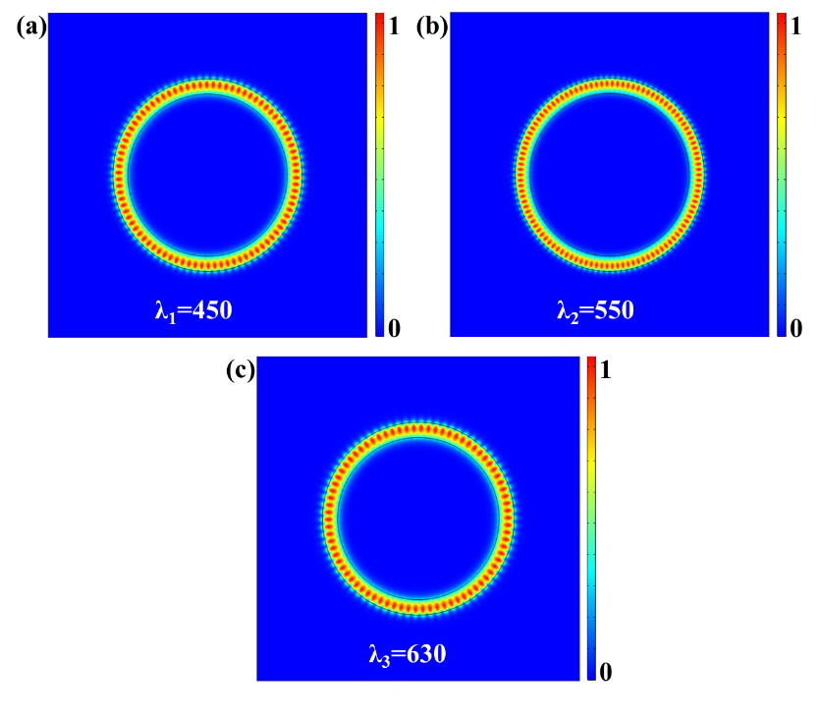

Figure S3. (a-c) The distribution of electric field in transverse cross-section for isolated polymer fiber μ-cavity, respectively.

**4. Numerical simulation for lowest modes and higher modes**

The higher order radial modes can be excited in the cavity. Fig. S4 shows the numerically simulated electric field distributions of the WGM lasing modes in the microcavity for lowest radial modes (in Fig. S4a) and higher order radial modes (in Fig. SS4b). The simulated microcavity is reduced by 12.5 times for distinguish pattern distribution.

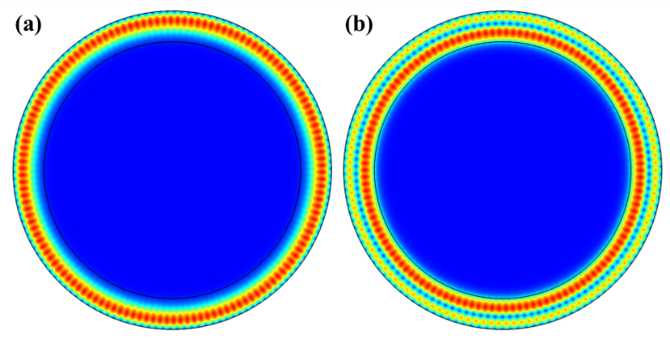

Figure S4. Numerically simulated electric field distribution for (a) lowest radial modes and (b) higher order radial modes in the cavity.

**5. The spectra of WGM lasing without the PSP and with the PSP**

Fig. S5 shows the PL emission spectra under different pump power from 5.7 μJ/cm2 to 82.9 μJ/cm2 without the PSP (in Fig. S5a) and the pump power from 45.4 μJ/cm2 to 175.3 μJ/cm2 with the PSP (in Fig. S5d), respectively. Fig. S5 shows the relationship between pump power and output density without the PSP (in Fig. S5c) and with the PSP (in Fig. S5d), the threshold of the coupling system are 8.4 μJ/cm2 and 61.2 μJ/cm2, without the PSP and with the PSP, marked by arrows, respectively.

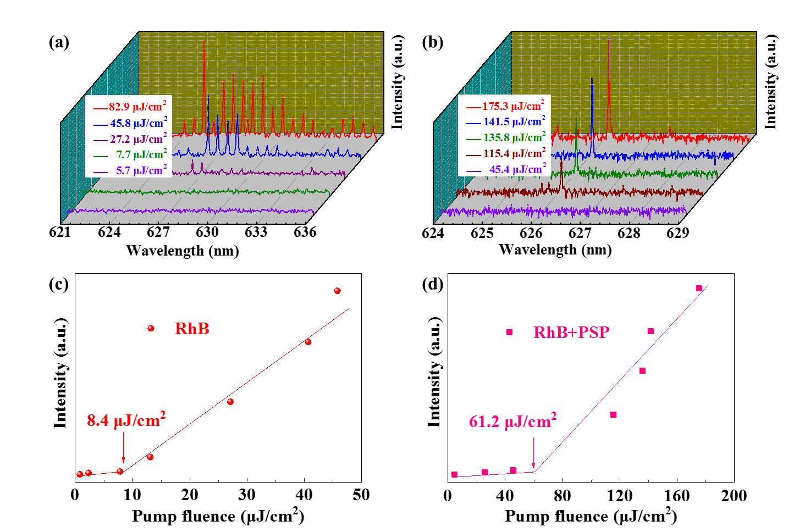

Figure S5. The spectra of WGM lasing (a) without the PSP and (b) with the PSP. The relationship between pump power fluence and output intensity (c) without the PSP and (d) with the PSP, the threshold are 8.4 μJ/cm2 and 61.2 μJ/cm2, marked by arrows, respectively.

**6. The high Q factor for isolated polymer fiber.**

Fig. S6a provides the stability of FWHM for the isolated polymer fiber μ-cavity. The polymer fiber has a very smooth surface, which can serve as an excellent WGM μ-cavity to provide multiple mode The lasing mode radiate are at different time from 0 to 300 seconds on the polymer fiber. The FWHM (red circles) are at different time on the polymer fiber (in Fig. S6b), indicating that the FWHM (0.033 nm) of output lasing have hardly changed in 300 seconds. The optical picture image is the isolated polymer fiber (in Fig. S6b). We can gain the Q factor can be estimated over 19000 by using the equation Q=λ⁄Δλ, where λ is 630 nm and Δλ is 0.033 nm, which proving the lower optical loss in the μ-cavity.

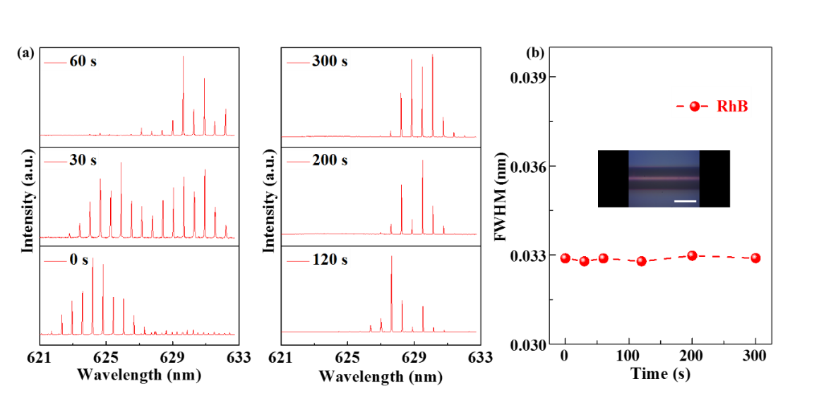

Figure S6. The lasing mode radiate within the range of 0 and 300 seconds. (a) The lasing mode radiate in the isolated μ-cavity. (b) The FWHM (red circles) are at different time on the polymer fiber. The scale bar: 100 μm.

**7. The mode selection mechanism in hybrid 2D-3D μ-cavity**

Numerically simulated electric field distributions of the lasing modes in the couple system including two relational μ-cavity, which are active μ-cavity and passive μ-cavity in the hybrid 2D-3D system. To achieve single mode lasing, the polymer fiber therein acts as gain μ-cavity to provide multiple lasing modes, and the polystyrene microsphere can serve as a loss channel to suppress most of the lasing modes. The hybrid 2D-3D coupled μ-cavity enable single mode lasing when all but one of the lasing modes are suppressed for the loss of the polystyrene microsphere. Fig. S7a-b indicate the mode selection mechanism in the couple system.

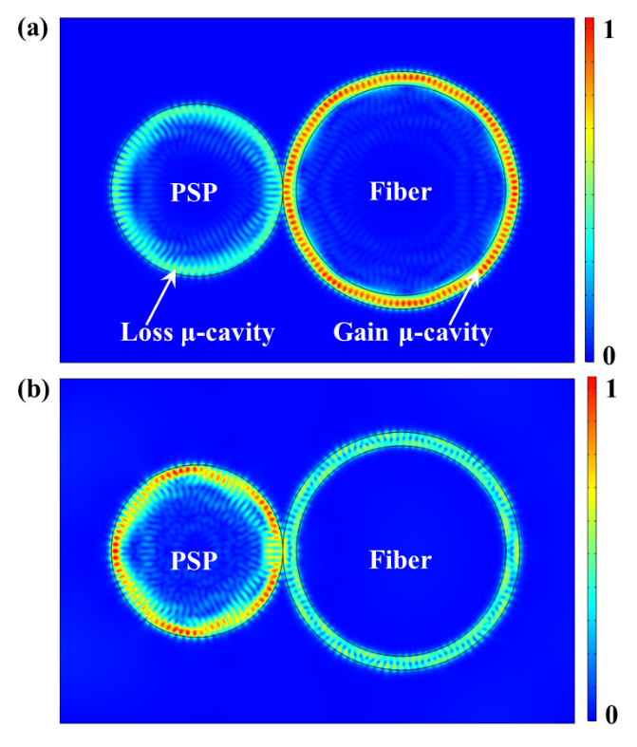

Figure S7. (a-b) Numerically simulated electric field distribution for mode selection mechanism in hybrid 2D-3D μ-cavity.

**8. The** **numerical simulation with different coupled efficiency**

The wavelength switch of single-mode laser can be realized by adjusting the resonant modes owing to the different coupled efficiency between gain μ-cavity and loss μ-cavity. According to the filtering effect, the polymer fiber therein serves as an excellent gain μ-cavity to provide multiple lasing modes while the PSP acts as the loss channel to suppress most of the lasing modes in the hybrid 2D-3D μ-cavity which enable single-mode lasing when all but one of the lasing modes are suppressed.

The laser mode will change owing to the different coupled efficiency in the coupled μ-cavity. Fig. S8 shows the numerically simulated electric field distribution under different spacing between active μ-cavity and passive μ-cavity with 0 nm, 50 nm, 100 nm and 200 nm (in Fig. S8a-d). The pump-controlled position of the coupled μ-cavity will alter the coupled efficiency. Therefore, the laser mode can be adjusted by altering the pump-controlled position. There are two modes (mode-1 and mode-2) in the hybrid 2D-3D μ-cavity, the mode-1 is confined in the WGM μ-cavity, which leading to lasing at mode-1. The coupled efficiency is altered between the gain μ-cavity and the loss μ-cavity, which altered the WGM resonant wavelength from mode-1 to mode-2, leading to laser output at mode-2.

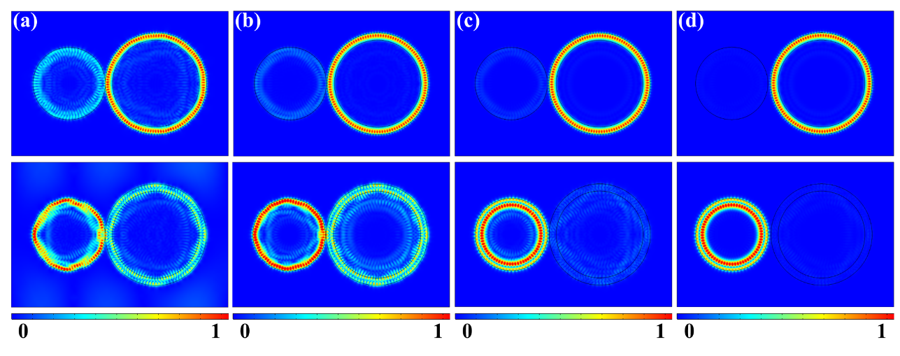

Figure S8. Numerically simulated electric field distribution under different spacing between active μ-cavity and passive μ-cavity with (a) 0 nm, (b) 50 nm, (c) 100 nm and (d) 200 nm.

**9. The threshold for single-mode and multiple mode lasing in hybrid cavity**

According to the filtering effect, the polymer fiber therein serves as an excellent gain cavity to provide multiple lasing modes while the PSP acts as a loss channel to suppress most of the lasing modes. The results demonstrate that the filtering effect is an effective way to realize single-mode lasing due to the mode selection mechanism.

There is an interesting phenomenon that the multiple lasing modes are obtained with the pump fluence increasing from 43.2 μJ/cm2 to 189.0 μJ/cm2. Our work not only study the mechanism of single-mode operation, but also provides the multiple lasing modes operating range in the 2D-3D hybrid μ-cavity.

Fig. S9a-b shows the spectra of single-mode WGM lasing under different pump power from 45.4 μJ/cm2 to 175.3 μJ/cm2 and the multiple mode WGM lasing under the pump power from 43.2 μJ/cm2 to 189.0 μJ/cm2 in the 2D-3D hybrid μ-cavity, respectively. The relationship between pump power and output density are shown of single-mode WGM lasing (in Fig. S9c) and of multiple mode WGM lasing (in Fig. S9d), the threshold of the coupling system are 61.2 μJ/cm2 and 101.2 μJ/cm2, marked by arrows, respectively.

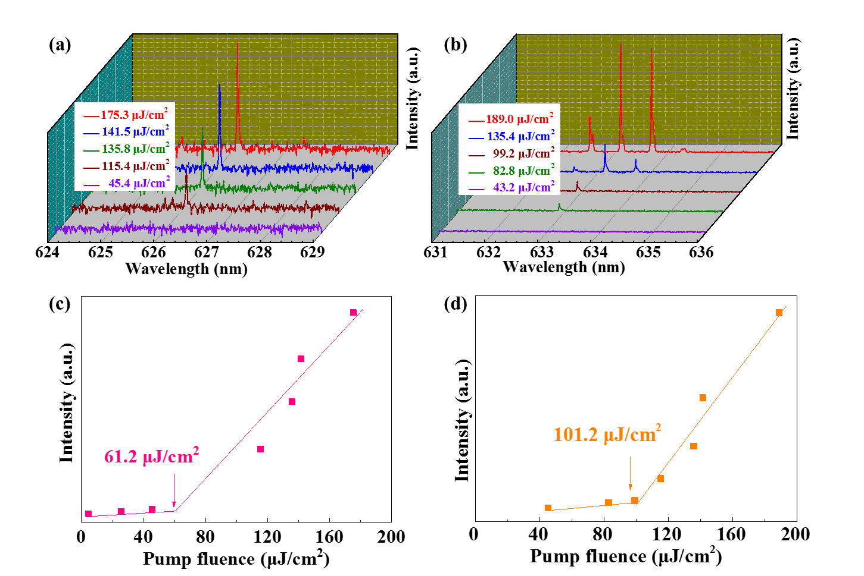

Figure S9. The PL spectra of single-mode WGM lasing (a) with the PSP and (b) multi-mode WGM lasing with the PSP. The relationship between pump power fluence and output intensity with single-mode lasing (c) and with multiple mode lasing (d), the threshold are 61.2 μJ/cm2 and 101.2 μJ/cm2, marked by arrows, respectively.

**10. The evolution of peak wavelength under different pump power**

The stability of peak wavelength of WGM lasing is important. In our experiment, the peak wavelength have little changed with increasing the pump power density from 20.71 μJ/cm2 to 86.30 μJ/cm2 as shown in Fig. S10a, which indicating that the pump power exhibited negligible influence to wavelength shift at less than 86.30 μJ/cm2. Fig. S10b provides the spectral map of the emission intensity with pump fluence. The highlighted lines are not drifting with increasing the pump fluence ranging from 20.71 μJ/cm2 to 86.30 μJ/cm2 as shown in Fig. S10b. The output density is increasing with increasing the pump power density. Moreover, the peak wavelength of the WGM lasing have little changed with increasing the operation pump power density as shown in Fig. S6c. All the PL spectrum emission is recorded in the room temperature and the environmental temperature is about 21 $℃$.

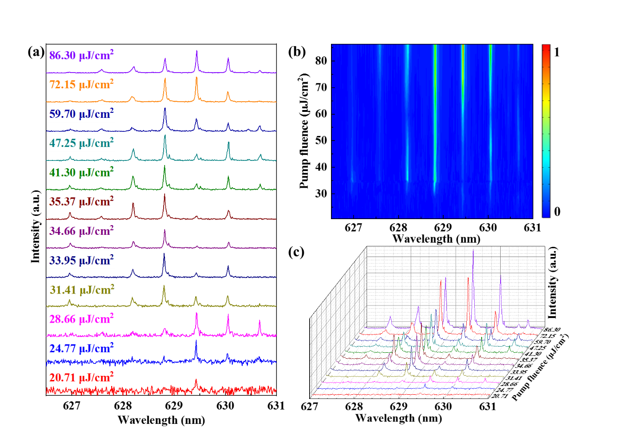

Figure S10. The evolution of peak wavelength with different pump power. (a) The peak wavelength have little changed with increasing the pump power. (b) Spectral map of the emission intensity with pump fluence. (c) The evolution of peak wavelength with increasing the pump power.

**11. The reverse evolution of peak wavelength under different pump power**

The restorative wavelength tunability is a prerequisite for WGM lasing. We study the reverse evolution of peak wavelength with changing the pump power ranging from 86.30 μJ/cm2 to 20.71 μJ/cm2 from top to bottom as shown in Fig. S11a, and the environmental temperature is about 21 $℃$. The output intensity of several laser modes has changed comparing with Fig. S10a. The mode competition leads to different output intensity of lasing in the different time. Moreover, the peak wavelength of PL emission has little changed, which indicating that the peak wavelength do not shift when altering the pump power at less than 86.30 μJ/cm2.

Fig. S11b provides the spectral map of the emission intensity with pump fluence. The highlighted lines are not drifting with increasing the pump fluence ranging from 20.71 μJ/cm2 to 86.30 μJ/cm2 as shown in Fig. S11b. The output intensity is increasing with increasing the pump power density. Moreover, the peak wavelength of the WGM lasing have little changed with increasing the operation pump power as shown in Fig. S11c.

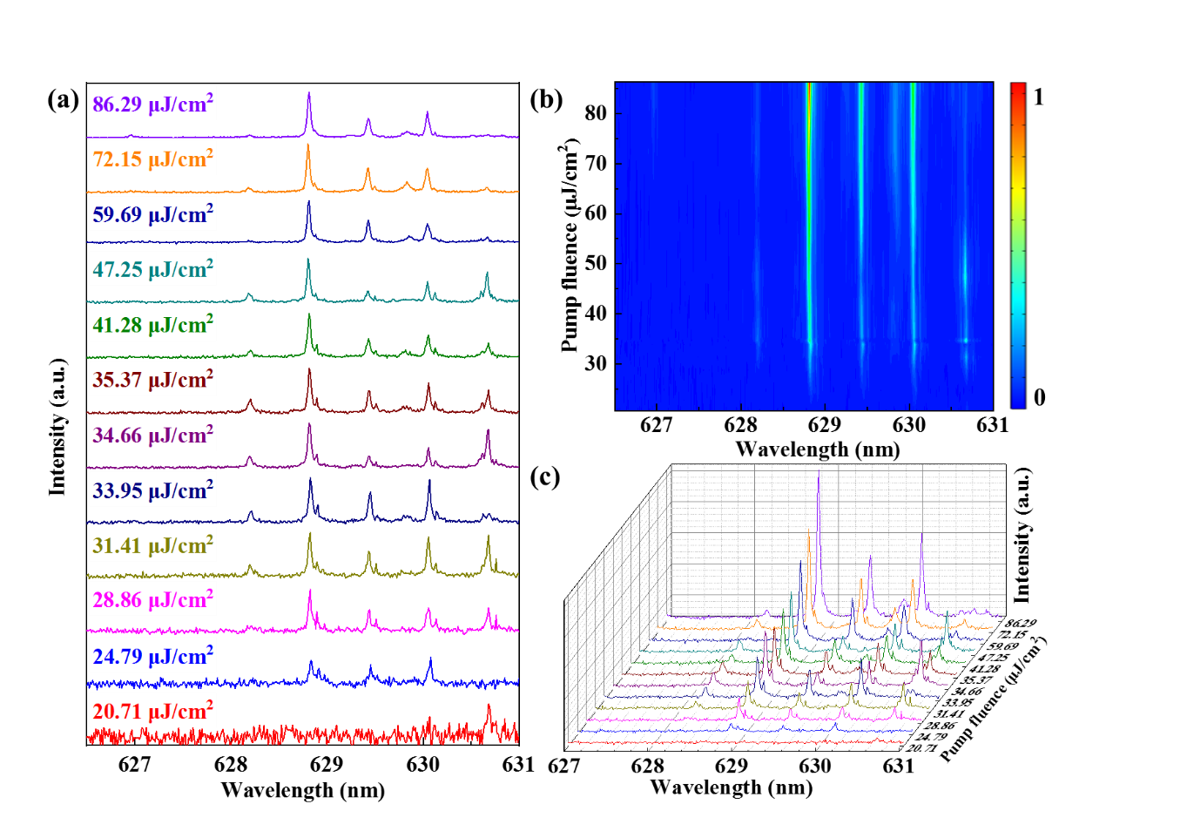

Figure S11. The reverse evolution of peak wavelength with different pump power. (a) The peak wavelength have little changed with increasing the pump power. (b) Spectral map of the emission intensity with pump fluence. (c) The evolution of peak wavelength with increasing the pump power.

**12. The blue-shifting of multimode lasing with increasing the temperature**

The PL emission spectrum are blue-shifting for isolated polymer fiber with increasing the environmental temperature from 21.2 $℃$ to 33.9 $℃$ as shown in Fig. S8. The peak wavelength for polymer fiber can be tuned by controlling the environmental temperature, which is the effective way to realize tunable multimode lasing.

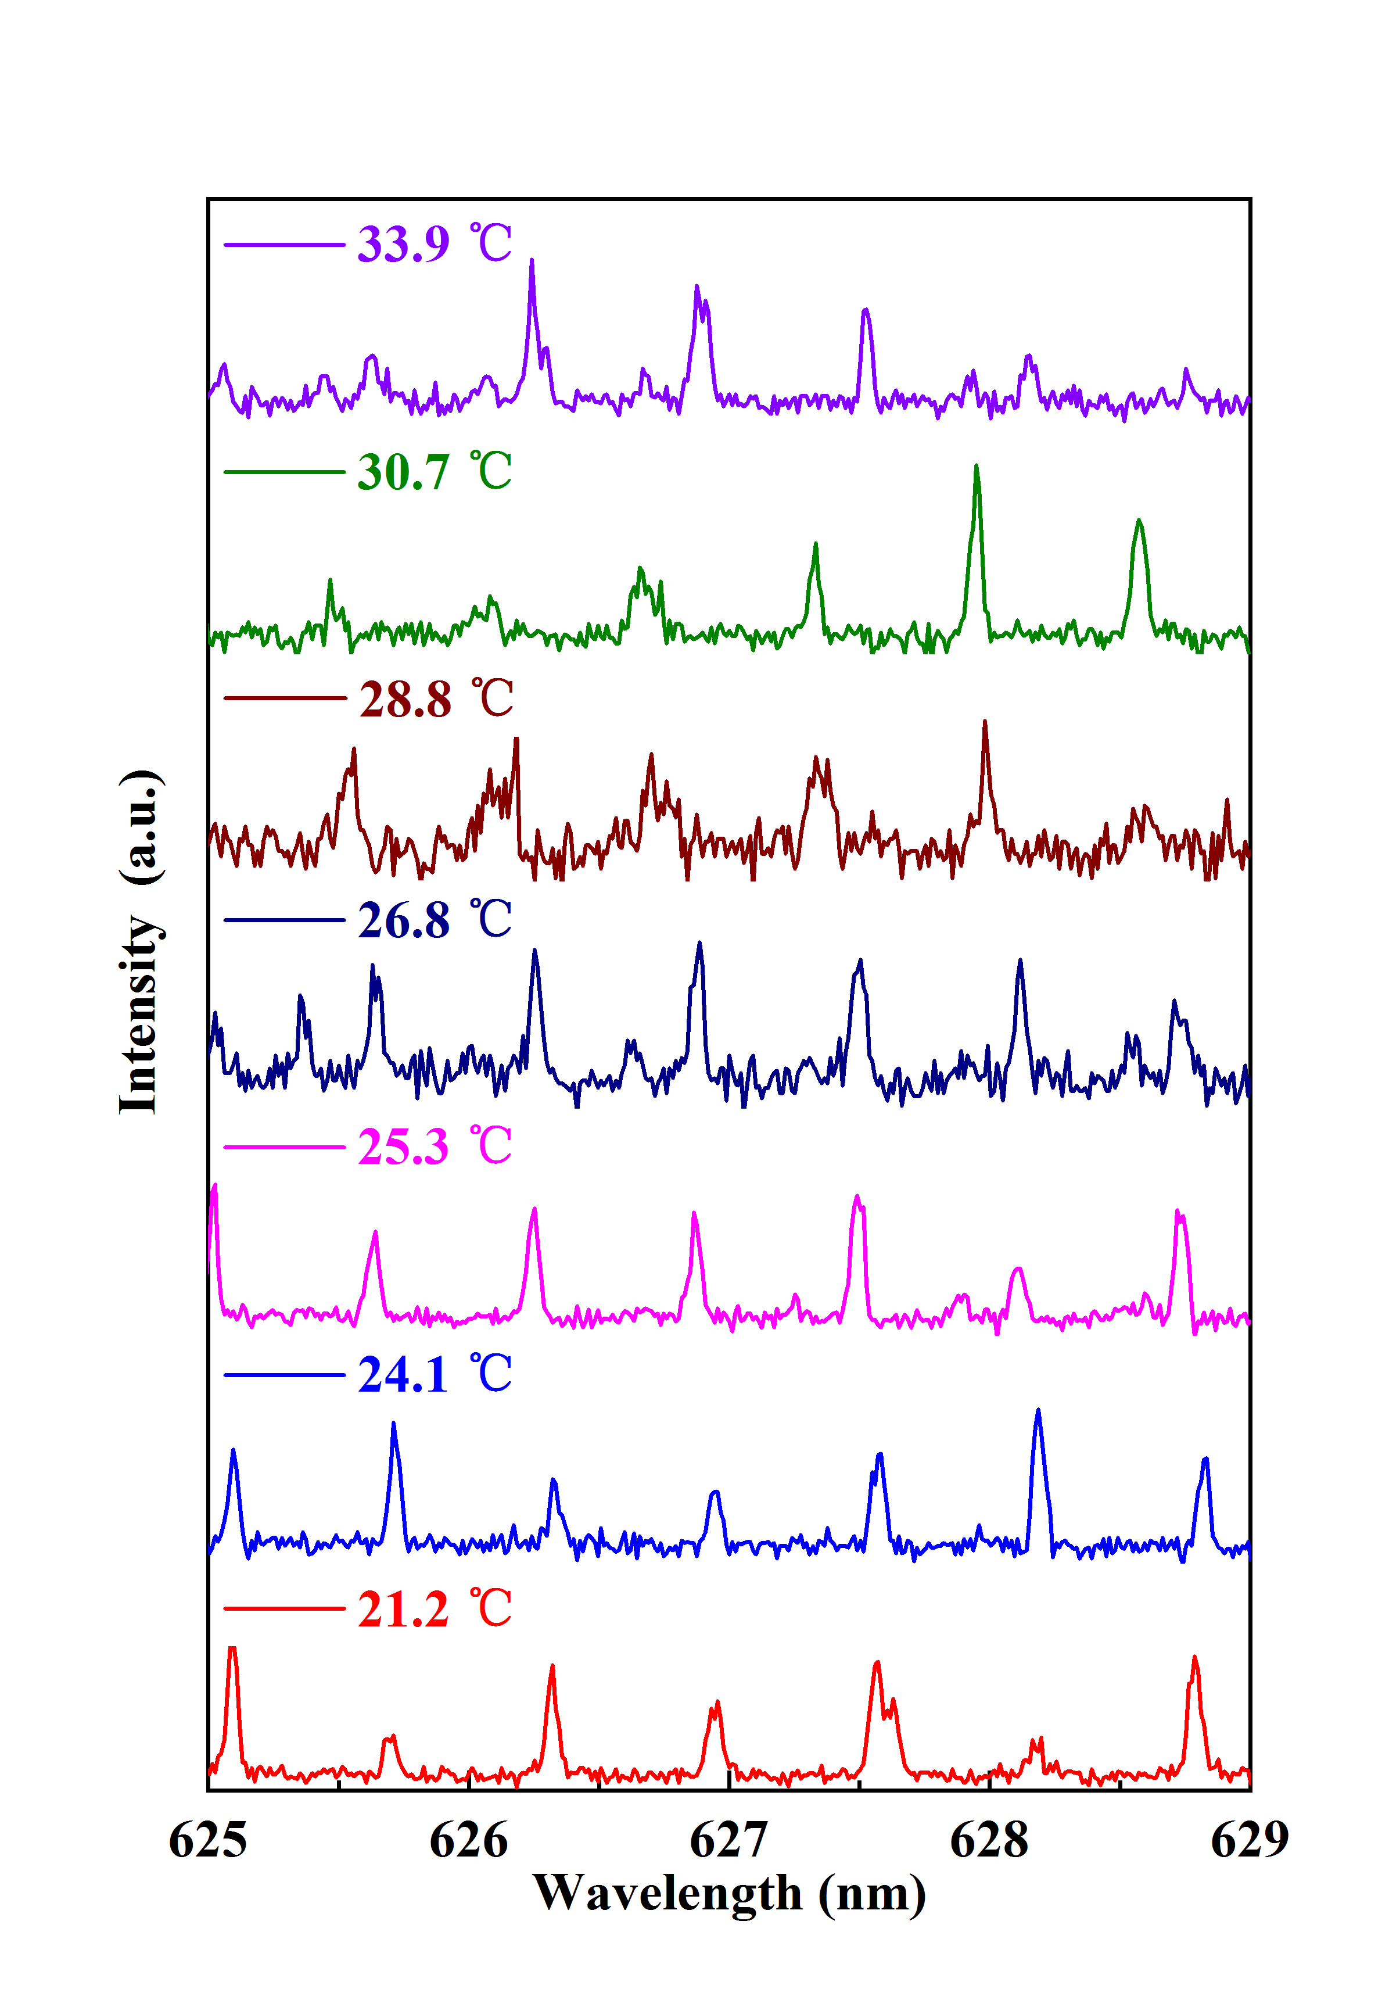

Figure S12. The blue-shifting of multiple mode lasing with increasing the temperature.

**13. The evolution of PL spectrum is blue-shifting and resversible**

The excellent temperature responsiveness provides a feasible method to control the peak wavelength for the polymer fiber. The effective refractive index of gain material decreases with increasing the temperature, the peak wavelength is also blue-shifting due to preserving the conditions for WGM resonance. To investigate the effect of the peak wavelength shift due to the temperature. We have observed that the evolution of PL spectrum is blue-shifting with increasing temperature range from 24.9 °C to 32.8 °C (in Fig. S13a). The wavelength of the laser can return to the original position with the decreasing of temperature to the room temperature as shown in Fig. S13b. The result indicates that the temperature sensor response is reversible.

The single-mode lasing is blue-shifting with increasing the temperature ranging from 23.2 °C to 26.9 °C in hybrid 2D-3D μ-cavity as shown in Fig. S13c. Therefore, we can control the wavelength shift by precisely adjusting the temperature, which might help to achieve the expected lasing mode.

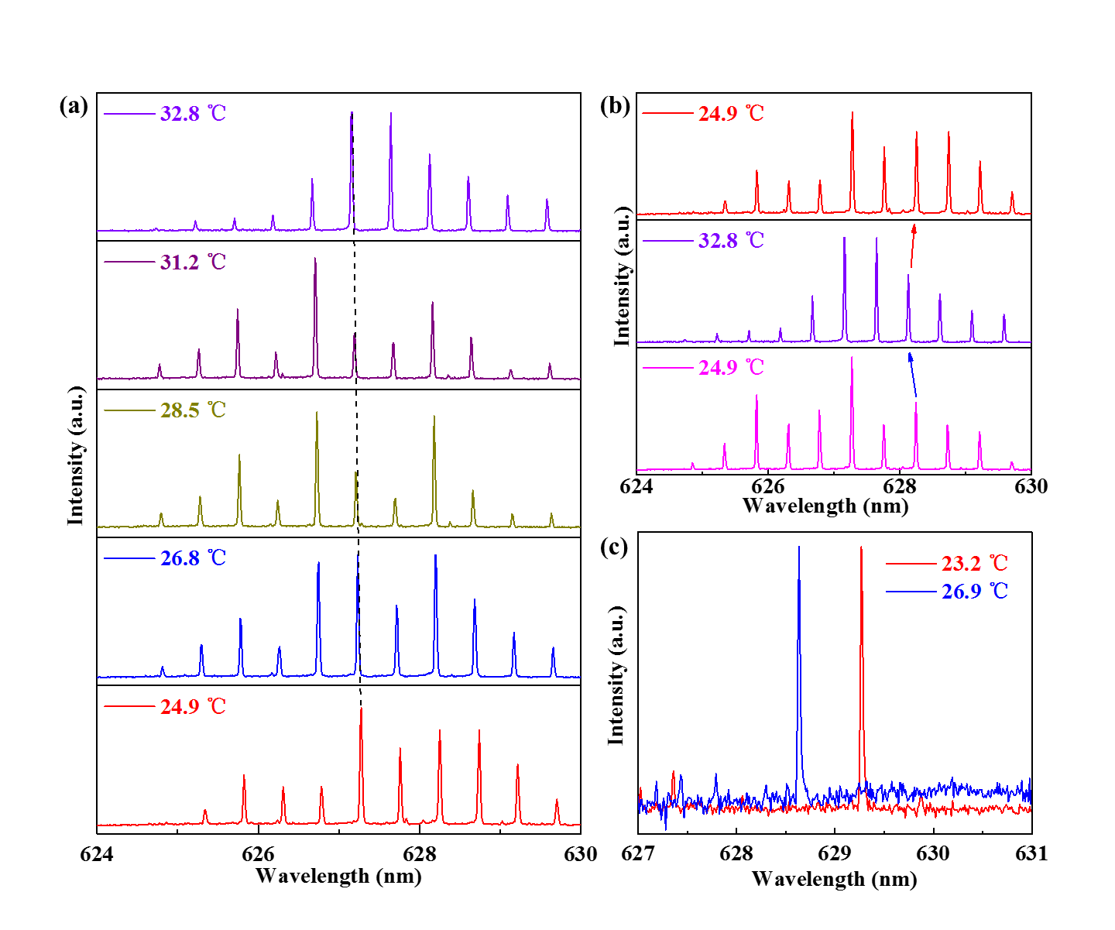

Figure S13. (a) The evolution of PL spectrum is blue-shifting with increasing temperature. (b) The temperature sensor response is reversible. (c) The single-mode is blue-shifting with increasing the environment temperature ranging from 23.2 ℃ to 26.9 ℃ in hybrid 2D-3D μ-cavity.

**14. The PL spectrum is blue-shifting for blue, green and red color laser**

The PL emission spectra of RGB lasing are demonstrated when pumped by a nanosecond laser with wavelength of 343 nm (third harmonics from a 1030 nm Yb:YAG laser, repetition frequency of 200 Hz, and pulse width of 1 ns). The short wavelength (green color laser and blue color laser) is easily bleached when pumped by ultraviolet light. The red-emitting laser threshold is the lowest than other laser. The low threshold indicate that the optical loss is small in the μ-cavity and the short wavelength absorption is more serious than long wavelength. Moreover, the quantum efficiency of molecule RhB is higher than S420 and uranin. Therefore, all the temperature experiments are carried out with the red color laser.

The blue color laser and green color laser have the same temperature responsiveness, which is the effective refractive index of gain material decreases with increasing the temperature. The peak wavelength is also blue-shifting. Fig. S14 shows the evolution of PL spectrum is blue-shifting with increasing temperature for blue color laser (in Fig. S14a), green color laser (in Fig. S14b) and red color laser (in Fig. S14c).

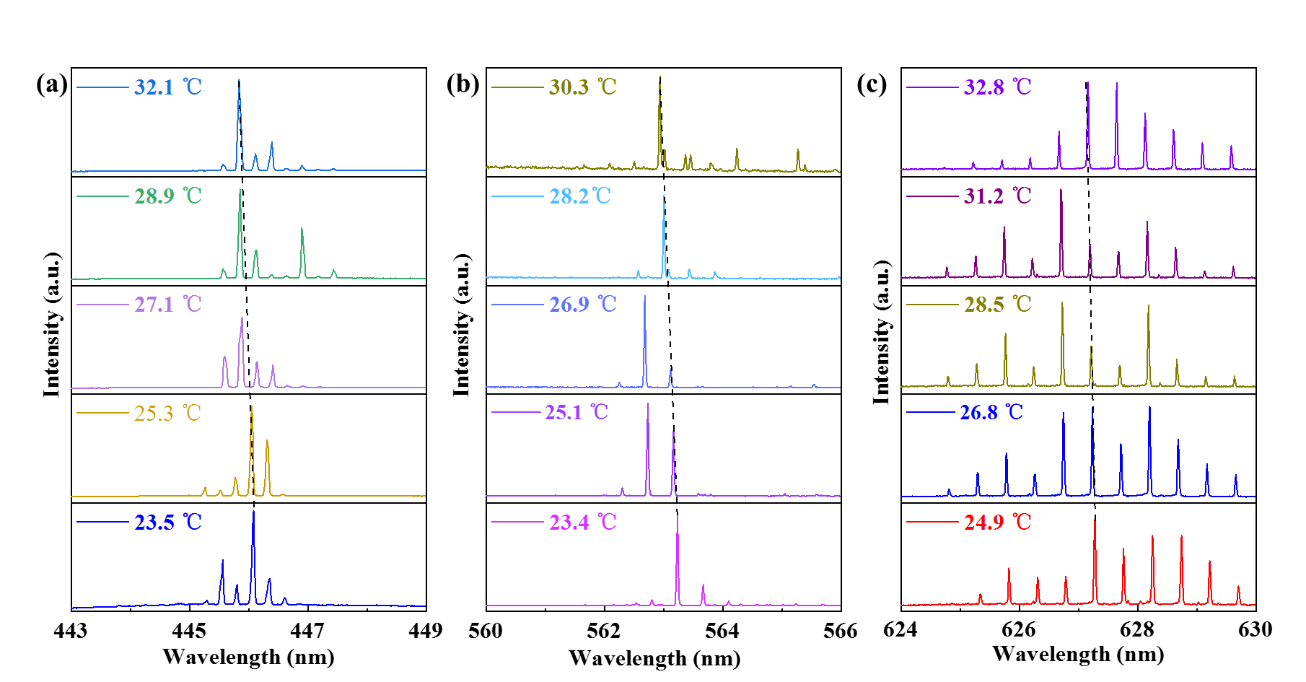

Figure S14. The evolution of PL spectrum is blue-shifting for (a) blue color laser, (b) green laser and (c) red laser with increasing temperature.

**15. The PSP diameter affect the wavelength of the selected mode**

The PSP is as an absorption source and the polymer fiber serves as gain μ-cavity in the 2D-3D hybrid μ-cavity. The polymer fiber therein serves as an excellent gain cavity to provide multiple lasing modes while the microsphere acts as a loss channel to suppress most of the lasing modes. Fig. R6 shows the spectra of WGM lasing with different the diameter of PSP with 100 μm (in Fig. S15a), 50 μm (in Fig. S15b), 30 μm (in Fig. S15c). The results indicate that the diameter of the PSP can affect the wavelength of the selected mode.

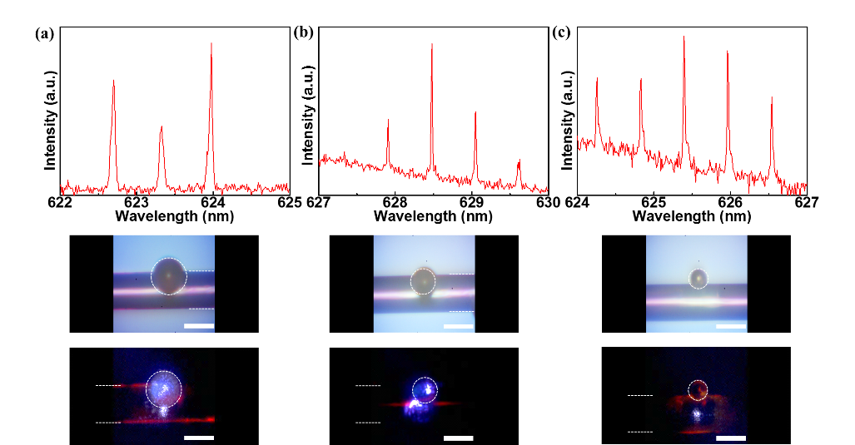

Figure S15. The spectra of WGM lasing with different the diameter of PSP with (a) 100 μm, (b) 50 μm, (c) 30 μm. Scale bars are 100 μm.

**16. The blue-shifting of single-mode in hybrid 2D-3D μ-cavity**

The PL emission spectrum is blue-shifting with increasing the environmental temperature from 38.1 ℃ to 40.1 ℃ in hybrid 2D-3D μ-cavity as shown in Fig. S16. The peak wavelength can be tuned by controlling the environmental temperature in the hybrid μ-cavity, we believe the strategy might switch the single mode lasing by precision control the temperature.

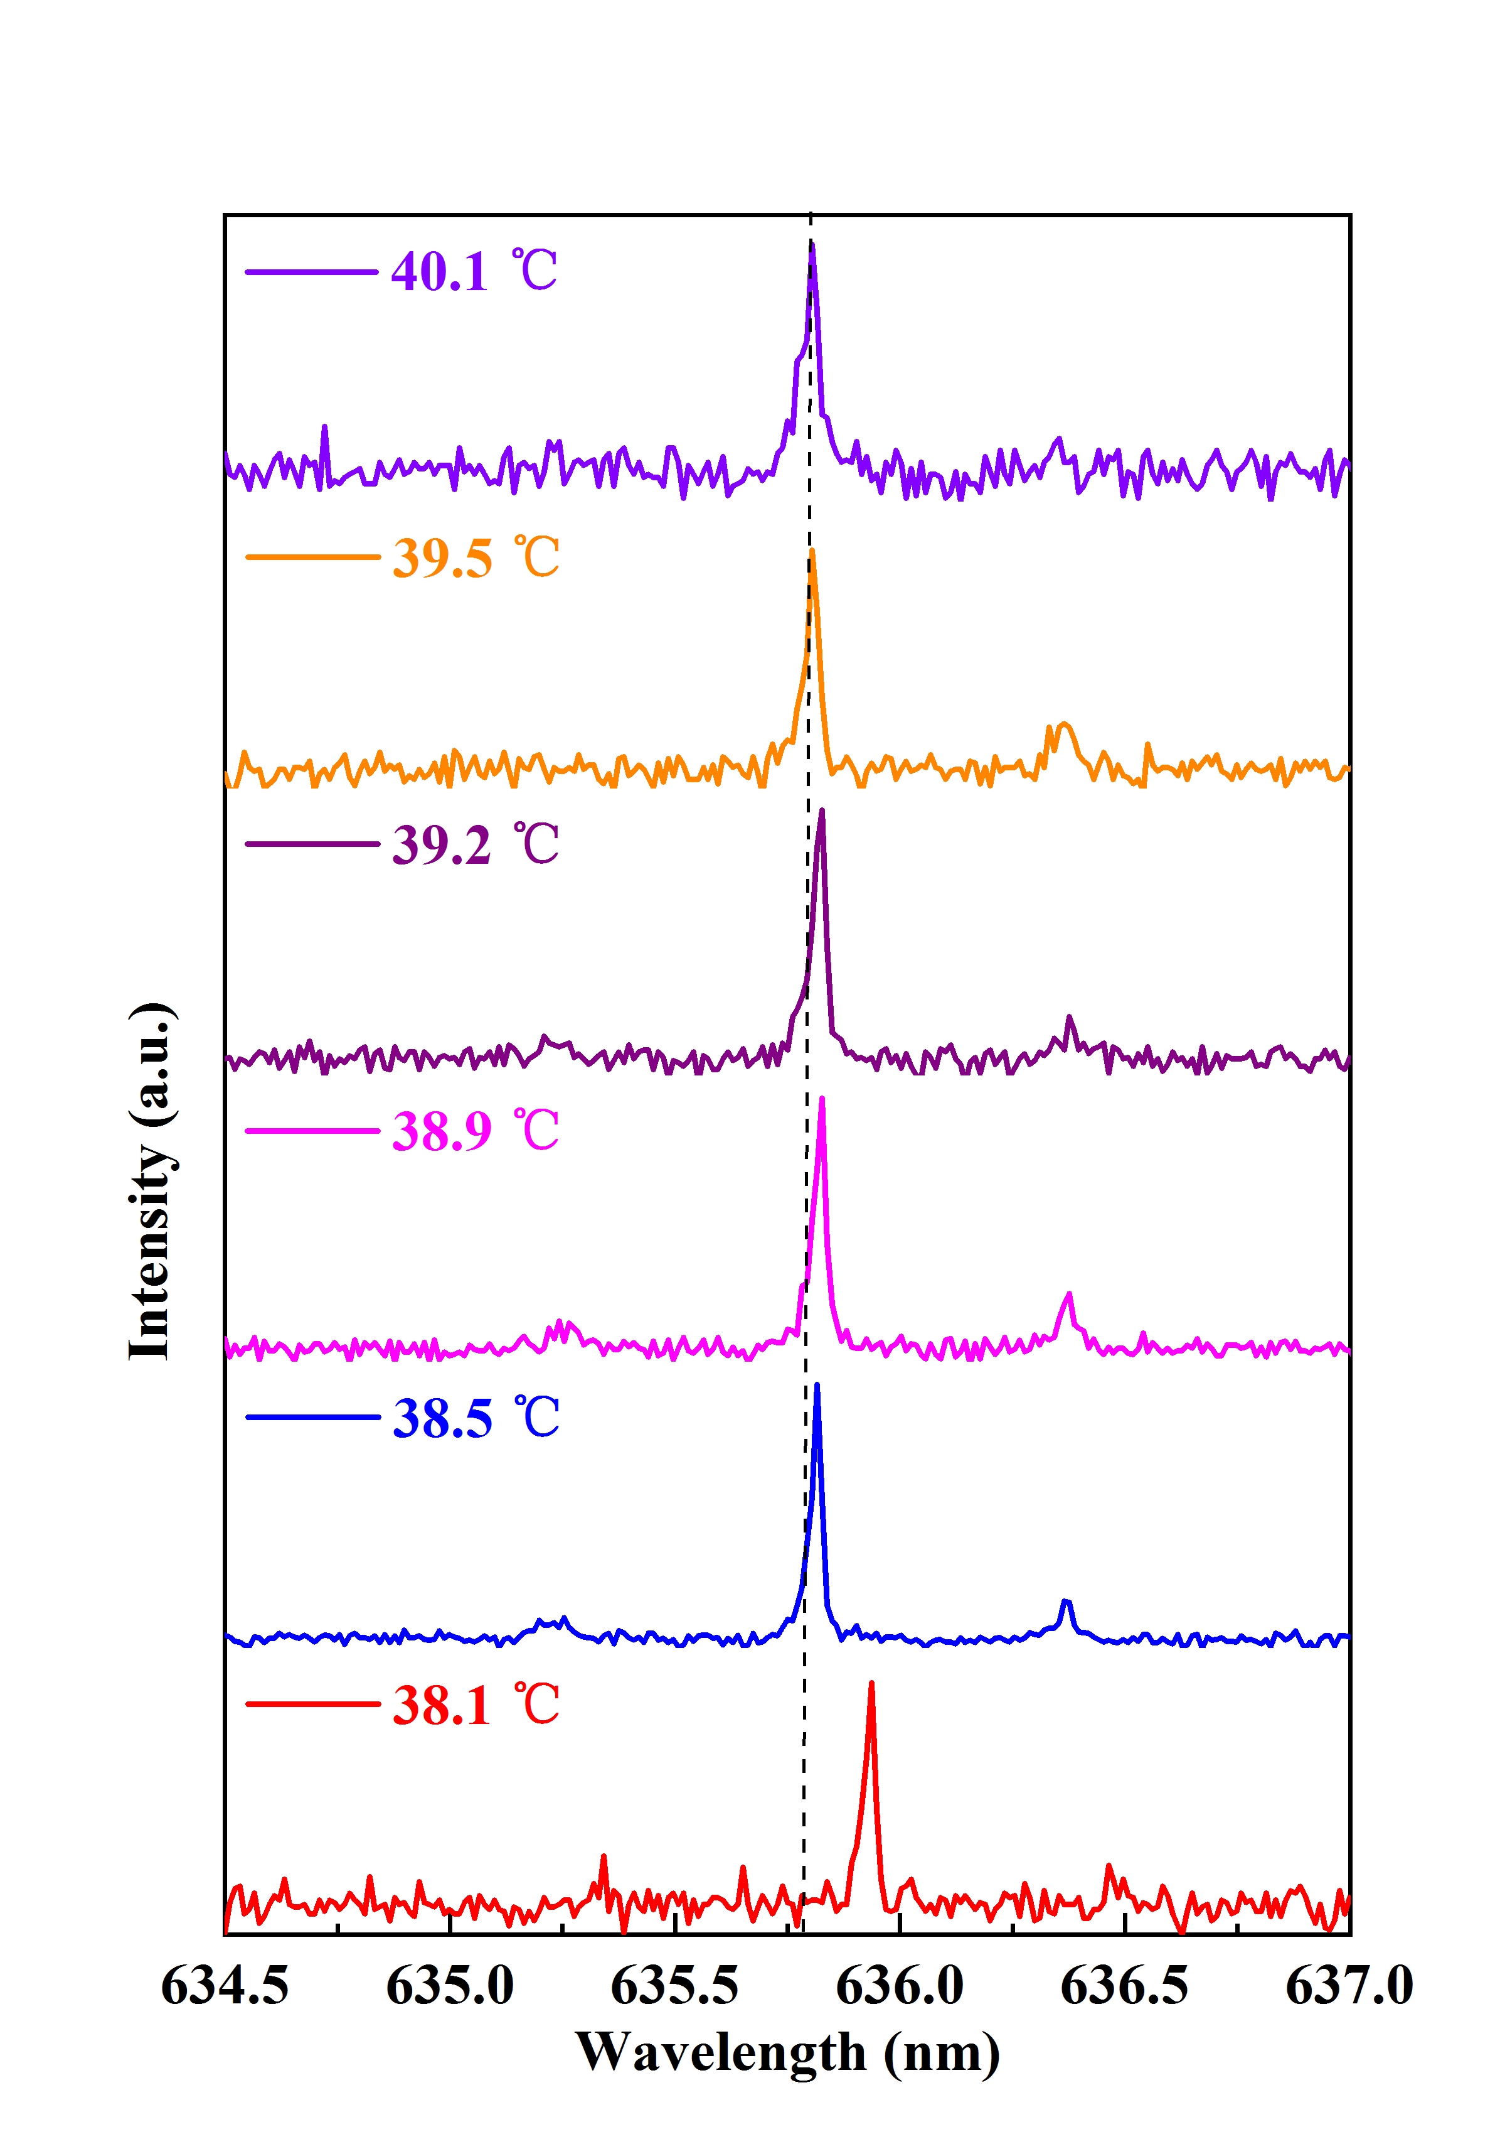

Figure S16. The blue-shifting of single-mode in hybrid 2D-3D μ-cavity.