Supplementary material

**Few picosecond dynamics of intraband transitions in THz HgTe nanocrystals**

Thibault Apretna1, Sylvain Massabeau1, Charlie Gréboval2,Nicolas Goubet2, Jérôme Tignon1, Sukhdeep Dhillon1, Francesca Carosella1, Robson Ferreira1, Emmanuel Lhuillier2, and Juliette Mangeney1*

1 Laboratoire de Physique de l’Ecole Normale Supérieure, ENS, Université PSL, CNRS, Sorbonne Université, Université Paris-Diderot, Sorbonne Paris Cité, Paris, France Paris.

2 Sorbonne Université, CNRS, Institut des NanoSciences de Paris, 4 place Jussieu, 75005 Paris, France.

**Table of content**

1. Material characterization 2

2. I-V characterization 4

3. Extraction of the complex refractive index $neff(ω)$ of the composite film 5

4. Permittivity including thermal average effects 6

5. Supplementary references 6

# Material characterization

For **scanning electron microscopy**, we dropcast the solution of CQD onto a doped Si substrate. Imaging is conducted using a FEI Magellan microscope. For imaging, we typically operate the electron beam with a 3 kV bias and a low 6 pA current. Energy dispersive X-ray spectroscopy is conducted in the same instrument using an Oxford probe.

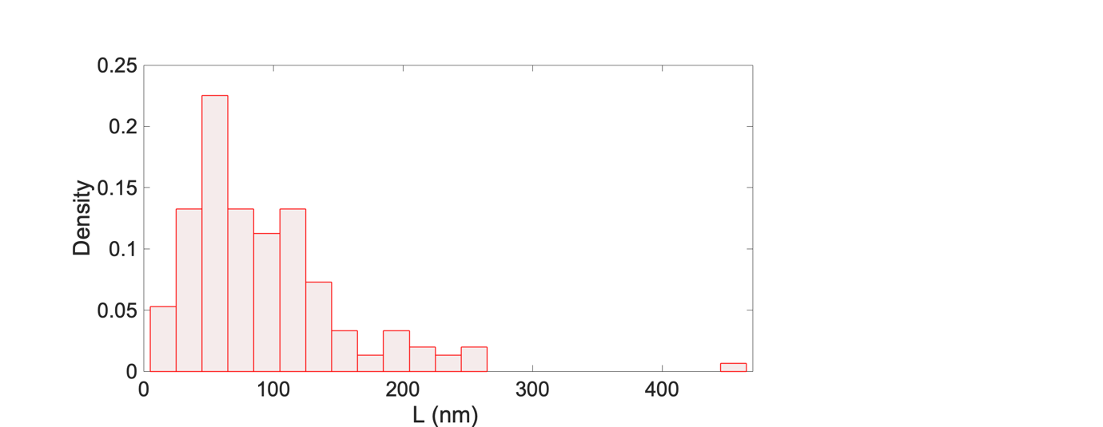

**Fig. S1**: Size distribution considered in the calculation deduced from scanning electron microscopy images with an average size of 90 nm, in agreement with X-ray diffraction data.

**Diffraction:** X-ray diffraction pattern is obtained by drop-casting the solution of nanocrystals on a Si wafer. The diffractometer is a Philips X’Pert, based on the emission of the Cu Kα line operated at 40 kV and 40 mA current. The diffraction pattern given in Figure S1 is consistent with the zinc blende phase of HgTe. Due to the significant variation in particle shape and the tendency of the particles to aggregate*,* we analyse the X-ray diffraction line width using the Debye–Scherrer equation to calculate a mean size of the NCs. A mean size of L=90 nm is extracted from the analyse of the X-ray diffraction line that is consistent with the small particles observed by electronic microscopy.

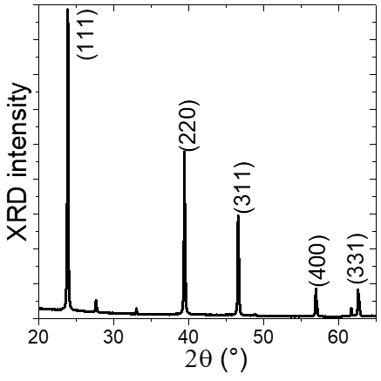

**Fig. S2**: X-ray diffraction pattern of large HgTe NCs.

**Raman spectroscopy** is carried out with a Labram HR800 (Horiba Jobin Yvon) spectrometer equipped with edge filters and coupled with a confocal microscope. The exiting beam was blue 458 nm line from an Argon Laser (Innova 90C-6 from Coherent). The confocal hole, which in our setup also acts as a spectrometer entrance slit, and was fixed at 200 µm. The x100 objective was used to probe the HgTe powder. Spectra are recorded between 50 and 400 cm-1 with a 1800 lines/mm grating resulting in a resolution of 1 cm-1. Spectrometer calibration was set using the 520.5 cm-1 band of a Si crystal. The effective laser power at the exit of the objective was between 2 and 4 mW.

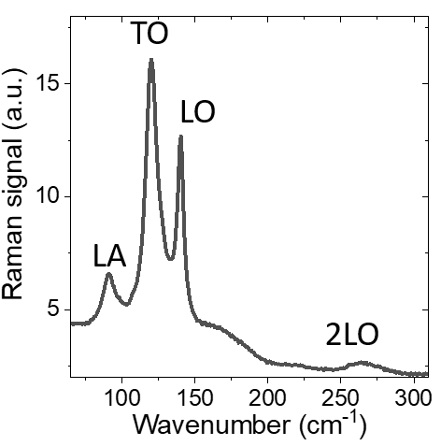

**Fig. S3**: Raman spectrum of a thin film made of large HgTe NCs.

# I-V characterization

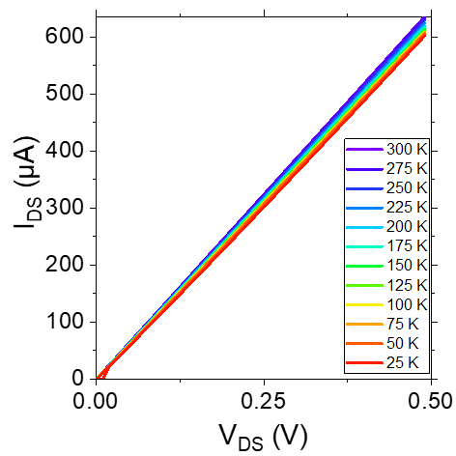

**Fig. S4**: I-V curve of a thin film made of large HgTe NCs at various temperature.

# Extraction of the complex refractive index ${\tilde{n}}_{eff}(ω)$ of the composite film

The calculation of the THz electric field propagation across the two samples links the amplitude transmittance $\tilde{t_{0}}\left(ω\right)$ to the complex refractive index ${\tilde{n}}_{eff}(ω)$ of the composite film. For this calculation, we do not include multiple reflections in the Si substrate as we perform a temporal windowing to exclude the echo from substrate reflections. Indeed, as the thickness of the silicon substrate is 285 µm (corresponding to an echo time delay of ≈6.5 ps), we limit our temporal window to 6 ps after the main peak. The spectral amplitude transmittance is expressed as:

$$\tilde{t_{0}}\left(ω\right)=\frac{4{\tilde{n}}_{eff}(ω)(1+n_{Si})}{(1+{{\tilde{n}}_{eff}(ω))({\tilde{n}}_{eff}(ω)+ n}_{Si})}{FP}_{01S}(ω)e^{i\frac{ω}{c}d({\tilde{n}}_{eff}(ω)-1)}e^{i\frac{ω}{c}Δd_{sub}{(n}_{si}-1)}$$

with ${FP}_{01S}\left(ω\right)≈\frac{1}{1-r_{01}r_{1S}e^{2i\frac{ω}{c}d_{1}{\tilde{n}}_{1}}}$, the multiple backward and forward reflections in the composite film, $r_{01}$ and $r_{1S}$ the amplitude reflection coefficient at the interface air-film and film-Si respectively, *nSi* the refractive index of the Si substrate, d=13.2 µm the thickness of the composite film, $Δd_{sub}$ is the Si substrate thickness difference between the two samples,  is the angular frequency and *c* is the speed of light in vacuum. We calculate the complex refractive index ${\tilde{n}}_{eff}(ω)$ by minimizing the error function defined by $δ\left(n_{eff};κ_{eff}\right)={δρ}^{2}+{δφ}^{2}$ with $δρ=ln\left(\left|{\tilde{t}}_{theo}\left(ω\right)\right|\right)-ln\left(\left|{\tilde{t}}_{mea}\left(ω\right)\right|\right)$ and (<https://thz.yale.edu/resources>).

Note that, in the THz-TDS measurements, we employ time-windowing and limit the recording temporal window to 6 ps after the main peak to eliminate the echoes from the multiple reflections within the 285 µm thick silicon substrate (corresponding to a first echo time delay of ≈6.5 ps).

# Permittivity including thermal average effects

To link the permittivity calculated here to the standard permittivity reported for small size NCs, we use the relation between the matrix elements of position and impulsion (for n≠m): $\left|z_{n,m}\right|=\left|ℏ {\left(p_{z}\right)}_{n,m}/[m_{e}^{*}\left(E_{n}-E_{m}\right)]\right|$ and the general relation $\sum_{i}{\sum_{j}{u_{i,j}}}=(1/2)\sum_{i}{\sum_{j}{\left(u_{i,j}+u_{j,i}\right)}}$ for a double-index summation, to transform the equation for $χ_{intra}\left(ω\right)$ into :

$$χ_{intra}(ω) =\frac{-2{e^{2}ℏ}^{2}}{{ε_{0 }m_{e}^{*}}^{2} L^{3}}\sum_{n}{\sum_{m≠n}{\sum_{k,l}{\frac{F_{n,k,l}-F_{m,k,l}}{E_{n}-E_{m}}}}} \frac{{\left|{\left(p_{z}\right)}_{n,m}\right|}^{2}}{{\left(E_{n}-E_{m}\right)}^{2}-{\left(ℏω+iγ\right)}^{2}}$$

It is also worth to notice that for low damping this latter formula can be further rewritten as

$$ε\left(ω\right)=ε_{∞}+χ_{intra}\left(ω\right)=ε_{∞}+\frac{e^{2}}{ε_{0 }m_{e}^{*} L^{3}}\sum_{n}{\sum_{m≠n}{\sum_{k,l}{\left[F_{n,k,l}-F_{m,k,l}\right]}}} \frac{f_{n,m}}{{\tilde{ω}}_{n,m}^{2}-ω^{2}-iωΓ}$$

where ${\tilde{ω}}_{n,m}=(E_{n}-E_{m})/ℏ$ is the frequency of the oscillator corresponding to the (*n,m*) transition and $Γ=2γ/ℏ$ its damping frequency, and $f_{n,m}=\frac{-2}{m_{e}^{*}} \frac{{\left|{\left(p_{z}\right)}_{n,m}\right|}^{2}}{E_{n}-E_{m}}$ the oscillator strength corresponding to this transition. Except for the factor $\sum_{k,l}{\left[F_{n,k,l}-F_{m,k,l}\right]}$, this expression reproduces the expressions reported in the literature for small size NCs [S1-S7], which therefore our model generalises to account for the unavoidable thermal average effects in intermediate and large size NCs.

# Supplementary references

[S1] Son, Juhee; Choi, Dongsun; Park, Mihyeon; Kim, Juyeong; Seob Jeong, and Kwang. Transformation of Colloidal Quantum Dot: From Intraband Transition to Localized Surface Plasmon Resonance. Nano Lett. 2020, 20, 4985–4992.

[S2] Zhang, Hui; Kulkarni, Vikram; Prodan, Emil; Nordlander, Peter; Govorov, Alexander O. Theory of Quantum Plasmon Resonances in Doped Semiconductor Nanocrystals. J. Phys. Chem. C 2014, 118, 16035–16042.

[S3] Prashant K. Jain, Plasmon-in-a-Box: On the Physical Nature of Few-Carrier Plasmon Resonances, J. Phys. Chem. Lett. 2014, 5, 3112.

[S4] Agrawal, A.; Cho, Shin Hum; Zandi, O.; Ghosh, S.; Johns, Robert W.; Milliron, Delia J. Localized Surface Plasmon Resonance in Semiconductor Nanocrystals. Chem. Rev. 2018, 118, 3121−3207.

[S5] Fan, X.; Zheng, W.; Singh, D. Light scattering and surface plasmons on small spherical particles. Light Sci Appl. 2014, 3**,** e179.

[S6] Shen, Guohua; Guyot-Sionnest, Philippe. HgS and HgS/CdS Colloidal Quantum Dots with Infrared Intraband Transitions and Emergence of a Surface Plasmon. J. Phys. Chem. C 2016, 120, 11744–11753.

[S7] Schimpf, A. M.; Thakkar, N; Gunthardt, C. E.; Masiello, D. J.; Gamelin D. R. Charge-Tunable Quantum Plasmons in Colloidal Semiconductor Nanocrystals. ACS Nano 2014, 8, 1065–1072.