Supplementary Information for

**Efficient generation of optical bottle beams**

Yuzhe Xiao1, Zhaoning Yu1,2, Raymond A Wambold1, Hongyan Mei1, Garrett Hickman2, Randall H Goldsmith3, Mark Saffman2, and Mikhail A. Kats1,2,4*

1Department of Electrical and Computer Engineering, University of Wisconsin-Madison, Madison, Wisconsin 53706, USA

2Department of Physics, University of Wisconsin-Madison, Madison, Wisconsin 53706, USA

3Department of Chemistry, University of Wisconsin-Madison, Madison, Wisconsin 53706, USA

3Department of Materials Science and Engineering, University of Wisconsin-Madison, Madison, Wisconsin 53706, USA

*Correspondence to: [mkats@wisc.edu](mailto:mkats@wisc.edu).

**1. Field profiles from parameter-sweep optimization**

Here we show the field profiles at 1 mm away from the trap that generate the traps in Fig. 3. More specifically, the far-field profiles that generate the traps in Figs. 3 (a-c) and Figs. 3 (d-f) are shown in Fig. S1 and S2, respectively.

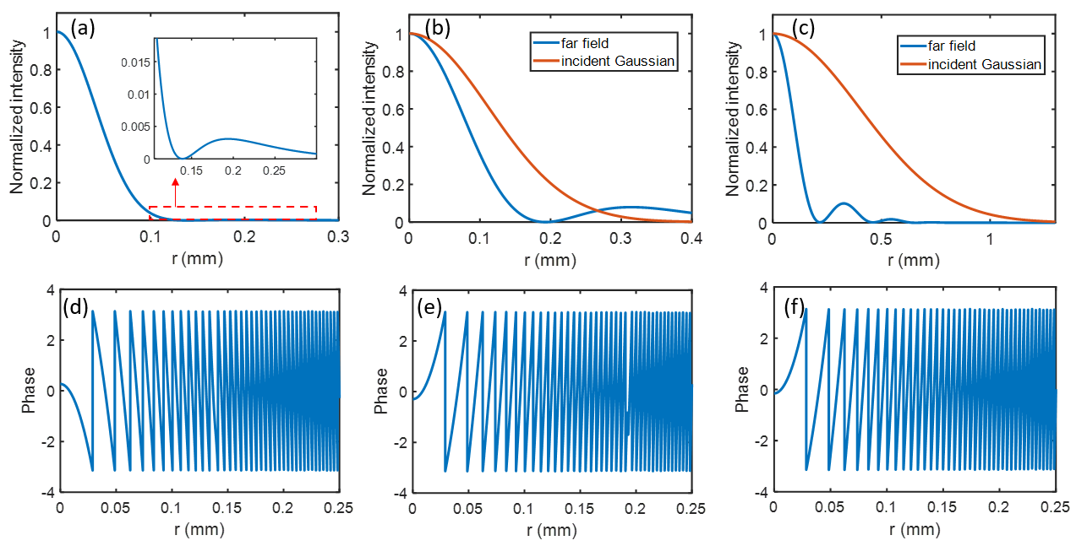

Fig. S1. (a-c): Intensity profiles of the far field as well as the incident Gaussian that generate the area bottle trap shown in Figs. 3 (a-c). (d-f): Corresponding phase profiles of the far field.

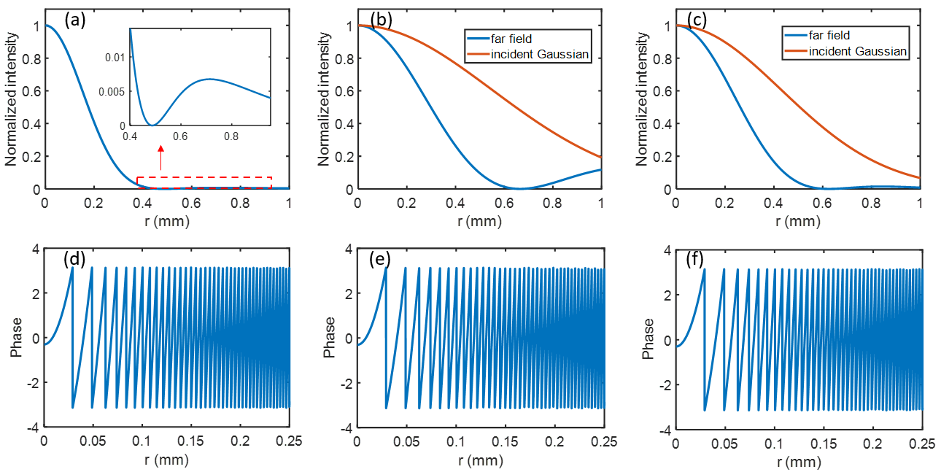

Fig. S2. (a-c): Intensity profiles of the far field as well as the incident Gaussian that generate the point bottle trap shown in Figs. 3(d-f). (d-f): Corresponding phase profiles of the far field.

**2. Trapping potential for optical bottle-beam traps**

Here we show the optical trapping potential for the bottle-beam traps shown in Fig. 3 in the main text. For a particle inside the trap, the corresponding trapping potential $U$ is related to the polarizability of the particle $α$ and light intensity $I$ as $U=-\left[\frac{α}{2ϵ_{0}c}\right]I$ [S1], where $c$ is the speed of light and $ϵ_{0}$ is the permittivity of free space. Typically, the trapping potential is expressed in terms of trapping temperature $U=k_{B}T$, where $k_{B}$ is the Boltzmann constant. The polarizability of a spherical particle with radius $r_{0}$ and relative permittivity $ϵ_{r}=ϵ_{particle}/ϵ_{surrounding}$ is $α=-4πϵ_{0}\frac{ϵ_{r}-1}{ϵ_{r}+2}r_{0}^{3}$ [S2]. Bottle beams can trap particles with $ϵ_{r}$ less than one, which could be particles made of materials with index less than one [S3]–[S5] or low-index particles in a higher-index liquid [S6], [S7]. Note that in most applications, one would be trapping low-index particles in a higher-index fluid, for which one would need to slightly re-design the metasurfaces.

We consider a trapping potential for a spherical particle of radius $r_{0}=$ 100 nm and a relative permittivity $ϵ_{r}=$ 0.8. Such a particle has a polarizability of 7.94 10-33 Cm2V-1. The trapping potential scales linearly with the light intensity. Here we assume an input laser power of 500 mW. The calculated optical trapping potential for the bottle-beam traps shown in Fig. 3 in the main text are plotted in Fig. S3. The values plotted are normalized to the $-k_{B}T_{0}$, where $T_{0}$ is room temperature (296 K). The contour line for the escape trapping potential $U_{escape}$ (which is related to the escape intensity $I_{escape}$ in Eq. 1 in the main text as: $U_{escape}=-\left[\frac{α}{2ϵ_{0}c}\right]I_{escape}$) is also shown for each trap. For an input laser power of 500 mW, the escape trapping potentials for the volume and point traps generated using two-Gaussian-beam interference (Method 1) are about 1.9 and 24 $k_{B}T_{0}$. The trapping potentials for the volume and point traps generated using metasurfaces designed with Method 2 increase to about 11 and 94 $k_{B}T_{0}$, while they are about 18 and 94 $k_{B}T_{0}$ for the traps generated using metasurfaces designed with Method 3.

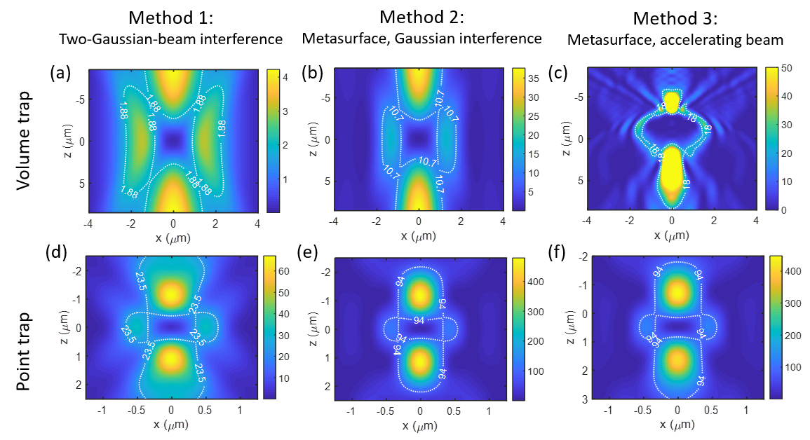

Fig. S3. Calculated trapping potential for the bottle-beam traps shown in Fig. 3 of the main text. The values plotted are normalized to $-k_{B}T_{0}$, where $T_{0}$ = 296 K (room temperature). The trapping potential is calculated for a low-index particle with relative permittivity $ϵ_{r}=0.8$ and radius $r_{0}=$ 100 nm with an input laser power of 500 mW.

**3. Local optimization of the bottle traps**

We found that the traps shown in Figs. 3 (b, e, f) are quite close to a local optimum because the best traps found from local optimization are quite close to these traps. As an illustration, Fig. S4 shows the result of one of the 500 simulations for the trap in Fig. 3(b). As shown in Fig. S4(a), the highest FOM is almost the same as the starting point (the red dotted line). The best trap from this local optimization shown in Fig. S4(b) looks almost identical to the one shown in Fig. 3(b). The field profiles as well as the incident Gaussian of the optimized trap are very close to the starting point.

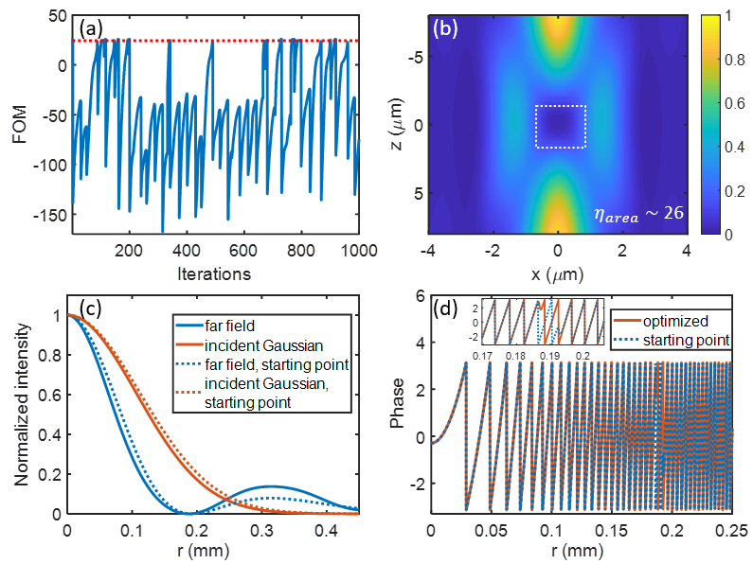

Fig. S4. (a): Evolution of FOM for different iterations of the local optimization of one simulation for the trap shown in Fig. 3(b). The FOM of the starting trap is indicated by the red dotted line. Out of 500 different simulations, the highest FOM is 26, which is very close to the trap in Fig. 3(b). (b): The trap profile of the best trap found in this simulation, which is almost identical to the trap shown in Fig. 3(b). (c) and (d) compare the far field profiles as well as the incident Gaussian for the best trap found by parameter-sweep optimization in Fig. 3(b) (dotted lines) and local optimization (solid lines).

For the trap shown in Fig. 3(c), the local optimization was able to find a trap with a FOM much higher. As an illustration, Fig. S5 shows the result of one of the 500 simulations for the trap in Fig. 3(c). As shown in Fig. S5(a), the highest FOM shows an improvement of about 60% over the starting point (the red dotted line). The best trap from this local optimization shown in Fig. 4(c) looks similar to the starting trap. The field profiles as well as the incident Gaussian of the optimized trap are close to the starting point.

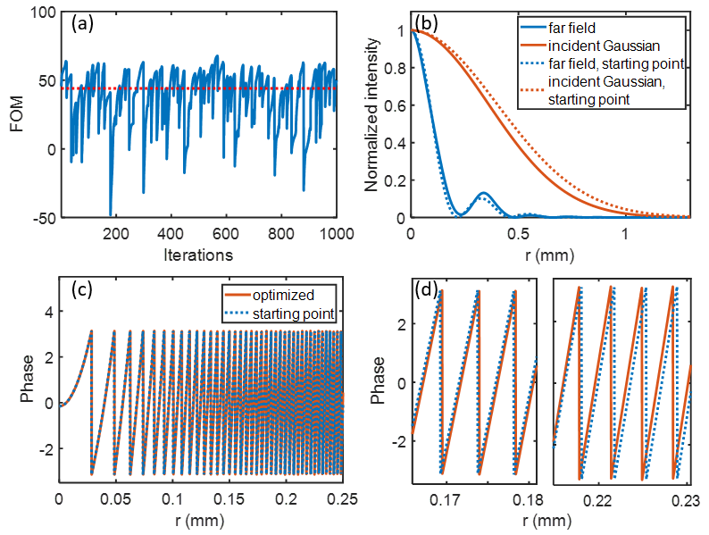

Fig. S5. (a): Evolution of FOM for different iterations of the local optimization of one simulation for the trap shown in Fig. 3(c). Out of 500 different simulations, the highest FOM is about 68, which shows an improvement of 60% from the starting value. (b-d) compare the far field profiles as well as the incident Gaussian for the best trap found by parameter-sweep optimization in Fig. 3(c) (dotted lines) and local optimization (solid lines).

**4. Global optimization of the bottle traps**

Here we compare the best area bottle beam traps found from the global optimization with those found from the local optimization.

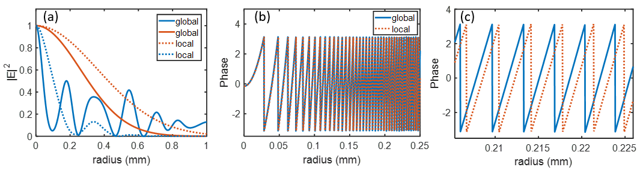

Fig. S6. (a): Comparison of the far field intensity profile as well as the incident Gaussian for the area bottle trap found from local (dotted lines) and global optimization (solid lines). Phase profiles for these two traps are plotted in (b), with the zoomed in portion near 0.22 mm shown in (c).

**5. Impact of metasurface resolution on bottle beam generation**

Many approaches can be used to generate optical bottle beams, including holography. In particular, spatial light modulators (SLMs) have been used to generate the required amplitude or phase response (i.e., a hologram) for generating bottle beams [S8]–[S10]. SLMs have one key advantage (tunability) and two key disadvantages (resolution, compactness) compared to static metasurfaces. Unlike most metasurfaces, SLMs are tunable. However, they also have a much lower spatial resolution than optical metasurfaces. Therefore, SLMs are not favorable for applications that require phase/amplitude profiles that changes rapidly with position.

As an example, we consider below five different metasurfaces with different resolutions to generate the bottle beam in Fig. 6 (d) in the main text. The phase profiles for these five metasurfaces are shown in Fig. S7 (a), with spatial resolution being infinite (continuous phase profile), and 330, 660, 990, 1980 nm. The calculated bottle-beam profiles for these five metasurfaces are plotted in Fig. S7 (b-f). Based on these results, it seems that a resolution close to or better than 1 micron is needed to generate such a bottle beam using the metasurface configuration discussed in Fig. 6. Note that the resolution requirement of 1 micron is only for this particular metasurface generating this particular bottle beam. In particular, here we consider a small device (10 micron radius) that is very close to the trap (15 micron away from the trap). SLMs can still be used to generate bottle beams in different configurations where the resolution requirement is lower [S8]–[S10].

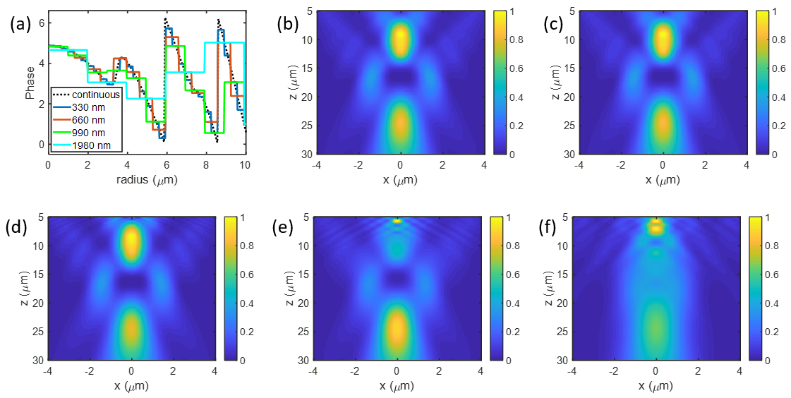

Fig. S7. Impact of metasurface resolution on bottle-beam generation. The phase profiles for these five metasurfaces are shown in (a), with resolution of infinite high (continuous phase), 330, 660, 990, and 1980 nm. The calculated bottle beam profiles for these five devices are plotted in (b-f).

**6. Robustness of the metasurface design**

Here we consider the robustness of metasurface design in Fig. 6 against fabrication errors. The metasurface can be directly etched from the device layer of a commercialized silicon-on-silicon wafer, whose thickness is very uniform. So, here we mainly consider the robustness of the design against the variations in the silicon cylinder diameter. We consider two types of variations: (1) random variations to the diameter of each cylinder, and (2) a uniform variation to the diameters of all cylinders. We simulated both cases using FDTD, and the results are shown in Fig. S8.

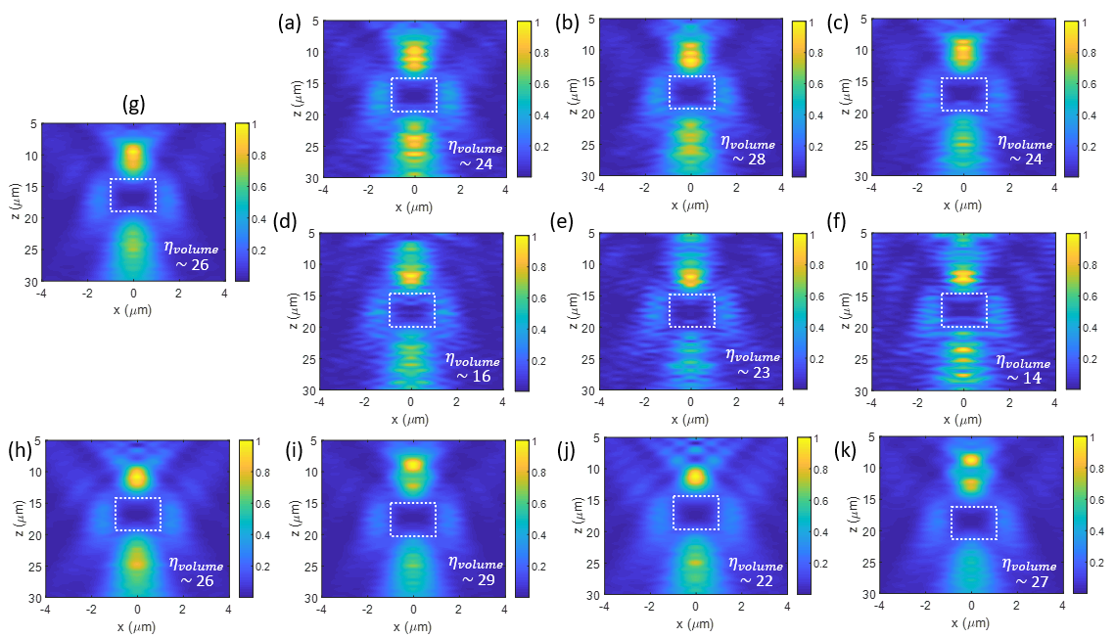

Fig. S8. Robustness of the metasurface design against variations in the diameter of the silicon cylinders. Panels (a-c) show the normalized intensity and $η$ of the bottle beam from three different randomly generated structures where the diameter of each cylinder was randomly varied with an offset between $\left[-10, 10\right]$ nm, while panels (d-f) show the case for random variation with an offset between $\left[-20, 20\right]$ nm. (g) is the original, unperturbed metasurface. Bottom figures (h-k) show the results when the diameters of all cylinders are uniformly increased (or decreased, if negative) by (h) 10 nm, (i) -10 nm, (j) 20 nm, and (k) -20 nm.

The result from the exact structure is shown in Fig. S8 (g) (which is the same in Fig. 6(d) in the main text). Figure S8 (a-c) shows the normalized intensity and $η$ of the bottle beam from three different randomly generated structures where the diameter of each cylinder was randomly varied with an offset between $\left[-10, 10\right]$ nm, while (d-f) show the case for random variation with an offset between $\left[-20, 20\right]$ nm. Figure S8 (h-k) show the results when the diameters of all cylinders are uniformly changed by 10, -10, 20, and -20 nm. These calculations show that the metasurface is robust against small variations in the diameters of the silicon cylinders.

**References**

[S1] H. Yu et al., “Chip-scale molecule trapping by a blue-detuned metasurface hollow beam,” J. Opt. (United Kingdom), 22, 4, 045104, 2020.

[S2] C. Balanis, Advanced engineering electromagnetics. John Wiley & Sons, 1999.

[S3] A. Shahsafi et al., “Mid-infrared Optics Using Dielectrics with Refractive Indices Below Unity,” Phys. Rev. Appl., 10, 3, 034019, 2018.

[S4] A. Shahsafi, J. Salman, B. E. Rubio Perez, Y. Xiao, C. Wan, and M. A. Kats, “Infrared Polarizer Based on Direct Coupling to Surface Plasmon Polaritons,” Nano Lett., 20, 12, 8483–8486, 2020.

[S5] N. Kinsey, C. DeVault, A. Boltasseva, and V. M. Shalaev, “Near-zero-index materials for photonics,” Nature Reviews Materials, 4, 12, 742–760, 2019.

[S6] K. T. Gahagan and G. A. Swartzlander, “Optical vortex trapping of particles,” Opt. Lett., 21, 11, 827, 1996

[S7] M. P. MacDonald, L. Paterson, W. Sibbett, K. Dholakia, and P. E. Bryant, “Trapping and manipulation of low-index particles in a two-dimensional interferometric optical trap,” Opt. Lett., 26, 12, 863, 2001.

[S8] P. Xu, X. He, J. Wang, and M. Zhan, “Trapping a single atom in a blue detuned optical bottle beam trap,” Opt. Lett., 35, 13, 2164, 2010.

[S9] C. Alpmann, M. Esseling, P. Rose, and C. Denz, “Holographic optical bottle beams,” Appl. Phys. Lett., 100, 11, 111101, 2012.

[S10] D. Barredo et al., “Three-Dimensional Trapping of Individual Rydberg Atoms in Ponderomotive Bottle Beam Traps,” Phys. Rev. Lett., 124, 2, 023201, 2020.