Supplementary material for “Edge detection with meta-lens: from one dimension to three dimensions”
Mu Ku Chen^{1,#}, Yue Yan^{1,#}, Xiaoyuan Liu¹, Yongfeng Wu¹, Jingcheng Zhang¹, Jiaqi Yuan¹, Zhengnan Zhang¹, and Din Ping Tsai^{1,}*

¹Department of Electronic and Information Engineering, The Hong Kong Polytechnic University, Kowloon, Hong Kong, China.

#These authors contributed equally to this work.
*Correspondence: dptsai@ieee.org

Details of Methods
Simulation
The achromatic meta-lens array is composed of gallium nitride (GaN) positive and inverse nanostructures. The numerical simulations of the nanostructures are used microwave studio commercial software from Computer Simulation Technology (CST). The optical properties of phase and transmittance are calculated and evaluated by the structural tuning. The refractive index of GaN is referred to this reference. (A. S. Barker, Jr et al., Phys. Rev. B 7, 743, 1973). The feature size is shown in Figure S1.

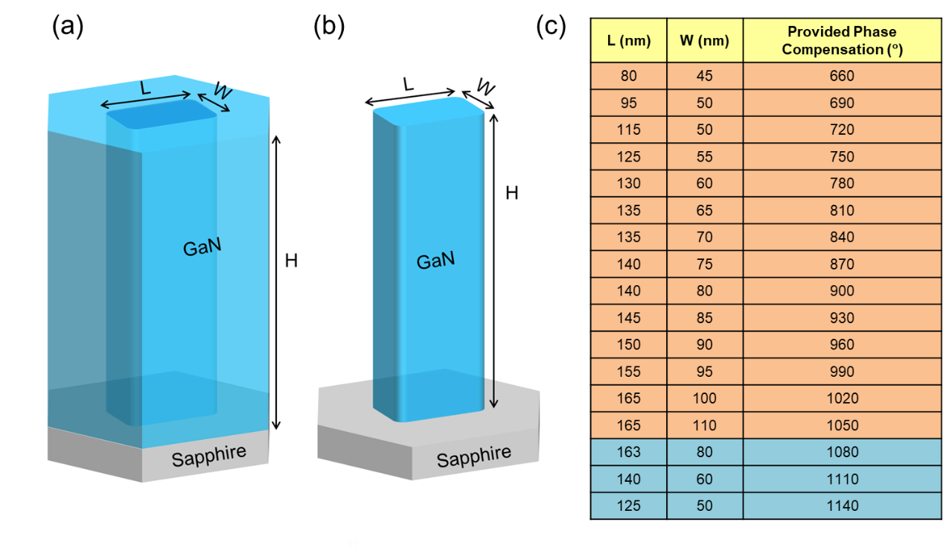
Fig. S1. The design of the GaN building blocks. (a) The negative nanostructure. (b) The positive nanostructure. (c) The feature size table of the nanostructure. The orange table is for the positive nanostructure, and the blue table is for the negative nanostructure.

Fabrication
The achromatic meta-lens array is fabricated through the standard electron beam lithography (EBL), several dry etching processes, and pattern transfer with the hard mask. Fig. S2 illuminates the detailed sample fabrication flow step by step. A sapphire substrate is polished on double sides. An undoped GaN layer with a thickness of 800 nm is grown on the double-polished sapphire by metalorganic chemical vapor deposition. For the high-aspect-ratio design of the GaN nanostructures, we have to use a hard mask to help with pattern transfer and the high-aspect-ratio etching capability. SiO₂ is a suitable material for the etching hard mask because of the selective etching ratio between it and GaN. A 400-nm-thick SiO₂ layer is deposited as the hard mask layer by the electron gun evaporator. A diluted ZEP520A (ZEP-520A: ZEPA = 1: 3) electron-beam resist is spin-coated on the currently prepared substrate for the EBL. The nanostructure configuration of the achromatic meta-lens is emerged by the electron-beam exposure and development process. A metal layer (Chromium) with 40 nm of thickness is deposited and done the lift-off process. The left metal layer is used as the hard mask for etching the SiO₂ layer. The pattern of the sample is transferred to the SiO₂ layer by reactive ion etching. After transferring the pattern on the SiO₂, we used the inductively coupled-plasma reactive ion etching to receive the GaN positive and inverse nanostructures on the sapphire with designed height and feature size. This final step is to use the wet etching with the buffered oxide etch (BOE) solution to remove the residue SiO₂ layer, and then the final achromatic meta-lens array sample is fabricated.
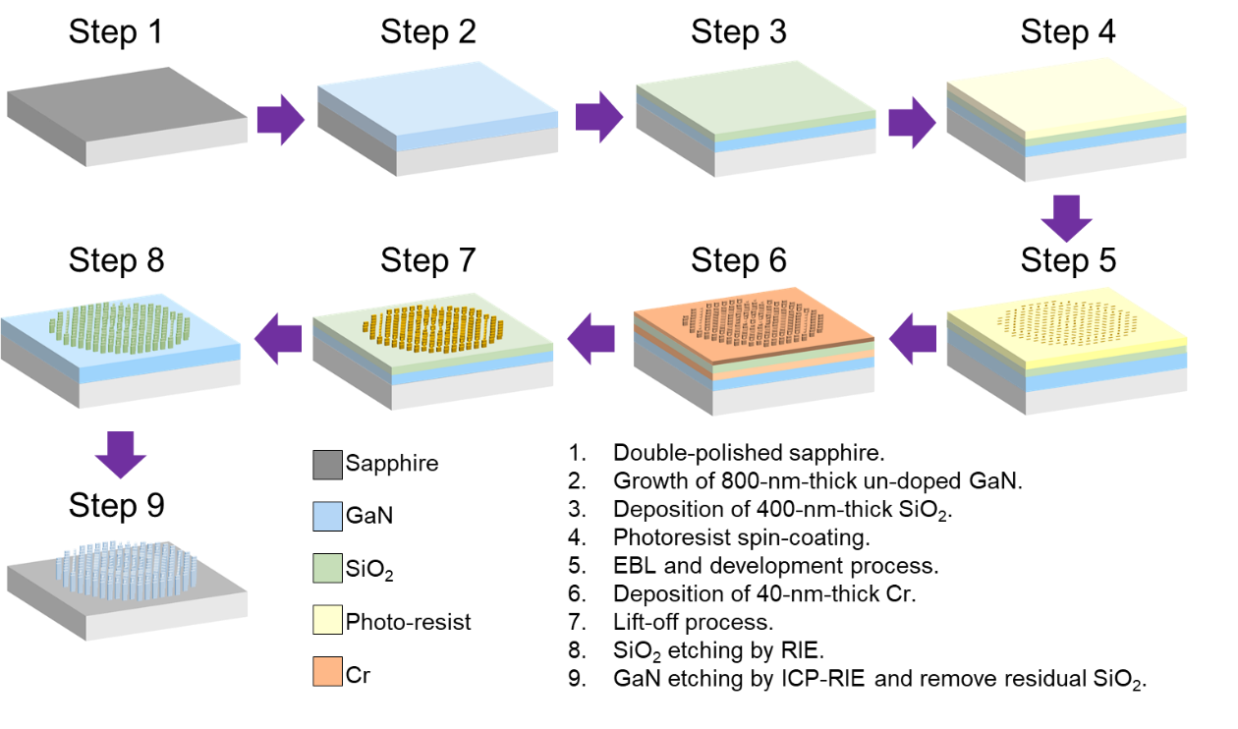
Fig. S2. The sample fabrication flow of the achromatic meta-lens array.

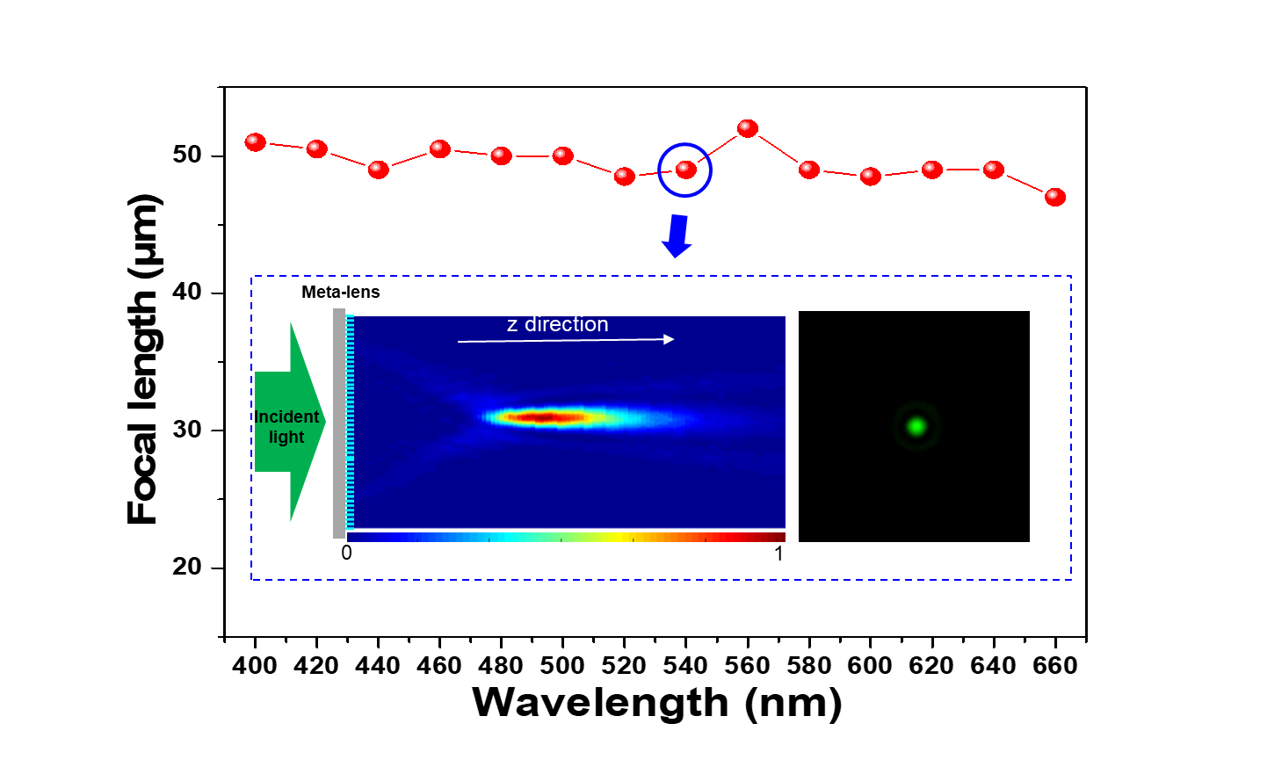
Fig. S3. Measured focal length at various incident wavelengths. Insert image: the measured light intensity profiles at 540 nm of wavelength (left side), and the measured light intensity of the focal spot at 540 nm of wavelength (right side).

Experimental setup
Light field imaging with achromatic meta-lens array
The light field optical system diagram is shown in Fig.S4. A commercial lens (AF-Nikkor D = 50 mm, f/1.8) and objective lens1 (7.5x, NA = 0.21) are used to image the real object to a small scale at the object plane of the meta-lens array. Since the achromatic meta-lens array is polarization-dependent, a linear polarizer (LP) and λ/4 waveplate are used to transfer the unpolarized illumination light to circular polarization. The image distance of the meta-lens array b was set as 58.5 µm, the objective distance of the meta-lens array a was calculated as 300 µm from the Gaussian lens equation . Objective lens2 (20x, NA = 0.42) is used to magnify the image onto a CMOS sensor. λ/4 waveplate and LP are used to remove the background noise.

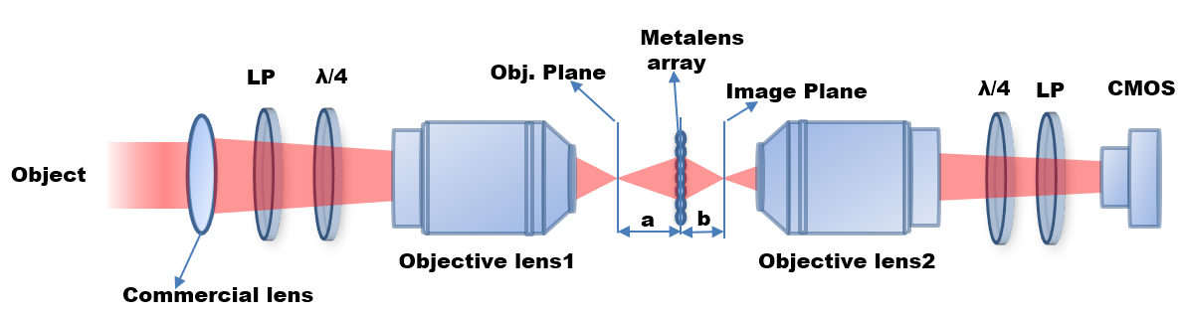
Fig.S4. Light field imaging system diagram.

Similar to the compound eyes of some insects, in the light field imaging system, each sub-image captured the objects from different directions. Disparity d appears that makes it possible for depth estimation and rendering the focused images at different depths. As shown in Fig. S5(a). d could be calculated as $d=D⋅b/a$. For the rendering algorithm, first, a patch of the pixel size of m that corresponds to the disparity size is selected and rotated 180° for every sub-images. The selected and rotated patches are then joined together as the reconstructed images at different depths for different d, as shown in Fig. S5 (b). Depth estimation could also be extracted from the disparity d. The farthest distance of the object means the smallest disparity. Disparity estimation steps are as follows and Fig. S5 (c) :
- select a region I (m, x, y) from the sub-image. (x, y) is the center of the sub-image, m is the selected region size which equals D/4.
- Move the selected region I(m, x, y) a p distance for the surrounding sub-images as I(m, x±p, y±p). p is a variable.
- Calculate $R(p)=\sum{[I(m,x±p,y±p)-I(m,x,y)]^{2}}$ for a different p value.
- Determine the minimum R (p), and the corresponding p is the disparity.
- Set disparity d=p; object distance a=D*b/d；
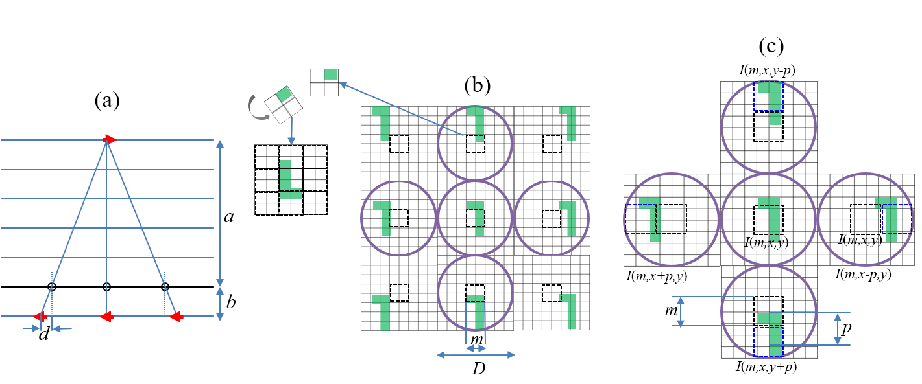
Fig. S5. (a) light field imaging process, (b) rendering algorithm for image reconstruction, (c) disparity estimation process.

Edge detection from 1D to 3D
1D and 2D edge detection
The 1D and 2D edge detection image process with light field imaging is shown in Fig S6. Fig. S6 (a) represents the sub-images of the ‘A’ pattern. The sub-images are shifted with one pixel along the x-direction, then subtract with the original sub-images. Then 1D differentiated light field image is obtained, as shown in Fig. S6 (b). Similarly, the sub-images are shifted with one pixel along both the x and y-direction, then subtract with the original sub-images. Then 2D differentiated light field image is obtained, as shown in Fig. S6 (c). Reconstructed edge images could be obtained with the rendering algorithm described above at a specific depth.

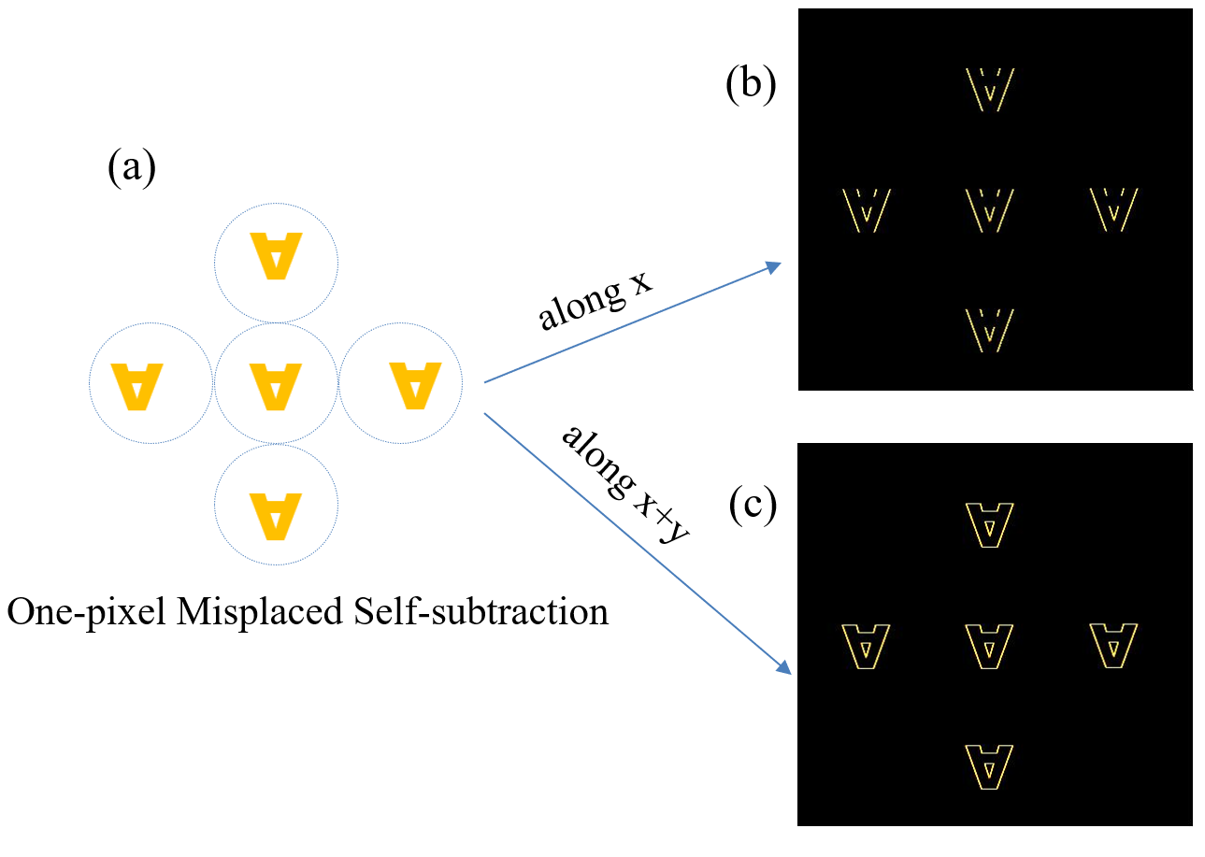
Fig. S6. light field for 1D and 2D edge detection.

Fig. S7 (a) shows the light field raw images captured by the light field imaging system with the achromatic meta-lens array. Fig. S7 (b) is the estimated disparities according to the method described above. The 1D and 2D edge images of the ‘A’ pattern are clearly extracted at depth =20 cm, as shown in Fig. S7 (c) and (d), respectively.

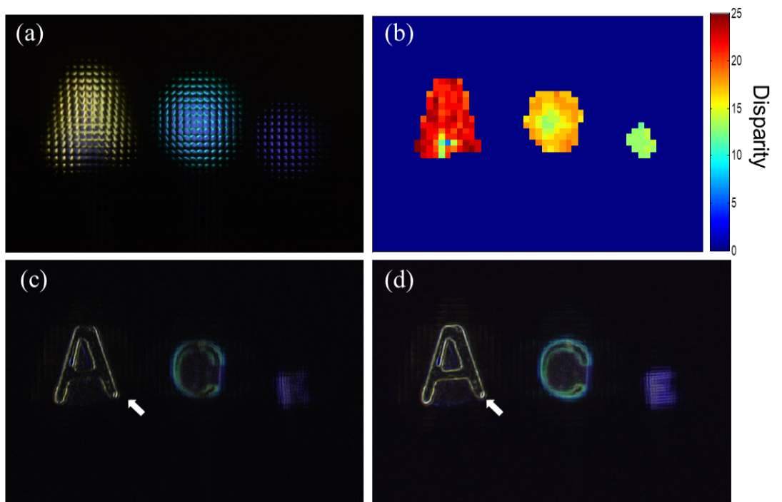
Fig. S7. (a) The light field raw data of three objects ‘A’, ‘C’, ‘E’ pattern at different depths, (b) the estimated disparities, (c) 1D edge image at depth = 20cm, (d) 2D edge image at depth = 20 cm.

3D edge detection
Light field imaging captures both the light intensity and directions of the objects, enabling 3D edge detection. After estimating the disparities of the objects, the rendering algorithm is then applied to extract the edge images at different depths with one single shot. Each pattern has the sharpest edge information while the other two patterns are blurred at their corresponding depth. We further characterize the 3D edge detection performance of the light field system with the meta-lens array. As marked with the white dotted line in Fig. S8 (a-c), we calculate the edge profile of every pattern at three corresponding depths. As shown in Fig. S9 (a-c), for each pattern, (i-iii) figures are the edge profiles at a depth of 20 cm, 25 cm, 47 cm, respectively. Taking Fig. S9 (a) as an example, edge profiles of ‘A’ are plotted at different depths. At depth 20 cm, the ‘A’ pattern has the sharpest edge information with the highest signal-noise ratio (SNR). While in the other depths, the ‘A’ pattern edges are blurred with low SNR. The other two patterns, ‘C’ and ‘E’ pattern, show similar property, and the blue arrows represent the sharpest edge profile of each pattern at its corresponding depths. The results show the high-quality performance of 3D edge detection with our designed meta-lens array.
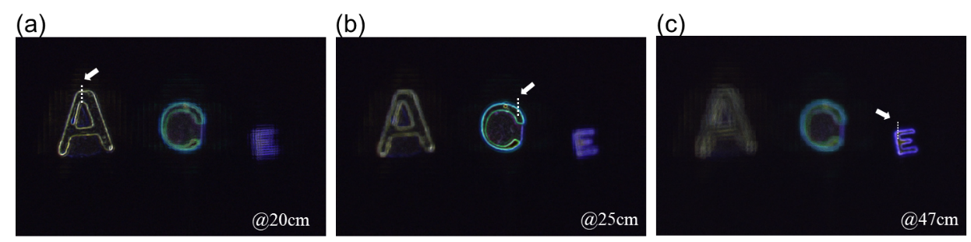
Fig. S8. extracted edge information at different focused depths for the ‘A,’ ‘C,’ ‘E’ pattern. The focused depth is 20, 25, and 47 cm, respectively.

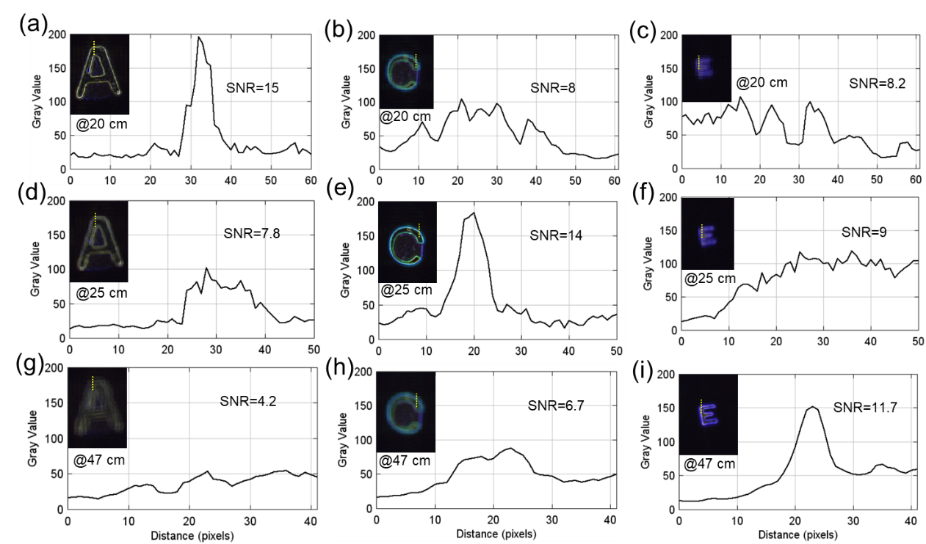
Fig. S9. Edge sharpness measurement results of the 3D edge imaging at various depths, and the cross-section diagram of the selected region of the pattern ‘A’, ‘C’, and ‘E.’ The insert images are rendering images focused at (a-c) 20 cm, (d-f) 25 cm, and (g-i) 47 cm, respectively.

