Supporting Information
Autologous tumor antigens and boron nanosheet-based nanovaccines for enhanced photo-immunotherapy against immune desert tumors
Zhe Sun^{1,3,4,†}, Taojian Fan^{2,†}, Quan Liu^{1,†}, Luodan Huang¹, Weibin Hu¹, Lulin Shi¹, Zongze Wu¹, Qinhe Yang^{3,*}, Liping Liu^{1,*}, and Han Zhang^{2,*}

1. Department of Hepatobiliary and Pancreatic Surgery, The Second Clinical Medical College (Shenzhen People's Hospital) of Jinan University, Shenzhen, 518020, P.R. China
2. Institute of Microscale Optoelectronics, Collaborative Innovation Centre for Optoelectronic Science & Technology, Key Laboratory of Optoelectronic Devices and Systems of Ministry of Education and Guangdong Province, College of Physics and Optoelectronic Engineering, Shenzhen Key Laboratory of Micro-Nano Photonic Information Technology, Guangdong Laboratory of Artificial Intelligence and Digital Economy (SZ), Shenzhen University, Shenzhen 518060, China
3. School of Traditional Chinese Medicine, Jinan University, Guangzhou, Guangdong, 510632, P. R. China
4. Integrated Chinese and Western Medicine Postdoctoral Research Station, Jinan University, Guangzhou, Guangdong 510632, P. R. China

†These authors contributed equally to this work

Catalogue

Experimental Section 45
1. Photothermal conversion efficiency (PTCE) 45
2. Storage stability. 47
3. Immunofluorescence. 47
3. Statistical analysis. 47
Figure 48
References 61

Experimental Section

Photothermal conversion efficiency (PTCE)
PTCE of BNSs and B@TA was measured and analyzed by irradiating a 1 cm path length quartz cuvette containing 1 mL BNSs and B@TA dispersion with different concentrations. NIR laser was generated using 808 nm, 5W, fiber tailed, multimode diode laser (Ningbo LaseverTM incorporated company). The temperature of the irradiated aqueous dispersion was recorded by an infrared thermal imager (FLIRTM E60, USA).
Following a reported method¹, when thermal equilibrium within a system is attained much faster than energy exchange with the surroundings, PTCE η can be determined by the formula
(S1)
Where η is the PTCE from incident laser energy to thermal energy, I is incident laser power (in the unit of mW), A₈₀₈ is the absorbance of the NSs at a wavelength of 808 nm, h is the heat-transfer coefficient, A is the area of the container, △Tmax is the temperature change at the maximum steady-state temperature(△Tmax=Tmax-Tamb, where Tmax is the maximum system temperature, Tamb is the ambient temperature of the surroundings). Qs represents heat dissipated from light absorbed by the sample cell itself, and it was measured independently using a sample cell containing pure water without NSs. When using borosilicate glass cells containing aqueous samples Qs is measured to be Qs = (0.54·I) mW. If the solvent is not water (eg. NMP, IPA), , where A solvent, 808 is the absorbance of the solvent at a wavelength of 808 nm, η solvent is the PTCE from incident laser energy to thermal energy it was measured independently using a sample cell containing that pure solvent.
Once given the incident laser power I, immediately gives Q_{s} = (0.54·I) mW. △T_{max}=T_{max}-T_{amb} and A₈₀₈ were easily obtained by measuring. Thus, only the hA remains unknown for calculating η.
To determine hA, a dimensionless driving force temperature θ is introduced
(S2)
where t is the real-time temperature of the nano-sheets aqueous dispersion.
Considering the laser radiation was shut off during the cooling period of the NSs aqueous dispersion, a useful relation was deduced as following
(S3)
where i termsare products of mass and heat capacity of system components (NSs aqueous dispersion, sample cell, etc.).
It was indicated from formula (S3) that hA can be directly derived by applying the linear time data from the cooling stage versus the negative natural logarithm of driving force temperature (the curve “t v.s. -lnθ”) and gives
(S4)
the right-hand side of the formula (S4) is the slope of the curve “t-(-ln(θ))”. The curve “t v.s. -lnθ” was immediately obtained by using the dependence of the temperature and time during the cooling period.
Hence, the ratio of t/(-lnθ) was obvious to be 205.2 from the slope of the curve “t v.s. -lnθ” (Figure S4). And then the product of hA is deduced to be 0.020467836 mW/°C by using equation (S4) and the given data (m_{water} = 1 g, C _{p,water} = 4.2 J/g). Finally, the PTCE of BNSs and B@TA at 808 nm can be determined to be 23.2% and 33.8% by substituting the value of hA into equation (S2).

Storage stability.
BNSs and B@TA (1 mL, 50 μg mL⁻¹) were taken and stored at room temperature and measured at different time points (0, 24, and 48h) by UV-Vis spectrophotometer, and the particle size and polydispersity were measured by Zeta-sizer (Malvern, UK) at different time points (0, 12, 24, 36, and 48h).

Immunofluorescence.
After flow cytometric analysis, the tumors of mice with various treatments were collected and then fixed with 4% paraformaldehyde, embedded in O.C.T. compound (Tissue-Tek), frozen in liquid nitrogen, and finally stored at -80 ℃ until staining. Cryosections (10 μm thick) were prepared on gelatin-coated microscope slides and baked in an oven for 1 h at 55 ℃. Anti-CD8-eFluor 615 antibodies (cat. no. 42-0081-82, eBioscience) was used for immunofluorescence histochemical staining of CD8+ T cells in tumor tissues. Tumor sections were blocked with 5% bovine serum albumin (BSA) followed by incubation with primary antibodies against CD8 at 4 ℃ overnight and fluorescent secondary antibodies for 1 h at 37 ℃ in the dark and then mounted for confocal imaging.

Statistical analysis.
Statistical analysis was evaluated using GraphPad Prism (8.0). All results are reported as the mean ± S.D. and comparisons were performed using the Student’s t-test, of less than 0.05 considered to be statistically significant.

Figure
Figure S1. XPS spectra of BNSs.

Figure S2. Calibration curve. The calibration curve of BCA in deionized water determined by UV-vis spectroscopy; Y=0.14*X + 0.1777, R=0.9969; X is the concentration (mg/mL).

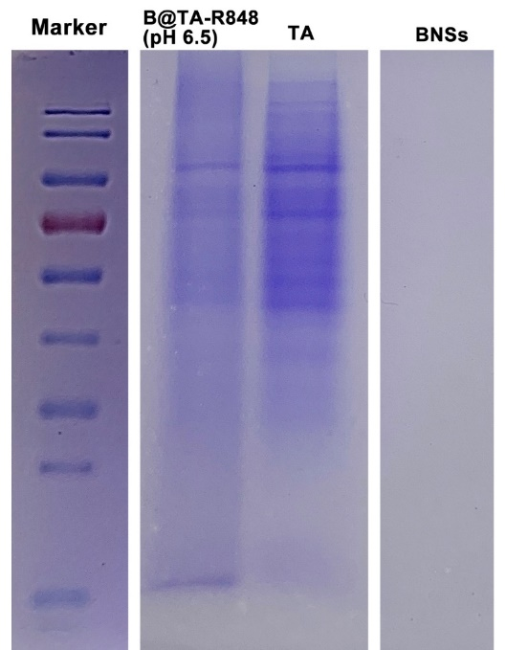
Figure S3. SDS-page. SDS-page of B@TA-R848 (pH 6.5), tumor antigen, and BNSs.

Figure. S4. Characterization of BNSs and B@TA. (A, B) UV-vis-NIR absorbance spectra of BNSs and B@TA; (C, D) Standard curve of photothermal conversation under 808 nm laser irradiation (2 W cm⁻²) of BNSs and B@TA; (E, F) Linear relationship between time and -ln θ calculated from cooling period after the laser was turned off.

Figure. S5. (A, B) The particle size and polydispersity of BNSs and B@TA for different storage times; (C) UV-vis absorbance spectra of BNSs and B@TA-R848 for different storage times.

Figure S6. Molecular structure of R848.

Figure S7. Drug loading efficiency. R848 loading capacities on B@TA (w/w%) with different B@TA concentrations.

Figure S8. Calibration curve. The calibration curve of R848 in the mixture of PBS buffer solution and methanol determined by HPLC spectroscopy; Y=0.04495*X + 2.09, R=0.9884; X is the concentration (μg/mL).

Figure S9. In vitro biocompatibility of dendritic cells. Relative viability of dendritic cells after incubation with BNSs and B@TA-R848 (concentrations of 10, 25, 50, 100, and 200 μg mL⁻¹) for 24 h

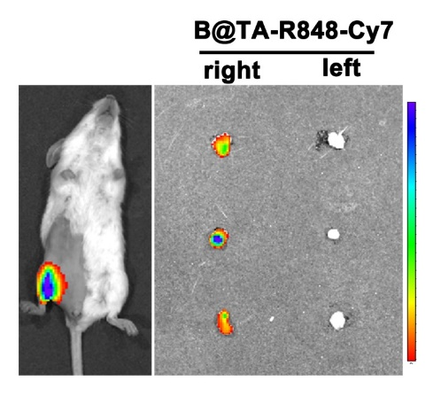
Figure S10. Ex vivo fluorescent images of lymph nodes 6 hours after subcutaneous injection of B@TA-R848-Cy7 in the right lower leg.

Figure S11. Biosafety testing. In vivo blood safety evaluation in healthy mice at 7 and 14 d after intravenous injection of saline, BNSs, and B@TA-R848.

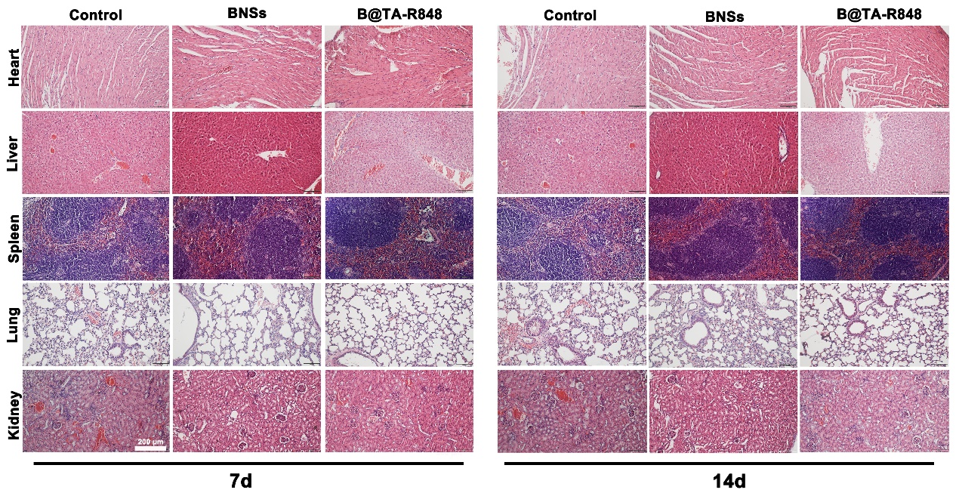
Figure S12. In vivo toxicity evaluation. In vivo toxicity of main organs at 7 and 14 d after intravenous injection of saline, BNSs, and B@TA-R848.

Figure S13. Isotype controls for the flow cytometry determination of CD markers on dendritic cells (A) and T cells(B).

References
1. Ren, W.; Yan, Y.; Zeng, L.; Shi, Z.; Gong, A.; Schaaf, P.; Wang, D.; Zhao, J.; Zou, B.; Yu, H.; Chen, G.; Brown, E. M.; Wu, A., A Near Infrared Light Triggered Hydrogenated Black TiO2 for Cancer Photothermal Therapy. Adv Healthc Mater 2015, 4 (10), 1526-36.

