**Hard and soft** **Lewis-base behavior** **for efficient and stable CsPbBr3 perovskite light-emitting diodes**

Changjiu Sun, Junli Wei, Jian Zhao*, Yuanzhi Jiang, Yilong Wang, Haiqing Hu, Xin Wang, Yongqin Zhang* and Mingjian Yuan

**\*Corresponding author:** **Jian Zhao and Yongqin Zhang**, School of Materials Science and Engineering, Qilu University of Technology (Shandong Academy of Sciences), Jinan 250353, P. R. China; Key Laboratory of Rubber-Plastics Ministry of Education/Shandong Provincial Key Laboratory of Rubber-Plastics, Qingdao University of Science & Technology, 266042, Qingdao, P. R. China; Key Laboratory of Organosilicon Chemistry and Material Technology of Ministry of Education, Hangzhou Normal University, Hangzhou 311121, China; and State Key Laboratory of Polymer Materials Engineering, Sichuan University, Chengdu 610065, China E-mail: [zhaojian@qust.edu.cn](mailto:zhaojian@qust.edu.cn) , http://orcid.org/0000-0002-7788-9026

**Changjiu Sun,** School of Materials Science and Engineering, Qilu University of Technology (Shandong Academy of Sciences), Jinan 250353, P. R. China; and Key Laboratory of Adv. Energy Mater. Chemistry (Ministry of Education), Renewable Energy Conversion and Storage Center (RECAST), College of Chemistry, Nankai University, 300071, Tianjin, P. R. China.

**Yilong Wang, Haiqing Hu and Xin Wang,** Key Laboratory of Rubber-Plastics Ministry of Education/Shandong Provincial Key Laboratory of Rubber-Plastics, Qingdao University of Science & Technology, 266042, Qingdao, P. R. China

**Junli Wei, Yuanzhi Jiang and Mingjian Yuan,** Key Laboratory of Adv. Energy Mater. Chemistry (Ministry of Education), Renewable Energy Conversion and Storage Center (RECAST), College of Chemistry, Nankai University, 300071, Tianjin, P. R. China.

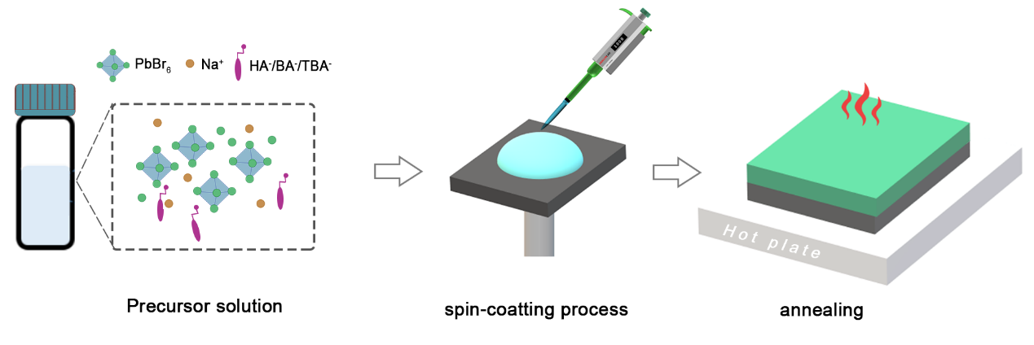

Fig. S1. Schematic illustration of the CsPbBr3 film fabrication process with carboxylate sodium salts.

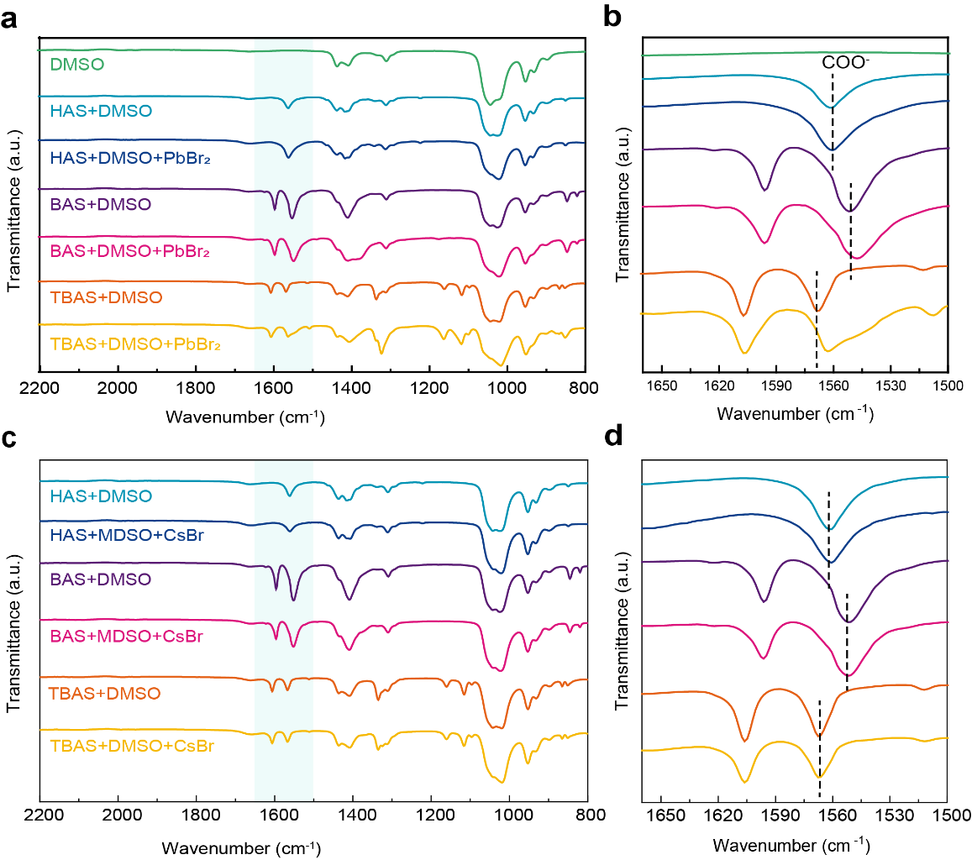

**Fig. S2** Fourier transform infrared characterizations. (a, b) FT-IR spectra of HAS, BAS, TBAS, HAS+PbBr2, BAS+PbBr2 and TBAS+PbBr2 powder in DMSO solvent. (c, d) FT-IR spectra of HAS, BAS, TBAS, HAS+CsBr, BAS+ CsBr and TBAS+ CsBr powder in DMSO solvent. The stretching vibration peaks of COO- group of HAS, BAS and TBAS located at 1561, 1551 and 1567 cm-1, respectively. While the COO- vibration red-shift to 1549 and 1561 cm-1 in the PbBr2+BAS and PbBr2+TBAS compounds. Obviously, the shift of the FT-IR spectra shows that the Lewis bases form the intermediate species with PbBr2.1

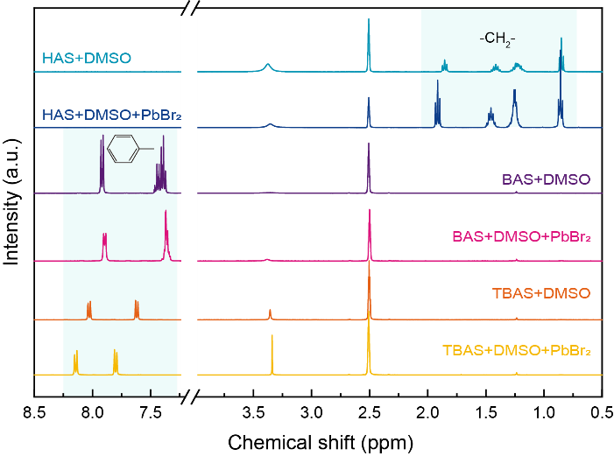

**Fig. S3** 1H nuclear magnetic resonance (NMR) spectroscopy characterizations. 1H NMR spectra of HAS, BAS, TBAS, HAS+PbBr2, BAS+PbBr2 and TBAS+PbBr2 powder in DMSO solvent. The obvious movement of the aromatic proton resonance signals in PbBr2+TBAS system indicating the robust coordination between TBA- and PbBr2.2

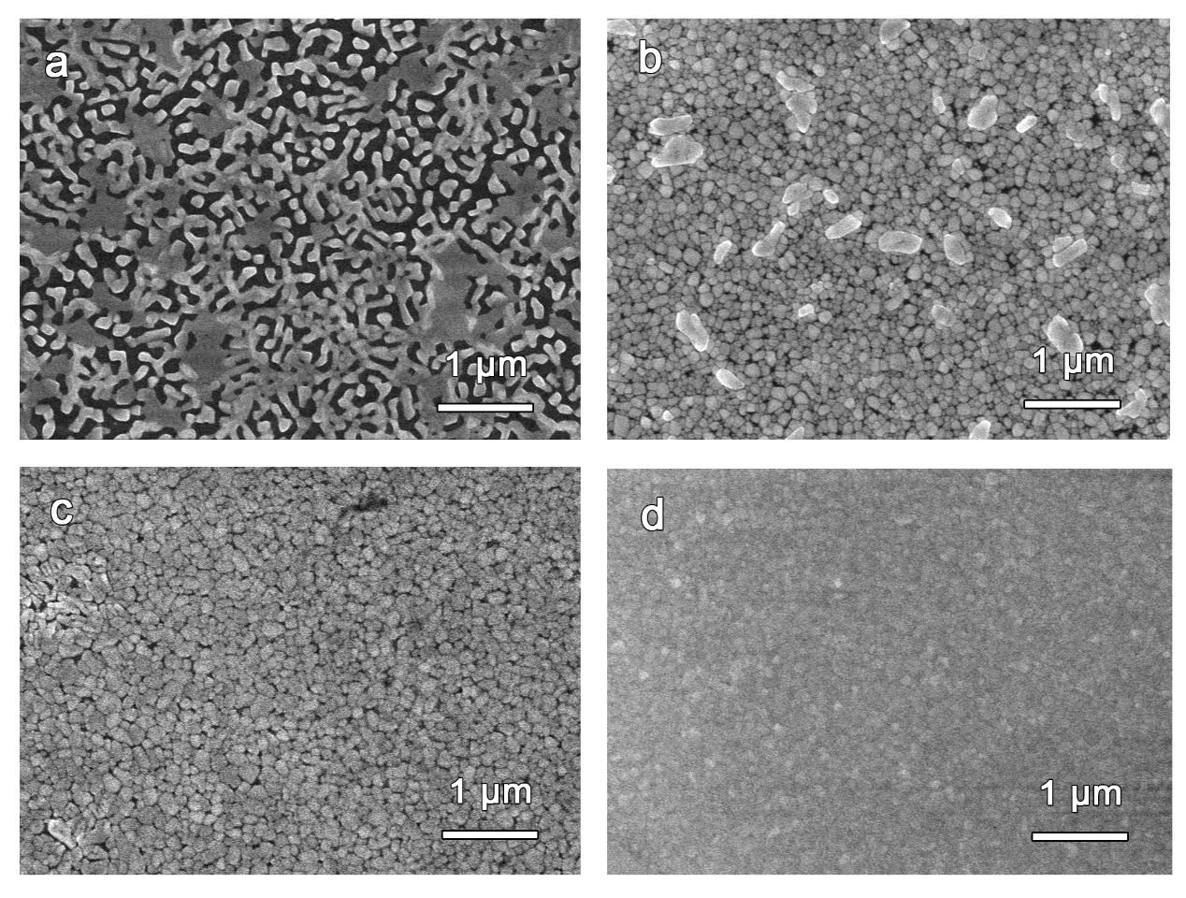

**Fig. S4.** SEM images of (a) original CsPbBr3 film and CsPbBr3 films passivated with (b) HAS, (c) BAS and (d) TBAS, respectively.

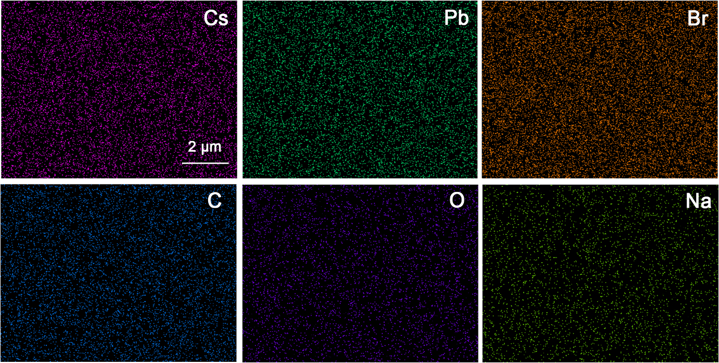

Fig. S5. EDS images of the Cs, Pb, Br, C, O and Na elements corresponding the 8% TBAS-modified CsPbBr3 film.

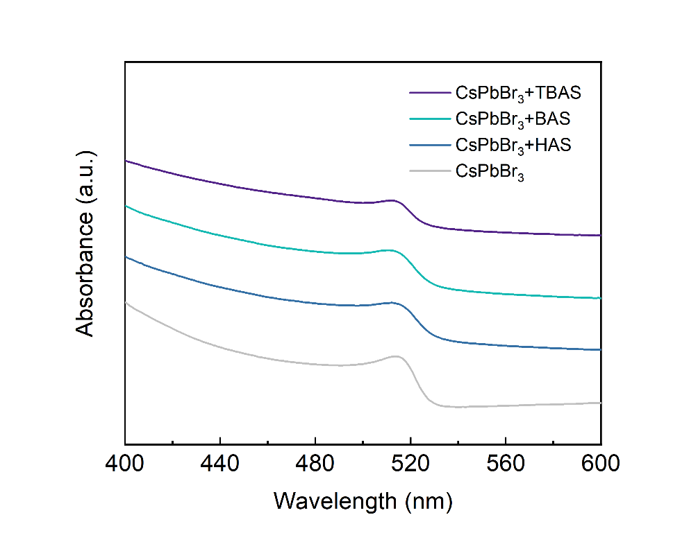

**Fig. S6.** UV–vis absorption spectra of original CsPbBr3 film and CsPbBr3 films with HAS, BAS and TBSA, respectively.

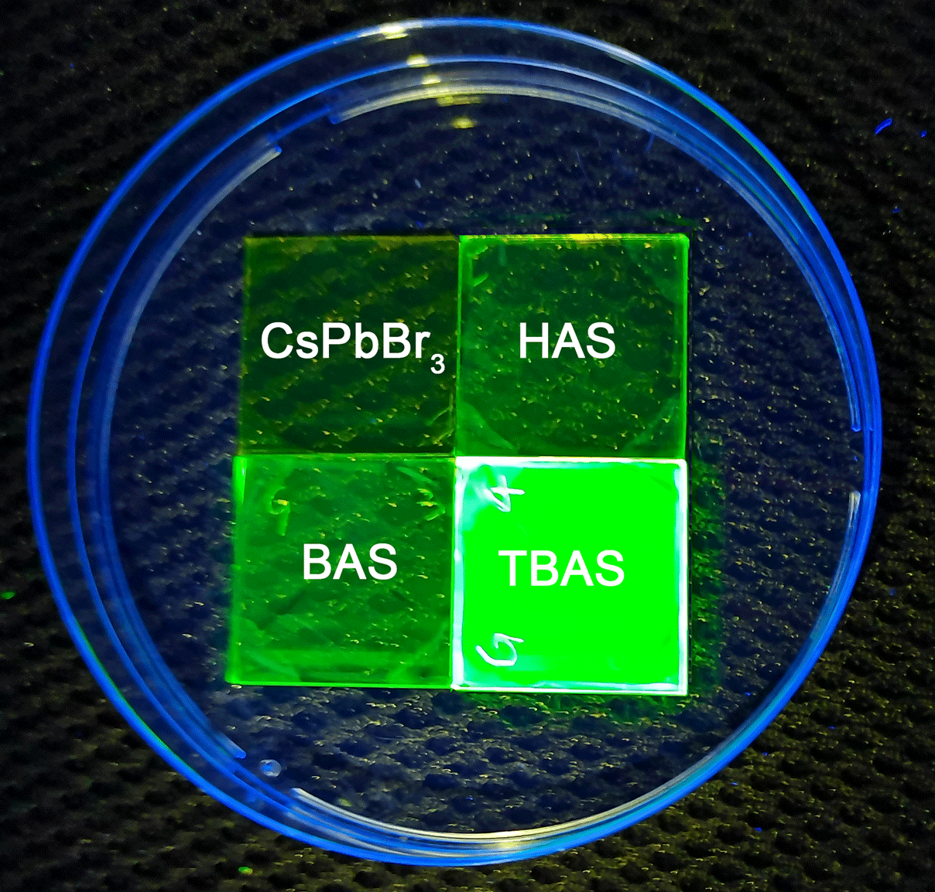

**Fig. S7.** Photoluminescence image of original CsPbBr3 film and CsPbBr3 films with HAS, BAS and TBSA, respectively.

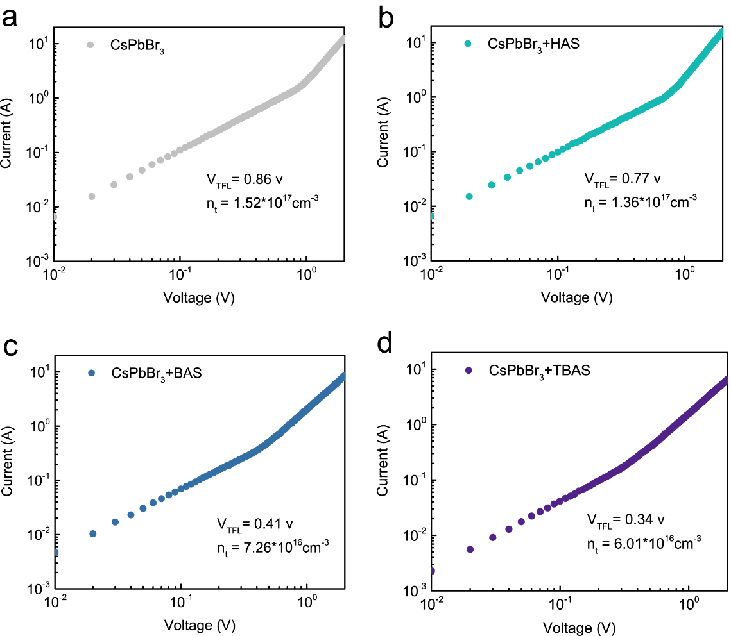

**Fig. S8.** Space charge limited current (SCLC) characterizations for quasi-2D perovskite films. Current-voltage (*J-V*) response for (a) original CsPbBr3 film and CsPbBr3 films with (b) HAS, (c) BAS and (d) TBSA, respectively. The defect density of each films have been labeled in each Fig..

An ITO/NiOx/PVK/PFNBr/perovskites/MoO3/Au device structure was employed for this measurement. In corresponding current - voltage responses, two distinctly different stages were observed. In low voltage region (ohmic region), a linear increase in current with voltage was observed, represents the trap state filling process. At high voltage region, the current shows a rapid nonlinear increase with increasing voltage. The starting point of the second region also means the limitation of trap filling, where the voltage in this point (*V*TFL) is proportional to the trap density, the formula can be expressed as: 3

Where *n*t is the trap density of the film, *e* is the elementary charge, *ε*0 are the vacuum dielectric constant, *ε* and *L* are relative dielectric constant and thickness of the perovskite film. The device with original and HAS, BAS, TBAS passivated CsPbBr3 perovskite films have *V*TFL of 0.88, 0.77, 0.41, and 0.34V, respectively, thus corresponding to *n*t of perovskite films 1.52 × 1017 cm-3, 1.36 × 1017 cm-3, 7.26 × 1016 cm-3 and 6.01 × 1016 cm-3, respectively.

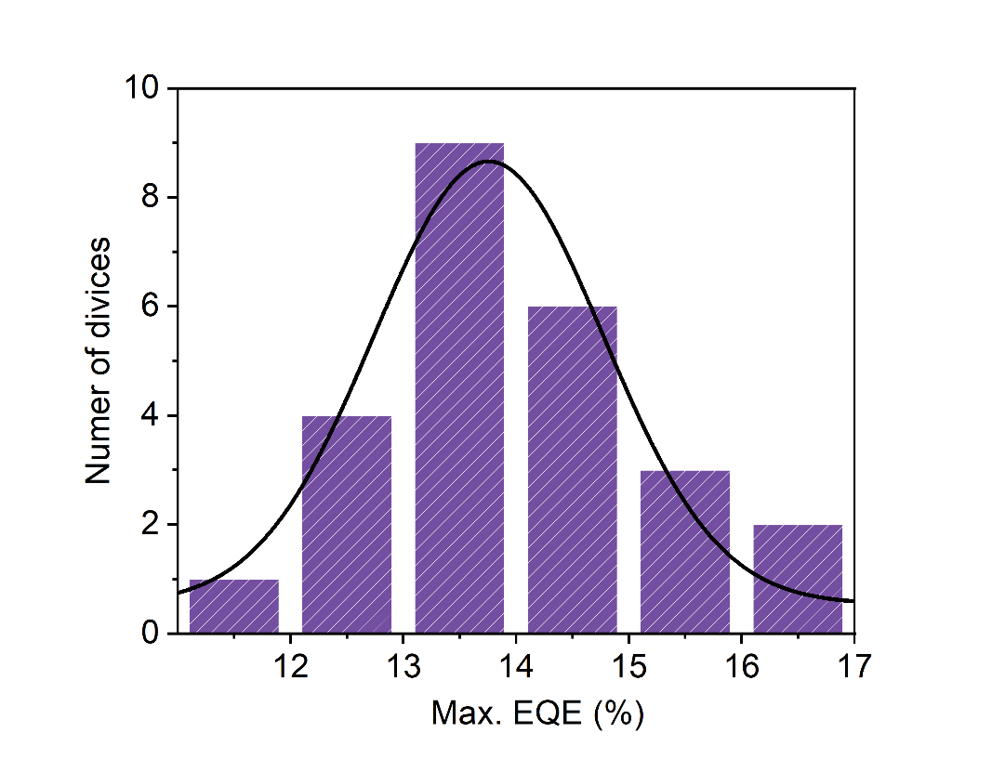

**Fig. S9** Histograms of maximum EQEs measured from 25 TBAS-modified CsPbBr3 devices.

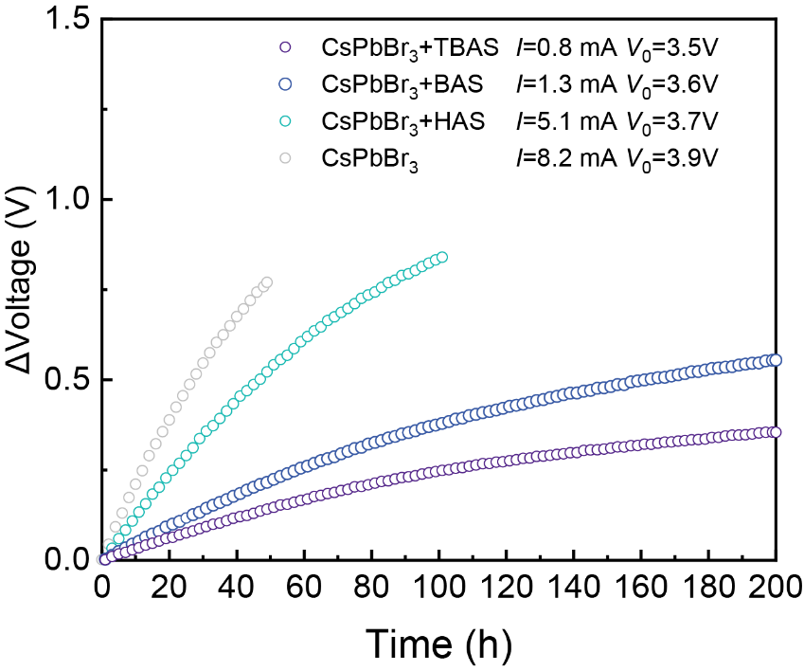

**Fig. S10** Voltage shifts of different CsPbBr3 LEDs under the constant current. The operational stability measurements were carried out under the constant current for an initial luminance of ~100 cd m–2. Compared to the original CsPbBr3 device, the devices incorporated with HAS, BAS and TBAS exhibited significantly lower shift during operation.

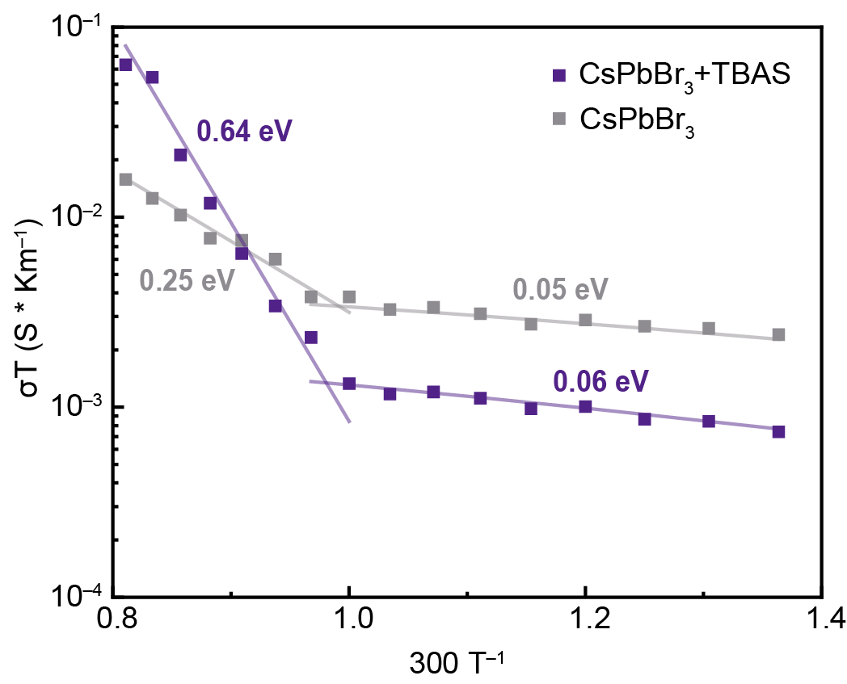

**Fig. S11** Temperature-dependent conductivity measurements to reveal the ion migration activation energies of original and TBAS incorporated CsPbBr3 films.

The ion migration activation energies can be extracted from the Nernst−Einstein relation:4

where *σ*0 is a constant, *T* is temperature, *k*b is the Boltzmann constant and *E*a is ion migration activation energy. The ion conduction activation energy of original CsPbBr3 film is around 0.25 eV. In contrast, adding TBAS in the film increased activation energy to 0.64 eV, representing the improved film stability.

**Table S1** HOMO-LUMO gap energies of these different Lewis bases.

|  |  |
| --- | --- |
| Sample | HOMO-LUMO gap |
| HA- | 4.89 eV |
| BA- | 4.28 eV |
| TBA- | 3.54 eV |
| 4-trifluoromethyl benzenesulfonic acid anion | 3.96 eV |
| (4-trifluoromethyl-phenyl)-phosphonic acid anion | 4.01 eV |

**Table S2** Electrical performance of original CsPbBr3 PeLEDs and CsPbBr3 PeLEDs incorporated with HAS, BAS and TBA, respectively.

|  |  |  |  |  |
| --- | --- | --- | --- | --- |
| Sample | Turn-on voltage  (V) | EL peak  (nm) | Max. EQE  (%) | Max. Lum.  (cd·m-2) |
| CsPbBr3 | 3.0 | 520 | 2.08 | 10,550 |
| CsPbBr3+HAS | 3.0 | 520 | 3.30 | 18,730 |
| CsPbBr3+BAS | 2.9 | 520 | 11.42 | 26,200 |
| CsPbBr3+TBAS | 2.8 | 519 | 16.75 | 37,860 |

**Supplementary Method 1** Calculation of the thickness of the crystal grain

The thickness of the crystal grain can be calculated according to the Scherrer sequence:5

where *D* is the average thickness of the crystal grain perpendicular to the crystal plane, λ is the wavelength of the X-ray, θ is the incident angle, K is a dimensionless shape factor, often taken as 0.89, and β is the half-height width of the diffraction peak. Thus, according to the XRD data, the calculated average thicknesses perpendicular to the (100) plane of original CsPbBr3 film and CsPbBr3 films incorporated with HAS, BAS and TBAS are 45.3, 34.0, 25.5 and 22.6 nm respectively.

**References**

1. H. R. Wang, X. Y. Zhang, Q. Q. Wu *et al.* "Trifluoroacetate induced small-grained CsPbBr3 perovskite films result in efficient and stable light-emitting devices." *Nat. Commun.*, vol. 10, no. 665, 2019.
2. M. Ban, Y. Zou, J. P. Rivett, et al. "Solution-processed perovskite light emitting diodes with efficiency exceeding 15% through additive-controlled nanostructure tailoring." *Nat. Commun.*, vol. 9, no. 3892, 2018.
3. D. Shi, V. Adinolfi, R. Comin *et al*. "Low trap-state density and long carrier diffusion in organolead trihalide perovskite single crystals." *Science*, vol. 347, no. 6221, pp. 519-522, 2015.
4. Y. Lin, Y. Bai, Y. Fang *et al.* "Suppressed ion migration in low-dimensional perovskites." *ACS Energy Lett.*, vol. 2, no. 7, pp. 1571-1572, 2017.
5. H. Chen, K. Li, H. Liu *et al.* "Dependence of power conversion properties of hole-conductor-free mesoscopic perovskite solar cells on the loading of perovskite crystallites." *Org. Electron.*, vol. 61, pp. 119-124, 2018.