Supplementary Information

Ligand-modulated electron transfer rates from CsPbBr3 nanocrystals to titanium dioxide

Xiaochun Liu†ab, Haifeng Zhao†ab, Linfeng Weiab, Xinjian Renab, Xinyang Zhangab, Faming Liab, Peng Zeng*ab and Mingzhen Liu*ab

a. School of Materials and Energy, University of Electronic Science and Technology of China, Chengdu 611731, P.R. China.

b. Center for Applied Chemistry, University of Electronic Science and Technology of China, Chengdu 611731, P. R. China

† Co-first authors.

Corresponding authors: Peng Zeng and Mingzhen Liu.

*Email: peng.zeng@uestc.edu.cn (P. Zeng); mingzhen.liu@uestc.edu.cn (M. Liu)



**Figure S1.** TEM image of OA/APTES-CsPbBr3 NCs with scale bars of 50 nm at low concentration. No cross-linking between different NCs is observed, indicating that inter-nanocrystal cross-linking in our APETS-NC systems can be excluded.

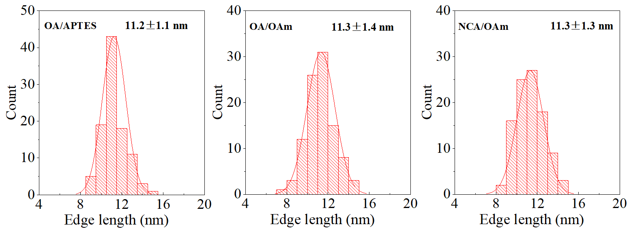

**Figure S2.** Size distribution of the synthesized OA/APTES-CsPbBr3, OA/OAm–CsPbBr3 and NCA/OAm–CsPbBr3 nanocrystals.



**Figure S3.** UV-Vis absorption spectra of APTES, OA, OAm and NCA solution in ethanol.

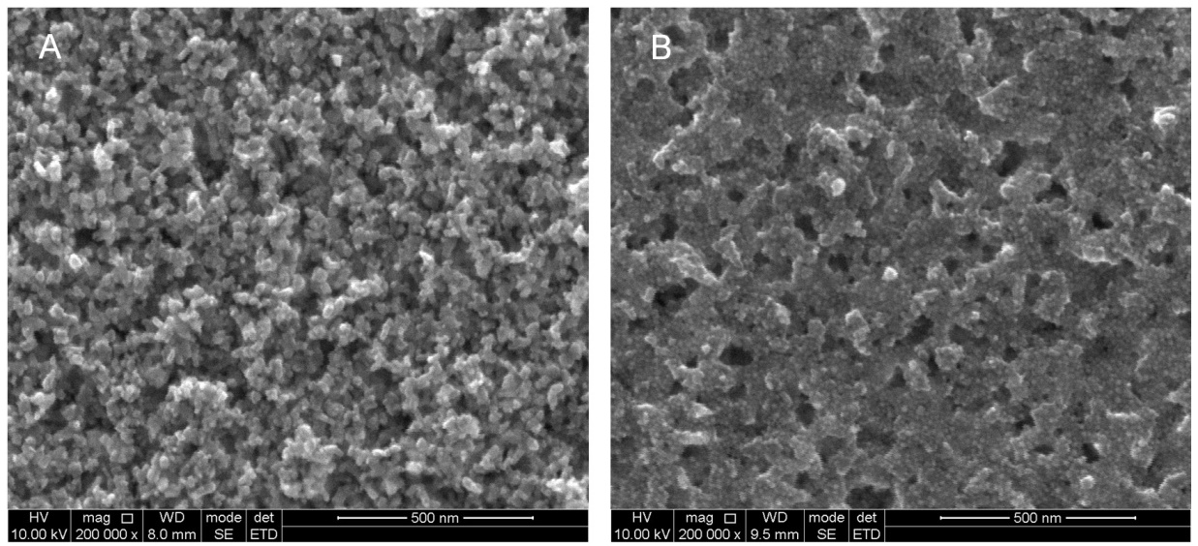

**Figure S4.** Top view SEM images of mesoporous TiO2 with (A) and without (B) OA/APTES-CsPbBr3 nanocrystals spin coated onto the surface under electron energy of 10 kV. The [homodisperse](javascript:;)d tiny particles can be clearly seen on surface of mesoporous TiO2 in (B), highlighting that CsPbBr3 nanocrystals have been successfully adsorbed onto the surface of mesoporous TiO2 without aggregation occurred.

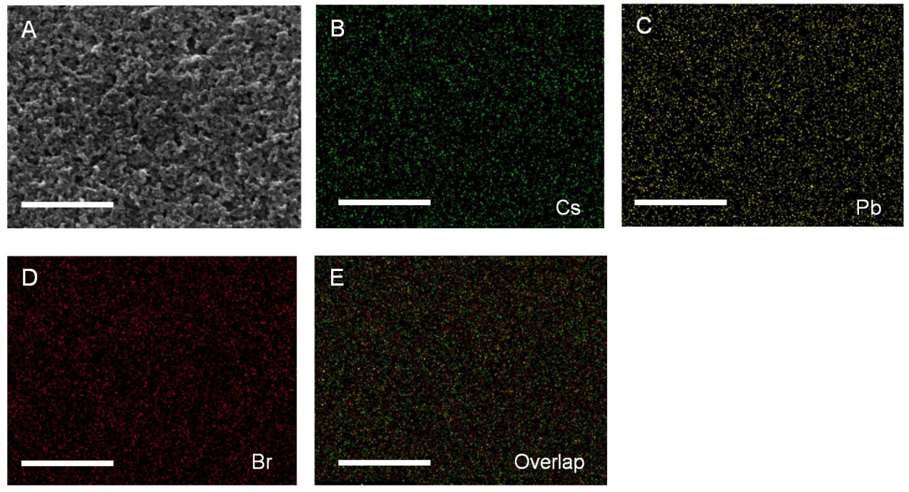

**Figure S5.** (A) SEM image of OA/APTES-CsPbBr3 nanocrystals attached to mesoporous TiO2. The corresponding elemental mapping images of (B) Cs (green), (C) Pb (yellow), (D) Br (red) and (E) overlapped image of OA/APTES-CsPbBr3 nanocrystals attached to mesoporous TiO2. Scale bars are 1 µm.

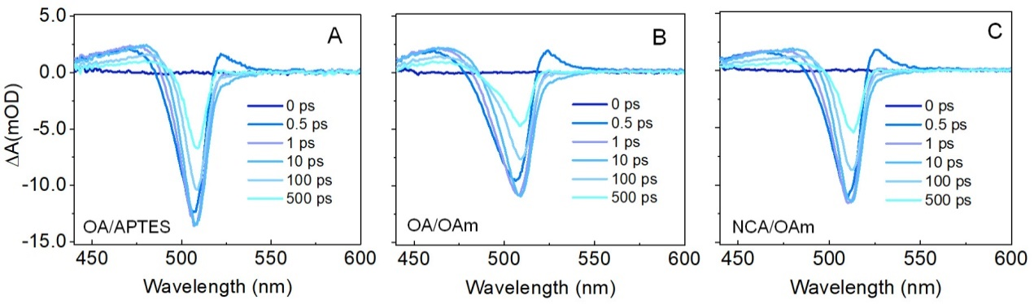

**Figure S6.** (A-C) TA spectra of OA/APTES-CsPbBr3, OA/OAm-CsPbBr3 and NCA/OAm-CsPbBr3 nanocrystals at indicated time delays following 400 nm pump excitation.

**Figure S7.** Normalized decay-associated spectra of OA/APTES-CsPbBr3, OA/OAm-CsPbBr3 and NCA/OAm-CsPbBr3 nanocrystals attached to PMMA and mesoporous TiO2.



**Figure S8.** Kinetics of photoinduced bleach signal at 510 nm for (A) OA/APTES-CsPbBr3, (B) OA/OAm–CsPbBr3 and (C) NCA/OAm-CsPbBr3 nanocrystals dispersed in octane.

**Determination of the average number of excitons per nanocrystal.**

Based on a basic assumption that the distribution of excitons in a nanoparticle conforms to Poisson distribution:

P(N)=<N>Nexp(-<N>)/N! (1)

where <N> is the average number of excitons per nanoparticle, the normalized transient bleach signal amplitude at early delay time immediately after the intraband relaxation can be given by [1]:

$$\left|\frac{∆A}{A}\right|=0.5P\left(1\right)+\sum_{i=2}^{∞}{P\left(i\right)}=1-P\left(0\right)-0.5P\left(1\right)$$

$$=1-[1+\frac{<N>}{2}] exp(-<N>)$$

Here, the fraction 0.5 results from the fraction bleaching of the 2-fold degenerate band edges of CsPbBr3 nanocrystals [2]. At very low pump fluence (<N> far less than 1), normalized transient bleach signal can be approximated by |∆A|/A ∝ <N>. Therefore, the average number of excitons per nanoparticle can be estimated by knowing the transient and steady state absorbance, |∆A| and A. In this work, for all three CsPbBr3 nanocrystal samples dispersed in octane, steady state absorbance A=0.2, the maximum bleach signal amplitude |∆A| ≈ 0.014 (Figure S8), thus we have <N> less than 0.14, within the linear dependence as discussed above. The pump fluence 16 nJ/pluse for transient measurements can avoid any multiple exciton induced effects.

**Reference**

[1] Aneesh J, Swarnkar A, Ravi VK, Sharma R, Nag A, Adarsht KV. Ultrafast exciton dynamics in colloidal CsPbBr3 perovskite nanocrystals: Biexciton effect and auger recombination. J Phys Chem C 2017;121:4734-4739.

[2] Swarnkar A, Chulliyil R, Ravi VK, Irfanullah M, Chowdhury A, Nag A. Colloidal CsPbBr3 perovskite nanocrystals: Luminescence beyond traditional quantum dots. Angew Chem Int Edit 2015;54:15424-15428.