Supporting Information

Towards Lab-on-Chip Ultra-Sensitive Ethanol Detection using Photonic Crystal Waveguide Operating in the Mid-Infrared

Ali Rostamian ^{a,*}, Ehsan Madadi-Kandjani ^{b}, Hamed Dalir ^{c}, Volker J. Sorger ^{d}, Ray T. Chen ^{a,c,*}

ª Dept. of Electrical and Computer Engineering, University of Texas, 10100 Burnet Road Bldg. 160, Austin, TX, USA 78758.
^{b} Department of Mechanical and Aerospace Engineering, California State University, 1250 Bellflower Blvd. Long Beach, CA 90840.
^{c} Omega Optics Inc., 8500 Shoal Creek Blvd., Bldg. 4, Suite 200, Austin, TX, USA 78758.
^{d} George Washington University, Washington DC 20052, USA.

* Corresponding author: E-mail: ali.rostamian@utexas.edu

Strip waveguide analysis

Figure S. 1 shows the FDE simulation result for the single-mode strip waveguide. It illustrates the mode profile for the fundamental TE mode. This propagating mode has a group velocity of n_{g} = 3.9 and an effective index of n_{eff} = 2.58.
Based on this FDE mode simulation and Equation S. 1, we calculated the optical overlap integral (f) for this mode to be ~2.5%.
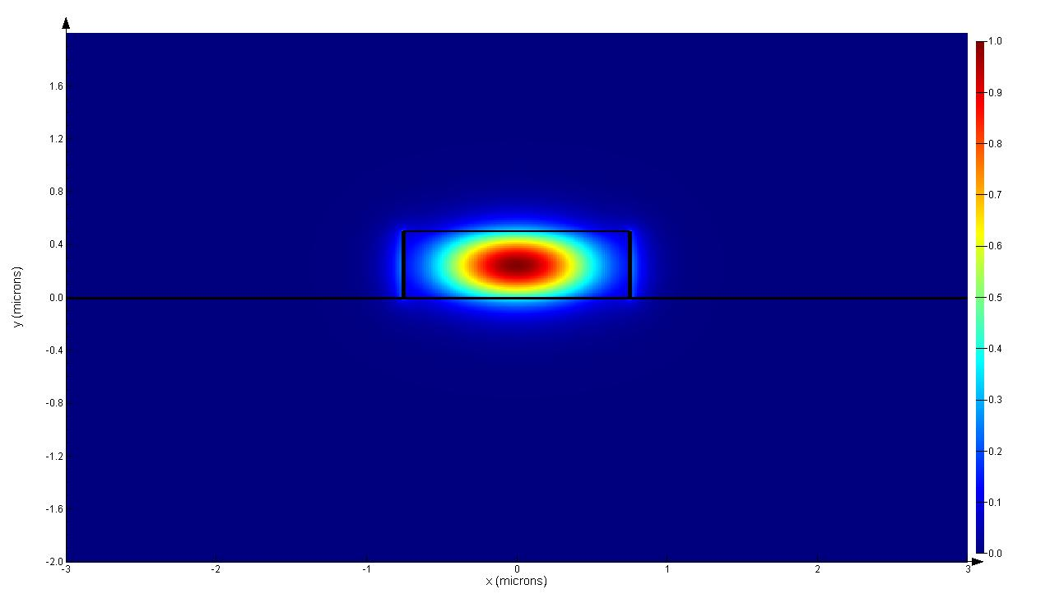
Si
Air
SiO₂
Figure S. 1 Fundamental TE mode profile for single mode

In our dispersive medium, the medium-specific absorption factor or $γ$ is defined as: $γ=f × (c/n)/v_{g}$, where f or the fill factor is defined as:
        - $f= \frac{\int{ε}{\left|\vec{E}\right|}^{2}{dr}_{analyte}^{3}}{\int{ε}{\left|\vec{E}\right|}^{2}{dr}_{analyte+dielectric}^{3}}$
Equation S. 1
We carried out the same analysis for the photonic crystal waveguide. Figure S. 2(a) shows the mode profile of the defect-guided propagating light in the photonic crystal waveguide.
Group index calculation
We deduced the group index n_{g} of the defect-guided mode in the photonic crystal waveguide, defined as $n_{g}=\frac{c}{ν_{g}}=c\frac{δk}{δω}$, from the dispersion diagram in Fig. 1(b) for our operating point. Figure S. 2(b) plots the group index as a function of wavelength. The estimated group index value extracted from the dispersion diagram of the guided mode that propagates through the waveguide at $λ=3.4 μm$ is n_{g} ~ 73 compared to a refractive index of n=1 in air. So this guided mode’s group index is ~18.8 times larger than the group index of the fundamental TE mode in the strip waveguide. Based on the PWE simulation result and Equation S. 1, the overlap factor for this high n_{g} propagating mode in PCW is 17.1%.
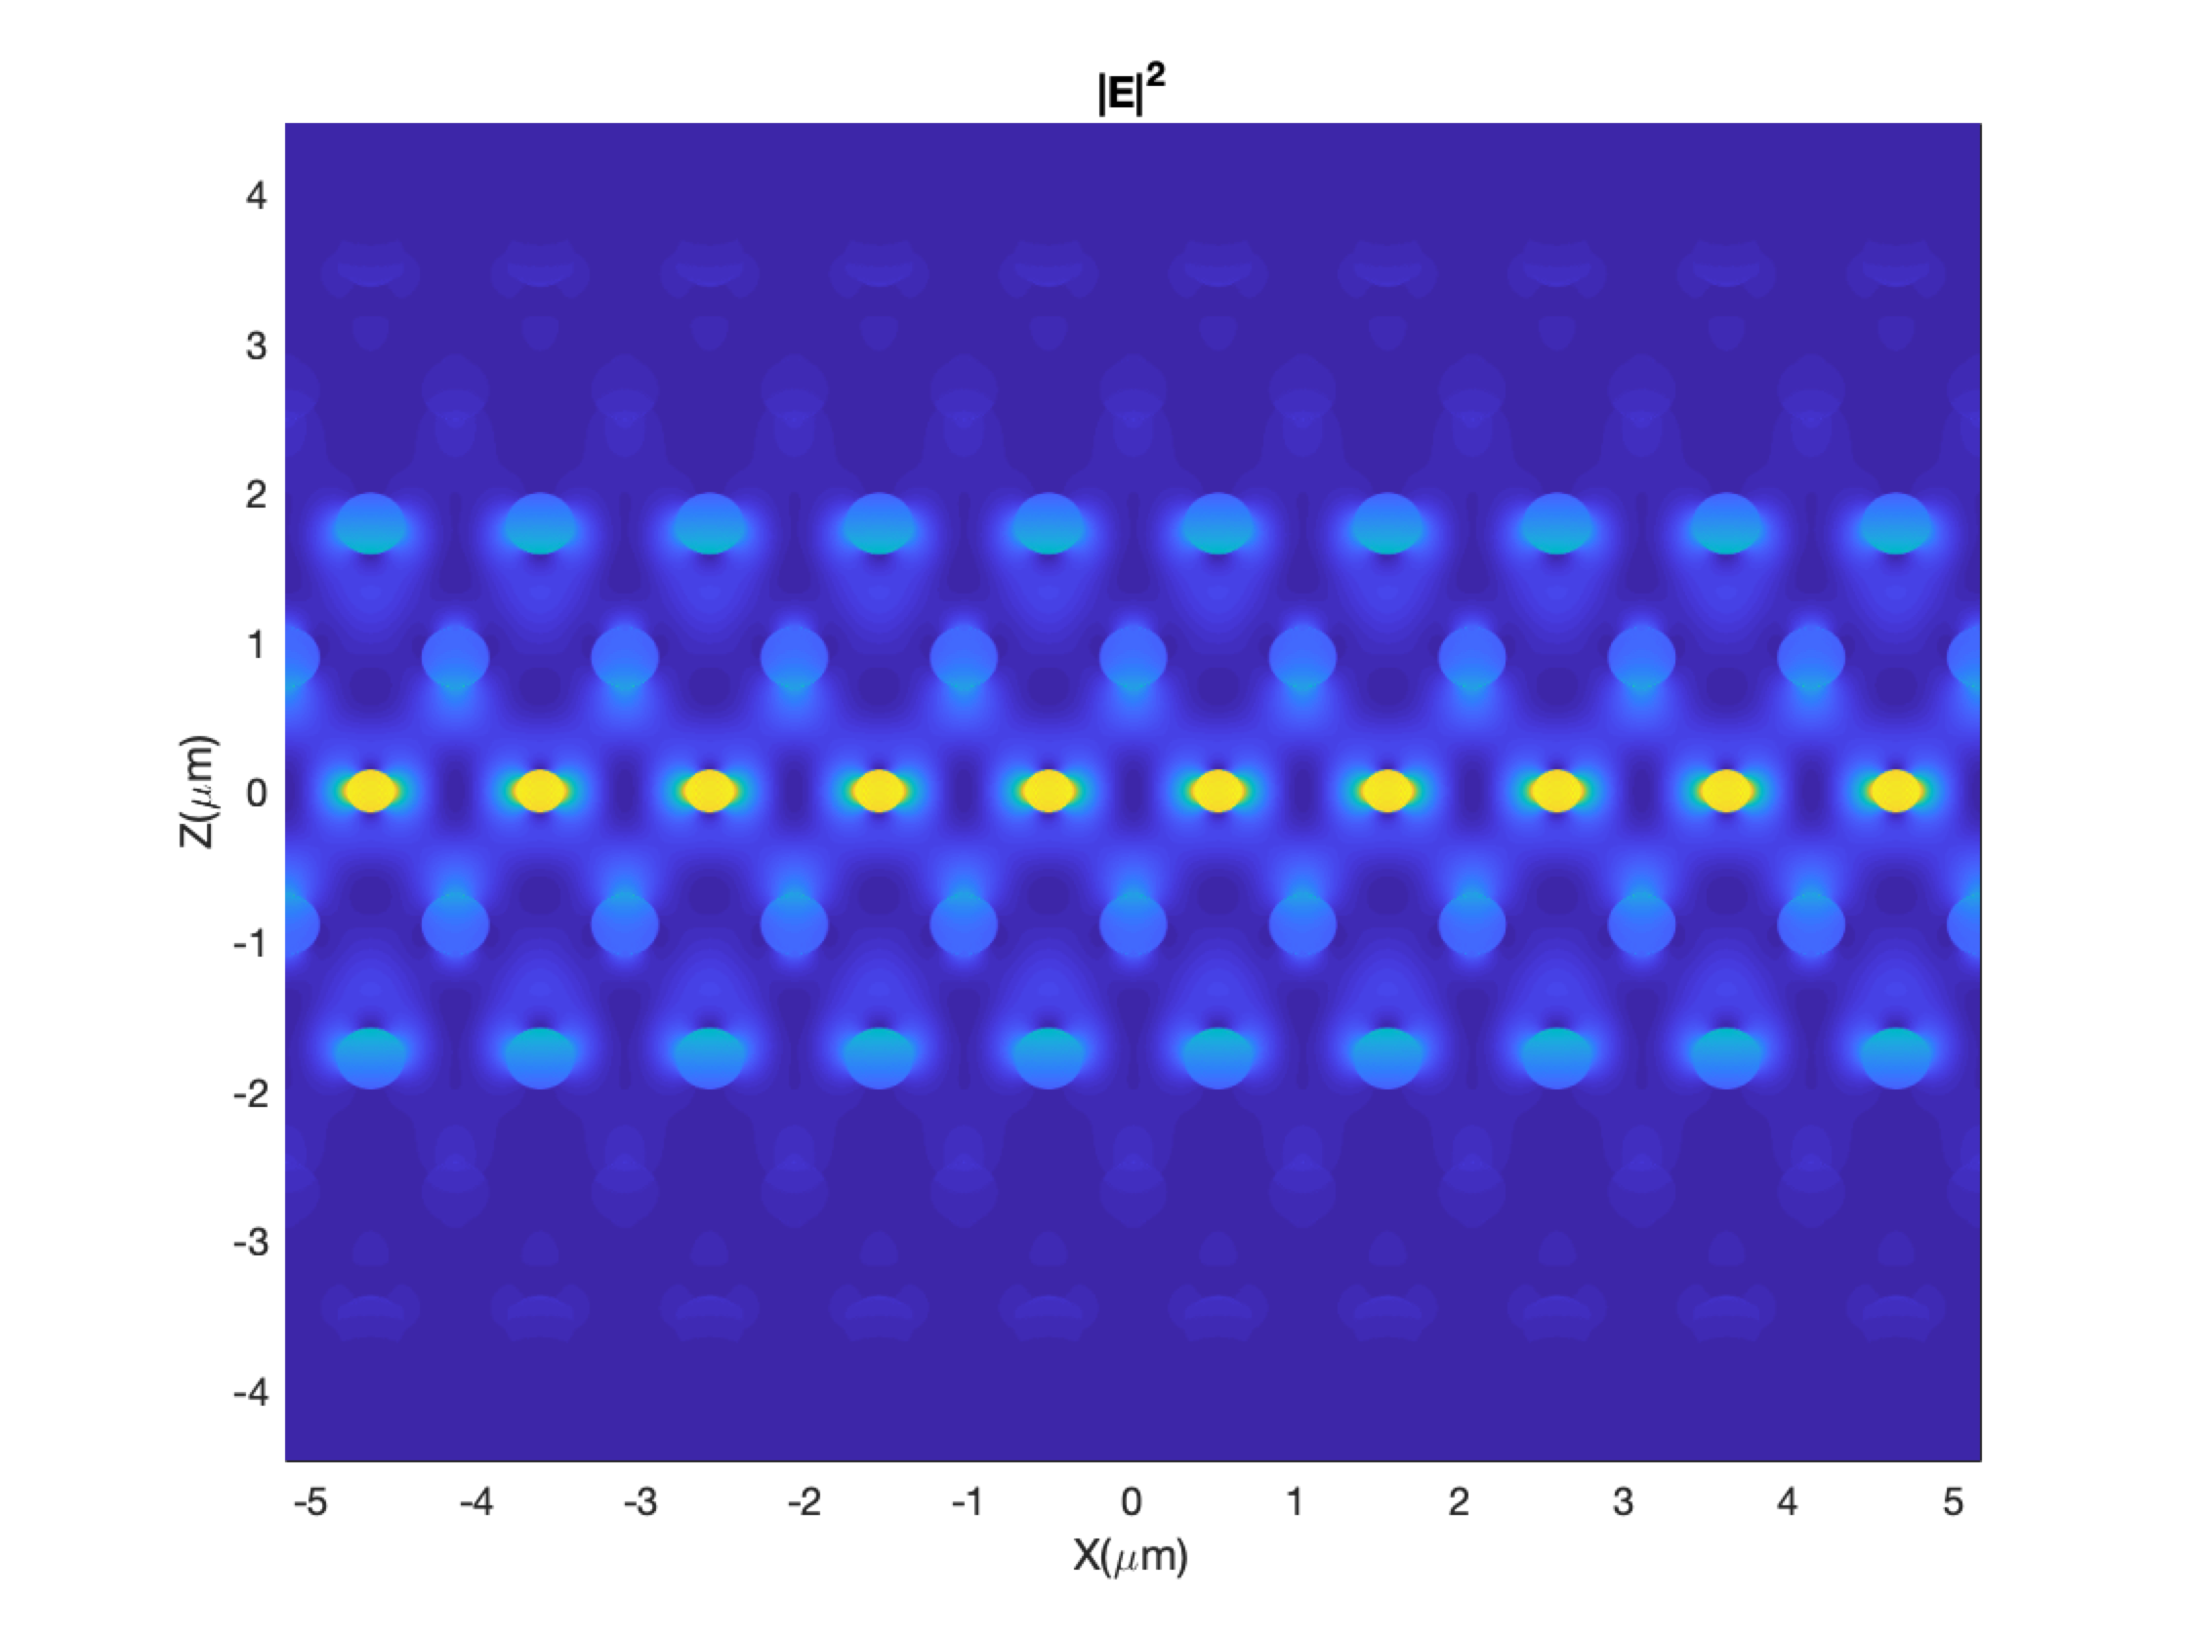
Figure S. 2 (a) Mode profile of the defect-guided propagating light in the photonic crystal waveguide (b) group index as a function of the wavelength

