Supplementary Information for:

**Ultra-compact and low-power-consumption silicon thermo-optic switch for high-speed data**

Ruihuan Zhang, Yu He, Yong Zhang, Shaohua An, Qingming Zhu, Xingfeng Li, and Yikai Su*

State Key Lab of Advanced Optical Communication Systems and Networks, Department of Electronic Engineering, Shanghai Jiao Tong University, Shanghai 200240, China.

*E-mail: yikaisu@sjtu.edu.cn

**Content**

1 Optimization method for a low-power-consumption thermo-optic switch 2

2 Mathematical description of the thermo-optic tuning process for a resonant cavity 4

2.1 Derivation of the differential equations for the heat conduction process of a solid cube 4

2.2 Calculation for the thermo-optic tuning process of a conventional silicon waveguide with bottom cladding 6

2.3 Calculation for the thermo-optic tuning process of a suspended silicon waveguide 8

2.4 Analysis of the dependence of the resonance wavelength on the material refractive index in a resonant cavity 13

2.5 Power consumption for the thermo-optic tuning process of a resonant cavity 16

2.6 Discussion 18

References 19

# 1 Optimization method for a low-power-consumption thermo-optic switch

Conventional thermo-optic switches based on silicon-on-insulator (SOI) platform are usually realized by applying over-cladding heaters on top of the silicon waveguides. The waveguides are surrounded by oxide claddings and exhibit large heat capacities, which result in considerable thermal dissipations during the heat conduction processes. To achieve a low-power-consumption thermo-optic switch, a suspended waveguide structure with air claddings is adopted to effectively decrease the heat capacity of the device.

In addition, it is viable to introduce a resonator with a high quality factor (Q-factor) to manipulate the optical field and further improve the tuning efficiency of the device. However, as a building block of the telecommunication networks and data centers, the switch unit is expected to allow high speed data transmission, which means a large bandwidth is needed for the resonator. As the bandwidth of the resonator is negatively related to the Q-factor, there is a trade-off between the high tuning efficiency and the high speed data transmission for the design of the resonator. Here we summarize our optimization process in the flow chart as shown in Figure 1S.

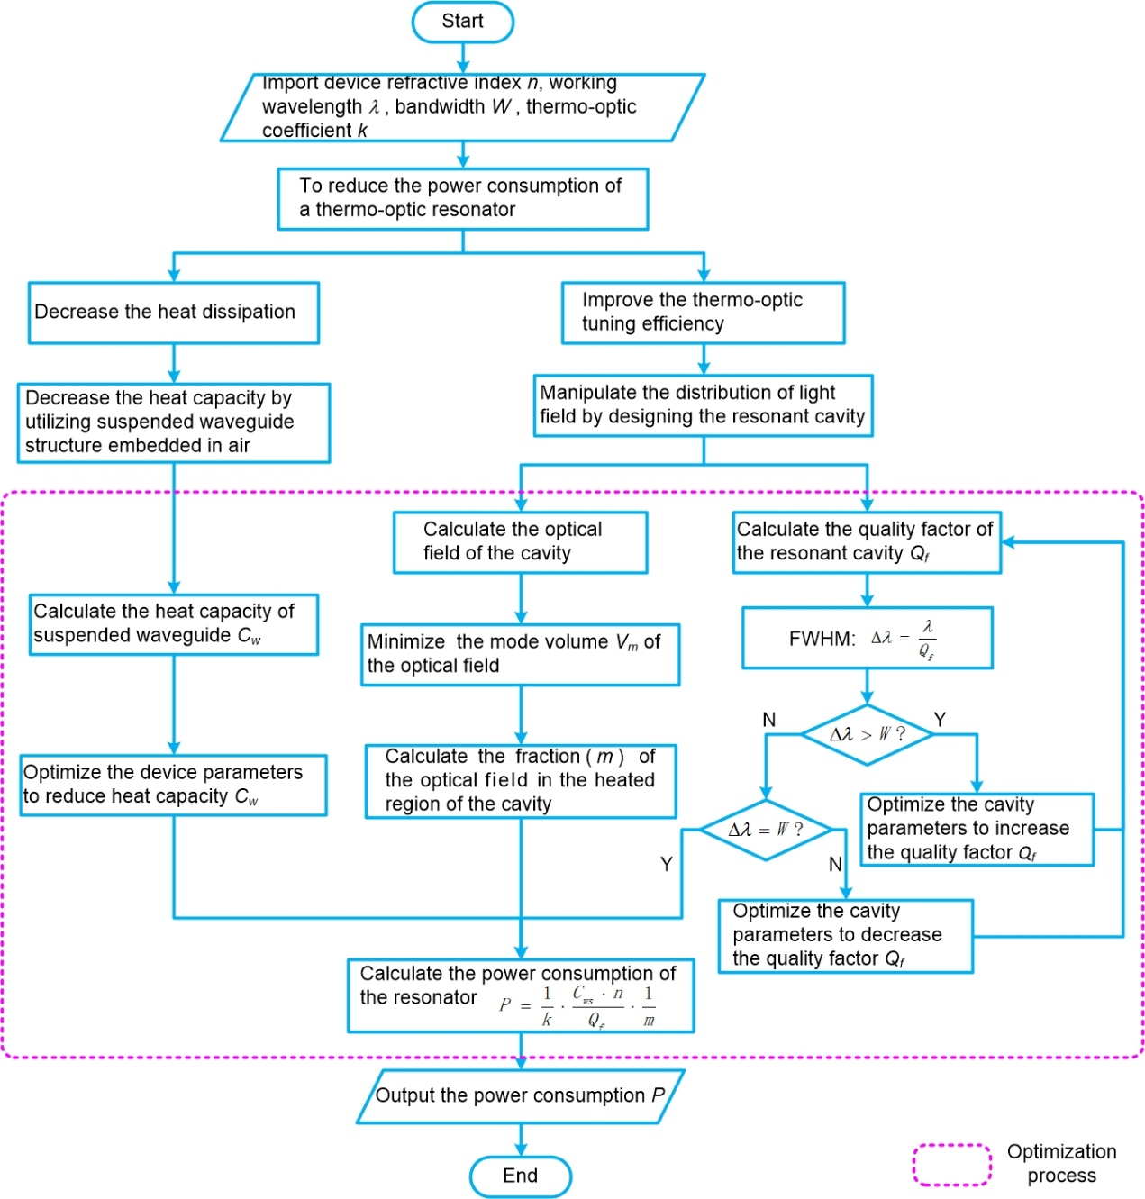

**Figure 1S:** Flow chart for the optimization process of a low-power-consumption TO resonator.

# 2 Mathematical description of the thermo-optic tuning process for a resonant cavity

**Prerequisites for the derivation of heat conduction process:**

1. The components of the studied system are constituted by isotropic homogeneous materials.
2. No heating sources exist inside the components.

## 2.1 Derivation of the differential equations for the heat conduction process of a solid cube

For a solid cube shown in Figure 2S, it follows the law of conservation of energy [1]. The increment of the internal thermal energy in the cube () can be calculated by evaluating the difference between the energy applied to the cube () and the energy subtracted from the cube ():

 =  –  (1)

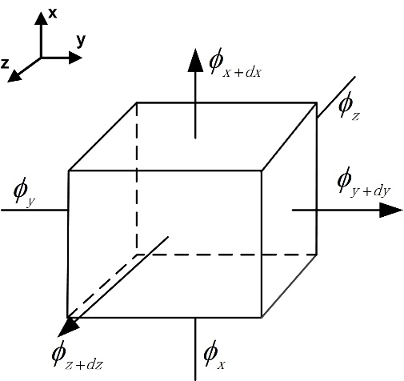

**Figure 2S:** Thermal model of an isotropic solid cube.

The increment of internal thermal energy in the solid cube is [1]:

, (2)

where  is the temperature at a certain time inside the solid cube, *ρ* and  are the density and specific heat capacity of the cube, respectively.

According to [1], the energy applied to the cube  can be described as:

, (3)

where  is the thermal conductivity of the material of the solid cube.

The energy subtracted from the cube  is:

 (4)

Substituting Eqs. (2), (3) and (4) into Eq. (1), the law of conservation of energy can be expressed as [1]:

 (5)

Thus, it can be obtained that:

. (6)

Then, the temperature variation of the solid cube can be obtained as [1]:

. (7)

In a steady-state heat conduction process, the temperature of the solid cube does not change over time [1]:

. (8)

Substituting Eq. (8) into (7), it can be obtained that [1]:

. (9)

Eq. (9) is the differential equation of the steady-state heat conduction process of a solid cube without any internal heat source. If the boundary conditions are not defined, the equation will have an infinite number of solutions.

## 2.2 Calculation for the thermo-optic tuning process of a conventional silicon waveguide with bottom cladding

Figure 3S shows the structure of a conventional silicon waveguide with top and bottom claddings. A metal heater is placed on top of the device. When we apply thermal power to the device through the micro-heater, the energy flows into the silicon waveguide and heat the waveguide up due to the large thermo-optic coefficient of silicon. Meanwhile, the heat conduction process happens when there is a temperature difference between the waveguide and the cladding. These two processes will eventually reach a balance and a steady-state heat conduction process can be achieved. In order to obtain the temperature of the waveguide, we would solve Eq. (9) by applying the boundary conditions.

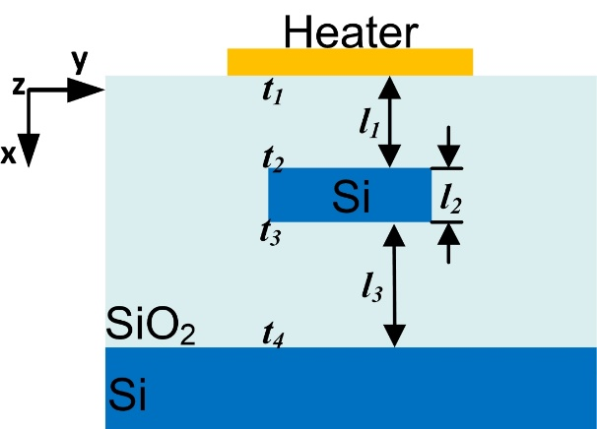

**Figure 3S:** Cross-section of the heated waveguide in the *x-y* plane.

Considering the heat conduction process of the waveguide in the *x-*direction:

. (10)

As shown in Figure 3S, the temperatures of the top and bottom surfaces of the silicon waveguide are  and , respectively.

After an integral operation on Eq. (10), the gradient of the temperature distribution for the silicon waveguide (), the top cladding () and the underlying cladding () can be obtained:

, (11) , (12)

, (13)

where  and  are the temperatures of the top and bottom surfaces of the silicon oxide, respectively, ,  and  are the thicknesses of the top silicon oxide cladding, silicon waveguide and the bottom silicon oxide cladding, respectively.

According to Fourier's law [1]:

, (14)

where  refers to the conducted heat through a unit area of the cross-section per second,  is the cross-sectional area of the waveguide in the *y-z* plane,  is the heat transferred to the waveguide per second.

Substituting Eq. (11) into (14):

, (15)

where  is the heat transferred to the waveguide,  is the thermal conductivity of silicon.

Then, it can be obtained that:

, (16)

, (17)

and

, (18)

where  and  are the heating power transferred to the upper silicon oxide and the underlying silicon oxide, respectively,  is the thermal conductivity of silicon oxide.

In a steady-state heat conduction process, the heat flowing through the plane of the cross-section is the same for each layer. Thus,

, (19)

. (20)

By solving the equation, it can be obtained that:

, (21)

and

. (22)

From Eqs. (11), (12) and (13), it can be noted that the temperature varies linearly along the propagation direction of the heat energy. So, it is viable to use the temperature at the center of the waveguide  to represent the average temperature of the waveguide:

. (23)

Since the heater is a good conductor of thermal energy [2], the temperature of the heater can be considered as uniformly distributed, which can be obtained as [1]:

, (24)

where  is the specific heat capacity of the heater.

Substituting Eq. (24) into (23), it can be obtained that:

. (25)

If the heat capacity of the waveguide is assumed to be , which represents the required heat to heated the waveguide up by 1*K*. Thus,

. (26)

## 2.3 Calculation for the thermo-optic tuning process of a suspended silicon waveguide

Figure 4S shows the cross-section view of a suspended silicon waveguide. When the waveguide is heated, the energy flowing into and out of the waveguide reaches a balance in the steady-state heat conduction process. Heat is transferred from the top surface to the bottom surface along the *x-*direction. The waveguide is surrounded by air due to the suspended structure. Compared with silicon, the air claddings have limited thermal conductivity, which can be considered as adiabatic layers in the heat conduction process [2]. The thermal energy generated by the heater is transmitted to the waveguide through the slab. This process includes three stages: (a) The heat conduction process from the heater to the slab waveguide along the *x-*direction. (b) The heat conduction process from the slab waveguide to the ridge waveguide along the *y-*direction. (c) The thermal energy applied to and subtracted from the ridge waveguide reach a balance.

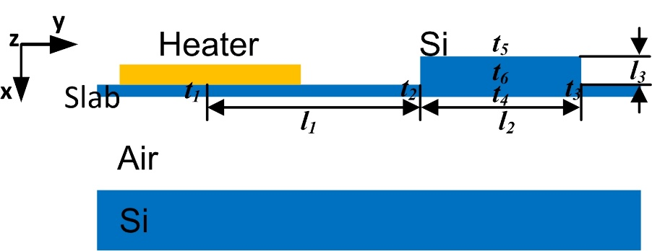

**Figure 4S:** Cross-section of the heated suspended waveguide in the *x-y* plane.

1. The heat conduction process from the heater to the slab waveguide along the *x-*direction. Since the thickness of the slab waveguide is only 50 nm, the top and bottom surfaces can be considered as in the same temperature. Due to the direct contact of the slab waveguide and the micro-heater, the temperature of the slab waveguide  is equal to the temperature of the heater:

. (27)

1. The heat conduction process from the slab waveguide to the ridge waveguide along the *y-*direction:

. (28)

As shown in Figure 4S, the temperature of the slab waveguide varies from  to  with a distance of .

After an integral operation on Eq. (28), it can be obtained that:

, (29)

where  is the temperature of the slab waveguide.

Substituting Eq. (29) into (14), it can be obtained that:

, (30)

where  is the cross-sectional area of the waveguide in the *x-z* plane,  is the heat transferred from the heater to the slab waveguide per second,  is the thermal conductivity of silicon.

In the steady-state of heat conduction process, the heat flowing through the plane of the cross-section is the same for each layer:

. (31)

Substituting Eq. (31) into (30), the temperature at the end of the slab waveguide  can be obtained:

. (32)

1. The thermal energy applied to and subtracted from the ridge waveguide reach a balance. In this process, heat flows from the end of the slab to the ridge waveguide along the *x-* and *y-*directions, respectively. Considering the heat conduction processes in the *x-* and *y-*directions:

. (33)

Boundary conditions can be written as:

 (34)

 (35)

 (36)

 (37)

where  is the temperature at the left interface of the slab waveguide and ridge waveguide (),  is the width of the ridge waveguide,  is the gradient of the temperature distribution at the right interface of the ridge waveguide (),  is the etching depth of the slab waveguide,  is the gradient of the temperature distribution at the top surface of the ridge waveguide (),  is the temperature at the intersection of the right and top surfaces of the ridge waveguide ().

Eq. (33) is a two-dimensional Laplace differential equation, and it can be solved by applying the boundary conditions. After the integral operations in the *x-* and *y-*directions, an elliptic equation of temperature can be obtained, which means the thermal field elliptically distributed in the ridge waveguide. For easier comparison with the conventional waveguide structure, this two-dimensional-conducting process can be decomposed into two heat conduction processes in the *x-* and *y-*directions, respectively.

In the *y-*direction:

, (38)

where  is the width of the ridge waveguide,  is the temperature at the end of the ridge waveguide in the *y-*direction.

Substituting Eq. (38) into (14), it can be obtained that:

, (39)

where  is the heat transferred from the slab waveguide to the bottom of the ridge waveguide.

In the *x-*direction:

, (40)

and

, (41)

where  is the height of the ridge waveguide,  is the temperature at the bottom of the ridge waveguide in the *x-*direction,  is the temperature at the top of the ridge waveguide in the *x-*direction.

Similarly, substituting Eq. (41) into (14), the heat transferred to the ridge waveguide  can be obtained that:

, (42)

where  the cross-sectional area of the ridge waveguide in the *x-z* plane. In the steady-state of heat conduction process, the heat flowing through the plane of the cross-section of each layer is equal:

, (43)

and

. (44)

Thus, it can be obtained that:

, (45)

, (46)

and

. (47)

According to Eq. (38) and (40), the temperature changes linearly in the *x-* and *y-*directions of the waveguide, respectively. The temperature of the ridge waveguide can be expressed as the temperature at the center of the waveguide (). Thus,

. (48)

Substituting Eq. (27) and (32) into (48):

. (49)

If the heat capacity of the waveguide is assumed to be , which represents the required heat to heated the waveguide up by 1*K*. Thus,

. (50)

## 2.4 Analysis of the dependence of the resonance wavelength on the material refractive index in a resonant cavity

In the thermal tuning process of a silicon resonant cavity, the refractive index changes as a function of the temperature. The refractive index of the waveguide  is related to the relative permittivity and relative permeability as below [3]:

. (51)

For silicon material, the relative magnetic permeability  is close to unity. In this case, the refractive index is [3]

. (52)

After a differential operation on both sides of Eq. (52), it can be obtained that [3]:

. (53)

Thus, it can be obtained that [3]:

. (54)

The relative permittivity of the resonant cavity changes with the variation of the refractive index. According to the perturbation theory, the small variation of the relative permittivity can be considered as a small perturbation applied to the resonance cavity ( ~ 1%).

When the refractive index variation is small enough ( < 1%), the relationship between  and  can be expressed as:

. (55)

According to the perturbation theory [3], the frequency shift  that results from the small perturbation  of the resonant cavity can be obtained:

, (56)

where  is the resonant frequency of the cavity,  is the electric field of the Bloch mode in the cavity.

Substituting Eq. (54) into (56), it can be obtained that [3]:

, (57)

and

. (58)

The numerator of  is the electric-filed energy distributed inside the perturbed region while the denominator of  is the electric-filed energy within the mode volume of the resonant cavity.

According to [3], the relationship between the wavelength  and the frequency  in dielectric materials with the refractive index of  can be expressed as:

. (59)

After a differential operation on both sides of Eq. (59), it can be obtained that:

. (60)

Substituting Eq. (58) into (60) yields:

. (61)

In a thermal tuning process, the refractive index of the silicon resonant cavity changes with the variation of the temperature. According to Ref. [4], the silicon thermo-optic coefficient is:

. (62)

Assuming  to be the thermo-optic coefficient, thus,

, (63)

where  and  is the variations of the refractive index and the temperature induced by the thermal tuning process, respectively.

Substituting Eq. (63) into (61), the wavelength shift can be obtained:

, (64)

where  is the refractive index of the silicon resonant cavity.

According to Eq. (24):

, (65)

where is the heat capacity of the resonant cavity, and is the heat flux produced by the thermal tuning process at the position of .

Substituting Eq. (65) into (64), it can be obtained that:

. (66)

Therefore, it can be concluded that the wavelength shift is positively related to the heat flux  induced by the heater for the optical resonant cavity.

## 2.5 Power consumption for the thermo-optic tuning process of a resonant cavity

For a thermo-optic tuning device, the heater is a metal with good thermal conductivity and electrical conductivity. It can be considered as a resistor, of which the electrical power consumption is converted into heat energy. Therefore, the relationship between the applied electrical power  and the heat flux  can be expressed by the following equation:

, (67)

where  is the electricity consumed by the heater,  is the heat energy generated by the heater,  is the conducting time of the heater.

If an electric power of  is applied to the heater, the wavelength shift  of the cavity should be:

. (68)

Substituting Eq. (66) into (68), it can be obtained that:

. (69)

In a resonant cavity-based thermo-optic switch, the wavelength shift is supposed to be larger than the 3-dB bandwidth to achieve a reasonable crosstalk value.

The definition of quality factor () in [5] is:

, (70)

where FWHM is the full width at half maximum, which is equal to the 3-dB bandwidth of the resonant cavity. Assuming that  is equal to the 3-dB bandwidth of the resonant cavity, it can be obtained that:

, (71)

and

. (72)

Substituting Eq. (69) into (72), *Qf* can be obtained:

. (73)

Then, the heat flux  can be expressed as:

. (74)

Substituting Eq. (67) into (74), The power consumption can be obtaine:

. (75)

## 2.6 Discussion

According to Eq. (75), when the refractive index of the dielectric material is obtained, the power consumption of a nanobeam waveguide is related to the following parameters:

1. Waveguide heat capacity (). The smaller the heat capacity of the waveguide is, the lower the tuning power is; or vice versa. Therefore, a smaller heat capacity can effectively improve the thermal tuning efficiency and decrease the power consumption of the device.
2. Quality factor of the nanobeam (). A high Q-factor () is desired to effectively reduce the power consumption of the nanobeam waveguide. However, the Q-factor is limited by the FWHM of the cavity, which is important for the switch in applications.
3. Fraction of the signal energy in the perturbed region.  is the fraction of the signal energy in the perturbed region. Generally, the fraction value is less than 1. If the mode volume () [3] of the cavity is small enough, the light field will be confined in the small region in which the change of the refractive index can be considered as uniform. Then, the perturbed region is approximately equal to the mode volume of the cavity, and the approximation of  can be obtained. The thermal tuning efficiency increases positively with the fraction value of the cavity.

# References

[1] T. M. Tritt, *Thermal conductivity: theory, properties, and applications.* (Springer Science & Business Media, 2005).

[2] D. R. Lide, *Handbook of Chemistry and Physics*, (CRC, 2008)

[3] John D. Joannopoulos. *Photonic Crystals 2nd.* (Princeton University, Princeton, 2008).

[4] R. A. Soref, “Silicon-Based Optoelectronics,” *Proc. IEEE*. **81**(12), 1687-1706, (1993).

[5] W. Bogaerts, et al. “Silicon microring resonators,” *Laser & Photon. Rev.*, **6**(1), 47-73, (2012).