Enhanced directional emission of monolayer WS2 with robust linear-polarization via one-dimensional photonic crystal slab

Han Li1, Jiajun Wang2, Yating Ma1, Jiao Chu2, Xiang’ai Cheng1, Lei Shi2,* and Tian Jiang1,*

Contact: lshi@fudan.edu.cn, tjiang@nudt.edu.cn

1 College of Advanced Interdisciplinary Studies, National University of Defense Technology, Changsha 410073, China

2 State Key Laboratory of Surface Physics, Key Laboratory of Micro- and Nano-Photonics Structures (Ministry of Education) and Department of Physics, Fudan University, Shanghai 200433, China

1. **Optical image of the monolayer WS2/PhC device**

The optical image of the monolayer WS2/PhC device is presented in Figure S1 below. The PhC slab is covered by an oversized monolayer WS2 membrane, ensuring a direct comparison for monolayer WS2 emission.

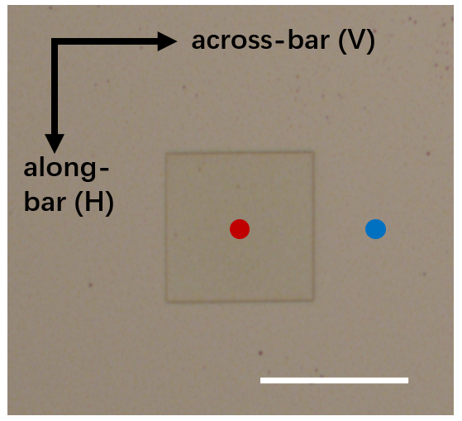

**Figure S1:** Optical image of the monolayer WS2/PhC device. Red (blue) dot refers to WS2 on PhC (flat) slab. White scale bar: 80 μm.

1. **Raman spectra of monolayer WS2**

Raman spectra of monolayer WS2 on both PhC slab and flat slab are measured, and component out-of-plane $A_{1g}$ and in-plane $E_{2g}^{1}$ modes are extracted in Figure S2. The interval between $A_{1g}$ and $E_{2g}^{1}$ modes are both calculated to be ~62 cm-1, which agrees well with the monolayer WS2.

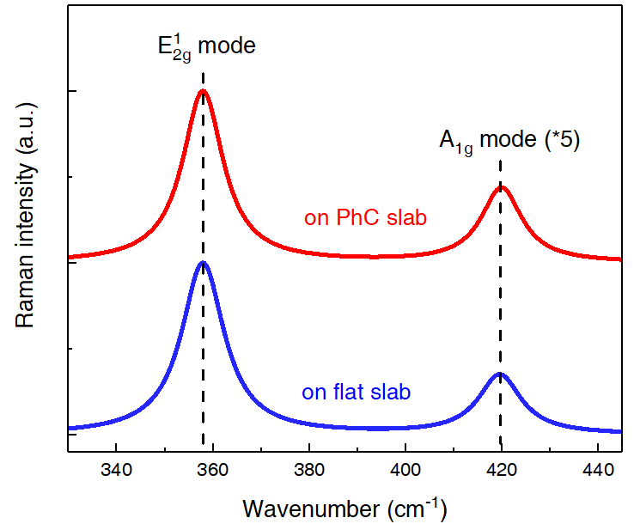

**Figure S2:** Raman spectra of monolayer WS2. Signals of out-of-plane $A_{1g}$ mode are magnified by five-fold for recognition.

1. **Reflectance of the PhC slab in vertical polarization**

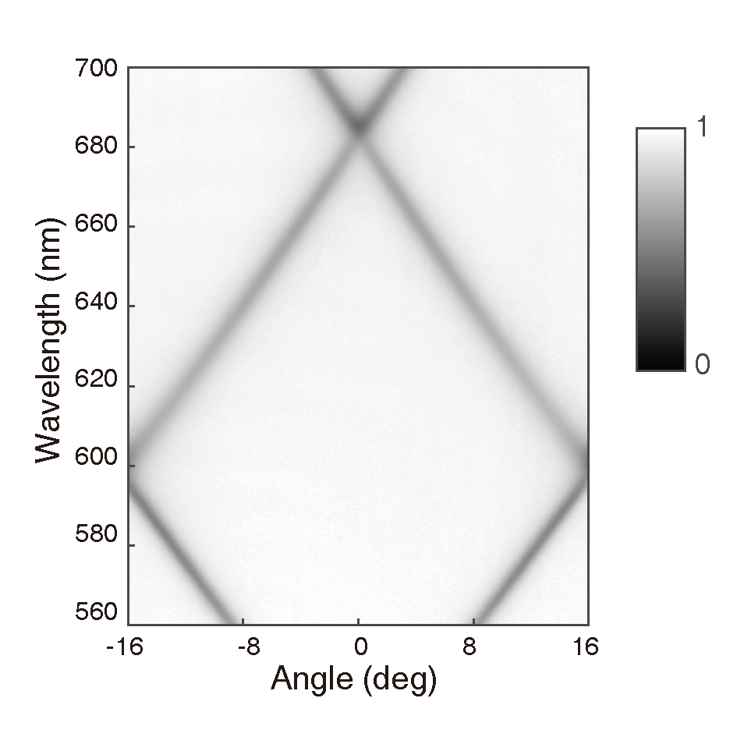

**Figure S3:** Reflectance of the PhC slab in vertical polarization. The reflectance is consistent with the designed band structure.

1. **Polarization-resolved PL spectra of monolayer WS2** **on flat slab**

Polarization-resolved PL spectra of monolayer WS2 on flat slab are recorded in Figure S3 under excitation with orthogonal polarizations. At room temperature, the horizontal and vertical polarization components of monolayer WS2 near matched, resulting in a rather poor and even neglectable DLP within 2%.

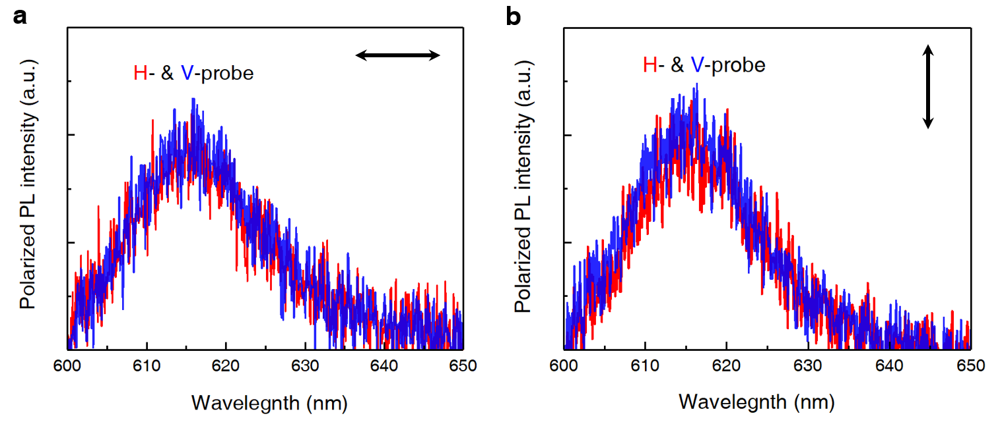

**Figure S4:** Polarization-resolved PL spectra of monolayer WS2 on flat slab. (a) Excitation with horizontal polarization. (b) Excitation with vertical polarization.

1. **Fitting results of normalized TR-PL decays**

In a normalized bi-exponential model, carriers recombine via the non-radiative and radiative process. We ignore the time-delay of TR-PL signal rising edge, because it has no influence on the fitting results. The TR-PL signal is modelled as $I\left(t\right)=A∙\exp\left({-t}/{τ_{1}}\right)+(1-A)∙\exp\left({-t}/{τ_{2}}\right)$, where $A (1-A)$ and $τ_{1}$ ($τ_{2}$) represent the ratio and lifetime of modelled non-radiative (radiative) process, respectively. And the fitting results are listed in Table S1.

**Table S1:** Fitting results of normalized TR-PL decays.

|  |  |  |  |  |
| --- | --- | --- | --- | --- |
| monolayer  WS2 | non-radiative | | radiative | |
| A | $τ_{1}$ (ns) | 1-A | $τ_{2}$ (ns) |
| on flat slab | 0.985 | 0.051 | 0.015 | 1.847 |
| on PhC slab | 0.928 | 0.053 | 0.072 | 0.304 |