Supporting Information

Stefan Fossati, Simone Hageneder, Samia Menad, Emmanuel Maillart, Jakub Dostalek*

Multi-resonant plasmonic nanostructure for ultrasensitive fluorescence biosensing

Fabrication process
The multi-period plasmonic grating – MPG – nanostructures were prepared using a series of nanolithography steps. UV-laser interference lithography – UV-LIL – was employed to generate a master structure in photoresist layer on the top of a glass substrate by using multiple exposures of an interference field followed by etching with a developer. Lloyd’s mirror configuration was used as showed in Figure S1A to record an interference field formed by two overlapping plane waves. Precise control of the pattern period Λ is achieved by adjusting the angle θ while the modulation depth is adjusted by the exposure time and development parameters.

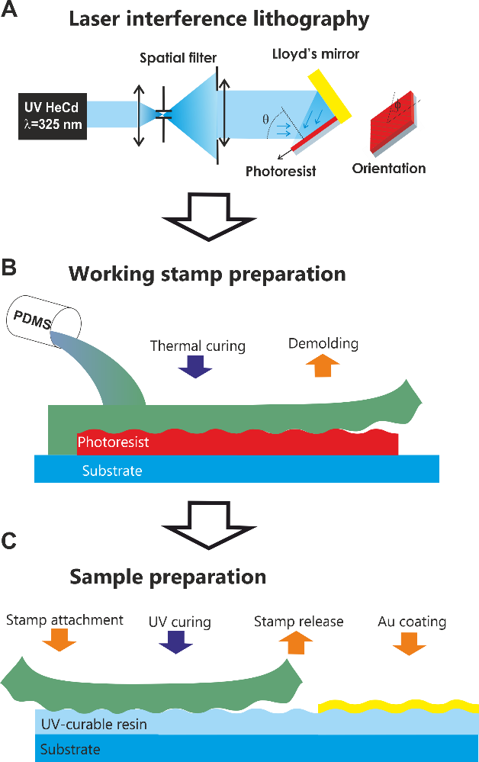

Figure. S1: A) UV–LIL setup in Lloyd’s mirror configuration, where the photoresist layer (red) is exposed to the interference pattern formed by two overlaid parts of the expanded collimated UV laser beam. Between multiple exposures, the sample is rotated around its normal axis by an azimuthal angle φ. B) Working stamp preparation by casting the prepared MPG topography to PDMS for C) UV-nanoimprint lithography replication, where the stamp is imprinted in thin layer of imprint resist, followed by curing with UV light before demolding of the PDMS working stamp.

Since preparation of higher numbers of MPG structures with identical parameters by using UV-LIL is impractical, UV-nanoimprint lithography – UV-NIL – was employed to replicate the master structure. First, a working stamp was prepared by casting the master structure to polydimethylsiloxane (PDMS) that was cured at controlled temperature (Figure S1B). After the curing, the stamp is demolded and used to replicate the pattern to nanoimprint resist (Amonil) on a glass substrate. Such copies with MPG topography were subsequently coated with a 100 nm gold film by vacuum thermal evaporation (Figure S1C).

Optical properties of grating coupled plasmon resonances
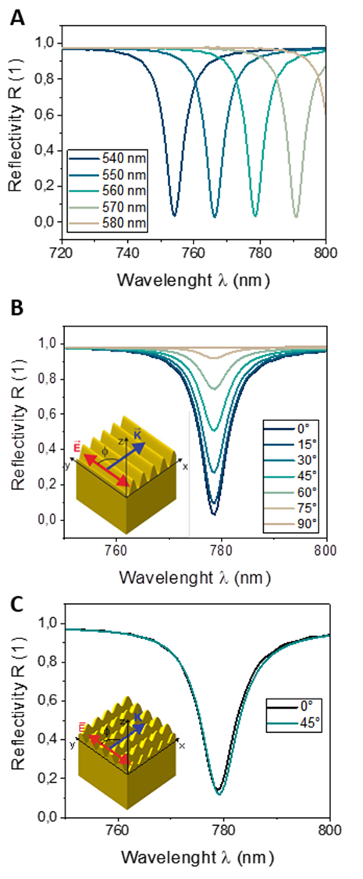

Figure S2: (A) Change of the spectral position of SPR with grating period for a single sinusoidal grating, 15 nm modulation depth, and gold – water interface. Coupling efficiency dependence on the polar angle φ between grating vector and electric field vector is shown for linear gratings in (B) and for crossed grating in (C).

Plasmon near-field intensity profile

Figure. S3: Distance dependence of the local electrical field enhancement averaged over the MPG along the axis perpendicular to the surface.

Measurement of fluorescence angular distribution

Figure. S4: The reader configured to image the back-focal plane of the objective lens, where the miniature mirror is located, by an additional lens (Lens 5).

Experimental observation of a fluorescence assay

Class | Spots
Dark reference | 19, 21
Illuminated but not functionalized | 1, 2, 3, 4, 7
MPG functionalized | 5, 6, 8, 9, 10, 12, 13, 16
Flat gold functionalized | 11, 14, 15, 17, 18, 20

Figure. S5: A) A schematic of the sensor chip with part of its area structured with gold-coated MPG and part of its area carrying flat gold surface that is clamped against a microfluidic flow-cell. The illuminated area is indicated by a red circle, the imaged area by a black square. In B) a fluorescence image obtained during the measurement in Figure 7 b) after titration up to 50 pM target analyte concertation is shown. The microfluidic channel is indicated in blue, the illuminated area with a red circle and the spots averaged to calculate the fluorescence signal are indicated in green.

NIL reproducibility
Reproducibility of the UV-NIL process was tested on 5 samples prepared using a PDMS stamp. The spectra were acquired in air to prevent contamination, before the samples were chemically modified (therefore the spectral positions differ from those presented in Figure 3 measured in contact with water). The spectral position of the resonances deviate by less than 2 nm, significantly smaller value than the resonance width.

Figure S6: Reflectivity spectra acquired from 5 nanoimprinted samples from the same master structure

Collection efficiency enhancement
A key challenge in making sensitive fluorescence assays is the collection efficiency of emitted fluorescence light for practical optical systems. For a freely rotating fluorophore in homogeneous medium, the emission is assumed to be isotropic despite the orientation sensitive absorption characteristics of the electrical dipole model, due to the random change of orientation during fluorescence lifetime. For an optical system with a given numerical aperture $NA=n\sin{θ}$ the collection only part of fluorescence light emitted to a cone with half angle $θ$ can be collected. In the case of isotropic emission, the fraction can be determined analytically by calculating the ratio of the surface of the emission cone to the overall surface.
$$\begin{aligned}A_{collected}=\int_{0}^{Θ}{\int_{0}^{2π}{ sinθ dϕ dθ}}=2π \left( 1-cosΘ\right) \#\left(1\right)\end{aligned}$$

$$\begin{aligned}CE=\frac{A_{collected}}{A_{sphere}}=\frac{A_{collected}}{4 π}=\frac{1}{2}\left(1-cosΘ\right) \#\left(2\right)\end{aligned}$$

For the MPG structure, collection efficiency was determined by calculating the farfield emission of a dipole in 15 nm distance from the surface. Four polar orientations of the dipole (0, 45°, 90°, 135°) with respect to the linear grating were considered. The emitted power to a cone of opening angle $Θ$ perpendicular to the interface was computed by numerical integration. A similar calculation was performed for an emitter on a flat gold surface. In this work, an optical system with numerical aperture NA=0.2 was used to image a large sample area in a flow cell. Collection efficiencies for this system were calculated and are shown in Figure S7.
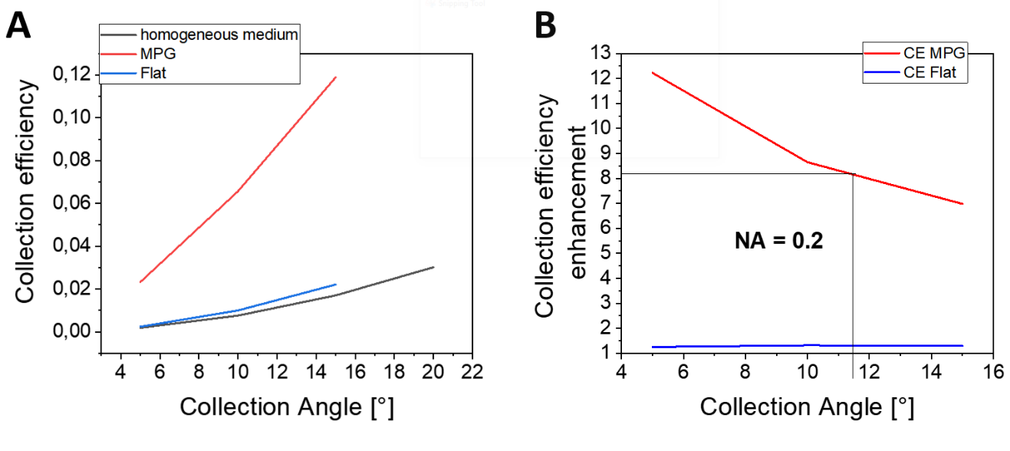
Figure S7: (A) Collection efficiency of an optical system with NA = 0.2 opt for an emitter located in a homogeneous medium (black), on a flat gold surface (blue) and on the MPG structure (red). (B) Enhancement of collection efficiency with respect to emitter in homogeneous medium for MPG and flat surfaces.

