**Supplementary Material**

**Ultrasensitive and Fast Photoresponse in Graphene/Silicon-On-Insulator Hybrid Structure by** **Manipulating the Photogating Effect**

*Hao Jiang1,2, Changbin Nie2, Jintao Fu2, Linlong Tang2, Feiying Sun2, Jiuxun Sun1,*, Jun Shen2, Shuanglong Feng2, Haofei Shi,*2 and Xingzhan Wei2,\**

1School of Physics, University of Electronic Science and Technology, Chengdu 610054, China

2Chongqing Institute of Green and Intelligent Technology, Chinese Academy of Sciences, Chongqing 400714, China.

3TianJin Jinhang Insitute of Technical Physics, Tianjin 300192, China

4Department of Physics, Harbin Institute of Technology, Harbin 150001, China.

**Corresponding Author**

* Prof. Jiuxun Sun, E-mail address: sjx@uestc.edu.cn

* Prof. Haofei Shi, E-mail address: shi@cigit.ac.cn

* Prof. Xingzhan Wei, E-mail address: weixingzhan@cigit.ac.cn

**S1 Synthesis of graphene and device**

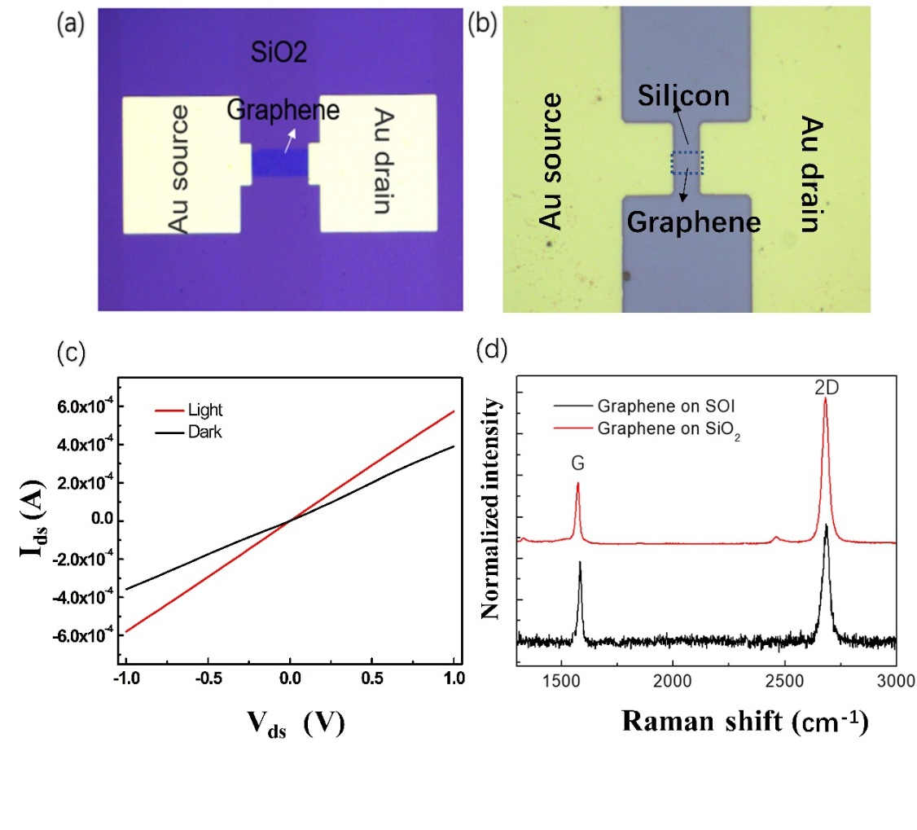

Figure. S1: Microscopic charts of the graphene-based devices on SiO2 (a) and SOI (b) substrates. (c) Ids-Vds curve of the GSOI device with or without illumination. (d) Raman spectra of the graphene on SOI (black curve) and SiO2/Si region (red curve)

Figures. S1 (a) and (b) are the microscopic images of graphene photodetectors based on SiO2 and SOI substrates, respectively. The graphene belongs to the same batch with the identical synthesis and transfer process, and therefore the doping degree is similar. The relevant Ids-Vds image of the GSOI device is shown in Figure. S1 (c), which shows that the contact between graphene and gold electrodes can be [classified](link:classified) [as](link:as) an ohmic contact. Figure. S1 (d) shows the Raman spectra of graphene transferred on Si and SiO2 respectively at the wavelength of 532nm. The *2D*/*G* intensity ratios are both larger than 1, which indicates the graphene is monolayer. Besides, the intensity of peak *D* related to defect is quite weak in the spectra, which proves the transferred graphene is of high-quality.

Table S1. Spot radius and area under different light power of 532nm light source

|  |  |  |
| --- | --- | --- |
| Optical power($\text{µ}$ w) | Spot radius (mm) | Spot area (mm2) |
| 920 | 3.57 | 40 |
| 860 | 3.19 | 32 |
| 350 | 2.98 | 28 |
| 90 | 2.76 | 24 |
| 17 | 1.95 | 12 |
| 3 | 1.59 | 8 |

To get accurate optical power density, the spot radius and area under different light power of 532nm light source are shown in Table S1, which are used to calculate the true responsivity of the device by $R=\frac{ΔI}{P_{e}}=(I_{light}{-}I_{dark}{)}×(P{×}\frac{S_{device}}{S_{light}})^{-1}$. The $S_{device}$ is 100 µm2.

**S2 Modulation law**

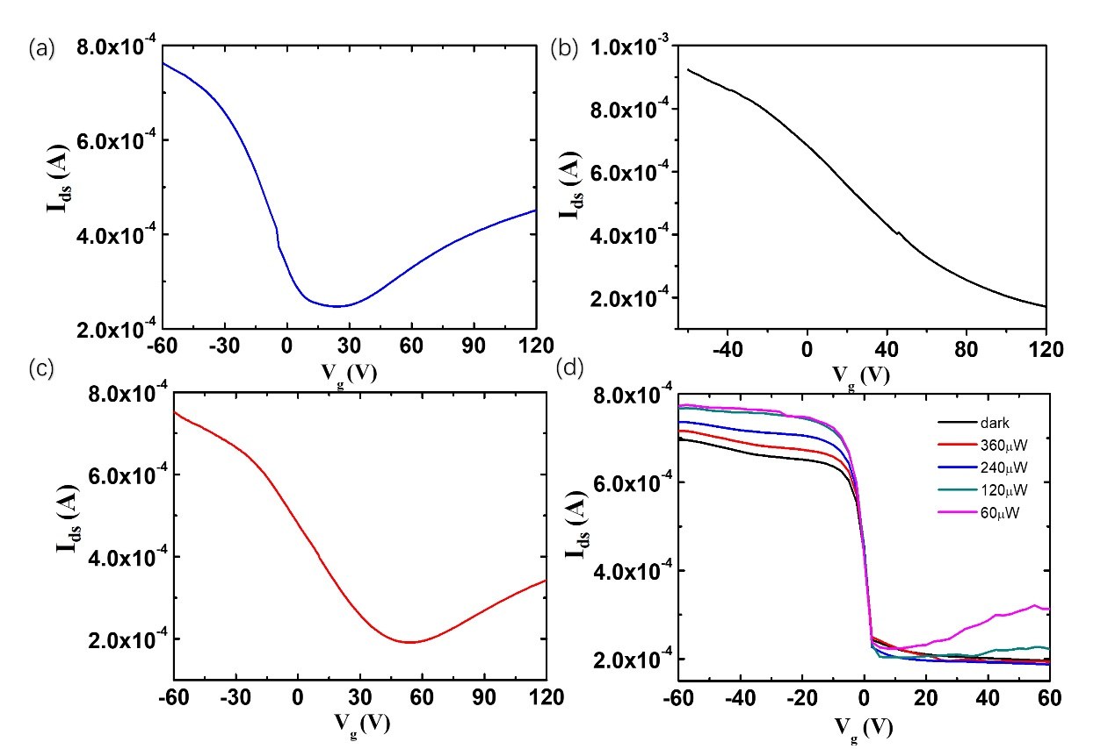

Figure. S2: Transfer curves of the lightly (a), heavily (b), and moderately (c) p-doped graphene devices. (d) Voltage modulation curves of the moderately p-doped GSOI device.

For clarifying the indirect modulation mechanism described in the text, we designed the GSOI devices with different doping levels. The doping level of graphene can be obtained by measuring its transfer curve and exploiting the bipolarity of GFET [1,2].Figure. S2 (a), (b), and (c) show the transfer curves of the lightly, heavily, and moderately p-doped graphene devices, respectively.

The graphene samples were soaked in ammonia water, and different doping effects can be realized by adjusting the concentration of the ammonia water. Figure. S2(d) shows the voltage modulation curves of the moderately p-doped graphene device. The net photocurrent can be significantly changed under the modulation of the vertical voltage. Obviously, as the optical power increases, the photocurrent will be enhanced. Note that the variation trend of *I*ds is similar to the lightly p-doped graphene device in Figure 2. (b) of the main text. The difference is that the *I*ds of the moderately p-doped graphene device nearly keeps unchanging as the positive voltage continuously increases. This phenomenon can be ascribed to the concentration of holes in the heavily p-doped graphene is extremely high; hence the variation of the majority carrier is quite difficult, even though a large vertical voltage is applied.

**S3 SOI photodetector without graphene**

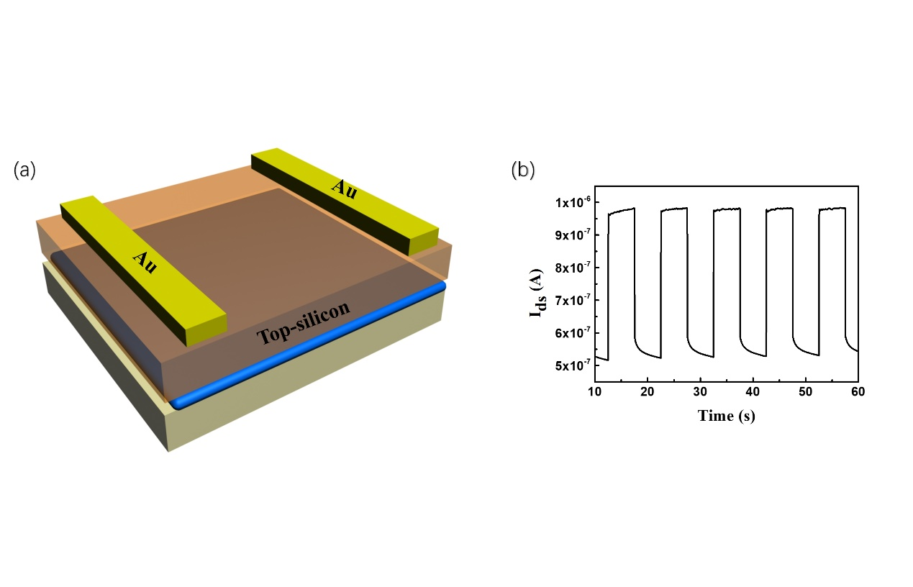

Figure. S3: (a) The schematic of SOI photodetector without graphene. (b) The transient photocurrent response of the SOI photodetector under 920 µW light power at the wavelength of 532 nm.

The SOI photodetector without graphene has been fabricated to compare with the GSOI devices of the same geometrical sizes. The schematic view and transient photoresponse of the SOI photodetector under 920 µW light power at the wavelength of 532 nm are shown in Figure. S3. The measured dark current is about 5.4⨯10-7 A, which is about three orders of magnitude smaller than the GSOI device (about 4⨯10-4 A) due to the excellent conductivity of graphene. Besides, the measured photocurrent obtained by Ilight-Idark is about 4.5⨯10-7 A, which is three orders of magnitude smaller than the counterpart of GSOI device (5⨯10-5 A). Thus, we could conclude that the amplification of photocurrent is caused by the photogating effect in the GSOI device.

**S4 Establishment of the simulation model**

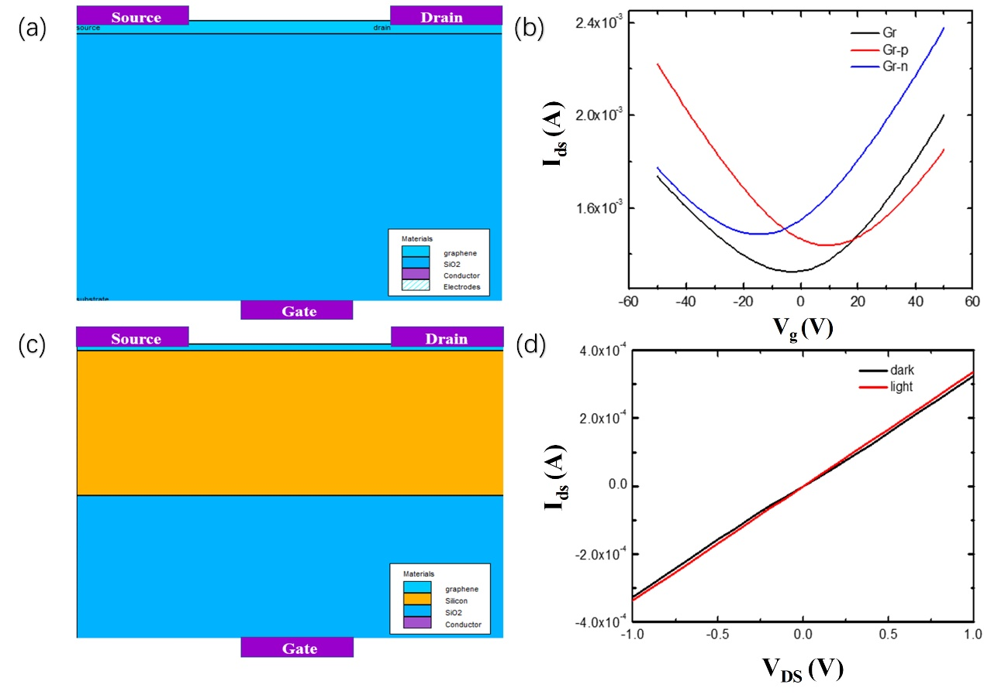

Figure. S4: (a) Simulation model of the graphene-SiO2 device. (b) Transfer curves of the intrinsic, n-type, and p-type graphene obtained by simulation. (c) Simulation model of GSOI device. (d) Calculated currents of the GSOI device in dark and light states.

A graphene model was established according to the reported references [3-5],in which the thickness of top-silicon was set to be 220 nm, the thickness of SiO2 was 2 µm, carrier density *nn,p* was set to be 1012cm-2, the mobility of graphene was 4000 cm2V-1s-1, and the dielectric constant $ε$, the electron affinity and electron affinity were 25, 4.25 eV, and 3⨯107cm/s, respectively. Figure. S4(a) show the structure of the model. Figure. S4(b) shows the modeled transfer curves for intrinsic, n-type, and p-type graphene, which are consistent with the experimental results. Also, Figure. S4 (c) model was established to verify the carrier transport mechanism between graphene and silicon in the GSOI device. Figure. S4 (d) shows the calculated currents of the GSOI device in dark and light states, which are in good agreement with the experimental data.

**S5 Analysis of the simulation model**

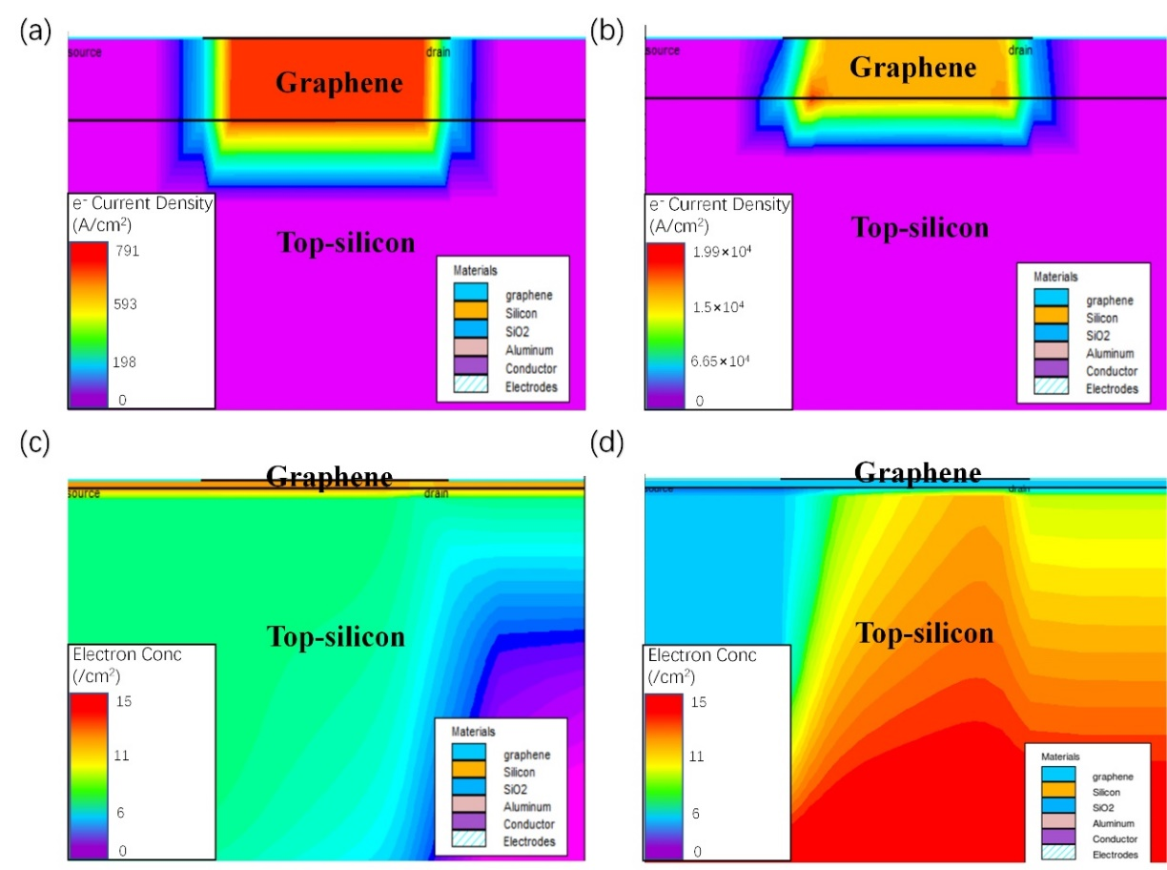

Figure. S5: Electric current density in the graphene channel of lightly p-doped GSOI device under -30V vertical voltage (a) and under 30V vertical voltage (b). Electrons distribution maps under -30V vertical voltage (c) and under 30V vertical voltage (d).

To analyze the modulation effect of the vertical voltage, the corresponding electric current density and electron distributions in top-silicon were modeled. When a negative vertical voltage is applied, a smaller electric current density is produced in the graphene channel, as shown in Figure. S5 (a), which is much smaller than the hole current density. In contrast, when a positive vertical voltage is applied, the electric current density in the graphene channel is larger than the case with negative vertical voltage, which shows that electrons play a dominant role in current transmission, as shown in Figure. S5 (b). Therefore, it can be explained that the change of carrier concentration in top-silicon can lead to the change of majority carrier type in graphene.

The electron distributions in top-silicon under different types of vertical voltage are shown in Figure. S5 (c) and (d). The electron concentration in top-silicon increases greatly when the positive vertical voltage is applied.

**S6 Time response characteristics of the device**

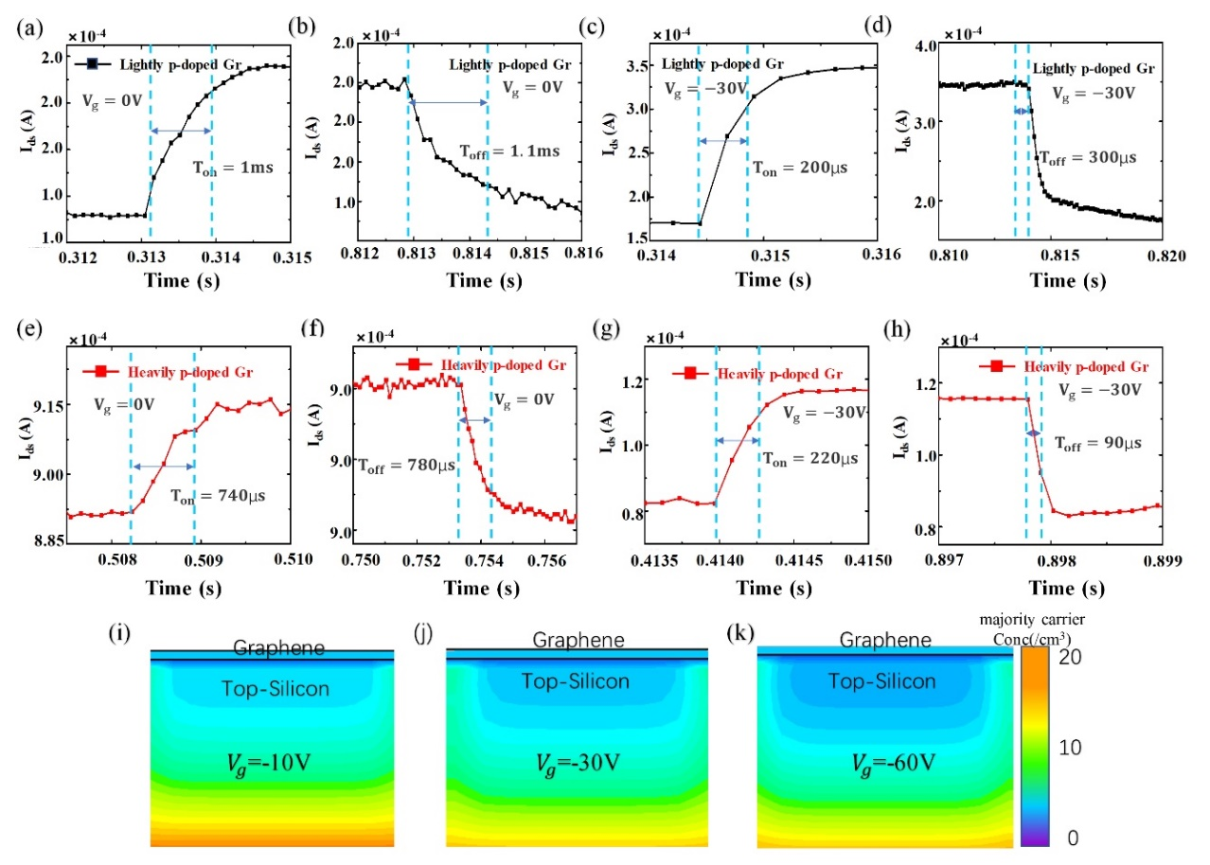

Figure. S6: Time-dependent responses of the GSOI Devices under different voltages. The transient photocurrent response of the lightly p-doped GSOI device without vertical voltage (a), (b) and under -30 V voltage (c), (d). The transient photocurrent response of heavily p-doped GSOI device without vertical voltage (e), (f) and under 30 V voltage (g), (h). The simulation of the distribution of majority carriers in the boundary region of top-silicon and graphene when *Vg* = -10 V (i), -30 V (j), and -60 V (k).

Figure. S6(a) and (b) show the transient photocurrent response of the lightly p-doped graphene device without vertical voltage, in which the rising edge time (Ton) and falling edge time (Toff) are 1 ms and 1.1 ms respectively. When a -30V voltage is applied, the photocurrent exhibits an increasement. Moreover, Ton and Toff are decreased to 200 µs and 300 µs, respectively, as shown in Figure. S6 (c) and (d). The photoresponse results of heavily p-doped graphene devices without modulation are shown in Figure. S6 (e) and (f), in which theTon is 740 µs and Toff is 780 µs. When the voltage of -30 V is applied, the net photocurrent is enhanced by about 5 times. Also, Ton and Toffare decreased to merely 220 µs and 90 µs, respectively, as shown in Figure. S6 (g) and (h).

We also simulated the distribution of majority carriers in the boundary region of top-silicon and graphene when *Vg* = -10 V, -30 V, and -60 V, as shown in Figure. S6 (i), (j) and (k). It can be seen that the concentration gradient will become more obvious with the increase of vertical voltage, which is beneficial [to](link:to) accelerate the photoresponse.

**S7 Comparison of the simulated and experimental modulation characteristic curves**

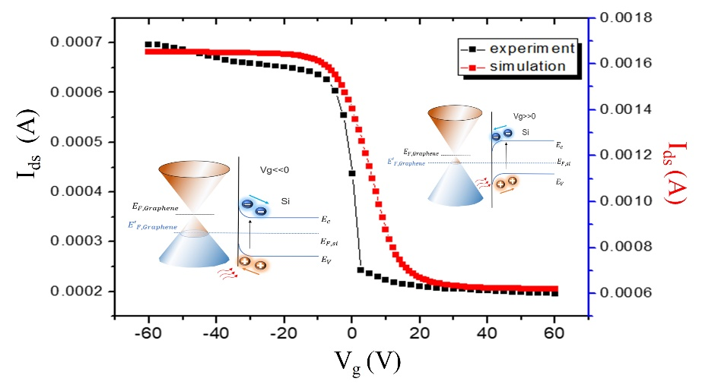

Figure. S7: Comparison of the simulated (red squares) and experimental (black squares) modulation characteristic curves of the heavily p-doped graphene device in the dark state. Insets show the energy band diagrams when the device is applied with negative and positive vertical voltages.

The modulation effect in the heavily p-doped graphene device in the dark state was also modeled to compare with the experiment results. Figure S7 shows the modeled and experimental results, which exhibit a good agreement both in magnitude and tendency. Similarly, the modulation can be divided into two processes. When the negative voltage is applied, the concentration of holes in silicon increases, and then the holes will be injected into the graphene, which leads to the increment of photocurrent. In contrast, when a positive voltage is applied, a large number of electrons will concentrate in silicon, which will be injected into the graphene, leading to the decrease of the current in the graphene tunnel. Note that this phenomenon is different from that of the lightly p-doped graphene devices because the concentration of holes in the heavily p-doped graphene is extremely high. Even though the concentration can be reduced to some extent through injecting the electrons under the modulation of positive voltage, the electrons cannot become the majority carriers. Therefore, when the positive vertical voltage is applied, the current decreases and tends to be saturated.

**S8 Noise measurement**

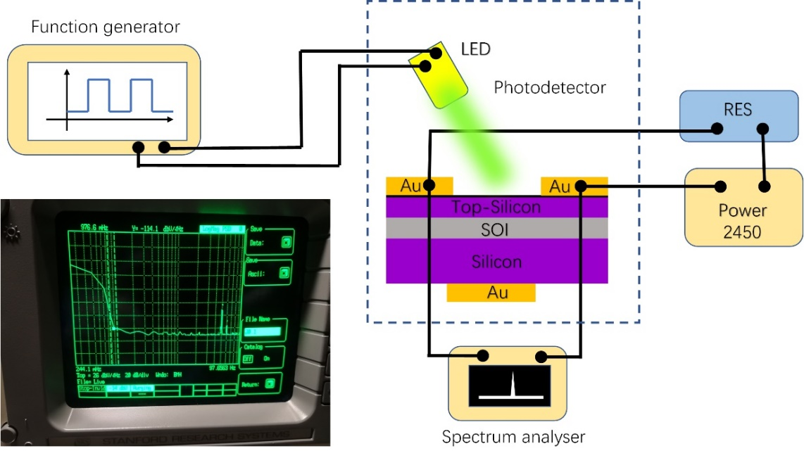

Figure. S8: Schematic view of the noise testing system.

It can directly calculate the ratio of shot noise of detectors, as reported in previous references [6,7],however, it usually ignores the Johnson and scintillation noises in the calculation. To accurately characterize the performances of GSOI devices, a noise testing platform was built according to the certified document [8].Through measuring the noise voltage, we can obtain the noise power, and the detectivity can be obtained through the following formula D*= $\frac{\sqrt{A⨯Δf}}{NEP}$. The schematic diagram of the testing system is shown in Figure. S8. The resistor is connected in series with the voltage source and the device. The spectrum analyzer is connected in parallel at both ends of the device. When the voltage source imposes a $U_{ds}$ voltage, the real-time current is $I_{dark}$ when there is no light. The Res resistance is equivalent to the device resistance, and the specific detectivity is obtained from the following formula.

D*= $\frac{\sqrt{A⨯Δf}}{NEP}$ = $\frac{\sqrt{A⨯Δf}⋅(\frac{U_{ds}}{I_{dark}}-Res){⋅R}_{responsibility}}{U_{n}}$

Through the measurement, a noise voltage of 2⨯10-6 V was obtained. A detectivity (D*) of 1.46⨯1013 Jones can be calculated based on the noise voltage.

**S9 Specification parameter of SOI**

The SOI wafers were brought from Suzhou Yancai Micro & Nano Technology Co., Ltd, and the relevant specification parameter is shown in the chart below.

Table S9. Specification parameter of SOI

|  |  |  |  |  |  |  |
| --- | --- | --- | --- | --- | --- | --- |
| Top-silicon | | | Oxide  Layer | Bottom-silicon | | |
| Type /  Dopant | Thickness | Resist  (ohm-cm) | Thickness | Type / Dopant | Thickness | Resist  (ohm-cm) |
| P | 220 nm | 1-20 | 2 µm | P | 500 µm | 1-20 |

**References**

[1] Novoselov KS, Geim AK, Morozov SV, et al. Electric field effect in atomically thin carbon films. Science, 2004; 306: 666-9.

[2] Reddy D, Register LF, Carpenter GD, et al. Graphene field-effect transistors. Journal of Physics D-Applied Physics 2012; 45: 019501.

[3] Johirul Islam M, et al. Study of characteristics curves top-gated graphene FET using Silvaco TCAD. Journal of Electronic Design Engineering 2017; 3: 3.

[4] Mobarakeh MS, Moezi N, Vali M, Dideban D. A novel graphene tunnelling field effect transistor (GTFET) using bandgap engineering. Superlattices And Microstructures 2016; 100: 1221-9.

[5] Safari A, Dousti M, Tavakoli MB. Monolayer graphene field effect transistor-based operational amplifier. Journal of Circuits Systems and Computers. 2019; 28: 1950052.

[6] Chang KE, Kim C, Yoo TJ, Kwon MG, et al. High-responsivity near-infrared photodetector using gate-modulated graphene/germanium schottky junction. Advanced Electronic Materials 2019; 5: 1800957.

[7] Shen J, Liu XZ, Song XF, et al. High-performance schottky heterojunction photodetector with directly grown graphene nanowalls as electrodes. Nanoscale 2017; 9: 6020-5.

[8] Fang YJ, Armin A, Meredith P, Huang JS. accurate characterization of next-generation thin-film photodetectors. Nat photon 2019; 13: 1-4.