Chemiluminescent carbon nanodots as sensors for hydrogen peroxide and glucose
Cheng-Long Shen¹, Guang-Song Zheng¹, Meng-Yuan Wu, Jian-Yong Wei, Qing Lou*, Yang-Li Ye, Zhi-Yi Liu, Jin-Hao Zang, Lin Dong and Chong-Xin Shan∗
Henan Key Laboratory of Diamond Optoelectronic Materials and Devices, Key Laboratory of Materials Physics, Ministry of Education, and School of Physics and Microelectronics, Zhengzhou University, Zhengzhou 450052, China
¹These authors contributed equally: Cheng-Long Shen, Guang-Song Zheng
Fig. S1 The High-resolution XPS spectra of the N1s (a) and O1s (b).
Fig. S2 The PL and CL spectra of the CDs.

Fig. S3 The measurement principle for the Eg of the CDs.
Fig. S4 The measurement principle for the HOMO levels of the CDs.

Note: The HOMO levels of the CDs was measured by the valence band XPS.[1, 2]The valence band potentials (E_{HOMO}^{NHE}) of the three CDs were obtained through fitting the cut-off edge of the low-energy XPS. The obtained E_{HOMO}^{NHE} is the VB _{potential} vs. NHE. As the NHE is equal to -4.5 eV, so E_{HOMO} =-E_{HOMO}^{NHE} - 4.5eV.As shown in Fig. S5, the E_{VB} of the CDs could be fitted with the valence band XPS data as 2.07 eV. So the energy level of HOMO for the CDs were thought as -6.57 eV. With the the energy level of HOMO, the energy level of LUMO could be calculated with E_{LUMO} = E_{HOMO} + E_{g} = -4.67 eV.
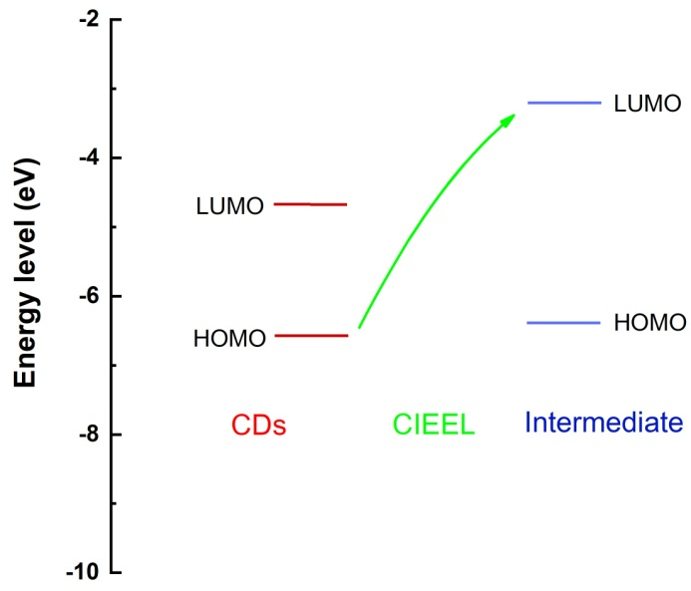
Fig. S5 Schematic illustration of the efficient CIEEL principle between the CDs and the intermediate from the peroxlate.
Fig. S6 The CL curves after mixing the lucigenin and H₂O₂ in the CL analysis system
Fig. S7 The CL curves the lucigenin after mixing the CDs into the mixture of TCPO and H₂O₂ in the CL analysis system.

Fig. S8 The SEM images of the CDs at low magnifications.
Notes:
As shown in Fig. S8, scanning electron microscope (SEM) image of CDs have been measured by depositing the CDs powder on clean silicon wafer, in which the black spots are the agglomerate of the individual CDs.
Note: The CL QYs of the CDs were measured using lucigenin (5.8×10⁻⁵ M) with H₂O₂ as oxidant with a known QY of 8.3×10⁻³ at PH = 11 according to the previous literatures. [9] According to the CL kinetic curves in the CL analysis instrument, the CL QYs were calculated according to the following equations:
(1)
(2)
(3)
Where φ_{luc} and φ_{CDs} is the CL QYs of the lucigenin and CDs, Q is the light emission integration obtained by the CL analysis instrument. n is the number of moles of lucigenin or the number of moles of TCPO.
Note: The detection limit of the nanoprobe has been determined to be 11.7 μM using the method suggested by IUPAC (A. G. Casado, et al, J. Chromatogr. A, 1996, 726, 133-139; G. L. Long, et al, Anal. Chem., 1983, 712A-724A). The computational formulas of the detection limit (LOD) for this nanoprobe are showed as follows:
XL = Xb + K*Sb ……………………………………………………… (1)
CL = XL - b / a = K*Sb / a ……..……………………………………….. (2)
XL means the response signal of the sample;
b means the mean of the blank signal value at multiple measurements;
Sb means the standard deviation of the blank signal value at multiple measurements;
K means a constant associated with confidence;
a means calibration curve slope;
CL means the detection limit (LOD) of the sensor.
Firstly, the CL intensity of the sensor without H₂O₂/glucose was obtained by 30 tests as the blank signal value. We can calculate the mean (b) and the standard deviation (Sb) of the 20 times blank signal. Secondly, the calibration curve slope (a) of the sensor was obtained. And the detection limit (LOD) of the sensor was calculated by the formula. In this work, the IFFS-A is conducted by Ruimai Electronic Science Co., China and the PMT (~1000 A/Lm) is not the best instrument at present. On the condition, the better CL analysis instrument with better PMT (such as Promega) with higher sensitivity than 1000 A/Lm can decrease the error from instrument (Sb) and decrease the LOD of chemiluminescent sensor in this work. Therefore, a better instrument can push down the LOD (Tab. S1).

Table S1. The CL property of different materials in previous reports.
CL emitter | CL system | sensing | LOD | Instrument | Ref
CDs | TCPO-H₂O₂ | H₂O₂ | 11.7 μM | IFFS-A | This work
CDs | TCPO-H₂O₂ | glucose | 12.6 μM | IFFS-A | This work
SPNR1 | CLsubstrate-O₂^{•−} | O₂^{•−} | 1.38 nM | Promega, USA | [4]
SPNR2 | CLsubstrate-O₂^{•−} | O₂^{•−} | 1.13 nM | Promega, USA | [4]
SPNR3 | CLsubstrate-O₂^{•−} | O₂^{•−} | 1.18 nM | Promega, USA | [4]
SPN-PFO | TCPO-H₂O₂ | --- | --- | Promega, USA | [5]
SPN-PFPV | TCPO-H₂O₂ | H₂O₂ | 5 nM | Promega, USA | [5]
SPN-PFBT | TCPO-H₂O₂ | --- | --- | Promega, USA | [5]
SPN-PFODBT | TCPO-H₂O₂ | --- | --- | Promega, USA | [5]
Au NPs | TCPO-H₂O₂ | --- | --- | Promega, USA | [6]
Perylene | TCPO-H₂O₂ | H₂O₂ | 6 nM | Home-made  luminometer | [7]
Perylene | TCPO-H₂O₂ | glucose | 10 nM | Photomultiplier | [8]

Reference:
[1] Fortes A D, Suard E, Knight K S. Negative linear compressibility and massive anisotropic thermal expansion in methanol monohydrate. Science 2011; 331: 742-6.
[2] Wang Y, Silveri F, Bayazit MK, et al. Bandgap engineering of organic semiconductors for highly efficient photocatalytic water splitting. Adv. Energy Mater. 2018; 8: 1801084.
[3] Maskiewicz R, Sogah D, Bruice T C . Chemiluminescent reactions of lucigenin. 1. Reactions of lucigenin with hydrogen peroxide. J. Am. Chem. Soc. 1979; 101: 5347-54.
[4] Dong Cui, Jingchao Li, Xuhui Zhao, et al. Semiconducting polymer nanoreporters for near-infrared chemiluminescence imaging of immunoactivation. Adv. Mater. 2020; 32: 1906314.
[5] Zhen X, Zhang C, Xie C, et al. Intraparticle energy level alignment of semiconducting polymer nanoparticles to amplify chemiluminescence for ultrasensitivein vivoimaging of reactive oxygen species. ACS Nano 2016; 10: 6400-6409.
[6] Cui H, Zhang Z, Shi M, et al. Light emission of gold nanoparticles induced by the reaction of bis(2,4,6-trichlorophenyl) oxalate and hydrogen peroxide. Anal. Chem. 2005; 77: 6402-6406.
[7] Zoonen P V, Kamminga D A, Gooijer C, et al. Flow injection determination of hydrogen peroxide by means of a solid-state-peroxyoxalate chemiluminescence reactor. Anal. Chim. Acta 1985; 167: 249-256.
[8] Williams D C, Huff G F, Seitz W R, A. Evaluation of peroxyoxalate chemiluminescence for determination of enzyme generated peroxide. Anal. Chem. 1976; 487: 1003-1006.
[9] Shen C L, Lou Q, Lv C F, et al. Bright and multicolor chemiluminescent carbon nanodots for advanced information encryption. Adv. Sci. 2019; 6: 1802331.

∗Corresponding author. E-mail: louqing1986@zzu.edu.cn (Qing Lou); cxshan@zzu.edu.cn (Chong-Xin Shan).

