Niyazi Ulas Dinc1, 2, Joowon Lim1, Eirini Kakkava1, Christophe Moser2 and Demetri Psaltis1

1Optics Laboratory, École Polytechnique Fédérale de Lausanne

2Laboratory of Applied Photonic Devices, École Polytechnique Fédérale de Lausanne

Computer Generated Optical Volume Elements by Additive Manufacturing: Supplementary Material

This document provides supplementary information to “Computer Generated Optical Volume Elements by Additive Manufacturing” manuscript.

For a more detailed view of Learning Tomography algorithm, the reader could check the references [1-3]. We implemented the algorithms by using custom scripts in MATLAB R2018a (MathWorks Inc., Natick, MA, USA) on a desktop computer.

1. Discussion on design parameters in varying layer separation scenario

In the Section “2.2 Representation Error” of the main text, two scenarios are investigated. The first scenario is imposing a constraint on $t_{l}$ to keep it fixed and keeping ${∆n=n}_{polymer}-n_{background}$ fixed as 0.2. This scenario provided the Figure 4A of the main text. Note that the first observation is that higher layer separation provides higher performance in terms of structural similarity index in all cases. Please note that phase-to-thickness converted elements and LT optimized elements have the fixed thickness variation. Therefore, the only changing parameter is the layer separation. For the phase mask stacks, the masks are taken as thin planes whose transmittance function is the following:

$$t\left(x,y\right)=\exp\left(j∆φ\left(x,y\right)\right) (1)$$

Where $j=\sqrt{-1}$ and $∆φ$ is the phase modulation of given pixel. Since the layers are modeled as phase objects as mentioned, increased reconstruction accuracy with increased layer separation is an expected result. Modulated light has more room to diffract and interact with more voxels. This result is in agreement with the discussion provided in [4]. It is important to note that equation (1) does not perfectly govern the layered volume elements when the phase modulation is implemented by varying thickness. It can provide a good approximation if the thickness variation is negligible compared to layer separation and if the thickness variation is not too large than the wavelength as well.

Another important aspect is the pixel pitch or transverse voxel dimensions in the case of volume elements. Each layer can be thought as superposition of many gratings. Since the strength of a grating is inversely proportional to its period, higher transverse voxel dimensions have less capability to modulate light. Moreover, for a fixed overall size, increasing the voxel dimensions reduces the number of different voxels and hence the degrees of freedom. Different voxel dimensions (obtained by averaging) are implemented and its effect on reconstruction is investigated by keeping other parameters the same. Figure 4A provides the results for transverse voxel dimensions of ${\left(0.5 μm\right)}^{2}$. In the Figure S1, we provide the same plots for different voxel dimensions under the same constraints with the structures investigated in Figure 4A. Figure S1 confirms the expectations. Note that in Figure S1D, we see that the effect of reducing the degrees of freedom starts to dominate the error in reconstruction rather than the representation error since we observe that the expected trend between Phase mask stack, Optimization with LT and Thickness conversion does not hold for all data points.

**Figure S1:** Structural similarity index plots for different transverse voxel dimensions. (A) $0.5μm×0.5μm$, (B) $1μm×1μm,$ (C) $2μm×2μm$ (D) $4μm×4μm$. Note that (A) is the same plot with the Figure 4A in the main text.

1. Discussion on design parameters in varying index scenario

In this part, we kept $L$ fixed and varied $∆n$ to obtain different $t_{l}$ values via Equation (2) of the main text. Obtained plots are given in Figure S2 for different transverse voxel dimensions. Note that the optimized phase mask stack has continuous RI values and sets the upper limit. Plots in Figure S2 show that LT performs better to suppress representation error except Figure S2D. Again, in Figure 2SD, we see that the effect of reducing the degrees of freedom starts to dominate the error in reconstruction rather than the representation error. Note that Figure 4B of the main text is obtained from Figure S2A. To get Figure 4B, results of LT optimized structure and thickness conversion structure are divided by corresponding results of discretized phase mask stack to eliminate the effect of discretization error and yield only the effect of representation error. Needless to say, x axis of Figure 4B of the main text is $1/∆n$ to make it coherent with Figure 4A where in Figure S2, the x axis is $∆n$. Another interesting note is that, LT outperforms discretized phase mask stack when the discretization is very coarse due to high index contrast, which results in less discrete thickness steps for a fixed resolution. This happens because LT optimizes according to given structural constraints including the thickness discretization. In the previous scenario where layer separation is varied, the difference between the phase mask stack and its discretized version is insignificant since we have 50 steps (corresponding to 50 thickness steps for the chosen resolution) to discretize the phase masks (Recall that $t_{l}$ is fixed for all $L$). Hence, they are not differentiated in Figure S1.

**Figure S2:** Structural similarity index plots for different transverse voxel dimensions. (A) $0.5μm×0.5μm$, (B) $1μm×1μm,$ (C) $2μm×2μm$ (D) $4μm×4μm$.

1. Full Volume Optimization
   1. Angular Multiplexing of More Modes

Amplitudes of reconstructed fields from the GRIN OVE that is designed to multiplex eight $LP$ modes are provided in Figure 8 of the main text. In Figure S3, phase profiles of the reconstructed fields are given. In addition, amplitudes and phase profiles of the desired fields are provided for comparison as well.

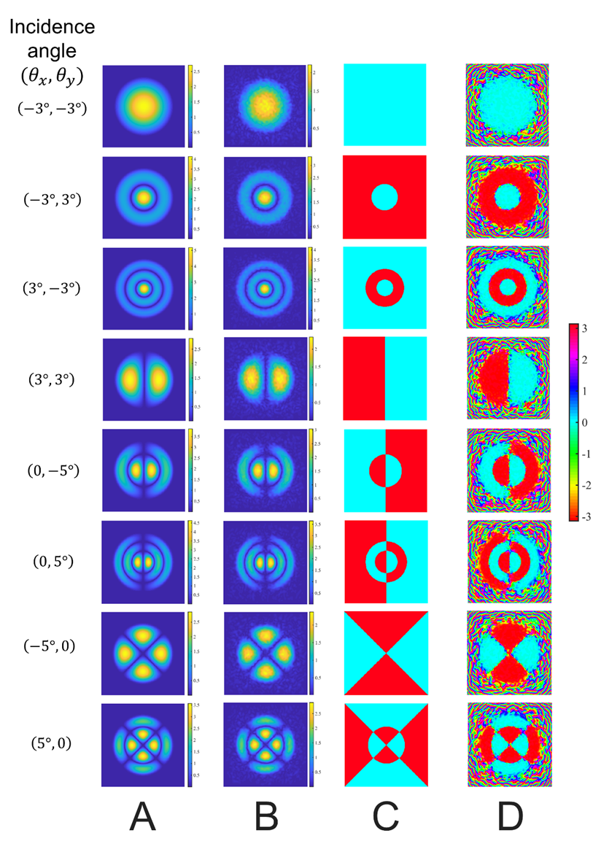**Figure S3:** Simulation results of GRIN volume element for multiplexing eight $LP$ modes. (A) The amplitude of the desired output fields. (B) The amplitude of the output fields reconstructed by the volume element. (C) The desired phase distributions of the output fields. (D) The phase distribution of the reconstructed field by the volume element. All the phase plots share the same Colorbar in radians on the right. All windows are 64μm by 64μm.

* 1. Classification of MNIST Digits

As stated in the main text, LT can learn how to correlate variants of classes. To demonstrate this, we conducted a classification task by using MNIST dataset. The GRIN volume element is trained by randomly selected 10000 images from the MNIST database. The obtained OVE is tested by randomly selected 2000 images that the OVE has not seen during the training. The optimization was intitiated with a uniform RI equal to 1.5. After training with the optical OVE using the LT algorithm as previously described we obtained 81.3% accuracy on the test set. The results are summarized in Figure S4. Figure S4A depicts how the classification works with GRIN OVE. A Fourier transform lens is virtually placed to map the output angles into spatial domain. Corresponding areas for each angle/digit are also provided. Figure S4B provides the obtained OVE and Figure S4C provides the confusion matrix.



**Figure S4:** Simulation results of GRIN volume element for classification task. (A) GRIN OVE classifies the digits by resulting output beams in different angles. FT Lens is the Fourier transform lens that maps the angles to corresponding points on the detector plane. (B) XY, YZ and XZ cut planes of the optimized volume by LT. Colorbar shows RI variation. (C) The confusion matrix after the test with 2000 examples.

1. Experimental Setup

The experiments performed by using an optical setup in which a spatial light modulator (SLM, Pluto-NIR2, Holoeye) is used to change the angle of incidence beam to the volume element. As the light source, Amplitude Laser - Satsuma generating pulses at 1030nm is used. First, the output of the SLM is imaged on the input plane of the 3-layer OVE to scan different angles. After the volume element, another 4f imaging system is used to relay the output field to detector plane. The sketch of experimental setup is given in Figure S5.



**Figure S5:** Sketch of the experimental setup for characterization of the manufactured volume element. M1 and M2 stand for Mirror 1 and Mirror 2. L1 and L2 stand for the lenses of the 4f imaging system for the input to the volume element and I1 stands for Iris 1 to block zero order reflection from the SLM. L3 and L4 stand for the lenses of the 4f imaging system for the output of the volume element and I2 stands for Iris 2 to block high frequency noise.

1. References

[1] Lim J, Ayoub AB, Antoine EE, Psaltis D. High-fidelity optical diffraction tomography of multiple scattering samples. Light Sci Appl 2019;8:82.

[2] Kamilov US, Papadopoulos IN, Shoreh MH et al. Learning approach to optical tomography. Optica 2015;2:517-22.

[3] Kamilov US, Papadopoulos IN, Shoreh MH et al. Optical Tomographic Image Reconstruction Based on Beam Propagation and Sparse Regularization. IEEE Trans Comput Imaging 2016;2-1:59-70.

[4] Wang H, Piestun R. Dynamic 2D implementation of 3D diffractive optics. Optica 2018;5:1220–8.