Supplementary Information:

Darkfield colors from multi-periodic arrays of gap plasmon resonators

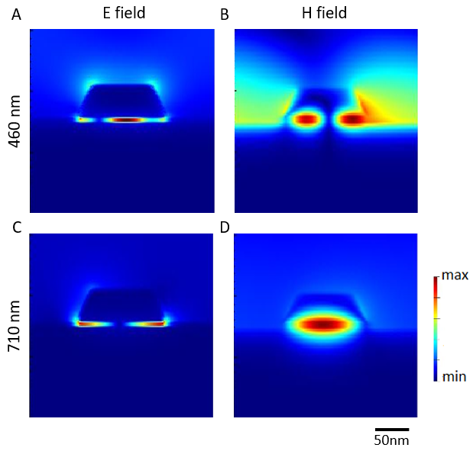
Fig. S1 (a) Electric field and (b) magnetic field for a square array of 120 nm wide Al disks with a period of 240 nm at a wavelength of 460 nm, corresponding to the second-order plasmon resonance mode. (c) Electric field and (d) magnetic field for the same array at a wavelength of 710 nm, corresponding to the first-order plasmon resonance mode.

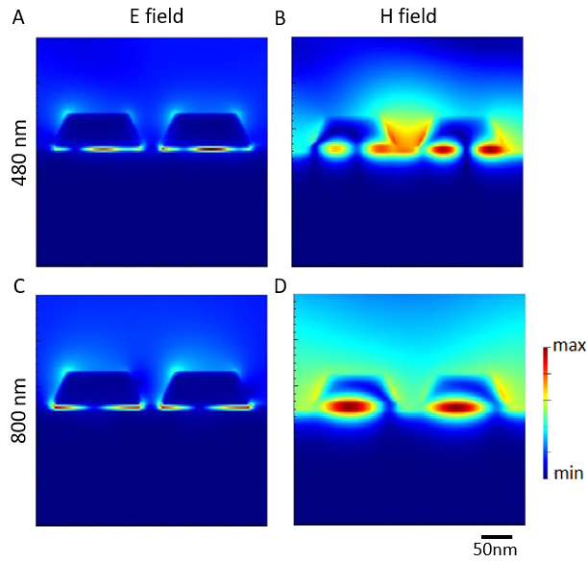
Fig. S2 (a) Electric field and (b) magnetic field for a square array of 120 nm wide Al disk clusters with an inter-disk gap g₁ of 20 nm and a period of 380 nm, at a wavelength of 480 nm, corresponding to the second-order plasmon resonance mode. (c) Electric field and (d) magnetic field for the same array at a wavelength of 800 nm, corresponding to the first-order plasmon resonance mode.

