Supporting information for:
“Strongly-coupled, high-quality plasmonic dimers fabricated using a sketch and peel technique”
Moritz Gittinger¹, Katja Höflich^{2,3}, Vladimir Smirnov¹, Heiko Kollmann¹, Christoph Lienau¹, and Martin Silies^{1,}*
¹Institute of Physics and Center of Interface Science, Carl von Ossietzky Universität Oldenburg,
D-26129 Oldenburg, Germany
² Helmholtz Zentrum für Materialien und Energie Berlin, Hahn-Meitner-Platz 1, D-14109 Berlin, Germany
³ Max Planck Institute for the Science of Light, D-91058 Erlangen, Germany

This document provides additional information about the experimental dark field spectroscopy set-up (Chapter S1), a proof of the functionality of the Sketch and Peel method (Chapter S2) and a discussion of the scattering intensity for dimer nanoantennas with varying gap sizes (Chapter S3).

S1 OPTICAL DARK-FIELD SPECTROCOPY SET-UP
Linear-polarized, ultra-broadband laser pulses from a coherent white light source (Fianium SC-450-4) with a spectrum ranging from 450 nm to 2 µm at a repetition rate of 4 MHz with few-picosecond pulse duration and an average pulse energy of 118 pJ at the sample position are collimated and focused to a diameter of approximately 1.1 mm x 120 µm (FWHM) onto the sample at an angle of approximately 75°.
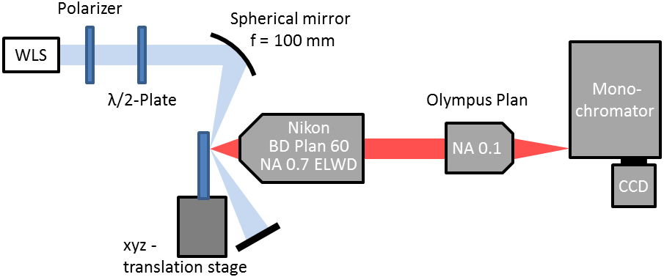
Fig S1: Scheme of the experimental dark-field spectroscopy set-up. A coherent white light source with variable polarization is used to excite isolated nanoantenna dimers. The scattering spectrum of the dimers is detected in reflection geometry and analyzed in a spectrometer.
The peak intensity is about 20 W/cm². The polarization of the light is controlled using an achromatic half-wave plate (B. Halle RAC 5.2.15 L) in combination with an ultrabroadband linear polarizer (Thorlabs GT10). Direct reflected light passes the collecting objective and is dumped into a beam block. The scattered light from the array of metallic nanostructures and hence the scattering spectrum of the localized SPR is collected in reflection geometry using an extra-long working distance glass objective with a numerical aperture of NA = 0.7 (Nikon, BD Plan 60x ELWD) and sent to a monochromator (Princeton Instruments Acton SP2500) attached to a LN₂-cooled CCD camera (Princeton Instruments, SPEC10 100BR). By imaging the array of particles onto the CCD of the spectrometer a selection of isolated pairs of nanoantennas is possible. The position of the sample in the laser focus can be adjusted in all three dimensions with a manual three-axis linear actuator.

S2 NOMINAL VS. MEASURED GAP SIZE
The gap sizes were measured by analyzing high-resolution Scanning Electron and Helium Ion Microscope images. The full width at half maximum of the cross-section along the long axis of the dimers were determined for each of the 606 nanorods. In Fig. S2 (a), the cross-section along a prototypical nanorod dimer shown is displayed. The inset shows the corresponding nanorod dimer that is also shown in Fig. 1(h) of the main document. The intensity values are normalized to the average value far away from the gap region, where charging effects, lead to an in increased signal level around the gap region, can be neglected. Now, in (b) the difference between the average measured gap size and the nominal gap size is displayed for each of the three fabrication processes (blue triangles: SaP, red squares: Gallium/Helium Lithography, green open squares: (Gallium Lithography)) as a function of the nominal gap size. Error bars indicate the standard deviation of each distribution. The difference between measured and nominal gap size is of the order of 1 nm, irrespective of gap size and fabrication method.
When cutting with the He⁺-ion beam, i.e., for SaP and Ga/He lithography, the standard deviation of the gap size distribution is about 1 nm, approximately a factor of two smaller than for those gaps written by pure Ga lithography. This demonstrates the improved precision reached He⁺-ion-based cutting.
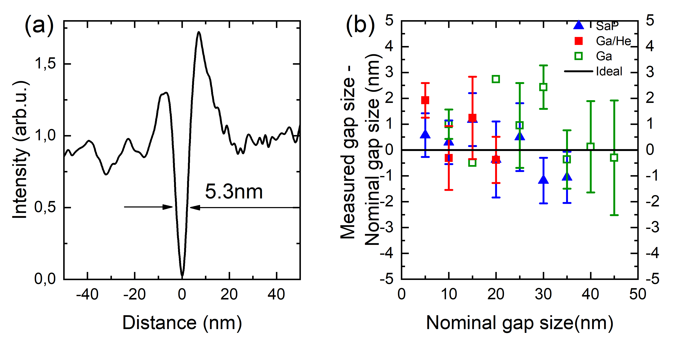
Fig S2: (a) Cross-section along the long axis of a prototypical nanorod dimer, shown in the inset, with a gap of 5.3nm. The cross section is marked by a white line. (b) Difference between measured and nominal gap size for all three fabrication processes as a function of the nominal gap size. Standard deviations of the gap size distributions are indicated by vertical bars and amount to ~ 1 nm for He⁺-ion cutting and to ~ 2 nm for pure Ga⁺ lithography.

S3 SUCCESSFUL SKETCH AND PEEL PROCESS

The nanoantennas are fabricated in arrays containing 5 x 6 nanoantennas with dimers separated by a distance of 3 µm. The gap size is kept constant within a single array. In Fig. S2 the outcome of the two steps of the Sketch and Peel process is shown.
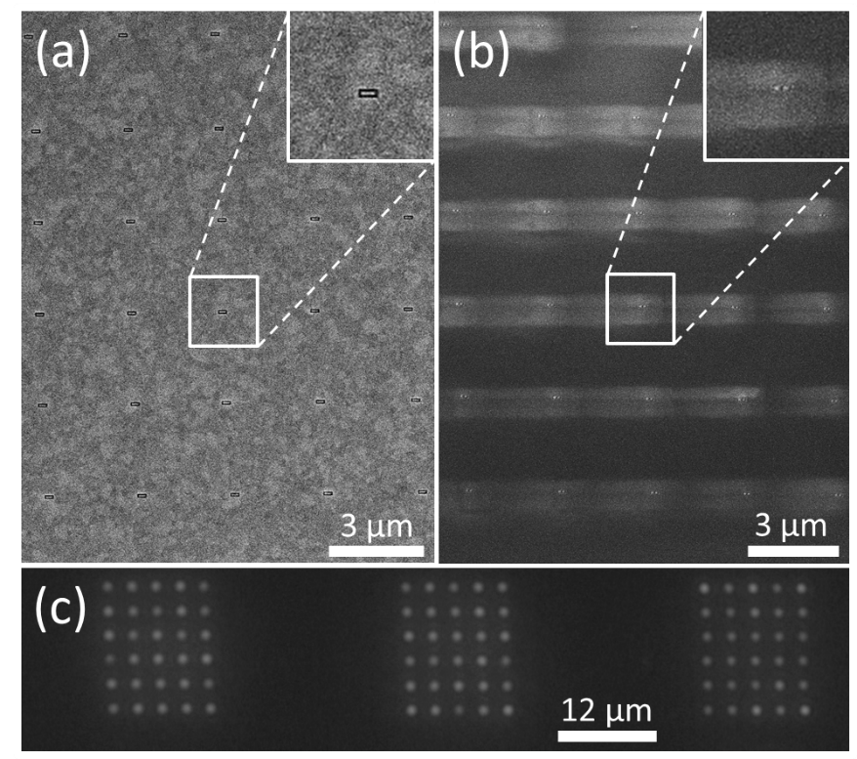
Fig S3: (a) Scanning electron micrograph of 30 nanoantennas, with outlines sketched by Ga-ion beam milling. The array is shown before the helium ion cutting and before the Sketch and Peel process. (b) Scanning electron micrograph of the same array after a He-ion beam cut of 25 nm and after the peel off process. Charging defects appear around the nanoantennas due the isolation and the nonconductive substrate. The inset in (a) and (b) shows a magnification of a single nanoantenna. The optical dark field image in (c) shows three arrays of dimers after the Sketch and Peel process. The middle arrays is the same as in (a) and (b).
In (a), a scanning electron micrograph of a prototypical array after the outline with the Ga-ion beam is shown. The inset shows a magnified view of a single nanonantennas. Afterwards the helium ion beam is used to cut the antennas in half and the Sketch and Peel process is applied to remove the outer gold film. In (b), a SEM image after the Sketch and Peel process is depicted. Due to the isolation of the nanoantennas and the use of a nonconductive substrate, charging defects appear around the nanoantennas preventing a more detailed image of the dimer structure. To confirm the successful SnP process, optical dark field images (c) were taken with a commercial optical microscope (Zeiss, Axio Observer.A1m). In Fig S2(c), an overview across three arrays of nanoantennas is given. The nanoantennas appear as point scatterers since the nanoantennas are smaller than the optical resolution of the dark field microscope. The scattering intensity is homogeneously distributed across the array of nanoantennas.
S4 SCATTERING CROSS SECTION
In Fig. S4, the experimentally measured, spectrally-integrated scattering intensity from single nanodimers $P=\int{I\left(λ\right)d}λ$ is given as a function of gap size for the dimers fabricated by Ga-ion lithography (red squares) and the Sketch and Peel-fabricated dimers (blue triangles). The experimental data are shown together with the spectrally-integrated and normalized scattering cross-sections from the simulation (black circles) on the second y-axis. As can be seen, all three graphs show a slight, more or less linear increase of scattering power with decreasing gap size. The slopes vary slightly with the strongest dependence on gap size for the Sketch and Peel-process and the weakest on for dimers fabricated by Ga-ion beam lithography
The linear increase in spectrally-integrated scattering intensity with decreasing gap size can be qualitatively explained by the increasing field localization between the gaps, which however comes at the cost of a decreasing mode volume, two opposing effects that seem to be nearly balanced.
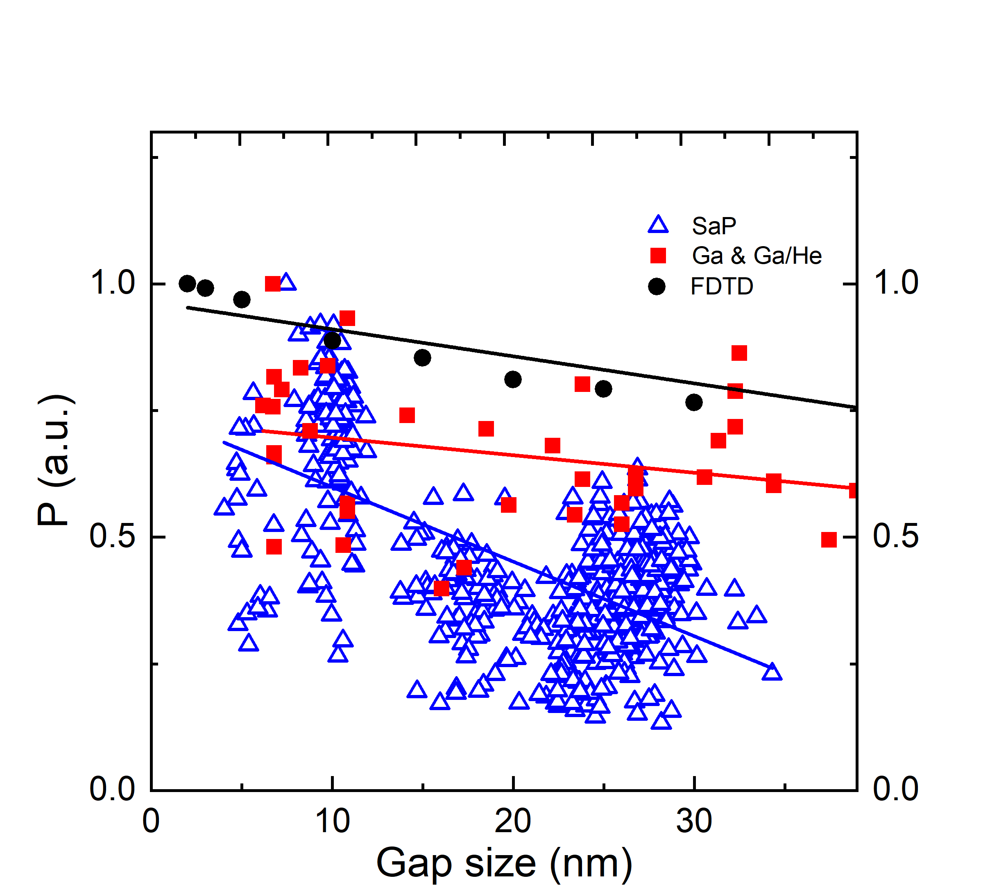
Fig S4: Spectrally-integrated, normalized scattering intensity (left y-axis, open triangles: SaP, red squares: Ga and Ga/He) of the nanorod dimers, measured experimentally as a function of gap size, together with the spectrally-integrated, normalized simulated scattering cross section, deduced from FTDT simulations (right y-axis). The solid lines represent linear fits to the data.

S5 NANOSIMS Measurements
An element-specific analysis of the milled area was performed for the Ga and Ga/He-fabricated dimer antennas by using a high-resolution secondary ion mass spectrometer (NanoSIMS). Here, a He+-ion beam is used to extract secondary ions from the target that are analyzed in a mass spectrometer. In Fig. S5, maps of the Ga⁺- (a) and Au⁺- (b) ion concentrations are presented for the region around the nanorod dimer antenna. A single dimer antenna is visible in the lower middle part of the maps. In (c) cross-cuts along the red (Ga) and blue (Au) arrows are presented. Here, 0 µm represents the origin and 1.8 µm the end of the arrows in (a) and (b). For positions between 0µm and 0.75µm, i.e., in regions inside the milled area, the signals from Ga (~15 counts) and Au (~30 counts) differ by a factor of two, while the oxygen signal (1300) is about two order of magnitude larger. Precise statements about the concentration of gallium and gold in the substrate are difficult due to the unknown extraction efficiency of all three materials by the He+-ion beam.
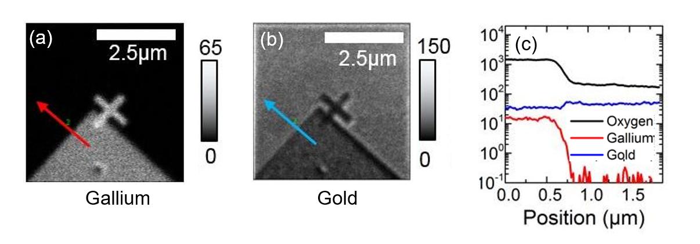
Fig S5: NanoSIMS images of the corner of an array (a+b). In (a) the signal coming from gallium, and in (b) the signal generated from gold is shown. Line-scans measuring the amount of oxygen (black line), gallium (red line) and gold (blue line) along the arrows (blue and red, arrows indicate scan direction) in the NanoSIMS images are shown in (c). The gallium concentration is the highest at positions where Ga-FIB milling was used, i.e. in between the rod antennas in (a).

