Supporting information for “Circular dichroism mode splitting and bounds to its enhancement with cavity-plasmon-polaritons”
Denis G. Baranov*, Battulga Munkhbat, Nils Odebo Länk, Ruggero Verre, Mikael Käll, and Timur Shegai
Department of Physics, Chalmers University of Technology, 412 96 Göteborg, Sweden
*email: denisb@chalmers.se

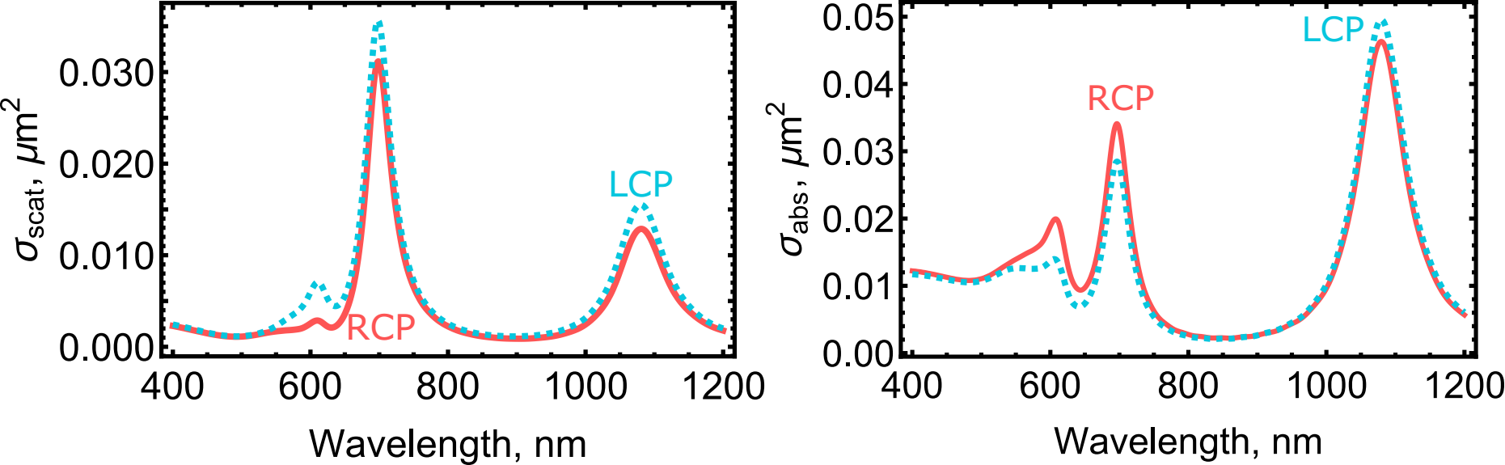
Fig. S1. Simulated scattering and absorption cross-section spectra of a single Au nanocrescent in air illuminated by a right- and left-circularly polarized plane wave from top.

Note S1.
Here, we discuss differences in spectral behavior of absorption and extinction cross-section of chiral scatterers. As Fig. S1 illustrates, the differential absorption cross-section of the Au nanocrescent flips its sign around 850 nm. At the same time, the differential scattering cross-section does not show sign flipping between the two lowest resonances, Fig. S1. This behavior can be understood if one considers a generic subwavelength chiral scatterer subjected to a monochromatic incident field $E,H$. Induced electric $p$ and magnetic $m$ dipole moments are related to the incident field via
$$\left(\begin{matrix}p \\ m\end{matrix}\right)=\left(\begin{matrix}{ε_{0}α}_{e} & -iχ/c \\ iε_{0}cχ & α_{m}\end{matrix}\right)\left(\begin{matrix}E \\ H\end{matrix}\right),$$
where $α_{e}$, $α_{m}$, and $χ$ are the electric, magnetic, and magneto-electric dipole polarizabilities [1]. Extinction power can be found as work done by the external field on the currents induced in the scatterer:
$W_{ext}=〈Re E∙Re \dot{p}+Re B∙Re \dot{m}〉=-\frac{ω}{2}Im(E∙p^{*}+B{∙m}^{*})$.
Differential extinction for two circular polarizations $E_{±}=E_{0}\left(1,∓i\right), H_{±}=∓i\sqrt{\frac{ε_{0}}{μ_{0}}}E_{±}$ therefore is $δW_{ext}=W_{ext,+}-W_{ext,-}∝Im χ$. Scattering power, on the other hand, is found as the work done by the induced currents on the radiated field. Recalling that induced electric and magnetic dipoles radiate into orthogonal spherical harmonics [2], we have
$W_{scat}=\frac{k^{4}}{12πε_{0}c}({\left|p\right|}^{2}+{\left|m/c\right|}^{2})$.
Again, for two circular polarizations we find ${ΔW}_{scat}=W_{scat,+}-W_{scat,-}∝Re [χ{\left(ε_{0}α_{e}+α_{m}\right)}^{*}]$. Therefore, as one can see, differential extinction and scattering depend on the dipole polarizabilities in very different ways, hence it is possible that the differential scattering does flip its sign, while differential absorption does not.

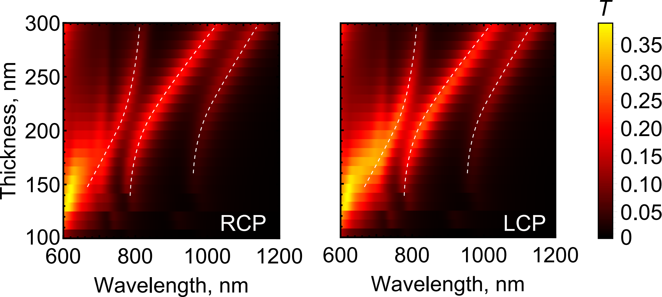
Fig. S2. Map of the simulated transmission spectra of the coupled plasmon-cavity system under illumination with two circular polarizations versus the cavity thickness at normal incidence for a square nanocrescent array with 300 nm period placed in the middle of the PMMA-filled cavity. The dashed lines are guides for the eye.

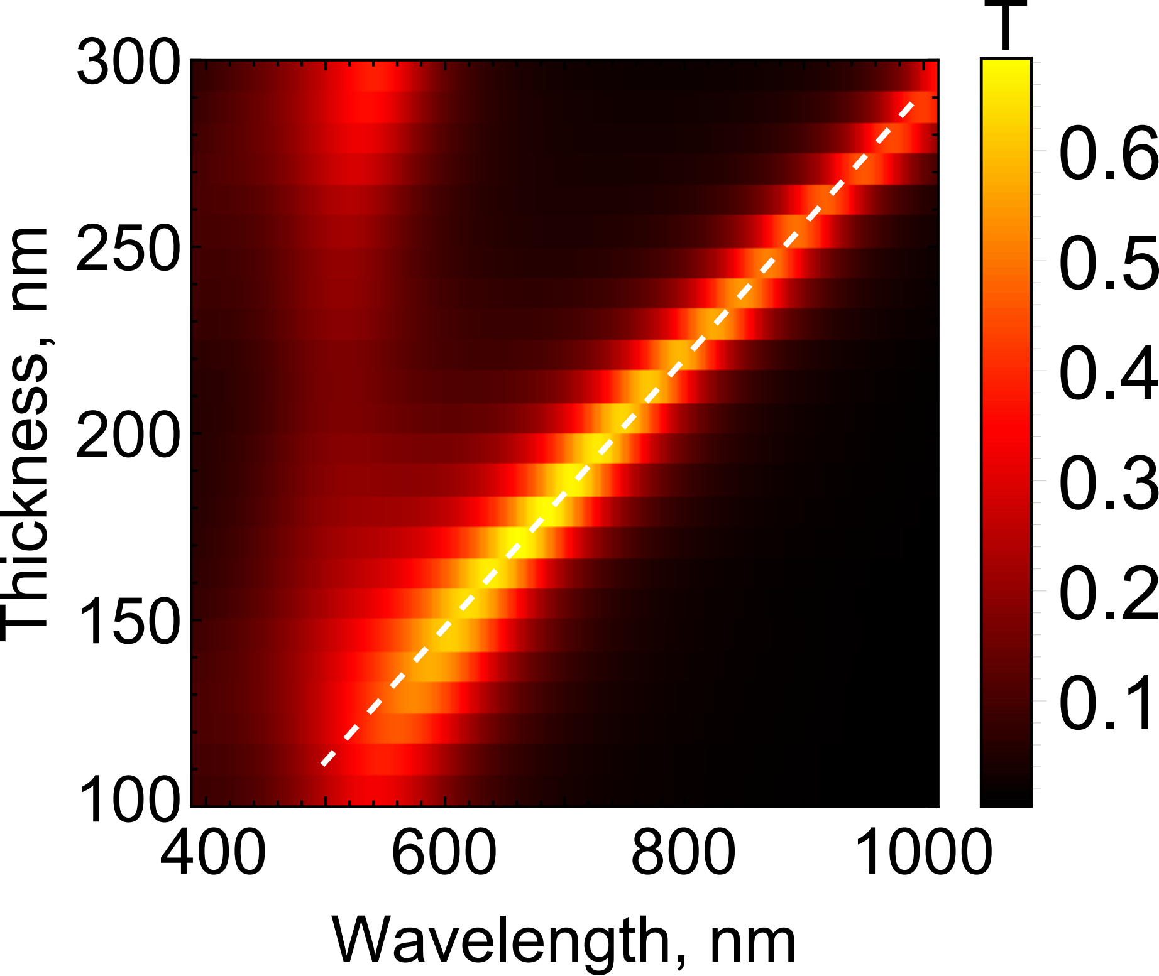
Fig. S3. Simulated normal incidence transmission spectra of the bare PMMA-filled cavity formed by two 20 nm thick Au mirrors versus its thickness. The dashed line indicates linear dispersion of the 1st order Fabry-Pérot cavity mode.

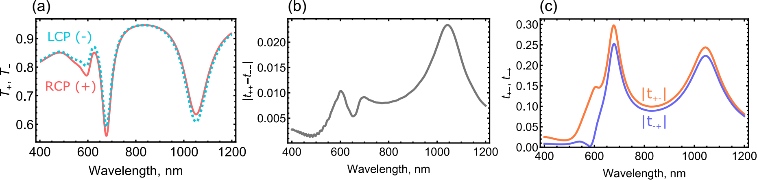
Fig. S4. Calculated Jones transmission matrix elements in the circular polarization basis for a square array of Au nanocrescents in air with 300 nm period illuminated at normal incidence. (a) Total transmission coefficients $T_{+}={\left|t_{++}\right|}^{2}+{\left|t_{-+}\right|}^{2}, T_{-}={\left|t_{--}\right|}^{2}+{\left|t_{+-}\right|}^{2}$ for two circular polarizations. (b) The difference of complex transmission coefficients ${|t}_{++}-t_{--}|$ revealing chiral response of the system. (c) Cross-polarization transmission coefficients $t_{+-}$ and $t_{-+}$ indicating the polarization conversion effect.

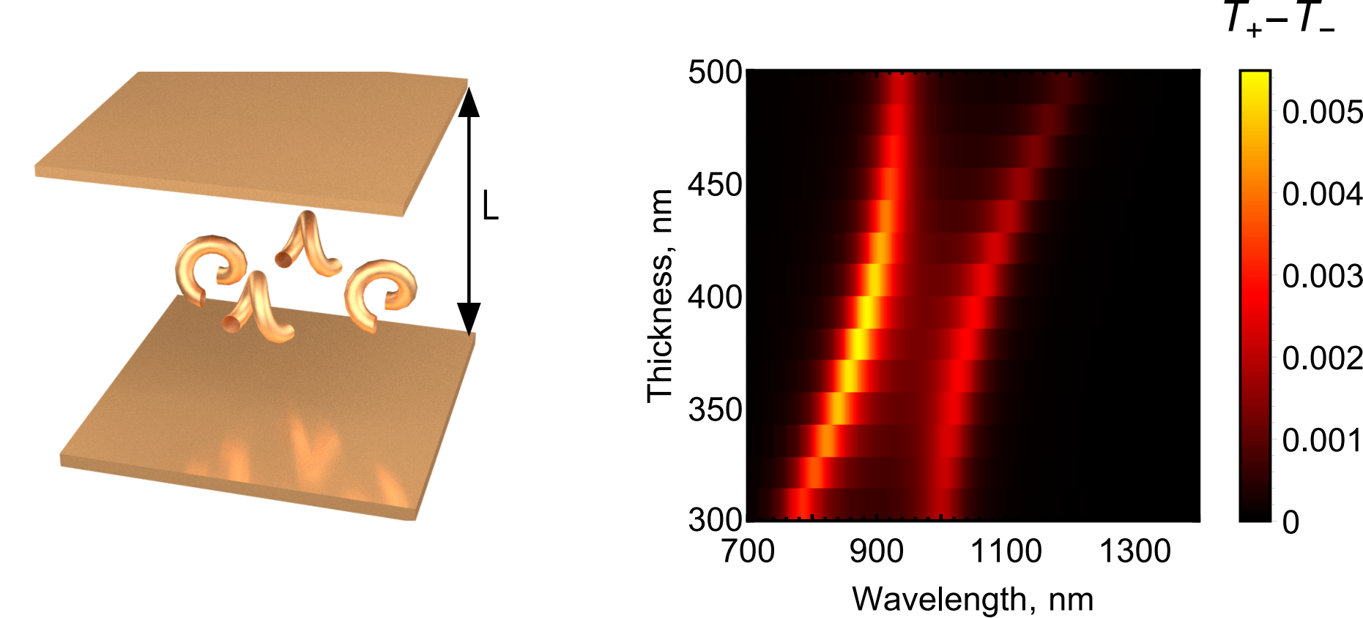
Fig. S5. Simulated differential transmission spectra through an array of chiral gold helices forming a $C_{4,z}$ symmetric unit cell as a function of the cavity thickness. The helices are 7 nm thick, 10 nm in radius, 20 nm period, and make 1 complete turn. The array period is 100 nm. The helices are placed inside the middle of an empty Fabry-Pérot cavity formed by two 15 nm thick Au mirrors.

Fig. S6. SEM images of fabricated chiral gold nanocrescents arrays revealing their homogeneous distribution over large area.

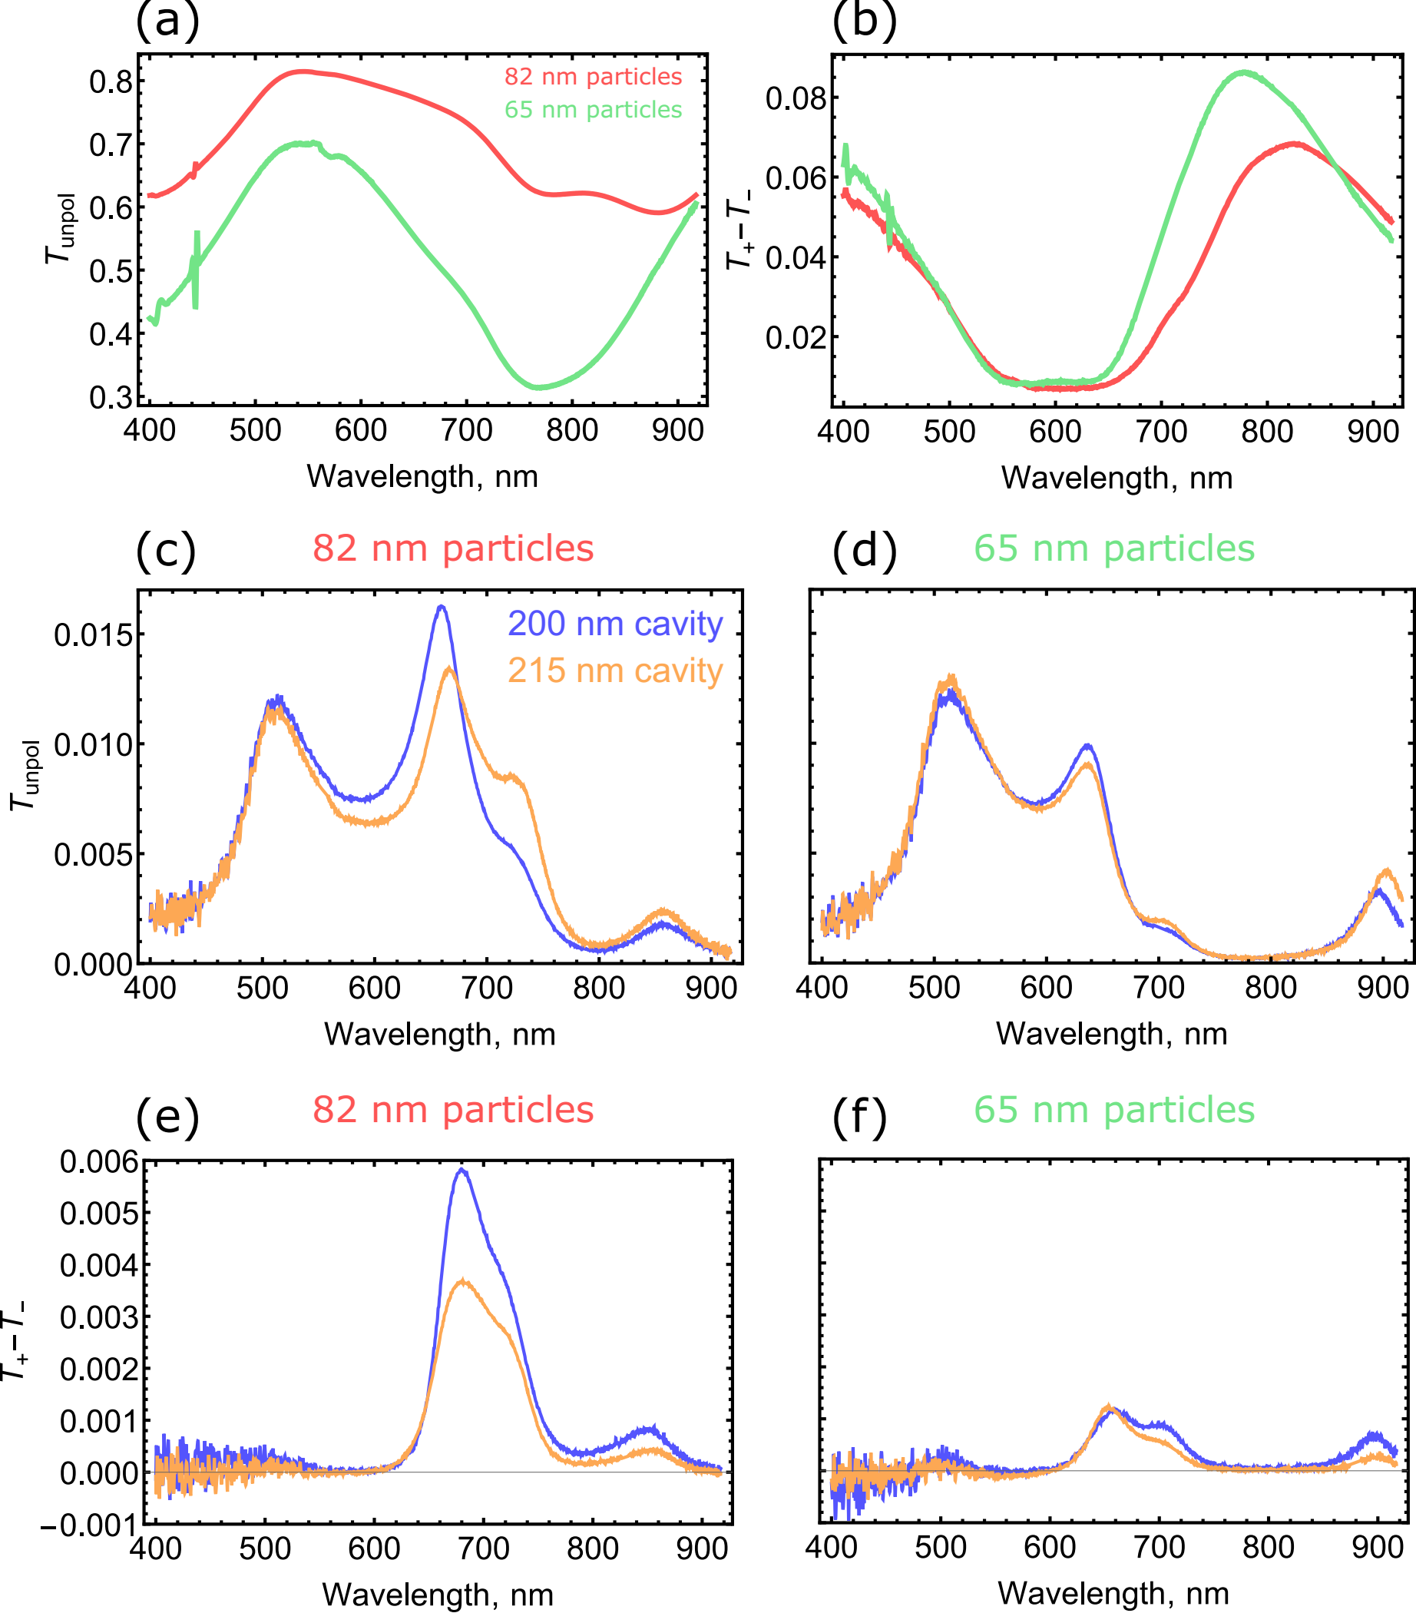
Fig. S7. Measurements of chiral bare and coupled systems. (a) Unpolarized transmission ($\frac{T_{+}+T_{-}}{2}$) spectra through the uncoupled chiral Au nanocrescents of 80 and 100 nm diameter on a glass substrate. Dips in transmission indicate resonances of the particles. (b) CD spectra for the same particles. (c,d) Unpolarized transmission ($\frac{T_{+}+T_{-}}{2}$) spectra chiral Au nanocrescents of 80 and 100 nm diameter positioned in the middle of Fabry-Pérot cavities of two different thickness. (e,f) The corresponding CD spectra for the same set of coupled structures.

[1] Y. Tang and A. E. Cohen, Phys. Rev. Lett. 104, 163901 (2010).
[2] L. Novotny and B. Hecht, Principles of Nano-Optics (Cambridge University Press, 2006).

