Supplementary Material
Focused Vortex-beam Generation Using Gap-surface Plasmon Metasurfaces
Fei Ding*, Yiting Chen, and Sergey I. Bozhevolnyi
SDU Nano Optics, University of Southern Denmark, Campusvej 55, DK-5230 Odense, Denmark
*E-mail: feid@mci.sdu.dk

Section S1. Full-wave simulations.
All numerical simulations were performed by using the commercial software Comsol Multiphysics (ver. 5.3) based on finite element method (FEM). For the design of unit meta-atoms (Figure 1), we modeled one cell by applying periodic boundary conditions on the vertical sides of the cell. The complex reflection coefficients were determined with respect to top surfaces of the meta-atoms with linearly polarized light being normally incident onto the metasurface. The medium above the metasurface was chosen to be air and truncated using the perfectly matched layer (PML) to minimize reflection. The permittivity of Au is described by the Drude model fitted with the experimental data [1], where the damping constant is increased by a factor of three to take into account the additional losses caused by the surface scattering and grain boundary effects in thin films. The silicon dioxide (SiO₂) spacer layer is taken as a lossless dielectric with the constant refractive index n = 1.45.

Section S2. Sample fabrication.
All the metasurfaces samples were fabricated using thin-film deposition and standard EBL techniques. First, a 3-nm-thick Ti, a 130-nm-thick Au, and a 3-nm-thick Ti were deposited onto a silicon substrate using electron-beam evaporation. Then a 110-nm-thick SiO₂ spacer layer was deposited via RF-sputtering. After that, the metasurface was defined using EBL employing a 200-nm-thick PMMA (4% in anisole, Micro Chem) layer at the acceleration voltage of 30 keV. After development in the solution of methyl isobutyl ketone (MIBK) and isopropyl alcohol (IPA) of MIBK: IPA=1:3, a 3-nm-thick Ti adhesion layer and a 77-nm-thick Au layer were deposited subsequently using electron-beam evaporation. The Au patterns were finally formed on top of the SiO₂ film after the lift-off process.
Section S3. Optical setup for metasurfaces characterization.
The performance of metasurfaces was studied using a custom-built optical system, as shown in Figure S1. The collimated optical beam from a tunable Ti: Sapphire laser passes through a half-wave plate and two linear polarizers to create a pure linearly-polarized light with controlled intensity. Then a long working distance objective (5X magnification, NA = 0.14) is used to slightly focus the linearly-polarized light onto the metasurface with a spot smaller than the metasurface. To capture the focused images at different x-y planes, a microscope imaging system including a long working distance objective (50X magnification, NA = 0.55), a tube lens, a linear polarizer, and a CCD camera is mounted together on a 3D translation stage (black dashed frame). During the measurement, the 3D stage is first moved to the image the surface of the metasurface. After that, the mounted microscope imaging system is moved along the axial direction (z-direction) to record the images at different x-y planes. Subsequently, the intensity distribution along the z-direction can be realized by stitching all the captured images.
Figure S1: Schematic of the experimental setup for characterizing the metasurfaces. HWP: half-wave plate, LP: linear polarizer, BS: beam splitter, Ob: objective, L: lens.

To prove the helicity wavefront of the focused vortex-beam, a homebuilt Michelson interferometer is used to perform the interference experiment, where the generated vortex-beam and the tilted Gaussian beam are arranged in the sample and reference arms, respectively (Figure S2). A beam splitter is used to generate a reference beam, which is finally added to interference with the generated vortex-beam by another beam splitter. To control the intensity of the reference beam, two linear polarizers are added in the reference arm.
Figure S2: Schematic of the experimental setup for characterizing the metasurfaces with vortex-beam generation. HWP: half-wave plate, LP: linear polarizer, BS: beam splitter, Ob: objective, L: lens, M: mirror.

Section S4. Measured intensity profiles of the metasurface samples with different topological charges at the design wavelength of λ_{d} = 850 nm.
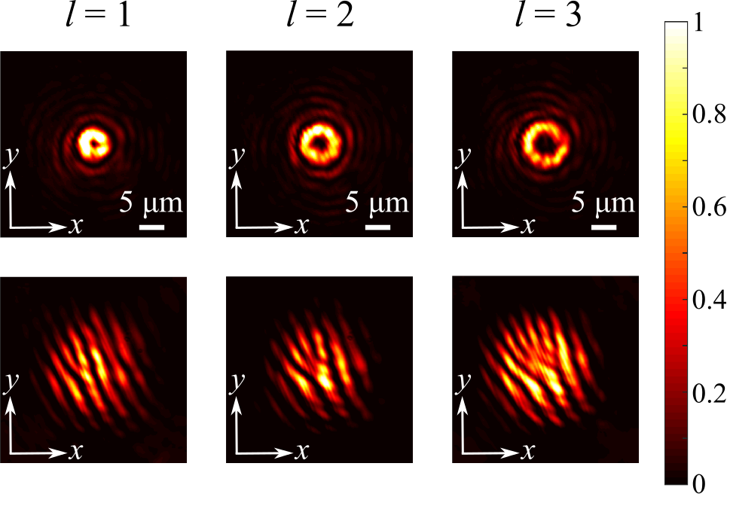
Figure S3: Measured intensity profiles at the focal planes of the metasurface samples with different topological charges at the design wavelength of λ_{d} = 850 nm. All the intensity profiles are measured in cross-polarization and the incident light is a normally incident x-polarized Gaussian beam.

Section S5. Measured intensity profiles of the metasurface sample with the topological charge of l = 2 at the wavelengths of λ = 775 nm and 950 nm.
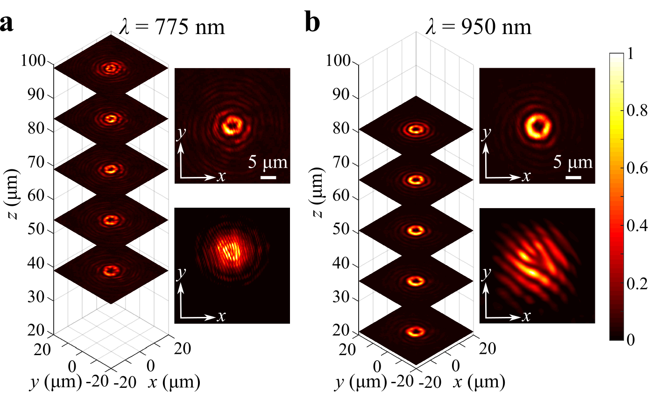
Figure S4: Measured intensity profiles of the metasurface sample with the topological charge of l = 2 at the wavelengths of λ = 775 nm and 950 nm. All the intensity profiles are measured in cross-polarization and the incident light is normally incident x-polarized Gaussian beam.

Section S6. Measured intensity profiles of the metasurface sample with the topological charge of l = 2 under y-polarized excitation at the design wavelength of λ_{d} = 850 nm.
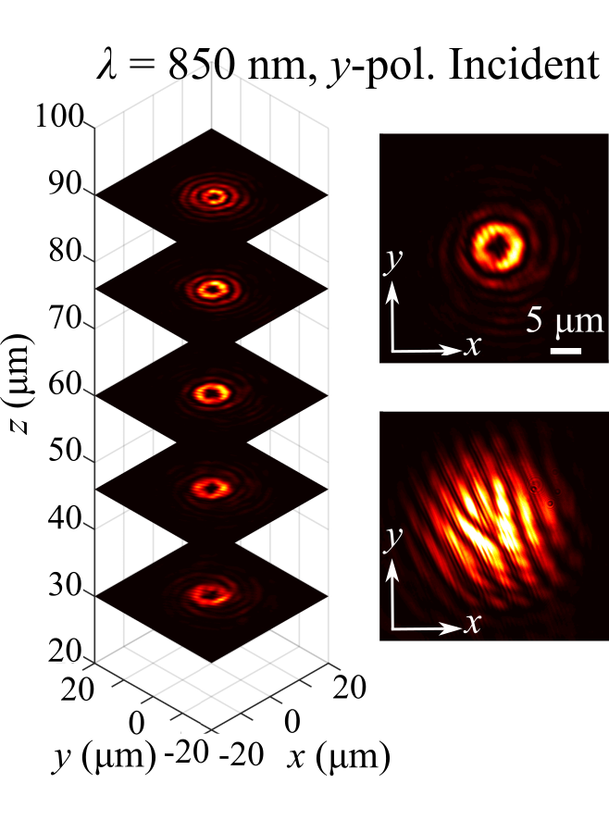
Figure S5: Measured intensity profiles of the metasurface sample with the topological charge of l = 2 under y-polarized excitation at the design wavelength of λ_{d} = 850 nm. All the intensity profiles are measured in cross-polarization and the incident light is normally incident x-polarized Gaussian beam.

References
- Johnson PB, Christy RW. Optical constants of the noble metals. Phys Rev B 1972;6:4370-4379.

