Supplementary material

Color Generation from Self-Organized Metalo-Dielectric Nanopillar Arrays
Ajith P. Ravishankar † *, Marvin A. J. van Tilburg † ‡, Felix Vennberg †, Dennis Visser † and Srinivasan Anand † ⁋

†Department of Applied Physics, KTH Royal Institute of Technology, Electrum 229, S-164 40 Kista, Sweden
‡Department of Applied Physics, Eindhoven University of Technology, 5600 MB Eindhoven, Netherlands.

*email: aprav@kth.se
⁋email: anand@kth.se

Sample sputtered time | Average height of the nanopillars measured using cross-sectional images (in nm) | Average radius (r) of the nanopillars measured using top-view images (in nm) | Average nearest neighbor distance between nanopillars (in nm) | Heights and radii of conical InP nanopillar model considered for FDTD simulations (in nm)
 |  |  |  | h_{t} | h_{b} | r_{b1} | r_{b2}
30 sec | 237±11 | 71±6 | 267±78 | 147 | 33 | 45 | 68
1 min | 336±5 | 80±7 | 278±84 | 227 | 49 | 28 | 53
2 min | 421±7 | 90±6 | 255±58 | 256 | 90 | 36 | 85
3 min | 557±20 | 104±6 | 302±76 | 325 | 137 | 51 | 106
4 min | 645±15 | 111±10 | 321±70 | 403 | 143 | 59 | 95

Table S1. Dimensions of the InP nanopillars formed using ion beam etching. The samples were sputter etched from 30 seconds to 4 minutes. The shape parameters (h_{t}, h_{b}, r_{b1} and r_{b2}) are described in the Figure 2B schematic.

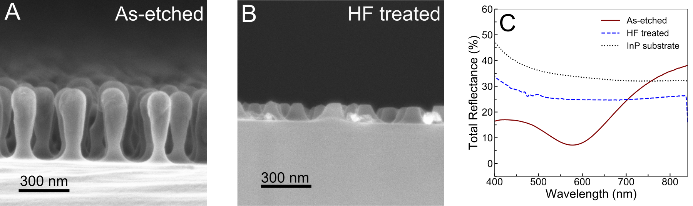

Figure S1. (A) Scanning electron microscope (SEM) cross-sectional image of InP nanopillars (average height ~ 420 nm) as formed by the ion beam sputter process. (B) InP nanopillars post-wet etch in hydrofluoric (HF) acid. (C) The observed total reflectance spectra for as-etched (brown, solid), HF-treated (blue, dashed) and bare InP (black, dotted) samples. Spectral features producing coloration is only seen for the as-etched structures.
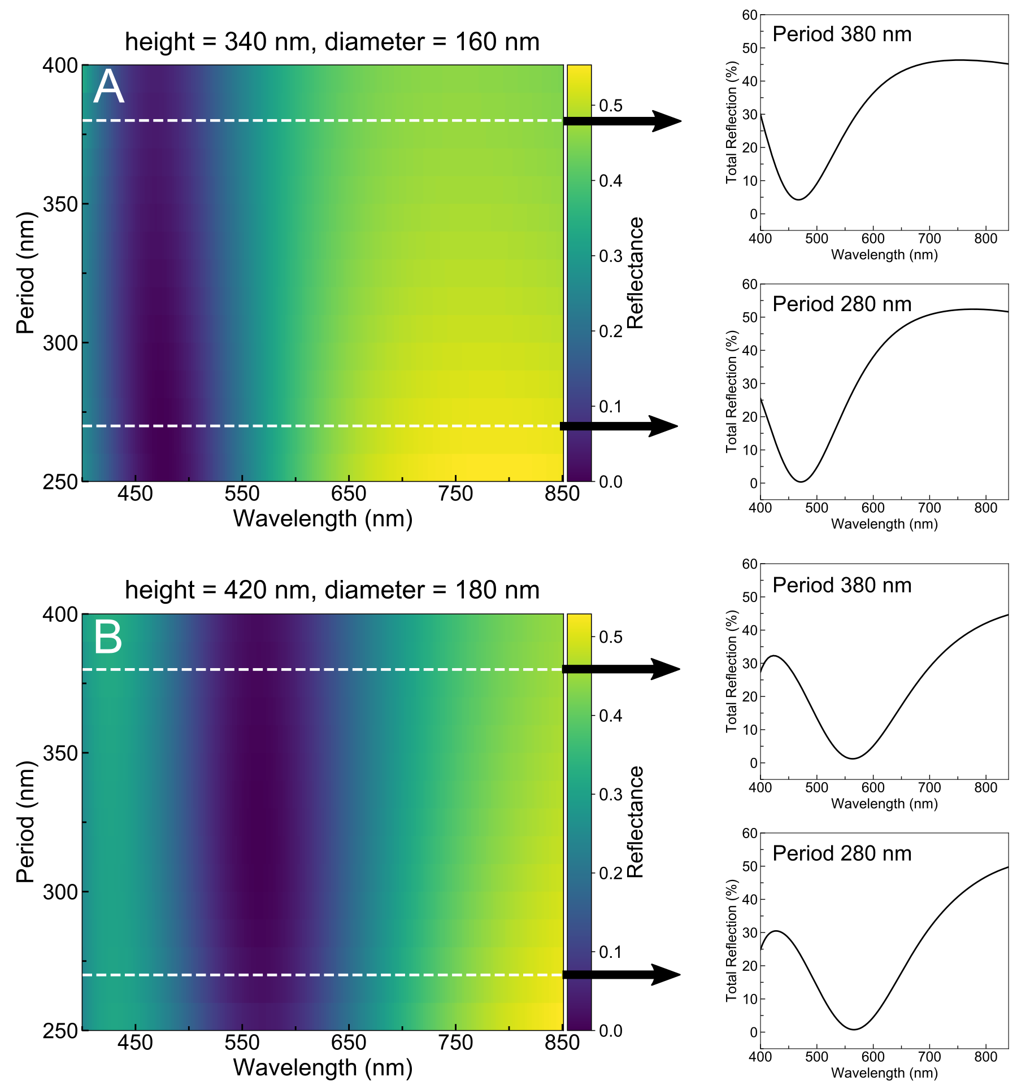

Figure S2. (A, B) Effect of the change in nanopillar array period on the total reflectance for nanopillars of different heights. Graphs on the right side are the total reflectance spectra at specified periods. Even though there are changes in the reflectance level with changing period, dip positions are not very sensitive to this change.

Figure S3. Comparison of the experimentally measured total reflectance and the simulated total reflectance on different types of pillars. The all-InP pillar mimics the shape of the pillars seen in SEM images, but contains InP cap. The cylindrical pillar simplifies the geometry but retains the In rich-cap. Neither of the structures can fully replicate the experimental values, implying that both shape and composition are important in producing the observed spectral features. Simulation of the In/InP structure is in good agreement with the experimental values.

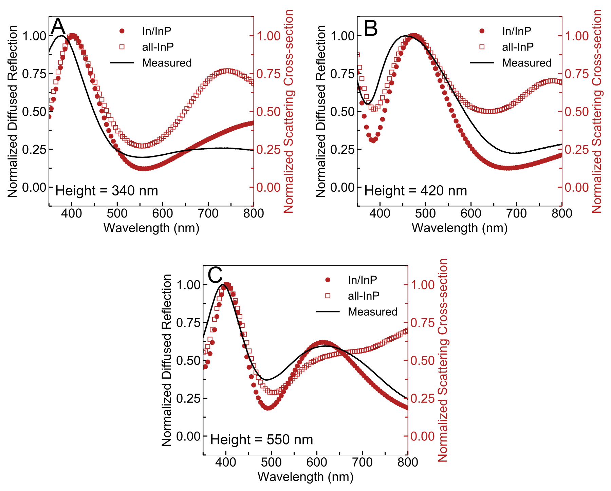

Figure S4. (A, B, C) Comparison between measured diffused reflectance and normalized scattering cross sections obtained from the TFSF simulations on a single InP nanopillar, for three different pillar heights. The scattering cross-section results from In/InP nanopillar model are consistently in better agreement with the experimental values compared to the all-InP nanopillar model.

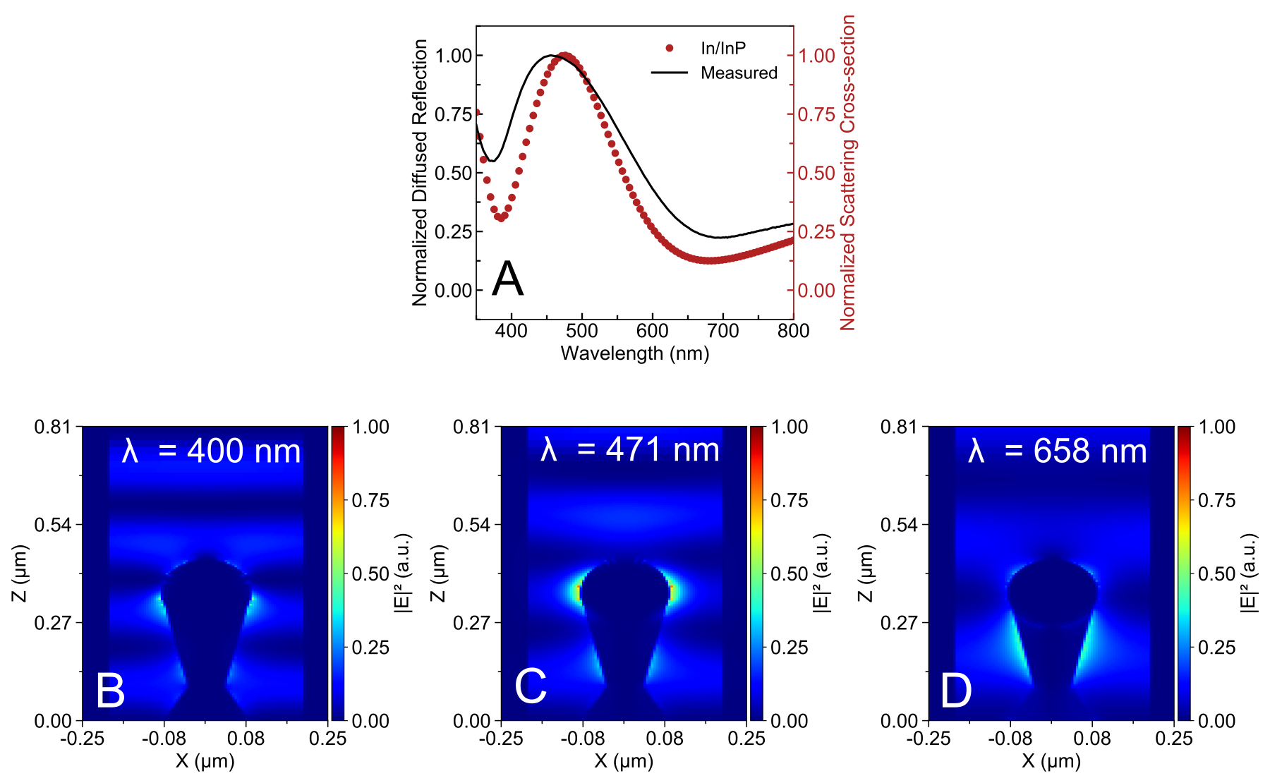

Figure S5. (A) The normalized diffused reflection (solid black line) and the normalized scattering cross-section (red circles) for pillar of height 420 nm. (B, C, D) Electric field intensity distribution for three wavelengths of interest. At 480 nm there is a resonant enhancement in electric field at the In cap which coincides with the scattering cross-section peak seen in the graph (A).

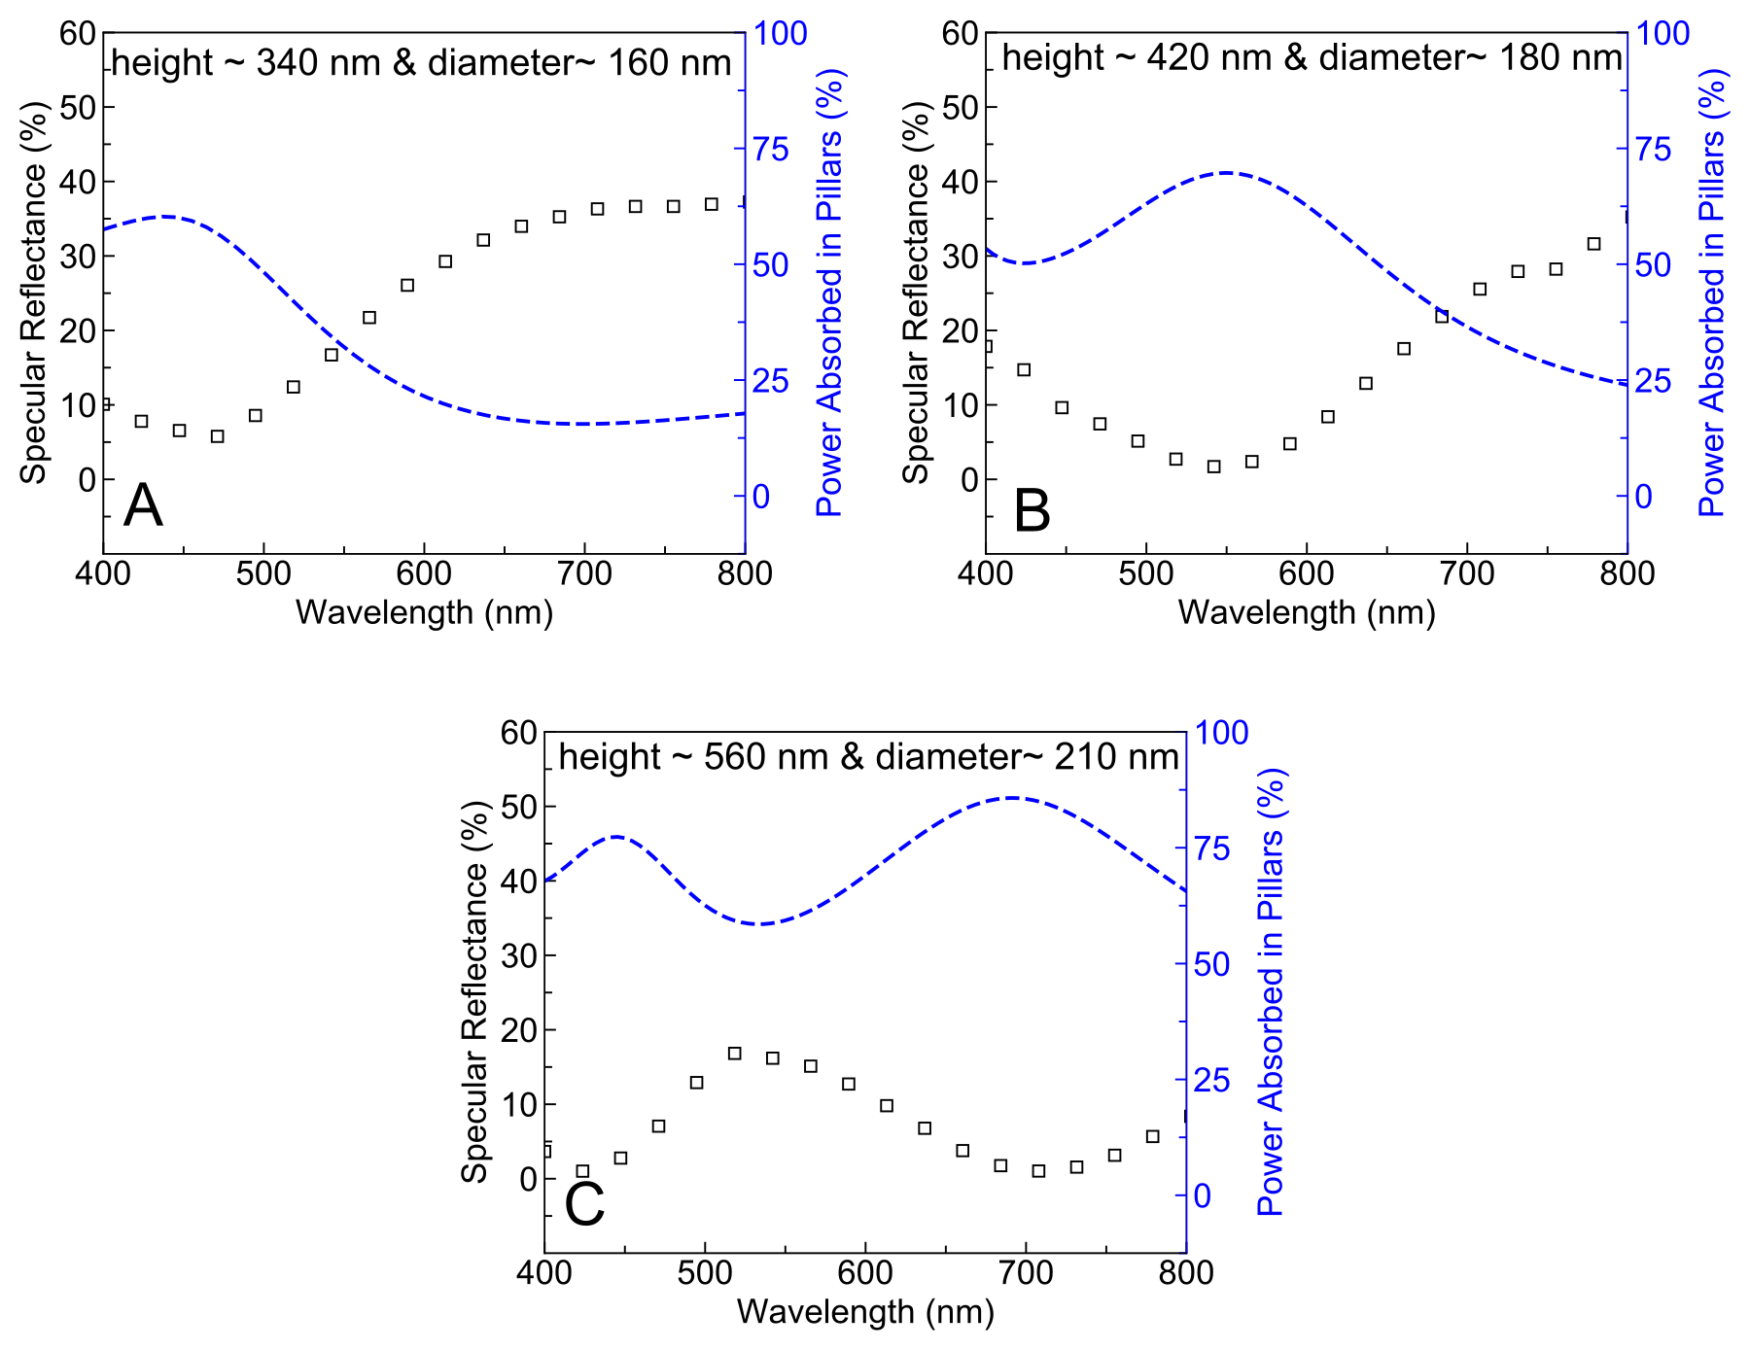

Figure S6. (A, B, C) Comparison between the specular reflectance (black boxes) obtained from FDTD simulations with supercell approximations and the calculated total spectral absorption (blue dashed) within the nanopillars of different heights. A clear relationship can be observed between the spectral dips in the specular reflectance and the absorption peaks.

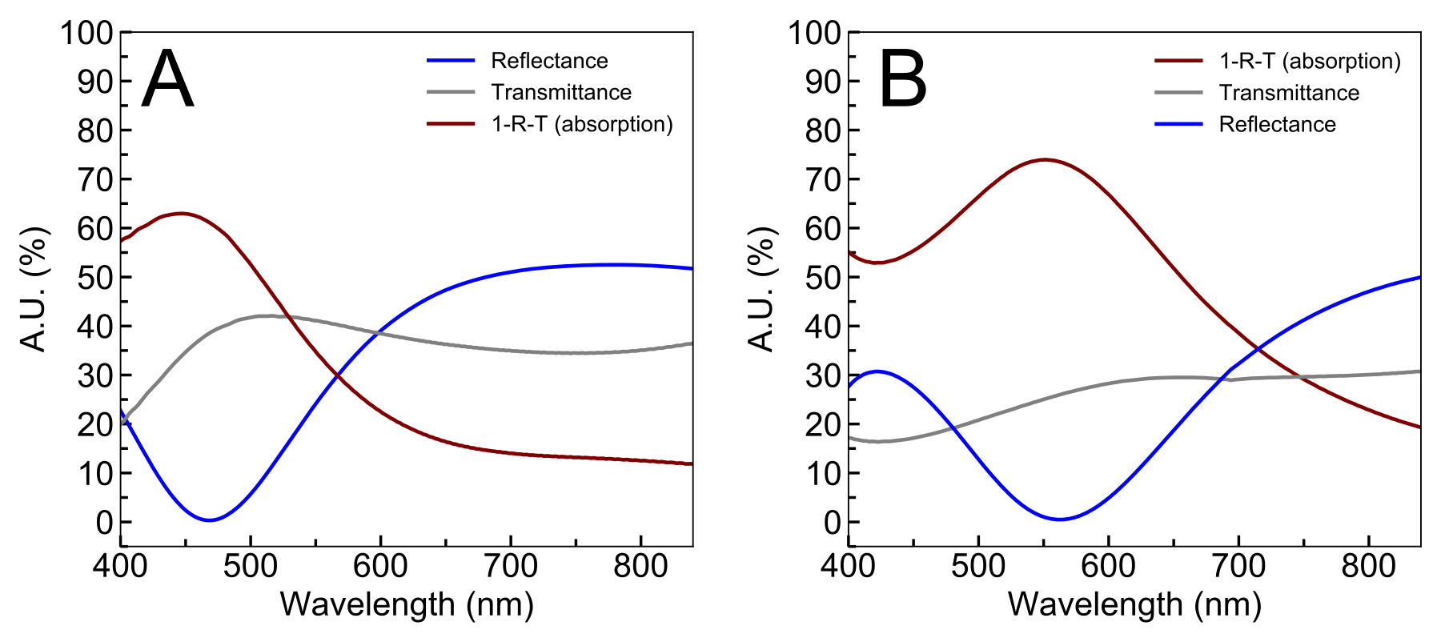

Figure S7. Simulated spectral reflectance (R), transmittance (T) and absorption (A = 1-R-T) profile for the In/InP nanopillar arrays with different heights (A) 340 nm (B) 420nm. The substrate has the same refractive index of bulk InP but the extinction coefficient is set to zero.
Chromaticity calculations

We have followed the standard procedure described in the reference 22 to estimate x and y chromaticities. The XYZ parameters for a spectrum in the visible regime (400-700 nm) are calculated using the following relation
$$X=\int_{λ=400 nm}^{λ=780 nm}{R_{λ}{\overline{x}}_{λ}S_{λ}dλ}$$
$$Y=\int_{λ=400 nm}^{λ=780 nm}{R_{λ}{\overline{y}}_{λ}S_{λ}dλ}$$
$$Z=\int_{λ=400 nm}^{λ=780 nm}{R_{λ}{\overline{z}}_{λ}S_{λ}dλ}$$

Where $R_{λ}$ is the measured spectra, ${\overline{x}}_{λ}$ is the CIE standard observer color matching function (CIE 1931 2°) and $S_{λ}$ is the illuminant (D65). x and y points for the CIE chromaticity plot are obtained by normalizing the X and Y values as X/(X+Y+Z) and Y/(X+Y+Z) respectively.

