Supplementary Material: Plasmonic near-field scanning nanoscope with cross-polarization detection technique
Hyeon Bo Shim and Jae W. Hahn*

Nano Photonics Laboratory, School of Mechanical Engineering, Yonsei University 50 Yonsei-ro, Seodaemun-gu, Seoul 03722, Republic of Korea
E-mail: Jaewhahn@yonsei.ac.kr

Calculation of electronic component
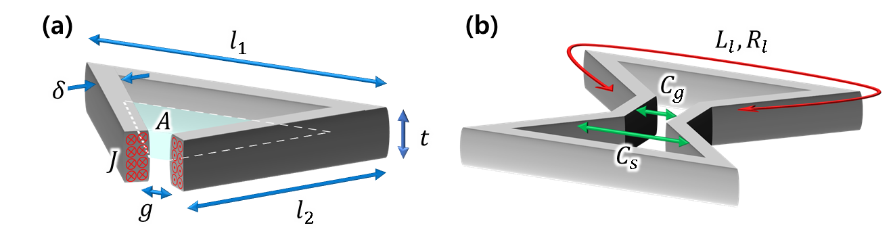
Figure S1: Dimensions of simplified wire loop for calculation (a) schematic of electrical components of wire loop (b)
Because the oscillating current induced by the incident electromagnetic field is restricted to skin depth according to its oscillation frequency, we can simplify the aperture into a wire loop that has fixed cross-sectional area. We define the dimensions as shown in Fig. S. 1(a) of this simplified wire loop: lengths of the wire $l_{1}, l_{2}$ indicate long and short segment that are equal to length of aperture outline, $g$ is gap distance, $t$ is metal layer thickness, $δ\sim λ/{2πκ}$ is skin depth for wavelength $λ$ and absorption coefficient $κ$, $A$ is area that enclosed by the single loop, and $J$ is current density. Using these dimensions, we iteratively calculate the values of the equivalent electrical components shown in Fig. S. 1(b).
At first, the loop resistance, $R_{l}={\left(l_{1}+2l_{2}\right)ρ}/{δt}$ is calculated from the definition of bulk resistance for the resistivity $ρ$.
Secondly, the loop inductance, $L_{l}=L_{1}+2L_{2}+L_{k}$ which is the summation of self-inductances, $L_{1}, L_{2}$ due to magnetic field induced in area $A$ by the wire loop segments $l_{1}, l_{2}$ and kinetic-inductance, $L_{k}=\left({m_{e}}/{n_{e}e^{2}}\right){\left(l_{1}+2l_{2}\right)}/{δt}$ [28,29] due to inertial mass of electron, where $m_{e}, n_{e}, e$ are mass, number density, and charge of electron, respectively. Specifically, we calculate $L_{1}, L_{2}$ directly using Biot-Savart low, which are ratios between each induced magnetic flux, $Φ_{1}, Φ_{2}$ that pass through the area $A$ and current on the loop $I_{loop}$ as shown in Eq. S1.
$$L_{i}=\frac{Φ_{i}}{I_{loop}}=\frac{1}{Jδt}\iint_{A}^{ }{B_{i}}dA=\frac{1}{Jδt}\iint_{A}^{ }{dA}\frac{μ_{0}}{4π}\iiint_{V}^{ }{\frac{\vec{J}dV×\vec{r}}{r^{3}}}, i=1,2 (S1)$$
Here, $B_{1},B_{2}$ are induced magnetic fields, $μ_{0}$ is magnetic permeability of surroundings, $V$ is volume of wire and $\vec{r}$ is position vector.
Induced magnetic fields are calculated by the following equations. The boundary for wire length is $-L$ to $L$, for wire width is $0$ to $δ$, for metal thickness is $0$ to $t$ due to the x-y plane symmetry. Also, we need only normal component of magnetic field for x-y plane as other components are canceled out due to the symmetric structure of the aperture. Therefore, we can define the magnitude of z-component of the induced magnetic field at a point of $(x^{'}, y^{'}, 0)$ by a current density $J$ flows in the wire as shown in Eq. S1-2.
$$B=2J\int_{0}^{t}{\int_{-L}^{L}{\int_{0}^{δ}{\frac{y^{'}+d}{{\left({\left(x^{'}-x\right)}^{2}+{\left(y^{'}+d\right)}^{2}+z^{2}\right)}^{3/2}}dd}dx}dz}=2J\int_{0}^{t}{{\left[\ln\left(\frac{\sqrt{{\left(x^{'}-x\right)}^{2}+{y^{'}}^{2}+z^{2}}+\left(x^{'}-x\right)}{\sqrt{{\left(x^{'}-x\right)}^{2}+{\left(y^{'}+δ\right)}^{2}+z^{2}}+\left(x^{'}-x\right)}\right)\right]}_{-L}^{L}dz} (S1-2)$$
In the case of oblique side of wire loop, the boundary for wire length becomes $0$ to $L$. Consequently, by integrating the entire equation for individual components of the log term, we derived the magnetic component induced by current flow in simplified wire loop as follows.
$$B_{1}\left(x^{'}, y^{'},0\right)=2J\left\{\begin{aligned}\left(y^{'}+δ\right)\left[\begin{aligned}\tan^{-1}\left(\frac{\left(x^{'}+L\right)t}{\left(y^{'}+δ\right)\sqrt{{\left(x^{'}+L\right)}^{2}+{\left(y^{'}+δ\right)}^{2}+t^{2}}}\right) \\ -\tan^{-1}\left(\frac{\left(x^{'}-L\right)t}{\left(y^{'}+δ\right)\sqrt{{\left(x^{'}-L\right)}^{2}+{\left(y^{'}+δ\right)}^{2}+t^{2}}}\right)\end{aligned}\right] \\ -y^{'}\left[\begin{aligned}\tan^{-1}\left(\frac{\left(x^{'}+L\right)t}{y^{'}\sqrt{{\left(x^{'}+L\right)}^{2}+{y^{'}}^{2}+t^{2}}}\right) \\ -\tan^{-1}\left(\frac{\left(x^{'}-L\right)t}{y^{'}\sqrt{{\left(x^{'}-L\right)}^{2}+{y^{'}}^{2}+t^{2}}}\right)\end{aligned}\right] \\ +t\ln\left(\frac{\frac{\sqrt{{\left(x^{'}+L\right)}^{2}+{y^{'}}^{2}+t^{2}}+\left(x^{'}+L\right)}{\sqrt{{\left(x^{'}+L\right)}^{2}+{\left(y^{'}+δ\right)}^{2}+t^{2}}+\left(x^{'}+L\right)}}{\frac{\sqrt{{\left(x^{'}-L\right)}^{2}+{y^{'}}^{2}+t^{2}}+\left(x^{'}-L\right)}{\sqrt{{\left(x^{'}-L\right)}^{2}+{\left(y^{'}+δ\right)}^{2}+t^{2}}+\left(x^{'}-L\right)}}\right) \\ +\left(x^{'}+L\right)\ln\left(\frac{\frac{\sqrt{{\left(x^{'}+L\right)}^{2}+{y^{'}}^{2}+t^{2}}+t}{\sqrt{{\left(x^{'}+L\right)}^{2}+{y^{'}}^{2}}}}{\frac{\sqrt{{\left(x^{'}+L\right)}^{2}+{\left(y^{'}+δ\right)}^{2}+t^{2}}+t}{\sqrt{{\left(x^{'}+L\right)}^{2}+{\left(y^{'}+δ\right)}^{2}}}}\right) \\ -\left(x^{'}-L\right)\ln\left(\frac{\frac{\sqrt{{\left(x^{'}-L\right)}^{2}+{y^{'}}^{2}+t^{2}}+t}{\sqrt{{\left(x^{'}-L\right)}^{2}+{y^{'}}^{2}}}}{\frac{\sqrt{{\left(x^{'}-L\right)}^{2}+{\left(y^{'}+δ\right)}^{2}+t^{2}}+t}{\sqrt{{\left(x^{'}-L\right)}^{2}+{\left(y^{'}+δ\right)}^{2}}}}\right)\end{aligned}\right\} (S1-3)$$
In the case of $B_{2}$, which is the magnetic field induced by oblique side of wire loop, we can replace the term of $+L$ into zero.
At last, the capacitance of gap for square gap area, $C_{g}=ε_{0}\left(t+δ+2g\right)$ is calculated with consideration of the edge effect [30]; the capacitance of side wall is $C_{s}=ε_{0}t\ln\left({2l_{1}}/g\right)$ for electric permittivity of surrounding, $ε_{0}$. Because these electrical components have symmetry and are connected in parallel, we calculate the values of electronic components of total loop, $R_{tot}={R_{l}}/2, L_{tot}={L_{l}}/2, C_{tot}=C_{g}+2C_{s}$, respectively.

Calculation of weight factor, $η$
According to the lambda zone theory, we can assume that most of light is illuminated within the interactive area because the beam waist of our system (525 nm in diameter with objective NA of 0.8) is smaller than the wavelength [31]. However, because the interactive portion of the incident beam is a component of the electric field, which is parallel to the aperture ridge, we compensate the effects of the incident angle into metal surface due to high NA objective lens. We integrate the portion of incident Gaussian beam that has parallel polarization vector to the aperture ridge. The polarization vector that refracted by the lens at a point of $(r,ϕ)$ is defined as Eq. S2-1 by applying rotation matrix where $\cos{θ}$ is defined as $\sqrt{{f^{2}}/{\left(r^{2}+f^{2}\right)}}$ by the refraction position with the focal length of the lens $f$.
$$\vec{p}=\left[\begin{aligned}{\vec{p}}_{x} \\ {\vec{p}}_{y} \\ {\vec{p}}_{z}\end{aligned}\right]=\left[\begin{aligned}\cos{θ}\cos^{2}{ϕ}+\sin^{2}{ϕ} \\ \cos{θ}\cos{ϕ}\sin{ϕ}-\cos{ϕ}\sin{ϕ} \\ -\sin{θ}\cos{ϕ}\end{aligned}\right] (S2-1)$$
We finally calculated the weight factor $η$ by integration of Gaussian beam with x-polarized component for Gaussian beam width of $w=2f\tan\left(\sin^{-1}{NA}\right)$ as
$$η=\frac{1}{2πw^{2}}\int_{0}^{2π}{\int_{0}^{∞}{e^{-\frac{r^{2}}{2w^{2}}}\left(\sqrt{\frac{f^{2}}{r^{2}+f^{2}}}\cos^{2}{ϕ}+\sin^{2}{ϕ}\right)rdr}dϕ} (S2-2)$$
Verification of calculated values of each component
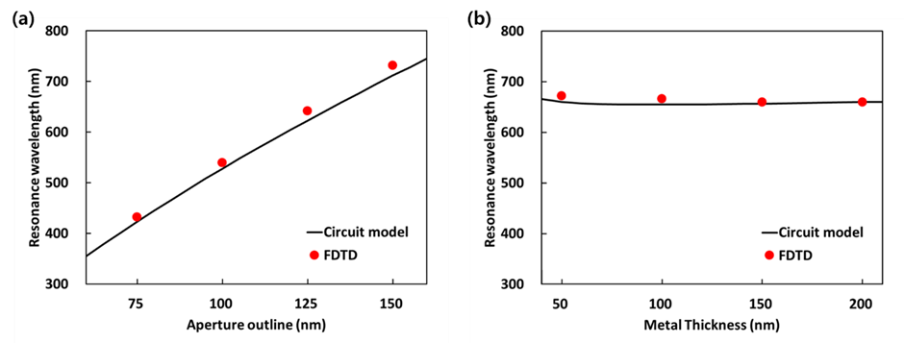
Figure S2: Resonance wavelength of bowtie nano-aperture on Al thin film for different aperture outline with film thickness of 100 nm (a), and different metal thickness with aperture outline of 135 nm. In both graph, black solid lines are calculated results with circuit model and red dots are simulation results. For every calculation, gap distance is fixed at 20 nm.
According to the values calculated above, we can discuss the resonance characteristics of the entire aperture system for different geometric parameters with the resonance wavelength, $λ_{r}={2π\sqrt{L_{tot}C_{tot}}}/{\sqrt{ε_{0}μ_{0}}}$. We choose a thin aluminum film for the metal layer with a fixed aperture gap distance of 20 nm. The calculated results of resonance wavelength with the circuit model (black solid lines) and FDTD (Lumerical) simulation results (red dots) are compared in Fig. S. 2 to verify our model. In the case of a uniform film thickness of 100 nm, as shown in Fig. S2(a) the resonance wavelength increases linearly as the aperture outline widens, which indicates the length of one side of aperture, because of the dominant effect of the larger inductance along with the larger area enclosed by the aperture. On the other hand, Fig. S2(b) shows a nearly constant trend although the change of metal thickness for equal aperture outline of 135 nm. Because the kinetic-inductance is inversely proportional to the cross-sectional area, and the self-inductance is decreased by the reduction in dominant current density on the neutral plane in the center of the metal, the increased capacitance with thicker metal is offset by the decrease in total inductance. Both the results are well fitted with FDTD simulation results being within 97% accuracy, on an average.

References
- Meservey R, Tedrow, PM. Measurements of the kinetic inductance of superconducting linear structures. J Appl Phys 1969;40:2028–34
- Shimazu Y, Yokoyama T. Measurement of kinetic inductance of superconducting wires and application for measuring flux state of josephson-junction loops. Physica C Supercond 2004;412–4:1451–4.
- Sydoruk O, Tatartschuk E, Shamonina E, Solymar L. Analytical formulation for the resonant frequency of split rings. J Appl Phys 2009;105:014903-1–014903-4.
- Kang J-H. Kim D-S, Park Q-H. Local Capacitor Model for Plasmonic Electric Field Enhancement. Phys Rev Lett 2009;102:093906-1–093906-4.

