Supportting information

S1 Characterization of vertical nanosheets in GNWs
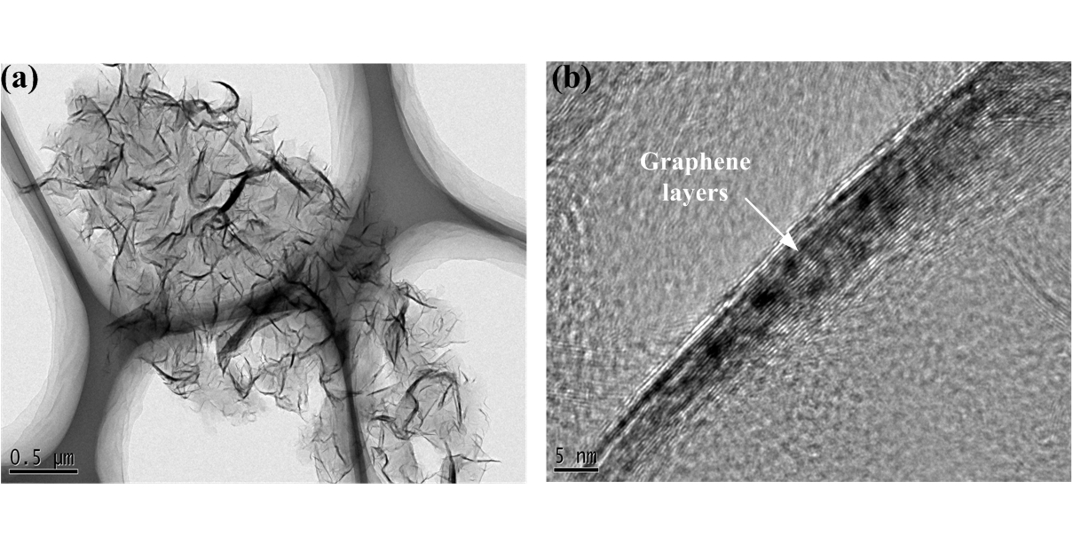
Figure S1 (a) and (b) Low and high magnification of TEM images of GNWs nanosheets, respectively.
The vertical nanosheets structure of GNWs is characterized by TEM. Wall-like edge crossed structure is observed by TEM and the composition of a single nanosheet is further characterized using a high-resolution TEM. As can be seen fromFig. (b) that a nanosheet is composed of several graphene layers with interval spacing of ~ 0.34 nm.

S2 Limitation of absorbance of GNWs

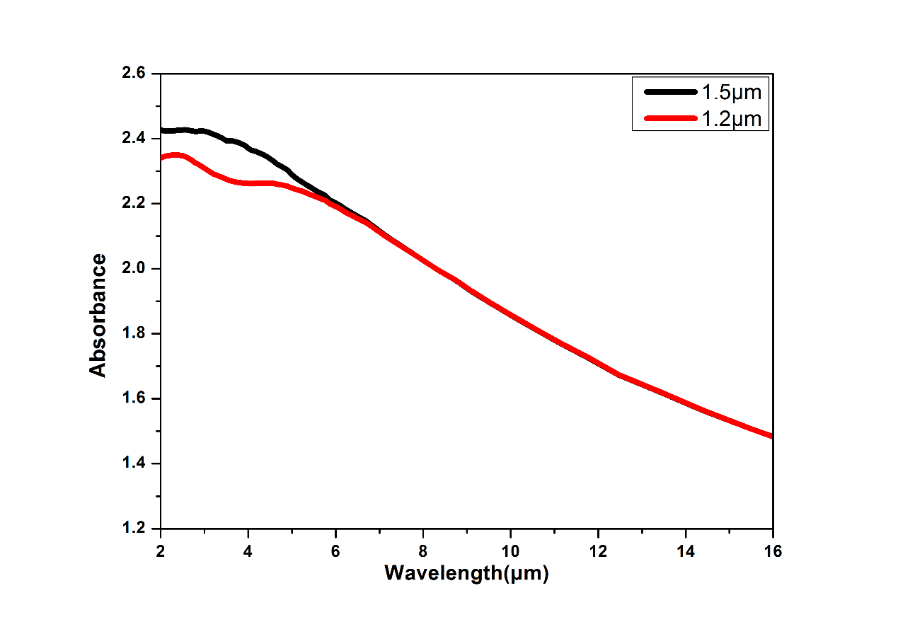
Figure S2. IR-absorbance spectra for the GNWs of 1.2 μm and 1.5μm in height, respectively.

We had made an experiment to obtain the limitation of absorbance with increasing the height of GNWs. As shown in Fig. S2, high GNWs, e.g. 1.2 μm corresponds to a strong light absorbance in comparison to the GNWs of 940 nm in height. When the height of GNWs is increased to be 1.5 μm, the limitation of absorbance of the GNWs is appeared. For bolometric or thermal active layer utility, height of 1.5 μm is the best option for its limited absorbance.

S3 Resistance change of GNWs under varying temperature with interval step of 1K and the ability of recoverability.
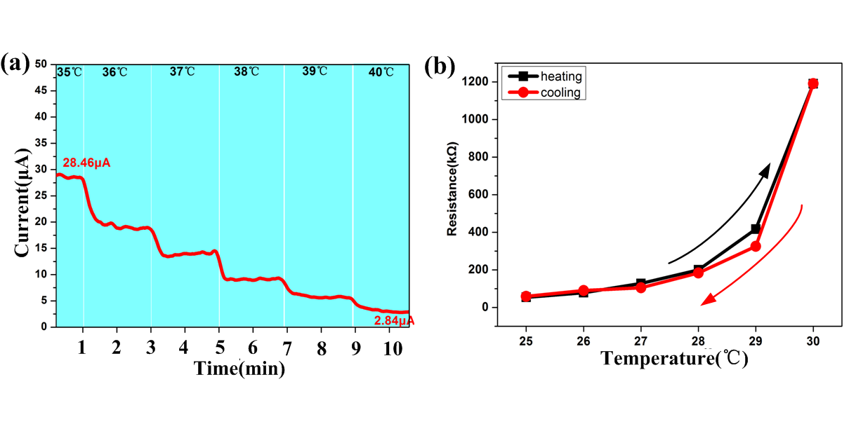
Figure S3. (a) Resistance change of GNWs/PMDS device under varying temperature with interval step of 1K, and (b) the ability of recoverability.

To prove that it is reasonable to measure the TCR with interval step of 5K, we made an extra experiment with interval step of 1K. The calculated TCR with respect to 35℃ and 40℃ is 180.4%/K, which is coincident with previous outcome, as shown in Fig. S3(a). Additionally, the heating-cooling process is demonstrated in Fig. S3(b) also, which means that our devices possess a good recoverability.

