Color display and encryption with a plasmonic polarizing metamirror: supplementary material
Maowen Song,^{1,2,3,†} Xiong Li,^{1,2,†} Mingbo Pu,¹ Yinghui Guo,¹ Kaipeng Liu,¹ Honglin Yu,³ Xiaoliang Ma,¹ and Xiangang Luo^{1,*}
¹State Key Laboratory of Optical Technologies on Nano-Fabrication and Micro-Engineering, Institute of Optics and Electronics, Chinese Academy of Sciences, P.O. Box 350, Chengdu 610209, China
²International Cooperative Research Center on Subwavelength Sciences, Institute of Optics and Electronics, Chinese Academy of Sciences, P.O. Box 350, Chengdu 610209, China
³Key Lab of Optoelectronic Technology and Systems of Education Ministry of China, Chongqing University, Chongqing 400044, China
*Corresponding author: lxg@ioe.ac.cn

Sample Fabrication
Figure S1 shows the fabrication process of the PSG. First, a silicon wafer is boiled in H₂SO₄:H₂O₂ (3:1) solution for 60 minutes and cleaned in deionized water, alcohol and acetone in sequence. Then the AR-3170 positive photoresist (PR) is spin-coated onto the silicon substrate at the speed of 4000 rpm and baked for 10 min at 100 °C. The thickness of the PR is about 120 nm measured by surface profiler. Periodic grating spanning 30 mm ×30 mm is generated by laser interference lithography with a HeCd laser at the wavelength of 325 nm. After exposure, the periodically patterned photoresist can be obtained after development in the solution AR 300-35. Then reactive-ion-etching (RIE) is used to transfer the grating to the silicon substrate with a thickness of 30 nm. Next, the photoresist on the patterned silicon is removed by acetone and the silicon is immersed in NH₃:H₂O₂:H₂O (1:2:10) solution for 5 minutes at room temperature. When the hydroxyl is formed, clean the patterned silicon with deionized water and coat silver film on it by magnetron sputtering. The silver is first sputtered with chamber pressure of 2 Pa and power of 20 W, which have been changed to 0.13 Pa and 200 W after the thickness of silver film reaches to 20 nm. The reason for forming hydroxyl on the silicon and sputtering silver with small power is to weaken the adhesion between the silicon and silver. When the thickness of the silver film reaches to 200 nm, the silver film is glued to another silicon dioxide superstrate with UV curable epoxy resin adhesive (X31213 produced by ZYMET), which is then cured by i-line mercury lamp at a wavelength of 365 nm and energy density of ≈100 J/cm². Finally, the patterned silver film together with the silicon dioxide superstrate is physically stripped off from the silicon substrate, due to the week adhesion between the silver grating and patterned silicon. As a result, a smooth silver film decorated with 30 nm-thick grooves is fabricated.

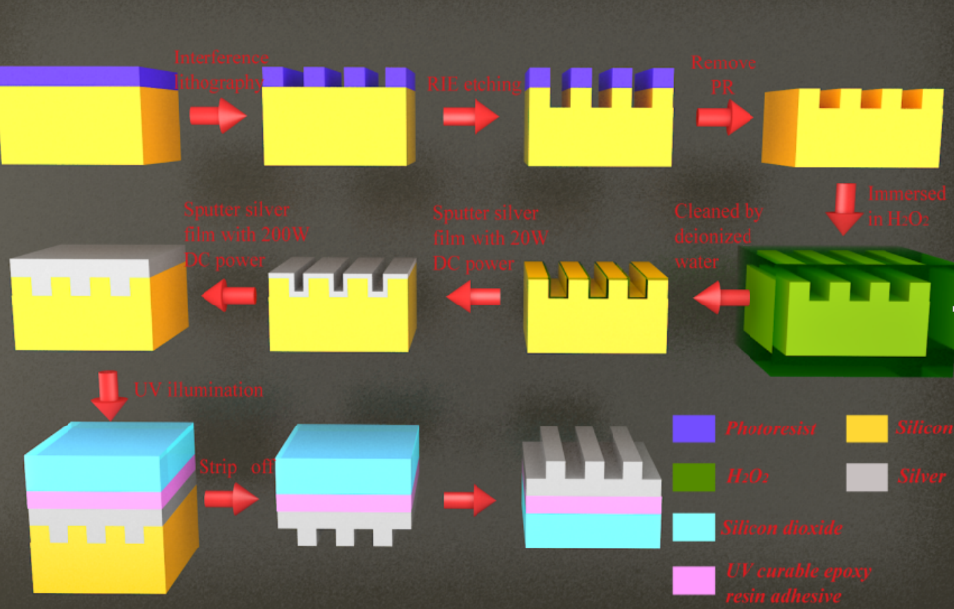
Fig. S1. Schematic diagrams for the fabricating process of the plasmonic grating

Experimental Setup
The experimental setup for both reflection spectra measurement and reflective imaging is shown in Figure S2. Two linear polarizers are placed in front of the sample and detector to generate the LP light and filter the reflective light with cross-polarization state, respectively. The incident polarization is titled 45º with respect to the grating direction. A combination of beam splitter and mirror is used to guide the reflected light to be detected as shown in Figure S2. For reflection spectra measurement, a tungsten lamp is used as light source and spectrometer as the detector. The reflectance of the sample is normalized to that from a silver mirror. Bright RGB color images are captured by using the same experimental setup except for replacing the light source and detector with a xenon lamp and a chromatic CMOS camera (DH-HV3151UC, Daheng Optics), respectively.
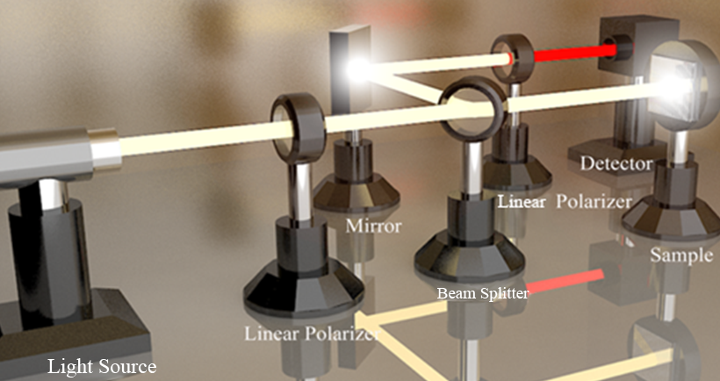
Figure S2．Schematic experiment setup for the measurement of structural colors. The red beam indicates the light polarized along -45 degree with respect to the grating direction.
Chromatic Sensing
Fig. S3. Chromatic sensing for the PSG with the period of 400 nm. (a) Different cross-polarization spectra for 45o polarized LP normal incidence when a relatively small refractive index change from 1 to 1.2 with a step of 0.02 is introduced in dielectric environment. (b) The corresponding chromatic coordinates are plotted in the CIE 1931 diagram.

